**Nesting Success of the Indian Cormorant *Phalacrocorax fuscicollis* (Aves:** **Suliformes: Phalacrocoracidae) in the Kamlanehru Zoological Park, Ahmedabad, India**

**ABSTRACT**

The Indian Cormorant *Phalacrocorax fuscicollis* is a freshwater species that has been nesting in the Kamlanehru Zoological Park, Ahmedabad, India, since 2019. Here, the breeding of the Indian shag was studied in 2021 to record the nesting success of species. The breeding activities of the Indian shag commenced in July and continued until November. The birds built their nests on *Azadirachta indica*, *Ficus religiosa* and *Peltophorum pterocarpum* trees. Both partners participated in nest building but males collected most of the materials. The incubation period was 28-30 days and the fledging period was up to 8 weeks. These observations provide new information on the nesting success of the Indian Cormorant.

**Keywords:** Shag, successful breeding, nesting, conservation, Kamlanehru Zoological Park.

**INTRODUCTION**

The Indian Cormorant *Phalacrocorax fuscicollis* is common and widespread in India, Pakistan, and Sri Lanka, and eastward to southern Indochina (Nelson 2005, Orta et al. 2020). In India, it had not been reported from Ahmedabad until 2019, when it was first observed nesting in the Kamlanehru Zoological Park. This paper reports new observations on the breeding ecology of the Indian Cormorant during 2021.

**MATERIALS AND METHODS**

**Study area**

Established in 1951, the 117-ha Kamlanehru Zoological Park is located on the outer periphery of Kankaria Lake in the city of Ahmedabad, [Gujarat](https://en.wikipedia.org/wiki/Gujarat), India. Kankaria Lake has a surface area of 31 ha and is surrounded with vegetation that provides suitable nesting habitat for the Eurasian Spoonbill (*Platalea leucorodia*), Black-headed Ibis (*Threskiornis melanocephalus*), Little Cormorant (*Microcarbo niger)*, Black-crowned Night Heron (*Nycticorax nycticorax*) and Eastern Cattle Egret (*Bubulcus coromanda*).

**Protocol**

Observations of nesting Indian Cormorants were recorded from July to Nov 2021, during the breeding season, with the aid of 10×50 binoculars and a camera for documentation. Sightings were recorded twice a week and nest counts, using the total count method (Bibby et al. 2000), were conducted during 10:15-11:15 hr and again during 16:30-17:30 hr. The number of nesting trees at the rookery were also counted (Patel & Thakker, 2021).

**RESULTS**

The Indian Cormorant nested successfully in a monospecific colony at the rookery since 2019. All nests were built of dry twigs with dry plant materials at the forking of branches or near the main trunk of the tree species *Azadirachta indica, Ficus religiosa* and *Peltophorum pterocarpum* trees (Patel *et al.* 2018), which surrounded the pen of the marsh crocodile (*Crocodylus palustris*), at a height of 6-8 m above the ground. The basal diameter of nests was up to 25cm and the depth of the nests was 8 cm . Males gathered the nest material.

Nest counts and photographs of Indian shag nests in 2019 and 2020 revealed approximately 52 nests. In 2021, 48 nests were counted. The nests were occupied for a period of 187 days, from the initiation of nest building on ***date*** to the termination of fledging on ***date***.

The incubation period was 28-30 days . The nests produced 2-3 chicks which were sooty black with a yellow gular pouch. The fledging period was noted as 7.5-8 weeks *** give exact dates ***. Both partners participated in feeding the young with the Indian catfish *** give scientific name ***, which is locally known as mangur. During study period of 2021, we noted around total of 150 Indian shags were present in the breeding site. No cormorants were observed after November 27.

***Plate (1,2,3,4,5,6)*** *– Photos of Indian Cormorant nests and chicks at the* *Kamlanehru Zoological Park in Ahmedabad,* [*Gujarat*](https://en.wikipedia.org/wiki/Gujarat)*, India*.

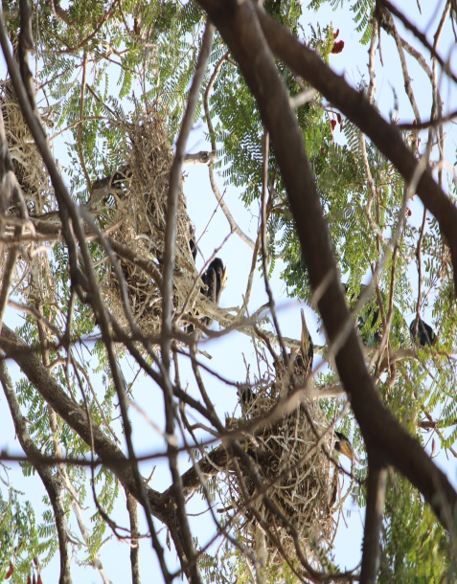 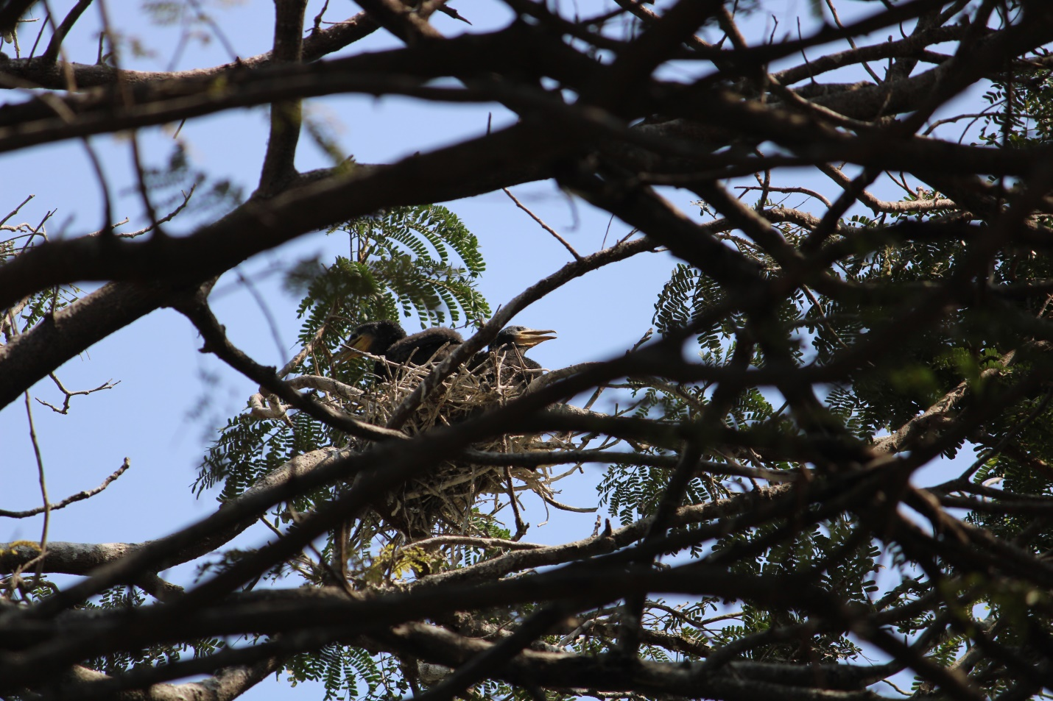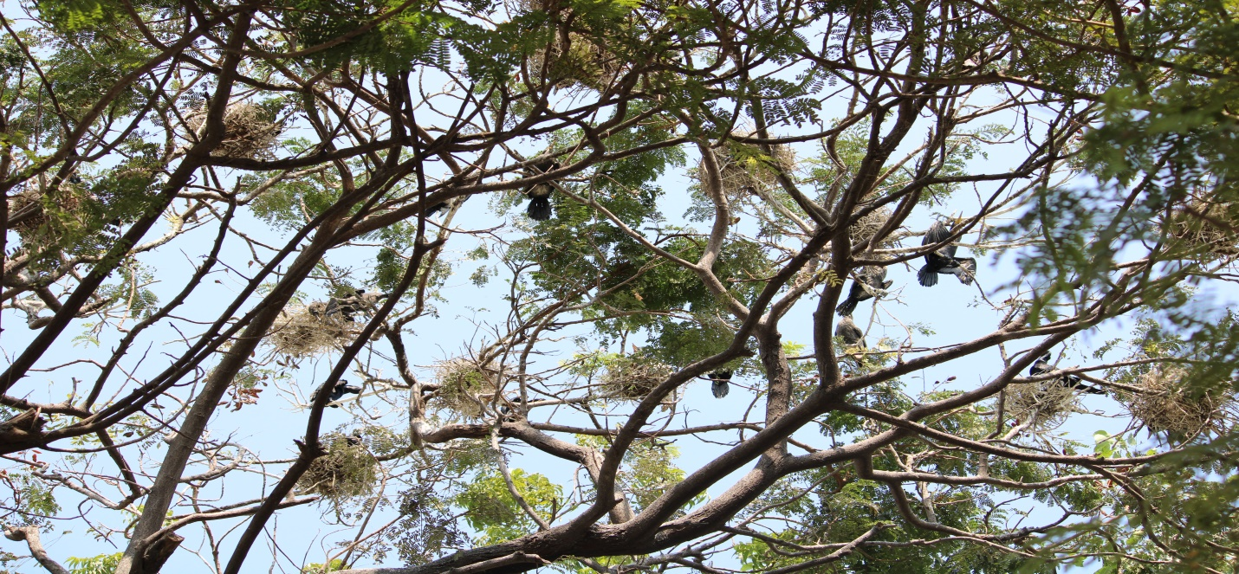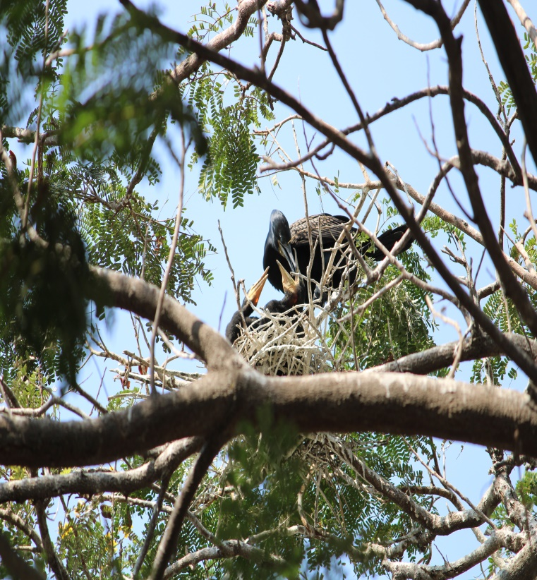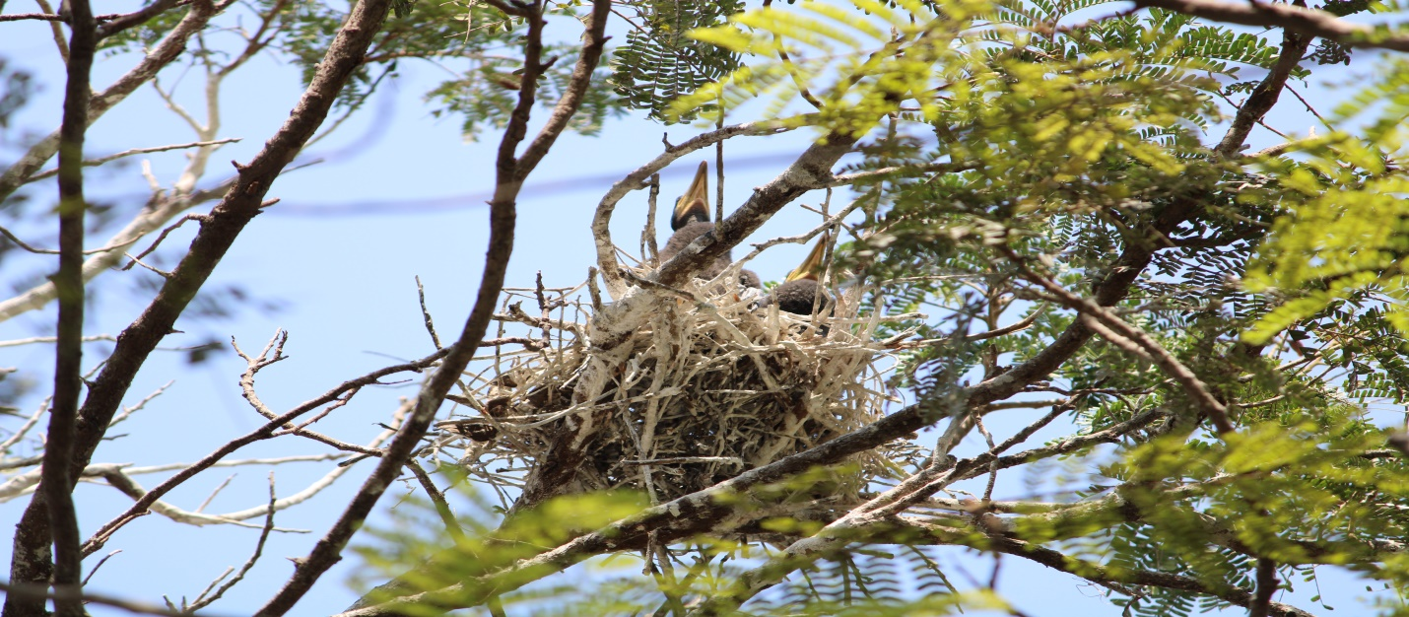

**DISCUSSION**

Gujarat have importance for many migratory birds and even during non- breeding seasons, based on their counts, as quoted by Patel & Thakker, 2021. This study is based on our first observation of successful breeding of Indian shag in Kamlanehru zoological Park has added significant ecological value to the area. Here, we observed the nesting was done more successfully during period of 2021. As photographic records from 2019 to 2023 were compiled and have noted that in 2022 the number of nests is less as compared to 2021 but during 2023 total number of nest count is same as compared to 2021. Nesting survival during 2021 and noted preceding years shows that the Indian shag was breeding quite successfully in KZP. Also, the Kankaria Lake plays a very significant role to supports the successful breeding of Indian shags. As Indian shag breeds during monsoon and fishes also breed during monsoon so, there is abundant prey available for young birds from Sept- Jan (Kahl 1971, Desai *et al*. 1974). We noted during noon time they seen as roosting and loafing till hours before sunset and leave around sunrise. Also, they observed while maintaining body which involves bathing, splashing and beating the water with wings, rolling one side and head dipping.

This KZP close to the Kankaria Lake is safe for breeding population of many birds with inclusion of Indian shag now. Also, the area provides huge availability of food as catchable prey- base and green vegetation for nesting with very less anthropogenic disturbances.

Generally, a representative shag breeding cycle occupies 19-20 weeks (Nelson, J.B., 2005). As noted that Also, with the inclusion of Johnsgard (1993), he mentioned that Indian shags use only sticks and vegetation lined with grass or other suitable plant material.

During the period of visits, with the explanation of Johnsgard (1993), we also noted that both male and female Indian shags produce conspicuous plumes during breeding season. During Pre- breeding season, Indian shag are mainly black, with deep blue gloss, scapulars, wing coverts bronzy with darker edges to feathers giving scaly pattern. Eye green, orbital ring green or black, facial skin variously described as black, pale green or purple black, Bill blackish, gular skin purple black with yellow edge or yellow all over. Legs, feet black. Whereas, Post- breeding, Indian shag lacks white head plumes, chin whitish, often mottled, overall plumage browner. Facial skin yellowish or brown with yellow marks, gular skin yellow.

**CONCLUSION**

As we noted the successful nesting of Indian shag in KZP as its aim is also conservation, research and educational trainings. Every year KZP records thousands of migratory birds with their heronry and Indian shag recorded for the first time here.

There is need to protect the breeding areas, especially when the existing wetlands and bird sanctuaries getting unsafe for nesting with involvement of public as picnic spots and KZP allowing more breeding birds in the urban setup. We believe that people should not be allowed near these trees during the breeding season. We also suggest that the Municipal Authorities should declare the roads adjoining to KZP as no honking zone or a silent zone.

Therefore, there is need to study the behaviour of waterbirds nesting in such urban settlements with their need for site- selection, food- source, and causes. This has huge implication on any conservation measures to be implemented and will help in policy making.

**References**

Ali, S., 1996. The book of Indian birds, 1st edition. Oxford University Press, New Delhi.

Anon. (2003). Wikipedia. Available at http://en.wikipedia.org/wiki/Cormorant# Species. Accesses date: 15-02-2003.

Bibby, C.J., N.D. Burgess, D.A. Hill & S.H. Mustoe (2000). Bird Census Techniques. Academic Press, London, 302pp.

Del Hoyo, J., Elliott, A. and Sargatal, J. (eds) (1992). Handbook of the Birds of the World, Vol. 1. ICBP, Lynx Edicions, Barcelona.

Desai, J. H., R. V. Shah, and G. K. Menon. 1974. Diet and food requirements of Painted Storks at the breeding colony in the Delhi Zoological Park. Pavo 12: 13-23.

Johnsgard, P.A. (1993). Cormorants, Darters and Pelicans of the World. Smithsonian Institution Press. Washington.

Joshi, P. and Shrivastava, V.K., 2012. Breeding biology and nest site selection of cattle egret (Bubulcus ibis) in Tawa Reservoir and surrounding area of Hoshangabad District (M.P). Asian J. exp. biol. Sci., 3: 525-530.

Kahl, M. P. 1971. The courtship of storks. Natural History 80: 36-4.

King, D.T. (1996). Movements of double-crested cormorants among winter roosts in the delta region of Mississippi. Journal of Field Ornithology, 67, 205–11.

Kour, D.N. and Sahi, D.N., 2013. Aspects of breeding biology of cattle egret, bubulcus ibis coromandus (boddaert) in Jammu, India. Int. J. environ. Sci., 3: 1547-1561.

Nelson, J.B. (2005). Pelicans, Cormorants and Their relatives: *The Pelecaniformes*, 17th vol. Oxford University Press, New York.

Niangthianhoi, S.L. & F.A. Khudsar (2015). The nesting success of the Oriental Darter Anhinga melanogaster (Aves: Suliformes: Anhingidae) in the Yamuna Biodiversity Park, New Delhi, India. Journal of Threatened Taxa 7(14): 8148–8153; <http://dx.doi.org/10.11609/jott.2430.7.14.8148-8153>.

Orta, J., D. A. Christie, F. Jutglar, and G. M. Kirwan (2020). Indian Cormorant (*Phalacrocorax fuscicollis*), version 1.0. In Birds of the World (J. del Hoyo, A. Elliott, J. Sargatal, D. A. Christie, and E. de Juana, Editors). Cornell Lab of Ornithology, Ithaca, NY, USA. https://doi.org/10.2173/bow.indcor1.01

Patel, N.A. Thakker, R.P (2021) Study on heronry of Painted Storks in and around of Sanathal Lake, Ahmedabad, Gujarat. International Journal of Zoology and Research, Vol.11, Issue 2, Dec 2021, 7-16.

Patel, R. S., Kadia, R., Bhatt, V. and Patel, V. (2018). Floristic Diversity of Family Malvaceae Found in Kankariya Zoo Campus, Ahmedabad, Gujarat, India. International Journal of Scientific Research in Science and Technology, Mar-Apr; 4(5): 603-609.

Siegel-Causey, D. (1986a). The courtship behaviour and mixed-species pairing of king and imperial blue eyed shags (Phalacrocorax albiventer and P. atriceps). Wilson Bulletin, 98, 571–80.

Siegel-Causey, D. (1986b). Behaviour and affinities of the Magellanic cormorant. Notornis, 33, 249–57.

Siegel-Causey, D. (1987). Behaviour of the red-footed cormorant (Phalacrocorax gaimardi). Notornis, 34, 1–9.

Siegel-Causey, D. (1988). Phylogeny of the Phalacrocoracidae. Condor, 90, 885–905.

Urfi, A. J. (1993). Breeding Patterns of Painted Storks (Mycteria leucocephala Pennant) at Delhi Zoo, India. Colonial Waterbirds, 16(1): 95-97.