Effect of exogenous human kisspeptin 10 on concentration of estradiol, progesterone and estrus behavior in Bhadawari Buffaloes

ABSTRACT
Kisspeptin is identified as a neuropeptide having its response on various endocrines leading to significant impact on reproductive physiology in livestock. The aim of the research was to evaluate the effect of Human Kisspeptin 10 (hKp10) on the concentration of plasma estradiol (E₂), progesterone (P₄) and visual estrus signs in cyclic Bhadawari buffalo. Four cyclic Bhadawari buffaloes pre-fitted with jugular cannula were administered hKp10 @ 1.5, 2.5, 5 µg/ kg body weight and 2ml normal saline as a control on D 10 of estrous cycle (D0- Day of estrus) in a fashion that none of the buffaloes received the same dose twice. All experimental buffaloes received all the hKp10 doses and/ or NS at least once at 2 days interval. Blood samples collected in heparinised tubes at -60, -30, 0 (just before injection of hKp10), 15, 30, 45, 60, 90 and 120 minutes after the hKp 10 and/ or NS injection. Plasma was separated. Estimation of E₂ and P₄ was done using ELISA kit. There was non-significant (P>0.05) increase in the level of plasma E₂ and P₄ at 1.5, 2.5 and 5µg/ kg body weight hKp10 doses in the treated buffaloes compared to control (NS infused samples). The response on visible estrus signs was significant when observed between untreated (control group) and hKp10 treated estrous cycle.
Key words- Kisspeptin, Estradiol, Progesterone, hKp10, Bhadawari buffaloes and estrus signs

- INTRODUCTION: Bhadawari is an improved riverine buffalo breed predominantly concentrated in Uttar Pradesh and Madhya Pradesh, India. The breed has an average age at 1st calving, service period, dry period, milk yield ad average calving interval are 48.6 months, 138 days, 220 days, 1029kg ad 445 days respectively (Sethi, 2005). It is highly tolerant to disease and resists adverse effects of high rise in temperature during summer (Arora et al., 2004). The average milk fat, Solid not Fat (SNF), protein and lactose recorded were 8.26, 9.57, 4.05 and 5.23 % respectively in Bhadawari milk (ICAR-IGFRI Annual Report 2015-16). It thrives well in the harsh agro-climatic conditions (Naha, 2013) making it suitable milch breed for the climate resilience. Generally, Bhadawari buffaloes have sub-optimum reproductive efficiency in terms of attainment of puberty and sexual maturity. The expression of estrus is very poor and often goes un-noticed. The different phases of reproductive cycle are regulated by interaction between hypothalamo- pituitary-gonadal axis. It is essential to know about the concentration of indigenous E₂, P₄and observation of signs of estrus in response to hKp10 administration between hKp10 treated and untreated group with an aim of alleviating the reproductive constraints like silent estrus or weak exhibition of heat signs in Bhadawari buffaloes. Several studies are reported on hormones in buffaloes including Murrah (Jerome et al., 2017), Nili- Ravi (Warriach et al., 2012), Surti (Chaudhari et al., 2022) and Jaffrabadi buffaloes (Raval et al., 2021). Inter-relationship between kisspeptin, E_{2,} P₄ and estrus behavioral signs has not been reported in buffaloes.
Kisspeptin is identified as a fascinating neuropeptide having a variety of roles in the reproductive physiology. It is synthesized mainly by the kiss1 gene present in the Hypothalamic kisspeptin-expressing neurones located in the anteroventral periventricular nucleus, periventricular nucleus, anterodorsal preoptic nucleus and arcuate nucleus (Han et al. 2005, Smith et al. 2005, 2006) as 145-aminoacid peptide that is cleaved proteolytically in a 54-amino acid called kisspeptin-54. They further degrade into shorter kisspeptin-14, kisspeptin-13 or kisspeptin-10. All functional kisspeptins share the same C terminal amino acid sequence that activates when binds with the G protein coupled/ GPR54 or Kiss 1r receptor (Ohtaki et al. 2001; Kotani et al. 2001; Muir et al. 2001). It has emerged as a key endogenous secretagogue of GnRH secretion (Messanger et al. 2005). Kisspeptin is found to be a controller of pulsatile GnRH secretion that regulates folliculogenesis, steroidogenesis and also cause GnRH surge that results in ovulation in females (Matzsuda et al. 2019). It is reported to be a robust stimulator of LH when used exogenously in cattle (Kadokawa et al. 2008), goat (Hashizume et al. 2010), sheep (Caraty et al. 2007), horse (Magee et al. 2009), pig (Lents et al. 2008), mouse (Gottsch et al. 2004), primate (Shahab et al. 2005) including human (Dhillo et al. 2005). Synthesis of kisspeptin and its hypothalamic presence is reported in buffaloes too (Chaikhun et al. 2016).
Various evidence indicates that KISS1–KISS1R signaling occurs primarily at the hypothalamic level to regulate GnRH secretion, there is increasing evidence that kisspeptin and/or its receptor are expressed at various other peripheral tissues of the reproductive system, including the gonads (Naniwa et al. 2013, Gaytan et al. 2014, Hu et al.2017, Cao et al. 2019). Ovarian expression of KISS1 and KISS1R mRNA and/or protein has been reported in various species, including human (Castellano et al. 2006), rat (Zhou et al.2014), cat (Cielesh et al. 2017), dog (Basini et a. 2018) and pig (Tanyapanyachon et al. 2018)
In Bhadawari buffalo the response of exogenous kisspeptin on plasma concentration of E₂ , P₄ and various estrus signs is not known and their reproductive importance has not been studied till date. The objective of the present study was to investigate the response of kisspeptin administration on the plasma concentration of E₂, P₄ and exhibition of estrus behaviors.
- MATERIALS AND METHODS
2.1 EXPERIMENTAL ANIMALS- Four cyclic Bhadawari buffaloes aged 4 to 5 years with mean body weight 265 kg were used for the experimentation at Livestock Farm Complex, Faculty of Veterinary and Animal Sciences (FVAS), Institute of Agricultural Sciences, Rajiv Gandhi South Campus (RGSC), Banaras Hindu University (BHU), Barkachha, Mirzapur-231001, India located at 25.05078° N, 82.59928° E. The maximum and minimum temperature recorded during the experiment ranged between 10⁰- 30⁰ C (December- March, 2024). These buffaloes were kept under semi intensive system, fed ad-libitum green and dry fodder with concentrate mixture at the rate of 1.5 kg per day per animal. They were examined for health, absence of anatomical abnormalities and were selected on the basis of regular estrous cyclicity.
2.2 EXAMINATIONS- Confirmation of ovulation and presence of CL was diagnosed by trans-rectal palpation and ultrasonography. They were given two consecutive prostaglandin analog (Vetmet 2ml, 500µg) injected at12 days interval for estrous synchronization.
2.3 TREATMENT PROTOCOL-
Administration of Kisspeptin and Dose
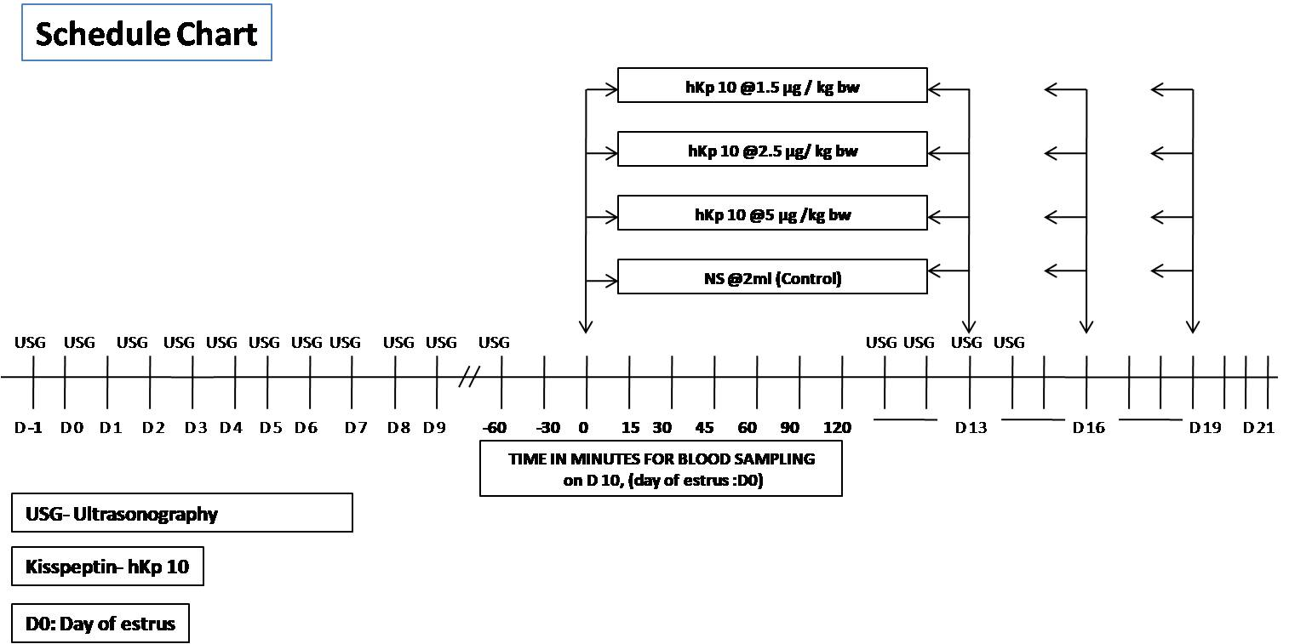
Human Kisspeptin 10 (112-121, amino acid sequence: YNW NSF GLR F-NH₂) (ANASPEC1mg) was used for therapeutic infusion and studied for its response at pre and post administration. All the four experimental buffaloes were given a single intravenous injection of hKp10 at the dose rate (1.5, 2.5 or 5µg/ kg. body weight.) or 2 ml NS as control. The compound was injected via jugular cannula pre fitted in one of the jugular veins a day before the infusion of drugs. All the buffaloes randomly received all the doses of treatment at two days interval starting from day 10 of estrus onset. Blood samples collected in heparinised tubes from all the buffaloes drawn at -60, -30, 0 minutes (just before injection of hKp10) and 15, 30, 45, 60, 90 and 120 minutes (after the injection) were immediately preserved in chilled icepacks. Plasma samples were separated by centrifugation at 3000 rpm for 15 min and stored at -20 °C until analysis of hormones done using ELISA kits. Plasma Estradiol concentration was estimated by Bovine Estradiol (E2) ELISA kit, Catalog No. CSB-E08173b, Detection Range- 50 pg/ml- 1200pg/ml, Sensitivity- 40 pg/ml, Detection wavelength- 450nm using competitive ELISA method. P₄ level was estimated using P₄ (Catalog No CSB-E08172b), Species- Bos taurus (Bovine), Detection Range- 1ng/ml- 70 ng/ml
Sensitivity- 0.2ng/ml, Detection wavelength- 450nm, based on quantitative principle and competitive ELISA.
Reproductive traits: The visible estrus behaviors like vulvar oedema, frequent micturation, cervical discharge, bellowing, mounting and salivation of hKp10 treated buffaloes were compared with the untreated estrus of Bhadawari buffaloes using Fisher Extract Test.
2.5 STATISTICAL ANALYSIS:
Statistical analysis was done by SPSS version 20. Mean and standard deviation were calculated by descriptive statistics. the level of significance in the concentration of plasma hormones were measured and compared using individual doses and control by one-way, repeated-measures ANOVA. To discover which specific means differed, the Bonferroni post hoc test was applied. Difference between the concentration of hormones before and after hKp10 infusion was compared using Student’s t-test. All data were analyzed using Microsoft excel and SPSS. Estrus behavioral signs were recorded between treated and control estrous cycles and were analysed based on Fisher’s Exact Test). The level of significance was calculated at p<0.05.
- RESULT AND DISCUSSION
3.1 Response of different doses of hKp10 on Estradiol (E₂) release:
Table 1 Response of different doses of hKp10 on E₂ at different time interval
Dose/ per kg bw | Estradiol (pg/ml) in minutes time interval
Dose/ per kg bw | 15 | 30 | 45 | 60 | 90 | 120
NS (Control) | 17.89ª ± 3.49 | 16.79 ª ±4.99 | 16.87ª ±4.23 | 16.51ª ±3.72 | 17.35ª ± 3.82 | 17.12 ª ± 3.53
1.5 µg  hKp10 | 17.85ª ± 5.1 | 19.16 ª ± 6.38 | 19.08ª ±5.20 | 19.11ª ±4.99 | 19.29 ª± 5.39 | 18.85 ª± 5.00
2.5 µg hKp10 | 22.58 ª ±4.28 | 23.17 ª ±4.47 | 21.63ª ±3.43 | 23.48ª ±2.67 | 23.38ª ± 2.69 | 23.82ª ± 2.86
5 µg hKp10 | 22.89 ª ±3.73 | 22.76 ª ± 4.44 | 22.93ª ±4.91 | 22.37 ª ±4.66 | 23.00ª ± 4.48 | 22.93ª ±4.08
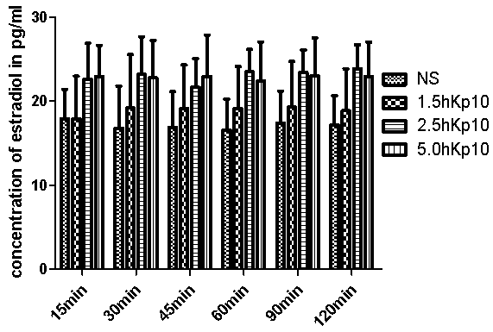
Fig 1 Response of different doses of hKp10 on E₂ at different time interval
The response of different doses of hKp10 is shown in (Table-1 & Figure-1). Plasma E₂ concentration in the saline infused treatment ranged from 17.10 to 22.89 pg/ml which did not vary significantly (p<0.05) compared to the basal E₂ concentration in buffaloes. Plasma E₂ concentration did not alter significantly (p<0.05) and estimated values were 17.85, 22.58 and 22.89 pg/ml following 1.5, 2.5 and 5 µg/kg. bw. i.v. infusion of hKp10 respectively at 15 minutes plasma samples. There was no significant increase in concentration of E₂ in plasma samples collected at different time schedules between different doses of hKp10 infusion.
Table2. Pre-post E₂ levels with response to hKp10
DOSE | E₂ (pg/ml)
DOSE | Pre hKp10 | Post hKp10
NS (Control) | 17.10±3.50 | 17.09±3.91
1.5µg/kg KP10 | 15.48±4.13 | 14.59±4.29
2.5 µg/kg KP10 | 21.06±3.02 | 19.82±3.21
5 µg/kg KP10 | 21.27±3.54 | 19.26±4.18
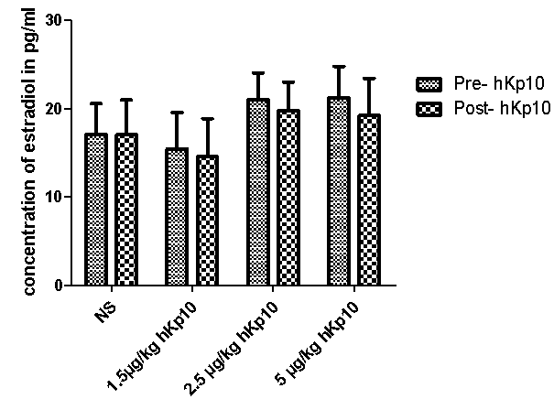
Figure-2 Response of pre and post hKp10 on Estradiol
The concentration of plasma E₂ using t-test was analyzed between pre and post hKp10 infusion (Figure-4). There was non-significant (p<0.05) variation in the concentration of E₂ in all the hKp10 doses post treatment compared to the pre treatment groups. There was no significant difference in NS infused group when pre and post E₂ concentration was compared. The highest level was recorded in hKp10 at 5 µg/kg hKp10 where the value of E₂ was 21.27 pg/ml in pre treatment and 19.26 pg/ml in post infusion plasma samples. Plasma E₂ ranged between 14.59 pg/ml to 21.27 pg/ml in all the treatment samples which were noted to be non-significant (p<0.05).
3.2 Response of different doses of hKp10 on Progesterone (P₄) release:
Table 3. Estrus behavior symptoms of Bhadawari buffaloes upon kisspeptin treatment
Dose/ per kg bw | Progesterone (ng/ml) in minutes time interval
 | 15 | 30 | 45 | 60 | 90 | 120
NS (Control) | 1.49ª ±0.38 | 1.42ª ±0.33 | 1.45ª ±0.341 | 1.38ª ±0.33 | 1.28ª±0.33 | 1.39ª ±0.35
1.5 µg  hKp10 | 1.36ª ±0.40 | 1.39ª ±0.37 | 1.39ª ±0.382 | 1.25ª ±0.36 | 1.27ª ±0.39 | 1.29ª ±0.36
2.5 µg hKp10 | 1.29ª ±0.34 | 1.39ª ±0.37 | 1.36ª ±0.292 | 1.42ª ±0.32 | 1.38ª ±0.32 | 1.34ª ±0.35
5 µg hKp10 | 1.25ª ± 0.31 | 1.11ª ±0.33 | 1.17ª ±0.329 | 1.13ª ±0.29 | 1.18ª ±0.30 | 1.16ª ±0.30
The response of different doses of hKp10 is shown in (Table-2 & Figure-2). Plasma P₄ concentration in the saline infused treatment ranged from 1.28 to 1.49 pg/ml which did not vary significantly (p<0.05) compared to the basal P₄ concentration in buffaloes. Plasma P₄ concentration did not alter significantly (p<0.05) and estimated values were 1.36, 1.29 and 1.25 pg/ml following 1.5, 2.5 and 5 µg/kg. bw. i.v. infusion of hKp10 respectively at 15 minutes plasma samples. There was no significant variation in concentration of P₄ in plasma samples collected at different time schedules between different doses of hKp10 infusion.
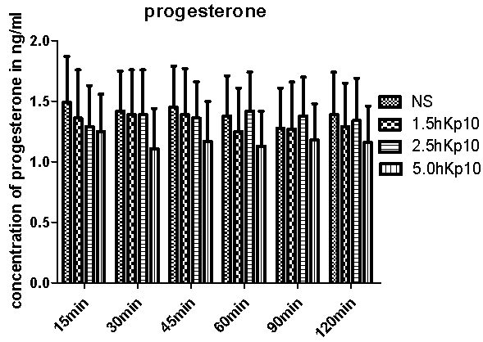
Figure-3. Response of hKp10 on P₄ at different time intervals (in minutes)
Table 4 Pre-Post P₄ level with response to hKp10
DOSE | P₄ (ng/ml)
DOSE | Pre hKp10 infusion | Post hKp10 infusion
NS (Control)) | 1.46±0.33 | 1.40±0.34
1.5µg/kg hKp10 | 1.45 ±0.35 | 1.32 ±0.37
2.5 µg/kg hKp10 | 1.35±0.30 | 1.36±0.33
5 µg/kg hKp10 | 1.20±0.32 | 1.17±0.30
The concentration of plasma P₄ using t-test was analyzed between pre and post hKp10 infusion (Table-2 & Figure-4). There was non-significant (p<0.05) difference in the concentration of P₄ in all the hKp10 doses post treatment groups compared to the pre treatment P₄ level. There was no significant difference in NS infused group when pre and post P₄ concentration was compared. The highest level was recorded in hKp10 at NS (control) where the value of P₄ was 1.46 ng/ml in pre treatment and 1.40 ng /ml in post infusion control (NS). Plasma P₄ ranged between 1.17 ng/ml to 1.46 ng/ml in all the treatment samples.
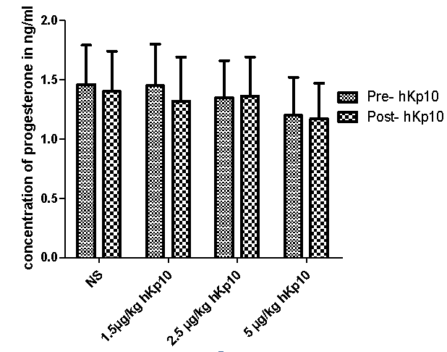
Figure 4 Response of hKp10 on progesterone concentration
Dutta et al. (2024) while exploring the impact of exogenous Kisspeptin-10 in Lakhimi cows on reproductive endocrines LH, progesterone and estradiol. There was significant increase in serum progesterone concentration on 10th day, concentration of LH on day1 and estradiol on the day before estrus (day 0- being the day of estrus). In this research the different doses of hKp10 and NS were given at random between D10 (Day 10 post estrus) to D19 (day 19 post estrus) and most of the doses of kisspeptin were administered in the luteal phase. It could be the reason of non-significant plasma E₂ level between the experimental animals.
There are several studies reported to have kisspeptin and its receptor present in certain peripheral tissues like ovaries showing local actions and also the expression by key ovarian cells in cattle. However, it was found that treating cultured bovine theca and granulosa cells with kisspeptin or kisspeptin antagonist did not modify steroid secretion. Hence, kisspeptin having a direct role in modifying production of ovarian steroids is not fully justified (Mattar et al., 2023).
Kaya et al. (2023) investigated the effects of kisspeptin, E₂, and P₄ levels at the time of artificial insemination (AI) on conception rates and also the relationship between Kiss-1 and E₂ levels in cattle between pregnant and non pregnant cattle. The Kiss-1 level at the time of AI in pregnant cows (80.58±4.4 pg/mL) was statistically higher than that in non-pregnant cows (66.68±2.48 pg/mL) (P=0.003). There were no significant differences in E₂ and P₄ levels between pregnant and non-pregnant cows. There was no significant correlation was between serum estrogen and progesterone levels. The experiment concluded that Kiss-1 levels at the time of AI may be used to predict the possibility of successful pregnancy in cattle.
The non significant difference in the level of P4 could be due to the treatments mostly given during the luteal phase of estrous cycle in all the experimental cyclic buffaloes. The random doses of hKp10 at 1.5, 2.5 and 5.0 µg/kg bw and NS (control) at 2 days intervals beginning at 10 day of estrus mostly lied within luteal phase.
Dutta et al. (2024) recorded no difference in P₄ in Kp treated and untreated Lakhimi cows, however they observed significantly higher concentration (p<0.05) of P₄ on 8th, 10th, 16th and 18th day of estrous cycle.
Several researches have revealed the expression of kisspeptin and KiSS1R in the granulose cells of ovaries of different animals (Cielesh et al, 2016). In buffaloes the expression of kisspeptin and KiSS1R is affected by the follicles, and the expression is higher in the granulose cells of the follicles with high progesterone concentration. In this study Kp-10 promoted progesterone synthesis through miR-1246 targeting StAR (steroid derived acute regulatory enzyme) and regulated free cholesterol transport in BGCs. (Rajin et al.2021).
With regard to steroidogenesis, it was reported that progesterone (P4) production by rat luteal cells was stimulated by kisspeptin (Peng et al.2013), while hCG-induced P4 production by rat GC was attenuated by a kisspeptin antagonist, kisspeptin 234 (Laoharatchatathanin et al. 2015). Kisspeptin was also shown to increase P4 production by porcine GC (Basini et al. 2018) and bovine GC (Guo et al. 2022). The above reports suggest a potential role of locally produced kisspeptins in the control of ovarian function.
3.3 Estrus signs recorded between treated and control estrous cycles (based on Fisher Exact Test)
Estrus signs | hKp10 treated | Control (untreated) | P- value
vulval oedema
% | 100% | 50% | 0.21
No./no. | 4/4 | 4/8 | 0.21
frequent micturation
% | 100% | 50% | 0.21
No./no. | 4/4 | 4/8 | 0.21
cervical discharge
% | 100% | 0%
No./no. | 4/4 | 0/8 | 0.002
Bellowing
% | 100% | 25%
No./no. | 4/4 | 0/8 | 0.002
Salivation
% | 100% | 100%
No./no. | 4/4 | 8/8 | --
Mounting
% | 50% | 0%
No./no. | 2/4 | 0/8 | 0.91
The response of kisspeptin treated estrous cycle showed significant increase (p<0.05) in the intensity of exhibition of estrus signs like cervical discharge and bellowing compared over untreated control group. Symptoms like vulval oedema, frequent micturation and mounting other animals were also seen in the treated groups but the level of increase were not statistically significant (p>0.05). Since the number of experimental animals were very less (no=4) further study using large sample size will authenticate the findings and kisspeptin as a therapeutic agent to activate and intensify estrus signs in a Bhadawari buffalo.
CONCLUSION
Kisspeptin is identified as a neuropeptide having its response on various endocrines leading to significant impact on reproductive physiology in livestock. In Bhadawari buffaloes, administration of hKp10 at different doses resulted in non-significant change in the concentration in blood plasma E₂ between the treated and control groups. There was significant increase in the intensity of estrous signs like cervical mucous discharge and bellowing in kisspeptin treated estrous cycle compared to the untreated group. Symptoms like vulval oedema, frequent micturition and mounting on other fellow buffaloes were increased non-significantly. The impact of kisspeptin on estrus signs could be studied better if the number of experimental animals was in larger number and treatment regime of kisspeptin hormone could be for more number of estrous cycles in Bhadawari buffaloes. The therapeutic use of kisspeptin to intensify the signs of estrus could be a boon to overcome the breeding constraints like salient estrus or weak estrus in buffaloes.

References:
- Sethi, R.K. (2003). Buffalo Breeds of India. Proceedings of Fourth Asian Buffalo Congress, New Delhi, India, 25 to 28 Feb.
- Arora, R., Vijh, R., Lakhchaura, B., Prasad, R. and Tantia, M. (2004). Genetic diversity analysis of two buffalo populations of northern India using microsatellite markers. Journal of Animal Breeding and Genetics 121(2), 111-118. doi:10.1111/j.1439-0388.2004.00451
- ICAR- Indian Grassland and Fodder Research Institute, Jhansi Annual Report 2015–16.
- Naha, B.C. (2013). Buffalo Genetic Resources in India and their Conservation." The Journal of Macro Trends in 1.1: 61–66. Web. 10 October 2014 Breed data sheet: Bhadawari. Domestic Animal Diversity Information System of the Food and Agriculture Organization of the United Nations. Accessed September Jmas Vol 1 Issue 1
- Jerome, A., Srivastava, S.K., Sherma, R.K., Sarkar, S.K. and Kumar, R. (2017). Follicular dynamics, hormonal and biochemical profile across seasons in buffaloes. Indian Journal of Animal Sciences 87 (7): 824–828. https://doi.org/10.56093/ijans.v87i7.72197
- Warriach, H.M., McGill, D., Bush, R.D. and Wynn, P.C. (2012). Production and Reproduction Performance of Nili-Ravi. J. Anim Plant Sci, 22(Sup 3): Page 121-124 ISSN: 1018-7081
- Chaudhari, D.V., Panchal, M.T., Dhami, A.J., Sarvaiya, N.P., Pathan, M.M., Hadiya, K.K., Patel, J.A. (2022). Follicular Dynamics and Endocrine Profile during Normal Estrous Cycle and Early Pregnancy in Surti Buffaloes. Vol 18 No.5 The Indian Journal of Veterinary Sciences and Biotechnology.
DOI: https://doi.org/10.48165/ijvsbt.18.5.01
- Raval, R.J., Parmar, K.H., Dhami, A.J., & Kavani, F.S. (2021). Ovarian Follicular Dynamics, and Hormonal and Biochemical Profile in Post-Pubertal and Postpartum Jaffrabadi Buffaloes. Ind J Vet Sci and Biotech, 17(1): 26-30. https://journals.acspublisher.com/index.php/ijvsbt/article/view/2224
- Han SK, Gottsch ML, Lee KJ, Popa SM, Smith JT, Jakawich SK, Clifton DK, Steiner RA, Herbison AE.2005Activation of gonadotropin-releasing hormone neurons by kisspeptin as a neuroendocrine switch for the onset of puberty. Journal of Neuroscience 2511349–11356.
DOI: 10.1523/JNEUROSCI.3328-05.2005

- Jeremy T. Smith, Matthew J. Cunningham, Emilie F. Rissman, Donald K Clifton, Robert A. Steiner, Regulation of Kiss1 Gene Expression in the Brain of the Female Mouse, Endocrinology, Volume 146, Issue 9, 1 September 2005, Pages 3686–3692, https://doi.org/10.1210/en.2005-0488
- Smith, J. T., Clifton, D. K., & Steiner, R. A. (2006). Regulation of the neuroendocrine reproductive axis by kisspeptin-GPR54 signaling. Reproduction, 131(4), 623-630. Retrieved Feb 25, 2025, from https://doi.org/10.1530/rep.1.00368
- Ohtaki, T., Shintani, Y., Honda, S., Matsumoto, H., Hori, A., Kanehashi, K. (2001). Metastasis suppressor gene KiSS-1 encodes peptide ligand of a G-protein coupled receptor. Nature 411:613e7 DOI: 10.1038/35079135
- Kotani, M., Detheux, M., Vandenbogaerde, A., Communi, D., Vanderwinden, J.M., Le Poul, E., Brézillon, S., Tyldesley, R., Suarez-Huerta, N, Vandeput F, Blanpain C, Schiffmann SN, Vassart. G, Parmentier, M. (2001). The metastasis suppressor gene KiSS-1 encodes kisspeptins, the natural ligands of the orphan G protein-coupled receptor GPR54. J Biol Chem. 14; 276(37):34631-6. doi: 10.1074/jbc.M104847200. Epub 2001 Jul 16. PMID: 11457843.
- Muir, A. I., Chamberlain, L., Elshourbagy, N. A., Michalovich, D., Moore, D. J., Calamari, A., Szekeres, P. G., Sarau, H. M., Chambers, J. K., Murdock, P., Steplewski, K., Shabon, U., Miller, J. E., Middleton, S. E., Darker, J. G., Larminie, C. G., Wilson, S., Bergsma, D. J., Emson, P., Faull, R., … Harrison, D. C. (2001). AXOR12, a novel human G protein-coupled receptor, activated by the peptide KiSS-1. The Journal of biological chemistry, 276(31), 28969–28975. https://doi.org/10.1074/jbc.M102743200
- Messager, S., Chatzidaki, E. E., Ma, D., Hendrick, A. G., Zahn, D., Dixon, J., Thresher, R. R., Malinge, I., Lomet, D., Carlton, M. B., Colledge, W. H., Caraty, A., & Aparicio, S. A. (2005). Kisspeptin directly stimulates gonadotropin-releasing hormone release via G protein-coupled receptor 54. Proceedings of the National Academy of Sciences of the United States of America, 102(5), 1761–1766. https://doi.org/10.1073/pnas.0409330102
- Matsuda, F., Ohkura, S., Magata, F., Munetomo, A., Chen, J., Sato, M., Inoue, N., Uenoyama, Y., & Tsukamura, H. (2019). Role of kisspeptin neurons as a GnRH surge generator: Comparative aspects in rodents and non-rodent mammals. The journal of obstetrics and gynaecology research, 45(12), 2318–2329. https://doi.org/10.1111/jog.14124
- Kadokawa, H., Matsui, M., Hayashi, K., Matsunaga, N., Kawashima, C., Shimizu, T., Kida, K., & Miyamoto, A. (2008). Peripheral administration of kisspeptin-10 increases plasma concentrations of GH as well as LH in prepubertal Holstein heifers. The Journal of endocrinology, 196(2), 331–334. https://doi.org/10.1677/JOE-07-0504
- Hashizume, T., Saito, H., Sawada, T., Yaegashi, T., Ezzat, A. A., Sawai, K., & Yamashita, T. (2010). Characteristics of stimulation of gonadotropin secretion by kisspeptin-10 in female goats. Animal reproduction science, 118(1), 37–41. https://doi.org/10.1016/j.anireprosci.2009.05.017
- Caraty, A., Smith, J. T., Lomet, D., Ben Saïd, S., Morrissey, A., Cognie, J., Doughton, B., Baril, G., Briant, C., & Clarke, I. J. (2007). Kisspeptin synchronizes preovulatory surges in cyclical ewes and causes ovulation in seasonally acyclic ewes. Endocrinology, 148(11), 5258–5267. https://doi.org/10.1210/en.2007-0554
- Magee, C., Foradori, C. D., Bruemmer, J. E., Arreguin-Arevalo, J. A., McCue, P. M., Handa, R. J., Squires, E. L., & Clay, C. M. (2009). Biological and anatomical evidence for kisspeptin regulation of the hypothalamic-pituitary-gonadal axis of estrous horse mares. Endocrinology, 150(6), 2813–2821. https://doi.org/10.1210/en.2008-1698
- Lents, C.A., Heidorn, N.L., Barb, C.R. and Ford, J.J. (2008). Central and Peripheral administration of kisspeptin activates gonadotropin but not somatotropin secretion in prepubertal gilts. Society for Reproduction and Fertility ISSN 1470-1626 (paper) 1741-7899 (online) DOI:10.1530/REP-07-0502
- Gottsch, M. L., Cunningham, M. J., Smith, J. T., Popa, S. M., Acohido, B. V., Crowley, W. F., Seminara, S., Clifton, D. K., & Steiner, R. A. (2004). A role for kisspeptins in the regulation of gonadotropin secretion in the mouse. Endocrinology, 145(9), 4073–4077. https://doi.org/10.1210/en.2004-0431
- Shahab, M., Mastronardi, C., Seminara, S. B., Crowley, W. F., Ojeda, S. R., & Plant, T. M. (2005). Increased hypothalamic GPR54 signaling: a potential mechanism for initiation of puberty in primates. Proceedings of the National Academy of Sciences of the United States of America, 102(6), 2129–2134. https://doi.org/10.1073/pnas.0409822102
- Dhillo, W. S., Chaudhri, O. B., Patterson, M., Thompson, E. L., Murphy, K. G., Badman, M. K., McGowan, B. M., Amber, V., Patel, S., Ghatei, M. A., & Bloom, S. R. (2005). Kisspeptin-54 stimulates the hypothalamic-pituitary gonadal axis in human males. The Journal of clinical endocrinology and metabolism, 90(12), 6609–6615. https://doi.org/10.1210/jc.2005-1468
- Chaikhun-Marcou, T., Sotthibandhu, P., Kyle, V., Yeo, S.H., Colledge, W.H. and Suadsong, S. (2016). Evidence of kisspeptin receptor expression in GnRH neurons in the preoptic area and arcuate hypothalamic nuclei in cycling buffaloes. Thai J Vet Med. 2016. 46(3): 381-390 DOI: 10.56808/2985-1130.2752
- Naniwa Y, Nakatsukasa K, Setsuda S, Oishi S, Fujii N, Matsuda F, Uenoyama Y, Tsukamura H, Maeda K, Ohkura S. Effects of full-length kisspeptin administration on follicular development in Japanese Black beef cows. J Reprod Dev. 2013 Dec 17;59(6):588-94. doi: 10.1262/jrd.2013-064. Epub 2013 Oct 10. PMID: 24107742; PMCID: PMC3934150.
- Gaytan, F., Garcia-Galiano, D., Dorfman, M. D., Manfredi-Lozano, M., Castellano, J. M., Dissen, G. A., Ojeda, S. R., & Tena-Sempere, M. (2014). Kisspeptin receptor haplo-insufficiency causes premature ovarian failure despite preserved gonadotropin secretion. Endocrinology, 155(8), 3088–3097. https://doi.org/10.1210/en.2014-1110
- Hu KL, Zhao H, Chang HM, Yu Y, Qiao J. Kisspeptin/Kisspeptin Receptor System in the Ovary. Front Endocrinol (Lausanne). 2018 Jan 4;8:365. doi: 10.3389/fendo.2017.00365. PMID: 29354093; PMCID: PMC5758547.
- Cao Y, Li Z, Jiang W, Ling Y, Kuang H. Reproductive functions of Kisspeptin/KISS1R Systems in the Periphery. Reprod Biol Endocrinol. 2019 Aug 9;17(1):65. doi: 10.1186/s12958-019-0511-x. PMID: 31399145; PMCID: PMC6689161.
- Castellano, J. M., Gaytan, M., Roa, J., Vigo, E., Navarro, V. M., Bellido, C., Dieguez, C., Aguilar, E., Sánchez-Criado, J. E., Pellicer, A., Pinilla, L., Gaytan, F., & Tena-Sempere, M. (2006). Expression of KiSS-1 in rat ovary: putative local regulator of ovulation?. Endocrinology, 147(10), 4852–4862. https://doi.org/10.1210/en.2006-0117
- Zhou, Q., Chen, H., Yang, S., Li, Y., Wang, B., Chen, Y., & Wu, X. (2014). High-fat diet decreases the expression of Kiss1 mRNA and kisspeptin in the ovary, and increases ovulatory dysfunction in postpubertal female rats. Reproductive biology and endocrinology : RB&E, 12, 127. https://doi.org/10.1186/1477-7827-12-127
- Cielesh, M. E., McGrath, B. M., Scott, C. J., Norman, S. T., & Stephen, C. P. (2017). The localization of kisspeptin and kisspeptin receptor in the canine ovary during different stages of the reproductive cycle. Reproduction in domestic animals = Zuchthygiene, 52 Suppl 2, 24–28. https://doi.org/10.1111/rda.12841
- Basini, G., Grasselli, F., Bussolati, S., Ciccimarra, R., Maranesi, M., Bufalari, A., Parillo, F., & Zerani, M. (2018). Presence and function of kisspeptin/KISS1R system in swine ovarian follicles. Theriogenology, 115, 1–8. https://doi.org/10.1016/j.theriogenology.2018.04.006
- Tanyapanyachon, P., Amelkina, O., & Chatdarong, K. (2018). The expression of kisspeptin and its receptor in the domestic cat ovary and uterus in different stages of the ovarian cycle. Theriogenology, 117, 40–48. https://doi.org/10.1016/j.theriogenology.2018.05.019
- Datta, A., Baruah, A., Bora, A., Dutta, D. , Goswami, J., Bhuyan, D. and Das, S. (2024). Exploring the impact of exogenous Kisspeptin-10 on ovarian follicular development and estrus behaviour in Lakhimi cows of Assam. Indian Journal of Animal Sciences 94 (7): 604–609 DOI:https://doi.org/10.56093/ijans.v94i7.147401
- Mattar D, Cheewasopit W, Samir M, Knight PG. Does kisspeptin exert a local modulatory effect on bovine ovarian steroidogenesis? Reprod Fertil. 2023 Feb 1;4(1):e220088. doi: 10.1530/RAF-22-0088. Epub ahead of print. PMID: 36745024; PMCID: PMC9986390.
- Kaya,S., Kacar,C., Ari, U.C., Merhan O., Demir, M.C., Bekyurek, T., Gurbulak K., (2023). Effects of estradiol, progesterone and kisspeptin-1 concentrations at the time of insemination on conception rates in cattle. Journal of the Hellenic Veterinary Medical Society, Vol.74 No. 2(2023), https://doi.org/10.12681/jhvms.27527
- Rajin, T. R., Patra, M. K., Sheikh, P. A., Singh, A. K., Mishra, G. K., Karikalan, M., Singh, S. K., Kumar, H., Gaur, G. K., & Krishnaswamy, N. (2022). Expression of kisspeptin and its receptor in different functional classes of ovarian follicle in the buffalo (Bubalus bubalis). Theriogenology, 179, 87–96. https://doi.org/10.1016/j.theriogenology.2021.11.017
- Peng J, Tang M, Zhang BP, Zhang P, Zhong T, Zong T, Yang B, Kuang HB.2013 Kisspeptin stimulates progesterone secretion via the ERK1/2 mitogen-activated protein kinase signaling pathway in rat luteal cells. Fertility and Sterility® Vol. 99, No. 5, April 2013 0015-0282/$36.00 Copyright ©2013 American Society for Reproductive Medicine, Published by Elsevier Inc. http://dx.doi.org/10.1016/j.fertnstert.2012.12.008
- Mattar, D., Cheewasopit, W., Samir, M., & Knight, P. G. (2023). Does kisspeptin exert a local modulatory effect on bovine ovarian steroidogenesis?. Reproduction & fertility, 4(1), e220088. Advance online publication. https://doi.org/10.1530/RAF-22-0088
- Laoharatchatathanin, T., Terashima, R., Yonezawa, T., Kurusu, S., & Kawaminami, M. (2015). Augmentation of Metastin/Kisspeptin mRNA Expression by the Proestrous Luteinizing Hormone Surge in Granulosa Cells of Rats: Implications for Luteinization. Biology of reproduction, 93(1), 15. https://doi.org/10.1095/biolreprod.115.127902
- Basini G, Grasselli F, Bussolati S, Ciccimarra R, Maranesi M, Bufalari A, Parillo F, Zerani M.2018Presence and function of kisspeptin/KISS1R system in swine ovarian follicles. Theriogenology 1151–8. ( 10.1016/j.theriogenology.2018.04.006) https://doi.org/10.1016/j.theriogenology.2018.04.006
- Latif, R., & Rafique, N. (2015). Serum kisspeptin levels across different phases of the menstrual cycle and their correlation with serum oestradiol. The Netherlands journal of medicine, 73(4), 175–178.
- Leonardi, C. E. P., Dias, F. C. F., Adams, G. P., & Singh, J. (2018). Effect of Kisspeptin-10 on plasma luteinizing hormone concentrations and follicular dynamics during the luteal phase in cattle. Theriogenology, 119, 268–274. https://doi.org/10.1016/j.theriogenology.2018.06.023
- Peng J, Tang M, Zhang BP, Zhang P, Zhong T, Zong T, Yang B, Kuang HB.2013Kisspeptin stimulates progesterone secretion via the ERK1/2 mitogen-activated protein kinase signaling pathway in rat luteal cells. Fertility and Sterility 991436–1443.e1. ( 10.1016/j.fertnstert.2012.12.008)
- Laoharatchatathanin T, Terashima R, Yonezawa T, Kurusu S, Kawaminami M.2015Augmentation of Metastin/Kisspeptin mRNA expression by the proestrous luteinizing hormone surge in granulosa cells of rats: implications for luteinization. Biology of Reproduction 93 15. ( 10.1095/biolreprod.115.127902)
- Basini G, Grasselli F, Bussolati S, Ciccimarra R, Maranesi M, Bufalari A, Parillo F, Zerani M.2018Presence and function of kisspeptin/KISS1R system in swine ovarian follicles. Theriogenology 1151–8. ( 10.1016/j.theriogenology.2018.04.006)
- Guo L, Xu H, Li Y, Liu H, Zhao J, Lu W, Wang J.2022Kisspeptin-10 promotes progesterone synthesis in bovine ovarian granulosa cells via downregulation of microRNA-1246. Genes (Basel) 13. ( 10.3390/genes13020298)

