Beetle (Insecta: Coleoptera) Fauna of Anjaw District, Arunachal Pradesh: New Records of Terrestrial and Aquatic Species

This should be Distributional notes on beetles of Anjaw District, Arunachal Pradesh

Abstract
Faunal surveys conducted in Anjaw district, Arunachal Pradesh, India, a region known for its rich biodiversity, have yielded 70 beetle species belonging to 49 genera and 12 families. Beetles play crucial roles in ecosystems as pollinators, decomposers, and predators. Among the species collected, 17 represent new records for Arunachal Pradesh, contributing significantly to our knowledge of the state's beetle diversity. Continued exploration of lesser-studied areas in the state of Arunachal Pradesh is anticipated to reveal further additions to the Coleopteran fauna.
Keywords
New Distribution records, Faunistic Survey

Introduction

Beetles (Coleoptera), characterized by their hardened forewings (elytra) and complete metamorphosis, represent the most species-rich group of organisms on Earth. With an estimated 389,487 described species globally [1], and likely many more undiscovered [2], understanding their diversity is a significant challenge. Beetles occupy a vast array of terrestrial and freshwater habitats, playing crucial ecological roles as pollinators, decomposers, predators, and more. India harbors a substantial portion of this diversity, with current estimates exceeding 21,000 species [3]. The Indian Himalayan region, a biodiversity hotspot, is particularly important, accounting for nearly half of India's known beetle fauna [4]. However, within this region, Arunachal Pradesh, despite its rich ecological potential, remains under-explored. Current records list over 1,064 beetle species for the state [4], highlighting the need for intensified biodiversity surveys. This study focuses on the beetle fauna of Anjaw district, Arunachal Pradesh, aiming to document species richness and provide new distributional records based on recent field surveys. As a result of these surveys, we have identified 70 species from 49 genera and 12 families, including 17 new records for Arunachal Pradesh. This significant finding contributes substantially to our understanding of the state's beetle diversity, and we anticipate that continued exploration of lesser-studied areas within the district will reveal further additions to the Coleopteran fauna.

Materials and Methods

Study area: Arunachal Pradesh, a biodiversity hotspot in northeastern India (26°28′N to 29°30′N, 91°30′E to 97°30′E), provides the broader ecological context for this study. Within this state, Anjaw district (27°33′N to 29°22′N, 95°15′E to 97°24′E) is of particular interest due to its unique and diverse characteristics. As the easternmost district of Arunachal Pradesh as well as India, Anjaw shares international borders with both China and Myanmar, a factor that likely influences its biogeography. The district's terrain is predominantly rugged and mountainous, encompassing elevations from subtropical valleys to high-altitude alpine zones. Dense forests, including a mix of coniferous and rhododendron species at higher elevations, blanket much of the landscape, providing diverse habitats for a variety of fauna. These forests are dissected by deep river valleys carved by the Lohit River and its tributaries, creating a complex and varied topography. The climate in Anjaw is strongly influenced by elevation, transitioning rapidly from subtropical conditions in the lower valleys to harsh alpine conditions at higher altitudes. This steep environmental gradient contributes significantly to the region's exceptional biodiversity, creating a mosaic of distinct habitats and making Anjaw an important area for ecological and entomological research.
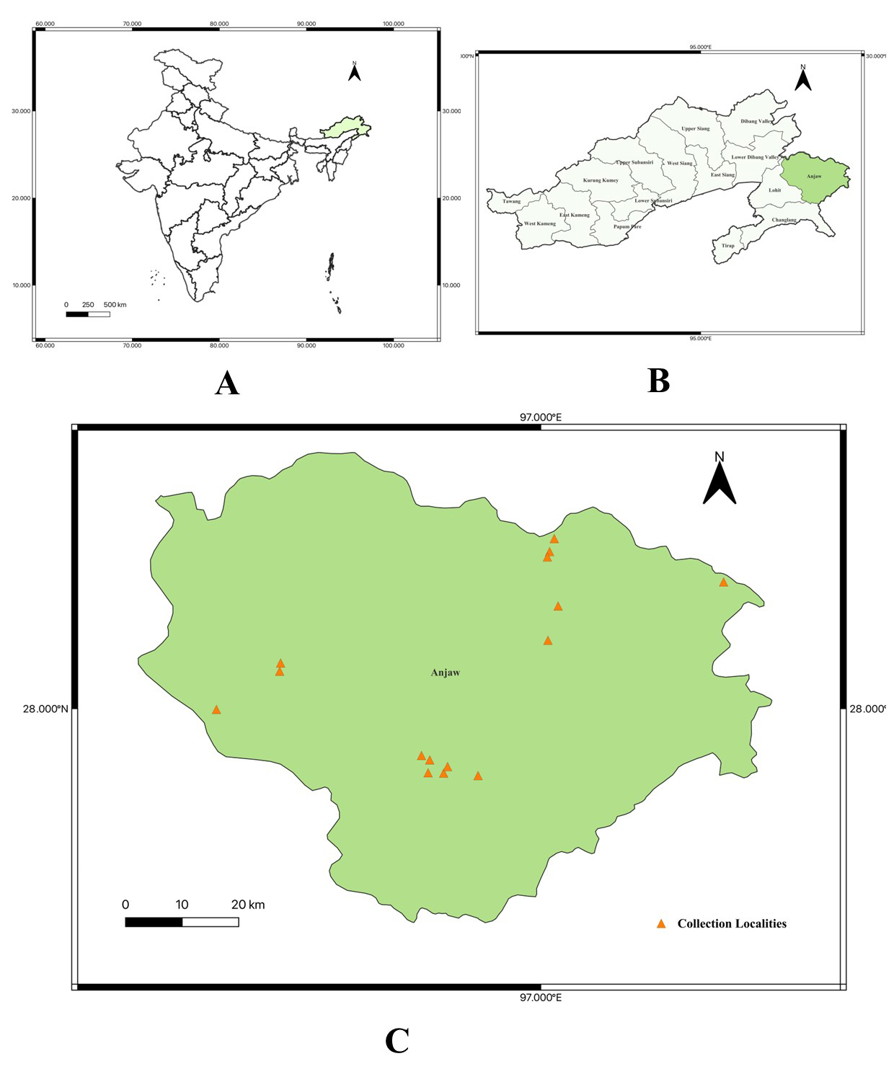
Figure 1. Sampling sites in Anjaw district, Arunachal Pradesh, India. Location of (A) Arunachal Pradesh in India, (B) Anjaw district in Arunachal Pradesh. (C) Map of Anjaw district showing sampling locations.

Faunistic Surveys and Collection: During 2023, a faunistic survey was conducted in Anjaw district, Arunachal Pradesh, India, resulting in the collection of beetle specimens from 14 distinct locations (Table 1) (Fig. 1. A-C). Sampling methods included light traps, hand-picking, and the use of D-type water nets for the collection of aquatic beetles. Specimens were euthanized using benzene vapor and initially preserved in 70% ethanol. Subsequently, specimens were dry-pinned for long-term preservation. Prior to identification, specimens were cleaned with a water and detergent solution to remove any adhering debris. Identification was carried out using established taxonomic literature, with particular emphasis on the morphology of male genitalia. the photographs of all 70 specimens are provided in figure 2 to 6. All voucher specimens are deposited in the collections of the Zoological Survey of India, Kolkata (ZSI).

Table 1. Geographic coordinates and altitudes of sampling sites in Anjaw district, Arunachal Pradesh, India.
Location | Locality | Latitude (N) | Longitude(E) | Altitude
Hawai | Hawai | 27.915910 | 96.78566 | 1055m
Hawai | 10 km from Hawai Bridge | 27.879830 | 96.887280 | 882m
Hawai | Circuit House | 27.884860 | 96.797590 | 1373m
Hawai | Lapkrong Village | 27.89606 | 96.83251 | 1281.8
Hawai | Mangkhong Village | 27.896056 | 96.8325070 | 1280m
Hayuliang | Hayuliang | 27.907950 | 96.800480 | 881.5m
Hayuliang | Army camp near Dalai bridge | 28.082180 | 96.532560 | 623.7m
Hayuliang | Near Dalai bridge | 28.0675 | 96.530850 | 592.6m
Tidding | Tidding bridge Anjaw entry Gate | 27.998730 | 96.417280 | 500.3m
Walong | Near Inspection Bungalow | 28.122965 | 97.012878 | 1206.8m
Walong | Kaho Village | 28.305690 | 97.024240 | 1429m
Walong | Karwii village towards Kaho | 28.227809 | 97.32851 | 1276m
Walong | Namti Sun rise view point | 28.184551 | 97.031114 | 1288m
Walong | Kibithu Village | 28.272650 | 97.011830 | 1383.6m

Results:

Taxonomic Account

Order Coleoptera Linnaeus, 1758
Suborder Adephaga Schellenberg, 1806
Family Gyrinidae Latreille, 1810
Subfamily Gyrininae Latreille, 1810
Tribe Dineutini Desmarest, 1851
Genus Patrus Aubé, 1838

- Patrus metallicus (Régimbart, 1884) (Fig. 2A)
Material examined: Hawai: 15.x.2023, 15 exs., leg., D. Gupta.
Distribution in India: Arunachal Pradesh, Sikkim, Uttarakhand, and West Bengal [5].
Global distribution: China, Laos, and Nepal [5,6,7].(headings should be non bold, only species name in bold condition ok)

Family Dytiscidae Leach, 1815
Subfamily Dytiscinae Leach, 1815
Genus Cybister Curtis, 1827
Subgenus Cybister Curtis, 1827

- Cybister (Cybister) posticus Aubé, 1838 (Fig. 2B)
Material examined: Walong: 14.x.2023, 5 exs., leg., D. Gupta.
Distribution in India: Arunachal Pradesh (new record), Assam, Bihar, Delhi, Gujarat, Himachal Pradesh, Madhya Pradesh, Maharashtra, Manipur, Meghalaya, Odisha, Sikkim, Uttar Pradesh, Uttarakhand, and West Bengal [8].
Global distribution: Bangladesh, China, Nepal, and Pakistan [8].

- Cybister (Cybister) tripunctatus lateralis (Fabricius, 1798) (Fig. 2C)
Material examined: Hawai: 15.x.2023, 15 exs., leg., D. Gupta.
Distribution in India: Andaman & Nicobar Islands, Andhra Pradesh, Arunachal Pradesh, Assam, Bihar, Delhi, Gujarat, Himachal Pradesh, Jammu & Kashmir, Karnataka, Madhya Pradesh, Maharashtra, Manipur, Meghalaya, Odisha, Rajasthan, Sikkim, Tamil Nadu, Tripura, Uttar Pradesh, Uttarakhand, and West Bengal [8].
Global distribution: Afghanistan, Bangladesh, Bhutan, China, Cyprus, Iran, Iraq, Japan, Kyrgyzstan, Mongolia, Myanmar, Nepal, Pakistan, Russia, Sri Lanka, Syria, Tajikistan, Turkey, Turkmenistan, and Uzbekistan [8].

Subfamily Hydroporinae Aubé, 1836
Genus Hydroglyphus Motschulsky, 1853

- Hydroglyphus geminus (Fabricius, 1792) (Fig. 2D)
Material examined: Hawai: 15.x.2023, 15 exs., leg., D. Gupta.
Distribution in India: Arunachal Pradesh (new record), Himachal Pradesh, Jammu & Kashmir, Madhya Pradesh, Rajasthan, Sikkim, and Uttarakhand [8].
Global distribution: Afghanistan, Bhutan, China, Cyprus, Iran, Iraq, Israel, Kazakhstan, Kyrgyzstan, Lebanon, Mongolia, North Korea, Nepal, Pakistan, Russia, Saudi Arabia, Syria, Tajikistan, Turkey, Turkmenistan, Uzbekistan, and Vietnam [8].
Subfamily Colymbetinae Erichson, 1837
Tribe Colymbetini Erichson, 1837
Genus Rhantus Dejean, 1833

- Rhantus sikkimensis Régimbart, 1899 (Fig. 2E)
Material examined: Hawai: 15.x.2023, 15 exs., leg., D. Gupta.
Distribution in India: Arunachal Pradesh, Himachal Pradesh, Meghalaya, Punjab, Sikkim, Uttarakhand, Uttar Pradesh, and West Bengal [8].
Global distribution: Bhutan, China, Myanmar, Nepal, and Pakistan [8].

Family Carabidae Latreille, 1802
Subfamily Cicindelinae Latreille, 1802
Tribe Cicindelini Latreille, 1802
Subtribe Cicindelina Latreille, 1802
Genus Cylindera Westwood, 1831
Subgenus Eriodera Rivalier, 1961

- Cylindera (Eriodera) albopunctata (Chaudoir, 1852) (Fig. 2F)
Material examined: Hayuliang: Dalai bridge, 19.x.2023, 5 exs., leg., D. Gupta.
Distribution in India: Arunachal Pradesh, Assam, Himachal Pradesh, Punjab, Sikkim, Uttarakhand, Uttar Pradesh, and West Bengal [9].

Subfamily Brachininae Bonelli, 1810
Tribe Brachinini Bonelli, 1810
Genus Pheropsophus Solier, 1833
Subgenus Stenaptinus Maindron, 1906

- Pheropsophus (Stenaptinus) nanodes Bates, 1892 (Fig. 2G)
Material examined: Hayuliang: 18.x.2023, 1 ex., leg., D. Gupta.
Distribution in India: Arunachal Pradesh and Assam [10].
Global distribution: China [10].

Subfamily Scaritinae Bonelli, 1810
Tribe Scaritini Bonelli, 1810
Subtribe Scaritina Bonelli, 1810
Genus Scarites Fabricius, 1775
Subgenus Scarites Fabricius, 1775

- Scarites (Scarites) sulcatus Olivier, 1795 (Fig. 2H)
Material examined: Hayuliang: Dalai Bridge, 19.x.2023, 1 ex., leg., D. Gupta.
Distribution in India: Arunachal Pradesh, Assam, Himachal Pradesh, Sikkim, Uttar Pradesh, Uttarakhand, and West Bengal [11].
Global distribution: Cambodia, China, Indonesia, Korea, Laos, Myanmar, Nepal, Pakistan, and Vietnam [11].

Subfamily Trechinae Bonelli, 1810
Tribe Trechini Bonelli, 1810
Subtribe Trechina Bonelli, 1810
Genus Trechus Clairville, 1806
Subgenus Trechus Clairville, 1806

- Trechus (Trechus) indicus Putzeys, 1870 (Fig. 2I)
Material examined: Walong: Near Inspection Bungalow, 12.x.2023, 1 ex., leg., D. Gupta.
Distribution in India: Arunachal Pradesh (new record), Himachal Pradesh, Uttarakhand, and West Bengal [12].

Tribe Bembidiini Stephens, 1827
Subtribe Bembidiina Stephens, 1827
Genus Asaphidion Gozis, 1886

- Asaphidion championi Andrewes, 1924 (Fig. 2J)
Material examined: Hayuliang: Dalai bridge, 19.x.2023, 2 exs., leg., D. Gupta.
Distribution in India: Arunachal Pradesh (new record), Assam, Himachal Pradesh, Uttar Pradesh, Uttarakhand, and West Bengal [11].

Genus Bembidion Latreille, 1802
Subgenus Politophanes Müller-Motzfeld, 1998
- Bembidion (Politophanes) phaedrum Andrewes, 1923 (Fig. 2K)
Material examined: Walong: Near Inspection Bungalow, 12.x.2023, 1 ex., leg., D. Gupta.
Distribution in India: Arunachal Pradesh (new record), Himachal Pradesh, and Uttarakhand [11].
Global distribution: China.

Subfamily Lebiinae Bonelli, 1810
Tribe Lebiini Bonelli, 1810
Subtribe Dromiusina Bonelli, 1810
Genus Dromius Bonelli, 1810
Subgenus Dromius Bonelli, 1810

- Dromius (Dromius) eremnus Andrewes, 1933 (Fig. 2L)
Material examined: Hawai: 10 km from Hawai Bridge, 16.x.2023, 1 ex., leg., D. Gupta.
Distribution in India: Arunachal Pradesh (new record), Himachal Pradesh, Uttarakhand, and West Bengal [13].

Genus Philorhizus Hope, 1838

- Philorhizus adoxus (Andrewes 1923) (Fig. 2M)
Material examined: Hawai: 10 km from Hawai Bridge, 16.x.2023, 1 ex., leg., D. Gupta.
Distribution in India: Arunachal Pradesh (new record), Himachal Pradesh, Uttarakhand, and West Bengal [14].

Subtribe Lebiina Bonelli, 1810
Genus Lebia Latreille, 1802
Subgenus Poecilothais Maindron, 1905

- Lebia (Poecilothais) calycophora Schmidt-Goebel, 1846 (Fig. 2N)
Material examined: Hawai: 10 km from Hawai Bridge, 16.x.2023, 1 ex., leg., D. Gupta.
Distribution in India: Arunachal Pradesh, Meghalaya, and Nagaland [10].
Global distribution: Malaysia, Thailand, and Indonesia [10].

Subfamily Platyninae Bonelli, 1810
Tribe Platynini Bonelli, 1810
Subtribe Platynina Bonelli, 1810
Genus Agonum Bonelli, 1810

- Agonum comatum (Andrewes, 1923) (Fig. 2O)
Material examined: Hayuliang: Dalai Bridge, 19.x.2023, 1 ex., leg., D. Gupta.
Distribution in India: Arunachal Pradesh, Assam, and Uttarakhand [15].
Global distribution: Vietnam [15].

Suborder Polyphaga Emery, 1886
Series Staphyliniformia Latreille, 1802
Superfamily Hydrophiloidea Latreille, 1802
Family Hydrophilidae Latreille, 1802
Subfamily Sphaeridiinae Latreille, 1802
Genus Sphaeridium Fabricius, 1775

- Sphaeridium daemonicum Fikáček & Kropáček, 2015
Material examined: Hawai: 15.x.2023, 5 exs., leg., D. Gupta.
Distribution in India: Arunachal Pradesh [16].
Global distribution: Myanmar [16].

- Sphaeridium severini d’Orchymont, 1919: 116
Material examined: Hawai: 15.x.2023, 15 exs., leg., D. Gupta.
Distribution in India: Arunachal Pradesh, Jammu and Kashmir, Kerala, Manipur, Meghalaya, Sikkim, Tamil Nadu, and West Bengal [16].
Global distribution: Cambodia, China, Indonesia, Laos, Nepal, Singapore, and Vietnam [16].

- Sphaeridium quinquemaculatum Fabricius, 1798
Material examined: Hawai: 15.x.2023, 28 exs., leg., D. Gupta.
Distribution in India: Andaman and Nicobar Islands, Andhra Pradesh, Arunachal Pradesh, Bihar, Karnataka, Kerala, Madhya Pradesh, Manipur, Punjab, Rajasthan, Tamil Nadu, Telangana, Tripura, Uttar Pradesh, Uttarakhand, and West Bengal [16].
Global distribution: China, Japan, India, Indonesia, Nepal, Philippines, Sri Lanka, Saudi Arabia, and Taiwan [16].
Superfamily Staphylinoidea Latreille, 1802
Family Staphylinidae Latreille, 1802
Subfamily Paederinae Fleming, 1821
Tribe Paederini Fleming, 1821
Genus Paederus Fabricius, 1775

- Paederus fuscipes Curtis, 1826 (Fig. 2P)
Material examined: Hayuliang: Army camp near Dalai bridge, 19.x.2023, 3 exs., leg. D. Gupta.
Distribution in India: Arunachal Pradesh, Assam, Himachal Pradesh, Manipur, Tripura, Sikkim, and West Bengal [17].
Global distribution: Bhutan, China, Europe, Iran, Iraq, Israel, Nepal, Hong Kong, Japan, Taiwan, Pakistan and Yunnan [17].

- Paederus nigricornis Bernhauer, 1911 (Fig. 3A)
Material examined: Hayuliang: 19.x.2023, 15 exs., leg., D. Gupta; Hawai, 10 km from Hawai Bridge, 16.x.2023, 28 exs., leg., D. Gupta.
Distribution in India: Arunachal Pradesh (new record), Himachal Pradesh, Kerala, Sikkim, Uttar Pradesh, Uttarakhand, and West Bengal [18].
Global distribution: Afghanistan, China, Iran, Nepal, and Pakistan [18].

Series Scarabaeiformia Crowson, 1960
Superfamily Scarabaeoidea Latreille, 1802
Family Lucanidae Latreille, 1804
Subfamily Lucaninae Latreille, 1804
Tribe Dorcini (Parry, 1864)
Genus Serrognathus Motschulsky, 1861
Subgenus Serrognathus Motschulsky, 1861

- Serrognathus (Serrognathus) titanus westermanni (Hope, 1842) (Fig. 3B)
Material examined: Hawai: Circuit House, 15.x.2023, 1 ex., leg., D. Gupta.
Distribution in India: Arunachal Pradesh, Assam, Meghalaya, and West Bengal [19,20].
Global distribution: Myanmar and Thailand [19,20].

Family Scarabaeidae Latreille, 1802
Subfamily Aphodiinae Leach, 1815
Tribe Aphodiini Leach, 1815
Genus Aphodius Hellwig, 1798

- Aphodius irregularis Westwood, 1839 (Fig. 3C)
Material examined: Hawai: 10 km from Hawai Bridge, 16.x.2023, 3 exs., leg., D. Gupta; Hawai, Mangkhong Village, 17.x.2023, 2 exs., leg., D. Gupta.
Distribution in India: Arunachal Pradesh, Himachal Pradesh, Jammu & Kashmir, Sikkim, Uttar Pradesh, and Uttarakhand [21, 22].
Global distribution: China, Nepal, and Pakistan [24].

- Aphodius elegans Allibert, 1847 (Fig. 3D)
Material examined: Hawai: Mangkhong Village, 17.x.2023, 18 exs., leg., D. Gupta.
Distribution in India: Arunachal Pradesh and Assam [23].
Global distribution: China, Japan, Russia, Taiwan, and Vietnam [24].

Subfamily Scarabaeinae Latreille, 1802
Tribe Coprini Kolbe, 1805
Genus Catharsius Hope, 1837

- Catharsius molossus (Linnaeus, 1758) (Fig. 3E)
Material examined: Hayuliang: Army camp near Dalai bridge, 19.x.2023, 4 exs, leg. D. Gupta.
Distribution in India: Andaman and Nicobar Island, Arunachal Pradesh, Assam, Bihar, Gujarat, Haryana, Himachal Pradesh, Karnataka, Kerala, Maharashtra, Meghalaya, Odisha, Rajasthan, Sikkim, Tamil Nadu, Uttar Pradesh, and West Bengal [25, 26].
Global distribution: Sri Lanka [24].

Genus Copris Geoffroy, 1762
Subgenus Copris Geoffroy, 1762

- Copris (Copris) magicus Harold, 1881 (Fig. 3F)
Material examined: Hawai: 10 km from Hawai Bridge, 16.x.2023, 5 exs., leg., D. Gupta. Hawai, Circuit House, 15.x.2023, 1 ex., leg., D. Gupta.
Distribution in India: Arunachal Pradesh, Gujarat, Karnataka, Kerala, and Tamil Nadu (Sewak, 2006; Ghosh et al., 2022, 2023a).
Global distribution: Sri Lanka [24].

Tribe Onthophagini Lacordaire, 1856
Genus Onthophagus Latreille, 1802
Subgenus Colobonthophagus Balthasar, 1963

- Onthophagus (Colobonthophagus) dama (Fabricius, 1798) (Fig. 3G)
Material examined: Hayuliang, Army Camp near Dalai Bridge, 19.x.2023, 1 ex., leg., D. Gupta.
Distribution in India: Andhra Pradesh, Arunachal Pradesh, Bihar, Chandigarh, Chhattisgarh, Himachal Pradesh, Karnataka, Kerala, Madhya Pradesh, Maharashtra, Meghalaya Odisha, Punjab, Sikkim, Tamil Nadu, Uttar Pradesh, Uttarakhand, and West Bengal [27, 28, 29].
Global distribution: Bhutan, Nepal, and Sri Lanka [24].

- Onthophagus (Colobonthophagus) ramosellus Bates, 1891 (Fig. 3H)
Material examined: Hawai: 10 km from Hawai Bridge, 16.x.2023, 5 exs., leg., D. Gupta.
Distribution in India: Arunachal Pradesh, Assam, Bihar, Chhattisgarh, Haryana, Himachal Pradesh, Karnataka, Madhya Pradesh, Maharashtra, Meghalaya, Punjab, Rajasthan, Tamil Nadu, Tripura, Uttar Pradesh, Uttarakhand, and West Bengal (30,29, 28).
Global distribution: Afghanistan, Myanmar and Pakistan [24].

Subgenus Gibbonthophagus Balthasar, 1935

- Onthophagus (Gibbonthophagus) luridipennis Boheman, 1858 (Fig. 3I)
Material examined: Hayuliang: Army Camp near Dalai Bridge, 19.x.2023, 3 exs., leg., D. Gupta. Hawai: Circuit House, 15.x.2023, 1 ex., leg., D. Gupta.
Distribution in India: Arunachal Pradesh, Assam, Karnataka, Meghalaya, Tripura, Uttar Pradesh, Uttarakhand, and West Bengal [30].
Global distribution: China, Indonesia, Myanmar, Philippines, Thailand, Vietnam, Taiwan, and Cambodia [24].

- Onthophagus (Gibbonthophagus) rectecornutus Lansberge, 1883 (Fig. 3J)
Material examined: Hawai: 10 km from Hawai Bridge, 16.x.2023, 1 ex., leg., D. Gupta. Walong: Near Kibithu Village, 13.x.2023, 2 exs., leg., D. Gupta.
Distribution in India: Andhra Pradesh, Arunachal Pradesh, Assam, Bihar, Gujarat, Haryana, Jharkhand, Karnataka, Kerala, Meghalaya, Nagaland, Rajasthan, Tamil Nadu, Tripura, Uttar Pradesh, Uttarakhand, and West Bengal [30, 29, 28].
Global distribution: Bhutan, China, Cambodia Indonesia, Malaysia, Myanmar, Sri Lanka, Thailand Nepal, and Taiwan [24].

Subgenus Matashia Matsumura, 1938
- Onthophagus (Matashia) kuluensis Bates, 1891 (Fig. 3K)
Material examined: Hawai: 10 km from Hawai Bridge, 16.x.2023, 12 exs., leg., D. Gupta. Hawai: Circuit House, 15.x.2023, 1 ex., leg., D. Gupta. Hayuliang: Army camp near Dalai bridge, 19.x.2023, 1 ex., leg., D. Gupta. Walong: Near Kibithu Village, 13.x.2023, 1 ex., leg., D. Gupta.
Distribution in India: Arunachal Pradesh, Gujarat, Haryana, Himachal Pradesh, Jammu & Kashmir, Punjab, Rajasthan, Uttar Pradesh, and Uttarakhand [25,31]
Global distribution: China, and Nepal [24].

Tribe Onitini Laporte, 1840
Genus Onitis Fabricius, 1798
- Onitis falcatus (Wulfen, 1786) (Fig. 3L)

Material examined: Hawai: 10 km from Hawai Bridge, 16.x.2023, 4 exs., leg., D. Gupta. Walong: Kaho Village, 14.x.2023, 4 exs., leg. D. Gupta. Hayuliang: Army Camp near Dalai Bridge, 19.x.2023, 1 ex., leg., D. Gupta. Hawai: Mangkhong Village, 17.x.2023, 2 exs., leg., D. Gupta. Hawai: Circuit House, 15.x.2023, 10 exs., leg., D. Gupta.
Distribution in India: Andhra Pradesh, Arunachal Pradesh, Assam, Bihar, Gujarat, Haryana, Himachal Pradesh, Jharkhand, Karnataka, Kerala, Madhya Pradesh, Maharashtra, Meghalaya, Odisha, Puducherry, Punjab, Rajasthan, Tamil Nadu, Tripura, Uttar Pradesh, Uttarakhand, and West Bengal [30,26,32,28].
Global distribution: China, Bangladesh, Taiwan, Vietnam, China, Myanmar, Philippines, Pakistan, Malaysia, and Nepal [24].

- Onitis excavatus Arrow, 1931 (Fig. 3M)
Material examined: Hawai: Circuit House, 15.x.2023, 4 exs., leg., D. Gupta. Hawai: 10 km from Hawai Bridge, 16.x.2023, 4 exs., leg., D. Gupta.
Distribution in India: Arunachal Pradesh, Assam, Himachal Pradesh, Meghalaya, Nagaland, and Uttarakhand [25,31].
Global distribution: China, Myanmar, Nepal, Pakistan, Taiwan, Thailand, and Vietnam [24].

Tribe Oniticellini Kolbe, 1905
Genus Liatongus Reitter, 1892
- Liatongus gagatinus (Hope, 1831) (Fig. 3N)
Material examined: Hawai: Mangkhong Village, 17.x.2023, 18 exs., leg., D. Gupta. Hawai, Circuit House, 15.x.2023, 1 ex., leg., D. Gupta. Hayuliang: Army camp near Dalai bridge, 19.x.2023, 1 ex., leg., D. Gupta.
Distribution in India: Arunachal Pradesh, Assam, Jammu and Kashmir, Himachal Pradesh, Meghalaya, Nagaland, Sikkim, Uttarakhand, and West Bengal [33].
Global distribution: China, Myanmar, and Nepal [24].

- Liatongus triacanthus (Boucomont, 1920) (Fig. 3O)
Material examined: Hawai: Mangkhong Village, 17.x.2023, 2 exs., leg., D. Gupta.
Distribution in India: Arunachal Pradesh (new record), Sikkim, and West Bengal [34, 35].
Global distribution: China, and Myanmar [34,24].

- Liatongus vertagus (Fabricius, 1798) (Fig. 3P)
Material examined: Hawai: Circuit House, 15.x.2023, 14 exs., Mangkhong Village, 17.x.2023, 8 exs., leg., D. Gupta. Hayuliang: Army camp near Dalai bridge, 19.x.2023, 6 exs., leg., D. Gupta. Hawai: 10 km from Hawai Bridge, 16.x.2023, 19 exs., leg., D. Gupta. Walong: Near Kibithu Village, 13.x.2023, 11 exs., leg., D. Gupta.
Distribution in India: Arunachal Pradesh, Assam, Himachal Pradesh, Manipur, Nagaland, Sikkim, Uttarakhand, and West Bengal [25,31,33,36]
Global distribution: Bhutan, China, Myanmar, and Thailand [24].

Genus Oniticellus Serville, 1825
- Oniticellus cinctus (Fabricius, 1775) (Fig. 4A)
Material examined: Tidding bridge Anjaw entry Gate: 20.x.2023, 1 ex., leg., D. Gupta. Hawai: 10 km from Hawai Bridge, 16.x.2023, 1 ex., leg., D. Gupta.
Distribution in India: Andhra Pradesh, Arunachal Pradesh, Assam, Chhattisgarh, Gujarat, Haryana, Himachal Pradesh, Karnataka, Kerala, Madhya Pradesh, Maharashtra, Meghalaya, Mizoram, Nagaland, Punjab, Rajasthan, Tamil Nadu, Tripura, Uttarakhand, and West Bengal [37, 30].
Global distribution: Cambodia, Indonesia, Malaysia, Nepal, Taiwan, and Thailand [24].

Subfamily Melolonthinae MacLeay, 1819
Tribe Melolonthini Leach, 1819
Genus Melolontha Fabricius, 1775

- Melolontha indica Hope, 1831 (Fig. 4B)
Material examined: Walong: Kaho Village, 14.x.2023, 6 exs., leg., D. Gupta.
Distribution in India: Arunachal Pradesh, Assam, Haryana, Himachal Pradesh, Jammu & Kashmir, Meghalaya, Sikkim, Uttarakhand, and West Bengal [38].
Global distribution: China, Nepal, and Pakistan [24].

- Melolontha chinensis Guérin-Méneville, 1838
Material examined: Hawai: 15.x.2023, 1 ex., leg., D. Gupta.
Distribution in India: Arunachal Pradesh [38].
Global distribution: China, and Vietnam [24].

Tribe Sericini Kirby, 1837
Genus Maladera Mulsant, 1871
Subgenus Omaladera Reitter, 1901

- Maladera (Omaladera) iridescens (Blanchard, 1850) (Fig. 4C)
Material examined: Hayuliang: Near Dalai bridge, 19.x.2023, 1 ex., leg., D. Gupta.
Distribution in India: Arunachal Pradesh (new record), Haryana, Jammu & Kashmir, Karnataka, Kerala, Maharashtra, Odisha, Punjab, Uttarakhand, and West Bengal [39, 40].
Global distribution: Nepal, and Pakistan [24].

Subgenus: Maladera Mulsant, 1871

- Maladera (Maladera) allopruinosa (Ahrens, 1998) (Fig. 4D)
Material examined: Hawai: Circuit House, 15.x.2023, 1 ex., leg., D. Gupta.
Distribution in India: Arunachal Pradesh, Bihar, Sikkim, and West Bengal [40].
Global distribution: Nepal [24].

Genus Neoserica Brenske, 1894

- Neoserica bhalukpongensis Ahrens & Fabrizi, 2016 (Fig. 4E)
Material examined: Hawai: Lapkrong Village, 17.x.2023, 1 ex., leg., D. Gupta.
Distribution in India: Arunachal Pradesh, and Assam [41, 39]
Global distribution: India [39]
Subfamily Rutelinae MacLeay, 1819
Tribe Anomalini Streubel, 1839
Genus Popillia Dejean, 1821
- Popillia cyanea Hope, 1831 (Fig. 4F)
Material examined: Hawai: Circuit House, 15.x.2023, 1 ex. Mangkhong, 17.x.2023, 1 ex., leg., D. Gupta. Hayuliang: Army Camp near Dalai Bridge, 19.x.2023, 1 ex., leg., D. Gupta.
Distribution in India: Arunachal Pradesh Assam, Himachal Pradesh, Jammu & Kashmir, Punjab, Sikkim, Uttarakhand, and West Bengal [29, 42].
Global distribution: China, Nepal, and Pakistan [24].

Genus Mimela Kirby, 1823
- Mimela horsfieldi Hope, 1835 (Fig. 4G)
Material examined: Hayuliang: Army Camp near Dalai Bridge, 19.x.2023, 5 exs., leg., D. Gupta.
Distribution in India: Arunachal Pradesh, Assam, Himachal Pradesh, Jammu and Kashmir, Meghalaya, Punjab, Sikkim, Uttarakhand, and West Bengal [29, 42].
Global distribution: China, Nepal, and Pakistan [24].

Subfamily Cetoniinae Leach, 1815
Tribe Goliathini Latreille, 1829
Genus Torynorrhina Arrow, 1907

- Torynorrhina distincta (Hope, 1841) (Fig. 4H)
Material examined: Walong: Near Kibithu Village, 13.x.2023, 1 ex., leg., D. Gupta.
Distribution in India: Arunachal Pradesh, Assam, Manipur, Meghalaya, Nagaland, Sikkim, and West Bengal [33,36].
Global distribution: China, Laos, Myanmar, Nepal, Thailand, and Vietnam [24].

Genus Trigonophorus Hope, 1831
Subgenus Trigonophorus Hope, 1831

- Trigonophorus (Trigonophorus) nepalensis (Hope, 1831) (Fig. 4I)
Material examined: Walong: Kaho Village, 14.x.2023¸ 1 ex., leg., D. Gupta. Hayuliang: Army Camp near Dalai Bridge, 19.x.2023, 1 ex., leg., D. Gupta.
Distribution in India: Arunachal Pradesh, Assam, Himachal Pradesh, Manipur, Meghalaya, Nagaland, Sikkim, and West Bengal [33,36].
Global distribution: Bhutan, China, and Nepal [24].

Superfamily Cucujoidea Latreille, 1802
Family Erotylidae Latreille, 1802
Subfamily Languriinae Crotch, 1873
Genus Tetraphala Sturm, 1843

- Tetraphala elongata (Fabricius,1801) (Fig. 4J)
Material examined: Walong: Karwii village towards Kaho, 14.x.2023, 1 ex., leg., D. Gupta.
Distribution in India: Arunachal Pradesh, Sikkim, and Uttar Pradesh. [43]
Global distribution: Bhutan, China, Malaysia, Singapore, and Taiwan. [43]

Family Nitidulidae Latreille, 1802
Genus Epuraea Erichson, 1843

- Epuraea ocularis Fairmaire, 1849 (Fig. 4K)
Material examined: Walong: Near Inspection Bungalow, 12.x.2023, 22 exs., leg., D. Gupta.
Distribution in India: Arunachal Pradesh, Assam, Jharkhand, Kerala, Odisha, Meghalaya, Rajasthan, Sikkim, Tamil Nadu, Uttar Pradesh, and West Bengal [44,45].
Global distribution: African Parts of Mediterranean Province, Angola, Australia, Cameroon, China, Indonesia, Japan, Korea, Laos, Madagascar, Malawi, Malaysia, Micronesia, Myanmar, Namibia, Nepal, New Caledonia, Papua New Guinea, Réunion, Seychelles, South Africa, Sri Lanka, Taiwan, Tanzania, Thailand, Togo, Uganda, USA, Vietnam, and Zaire [44,45].

Family Coccinellidae Latreille, 1807
Subfamily Coccinellinae Latreille, 1807
Tribe Coccinellini Latreille, 1807
Genus Calvia Mulsant, 1846

- Calvia sykesii (Crotch, 1874) (Fig. 4L)
Material examined: Walong: Near Kibithu village, 13.x.2023, 3 exs., leg., D. Gupta.
Distribution in India: Arunachal Pradesh, Assam, Manipur, Meghalaya, Sikkim, Tamil Nadu, and West Bengal [46]
Global distribution: Nepal [47; 48, 49]

Genus Coccinella Linnaeus, 1758
- Coccinella septempunctata Linnaeus, 1758 (Fig. 4M)
Material examined: Walong: Namti sun rise view point, 13.x.2023, 9 exs., leg., D. Gupta. Walong: Kaho Village, 14.x.2023, 1 ex., leg., D. Gupta. Hawai: 10 km from Hawai Bridge, 16.x.2023, 1 ex., leg., D. Gupta. Hayuliang: Near Dalai Bridge, 19.x.2023, 1 ex., leg., D. Gupta.
Distribution in India: Widely distributed throughout India including Arunachal Pradesh [46].
Global distribution: China, Afro-tropical Region, North America, Pakistan, and Sri Lanka [48,49,50,51].

Genus Harmonia Mulsant, 1846
- Harmonia sedecimnotata (Fabricius, 1801) (Fig. 4N)
Material examined: Hawai: 16.x.2023, 1 ex., leg., D. Gupta. Hayuliang: 18.x.2023, 1 ex., leg., D. Gupta.
Distribution in India: Arunachal Pradesh, Sikkim, and West Bengal [46].
Global distribution: China, Nepal and Southeast Asia [48,49,50].

Genus Oenopia Mulsant, 1850

- Oenopia kirbyi Mulsant, 1850
Material examined: Hawai: Circuit House, 15.x.2023, 1 ex., leg., D. Gupta.
Distribution in India: Arunachal Pradesh, Meghalaya, Mizoram, Sikkim, and West Bengal [46].
Global distribution: Bhutan, China, Myanmar, Nepal, and Thailand [52,48, 49,50].

- Oenopia mimica Weise, 1902
Material examined: Hawai: Circuit House, 15.x.2023, 1 ex., leg., D. Gupta. Hawai: Mangkhong village, 17.x.2023, 1 ex., leg., D. Gupta.
Distribution in India: Arunachal Pradesh, Meghalaya, Mizoram, Sikkim, and West Bengal [46].
Global distribution: Bhutan, China, Myanmar, Nepal, and Thailand [52,48, 49,50].
- Oenopia sexareata (Mulsant, 1853) (Fig. 4O)
Material examined: Walong: Near Inspection Bungalow, 12.x.2023, 1 ex., leg., D. Gupta. Hawai: 10 km from Hawai Bridge, 16.x.2023, 2 exs., leg., D. Gupta.
Distribution in India: Arunachal Pradesh, Assam, Bihar, Himachal Pradesh, Meghalaya, Sikkim, Uttar Pradesh, and West Bengal [46].
Global distribution: Bhutan, China, Indonesia, Japan, Myanmar, Nepal, and Vietnam [53,52,48, 49,50].

Superfamily Chrysomeloidea Latreille, 1802
Family Cerambycidae Latreille, 1802
Subfamily Cerambycinae Latreille, 1802
Tribe Compsocerini Thomson, 1864
Genus Rosalia Audinet-Serville, 1833
Subgenus Eurybatus Thomson 1860

- Rosalia (Eurybatus) formosa (Saunders, 1839) (Fig. 4P)
Material examined: Hawai: 15.x.2023, 1 ex., leg., D. Gupta.
Distribution in India: Arunachal Pradesh, Assam, Mizoram, Sikkim, Uttar Pradesh, and West Bengal [54].
Global distribution: China, Laos, Nepal, and Taiwan [54].

Tribe Clytini Mulsant, 1839
Genus Chlorophorus Chevrolat, 1863

- Chlorophorus hederatus Heller, 1926 (Fig. 5A)
Material examined: Hawai: Mangkhong Village, 17.x.2023, 1 ex., leg., D. Gupta.
Distribution in India: Arunachal Pradesh (new record), Assam and West Bengal [54, 39].
Global distribution: China, Laos, Myanmar, and Thailand [54].

Tribe Xystrocerini Blanchard, 1845
Genus Xystrocera Audinet-Serville, 1834

- Xystrocera globosa (Olivier, 1795) (Fig. 5B)
Material examined: Hayuliang: 18.X.2023, 1 ex., leg., D. Gupta.
Distribution in India: Andaman & Nicobar Islands, Arunachal Pradesh, Assam, Karnataka, Madhya Pradesh, Maharashtra, Manipur, Meghalaya, Tamil Nadu, Tripura, Uttarakhand, and West Bengal [54].
Global distribution: Celebes, Egypt, Hawaiian France Islands, Indonesia, Japan, Madagascar, Malay Peninsula, Java, Manilla, Mauritius, Myanmar, Australia, Philippines, Puerto Rico, Sri Lanka, Thailand and United States of America [54].

Subfamily Lamiinae Latreille, 1825
Tribe Lamiini Latreille, 1825
Genus Macrochenus Guérin-Méneville, 1843

- Macrochenus guerinii (White, 1858) (Fig. 5C)
Material examined: Hyauliang: Near Dalai Bridge, 19.x.2023, 2 exs., leg., D. Gupta.
Distribution in India: Arunachal Pradesh, Meghalaya, Sikkim, Tripura, and West Bengal [54, 39].
Global distribution: Bangladesh, China, Laos, Myanmar, Nepal, Thailand, and Vietnam [54].

Superfamily Chrysomeloidea Latreille, 1802
Family Chrysomelidae Latreille, 1802
Subfamily Criocerinae Latreille, 1802
Genus Lilioceris Reitter, 1912

- Lilioceris cheni Gressit and Kimoto, 1961 (Fig. 5D)
Material examined: Hawai: 10 km from Hawai Bridge, 16.x.2023, 3 exs., leg., D. Gupta.
Distribution in India: Arunachal Pradesh (new record), Assam, Meghalaya, West Bengal [55, 56, 57, 39].
Global distribution: China, Laos, Myanmar, Nepal, and Thailand [56, 58].

- Lilioceris impressa (Fabricius, 1787) (Fig. 5E)
Material examined: Hawai: 10 km from Hawai Bridge, 16.x.2023, 1 ex., leg., D. Gupta.
Distribution in India: Andaman and Nicobar Islands, Andhra Pradesh, Arunachal Pradesh (new record), Assam, Bihar, Chhattisgarh, Haryana, Kerala, Meghalaya, Maharashtra, Madhya Pradesh, Punjab, Rajasthan, Tamil Nadu, Tripura, Uttar Pradesh, and West Bengal [55,56, 39].
Global distribution: Cambodia, China, Hainan, Indonesia, Myanmar, Nepal, Philippines, Sri Lanka, Thailand, Laos, and Vietnam [56, 58].

Subfamily Chrysomelinae Latreille, 1802
Genus Potaninia Weise, 1889

- Potaninia assamensis (Baly, 1879) (Fig. 5F)
Material examined: Hawai: Hayuliang, Army Camp near Dalai Bridge, 19.x.2023, 4 exs., leg., D. Gupta.
Distribution in India: Arunachal Pradesh (new record) and Assam [59, 56].
Global distribution: China, India, Laos, Myanmar, Thailand, and Vietnam [60].

Subfamily Galerucinae Latreille, 1802
Genus Aplosonyx Chevrolat, 1836

- Aplosonyx chalybaeus (Hope, 1831) (Fig. 5G)
Material examined: Hawai: 10 km from Hawai Bridge, 16.x.2023, 2 exs., leg., D. Gupta.
Distribution in India: Arunachal Pradesh (new record), Assam, Sikkim, and West Bengal [61, 56].
Global distribution: Bhutan, China, Myanmar, Nepal, Vietnam [56].

Genus Monolepta Chevrolat in Dejean, 1836

- Monolepta signata (Olivier, 1808) (Fig. 5H)
Material examined: Hayuliang: Dalai Bridge, 19.x.2023, 2 exs., leg., D. Gupta.
Distribution in India: Andhra Pradesh, Arunachal Pradesh, Assam, Bihar, Chhattisgarh, Haryana, Karnataka, Kerala, Maharashtra, Madhya Pradesh, Odisha, Punjab, Rajasthan, Tamil Nadu, Uttarakhand, Uttar Pradesh, and West Bengal [61, 56, 62].
Global distribution: Bangladesh, Bhutan, China, Indonesia, Japan, Malaysia, Myanmar, Nepal, Philippines, Singapore, Sri Lanka, Thailand, and Vietnam [63].

Genus Aulacophora Chevrolat in Dejean, 1836

- Aulacophora indica (Gmelin, 1790) (Fig. 5I)
Material examined: Walong: Kibithu, 13.x.2023, 4 exs., leg., D. Gupta. Hawai: 16.x.2023, 6 exs., leg., D. Gupta.
Distribution in India: Assam [64] and Arunachal Pradesh (new record).
Global distribution: China, Indonesia, Japan, Laos, Malaysia, Myanmar, Nepal, Philippines, South Korea, Thailand, Taiwan, and Vietnam [64].

- Aulacophora foveicollis (Lucas, 1849) (Fig. 5J)
Material examined: Hayuliang: 19.x.2023, 12 exs., leg., D. Gupta. Hawai: 16.x.2023, 8 exs., leg., D. Gupta.
Distribution in India: Andhra Pradesh, Arunachal Pradesh, Assam, Bihar, Chhattisgarh, Gujarat, Haryana, Karnataka, Kerala, Maharashtra, Madhya Pradesh, Odisha, Punjab, Rajasthan, Tamil Nadu, Uttarakhand, Uttar Pradesh, West Bengal [61, 56, 62, 63, 3].
Global distribution: Bangladesh, Bhutan, China, Indonesia, Japan, Malaysia, Myanmar, Nepal, Philippines, Singapore, Sri Lanka, Thailand, and Vietnam [63].

- Aulacophora lewisii (Baly, 1874) (Fig. 5K)
Material examined: Hayuliang: Dalai Bridge, 19.x.2023, 5 exs., leg., D. Gupta.
Distribution in India: Andhra Pradesh, Arunachal Pradesh, Assam, Bihar, Chhattisgarh, Haryana, Karnataka, Kerala, Maharashtra, Madhya Pradesh, Odisha, Punjab, Rajasthan, Tamil Nadu, Uttarakhand, Uttar Pradesh, and West Bengal [61, 56, 62, 63].
Global distribution: Bangladesh, Bhutan, China, Indonesia, Japan, Malaysia, Myanmar, Nepal, Philippines, Singapore, Sri Lanka, Thailand, and Vietnam [64].

Genus Altica Geoffroy, 1762
- Altica caerulescens (Baly, 1874) (Fig. 5L)
Material examined: Hawai: 16.x.2023, 8 exs., leg., D. Gupta.
Distribution in India: Jammu and Kashmir [65] and Arunachal Pradesh (new record).
Global distribution: China, Japan, Ryukyu Island, South Korea, and Taiwan [66, 65].

Subfamily Cassidinae Gyllenhal, 1813
Tribe Cassidini Gyllenhal, 1813
Genus Aspidomorpha Hope, 1841
- Aspidomorpha dorsata (Fabricius, 1787) (Fig. 5M)
Material examined: Hawai: Hayuliang, Army Camp near Dalai bridge, 19.x.2023, 2 exs., leg., D. Gupta.
Distribution in India: Arunachal Pradesh, Assam, Karnataka, Kerala, Maharashtra, Meghalaya, Sikkim, Tamil Nadu, and West Bengal [67, 68, 69, 70, 71, 72, 73,32].
Global distribution: China, Indonesia, India, Laos, Malaysia, Myanmar, Nepal, Philippines, Thailand, and Vietnam [74,75,76].

- Aspidomorpha indica Boheman, 1854 (Fig. 5N)
Material examined: Hawai: 16.x.2023, 1 ex., leg., D. Gupta.
Distribution in India: Andhra Pradesh, Arunachal Pradesh, Assam, Karnataka, Kerala, Sikkim, Maharashtra, Meghalaya, Odisha, Tamil Nadu, Uttarakhand, and West Bengal [67,77,78,79, 80,81,68,69,82,83,73,35].
Global distribution: Bangladesh, China, Indonesia, India, Laos, Malaysia, Myanmar, Nepal, Pakistan, and Philippines [74,75,76].

- Aspidomorpha sanctaecrucis (Fabricius, 1792) (Fig. 5O)
Material examined: Walong: Near Kibithu Village, 13.x.2023, 10 exs., leg., D. Gupta.
Distribution in India: Assam, Arunachal Pradesh, Chhattisgarh, Jharkhand, Karnataka, Kerala, Madhya Pradesh, Meghalaya, Maharashtra, Odisha, Punjab, Chandigarh, Sikkim, Tamil Nadu, Tripura, Uttarakhand, and West Bengal [84, 67, 78, 79, 68, 72, 35]
Global distribution: Bhutan, China, Laos, Myanmar, Nepal, Malaysia, Pakistan, Thailand, Sri Lanka, and Vietnam [74,75,76].

Tribe Notosacanthini Gressitt, 1952
Genus Notosacantha Chevrolat, 1836

- Notosacantha maculipennis (Boheman, 1856) (Fig. 5P)
Material examined: Hawai: 16.x.2023, 8 exs., leg., D. Gupta.
Distribution in India: Arunachal Pradesh, Meghalaya, Sikkim, Uttarakhand, and West Bengal [67,78, 68,69,70,83, 76].
Global distribution: Bhutan, India, Myanmar, Nepal, and Pakistan [75,76].

DISCUSSION
Surveys conducted in the Anjaw district of Arunachal Pradesh, India (Table 1; Figure 1), yielded 70 species of Coleoptera, encompassing both terrestrial and aquatic forms. These beetles belonged to 49 genera and 12 families. The most diverse family was Scarabaeidae (24 species), followed by Chrysomelidae (13), Carabidae (10), Coccinellidae (6), Cerambycidae (4), Dytiscidae (4), Hydrophilidae (3), Staphylinidae (2), and one species each from Lucanidae, Gyrinidae, Erotylidae, and Nitidulidae. This study yielded significant range extensions and new distribution records for 17 Coleoptera species for Arunachal Pradesh: six Chrysomelidae (Lilioceris cheni, L. impressa, Potaninia assamensis, Aplosonyx chalybaeus, Aulacophora indica, Altica caerulescens); five Carabidae (Trechus indicus, Asaphidion championi, Bembidion phaedrum, Dromius eremnus, Philorhizus adoxus); two Scarabaeidae (Liatongus triacanthus, Maladera iridescens); two Dytiscidae (Cybister posticus, Hydroglyphus geminus); one Cerambycidae (Chlorophorus hederatus); and one Staphylinidae (Paederus nigricornis). For instance, Cybister posticus while widely distributed across India was previously unknown from Arunachal Pradesh, highlighting the potential for overlooked biodiversity even in relatively well-studied groups. Similarly, Trechus indicus, previously known from the western Himalayas, was discovered in Arunachal Pradesh, significantly expanding its known range eastward [63]. The discovery of Asaphidion championi, Bembidion phaedrum, Dromius eremnus, and Philorhizus adoxus in Arunachal Pradesh represents a notable eastward extension of their distributions within India. Several Scarabaeidae species also exhibited new records for Arunachal Pradesh. Liatongus triacanthus, and Maladera iridescens were recorded for the first time in the state, adding to the growing knowledge of Scarab beetle diversity in the region. The new record of Paederus nigricornis in Arunachal Pradesh fills a gap in its known distribution across the Himalayas [63]. The Chrysomelidae family also contributed significantly to the new records. Lilioceris cheni, L. impressa, Potaninia assamensis, Aplosonyx chalybaeus, Aulacophora indica, and Altica caerulescens were all documented for the first time in Arunachal Pradesh. These records not only broaden the known distribution of these species within India but also highlight the rich Chrysomelidae fauna of the Eastern Himalayas. The discovery of Potaninia assamensis in Arunachal Pradesh, in addition to its presence in Assam, reinforces the importance of this region for the genus's distribution. Similarly, the record of Aulacophora indica in Arunachal Pradesh expands its known Indian distribution beyond Assam. The new record of Altica caerulescens in Arunachal Pradesh significantly expands its known range within the Indian subcontinent, previously recorded only from Jammu and Kashmir. These new records and range extensions underscore the importance of continued biodiversity exploration in Arunachal Pradesh. The state's unique geographical location and diverse habitats likely harbor even more undiscovered species, making it a crucial area for future taxonomic and ecological research.
The distribution data presented here offer insights into the biogeographical affinities of the beetle fauna of Arunachal Pradesh. The presence of species with distributions extending into the Eastern Himalayas, Southeast Asia, and even the Palearctic region suggests a complex interplay of historical and contemporary factors shaping the region's beetle diversity. For instance, the presence of Lebia (Poecilothais) calycophora, with a distribution extending into Southeast Asia, reflects the region's connection to the Indo-Malayan bio-geographic realm [10]. The occurrence of Patrus metallicus, also found in China, Laos, and Nepal, reinforces the influence of the broader Asian fauna on the region [5].
The diverse beetle fauna documented in this study likely plays crucial roles in various ecological processes, including decomposition, pollination, and pest control. Dytiscidae, Hydrophilidae, and other aquatic beetles are important predators in aquatic ecosystems [5,8,16]. Scarabaeidae beetles are known for their role in nutrient cycling, while Coccinellidae beetles are valuable biocontrol agents [48]. Understanding the diversity and distribution of these beetles is essential for assessing their ecological roles and for developing effective conservation strategies [48,46].
Arunachal Pradesh, a biodiversity hotspot, faces increasing threats from habitat loss and degradation [4]. The findings of this study emphasize the need for continued research and monitoring to assess the impacts of these threats on beetle diversity. The documentation of new records and the understanding of distribution patterns provide a baseline for future studies aimed at tracking changes in beetle communities and for informing conservation management decisions. Further research focusing on the ecological roles of these beetles, their specific habitat requirements, and the potential impacts of anthropogenic activities is crucial for developing effective conservation strategies to protect the rich beetle diversity of Arunachal Pradesh.
This study provides a valuable snapshot of the beetle diversity in a specific area of Arunachal Pradesh. Future research should focus on expanding the geographic scope of surveys to cover other districts and habitats within the state. Integrating molecular techniques with traditional taxonomy will further enhance our understanding of species boundaries and phylogenetic relationships. Long-term monitoring programs are also needed to assess the impacts of environmental changes on beetle communities and to guide conservation efforts.

References
- Zhang ZQ. Phylum Arthropoda. In: Zhang, ZQ (Ed.) Animal biodiversity: An outline of higher-level classification and survey of Taxonomic richness (Addenda, 2013). Zootaxa. 2013; 3703: 17–26.
- Grove S, Stork N. An inordinate fondness for beetles. Invertebrate Systematics. 2000; 14: 733–739.
- Gupta D, Chandra K, Ghosh J, Das P, Dutta S, Saini J. Insecta: Coleoptera. In: Faunal Diversity of Biogeographic Zones of India: Gangetic Plains, Zoological Survey of India, Kolkata. 2022; 233–277.
- Chandra K, Gupta D, Gopi KC, Tripathy B, Kumar V. Faunal Diversity of Indian Himalaya. Zoological Survey of India, Ko lkata. 2018; 1–872.
- Vazirani TG. The Fauna of India: Coleoptera: family Gyrinidae and family Haliplidae. Director, Zoological Survey of India, Kolkata. 1984; 1–138.
- Hájek J, Fery H. Family Gyrinidae Latreille, 1810. In: Löbl I, Smetana D (Eds.) Catalogue of Palaearctic Coleoptera. Volume 1. Archostemata, Myxophaga, Adephaga. Brill, Leiden, Boston. 2017; 22–29.
- Hájek J, Fery H. Catalogue of Palearctic Gyrinidae (Coleoptera). 2022; Internet version 2022–01–01.
- Ghosh SK, Nilsson AN. Catalogue of the diving beetles of India and adjacent countries (Coleoptera: Dytiscidae). Skorvnopparn, Umeå, Supplement. 2012; 3:1–77.
- Pearson DL, Jürgen W, Robert EA, Uniyal VP, Anichtchenko A. A Field Guide to Tiger Beetles of India: Identification and Biology of the Cicindelidae. Bishen Singh Mahendra Pal Singh, Dehradun. 2020; 315pp.
- Andrewes HE. Catalogue of Indian Insects, Part 18: Carabidae. Government of India, Central Publication Branch, Calcutta. 1930; 1–389.
- Kushwaha RK, Hegde VD. Insecta: Coleoptera: Carabidae. In: Fauna of Himachal Pradesh. Vol. 1, State Fauna Series, Zoological Survey of India, Kolkata. 2021; 597–612.
- Andrewes HE. Coleoptera, Carabidae. Vol. II – Haraplinae – I. Taylor and Francis, London. 1935;i-xvi, 1-323,Pl.I-V.
- Andrewes HE. XLVII. Papers on Oriental Carabidae – XXVIII. The Annals and Magazine of Natural History. 1933; 11(63):399–413.
- Andrewes HE. Papers on Oriental Carabidae – XII. The Annals and Magazine of Natural History. 1923b; 12:679–690.
- Andrewes HE. Papers on Oriental Carabidae – X. The Annals and Magazine of Natural History. 1923a; 12(68):212–223.
- Gupta, D., Sonali, S., Ghosh, S. K., DAS, P., Jaiswal, D., & Chandra, K. A Catalogue of Indian Hydrophiloidea (Insecta: Coleoptera). Zootaxa, 2024; 5546(1), 1-92.
- Sar A, Bhunia D, Ghosh J, Das P, Gupta D, Chandra K. Insecta: Coleoptera : Staphylinoidea. In: Fauna of Himachal Pradesh, State Fauna Series, Zoological Survey of India, Kolkata. 2021; 26:589–642.
- Kavyamol PM, Vineesh PJ, Vineetha VP. First record of vesicant beetles: Paederus nigricornis Bernhauer, 1911 from south India; P. extraneus Wiedemann, 1823 and P. alternans Walker, 1858 (Staphylinidae. Paederinae) from Kerala. Entomon. 2023; 48(1):117–122.
- Arrow GJ. The Fauna of India including Pakistan, Ceylon, Burma and Malaya. (Col. Lamell. IV, (Lucanidae and Passalidae). Taylor & Francis, London, E.C., 1949; IV: 1-274, pl. 23.
- Krajcik, M. Lucanidae of the World. Catalogue – Part II. Encyclopaedia of the Lucanidae (Coleoptera: Lucanidae). Printed by the Author, Plzen, Czech Repu., 2003.
- Chandra K. Annotated check-list of Aphodiinae (Scarabaeidae: Coleoptera) from India. Records of the Zoological Survey of India. 1999; 97(2):87–108.
- Balthasar V. Monographie der Scarabaeidae und Aphodiidae der Palaearktischen und Orientalischen Region. (Coleoptera: Lamellicornia), Verlag der Tschechoslowakischen Akademie der Wissenschaften Prag. 1964. III, 1–652, 224 figs.
- Chandra K. Gupta D. 2017. Coleoptera: Scarabaeidae: Scarabaeinae. In: Fauna of Tawang, Arunachal Pradesh, Zoological Survey of India, Kolkata, 2017; 145–166.
- Schoolmeesters, P. World Scarabaeidae Database (version 2024-12-04). In: O. Bánki, Y. Roskov, M. Döring, G., Ower, D.R., Hernández Robles, C.A, Plata Corredor, T., Stjernegaard Jeppesen A, Örn T., Pape, D., Hobern, S., Garnett, H., Little, R.E., DeWalt, K., Ma, J., Miller, T., Orrell, R., Aalbu, J. & Abbott, C.A. Catalogue of Life (Version 2025-01-17). Catalogue of Life, Amsterdam, Netherlands. 2025; https://doi.org/10.48580/dgmv5-38g.
- Chandra K., Gupta D. An inventory of scarab beetles (Coleoptera: Scarabaeidae) of Achanakmar-Amarkantak Biosphere Reserve, Chhattisgarh, India. International Journal of Science and Nature. 2012a; 3(4):886–891.
- Ghosh J, Bhunia D, Sarkar SK, Ghosh P, Gupta D. An updated list of family Scarabaeidae (Coleoptera: Scarabaeoidea) along with new faunistic records from Mizoram, India. Records of the Zoological Survey of India. 2023a; 123(2):171–178.
- Gupta D, Chandra K, Khan S. An updated checklist of scarabaeoid beetles (Coleoptera: Scarabaeoidea) of Pench Tiger Reserve, Madhya Pradesh, India. Journal of Entomology and Zoology Studies. 2014; 2(5):225–240.
- Gupta D, Ghosh P, Wani I, Sonali S, Deb S, Ghosh AK. New geographical distribution of dung beetles (Coleoptera: Scarabaeidae: Scarabaeinae) from Indian States. Uttar Pradesh Journal of Zoology. 2023b; 44(24):65–75.
- Ghosh J, Gupta D, Chandra K, Saha GK. Scarab Beetles (Coleoptera: Scarabaeidae) of North-East India. Nature Books India, Delhi. 2022; 1–200.
- Ghosh J, Saha GK, Gupta D, Chandra K. Checklist of scarab beetles (Coleoptera: Scarabaeidae) from Tripura, India. Records of the Zoological Survey of India. 2021; 121(3):383–391.
- Chandra K, Gupta D. Pleurostict scarabs (Coleoptera: Scarabaeidae): new distributional records in Arunachal Pradesh (North-East India). Check List. 2012b; 8(5):889–893.
- Ghosh P, Das P, Gupta D, Raghunathan C. Tortoise beetles (Coleoptera: Chrysomelidae: Cassidinae) of West Bengal, India. International Journal of Zoology and Applied Biosciences. 2023b; 8(2):22–28.
- Ghosh J, Goutam KS, Gupta D, Chandra K. Studies on a collection of family Scarabaeidae (Coleoptera: Insecta) from Nagaland, India. Advances in Zoology and Botany. 2020a; 8(3):99–108.
- Löbl I, Smetana A. Scarabacoidea, Scirtoidea, Dascilloidea, Buprestoidea and Byrrhoidea. Catalogue of Palearctic Coleoptera. Apollo Books, Stenstrup. 2006; 3:1–690.
- Sarkar SK, Kharel BP. A first faunistic study on the tribe Oniticellini Kolbe, 1905 (Coleoptera: Scarabaeidae) of Baikunthapur Tropical Forest of the Himalayan foothills, West Bengal, India. Biodiversity Data Journal. 2014; 8: e57444.
- Ghosh J, Saha GK, Gupta D, Chandra K. Checklist and new records of family Scarabaeidae (Coleoptera) from Manipur, India. Records of the Zoological Survey of India. 2020b; 120(4):409–421.
- Chandra K, Gupta D. Taxonomic studies on dung beetles (Coleoptera: Scarabaeidae, Geotrupidae, Hybosoridae) of Chhattisgarh, India. Munis Entomology & Zoology. 2013; 8(1):331–360.
- Gupta D, Keith D, Bhunia D, Das P, Ghosh J, Chandra K. Review of Melolontha Fabricius, 1775 (Coleoptera: Scarabaeidae: Melolonthinae) from India with the description of two new species. Zootaxa. 2023a; 5263(2):191–216.
- Chandra K, Kosygin L, Raghunathan C, Gupta D. Faunal Diversity of Biogeographic Zones of India: North East. Zoological Survey of India, Kolkata. 2021; 1–720.
- Bhunia D, Gupta D, Chandra K, Ahrens D. A new species and new records of Sericini chafers from the Lower Gangetic Plains in India (Coleoptera: Scarabaeidae: Sericinae). Zootaxa. 2023; 5353(4):351–371.
- Ahrens D, Fabrizi S. A monograph of the Sericini of India (Coleoptera: Scarabaeidae). Bonn Zoological Bulletin. 2016; 65:1–355.
- Wani I, Ghosh J, Gupta D. Shining leaf chafers (Coleoptera: Scarabaeidae: Rutelinae) of Jammu and Kashmir, India. Records of the Zoological Survey of India. 2023; 123(i2S):453–458.
- Wegrzynowicz P. Family Erotylidae Latreille, 1802. In: Löbl I, Smetana A (eds). Catalogue of Palaearctic Coleoptera, Volume 4. Apollo Books, Stenstrup. 2007; pp. 531–546.
- Jelínek J, Audisio P. Nitidulidae. In: Löbl I, Smetana A (eds). Catalogue of Palaearctic Coleoptera 4. Apollo Books, Stenstrup. 2007; 459–491.
- Dasgupta J, Pal TK, Hegde VD. On Epuraea Erichson of Assam, India (Coleoptera: Nitidulidae: Epuraeina). Halteres. 2016; 7:5–28.
- Das P, Chandra K, Gupta D. The Ladybird beetles (Coleoptera: Coccinellidae) of Arunachal Pradesh, East Himalaya, India with new combinations and new country records. Bonn Zoological Bulletin. 2020; 69(1):27–44.
- Booth RG. A review of the species of Calvia (Coleoptera: Coccinellidae) from the Indian subcontinent, with descriptions of two new species. Journal of Natural History. 1997; 31:917–934.
- Poorani J. An annotated checklist of the Coccinellidae (Coleoptera) (excluding Epilachninae) of the Indian subregion. Oriental Insects. 2002b; 36(1):307–383.
- Poorani J. An annotated checklist of the Coccinellidae (Coleoptera) of the Indian subregion. 2004; 1–90. Available at: http://www.angelfire.com/bug2/j_poorani/checklist.pdf [Accessed May 22, 2019].
- Kovář I. Family Coccinellidae Latreille, 1807. In: Löbl I, Smetana A (eds). Catalogue of Palaearctic Coleoptera, Volume 4. Apollo Books, Stenstrup. 2007; pp. 568–631.
- Poorani J, Sambath S. Insecta: Coleoptera: Coccinellidae. In: Fauna of Tawang, Arunachal Pradesh. Zoological Survey of India, Kolkata. 2017; 167–171.
- Poorani J. A review of the genus Oenopia Mulsant (Coleoptera: Coccinellidae) of the Indian subcontinent, with description of a new species. Oriental Insects. 2002a; 6(1):97–116.
- Canepari C. Coccinellidae (Coleoptera) from the Nepal Himalayas. Stuttgarter Beiträge zur Naturkunde Serie A (Biologie). 1997; 565(65):1–65.
- Kariyanna B, Mohan M, Gupta R, Vitali F. The checklist of longhorn beetles (Coleoptera: Cerambycidae) from India. Zootaxa. 2017; 4345(1):1–317.
- Jacoby M. The Fauna of British India, including Ceylon and Burma. Coleoptera, Chrysomelidae, Vol. 1. London, Taylor and Francis. 1908; 534pp.
- Kimoto S. Systematic Catalog of the Chrysomelidae (Coleoptera) from Nepal and Bhutan. Bulletin of Kitakyushu Museum of Natural History & Human History. 2005; 3(A):113–114.
- Tishechkin AK, Konstantinov AS, Bista S, Pemberton RW, Center TD. Review of the continental Oriental species of Lilioceris Reitter (Coleoptera: Chrysomelidae: Criocerinae) closely related to Lilioceris impressa (F.). ZooKeys. 2011; 103:63–83.
- Warchalowski A. An attempt on a review of Lilioceris Reitter, 1913 – species from continental part of south-eastern Asia (Coleoptera: Chrysomelidae: Criocerinae). Genus. 2011; 22(1):95–122.
- Maulik S. The Fauna of British India, including Ceylon and Burma. Coleoptera, Chrysomelidae (Chrysomelinae and Halticinae). London, Taylor and Francis. 1926; 442pp.
- Cho HW, Kim SK. An integrative approach reveals a new species of flightless leaf beetle (Chrysomelidae: Suinzona) from South Korea. Scientific Reports. 2021; 11:8595.
- Maulik S. The Fauna of British India, including Ceylon and Burma. Coleoptera, Chrysomelidae (Galerucinae). London, Taylor and Francis. 1936; 648pp.
- Singh OT, Chakravorty J, Varatharajan R. Entomofauna of Kane Wildlife Sanctuary, Arunachal Pradesh, northeastern India. Journal of Threatened Taxa. 2010; 2(13):1392–1400.
- Gupta D, Chandra K, Das P, Ghosh J. Insecta: Coleoptera. In: Faunal Diversity of Indian Himalaya. Zoological Survey of India, Kolkata. 2018; 399–590.
- Lee CF, Beenen R. Revision of the genus Aulacophora from Taiwan (Coleoptera: Chrysomelidae: Galerucinae). Zootaxa. 2015; 3949(2):151–190.
- Mahendiran G, Dar MA, Akbar SA. Altica himalayensis (Chen), an emerging pest of temperate horticultural crops from Kashmir valley. Halteres. 2019; 10:7–18.
- Gruev B, Döberl M. General distribution of the flea beetles in the Palaearctic subregion (Coleoptera: Chrysomelidae: Alticinae), Supplement. Pensoft Series Faunistica, No 42. Pensoft Publishers, Bulgaria. 2005; 1312pp.
- Maulik S. The Fauna of British India. Coleoptera. Chrysomelidae (Hispinae and Cassidinae). Taylor & Francis, London. 1919; 1–439.
- Borowiec L. New records and new synonyms of Asiatic Cassidinae (Coleoptera, Chrysomelidae). Polish Journal of Entomology. 1990; 59:677–711.
- Borowiec L. New records of Asian and Australopapuan Cassidinae, with a description of five new species of Cassida from Thailand (Coleoptera: Chrysomelidae: Cassidinae). Genus. 2001; 12:493–562.
- Borowiec L. New records of Asian and Australopapuan tortoise beetles (Coleoptera: Chrysomelidae: Cassidinae). Genus. 2009; 20:435–484.
- Borowiec L, Takizawa H. Notes on Chrysomelid beetles (Coleoptera) of India and its neighboring areas. Part 10. Japanese Journal of Entomology. 1991; 59:637–654.
- Raychaudhuri D, Saha S. Atlas of Insects and Spiders of Buxa Tiger Reserve. Nature Books India, Kolkata. 2014; 357.
- Ghate HV, Borowiec L, Rane NS, Ranade SP, Pandit S. Tortoise beetles and their host plants from Pune (Maharashtra state, India) and nearby places (Coleoptera: Chrysomelidae: Cassidinae). Genus. 2003; 14:519–539.
- Świętojańska J. A revision of the tribe Aspidimorphini of the Oriental Region (Coleoptera: Chrysomelidae: Cassidinae). Genus (suppl.). 2001; 1–318 + 18 pl.
- Borowiec L, Świętojańska J. Cassidinae of the world – an interactive manual (Coleoptera: Chrysomelidae). 2024. Available from: https://www.cassidae.uni.wroc.pl/katalog%20internetowy/index.htm [Accessed February 18, 2025].
- Sekerka L, Świętojańska J. Cassidinae. In: Bezdĕk J, Sekerka L (eds). Catalogue of Palaearctic Coleoptera, Vol. 6/2/1, Chrysomeloidea II (Orsodacnidae, Megalopodidae, Chrysomelidae). 2024; 233–272.
- Vazirani TG. Notes on collection of Hispinae and Cassidinae (Coleoptera: Chrysomelidae) from N. E. India. Records of the Zoological Survey of India. 1972; 66:143–152.
- Kimoto S. Notes on the Chrysomelidae from Taiwan, China. X. Entomological Review of Japan. 1981; 36:1–4.
- Takizawa H. Notes on Chrysomelid beetles (Coleoptera, Chrysomelidae) of India and its neighboring areas, Part I. Kontyu. 1985; 53:565–575.
- Takizawa H. Notes on Chrysomelid beetles of India and its neighboring areas, Part 3 (Coleoptera, Chrysomelidae). Entomological Review of Japan. 1986; 41:35–47.
- Borowiec L. Asiatic Cassidinae (Coleoptera, Chrysomelidae) in Polish collections. Polish Journal of Entomology. 1985; 55:25–38.
- Basu CR, Halder SK. Insecta: Coleoptera: Chrysomelidae. In: Director (ed.) Fauna of Orissa. State Fauna Series 1: Part 1. Zoological Survey of India, Calcutta. 1987; 213–240.
- Basu CR. Insecta: Coleoptera: Chrysomelidae. In: Alfred JRB (ed.) Fauna of Meghalaya. State Fauna Series 4: Part 5. Zoological Survey of India, Calcutta. 2000a; 235–381.
- Maulik S. Cryptostomes from the Indian Museum. Records of the Zoological Survey of India. 1913; 9:104–118.

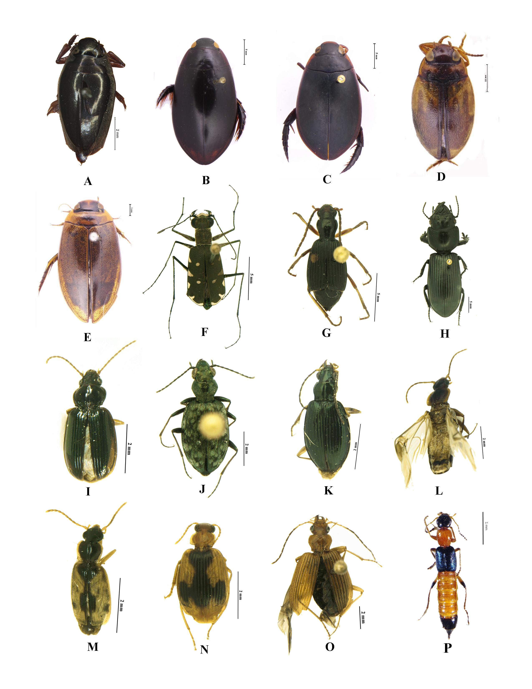

Figure 2. (A-P): A. Patrus metallicus (Régimbart, 1884); B. Cybister (Cybister) posticus Aubé, 1838; C. Cybister (Cybister) tripunctatus lateralis (Fabricius, 1798); D. Hydroglyphus geminus (Fabricius, 1792); E. Rhantus sikkimensis Régimbart, 1899; F. Cylindera (Eriodera) albopunctata (Chaudoir, 1852); G. Pheropsophus (Stenaptinus) nanodes Bates, 1892; H. Scarites (Scarites) sulcatus Olivier, 1795; I. Trechus (Trechus) indicus Putzeys, 1870; J. Asaphidion championi Andrewes, 1924; K. Bembidion (Politophanes) phaedrum Andrewes, 1923; L. Dromius (Dromius) eremnus Andrewes, 1933; M. Philorhizus adoxus (Andrewes 1923); N. Lebia (Poecilothais) calycophora Schmidt-Goebel, 1846; O. Agonum comatum (Andrewes, 1923); P. Paederus fuscipes Curtis, 1826.

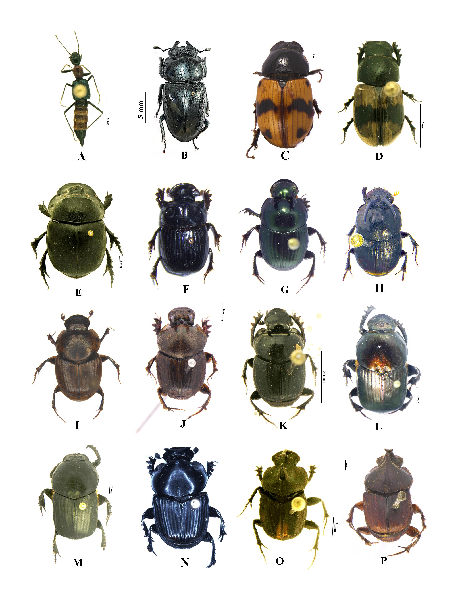

Figure 3. (A-P): A. Paederus nigricornis Bernhauer, 1911; B. Serrognathus (Serrognathus) titanus westermanni (Hope, 1842); C. Aphodius irregularis Westwood, 1839; D. Aphodius elegans Allibert, 1847; E. Catharsius molossus (Linnaeus, 1758); F. Copris (Copris) magicus Harold, 1881; G. Onthophagus (Colobonthophagus) dama (Fabricius, 1798); H. Onthophagus (Colobonthophagus) ramosellus Bates, 1891; I. Onthophagus (Gibbonthophagus) luridipennis Boheman, 1858; J. Onthophagus (Gibbonthophagus) rectecornutus Lansberge, 1883; K. Onthophagus (Matashia) kuluensis Bates, 1891; L. Onitis falcatus (Wulfen, 1786); M. Onitis excavatus Arrow, 1931. N. Liatongus gagatinus (Hope, 1831); O. Liatongus triacanthus (Boucomont, 1920); P. Liatongus vertagus (Fabricius, 1798).

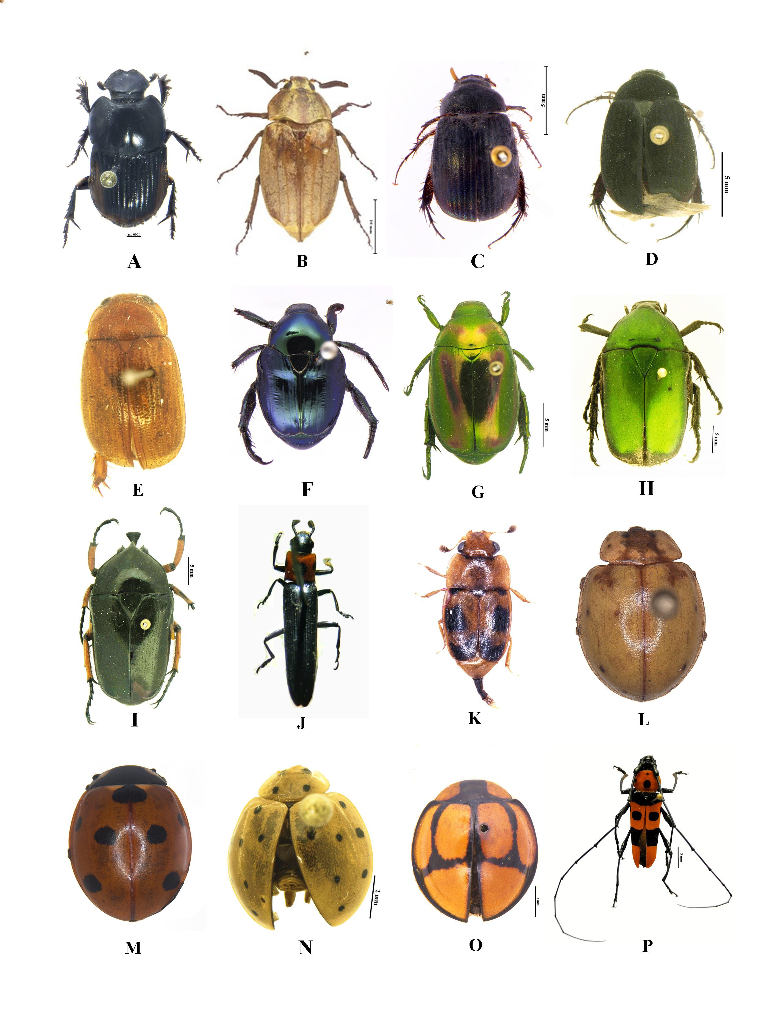

Figure 4. (A-P): A. Oniticellus cinctus (Fabricius, 1775); B. Melolontha indica Hope, 1831; C. Maladera (Omaladera) iridescens (Blanchard, 1850); D. Maladera (Maladera) allopruinosa (Ahrens, 1998); E. Neoserica bhalukpongensis Ahrens & Fabrizi, 2016; F. Popillia cyanea Hope, 1831; G. Mimela horsfieldi Hope, 1835; H. Torynorrhina distincta (Hope, 1841); I. Trigonophorus (Trigonophorus) nepalensis (Hope, 1831); J. Tetraphala elongata (Fabricius,1801); K. Epuraea ocularis Fairmaire, 1849; L. Calvia sykesii (Crotch, 1874); M. Coccinella septempunctata Linnaeus, 1758; N. Harmonia sedecimnotata (Fabricius, 1801); O. Oenopia sexareata (Mulsant, 1853); P. Rosalia (Eurybatus) formosa (Saunders, 1839).

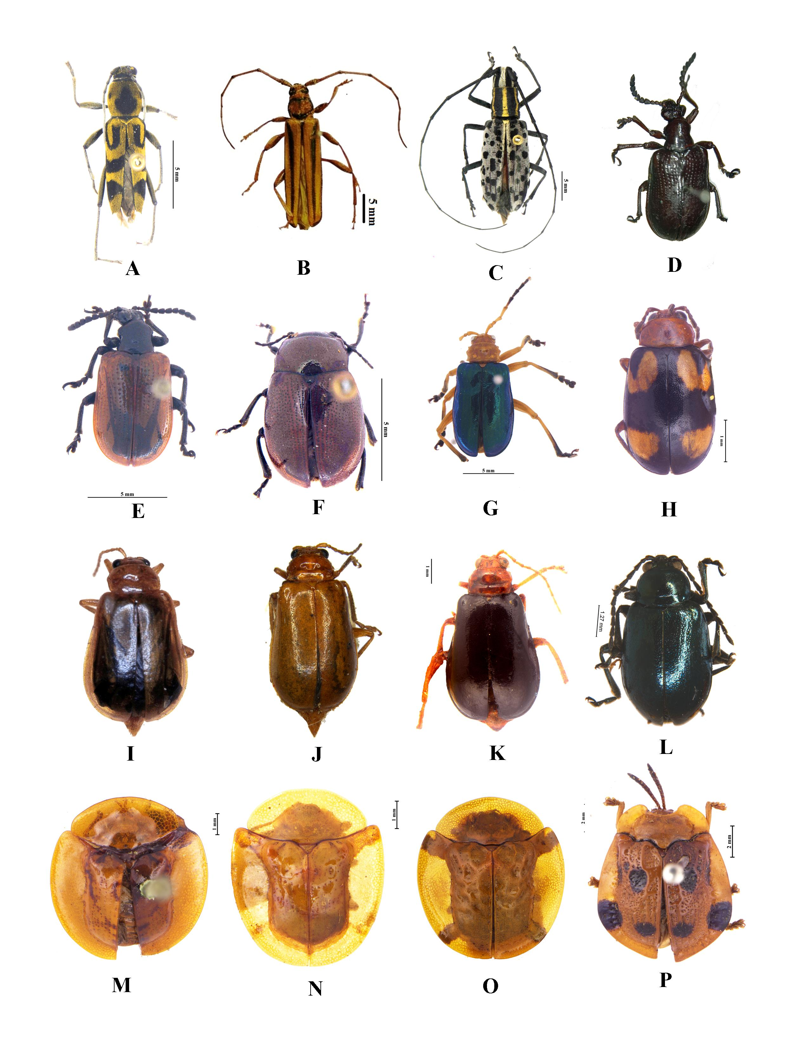

Figure 5. (A-P): A. Chlorophorus hederatus Heller, 1926; B. Xystrocera globosa (Olivier, 1795); C. Macrochenus guerinii (White, 1858); D. Lilioceris cheni Gressit and Kimoto, 1961; E. Lilioceris impressa (Fabricius, 1787); F. Potaninia assamensis (Baly, 1879); G. Aplosonyx chalybaeus (Hope, 1831); H. Monolepta signata (Olivier, 1808); I. Aulacophora indica (Gmelin, 1790); J. Aulacophora foveicollis (Lucas, 1849); K. Aulacophora lewisii (Baly, 1874); L. Altica caerulescens (Baly, 1874); M. Aspidomorpha dorsata (Fabricius, 1787); N. Aspidomorpha indica Boheman, 1854; O. Aspidomorpha sanctaecrucis (Fabricius, 1792); P. Notosacantha maculipennis (Boheman, 1856).

