***Short communication***

**Identification notes of *Johnius* fishes from Bay of Bengal Coast, Andhra Pradesh.**

**Abstract**

Fishes are commercially valuable vertebrates, easily accessible protein sources for all human populations despite of their financial status. Andhra Pradesh has one of the long coastal lines in country, and largely partaking in the production of marine products and influencing state as well as country’s exporting capacity. *Johnius* one of the highly preferred consumable fish species. Our recent studies revealed five species of *johnius* occurrence in coastal of waters of Andhra Pradesh and discussed here as identification notes*.*

**Introduction**

The croaker family, Sciaenidae, includes ray-finned fishes of the genus *Johnius.* They are accustomed to making knocking, croaking, and purring noises (Lin et al. 2007). Usually measuring less than 30 cm, *Johnius* croakers are comparatively small Scaienids in general find in Indo-West Pacific waters (Chao et al. 2019). Between 12 and 20 pairs of dendritic appendages line the sides of their distinctive hammer-shaped swim bladder (Kunio 2022). The dorsal corner of the gill opening is reached by the first lateral appendage. They have large paired sagittal otoliths that are triangular. Usually found sub-terminally to inferiorly, these fishes have a tiny mouth. The majority of species lack a barbel on their chin, however a few have a short one (Chao et al. 2019). The biggest species, such as *J. dussumieri and J. dorsalis.* In recent past several workers working on fish and fishery resources of Andhra Pradesh coastal watersSujatha, 1995*;* Chatla and Padmavathi (2021). Present identification notes based on collected specimens from Visakhapatnam, Kakinada, Machilipatnam, and Veta Palem landing centers of the Andhra Pradesh coast during out study period.

**Methodology**

Present work result of several fish investigatory surveys conducted in Visakhapatnam, Kakinada, Machilipatnam, and Veta Palem landing centers of the Andhra Pradesh coastal waters during the period of 2020-2022. Collected specimens preserved in 10% of formalin and labelled with all necessary details and transformed to laboratory for further studies.

**Results and discussion**

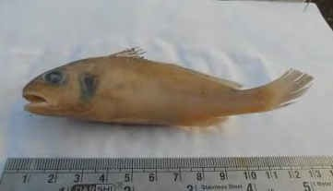***Johnius glaucus* (Day, 1876)**

**Genus: *Johnius fig1 : Johnius glaucus***

**Species: *glaucus***

**Description**: Body elongated greyish green along the back. Silvery below. Greatest width of head equals half its length. Snout rounded, slightly overhanging the jaws. Upper jaw overlaps the lower jaw. Pre-opercle with distinct and widely separated denticulation most developed at the angle. Opercle with 2 spines. Snout with three pores across its base and five along its free boarder. A diffused bluish blotch on the opercle. Teeth villiform in both jaws with an outer enlarged row of somewhat conical ones in the pre-maxillaries. Dorsal spines moderately strong. Pectoral falciform, as long as the head excluding the snout. Ventrals reach half way to the anal, second anal spine strong. Caudal rounded slightly wedge shaped.

**Common name:** Pale spot fin croaker

**Habit and habitat:** Marine, brackish, demersal.

**Economic importance**: Commercial

**Distribution: Western** –Indian Oceans. North west coast of India.

***Johnius borneensis* (Bleeker, 1851)**

***Sciaena vogleri* (Bleeker, 1853)**

***Otolithus vogleri* (Bleeker, 1853)**

***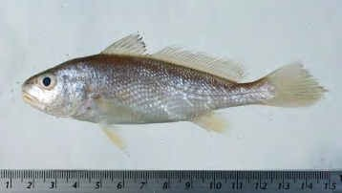*Genus: *Johnius fig2 : Johnius borneensis***

**Species: *borneensis***

**Description:** Body elongated and perch-like. Dorsal profile more convex than the abdomen. Body silvery in colour. Snout rounded but not swollen or projecting, mouth large, oblique, upper jaw extending backward below posterior half of eye. No barbels on chin. Teeth in narrow bands well differentiated into large and small in both jaws but non canine-like. Preopercle distinctly but finely serrated. The shoulder scale serrated. Dorsal spines of moderate strength. The second to the fifth sub-equal in length. Pectoral as long as the head behind the first fourth of the eye.Ventral reach half way to the anal. 2nd anal spine weak and long. Caudal wedge shaped.

**Common name:** Sharp nose hammer croacker

**Habit and habitat:** Marine, brackish, bentho-pelagic and freshwater.

**Economic importance:** Commercial

**Distribution:** Indo–West Pacific.

**Fig 3: *Johnius trachycephalus***

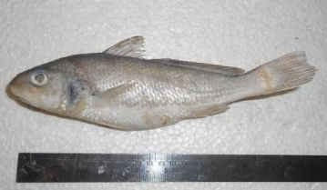***Johnius trachycephalus* (Bleeker, 1851)**

***Corvina trachycephalus* (Bleeker, 1851)**

***Otolithoides siamensis* (Fowler, 1934)**

**Genus*: Johnius***

**Species: *trachycephalus***

**Description:** Body elongated fusiform, golden in colour. Head is longer than broad. Snout is blunt. Eyes large. Lower region of the head spotted with black dots. Dorsal fin edged with black. Pectoral fin also black in colour. Lateral line is curved. Caudal peduncle is long. Caudal fin smooth and leaf-like. Pelvic fin outer rays filamentous. No barbels on chin. Scale rows above lateral line 12, below lateral line 17. Gill rackers 12.

**Common name:** Leaf tail croacker.

**Habit and habitat:** Marine, freshwater, brackish water, bentho-pelagic.

**Economic importance:** Commercial

**Distribution:** Indo–Pacific; India, Thailand, Sumatra and Borneo.

***Johnius dussumieri* (Cuvier, 1830)**

***Sciana dussumieri* (Cuvier, 1830)**

***Sciana sina* (Cuvier, 1830)**

**Genus: *Johnius***

**Species: *dussumieri***

**Description:** Body elongated and perch-like. Height of head equals in its length excluding snout. Snout rather inflated, scarcely overhanging the jaws. Pre-opercle rounded. Some distinct spinate teeth at its angle. Five pores under the symphysis of marbel. Snout with three pores across its base. Teeth villiform. Dorsal fin spines weak. Third and fourth spine longest. Pectoral as long as the head without snout. Ventral reaches nearly half way to the anal. Caudal wedge shaped.

**Common name:** Sin croacker**.**

**Habit and habitat:** Marine, freshwater, brackish**.**

**Economic importance:** Commercial

**Distribution:** India, Pakistan to the Andaman Islands**.**

***Johnius carutta* (Bloch, 1793) fig 4 : *Johnius dussumieri***

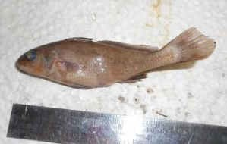***Sciaena carutta* (Bloch, 1793)**

***Johnius carutta* (Bloch, 1793)**

**Genus: *Johnius***

**Species: *carutta***

**Description:** Body elongated purplish brown in colour. Greatest width of head equals 2/3 of its length, its height equals its length excluding snout. Snout inflated overhanging the upper jaw, which slightly overlaps the lower. The maxilla reaches to below middle of the eye. Pre-opercle crenulated,

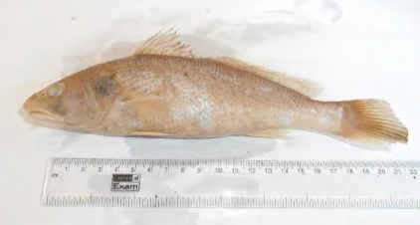

Fig 5 : ***Johnius carutta***

opercle with two weak spins. A row of pores across the snout. A central pore beneath the symphysis of the mandible having two more on either side of it. Teeth villiform in both jaws. Some teeth on outer row and in the anterior portion of the pre-maxillaries being enlarged. Somewhat conical. Dorsal spines weak. 2nd and 3rd the longest, pectoral as long as the head excluding the snout. IInd anal spine weak. Lateral line curved.

**Common name:** Karut croacker.

**Habit and habitat:** Marine, freshwater, brackish water, demersal.

**Economic importance: Minor commercial**

**Distribution:** India and Pakistan

**Conclusions**

Present identification notes of *johnius* fishes would be helpful for future fish biologist’s investigations and give some basic knowledge to access the available fish species characters of genus *johnius* in coastal waters of Andhra Pradesh.

**Ethical statement**

The fish species studied in the present study are not protected under The Wildlife Protection Act, 1972 (Last amended in 2013), Government of India, All the guidelines on animal use and care were followed accordingly.

**References**

Chatla D, Padmavathi P (2021). Fish diversity of coastal Andhra Pradesh, southeast coast of India. Adv. Anim. Vet. Sci. 9(9): 1424-1436

Chao, Ning Labbish; Chang, Chih-Wei; Chen, Meng-Hsien; Guo, Chang-Chang; Lin, Bai-An; Liou, You-Yu; Shen, Kang-Ning; Liu, Min (2019). *Johnius taiwanensis*, a new species of Sciaenidae from the Taiwan Strait, with a key to *Johnius* species from Chinese waters. *Zootaxa.* 4651 (2): 259–270. doi:10.11646/zootaxa.4651.2.3

Kunio Sasaki (2022). Family Sciaenidae Croakers, Drums and Cobs". In Phillip C Heemstra; Elaine Heemstra; David A Ebert; Wouter Holleman; John E Randall (eds.). Coastal Fishes of the Western Indian Ocean Volume 3 (PDF). South African Institute for Aquatic Biodiversity. pp. 389–414. ISBN 978-1-990951-30-5.

Lin, Yuan C.; Mok, Hin K.; Huang, Bao Q. (2007). "Sound characteristics of big-snout croaker, *Johnius macrorhynus* (Sciaenidae)". The Journal of the Acoustical Society of America. 121 (1): 586–593. doi:10.1121/1.2384844

Sujatha K (1995). Finfish constituents of trawl by-catch off Visakhapatnam. Fish. Technol. 32: 56-56