Biology study of white grub, Holotrichia serrata (Scarabaeidae; Coleoptera)
Studies on the biology of the white grub, Holotrichia serrata Fabr.
(Scarabaeidae : Coleoptera)

Abstract
White grub is a subterranean pest, with life cycle is of about an one year. Here biology of white grub is studied under laboratory conditions. Egg period lasts for 9.28 ± 0.68 days. The first instar takes about 27.88 ± 0.27 days. Second instar takes slightly longer,
35.56 ± 0.075 days and T the third instar stage, takes still longer 87.72 ± 0.92 days. Pupal period averaged 27.4 ±0.24 days. Adult phase was divided into two categories. The quiescent (inactive) stage and the aerial (active) stage. The quiescent adult stage takes 83.12 ±0.06 days. Aerial stage takes 29.34 ±0.13 days. Thus, the total duration of life cycle was found to be of about ------days.
Introduction
White grub larva is a polyphagous pest of which the larvae affects roots of various crops, including sugarcane, groundnut, maize, pearl millet, cowpea, sorghum, pigeon pea, cluster beans, rajmash, soybeans, upland rice, ginger, pear, potato, apple, walnut, mulberry, cherry, chilly, onion and chrysanthemum. Adults feed on the leaves of trees such as neem, acacia, oak, bhimal, toon, khirak and Rhododendron (Mishra 2001). Among the 1500 species of white grubs documented in India, 40 species are considered to be the pests causing significant damage to both field and horticultural crops across the country (Madhusudhan et al., 2021). The larvae are subterranean and the adults are found to occupy both subterranean and aerial life. The duration of grub is about 6 months and the adult occupies 2-4 months with 5-15 days of aerial life. The yield loss caused by the white grub ranges from 12 to 100% (Pokhrel 2004, Rai et al., 2013). The data on clump damage and crop age confirmed that larval damage was more severe during March ratoon crop at 4 months old, while the lowest damage was seen during January ratoon crop at 6 months old and January seedling crop at 7 months of age.old (Visalakshi et al., 2023).
The first instar of white grub feeds on organic matter from the soil and the later instars feeds on roots of cultivated crops (Venkateswaran et al., 2022). It is called as national pest (Mehta et al., 2010) since the distribution starts from Northern Himalayan region to Tamil Nadu (Jackson and Klein 2006). In Tamil Nadu, Tiruvannamalai, Kallakurichi, Dhramapuri, Namakkal are the hotspot areas for white grub occurrence.In India, Tamil Nadu stands 5th place with an area of 0.18 million hectare, 4th place in production with 16.54 million tonnesand 3rd place in productivity with 92,002 kg/ ha in sugarcane cultivation(Bee and Rahman 2020).White grubs are usually more prevalent in sandy or sandy loam soils than heavier soil, but they can also infest turfs grown in clay soils.
Materials and methods
The mass culturing of white grubs was conducted at Department of Entomology, AnbilDharmalingam Agricultural College and Research Institute, Tiruchirappalli. Rearing from adult beetles attracted to the light trap were manually collected and placed in the walk-in cages at the screen house filled with red soil and sand mixture (2:1) measuring 2m x 2m x 5m, a modified methodology of Srikanth et al., 2011. Another method was tried with insect rearing cages (50 × 50 × 100 cm) where eight small mud pots (10 cm dia.) were maintained in two small plastic trays (35 x 15 x15 cm) containing red earth and sand (Theurkar et al., 2012). The adults were released into the cages along with neem leaves based on the results of multiple choice test and observed for the oviposition. Rearing of larvae (second or third instar) was done using one week old maize roots as feeding material by using the same method (Rani, Riazuddin, et al., 2021).Observations were taken from November 2023 to October 2024.
Results
Biology of white grub
The life cycle of white grub is about one year. The egg period lasted approximately 9.28 ± 0.68 days, spanning from 7 to 12 days. The duration of first instar was about 27.88 ± 0.27 days and ranged from 13 to 30 days. The second instar period was slightly longer,
35.56 ± 0.075 days and ranged from of 23 to 59 days. The third instar stage, had the longest larval period, with on an average s lasted for of 87.72 ± 0.92 days and ranged from 64 to 85?? days.(please check)
Following larval stages, pupal period averaged 27.4 ±0.24 days and ranged from 15 to 38 days. The adult phase was divided into two stages: the quiescent (inactive) stage and the aerial (active) stage. The quiescent adult stage had an average duration of 83.12 ±0.06 days and ranged from 60 to 103 days. In contrast, the aerial adult stage lasted until 29.34 ±0.13 days and ranged from 18 to 45 days. (Table 1 and Plate. 1).
Discussion
The life cycle of white grub was found to be one year and hence, overlapping generations were seen under under field condition and it makes the farmers difficult to manage the pest. So the study of biology is important to make timely control measures against white grub. The egg period lasted n approximately for 9.28 ± 0.68 days which aligned with the report of Patel and Yadav (2013), who observed an egg duration of 7 to 10 days in a closely related species, Holotrichia consanguinea. It was in contrary to Rani et al.,(2021)who reported that Holotrichia nagpurensis egg period averaged about 14 days. In a study by Bhawane et al.,(2012), Holotrichia karschi egg took 10–16 days, the first instar took about 27.88 ± 0.27 days, the second instar was 35.56 ± 0.075 days, the third instar stage averaged 87.72 ± 0.92 days. This was in line with Rani et al., (2021)who reported that the larval instars occupied approximately 110 days in Holotrichia consanguinea. This was in contrary to Mishra (2001), who reported the larval period varied from 294 - 323 days and also Bhattacharyya et al. (2015) who reported that larval phase extended from 635 to 671 days. The extended duration of the third instar stage, the longest larval period, was in consistent with findings of Veeresh (1977), who reported prolonged feeding and growth during this phase, as larvae accumulated resources in preparation for pupation. The wider duration in the third instar period, from 64 to 85 days, may be attributed to variations in soil conditions and food availability, as suggested by Coutinho et al. (2011). Approximately the findings coincided with Kumar and Prasad (2020) who reported that larval period of H. serrata extended from 5 to 8 months. The pupal period averaged about 27.4 ± 0.24 days. Daravath et al. (2020) noted similar pupal durations in
H. fissa and H. consanguinea which ranged from 20 to 35 days. The quiescent adult stage had a duration of 83.12 ± 0.06 days, aerial adult stage lasted n for about 29.34 ± 0.13 days. The report aligned with Rani et al.,(2021)who reported that adults lived for 101.860 ± 3.575 days. In controlled settings, the adults lived for 25 days.
Conclusion
The study of the biology of Holotrichia serrata, a significant white grub pest, reveals that its life cycle spans approximately one year, with distinct developmental stages. The egg period lasts about 9.28 days, and the larval stages, from first to third instar, vary in duration, with the third instar being the longest at around 87.72 days. The pupal phase averages 27.4 days, and the adult phase is divided into a quiescent stage (83.12 days) and an aerial stage (29.34 days). These findings provide valuable insights into the pest's life cycle, which is crucial for designing effective pest management strategies. The extended larval period, especially in the third instar, highlights the importance of understanding environmental factors, such as soil conditions and food availability, in managing the pest. Furthermore, the overlapping generations in field conditions complicate pest control efforts, emphasizing the need for timely intervention. The study's results of the present studies align with previous research on closely related species, with some variations that could be attributed to differences in environmental factors and pest species. Understanding these biological characteristics is essential for formulating control measures and minimizing crop damage caused by H. serrata.

References
Mishra, PN. 2001. "Scarab fauna of Himalayan region and their management." Indian phytophagous scarabs and their management: present status and future strategy. Agrobios, Jodhpur:74-85.
Madhusudhan, KT, JB Gopali, MP Basavarajappa, and VD Gasti. 2021. "Development of IPM modules against root grubs, Holotrichia serrata (F.) in onion ecosystem." Journal of Experimental Zoology India 24 (1).
Pokhrel, MR. 2004. "Field survey of white grubs and laboratory evaluation of Metarhizium anisopliae (Metsch.) Sorokin for its control with side effects on Bombyx mori L in. M. Sc. Ag." Agriculture). Institute of Agriculture and Animal Science, Tribhuvan University, Rampur, Chitwan, Nepal.
Rai, Deepak, SN Sushil, J Stanley, JP Gupta, and Veenika Singh. 2013. "Deployment of Noval Technologies for The Management of White Grubs in Lower Hills of NW Himalyan Region." International Journal of Horticulture 3.

Visalakshi M, Patil J, Suresh M, and Manisha BL. 2023. "Seasonal Incidence and Eco Friendly Management of White Grub in Sugarcane Using Entomopathogenic Nematode and Entomopathogenic Fungus in Andhra Pradesh, India." International Journal of Environment and Climate Change13(9):696-706.
Venkateswaran K, Shrivastava A, Agrawala PK, Prasad AK, Manda K, Parmar VS and Dwarakanath BS. 2022. "Immune-modulation by 7, 8-diacetoxy-4-methylthiocoumarin in total body-irradiated mice: Implications for the mitigation of radiation-induced hematopoietic injury." Life Sciences 311: 121140.
Mehta, PK, RS Chandel, and YS Mathur. 2010. "Status of white grubs in north western Himalaya."
Jackson, Trevor A, and Michael G Klein. 2006. "Scarabs as pests: a continuing problem." The Coleopterists Bulletin 60 (mo5):102-119.

Bee, Nida, and Fazlur Rahman. 2020. "Growth rate of area, production and productivity of sugarcane crop in India." International Journal of Environmental& Agriculture Research 6 (4):13-19.

Srikanth, J, G Santhalakshmi, and R Nirmala. 2011. "An improved bioassay method for entomopathogenic fungi of sugarcane pests and its evaluation in studies of virulence in subcultures." Sugar Tech 13:156-165.
Rani, Seema, Rinni Saharwat Riazuddin, Manish Kumar Sharma, and Jagpal Singh. 2021. "Biology study of white grub Holotrichia nagpurensis (Scarabaeidae: Melolonthinae)." Int. J. Agric. Appl. Sci 2 (1):57-60.

TheurkarRani, Seema, Rinni Saharwat, Manish Kumar Sharma, and Jagpal Singh. 2021. "Biology of sugarcane beetle, h Holotrichia consanguinea blanchard (Coleoptera: Scarabaeidae)." Journal of Experimental Zoology India 24 (2).
Bhawane, GP, AB Mamlayya, SR Wagh, and AK Chaugule. 2012. "Diversity of white grub beetles and their host range from northern, western ghats, Kolhapur District (MS) India." The Bioscan 7 (4):589-596.
Bhattacharyya B, Gogoi I, Das PPG, and Kalita B. 2023. "Management of agricultural insect pests for sustainable agriculture and environment." In Sustainable Agriculture and the Environment (pp. 161-193). Academic Press.
Veeresh, GK. 1977. Studies on the Root Grubs in Karnataka: With Special Reference to Bionomics and Control of Holotrichia Serrata Fabricius (Coleoptera, Melolonthinae): University of Agricultural Sciences.
Coutinho, Gilmar Vieira, Elias Soares Gomes, Crébio José Ávila, Ivana Fernandes da Silva, Eduardo Neves Costa, and Mariana Alejandra Cherman. 2021. "First record of Plectris aliena Chapin, 1934 (Coleoptera: Melolonthidae) as a potential sugarcane pest in Brazil." Scientia Agricola 79 (2):e20200128.
Daravath V, Kasbe SS, Musapuri S. 2020 . “Flower chafer beetle (Oxycetonia versicolor Fabricius) on the verge of becoming a major pest on cotton in Telangana region of India: a frst report.” Journal of Entomology and Zoology Studies8:242–246
( References are not arranged alphabetically and year wise)

Table 1. Biology of different life stages of white grub (Holotrichia serrata) attacking
Sugarcane

Bio stages | Mean* ± SE(Days) | Range (days)
Egg Period | 9.28 ±0.68  (3.13)ª | 7-12
Ⅰ 1st instar period | 27.88 ± 0.27  (5.33)^{b} | 13-30
Ⅰ2nd instar period | 35.56 ± 0.075  (6.00)^{c} | 23-59
Ⅲ 3rd instar period | 87.72 ± 0.92  (9.39)^{d} | 64-85
Pupal period | 27.40 ± 0.24  (5.28)^{b} | 15-38
Adult period (quiscent stage) | 83.12 ± 0.06  (9.14)^{d} | 60-103
Adult period (aerial stage) | 29.34 ± 0.13  (5.46)^{b} | 18-45
SEd | 0.65
CD (P=0.05) | 1.33
(*Mean of five replications; Figures in the parentheses are square root of x+0.5 transformed values)

Plate 1. Stages of white grub collected from sugarcane
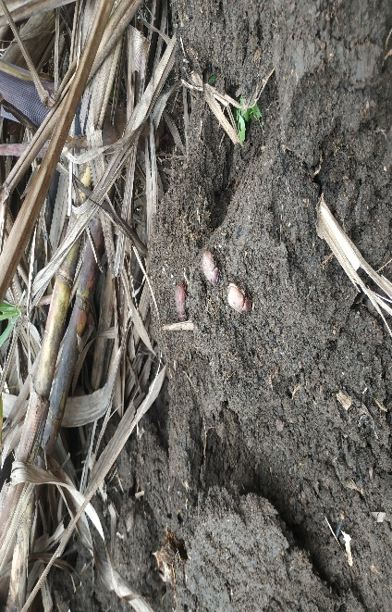 | 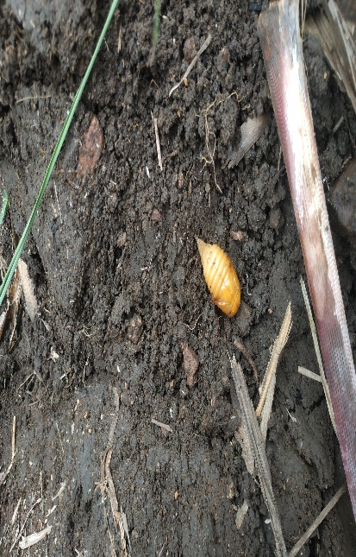
Quiescent stage adult | Pupa of white grub
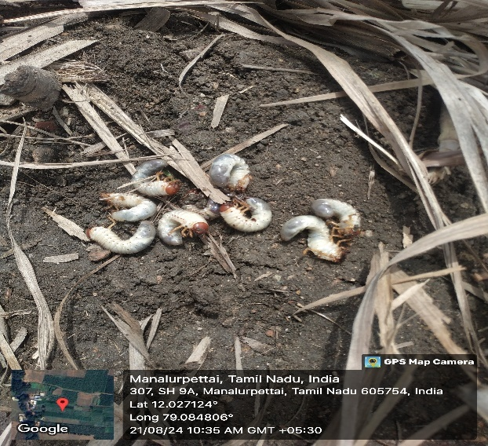 | 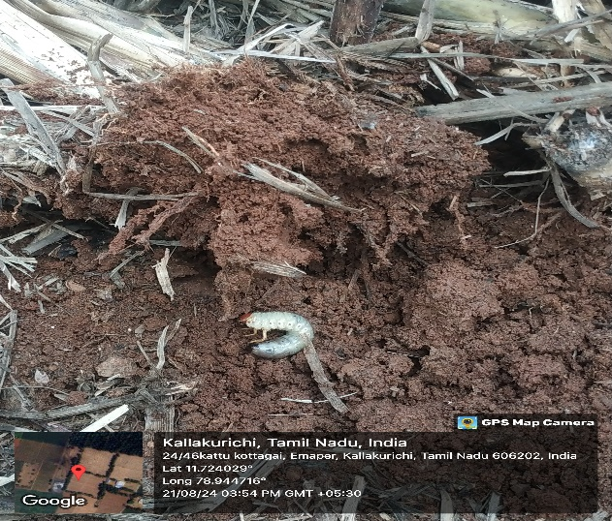
Larva

