**ADVANCE TECHNIQUES USED IN FORENSIC ENTOMOLOGY**

**Abstract**

Forensic Entomology plays a very important role in forensic science. It provides valuable inputs for crime scene investigation. This involves looking into the many pest species that are commonly related to dead bodies, as well as their life cycles and biological presence in a specific environment.

This review included concepts of forensic entomology, stages of decomposition and the latest techniques used by entomologists. It gives the detailed study of different techniques that are used to examine the entomological evidences, such as molecular analysis, entomotoxic analysis, Micro CT, cuticular hydrocarbon analysis, etc. by taking the references of previous researches. This review focuses light on the factors affecting PMI estimates and analyzes the uses of entomological data in PMI estimation. The main task is to determine the age of the insects. This review focuses on the advantages and disadvantages of age-determined methodologies. The aim of this study is to summarize techniques that are so far used commonly and all the latest advances made in the concerned field.

All these methods have shown more reliable results, adequate accuracy and more effectiveness. As evidence contamination is a major setback in providing results, these techniques have less risk of contamination of evidence and have also proved to be less time consuming.

**Keywords**: Advance techniques, Death time estimation, Forensic Entomology, Insects, post-mortem interval.

**ABBREVIATIONS –**

PMI – post mortem interval

Micro CT – microcomputed tomography

PCR – polymerase chain reaction

RFLP – restriction fragment length polymorphism

DNA – deoxyribonucleic acid

RAPD – random amplified polymorphic DNA

HPLC – high performance liquid chromatography

GC-MS – gas chromatography- mass spectroscopy

LC-MS - liquid chromatography- mass spectroscopy

SEM – scanning electron microscope

**1 INTRODUCTION** –

Forensic entomology is the branch of forensic science that deals with the study of insects of class arthropods in relation to criminal investigation (Sanjay Kumar Meena, 2020).It focuses on the study of insects to identify the outlook of crime, like post mortem interval, position or location of body, etc. Insects are the very important evidence for the entomologist according to the time period, location, temperature, climate, etc there are various insects that are developed on the dead body. A Forensic Entomologist examines the different stages of insects on the body as egg, larva, pupa and adults which change with respective time periods. Forensic entomologists collect all the insects from the crime scene, examine the breed of insect and analyze the stage of the insect then compare according to climate and assume the location, time since death and also provide a link of the type of crime. The entomology work on locard’s principle of exchange “everything that comes in contact leaves the traces” that means the insects leaves the traces when comes in contact with crime scene, victim, etc. (Isaac Joseph, 2011).

**2 Forensic entomology fields**

Forensic entomology is classified into three field and subfields:

· Urban entomology- It is the field of forensic entomology that included study of insects and arthropods found in urban areas, such as soil, garbage or muddy water, etc. to find out the cause and infestation in places like buildings and gardens (Raut, 2008).

· Stored products entomology- this subfield is related to investigation of cases of insects like contamination of packet food and any legal case on food quality and

Safety (Ian Robert Dadour, 2014).

· Medicolegal entomology- this subfield is related to study of insects and arthropods from the crime scene, to collect evidences to conclude the cause, time and location of death (Ian Robert Dadour, 2014).

· These field and subfields help to get the answer of why, what and where related to any cases.

**2 STAGES OF DECOMPOSITION** -

· Fresh stage – It is the 1st stage of decomposition that starts immediately after death and ends when the body starts to expand. It up to 1 to 2 days. This stage is called autolysis or self -digestion. That means quickly stopping the respiratory and blood circulation in the body, which increases the amount of carbon dioxide acidic in the body. Due to acidic natures the cells get damaged and released enzymes. The rigor mortis (stiffening of the body) also takes place in this stage (Raut, 2008).

· Bloat stage – 2nd stage of decomposition. In these stages the body starts swelling, the enzymes released in 1st stages produce infinite gases. Due to the gases, the body becomes four times its original size. Also, the skin color is getting darker due to the sulfur compound chemical discharge by bacteria. Highly unpleasant smell is produced by enzymes called in terms of putrefaction. Smell can stay for a long time (ML, 1993).

· Decay stage – In 3rd stage of decomposition the body fluids are released from the opening of the body. The organs, skin start melting and degenerating. The hard tissues of the body such as hair, cartilages, bones, etc. are left over after all soft tissue has decomposed (give the source of this information).

· Dry stage – In this stage starts when only traces of decaying tissues are left. This stage is challenging because it has many tasks and difficult to define the boundaries. Many varieties of creatures reside and some content of moisture is there due to dew, rain, etc. Very small quantities of partially decaying materials are present there (Bornemissza, 1957).

· Skeletal stage – skeletonization doesn’t have any exact time duration that depends upon the decomposition of organic and inorganic materials. At this stage of decomposition, the investigators get clues from the soil samples (Vass, 2022).

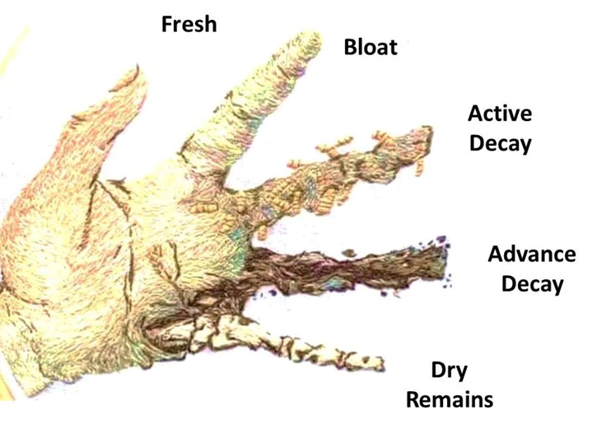

Figure.1 Stages of Decomposition

Reference: <https://forensicfield.blog/tag/dead-body-decomposition-stages/>

2.1 After the death, insects are the first present on all openings of the body. There are 4 categories of insects studied as follows:

* Necrophages – It gather the insects that come first to feed body tissues and stay for shorter time like half of day or one day. They are very useful for PMI Estimation (GOFF, 2000).
* Predators - When more study is done, particularly on the parasites, this class is also turning into a helpful tool for predicting the post-mortem interval. Parasites that might consume other species that have previously occupied the body.
* Omnivorous - In this category including animals like beetles that owns the breakdown process, significantly less helpful for determining the PMI (GOFF, 2000).
* Incidental or adventurous – which are only accidental visits and typically have no forensic significance. But no matters the categories all the insects need to be counted by entomologist (Mudassir Alam, 2024).

**3 LIFE CYCLE OF INSECTS –**

Most common insects found on bodies are flies and beetles; both are from the different taxa with significance in Forensic Entomology. Flies are the very previous insects to appear after the death. Around the natural orifices or injuries on body, female flies will lay eggs or live larvae. So, the larvae produce bacteria and enzymes that will aid in the soft tissue consumption of the corpse.

The life cycle of insect’s results from some biological changes known as metamorphosis, which involved different stages that included the vast changes to insect body structure as result of cell growth and differentiation. The life cycle of an insect include four stages: egg, larva, pupae, and adult. Not every bug will go through each of the four phases (Martin H Villet, 2011).

Egg – In this the adult female insect that lays the eggs. While some eggs can develop through parthenogenesis without fertilization, others require coupling and fertilization in order to grow up. As the eggs hatch, larvae appear.

Larva - The insect's larval stage is when it is still juvenile and feeds. Larvae and adults have extremely distinct appearances, live in different environments, and eat different things. Maggots, grubs, and caterpillars are a few types of larvae. As they develop, larvae molt, or lose their outer shell, multiple time.

Pupa - The pupa spent much of this stage resting and not active. The pupa's adult structure is rearranged by the bursting larval tissues. The pupa molts once this procedure has concluded, appearing as an adult with two wings. During the pupa stage, the insect's wings fully mature and it becomes an adult, entering the world (Insect Life Cycle , n.d.).

Adult – In this stage, insects have tactile hair which is present on the antennae, legs, and torso of adult insects, aids in the insects' ability to sense their surroundings. An insect's entire surface is covered in tactile hair. The adult insect is sexually developed at this point and mostly engages in reproduction (kualo, n.d.).

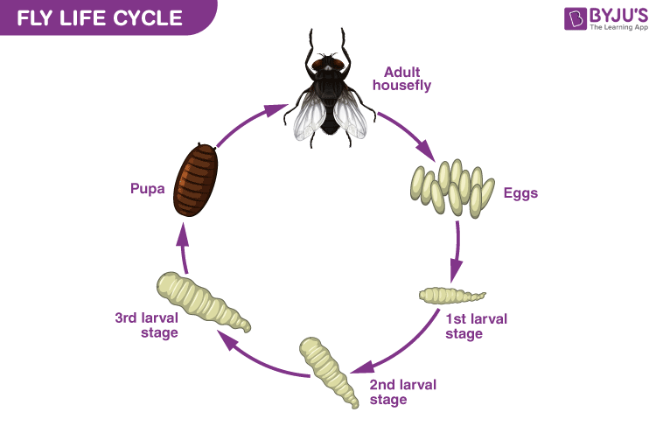

Figure 2 life cycle of fly

Reference: <https://byjus.com/biology/fly-life-cycle/>

# **4 COLLECTION AND PRESERVATION OF ENTOMOLOGICAL SAMPLES-**

Collection of entomological evidence may be in different stages of eggs, maggots, pupae, beetles and different areas of cadavers and surrounding environment. Collected samples provided clues about the injuries, time since death, locations, etc. for the collection appropriate tools and techniques are used such as gold, silver, or bronze standards that depends on the experts of the crime scene investigations.[15]

Gold Standard: In the use of specialist tools like entomology kits, brushes, forceps, spoons, insect nets, sticky traps, vented containers and a chilled fridge for transportation. Gathers microclimatic information for ten to twelve days following discovery, including soil temperature, humidity, photoperiod, temperature of the larvae mass, and ambient temperature.

Sliver Standards: Here, involves the collection of any stage of development by pathologist, police officer, or medical examiner with the trained forensic examiners. They use containers, preservatives, and disposable forceps that are given by the organization in charge of the crime scene gathers information from the closest meteorological station about the surrounding temperature and rainfall (Tharindu B. Bambaradeniya, 2023).

Bronze Standards: In this involves collecting eggs, larvae, and pupae with an unskilled police officer or field technician using containers, preservatives, and disposable forceps that are given by the organization in charge of the crime scene (Chada Anu Reddy, 2023).

Preservation of insects or entomological evidence can be refrigerated or frozen for a short period of time. Transfer delicate specimens such as eggs, pupae, beetles, maggots, and soil samples to the entomologist immediately by placing them in an upright cardboard box. For various insect specimens, use the proper preservation techniques, such as killing, pinning, labeling, and keeping in alcohol or other preservatives such as ethyl alcohol, 70-80%isopropyl alcohol, 37%formalin in water, and methanol. Make careful to record the gathering and conservation procedure using thorough notes, pictures, and chain of custody paperwork.

Labeling inside and outside of the preservative containers should properly indicate the date, time, case reference number, and type of specimen.

The proposed downstream investigation, such as morphological identification, toxicity, or molecular approaches, will determine which preservative is best. The most used preservative for gathering general entomological data is ethanol.

## 5 ADVANCED TECHNIQUES USED IN FORENSIC ENTOMOLOGY –

### 5.1 Electron Microscope (scanning electron microscope)

A wide range of morphological characteristics are available for identifying fly eggs by using the SEM. As long as there is enough time, suitable tools, and the specific fly eggs are available, the SEM procedure operates well. Considering these morphological variations, for Forensic Entomologists these is a useful tool that can assist in determining a PMI and other linked information, like whatever the body has been moved after the death. Some morphological traits that can be used to differentiate between species includes the and form of median area, the presence and lack of holes or anesthetic. One technique that can be used to identify important molecular features of eggs and maggots is scanning electron microscopy (SEM) (N. Ubero-Pascal, 2010).

SEM is used to analyze fly artifacts produced by insects on rough surfaces and some fabrics also. It helps to differentiate bloodstain from the fly artifacts on the basis of amorphous crystals and absence of RBCs. It is non-destructive, allowing for analysis of evidence without damaging it. Particularly useful for biological samples like insects (Guido Pelletti, 2019).

### 5.2 Entomotoxicology

The study of using insects as a substitute for toxicological samples is known as Entomotoxicology. The excessive use of medications, pesticides, insecticides and poison is a major cause of death globally. In this condition, the original toxicological samples like tissues, body fluids, organs are no longer available sometime, so the second reliable specimen insects are available (Rito Chophi, 2019). As insects use dead bodies as food supply for their larvae, they are important to investigation. During their time of feeding on cadaveric tissues, the larvae's metabolic system absorbs all the substances from cadavers, which include medicines and other hazardous compounds like drugs, poisons found in the tissue. To detect these substances from insects Immunoassay, HPLC, LC-MS, GC-MS has been utilized commonly (Matthias Gosselin). Entomotoxicology is one of the best tools to detect poisonous substances. Sometimes it is challenging to do toxicological testing on bodies that are skeletonized or in an advanced decay stage of decomposition so the larvae consume substances that can be examined using thin layer chromatography. Toxins have the ability to affect larvae’s developmental phases. The presence of heroin or cocaine in the body may speed up the colonization and poisons such as malathion postpone the colonization of insects (D. W. Sadler, 1995).

### 5.3 Molecular Identification (DNA Analysis)

Most of the time the entomological evidence is not accurately examined for species identification. Molecular data is helpful to identify insect species, morphological identification is obtained. Here we need to extract mitochondrial DNA materials, and also need to prepare the DNA extraction samples by using various methods. By the identification of the correct species, estimate the age of larvae. In this method for determining species, we need to perform morphological comparison, which takes lots of effort and skilled people with specialized knowledge about the DNA estimation. To overcome the challenge, species identification is done by using polymerase chain reaction (PCR), random fragment length polymorphism (RFLP), randomly amplified polymorphic DNA(RAPD), Inter simple sequence repeat (ISSR). Only the suitable region of larvae’s genome is used as reference data (K Schoenly, 1987).

### 5.4 Micro CT (Micro- computed tomography)

In Forensic entomology the microCT has become a very important tool that enhances the analysis of insect anatomy and developmental stages in post-mortem examination, it allows the visualization of insect larvae, pupae and adults inside the plant tissues to display the exact arrangement of space (Schmidt VM, 2022). All this information is crucial to understand the feeding habits, growth, and ecological functions of insects. Micro CT techniques provide the high-resolution view of insect anatomy without any destruction of samples, this is essential for estimating the postmortem interval and to understand the ecological connections between insects and the crime scenes (Nur Aliah, 2024). These techniques allow researchers to examine external and internal structures of insects in traditional techniques that need to follow the dissection procedure which can destroy the valuable morphological information, but here in advance no need of dissection, it provides reliable parameters for age, time estimations. The primary advantage of the technique is its non-invasive nature, allowing detailed examination with any damage to samples (Donkó, 2022).

### 5.5 Stable Isotope Analysis

Stable Isotope Analysis has become the most precious tool in forensic entomology, that provides a deeper view of geographic origin and life cycle of insects with respect to human remains. This technique includes the study of stable isotopic composition of elements like carbon, nitrogen, hydrogen and oxygen in insects’ tissues, so the researcher gets information about diet, environment in which the insects developed. By using these techniques forensic entomologists can deduct the information about the insect diet such as whether it contained organic material or human remains. By studying isotopes, we can identify the breakdown process of insects. The implementation of this method can enhance the precision of their evaluations and provide important information about the situation surrounding a death. But the biggest obstacles to the use of isotope analyses in forensic entomology are its errors, lack of requirements and lack of reference materials (Agency, 2009).

**6 CONCLUSION –**

This review renovates more of the recent knowledge that applied in forensic entomology, or all the situations that faced by the entomologist are significantly documented in the literature. One of the key concerns of forensic entomologists is education and practical knowledge about the entomological evidence while collecting the insects and other biological fluids from the crime scene, their collection and preservation is a major part for entomologists. The review helps to make an appropriate collection and examination. Their decision making will enhance by reading this document. It cannot be overstated how important it is that these efforts be of the highest quality if the forensic entomologist and the case in general are to profit from the evidence and related data especially in the view of the court future examination of it.

# References

Agency, I. A. (2009). Manual for the use of stable Isotopes in Entomology. Retrieved from https://www.iaea.org/sites/default/files/21/06/nafa-ipc-manual-iaea _si_hi-res_final.pdf

Bornemissza, G. (1957). An analysis of Arthropod succession in Carrion and the effect of its decomposiion on the soil fauna. *Australian Journal of Zoology, 5*(1), 1-12. doi:10.1071/ZO9570001

3.Chada Anu Reddy, S. K. (2023). Methods in Entomology: Collecting, Preservation, Curation and Identification. In G. C. Vikram, *Entomology Rededined Current Trends and Future Directions* (1st ed., pp. 177-191). new delhi: Elite Publishing House. Retrieved from https://www.researchgate.net/publication/375861600_Methods_in_Entomology_Collecting_Preservation_Curation_and_Identification

4.D. W. Sadler, C. F. (1995). Drug accumulation and elimination in calliphoria vicina larvae . *Forensic Science International , 71*(3), 191-197. doi:10.1016/0379-0738(94)01663-1

5. Donkó, T. P. (2022). A conceptualisation of computed tomography outputs in entomological research by step by step displaying trough the CT-based visualization of a wood-boring larvae. *Acta Phytopathologica et Entomologica Hungarica, 57*(2), 127-138. doi:10.1556/038.2022.00148

6. GOFF, M. L. (2000). A fly for the prosecution : how insect evidence helps solve crimes. In https://archive.org/search.php?query=creator%3A%22Goff%2C+M.+Lee+%28Madison+Lee%29%22. Cambridge, Mass. : Harvard University Press. Retrieved from https://archive.org/search.php?query=creator%3A%22Goff%2C+M.+Lee+%28Madison+Lee%29%22

7. Guido Pelletti, M. C. (2019, September ). Scanning electron microscopy in the identification of fly artifacts. *International Journal of Legal Medicine , 133*(3), 1575-1580. doi:10.1007/s00414-019-02090-5

8. Ian Robert Dadour, B. M. (2014, July). Forensic Entomology: A Synopsis, Guide, and Update. *Essential of Autopsy Practice* , 105-130. doi:10.1007/978-1-4471-5270-5_6

9. *Insect Life Cycle* . (n.d.). Retrieved from BYJU'S.COM: https://byjus.com/biology/insect-life-cycle/

10. Isaac Joseph, D. G. (2011, july 23). The use of insects in forensic investigations: An overview on the scope of forensic entomology. *Journal of Forensic Dental Sciences, 3*(2), 89-91. doi: 10.4103/0975-1475.92154

11. K Schoenly, W. R. (1987). Dynamics of heterotrophic succession in carrion arthropod assemblages: discrete seres or a continuum of change? *Oecologia, 73*(2), 192-202. doi:10.1007/BF00377507

12. kualo. (n.d.). *Amateur Entomologists' Society*. Retrieved 1997, from www.amentsoc.org: https://www.amentsoc.org/insects/fact-files/life-cycles.html

13. Martin H Villet, J. A. (2011, August). Advances in Entomological Methods for Death Time Estimation. *Forensic Pathology Reviews, 6*, 213-237. doi:10.1007/978-1-61779-249-6_11

14. Matthias Gosselin, S. M. (n.d.). Entomotoxicology, experimental set-up and interpretation for forensic toxicologists. *Forensic Science International, 208*(1-3), 1-9. doi:10.1016/j.forsciint.2010.12.015

15. ML, G. (1993). Estimation of Postmortem Interval Using Arthropod. *Forensic Science Review, 5*, 81-94. Retrieved from http://forensicsciencereview.com/Abstract/5-6A%20(Goff).pdf

16. Mudassir Alam, K. A. (2024, January). FORENSIC ENTOMOLOGY: A COMPREHENSIVE REVIEW ON INSECT-BASED APPROACHES IN CRIMINAL FORENSICS . *Munis Entomology & Zoology, 19*(1), 132-145. Retrieved from https://www.researchgate.net/publication/377020058

17. N. Ubero-Pascal, I. A.-E. (2010, december). Microscopy and forensic entomology. *Microscopy: Science, Technology, Applications and Education* , 1548-1556. Retrieved from https://www.researchgate.net/publication/256250031

18. Nur Aliah, N. H. (2024, march 10). Age Determination of Chrysomya megacephala Pupae through Feflectance and Machine learning Analysis . *Insects, 36* (3), 640-653. doi:10.3390/insects15030184

19. Raut, S. (2008). *forensic entomology* . Retrieved from www.santoshraut.com: https://www.santoshraut.com/forensic/entomology.htm

20. Rito Chophi, S. S. (2019, october ). Forensic entomotoxicology: Current concepts, trends and challenges. *Journal of Forensic and Legal Medicine, 67*, 28-36. doi:10.1016/j.jflm.2019.07.010

21. Sanjay Kumar Meena, S. D. (2020, June). A Review on Forensic Entomology. *National Journal of Environment & Scientific Research , 1*(2). Retrieved from https://www.researchgate.net/publication/352074129

22. Schmidt VM, Z. P. (2022, July 25). Application of Micro-Computed Tomography for the Estimation of the Post-Mortem Interval of Human Skeletal Remains. *BIOLOGY, 11*(8). doi:10.3390/biology11081105

23. Tharindu B. Bambaradeniya, P. A. (2023, june ). ASummaryofConcepts, Procedures and Techniques Used by Forensic Entomologists and Proxies. *Insects, 14*(6), 26. doi:10.3390/insects14060536

24. Vass, D. A. (2022, september 19). *the stages of human decomposition* . Retrieved from www.aftermath.com: https://www.aftermath.com/content/human-decomposition/