**An insight into the occurrence of mosquitoes in Phytotelmata of southern West Bengal, India**

**Abstract**

The phytotelma is a small, isolated, collected water body in a living or dead plant part of a terrestrial ecosystem. The ecosystem in phytotelmata supports the nourishment and development of various organisms and acts as an important breeding ground for disease-spreading vector mosquitoes. The present study deals with the occurrence of mosquito species in various phytotelmata of southern West Bengal in India. The natural phytotelmata are decreased day-by-day from human habitation and some artificial phytotelmata are mimicking the natural phytotelmata. The results of the study state that the artificial telmata are more available and accessible in the post-monsoon period (months of September to November) for developing the bamboo super-structure or pandals in various festivals. These artificial phytotelmata effectively promote the development of the different life stages of different mosquitoes (e.g., *Anopheles* sp., *Aedes* sp., etc.) for which the vector-borne diseases (e.g., dengue, malaria) become endemic in North 24 Parganas and its adjacent areas during the post-monsoon period of festivals.

**Keywords:** Artificial phytotelmata,Diversity of phytotelmata, Gangetic plains, Mosquito diversity, Vectoring mosquito.

1. **Introduction**

The phytotelmata is a crucial but unfamiliar ecosystem that is a major natural mosquito breeding site for various species [1]. The phytotelmata generally include tree holes, bamboo stumps, leaf axils, fallen leaves, and fruit husks [2,3]. The water source of the phytotelmata is usually rainwater and plant sap. The aquatic microfauna present in phytotelmata is composed of a mixture of species that inhabit soil and freshwater [4,5]. These are lentic habitats, unique for their small size, discreteness, and ephemerality [6], and are known to accommodate aquatic invertebrates [3,7], most dominated by insect larvae at high densities [8]. Detritus aquatic insects use phytotelmata as their primary habitat, and some reside permanently [2,3,9]. Phytotelmata have been studied to determine various factors that influence the structure of insect communities [10,3,11,12]. Water-filled tree holes are the most tractable small aquatic system, partly because they are relatively persistent and can be mimicked with plastic cups, bamboo sections, or other inexpensive materials [13].

Mosquitoes have varying preferences for different types of phytotelmata depending on conditions such as appropriate microhabitat, food availability, breeding opportunities, and predator escape. It serves as an excellent indicator of the condition of insects and vectors in a specific area. To complete their early life cycle phases, mosquitoes that transmit various diseases including dengue, filariasis, malaria, and others seek phytotelmata (i.e., egg, larva, pupa) [14].

There are several studies on the phytotelmata with different aspects of medically important insect biology and their vector incidents in human society nationally and internationally [13,15,16], but it is yet to be studied in West Bengal in detail. Our study aims to quantify different invertebrate species inhabiting three types of phytotelmata such as the extracted bamboo stump (used as pandals and construction materials) and the leaf axil of Colocasia sp. and Musa sp. The diversity, density, relative abundance, and seasonal dynamics of those organisms, especially available mosquitoes in the phytotelmata have been examined. Effects of the natural and artificially occurring phytotelmata and the density and relative abundance of the mosquitoes are also determined here.

1. **Materials and methods**

## **2.1 Study Site**

The study was carried out in the two urban areas (Naihati municipality, 22°54’N, 88°24E’), and Bhatpara municipality, 22°85’N, 88°39E) in North 24 Parganas district, West Bengal, India.

## **2.2 Study Period**

The study was done in two timelines, in the first, the study samples were collected only in the rainy season (June 2017 to September 2017). Secondly, samples were collected throughout the year taking three consecutive years *viz.,* 2017, 2018, and 2019. The samples were collected randomly from the leaf-axil of *Colocasia* sp., *Musa* sp., and bamboo stump phytotelmata (n = 750. Two hundred fifty samples of each type of phytotelmata.

## **2.3 Sampling and physicochemical parameter analysis of the phytotelmata**

For sampling, we selected leaf-axils of two plants (banana plants, *Musa* sp., and elephant ear plants, *Colocasia* sp.), which were considered as natural-telmata, and the man-made extracted bamboo stumps, which were considered as artificial-telmata. The impound water sample and the different biological specimens were collected in glass beakers with the help of glass pipettes (10 ml and 25 ml in volume). The collected specimens were transferred to glass vials containing 70% alcohol for preservation and further investigations.

The physico-chemical parameters include the height of the phytotelmata from the ground, the amount of water, and the temperature, and pH of the water in the phytotelmata. These were noted following a standard protocol [17]. The temperature of the water samples was recorded with the help of a Comet Borosilicate glass mercury thermometer. The pH of the samples was recorded with pH paper (Amicikart 5-meter pH test strips, acid test paper water litmus testing kit). The heights of the phytotelmata from the respective ground level were measured with a scale calibrated in inches.

## **2.4 Specimen identification**

The collected mosquito samples were identified up to the genus following dichotomous keys [18,19,]. However, other organisms were recorded with their common English names.

## **2.5 Data analysis**

The species diversity, density, evenness, and relative abundance for the Shannon-Weiner index were recorded. The seasonal dynamics of the mosquitoes were determined in the study using standard software and protocol.

1. **Results**

Approximately, nine groups of organisms such as mosquitoes (Anopheles, Culex, Aedes, and Toxorhynchitis), ants, snails, aphids, leech, tubifex, dipteran maggots, banana beetle, and earthworm were found around 750 phytotelmata in three study sites of lower Gangetic plains of West Bengal (Table 1). The phytotelmata comprised of various life stages of the mosquitoes (i.e., the eggs, larva, pupa, and adult),

To understand the diversity, the Shannon diversity index was performed in different types of phytotelmata that showed surprisingly in all types of phytotelmata Shannon index diversity is very low (Table 2). It is also found that mosquitoes are more abundant in all types of phytotelmata (Table 1).

The species richness is relatively greater in natural phytotelmata (leaf axil of *Musa* sp. and *Colocasia* sp.) than in artificial telmata. It is also observed that the species richness is higher in the *Musa* sp. than in the *Colocasia* sp. (Table 2). The species richness is directly proportional to the water volume in the telmata; i.e., more water supports to occur of more species diversity (Table 1). The organisms of different species in telmata mostly prefer neutral or slightly acidic water (Table 1). The height of the telmata has no impact on the species diversity among the telmata (Table 1).

**Table 1.** Different organisms in the phytotelmata of lower Gangetic plains of West Bengal.

|  |  |  |  |  |  |  |  |  |  |  |  |  |  |  |  |  |  |  |  |  |  |  |
| --- | --- | --- | --- | --- | --- | --- | --- | --- | --- | --- | --- | --- | --- | --- | --- | --- | --- | --- | --- | --- | --- | --- |
| Sl.no | Nature of phytotelmata |  | no. of phytotelmata study | Infected no. of phytotelmata | Total no. of individual | Mosquito no. | | | |  |  | Ant | snail | aphid | Leech | Tubifex | Dipteran maggot | Banana beetle | Earth worm | P  H | Vol. of water | Height  of phyto  telmata |
|  |  |  |  |  |  | Ano  pheles | Cu  lex | Aedes | Toxorhynchites | Total |  |  |  |  |  |  |  |  |  |  |  |  |
| 1 | Leaf axil of  *Musa* sp. |  | 250 | 195 | 440 | 62 | 98 | 29 | 5 | 194 |  | 75 | 16 | 36 | 7 | 42 | 22 | 15 | 33 | 7 | 4.9 | 74 |
| 2 | Leaf axil of  *Banana* sp. |  | 250 | 220 | 480 | 75 | 104 | 15 | 4 | 198 |  | 112 | 59 | 39 | 16 | 24 | 12 | 0 | 20 | 7 | 4.5 | 6.5 |
| 3 | Bamboo stump |  | 250 | 87 | 256 | 79 | 55 | 70 | 12 | 216 |  | 27 | 3 | 0 | 4 | 0 | 0 | 0 | 6 | 7 | 3.7 | 58 |

**Table 2:**

It is found that the diversity of all mosquito species is very low in all telmata (Table 3). It is observed that the species diversity is very low in all telmata. The species richness, evenness,

**Table 2.** Species richness, evenness, and H’ index of mosquitoes in the different types of phytotelmata in West Bengal.

|  |  |  |  |
| --- | --- | --- | --- |
|  | **Phytotelmata** | | |
| ***Musa* sp.** | ***Colocasia* sp** | **Bamboo stump** |
| **H'-index** | 1.087920461 | 0.980215553 | 1.241930018 |
| **Evenness** | 0.271980115 | 0.245053888 | 0.310482504 |
| **Species**  **Richness** | 4 | 4 | 4 |

**Table 3.** Species richness, evenness, and H’ index of different organisms present in the various types of phytotelmata in West Bengal.

|  |  |  |  |
| --- | --- | --- | --- |
|  | ***Musa* sp.** | ***Colocasia* sp.** | **Bamboo stump** |
| **H'-index** | 1.73732899 | 1.654264029 | 0.585648919 |
| **Evenness** | 0.790692498 | 0.795532837 | 0.363884133 |
| **Species Richness** | 9 | 8 | 5 |

and the H’-index of different groups of organisms are almost similar in the telmata but greater in natural telmata (leaf axil) than those in artificial telmata (bambu stump) (Figure 1). The H’-index and evenness of different types of mosquitoes are slightly greater in the artificial telmata (Extracted bamboo stump) than in other natural telmata (Figure 2).

The abundance of mosquitoes is relatively smaller in the natural telmata than in the artificial telmata. The *Culex* sp. is more abundant, followed by *Anopheles* sp, *Aedes* sp, and *Toxorhynchites* sp. in the telmata of leaf axils. In contrast, *Anopheles* sp. is greater in the artificial telmata and followed by *Aedes* sp., *Culex* sp., and *Toxorhynchites* sp (Figure 3). It is also found that the smaller water volume in the artificial telmata supports more mosquito species than that in the natural telmata. The low pH of the artificial telmata supports more mosquitoes than the natural telmata. The abundance of the *Aedes* sp. and *Toxorhynchites* sp. is directly correlated to the height of the telmata from ground level (Figure 4). In natural telmata, all types of mosquitoes are comparatively greater from June to August. The humidity and temperature of the telmata are directly proportional to the abundance of mosquitoes. The *Culex* sp is dominant over other mosquitoes throughout the study period (Figure 5 and 6).

The mosquito abundance is greater in the artificial telmata in Sept - Nov., however, *Aedes* sp. is more dominant in those months than other mosquitoes (Figure 7 and 8). The availability of artificial telmata (e.g., Extracted bamboo stump) is relatively greater in the post-monsoon (Sept-Nov) season than in the monsoon (Jun-Aug) and pre-monsoon (Mar-May) season. In the artificial telmata, we observed there are some black-colored dormant mosquito eggs attached to the extracted bamboo stum’s inner side. These are mainly eggs of *Aedes* sp. As a result, the two most occurring diseases such as dengue and malaria are spread out due to the availability of their insect vectors *viz. Aedes* sp. and *Anopheles* sp.

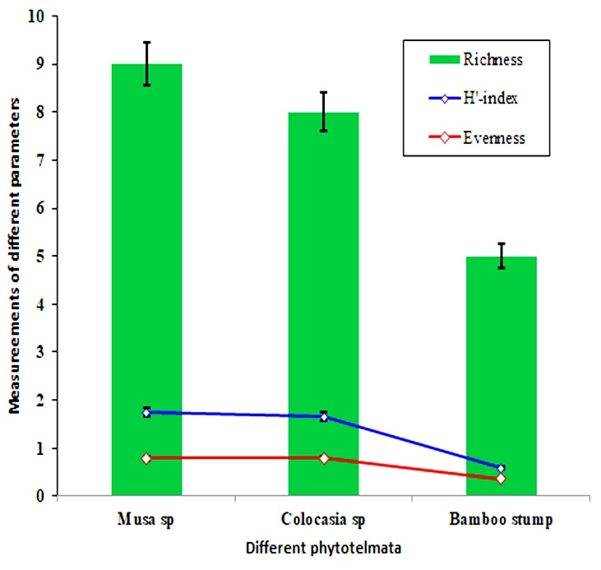

**Figure 1** The graphical representation of the species occurrence in three phytotelmata, showing the species richness, Shanon-Weiner (H') index, and evenness of different types of organisms.

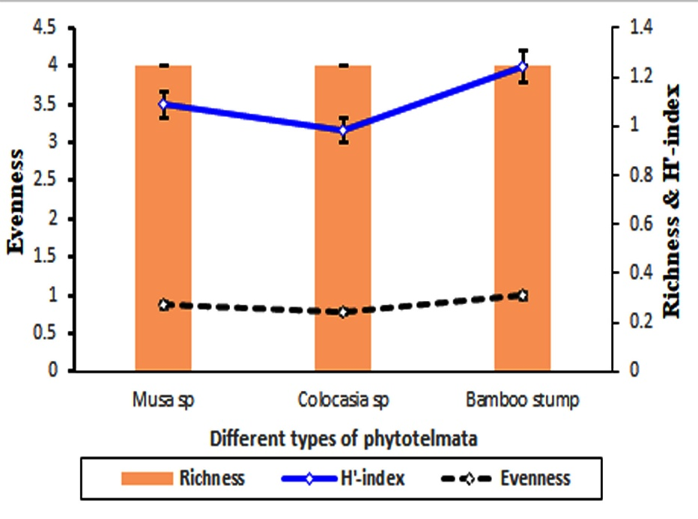

**Figure 2** The graphical representation of the species occurrence in three phytotelmata, showing the species richness, H'-index (Right side), and evenness (Left side) of the mosquitoes.

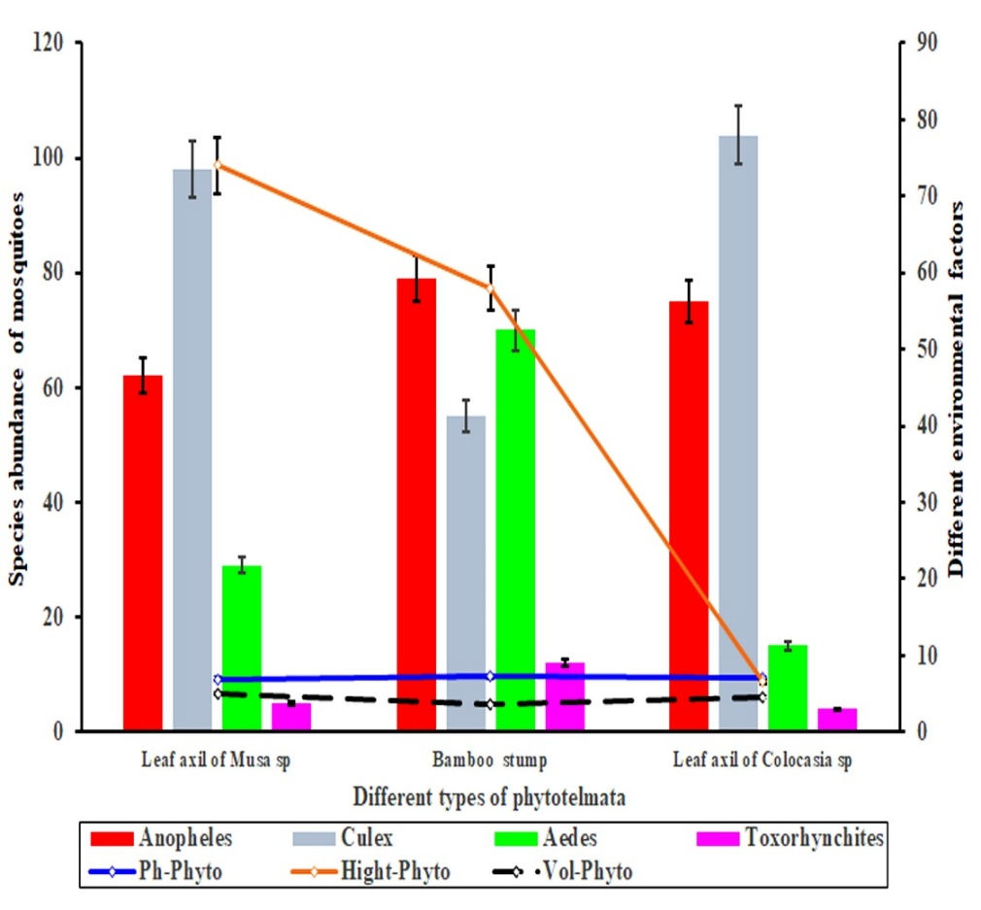

**Figure 3** Different types of mosquito species in phytotelmata. Species abundance of mosquito species is plotted on the left axis and different environmental factors are plotted on the right axis of the plot of different types of phytotelmata. Error bars are standard errors (*p = .05*).

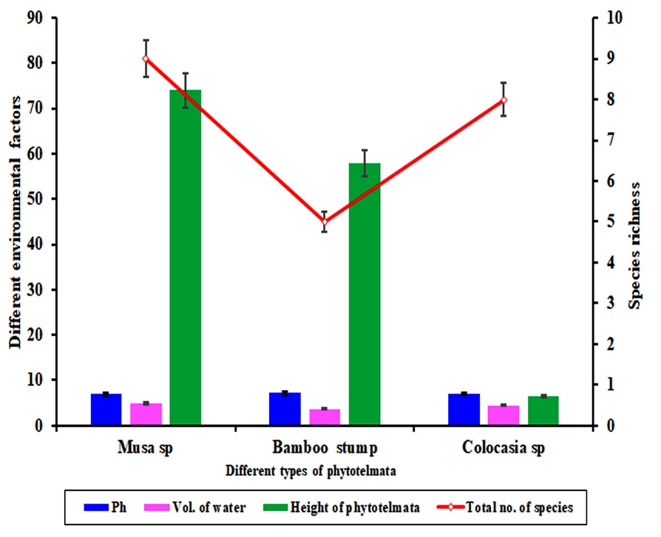

**Figure 4** Different types of phytotelmata. Effects of different environmental factors (bar graph and the left axis) Species richness (line graph and the right axis) of different types of phytotelmata. Error bars are standard errors (*p = .05*).

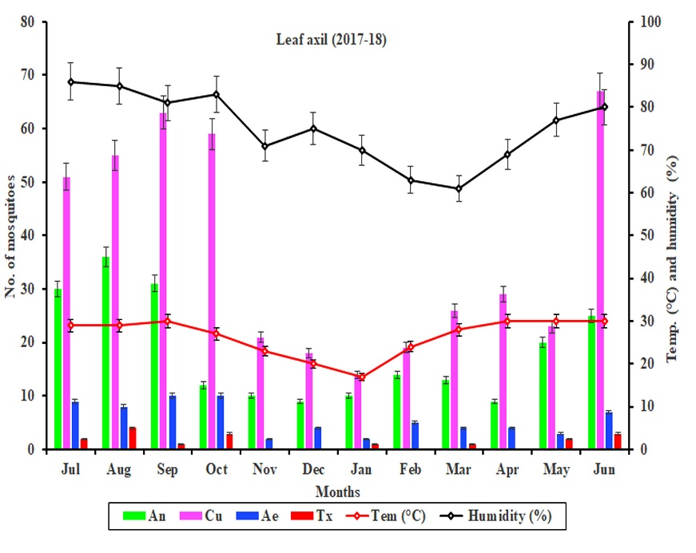

**Figure 5** Number of mosquitoes and environmental effects on Leaf axil (LA) in the year 2017-2018.The number of mosquitoes is plotted on the left axis (July to June) and different environmental factors (temperature and humidity) are plotted on the right axis of the plot. Error bars are standard errors (*p = .05*).

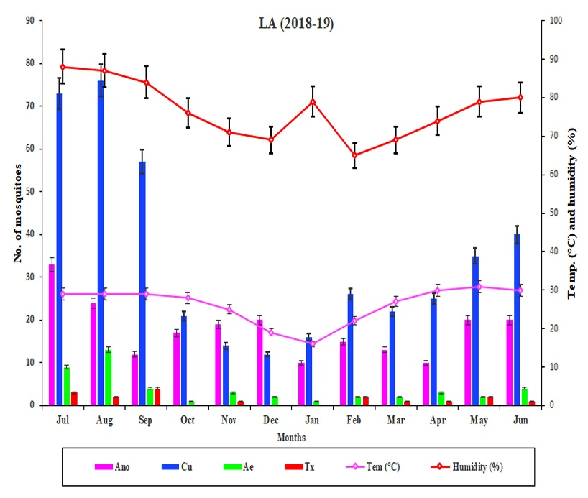

**Figure 6** Number of mosquitoes and environmental effects on Leaf axil (LA) in the year 2018-2019.The number of mosquitoes is plotted on the left axis (July to June) and different environmental factors (temperature and humidity) are plotted on the right axis of the plot. Error bars are standard errors (*p = .05*).

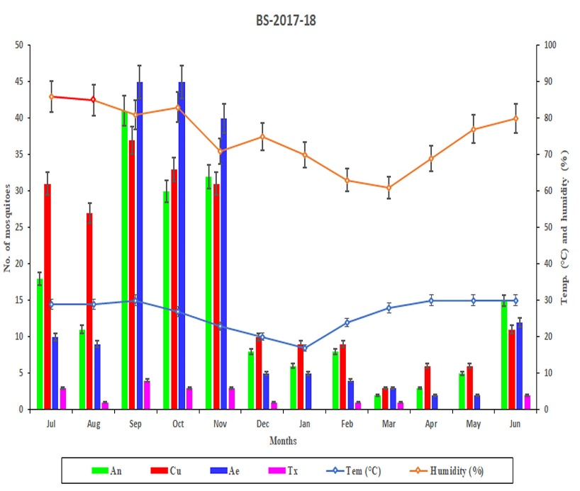

**Figure 7** Number of mosquitoes and environmental effects on Bamboo Stump (BS) in the year 2017-2018.The number of mosquitoes is plotted on the left axis (July to June) and different environmental factors (temperature and humidity) are plotted on the right axis of the plot. Error bars are standard errors (*p = .05*).

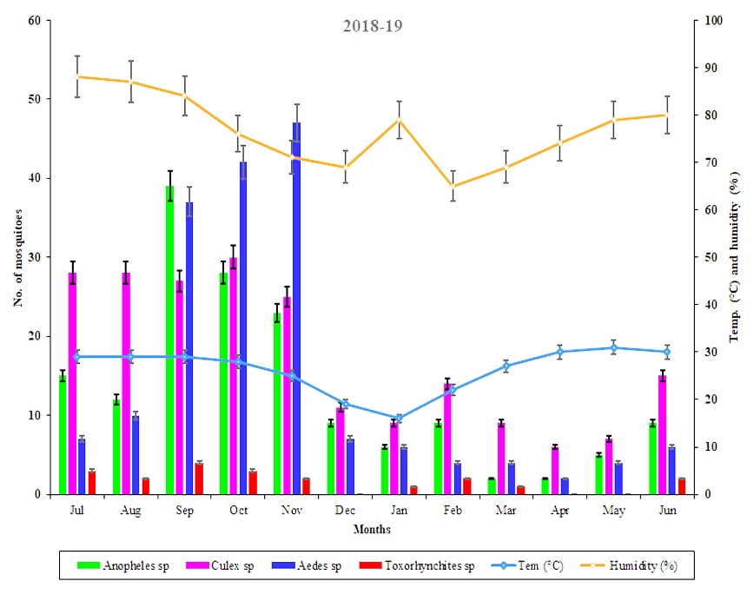

**Figure 8** Number of mosquitoes and environmental effects on Bamboo Stump (BS) in the year 2018-2019.The number of mosquitoes is plotted on the left axis (July to June) and different environmental factors (temperature and humidity) are plotted on the right axis of the plot. Error bars are standard errors (*p = .05*).

1. **Discussion**

The organisms which are found in different types of phytotelmata are mainly invertebrates. The species richness of different groups is greater in natural telmata than in artificial telmata. The species richness correlated with the amount of water and the stability of water in phytotelmata. It is assumed that the ability of water holding and stability in natural telmata is greater than in artificial telmata and is corroborated by some other research [20], but no such correlation is found with the height of phytotelmata from the ground. It is opposite the work by Majumder *et al.,* 2011 [17]. Different types of diseases spreading to mosquitoes are more abundant than other groups of organisms in all phytotelmata. Even mosquito is the only group where all the stages of the life cycle are available in phytotelmata [21]. The different life stages of mosquitoes are more available in artificial telmata than natural telmata, mosquitoes prefer to breed and nourish artificial telmata than natural telmata. The telmata in the bamboo stump are basic because of the low species richness in the artificial telmata and they release less CO2 [22].

The area of North 24-Parganas is more prone to malaria and dengue due to the availability of the artificial breeding grounds of the respective mosquito vectors [23]. The results of the present study stated that the artificial telmata is relatively preferred by the *Aedes* and *Anopheles* mosquitoes. It is found that most of the mosquito species are adapted to breed in less amount of water in artificial telmata. It is assumed that water stability is less in these types of telmata. The *Aedes* sp.and *Toxorhynchites* sp. arepreferred more height than another two mosquitoes as a breeding ground from ground level. The eggs of *Aedes* sp. mosquitoes which are already present in the artificial telmata remain alive and start their lifecycle again from the dormant stage in the presence of even a small quantity of water. So, the number of more harmful and disease-spreading vectors *Aedes* sp*.* comparatively more at these times.

Different types of mosquitoes are greater in number month of June to August. It is assumed that rainfall and humidity enhance mosquito flight activity. Rainfall also provides breeding sites for mosquito to lay their eggs Mosquitoes have high peaks at 84 % to 88% relative humidity. It is corroborated by the study of Selvan *et al*., 2016 [16]. The mosquito abundance in artificial telmata (extracted bamboo stump) is greater in the monsoon period. During this period more harmful diseases spreading mosquitoes *Aedes* and *Anopheles* were greater than other types of less harmful mosquitoes. Species diversity is very low in the overall studied telmata. The natural telmata are more diverse than artificial telmata due to the presence of different types of predatory organisms. These predatory organisms predate the egg, larva, and pupa of different types of mosquitoes and biologically control the mosquito vector.

1. **Conclusion**

The phytotelmata in the present study areas enhance the development and survivability of different types of organisms, especially disease-borne vector mosquitoes *viz., Aedes, Anopheles,* and*Culex*. The natural telmata (leaf-axil of *Colocasia,* and *Musa*) are very much restricted in some areas of the urban society, but artificial extracted bamboo stumps are frequented everywhere in the urban area as festive and construction structures. The eggs of the *Aedes* mosquitoes are adapted to live in the artificial telmata even in dry conditions also. As a result, the populations of the *Aedes* mosquitoes are significantly increased throughout the festive periods. It is also evident that the population of the *Aedes* and *Anopheles* are enormously greater in the post-monsoon period in the study areas probably due to the development of bamboo structures for festivals and building purposes.

**Reference**

1. Brown, R. and D. Fish. 1983. The psychological causality implicit in language. Cognition. 14: 237-273.
2. Greeney, H.F. 2001. The insects of plant-held waters: a review and bibliography. J. Trop. Ecol. 17: 241-260.
3. Kitching, R.L. 2001. Food webs in phytotelmata:“bottom-up” and “top-down” explanations for community structure. Annu. Rev. Entomol. 46: 729-760.
4. Maguire, B. 1971. Phytotelmata: biota and community structure determination in plant-held waters. Annual review of ecology and systematic. 439-464.
5. Richardson, B.A. 1999. The bromeliad microcosm and the assessment of faunal diversity in a Neotropical forest 1. Biotropica 31: 321-336.
6. Yule, C.M. and Y.H. Sen. 2004. Freshwater invertebrates of the Malaysian region. Academy of Sciences Malaysia.
7. Williams, D.D. 2006. The biology of temporary waters. Oxford University Press, USA.
8. Frank, J.H. and L.P. Lounibos. 1987. Phytotelmata: swamps or islands? Fla. Entomol. 14-20.
9. Yanovlak, S.P. 2001. The Macrofauna of Water‐filled Tree Holes on Barro Colorado Island, Panama 1. Biotropica 33: 110-120.
10. Barrera, R. 1996. Species concurrence and the structure of a community of aquatic insects in tree holes. J. Vector Ecol. 21: 66-80.
11. Sota, T., M. Mogi, and E.Hayamizu. 1994. Habitat stability and the larval mosquito community in tree holes and other containers on a temperate island. Researches on population ecology 36: 93-104.
12. Yanoviak, S.P. 1999. Community structure in water-filled tree holes of Panama: effects of hole height and size. Selbyana 106-115.
13. Das, K.A. and K.A. Nishadh, 2013. Tree hole aquatic habitat: a model for ecological experiments. Conserv. Sci. 1: 36-38.
14. Yee, D.A., D. Allgood, J.M. Kneitel, and K.A. Kuehn. 2012. Constitutive differences between natural and artificial container mosquito habitats: vector communities, resources, microorganisms, and habitat parameters. J. Med. Entomol. 49: 482-491.
15. Munirathinam, A., R. Krishnamoorthi, G. Baskaran, R. Govindarajan, A.Veerapathiran, A. Venkatesh, and B.K. Tyagi. 2015. Mosquito diversity in Keeriparai and Mundanthurai hill ranges of the Western Ghats, southern India. J. Threat. Taxa.7:7552-7556.
16. Selvan, P.S., A. Jebanesan, and D.Reetha. 2016. Entomofaunal diversity of tree hole mosquitoes in Western and Eastern Ghats hill ranges of Tamilnadu, India. Acta trop. 159: 69-82.
17. Majumder, J., Goswami, R and Agarwala, B. 2011. A preliminary study on the insect community of Phytotelmata: an ephemeral ecosystem in Tripura, Northeast India. NeBIO Vol. 2, No. 3, September 2011, 27 - 31
18. Bram, R.A. 1967. Classification of Culex subgenus Culex in the new world (Diptera: Culicidae). Proceedings of the United States National Museum.
19. Darsie, R.J., 1985. Mosquitoes of Argentina. Part I. Keys for identification of adult females and fourth stage larvae in English and Spanish (Diptera, Culicidae).
20. Albicócco, A.P., A.E. Carbajo, and D. Vezzani, 2011. Mosquito community structure in phytotelmata from a South American temperate wetland. J. Vector Ecol. 36: 437-446.
21. Rossi, G. C., &amp; Harbach, R.E, 2008. Phytotelmat0myia, a new neotropical subgenus of Culex (Diptera: Culicidae). Zootaxa, 1879(1), 1-17.
22. Bauer, U. and W. Federle, 2009. The insect-trapping rim of Nepenthes pitchers: surface structure and function. Plant signaling & behavior. 4:1019-1023.
23. Campos, R.E. and T.J. Zavortink. 2010. Description of the larva and pupa and redescription of the adults of Isostomyia paranensis (Brèthes)(Diptera: Culicidae). Zootaxa. 2689: 27-36.