***Original Research Article***

**Plankton diversity of Bornadi River Basin with special reference to Indo-Bhutan Landscape, BTR, Assam, India**

**Abstract**

The present study was conducted to assess the plankton diversity of the Bornadi River Basin with special reference to Indo-Bhutan Landscape, BTR, Assam, India. A total of 50 genera of planktons were found, out of which the phytoplankton populations comprised 31 genera while the zooplankton populations comprised 19 genera. The study revealed that the relative abundance of phytoplankton was predominated by Chlorophyta representing the highest proportion (65.9%), followed by Cyanophyta (17.4%) and Bacillariophyta (16.7%). Chlorophyta remained dominant seasonally (64.1–69.7%) and spatially (62.8–69.1%). The relative abundance of zooplankton was dominated by Copepoda representing the highest proportion (35.6%), followed by Rotifera (33.4%), Protozoa (19%), and Cladocera (11.9%). *Brachionus sp.* showed the highest abundance during pre-monsoon and monsoon, *Cyclops sp.* during retreating monsoon and winter. Site-specific abundance revealed that *Cyclops sp.* was most dominant in all sites. The study also revealed that seasonal variations significantly influenced the diversity, abundance, and community structure of zooplankton and phytoplankton, with the monsoon enhancing zooplankton diversity and winter encouraging phytoplankton proliferation.

**Keywords:** Plankton, diversity, abundance, chlorophyta, copepod, Bornadi River Basin.

**Introduction**

Plankton constitutes the microscopic components of aquatic ecosystems representing a highly sensitive floating community that is primarily affected by water pollution. Consequently, any adverse alterations in the aquatic ecosystem impact both the diversity and biomass of this community (Summarwar, 2012). It has an ecological importance being the fundamental link between food webs functioning as a measure of ecosystem fertility. It also represents the most sensitive constituent of the aquatic ecosystem, serving as an indicators of environmental disturbances (Carle, 1979). Plankton is categorized into phytoplankton (plant-like) and zooplankton (animal-like). Phytoplankton serves as a primary producer in aquatic ecosystems, playing a vital role in energy flow, material cycling as well as transfer (Song *et al.,* 2020; Zhao *et al.,* 2020). Zooplankton significantly influences the food chain, participating in the self-purification mechanisms of aquatic ecosystems and acting as a basic food source for fish as well as other invertebrates (Wetzel, 2001; Błędzki and Rybak, 2016; Sharma, 2020). Literature analyses indicate that, although several works on plankton diversity have been documented from various regions of India, there is limited research done in the freshwater bodies of Assam and Northeast India. This study aims to document the plankton diversity in the Bornadi River Basin in the Indo-Bhutan landscape in Assam, India.

**Materials and methods:**

***Study area***

The current study was carried out in the Bornadi River Basin in Indo Bhutan landscape. The Bornadi River basin, mastered by the river Bornadi, is one of the major northern tributary river basins of the Brahmaputra Valley in Assam, India (Baruah, 2015). The Bornadi River itself represents the present political boundary between the present Udalguri and Darrang districts (formerly Darrang District), the present Baksa district, and the northern part of Kamrup district. This river Bornadi or ‘Barnoi’ originates from the ‘Ranga Noi’ in the northern foothills of the Bhutan Himalaya at an altitude of 550m above the mean sea level and flows for about 205 km from north to south and meets the Brahmaputra at the place named “Rohinimukh” near North Guwahati (Sarma, 2008). Six representative sampling sites (S1, S2, S3, S4, S5, and S6) were selected considering the variability in microhabitat and hydrological characteristics of the Bornadi River Basin (**Fig.**1).

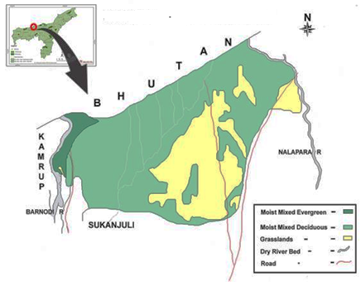

**Fig. 1:** Bornadi Wildlife Sanctuary, Assam showing the Bornadi River Basin

(Source: Assam Biodiversity Portal)

***Sample collection and analysis***

Water samples were collected in the early morning twice every month. Plankton samples were collected by filtering 100 liters of water through a 55 μm mesh bolting silk net (plankton net). Samples were collected and kept in a 5% formaldehyde solution within plastic sample vials. The sample was then centrifuged for 10 minutes at 10000 rpm after bringing the volume to 10 ml and the identification and further examination were done as per Trivedy & Goel (1986) and APHA (2012). Plankton identification and counting were performed using a binocular light microscope at the requisite magnifications of 10X initially, followed by 40X. The phytoplankton was categorized to the genus level following Bellinger and Sigee (2010), Brook (1959), Kimor and Pollingher (1965), Stansbery (1971), Vinyard (1975), Weber (1971), Dillard (1989), etc. The zooplankton was categorized to the genus level based on the works of Edmandson (1966), Ruttner-Kolisko (1974), Pennak (1978), Battish (1992), Michael and Sharma (1998), Sharma (1998), Kar and Barbhuiya (2002, 2004), Goswami (2004), Sharma and Sharma (2008), Munshi *et al.* (2010), Das and Kar (2013), etc. The quantitative examination of plankton (u.l-1) was conducted by extracting 1 ml of well-mixed preserved samples with a wide-mouthed graduated pipette, which was subsequently transferred into a Sedgwick Rafter cell and inspected under a stereoscopic microscope.

***Statistical analysis***

The following formula was used to calculate the relative abundance (% of catch) and species diversity across six distinct sample stations:

Number of samples of a specific fish species X 100

**RA** =

Total number of samples

**Shannon-Wiener (H’) Index** (Shannon & Weaver, 1949) = – Σ Pi In Pi

where Pi is defined as S divided by N.

S represents the count of individuals belonging to a specific species.  
 N represents the total count of all individuals within the sample.   
 ln represents the logarithm with base e.

**Pielou’s Evenness Index (J)** (Pielou, 1966) = H / In S.

where H represents the Shannon-Wiener diversity index.

S represents the total count of species present in the sample.

***Simpson's index of dominance*** D (Gini, 1912; Simpson, 1949; Herfindahl, 1950; Hirschman, 1964)= ∑(nᵢ/N) ² or D= (Σ n (n - 1) **/** N (N - 1))

where nᵢ is the number of individuals of species 'i', and

N is the total number of individuals in the community.

***Simpson index of diversity*** **(1-D)** = 1 - (Σ n (n - 1) **/** N (N - 1))

where n represents the number of individuals of each species

N is the total number of individuals in the sample.

MS Excel software, MEGA, and Bio Diversity Pro program were used to compute the statistical analysis for distribution, species diversity, abundance, rarefaction curves, species distribution plots, and abundance plots (rank) distributions for the species in the Bornadi river basin.

**Results**

A total of 50 genera of planktons were recorded in the Bornadi River Basin of which 31 genera belonged to the phytoplankton while the other 19 genera comprised the zooplankton. Among the 31 genera, three major groups of phytoplankton namely Bacillariophyta, Chlorophyta, and Cyanophyta, consisting of 25 families, and 18 orders were recorded. Chlorophyta had the highest diversity comprising 17 genera, which account for 54.84% of the total genera. This was followed by Bacillariophyta with 8 genera contributing 25.81% while Cyanophyta with 6 genera contributing 19.35% of the total genera. The overall relative abundance of phytoplankton in the Bornadi River Basin was predominated by Chlorophyta representing the highest proportion of 65.9%, followed by Cyanophyta (17.4%) and Bacillariophyta (16.7%). The seasonal abundance of phytoplankton was primarily dominated by Chlorophyta (64.1-69.7%) while second rank was occupied by Bacillariophyta during monsoon (17.1%) and Cyanophyta during pre-monsoon (18.4%), retreating monsoon (18.4%) and winter (19.2%) (**Fig.**2). Regarding the seasonal abundance at the generic level, *Closterium sp.* showed the highest abundance (10.4%) during monsoon, *Chlamydomonas sp.* (9.4%) during pre-monsoon, *Spirogyra sp.* (8.0%) during retreating monsoon and *Microspora sp.* (7.0%)during winter. The abundance of phytoplankton throughout all sites showed a clear dominance of Chlorophyta, accounting for 62.8-69.1%. This was followed by Bacillariophyta (16.7-18.7%) in S1, S2, and S3, and Cyanophyta (19.3-21.4%) in S4, S5 and S6. Again, Cyanophyta ranked the lowest group in S1, S2, and S3 (13.2-16.8%), while Bacillariophyta in S4, S5, and S6 (15.3-15.8%) (**Fig.** 2). Site-specific abundance also revealed that *Gonatozygon sp.* was most prevalent in S1 (8.5%), *Chlamydomonas sp.* in S2 (8.6%) and S4 (7.7%), *Microspora sp.* in S3 (7.5%) and *Closterium sp.* in S5 (8.1%) and S6 (7.8%).

Fig. 2: Seasonal and spatial variations of different groups of phytoplankton in the Bornadi River Basin

The rarefaction curve shows the maximum species richness in winter followed by retreating monsoon, pre-monsoon, and monsoon (**Fig.**3).

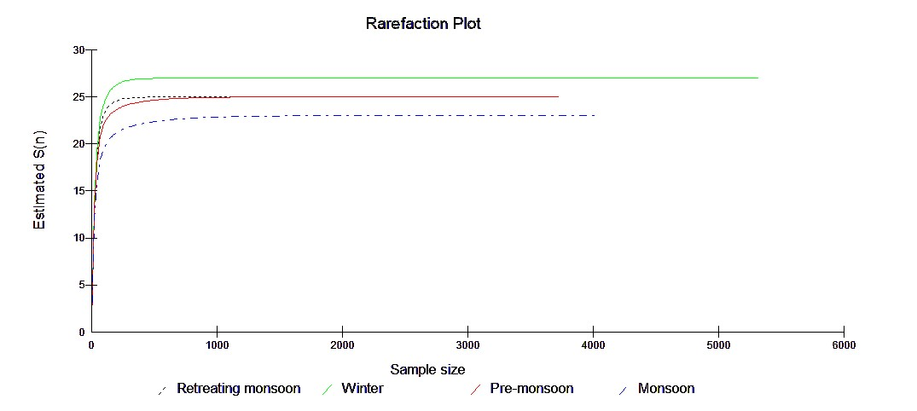

Fig. 3: Season-wise rarefaction curves of phytoplankton in the Bornadi River Basin

The phytoplankton community revealed wide variation in distribution during all the seasons (**Fig**.4). The scatter plot represents the species distribution of phytoplankton across different seasons, showing the relationship between mean abundance and variance on a logarithmic scale, suggests that species abundance varies over multiple orders of magnitude. The higher variance at higher mean values could be due to seasonal blooms, where phytoplankton populations experience rapid growth and decline, especially in response to nutrient availability, light intensity, and temperature changes. Lower mean values with low variance might correspond to the monsoon season when phytoplankton was present in smaller but more stable numbers.

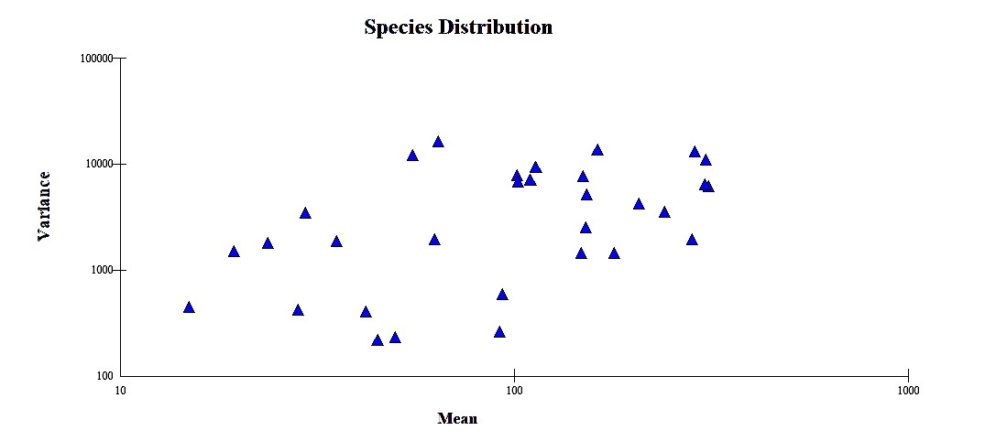

Fig. 4: Species distribution plot for phytoplankton community in the Bornadi River Basin

The study also documented four major groups of zooplankton viz. Cladocera, Copepoda, Protozoa, and Rotifera comprise 19 genera, belonging to 15 families and 6 orders. Cladocera had the highest diversity comprising 7 genera, which accounted for 36.84% of the total genera. This was followed by Rotifera with 5 genera, contributing 26.32%, Copepoda with 4 genera contributing 21.05%, and Protozoa with 3 genera contributing 15.79%. The overall relative abundance of zooplankton in the Bornadi River Basin was dominated by Copepoda representing the highest proportion of 35.6%, followed by Rotifera (33.4%), Protozoa (19.0%) and Cladocera (11.9%). The seasonal abundance of zooplankton was primarily dominated by Copepoda (36.4-39.1%) except in monsoon which was dominated by Rotifera with 36.1%. This was followed by Rotifera (31.7- 33.6%) except in monsoon by Copepoda (30.1%), Protozoa (17.8- 21.8%) and Cladocera (10.1-12.7%) (**Fig**. 5). Regarding the seasonal abundance at generic level, *Brachionus sp.* showed the highest abundance (21.7%) during pre-monsoon and monsoon (14.5%), *Cyclops sp.* during retreating monsoon (14.8%) and winter (17.4%). The abundance of zooplankton throughout all sites showed a clear dominance of Copepoda accounting for 35.1-37.3% except in S3 where Rotifera had the highest relative abundance of 35.1%. This was followed by Rotifera (26.8-32.4%) except Copepoda in S3 with 33.4%, protozoa (17.1-21.9%) and Cladocera (9.1-15.7%) (**Fig**. 5). Site-specific abundance revealed that *Cyclops sp.* was most prevalent in S1 (13.3%), S2 (13.9%), S3 (11.3%) and S4 (12.2%), S5 (13%) and S6 (12.6%).

Fig.5. Seasonal and spatial variations of different groups of zooplankton in the Bornadi River Basin

The rarefaction curve shows the maximum species richness in monsoon and pre-monsoon followed by retreating monsoon and winter (**Fig**. 6).

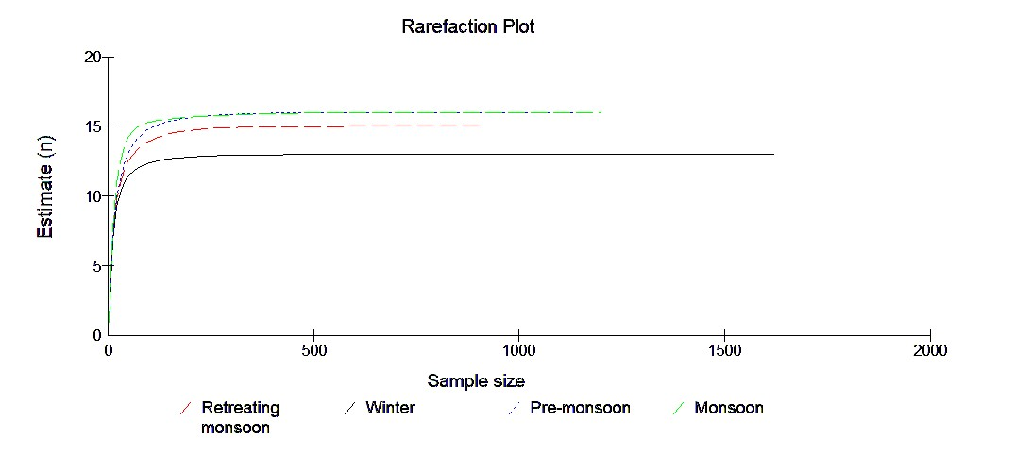

Fig. 6: Season-wise rarefaction curves of zooplankton in the Bornadi River Basin

The distribution of zooplankton revealed wide variation in distribution pattern during all the seasons (**Fig.**7). The scatter plot represents the zooplankton distribution across different seasons showing the relationship between the mean and variance of species on a logarithmic scale indicating a broad range of values for mean abundance and variance. The data points form a trend rather than being randomly scattered, suggesting that different species had varying seasonal abundance patterns. Some species exhibited low mean abundance with low variance, while others showed high mean abundance with high variance. Higher variance at higher mean values further suggests that in peak seasons (namely monsoon), zooplankton populations fluctuate more significantly.

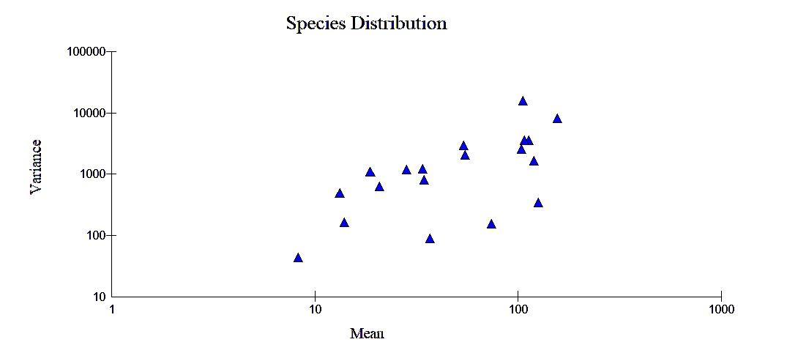

Fig. 7: Species distribution plot for the zooplankton community in the Bornadi River Basin

The study exhibited a higher number of phytoplankton (5321) and the highest species richness (27) in winter suggesting peak production of phytoplankton possibly due to stable conditions and nutrient availability. Monsoon had the lowest species richness (23), likely due to environmental stressors namely heavy rainfall and water turbulence. Monsoon had the lowest evenness (J’ = 0.908), indicating dominance by a few species. Winter had the lowest dominance (D = 0.047) and highest diversity (1-D = 0.953), suggesting a stable ecosystem. Monsoon had the highest dominance (D = 0.067), showing certain species dominance. For zooplankton, winter had the highest number of individuals (518) but the lowest species richness (13) indicating the dominance of few species. Pre-monsoon and monsoon had the highest species richness (16) likely due to nutrient influx. Monsoon had the highest diversity (H’ = 2.62) suggesting a more balanced community, while winter had the lowest diversity (H’ = 2.38) indicating species dominance. Monsoon had the highest evenness (J’ = 0.95) because species were more equally distributed, whereas pre-monsoon had the lowest evenness (J’ = 0.89) indicating the dominance of some species. Monsoon had the lowest dominance (D = 0.079) and highest diversity (1-D = 0.921) indicating a uniform distribution pattern. Pre-monsoon had the highest dominance (D = 0.105) indicating dominance of fewer species.

**Discussion**

The phytoplankton diversity in the Bornadi River Basin was dominated by Chlorophyta, which comprises 17 genera (54.84%) and accounted for the highest relative abundance (65.9%). Chlorophyta remained dominant seasonally (64.1–69.7%) and spatially (62.8–69.1%). Similar findings were also documented in the studies conducted in the River Cauvery (Annalakshmi and Amsath, 2012), in Pagladia River of Assam (Das, 2013), in the upper reaches of the Brahmaputra in Assam (Baishya, 2021), in Mula River of Western Ghats (Thippeswamy, 2024) and in Ganga River at Prayagraj (Kumar *et al.*, 2025). Among zooplankton, in terms of relative abundance, Copepoda was dominant (35.6%) followed by Rotifera (33.4%), Protozoa (19%), and Cladocera (11.9%). Seasonally, Copepoda also remained the dominant group (36.4–39.1%) except in the monsoon, where Rotifera was dominant (36.1%). Similarly site-wise, Copepoda was dominant in most of the sites (35.1–37.3%), except in S3, where Rotifera was the most abundant (35.1%). Regarding the seasonal abundance at the generic level, *Brachionus sp.* showed the highest abundance (21.7%) during pre-monsoon and monsoon (14.5%), *Cyclops sp.* during retreating monsoon (14.8%) and winter (17.4%). Site-specific abundance revealed that *Cyclops sp.* was most prevalent in S1 (13.3%), S2 (13.9%), S3 (11.3%), and S4 (12.2%), S5 (13%) and S6 (12.6%). Copepods and Rotifers were recognized as the dominant taxa in the research conducted by Maruthanayagam et al. (2003) in Thirukkulam pond (Tamil Nadu), Bhandarkar and Paliwal (2010) in Lakhani (Maharashtra), Yalavigi (2015) in Chikodi (Halatti) Tank (Karnataka), and Yannawar *et al.* (2022) in the Godavari River (Maharashtra).

The results indicated seasonal variations in zooplankton and phytoplankton communities possibly due to the influence of environmental factors such as nutrient availability, water turbulence, and stability. For phytoplankton, winter supports the highest diversity and abundance, likely due to stable environmental conditions and sufficient nutrient availability. Monsoon, however, experiences reduced species richness and evenness, possibly due to environmental stressors such as heavy rainfall and increased water turbulence, which may disrupt phytoplankton communities. The lower dominance in winter suggests a more stable ecosystem, whereas the higher dominance in monsoon reflects the prevalence of a few species better adapted to changing conditions. The dominance of a few zooplankton species in winter, despite the highest abundance, suggests that only certain species thrive under cold conditions. In contrast, the monsoon season supports higher diversity and evenness due to favorable environmental conditions, such as nutrient influx and increased water mixing. Overall, seasonal changes play a crucial role in shaping zooplankton and phytoplankton diversity, abundance, and community structure, with monsoons promoting higher zooplankton diversity and winter favoring phytoplankton growth.

**Conclusion**

The current study demonstrated that the Bornadi River Basin had elevated biological productivity, characterized by a higher population density of plankton. This study establishes a framework for future research on the abundance, composition, and distribution of phytoplankton and zooplankton in the Bornadi River Basin.

**References**

Annalakshmi, G., & Amsath, A. (2012). Studies on the hydrobiology of river Cauvery and its tributaries Arasalar from Kumbakonam region (Tamil Nadu, India) with reference to phytoplankton. *International Journal of Plant, Animal and Environmental Sciences, 2*, 37–46.

APHA. (2012). Standard methods for the examination of water and wastewater (21st ed.). American Public Health Association, American Water Works Association & Water Environment Federation, New York.

Baishya, R. A. (2021). Fish faunal diversity in upper reaches of the river Brahmaputra, Assam, India and biology ofSystomus sarana (Hamilton).PhD Thesis. Gauhati University, Assam.

Baruah, D. (2015). Water resource potentiality and its domestic utilization in the fluvio-geomorphological environment of Barnadi River Basin in Assam. Ph.D. Thesis. Gauhati University, Assam.

Battish, S. K. (1992). Freshwater zooplankton of India. Oxford & IBH Publishing Co., Ltd., New Delhi, India.

Bellinger, E. G., & Sigee, D. C. (2010). Freshwater algae identification and use as bioindicators. Wiley-Blackwell.

Bhandarkar, S., & Paliwal, G. T. (2010). On some copepods from Lakhani, Maharashtra. Environment Conservation Journal*, 11*(3), 81–83. https://doi.org/10.36953/ECJ.2010.110315

Błędzki, L. A., & Rybak, J. I. (2016). Freshwater crustacean zooplankton of Europe: Cladocera & Copepoda (Calanoida, Cyclopoida) key to species identification, with notes on ecology, distribution, methods and introduction to data analysis. *Springer*, Cham, Switzerland.

Brook, A. J. (1959). The status of desmids in the plankton and the determination of phytoplankton quotients. The Journal of Ecology*, 47*, 429–445.

Carle, F. L. (1979). Environmental monitoring potential of the Odonata with a list of rare and endangered Anisoptera of Virginia, United States. Odonatologica*, 8*, 319–323.

Das, H. 2013. Ecology of Pagladia River of Assam with special reference to its fisheries*.* Ph.D. Thesis, Gauhati University, Assam.

Das, U., & Kar, D. (2013). A comparative study on qualitative and quantitative analysis of zooplankton in relationship with physico-chemical properties of water between Karbala Lake and Baram Baba Pond of Cachar District, Assam. International Journal of Current Research, 5, 3038–3041.

Dillard, G. E. (1989). Freshwater algae of the Southeastern United States. Western Kentucky University, USA.

Edmandson, W. T. (1966). Freshwater biology (2nd ed.). John Wiley & Sons, New York.

Gini, C. (1912). Variabilita e mutabilita. Studi econ. Giur. Fac. Giurisp. Univ. Cagliari.

Goswami, S. C. (2004). Zooplankton methodology: Collection and identification – A field manual. National Institute of Oceanography.

Herfindahl, O. (1950).Concentration in the US steel industry. Unpublished Doctoral Dissertation, Columbia University.

Hirschman, A. O. (1964). The paternity of an index. The Amrican Economic Review. 54(5), 761-762.

Kar, D., & Barbhuiya, M. H. (2002). An account of zooplankton of Chatla Haor wetland, a floodplain wetand in Cachar district of Assam. Environment and Ecology, 22(1), 247-248.

Kimor, B., & Pollingher, U. (1965). The plankton algae of Lake Tiberias. Ministry of Agriculture: Department of Fisheries, Sea Fisheries Research Station, Haifa, 76.

Kumar, J., Patel, A., Alam, A., Kumar, V., Thakur, V., Jha, D., Mishra, S., Verma, R., Verma, S., & Das, B. (2025). Diel variation of phytoplankton community influence under varying water quality in the Ganga River at Prayagraj, India. Authorea.

Maruthanayagam, C., Sasikumar, M., & Senthilkumar, C. (2003). Studies on zooplankton population in Thirukkulam pond during summer and rainy seasons. Nature, Environment and Pollution Technology, 2(1), 13–19.

Michael, R. G., & Sharma, B. K. (1988). Indian Cladocera: Fauna of India and adjacent countries series. Zoological Survey of India, Calcutta.

Munshi, J. D., Roy, S. P., & Munshi, J. S. (2010). Manual of freshwater biota. Narendra Publishing House, Delhi, India.

Pennak, R. W. (1978). Freshwater invertebrates of the United States (2nd ed.). John Wiley & Sons, New York.

Pielou, E. C. (1966). The Measurement of diversity in different types of biological collections. Journal of Theoretical Biology, 13, 131-144.

Ruttner-Kolisko, A. (1974). Planktonic rotifers: Biology and taxonomy. Binnengewässer Supplement, 26, 146.

Sarma, J. N. (2008). Asamar Nad-Nadi. Assam Sahitya Sabha, Kiran Prakashan, Dhemaji (Assam).

Shanon, C. E., & Weaver, W. (1949).The mathematical theory of communication. University of Illinois Press.

Sharma R. C. Habitat ecology and diversity of freshwater zooplankton of Uttarakhand Himalaya, India. Biodiversity International Journal. 2020; 5:188–196.

Sharma, B. K. (1998). Freshwater rotifers (Rotifera: Eurotatoria). Fauna of West Bengal, State Fauna Series, 3(11), 341–461.

Sharma, S., & Sharma, B. K. (2008). Zooplankton diversity in floodplain lakes of Assam. Records of the Zoological Survey of India, Occasional Paper No. 290.

Simpson, E. H. (1949). Measurement of diversity. 163, 688. https://doi.org/10.1038/163688a0.

Song, J., Hou, C., Liu, Q., Wu, X., Wang, Y., & Yi, Y. (2020). Spatial and temporal variations in the plankton community because of water and sediment regulation in the lower reaches of the Yellow River. Journal of Cleaner Production, 261, 120972. https://doi.org/10.1016/j.jclepro.2020.120972

Stansbery, D. H. (1971). The distribution of algae by division, classes, and order. Ohio State University.

Summarwar, S. (2012). Studies on plankton diversity in Bisalpur Reservoir. International Journal of Life Sciences, Biotechnology & Pharmaceutical Research, 1(4), 1–8.

Thippeswamy, S. (2024). Biodiversity of the Western Ghats and Sri Lanka. In T. Pullaiah (Ed.), Apple Academic Press (pp. 319–341).

Trivedy, R. K., & Goel, P. K. (1986). Chemical and biological methods for water pollution studies. Environmental Publications, Karad, p. 250.

Vinyard, W. C. (1975). A key to the genera of marine planktonic diatoms of the Pacific coast of North America. Western Kentucky University, USA, 26.

Weber, C. I. (1971). A guide to the common diatoms at water pollution surveillance system: Analytical quality control. U.S. Environmental Protection Agency. Cincinnati, Ohio

Wetzel, R. G. (2001). Limnology: Lake and river ecosystems (3rd ed.). Academic Press, San Diego.

Yalavigi, Y. H. (2015). Study of zooplankton diversity and density in Chikodi (Halatti) tank. International Journal of Recent Scientific Research, 6, 7802–7806.

Yannawar, V. B. (2022). Identification of freshwater zooplankton in Godavari River concerning the food chain in the aquatic ecosystem of Nanded, Maharashtra, India. International Journal of Agricultural and Natural Sciences, 15(1). Retrieved from https://www.ijans.org/index.php/ijans/article/view/545

Zhao, G., Pan, B., Li, Y., Zheng, X., Zhu, P., Zhang, L., & He, H. (2020). Phytoplankton in the heavy sediment-laden Weihe River and its tributaries from the northern foot of the Qinling Mountains: Community structure and environmental drivers. Environmental Science and Pollution Research, 27, 8359–8370. https://doi.org/10.1007/s11356-019-07346-6

Table 1: Phytoplankton diversity in the study sites of Bornadi River Basin with overall relative abundance.

|  |  |  |  |  |
| --- | --- | --- | --- | --- |
| **Group** | **Order** | **Family** | **Genus** | **Relative abundance** |
| **Bacillariophyta** | Fragilariales | Fragilariaceae | *Diatoma* J.B.M. Bory de Saint-Vincent, 1824 | 0.4 |
| Naviculales | Amphipleuraceae | *Frustulia* L. Rabenhorst, 1853 | 1.1 |
| Cymbellales | Gomphonemataceae | *Gomphonema* C.G. Ehrenberg, 1832 | 3.7 |
| Naviculales | Pleurosigmataceae | *Gyrosigma* A.H. Hassall, 1845 | 1.3 |
| Naviculales | Naviculaceae | *Navicula* J.B.M. Bory de Saint-Vincent, 1822 | 6.1 |
| Surirellales | Surirellaceae | *Surirella* P.J.F. Turpin, 1828 | 1.1 |
| Fragilariales | Fragilariaceae | *Synedra* C.G. Ehrenberg, 1830 | 2.4 |
| Tabellariales | Tabellariaceae | *Tabellaria* C.G. Ehrenberg ex F.T. Kützing, 1844 | 0.7 |
| **Chlorophyta** | Cladophorales | Cladophoraceae | *Chaetomorpha* Kützing, 1845 | 0.5 |
| Chaetophorales | Chaetophoraceae | *Chaetophora* F.Schrank, 1783 | 0.9 |
| Cladophorales | Cladophoraceae | *Cladophora* Kützing, 1843 | 2.9 |
| Chlamydomonadales | Chlamydomonadaceae | *Chlamydomonas* Ehrenberg, 1833 | 7.9 |
| Desmidiales | Closteriaceae | *Closterium* Nitzsch ex Ralfs, 1848 | 7.7 |
| Desmidiales | Desmidiaceae | *Desmidium* C.Agardh ex Ralfs, 1848 | 3.8 |
| Desmidiales | Desmidiaceae | *Docidium* Brébisson ex Ralfs, 1848 | 1.6 |
| Chlamydomonadales | Volvocaceae | *Eudorina* Ehrenberg, 1832 | 2.8 |
| Desmidiales | Gonatozygaceae | *Gonatozygon* De Bary, 1856 | 7.7 |
| Sphaeropleales | Hydrodictyaceae | *Hydrodictyon* Roth, 1797, nom. cons. | 2.6 |
| Ulotrichales | Microsporaceae | *Microspora* Thuret, 1850, nom. Cons | 7.2 |
| Microthamniales | Microthamniaceae | *Microthamnion* Nägeli, 1849 | 2.6 |
| Oedogoniales | Oedogoniaceae | *Oedogonium* Link ex Hirn, 1900 | 1.4 |
| Chlamydomonadales | Volvocaceae | *Pandorina* Bory, 1826 | 0.7 |
| Cladophorales | Cladophoraceae | *Rhizoclonium* Kützing, 1843 | 4.1 |
| Spirogyrales | Spirogyraceae | *Spirogyra* Link, 1820, nom. cons. | 7.1 |
| Chlamydomonadales | Volvocaceae | *Volvox* Linnaeus, 1758 | 4.5 |
| **Cyanophyta** | Nostocales | Aphanizomenonaceae | *Anabaena* Bory de Saint-Vincent ex Bornet & Flahault, 1886 | 3.9 |
| Chroococcales | Microcystaceae | *Microcystis* Lemmermann, 1907, nom. et typ. cons. | 3.8 |
| Nostocales | Nostocaceae | *Nostoc* Vaucher ex Bornet & Flahault, 1886 | 5.2 |
| Oscillatoriales | Oscillatoriaceae | *Oscillatoria* Vaucher ex Gomont, 1892 | 2.3 |
| Nostocales | Rivulariaceae | *Rivularia* C.Agardh ex Bornet & Flahault, 1886, nom. Cons | 0.6 |
| Spirulinales | Spirulinaceae | *Spirulina* Turpin ex Gomont, 1892 | 1.6 |

Table 2: Zooplankton diversity in the study sites of Bornadi River Basin with overall relative abundance.

|  |  |  |  |  |
| --- | --- | --- | --- | --- |
| **Group** | **Order** | **Family** | **Genus** | **Relative abundance** |
| Cladocera | Anomopoda | Chydoridae | *Alona* Baird, 1843 | 2.8 |
| Anomopoda | Bosminidae | *Bosmina* Baird, 1845 | 1.1 |
| Anomopoda | Daphniidae | *Ceriodaphnia* Dana, 1853 | 3.0 |
| Anomopoda | Daphniidae | *Daphnia* O.F. Müller, 1785 | 0.7 |
| Anomopoda | Chydoridae | *Leydigia*Kurz, 1875 | 1.5 |
| Anomopoda | Macrothricidae | *Macrothrix* Baird, 1843 | 1.1 |
| Anomopoda | Moinidae | *Moina* Baird, 1850 | 1.7 |
| Copepoda | Cyclopoida | Cyclopidae | *Cyclops* O. F. Müller, 1785 | 12.7 |
| Calanoida | Diaptomidae | *Diaptomus* Westwood, 1836 | 2.8 |
| Cyclopoida | Cyclopidae | *Mesocyclops* Sars G.O., 1914 | 10.3 |
| -- | -- | *Naupilus* O. F. Müller, 1785 | 9.8 |
| Protozoa | Arcellinida | Arcellidae | *Arcella* Ehrenberg (1832) | 8.5 |
| Arcellinida | Centropyxidae | *Centropyxis* Stein, 1857 | 6.1 |
| Arcellinida | Difflugiidae | *Difflugia* Leclerc, 1815 | 4.5 |
| Rotifera | Ploima | Brachionidae | *Brachionus* Pallas, 1766 | 8.7 |
| Flosculariaceae | Trochosphaeridae | *Filinia* Bory de St. Vincent, 1824 | 2.3 |
| Ploima | Brachionidae | *Keratella* Bory de St. Vincent, 1822 | 4.4 |
| Ploima | Lepadellidae | *Lepadella* Bory de St. Vincent, 1822 | 9.2 |
| Ploima | Lecanidae | *Lecane* Nitzsch, 1827 | 8.8 |

**Table 3**: Seasonal variation of different index values

|  |  |  |  |  |  |  |
| --- | --- | --- | --- | --- | --- | --- |
| Seasons | Total Individuals | Total Species | Shannon H' | Pielou’s Evenness (J) | Simpsons Index of Dominance (D) | Simpsons Index of Diversity (1-D) |
| Phytoplankton | | | | | | |
| Retreating Monsoon | 2790 | 25 | 3.077 | 0.956 | 0.051 | 0.949 |
| Winter | 5321 | 27 | 3.146 | 0.954 | 0.047 | 0.953 |
| Pre-monsoon | 3739 | 25 | 3.028 | 0.941 | 0.054 | 0.946 |
| Monsoon | 4026 | 23 | 2.849 | 0.908 | 0.067 | 0.933 |
| Zooplankton | | | | | | |
| Retreating Monsoon | 296 | 15 | 2.48 | 0.92 | 0.092 | 0.908 |
| Winter | 518 | 13 | 2.38 | 0.93 | 0.102 | 0.898 |
| Pre-monsoon | 404 | 16 | 2.46 | 0.89 | 0.105 | 0.895 |
| Monsoon | 443 | 16 | 2.62 | 0.95 | 0.079 | 0.921 |