***Original Research Article***

**HISTOPATHOLOGICAL CHANGES IN KIDNEY OF FISH *CLARIAS GARIPINUS* EXPOSED TO CYPERMETHRIN (25% EC)”**

**Abstract**

Pesticide contamination poses a significant threat to aquatic ecosystems, with cypermethrin, a widely used synthetic pyrethroid, raising concerns due to its toxic effects on non-target organisms. This study investigates the histopathological alterations in the kidneys of *Clarias gariepinus* following exposure to sub-lethal concentrations of cypermethrin (25% EC). Healthy fish were acclimatized and subjected to a static renewal bioassay to determine the 96-hour LC50 value, recorded at 0.273 ± 0.007 µL/L. Specimens were then exposed to 1/5th of the LC50 concentration for 14 days, after which renal tissues were examined microscopically. Histopathological analysis revealed significant renal damage, including glomerular shrinkage, widening of Bowman’s space, tubular degeneration, nuclear pyknosis, karyolysis, and cytoplasmic vacuolation. Additionally, hydropic swelling and interstitial tissue disintegration indicated severe nephrotoxic stress. These findings suggest that cypermethrin exposure compromises kidney function in *C. gariepinus*, potentially impairing osmoregulation and excretion. The observed renal damage underscores the ecological risks associated with cypermethrin contamination in freshwater bodies, highlighting the urgent need for stricter pesticide regulation and environmental monitoring. This study provides crucial insights into pesticide-induced nephrotoxicity in fish, reinforcing the importance of sustainable agricultural practices to mitigate aquatic pollution.

**Keywords:** Cypermethrin toxicity, *Clarias gariepinus*, histopathology, nephrotoxicity, aquatic pollution

**Introduction**

Aquatic ecosystems are highly susceptible to contamination by agrochemicals, particularly pesticides, which pose serious threats to aquatic organisms. Pesticides enter water bodies primarily through surface runoff, leading to ecosystem degradation and increased disease prevalence in aquatic life. These toxic substances can sorb onto suspended particles and accumulate in sedimentary layers, disrupting the aquatic food web and deteriorating water quality. Exposure to pesticide residues has been associated with elevated levels of ammonium, nitrite, nitrate, and sulfate in aquatic systems, posing significant risks to both ecological integrity and human health [1-3].

Pesticides can profoundly impact aquatic food webs through various mechanisms. For instance, neonicotinoid insecticides have been shown to disrupt aquatic ecosystems, causing declines in zooplankton populations and, consequently, reductions in fishery yields [3]. Furthermore, pesticide accumulation in aquatic environments can lead to biomagnification, wherein the concentration of these toxic substances increases progressively up the food chain. This process results in heightened toxicity levels in predatory species, including fish consumed by humans, thereby extending the adverse effects of pesticide contamination beyond the immediate aquatic ecosystem [4].

The pervasive presence of pesticides in aquatic ecosystems underscores the urgent need for effective management strategies to mitigate their impact on biodiversity and water quality. Implementing bioremediation techniques and promoting sustainable agricultural practices are crucial steps toward reducing pesticide pollution in these environments [5]. Among these pesticides, cypermethrin, a synthetic pyrethroid insecticide, is widely used in agriculture and pest control due to its high efficacy and relatively low environmental persistence [6]. However, its extensive application has raised concerns regarding its toxic effects on non-target aquatic species, particularly fish, which serve as key bioindicators of environmental pollution [7].

Fish kidneys play a crucial role in osmoregulation and excretion, making them particularly vulnerable to toxicants in contaminated water bodies [8]. Exposure to cypermethrin has been linked to significant histopathological alterations in renal tissues, impairing kidney function and compromising overall fish health and survival [9-11]. Previous studies have documented various pathological changes in fish kidneys following cypermethrin exposure, including degeneration of renal tubules, glomerular atrophy, and increased vacuolation in kidney tissues [8], [12].

*Clarias gariepinus*, commonly known as the African catfish, is a widely distributed freshwater species of significant ecological and economic importance. Due to its broad habitat range, it is frequently exposed to environmental pollutants, including pesticides. Investigating histopathological changes in the kidneys of *C. gariepinus* following cypermethrin exposure provides crucial insights into the sub-lethal effects of this pesticide on aquatic organisms, contributing to environmental risk assessments and pollution mitigation strategies [13], [7]. Histopathological alterations in *C. gariepinus* have been reported in response to various environmental stressors, including exposure to *Melaleuca cajuputi* extract [14], pesticide contamination [15] and organophosphate pesticides [16].

The present study aims to evaluate the histopathological alterations in the kidneys of *C. gariepinus* exposed to cypermethrin (25% EC). By assessing the extent of renal damage, this research seeks to enhance understanding of cypermethrin-induced toxicity in freshwater fish, providing valuable information for the regulation and management of pesticide pollution in aquatic environments.

**Materials and Methods**

**Experimental Fish and Acclimatization**

Healthy specimens of *Clarias gariepinus*, with an average weight of 100 ± 10 g and a length of 15 ± 2 cm, were collected from local freshwater bodies and acclimatized to laboratory conditions for two weeks. The fish were maintained in aerated tanks with dechlorinated tap water at a temperature of 25 ± 2°C, dissolved oxygen of 6.5 ± 0.5 mg/L, and a pH of 7.2 ± 0.3. The fish were fed a commercial pellet diet once daily and kept under a 12:12 h light-dark cycle. During acclimatization, the fish were observed for any signs of disease or abnormalities.

**Toxicity Test and LC50 Determination**

A static renewal bioassay was conducted following standard protocols [17] to determine the median lethal concentration (LC50) of cypermethrin (25% EC) for *Clarias gariepinus*. Fish were exposed to different concentrations of cypermethrin (ranging from 0.001 to 0.1 mg/L) for 96 hours. Mortality was recorded at 24, 48, 72, and 96 hours, and LC50 values were calculated using the Probit analysis method [18]. The 96-hour LC50 value for cypermethrin was found to be 0.273 ± 0.007gµl Lit-1.

**Experimental Design**

Fish were divided into control and treatment groups. The control group was maintained in pesticide-free water, while the treatment groups were exposed to sub-lethal concentrations (1/5th of the 96-hour LC50) of cypermethrin for 14 days. The exposure medium was renewed every 48 hours to maintain pesticide stability. At the end of the exposure period, fish were euthanized, and kidney tissues were carefully dissected for histopathological examination.

**Histopathological Analysis**

Kidney samples were fixed in 10% neutral buffered formalin for 24 hours, dehydrated through a graded series of ethanol, and embedded in paraffin. Sections of 5 µm thickness were prepared and stained with Hematoxylin and Eosin (H&E) for microscopic examination. Histopathological alterations were analyzed under a light microscope, and observed changes were documented and compared between control and exposed groups.

**Observations and Results:**

**Histological structure of Kidney in control *Clarias gariepinus*:**

In control specimens of *Clarias gariepinus*, the kidney exhibits a normal histological structure. It is composed of two distinct regions: the head kidney and the body kidney. The head kidney primarily consists of lymphoid tissue, which plays a crucial role in immune function. In contrast, the body kidney contains glomerular nephrons interspersed with interstitial lymphoid tissues (Figs. 1 & 2).Each glomerular nephron is structurally organized into a renal corpuscle and a renal tubule. The renal corpuscle comprises a highly vascularized glomerulus, which is enclosed within Bowman’s capsule. This capsule consists of two distinct layers: an outer parietal epithelium and an inner visceral epithelium. The space between these layers, known as Bowman’s space, separates the glomerulus from the surrounding renal structures (Figs. 2 & 3).The renal tubules, which include proximal and distal segments, are lined with a single layer of epithelial cells. These tubules are positioned in close proximity to Bowman’s capsule, facilitating efficient filtration and reabsorption processes. The glomeruli and renal tubules in control fish remain structurally intact, indicating normal renal function and histological integrity (Figs. 1, 2 & 3).

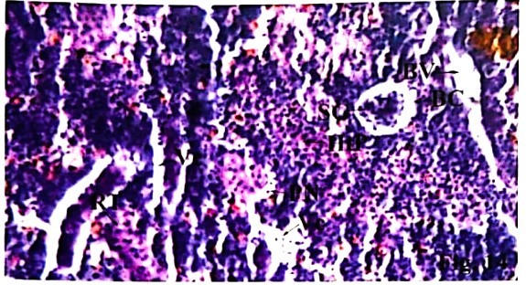

**Fig. 1.** Section of kidney of control fish, Clarias gariepinus showing normal Bowman's capsule, glomerulus, and proximal and distal tubules (H & E × 400).

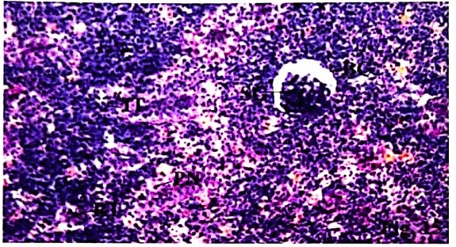

**Fig. 2.** Section of kidney of control fish, Clarias gariepinus showing Bowman's capsule, Renal tubules, and Interstitial tissue and Hemopoietic tissue (H & E × 400).

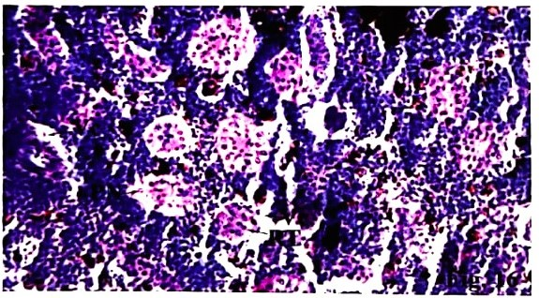

**Fig. 3.** Section of kidney of control fish, Ophiocephalus striatus showing normal Bowman's capsule, glomerulus, and proximal and distal tubules (H & E × 100).

### **Abbreviations:** BC - Bowman's capsule, GL - Glomerulus, PT - Proximal tubule, RT - Renal tubule, BV - Blood vessel, HT - Hemopoietic tissue, IT - Interstitial tissue.

**Histological Changes in Kidney of *Clarias gariepinus*** **exposed to Cypermetrin (25% EC):**

Exposure of *Clarias gariepinus* to a sub lethal concentration (LC50) dose of Cypermethrin for 96 hours induces significant histopathological alterations in the kidney. These changes are particularly evident in the renal corpuscle and renal tubules, indicating severe structural damage (Fig. 4).One of the most prominent histological changes observed is glomerular shrinkage, which leads to an increased space between the glomerulus and Bowman’s capsule. This widening of Bowman’s space suggests impaired filtration efficiency and compromised renal function (Fig. 5). Furthermore, the renal tubules exhibit pronounced tubular degeneration and necrosis, further disrupting normal kidney function (Fig. 6). At the cellular level, nuclear pyknosis (condensation of chromatin) and karyolysis (dissolution of the nucleus) are evident within the renal tubule cells. These nuclear abnormalities, combined with cytoplasmic degeneration, lead to the breakdown of renal tubule structure, resulting in disorganized and disintegrated tubules. Additionally, the presence of fat vacuoles suggests severe cellular distress and metabolic disturbances (Figs. 4, 5 & 6). Loss of cellular integrity is accompanied by widespread disorganization of connective tissues and degeneration of interstitial tissue. Hypertrophy of nuclei in the renal tubule cells is also observed, indicating an abnormal cellular response to toxic exposure. Due to these degenerative changes, renal tubules of varying diameters are seen, further emphasizing the extent of structural damage. Hydropic swelling, characterized by excessive accumulation of edematous fluid between renal tubules, is another notable pathological feature. This condition leads to cellular swelling and further compromises renal function. Additionally, vacuolation in the epithelial cells of the renal tubules is observed, along with evident damage to blood vessels, which could impair renal circulation and nutrient exchange (Figs. 4, 5 & 6).

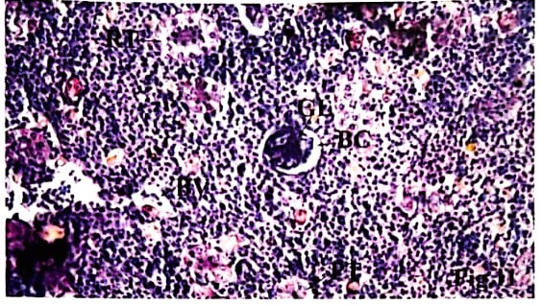

**Fig. 4.** Section of kidney of Clarias gariepinus exposed to Cypermethrin showing vacuolation and disorganized tubules (fat vacuoles), damaged blood vessel, glomerular shrinkage, increase in space between glomerulus and Bowman's capsule. (H & E × 400).

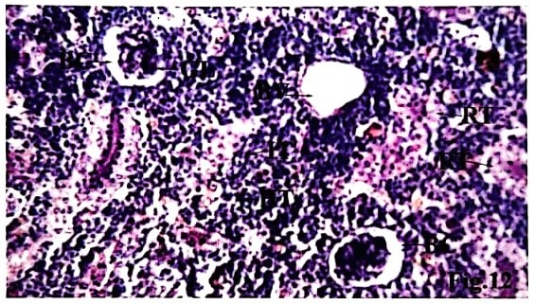

**Fig. 5.** Section of kidney of Clarias gariepinus exposed to Cypermethrin showing loss of integrity and interstitial tissue, vacuolization, shrunk glomeruli, nuclear pyknosis, and karyolysis in renal tubules. Increase in space between glomerulus and Bowman's capsule (H & E × 400).

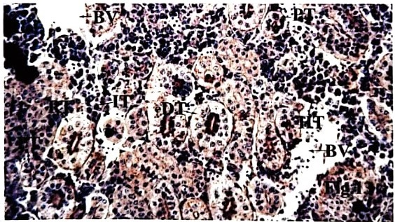

**Fig. 6.** Section of kidney of Clarias gariepinus exposed to Cypermethrin showing loss of integrity and interstitial tissue, vacuolization, and degenerating renal tubules. (H & E × 400).

### **Abbreviations:** GL - Glomerulus, IT - Interstitial tissue, BC - Bowman's capsule, BV - Blood vessel, DT - Distal tubule, PT - Proximal tubule, RT - Renal tubule, HtP - Heterogenous parenchyma, PN - Pyknotic Nuclei, Ve - Vacuolization, SG - Shrinked glomeruli.

**Discussion**

The present study provides a comprehensive evaluation of the histopathological alterations in the kidney of *Clarias gariepinus* following exposure to Cypermethrin (25% EC), a widely used pyrethroid insecticide. The findings revealed significant structural damage in renal tissues, indicating severe nephrotoxicity and impaired renal function. These results align with previous studies documenting similar histopathological changes in fish exposed to various environmental toxicants [1], [13].

The kidney is a crucial excretory and osmoregulatory organ in fish, responsible for maintaining electrolyte balance, regulating blood pH, and facilitating erythropoiesis [19]. The head kidney, in particular, plays a vital role in erythropoiesis, contributing to the production of red blood cells [20-21]. In control fish, the kidney exhibited a normal histological structure with intact Bowman’s capsules, well-defined glomeruli, and organized renal tubules. However, exposure to the LC50 dose of Cypermethrin (0.27 µl/L) for 96 hours induced significant degenerative changes, disrupting renal function and structural integrity.

One of the most notable histopathological alterations observed was glomerular shrinkage, resulting in a pronounced increase in Bowman’s space. This change suggests impaired glomerular filtration and potential renal dysfunction, similar to findings reported by Ortiz [22], Indirabai et al. [23] and Muthukumaravel et al. [24]. Additionally, cellular vacuolation was prominent in Cypermethrin-exposed fish, a pathological feature also observed in *Heterobranchus bidorsalis* [25], *Cyprinus carpio* [26], and *Clarias* species [20] following pesticide and heavy metal exposure.

A significant immune response to Cypermethrin toxicity was indicated by the formation of melanomacrophage centers, which play a crucial role in detoxification and immune defense [27], [19]. The presence of these centers has been documented in fish exposed to insecticides [1], [8]. Additionally, karyolysis, a hallmark of nuclear degradation, was observed in renal tubules, leading to structural disorganization and necrosis. These degenerative changes are consistent with findings by Das and Mukherjee [28] and Olufayo and Alade [25].

Further cellular abnormalities included nuclear pyknosis and necrosis, indicative of severe cytotoxic effects, leading to renal architectural breakdown. These pathological features have been reported in *Cirrhinus mrigala* [27], *Heteropneustes fossilis* [29], and *Oreochromis niloticus* [30] following exposure to various environmental pollutants. Necrosis of renal tubules and glomerular impairment severely affect renal physiology and electrolyte balance in fish [20].

Hydropic swelling, characterized by the accumulation of edematous fluid between renal tubules, was another significant alteration observed in this study. Similar pathological symptoms have been reported in *Mystus tengara* exposed to Cypermethrin [31], Silver barb (*Barbonymus gonionotus*) exposed to Quinalphos 25 EC [30], and Nile tilapia (*Oreochromis niloticus*) exposed to Kinalux 25 EC [32]. Additionally, renal damage characterized by vacuolation, pyknosis, and necrosis has been observed in *Heterobranchus bidorsalis* exposed to Cypermethrin [25] and *Cirrhinus mrigala* subjected to lethal and sublethal doses of the same pesticide [27].

Similar histopathological alterations have been reported in various fish species exposed to different environmental contaminants. Ikele et al. [33] documented renal damage in *Clarias gariepinus* exposed to diethyl phthalate, while Indirabai et al. [23] observed comparable nephrotoxicity in *Labeo rohita* following exposure to endosulfan. Butchiram et al. [34] reported significant renal damage in *Channa punctatus* exposed to alachlor, while Ayoola and Ajani [35] documented similar findings in African catfish (*Clarias gariepinus*) subjected to Cypermethrin. Ortiz [22] observed nephrotoxic effects in Mugil species, *Cyprinus carpio*, and *Barbus* species exposed to lindane. Renal tubular degeneration, including a reduction in the size of distal convoluted tubules and vacuolations, has also been reported in *Catla catla* following exposure to chlorpyrifos [36].

The findings of the present study align with previous research highlighting the detrimental effects of pesticide pollution on aquatic ecosystems. Cypermethrin, being a synthetic pyrethroid, is highly toxic to fish, causing oxidative stress and metabolic disturbances [6]. Acute and chronic exposure to such pesticides has been shown to reduce fishery yields by disrupting aquatic food webs [3-4]. Studies on pesticide contamination in freshwater bodies have also demonstrated a direct link between pesticide exposure and renal histopathology in various fish species, including *Clarias gariepinus* [16], [14].

Overall, the histopathological alterations observed in the present study, including glomerular shrinkage, widening of Bowman’s space, vacuolation, karyolysis, pyknosis, necrosis, hydropic swelling, and cytoplasmic degeneration, highlight the nephrotoxic effects of Cypermethrin on *Clarias gariepinus*. These results emphasize the need for stringent environmental monitoring and regulation of toxic pollutants to protect aquatic life. Furthermore, future research should focus on exploring potential protective agents or remediation strategies to counteract the harmful effects of pesticide exposure in fish populations [1], [5].

**Conclusion**

This study provides crucial insights into the histopathological effects of cypermethrin exposure on the kidneys of *Clarias gariepinus*. The structural damage observed, including glomerular shrinkage, tubular degeneration, nuclear abnormalities, and cytoplasmic vacuolation, underscores the vulnerability of fish renal tissues to pesticide toxicity. These alterations indicate severe physiological stress, which can impair essential functions such as filtration, osmoregulation, and waste excretion, ultimately affecting fish health and survival. By highlighting the extent of renal damage caused by cypermethrin, this study emphasizes the broader ecological implications of pesticide contamination in aquatic environments. Given its widespread use in agriculture, its potential to accumulate in water bodies poses a significant threat to fish populations and, by extension, aquatic food webs. This necessitates urgent action to regulate pesticide discharge, enforce stricter environmental policies, and promote eco-friendly alternatives. Additionally, further studies should explore long-term exposure effects, recovery potential, and possible protective interventions to mitigate cypermethrin-induced toxicity in freshwater species. This research reinforces the growing body of evidence supporting the need for sustainable pest management practices. Protecting aquatic ecosystems from such pollutants is essential for maintaining biodiversity and ensuring the stability of freshwater resources.

**Declaration: Authors have declared that no competing interests exist.**

**References:**

[1] **AbuQamar, S. F., El-Saadony, M. T., Alkafaas, S. S., Elsalahaty, M. I., Elkafas, S. S., Mathew, B. T., Aljasmi, A. N., Alhammadi, H. S., Salem, H. M., Abd El-Mageed, T. A., Zaghloul, R. A., Mosa, W. F. A., Ahmed, A. E., Elrys, A. S., Saad, A. M., Alsaeed, F. A., & El-Tarabily, K. A. (2024). Ecological impacts and management strategies of pesticide pollution on aquatic life and human beings.** Marine Pollution Bulletin, 206**, 116613.** <https://doi.org/10.1016/j.marpolbul.2024.116613>

[2] **Kumar, P., Kumar, R., Thakur, K., et al. (2023). Impact of pesticides application on aquatic ecosystem and biodiversity: A review.** Biological Bulletin of the Russian Academy of Sciences, 50**, 1362–1375.** <https://doi.org/10.1134/S1062359023601386>

[3] **Yamamuro, M., Komuro, T., Kamiya, H., Kato, T., Hasegawa, H., & Kameda, Y. (2019). Neonicotinoids disrupt aquatic food webs and decrease fishery yields.** Science, 366**(6465), 620–623.** <https://doi.org/10.1126/science.aax3442>

[4] **Jensen, O. P. (2019). Pesticide impacts through aquatic food webs.** Science, 366**(6465), 566–567.** <https://doi.org/10.1126/science.aaz6436>

[5] **Rachna, Singh, M. P., Goswami, S., et al. (2024). Pesticide pollution: Toxicity, sources, and advanced remediation approaches.** Environmental Science and Pollution Research, 31**, 64385–64418.** <https://doi.org/10.1007/s11356-024-35502-0>

[6] **Saha, S., & Kaviraj, A. (2008). Acute toxicity of synthetic pyrethroid cypermethrin to some freshwater organisms.** Bulletin of Environmental Contamination and Toxicology, 80**(1), 49–52.** <https://doi.org/10.1007/s00128-007-9314-4>

[7] **Velmurugan, B., Mathews, T., & Cengiz, E. I. (2009). Histopathological effects of cypermethrin on gill, liver, and kidney of freshwater fish** Clarias gariepinus **(Burchell, 1822), and recovery after exposure.** Environmental Technology, 30**(13), 1453–1460.** <https://doi.org/10.1080/09593330903207194>

[8] **Sharma, P., Mehta, A., & Faggio, C. (2021). Impact of cypermethrin in nephrocytes of freshwater fish** Catla catla**.** Environmental Toxicology and Pharmacology, 88**, 103739.** <https://doi.org/10.1016/j.etap.2021.103739>

[9] **Kaur, K., Jindal, R., & Faggio, C. (2021). Impact of cypermethrin in nephrocytes of freshwater fish** Catla catla**.** Environmental Toxicology and Pharmacology, 88**, Article 103739.** <https://doi.org/10.1016/j.etap.2021.103739>

[10] **Begum, G. (2012). Impact of cypermethrin on fingerlings of common edible carp (**Labeo rohita**).** Environmental Toxicology and Pharmacology, 34**(1), 1–6.** <https://pubmed.ncbi.nlm.nih.gov/22666103/>

[11] **Singh, D., & Singh, A. (2002). Piscicidal effect of some common plants of India commonly used in freshwater bodies against target animals.** Chemosphere, 49**(1), 45–49.** <https://doi.org/10.1016/S0045-6535(02)00157-3>

[12] **Ullah, S., Zuberi, A., Alagawany, M., Farag, M. R., Dadar, M., Karthik, K., & Dhama, K. (2018). Cypermethrin-induced toxicities in fish and adverse health outcomes: Its prevention and control measure adaptation.** Journal of Environmental Management, 206**, 863–871.** <https://doi.org/10.1016/j.jenvman.2017.11.076>

[13] **Adegun, A. O., Akinnifesi, T. A., Ololade, I. A., Busquets, R., Hooda, P. S., Cheung, P. C. W., & Barker, J. (2020). Quantification of neonicotinoid pesticides in six cultivable fish species from the River Owena in Nigeria and a template for food safety assessment.** Water, 12**(9), 2422.** <https://doi.org/10.3390/w12092422>

[14] **Hassan, M., Melad, A. A. N., Zakariah, M. I., & Yusoff, N. A. H. (2023). Histopathological alterations in gills, liver, and kidney of African catfish (**Clarias gariepinus**, Burchell 1822) exposed to** Melaleuca cajuputi **extract.** Tropical Life Sciences Research, 34**(2), 177–196. https://doi.org/10.21315/tlsr2023.34.2.9**

[15] **Adeogun, A. O., Ibor, O. R., Chukwuka, A. V., & Arukwe, A. (2020). Environmental concentrations of pesticides induce histopathological alterations in the kidney and liver of** Clarias gariepinus**.** Environmental Science and Pollution Research, 27**(12), 13536–13549.** <https://doi.org/10.1007/s11356-020-07902-1>

[16] **Doherty, V. F., Ladipo, M. K., Aneyo, I. A., Adeola, A., & Odulele, W. Y. (2016). Histopathological alterations, biochemical responses, and acetylcholinesterase levels in** Clarias gariepinus **as biomarkers of exposure to organophosphate pesticides.** Environmental Monitoring and Assessment, 188**(5), 312.** <https://doi.org/10.1007/s10661-016-5299-y>

[17] APHA (2023) American Public Health Association (APHA), American Water Works Association (AWWA), & Water Environment Federation (WEF). Standard methods for the examination of water and wastewater (24th ed.). APHA Press.

[18] Finney, D. J. (1971). Probit analysis (3rd ed., p. 333). Cambridge University Press.

[19] Prabhahar, C., Saleshrani, K., Tharmaraj, K., & Vellaiyan, M. (2012). Effect of cadmium compound on the histological changes of various vital organs of the freshwater fish Cirrhinus mrigala. International Journal of Pharmaceutical and Biological Archives, 3(1), 84–88.

[20] Pantung, N., Helander, K. G., Helander, H. F., & Cheevaporn, V. (2008). Histopathological alterations of hybrid walking catfish (Clarias macrocephalus × Clarias gariepinus) in acute and subacute cadmium exposure. Environment Asia, 1, 22–27.

[21] Iqbal, F., Qureshi, I. Z., & Ali, M. (2004). Histopathological changes in the kidney of common carp (Cyprinus carpio) following nitrate exposure. Journal of Research Science, Bahauddin Zakariya University, Multan, 15(4), 411–418.

[22] Ortiz, J. B., Canales, G. D. M. L., & Sarasquete, C. (2003). Histopathological changes induced by lindane (γ-HCH) in various organs of fishes. Scientia Marina, 67(1), 53–61.

[23] Indirabai, W. P. S., Tharani, G. G., & Seetha, P. (2010). Impact of sub-lethal concentration of endosulfan on biochemicals and histology of organ tissues of freshwater fish, Labeo rohita (Hamilton, 1822). The Bioscan, 5, 215–218.

[24] Muthukumaravel, K., Rajaraman, P., Nathiya, N., Govindarajan, M., & Raveendran, S. (2013). Studies on the histopathology of selected organs of freshwater fish Labeo rohita exposed to pesticides monocrotophos. International Journal of Recent Scientific Research, 4(11), 1728–1735.

[25] Olufayo, M. O., & Alade, O. H. (2012). Acute toxicity and histological changes in gills, liver, and kidney of catfish, Heterobranchus bidorsalis, exposed to cypermethrin concentration. African Journal of Agricultural Research, 7, 4453–4459.

[26] Reddy, S. J. (2012). Cadmium effect on histo-biomarkers and melano-macrophage centers in liver and kidney of Cyprinus carpio. World Journal of Fish and Marine Sciences, 4(2), 179–184.

[27] Prashanth, M. S. (2011). Histopathological changes observed in the kidney of freshwater fish Cirrhinus mrigala (Hamilton) exposed to cypermethrin. Recent Research in Science and Technology, 3(2), 59–65.

[28] Das, B. K., & Mukherjee, S. C. (2000). Sub-lethal effect of quinalphos on selected blood parameters of Labeo rohita (Ham.) fingerlings. Asian Fisheries Science, 13, 225–233.

[29] Rakhi, S. F., Reza, A. H. M. M., Hossen, M. S., & Hossain, Z. (2013). Alterations in histopathological features and brain acetylcholinesterase activity in stinging catfish Heteropneustes fossilis exposed to polluted river water. International Aquatic Research, 5(7), 1–18.

[30] Mostakim, G. M., Mishu, M. M., Rahman, M. K., & Islam, M. S. (2014). Chronic toxicity of organophosphorous pesticide Quinalphos 25EC and its effects on the morphological alterations in the kidney and livers of Silver barb (Barbonymus gonionotus). Proceedings of the 5th International Conference on Environmental Aspects of Bangladesh (ICEAB 2014).

[31] Haque, S. M., Sarkar, C. C., Khatun, S., & Sumon, K. A. (2017). Toxic effects of agro-pesticide cypermethrin on histological changes of kidney in Tengra (Mystus tengara). Asian Journal of Medical and Biological Research, 3(4), 494–498.

[32] Nannu, M. T. A. (2014). Effects of kinalux, an organophosphorus pesticide on the hematological parameters and some organs of Nile tilapia (Oreochromis niloticus) (MS thesis). Department of Fisheries Biology and Genetics, Bangladesh Agricultural University, Mymensingh, Bangladesh.

[33] Ikele, C. B., Mgbenka, B. O., & Oluah, N. S. (2011). Histopathological effects of diethyl phthalate on Clarias gariepinus juveniles. Animal Research International, 8(3), 1431–1438.

[34] Butchiram, M.S., Tilak, K.S. and Raju, P.W. (2009). Studies on histopathological changes in the gill, liver and kidney of *Channa punctatus* (Bloch) exposed to Alachlor. *J. Environ. Biol*., 30: 303-306.

[35] Ayoola, S. O., & Ajani, E. K. (2008). Histopathological effects of cypermethrin on juvenile African catfish (Clarias gariepinus). World Journal of Biological Research, 1, 1–14.

[36] Tilak, K., Rao, K., & Veeraiah, K. (2005). Effects of chlorpyrifos on histopathology of the fish Catla catla. Journal of Ecotoxicology and Environmental Monitoring, 15(2), 127–140.