***Short Research Article***

**ICHTHYOFAUNAL DIVERSITY OF KORAPPUZHA AND KANAYANKODE**

**RIVERS, KOZHIKODE, KERALA, INDIA.**

**Abstract**

The present study documents the fish diversity of the Korappuzha and Kanayankode rivers in Kozhikode district. Collections were conducted over a period of six months, from January to June 2024, using cast nets, drift nets, and hooks and lines. A total of 21 species, belonging to 8 orders and 18 families, were recorded, with the order Perciformes exhibiting the highest diversity. Gerres filamentosus was the most abundant species in the Korappuzha River, while Etroplus suratensis dominated in the Kanayankode River. The Shannon–Wiener biodiversity index (2.26–2.86) indicated a high level of diversity in both rivers. Notably, Horabagrus brachysoma and Hyporhamphus xanthopterus, species classified as Vulnerable by the IUCN, were also recorded. This study highlights the biodiversity and conservation significance of these river ecosystems.

**Key words**

Icthyodiversity, Kanayankode River, Korapuzha River, Horabagrus brachysoma, Hyporhamphus xanthopterus, Perciformes, Conservation

**Introduction**

In aquatic ecosystems, ichthyodiversity refers to the diversity of fish species present. This diversity can encompass variations at different levels, including alleles or genotypes within a fish population, species or life forms within a fish community, or the overall species composition across an entire aquatic region (Burton *et al.,* 1992).According to Fish base (2024) almost 35600 species of fish had been described, which is more than the combined total of all other vertebrate species: mammals, amphibians, reptiles and birds. The world's aquatic biodiversity is declining at an alarming rate due to factors such as habitat loss, pollution, the introduction of invasive species, overexploitation, and other human activities (Thuiller *et al.,* 2005; Jung *et al.,* 2019; Hu *et al.,* 2024). The study of freshwater fish diversity is a critical aspect of aquatic ecology, providing insights into the health, functionality, and biodiversity of freshwater ecosystems. Freshwater environments, including rivers, lakes, and wetlands, support a rich variety of fish species, each adapted to unique ecological niches. Numerous studies have been conducted on the fish diversity of freshwater ecosystems, including those by Ponniah and Gopalakrishnan (2000), Ghosh (2001), Manimekalan and Arunachalam (2002), Kurup *et al.,* ( 2006), Gopi (2006), Sreekantha *et al.,* (2007), Raghavan *et al.,*(2008), and Zeena and Beevi (2011). Vijayakumar and Fabiola (2021) studied the freshwater fish diversity of the Korappuzha River, along with their conservation status. A total of 18 fish species belonging to eight orders and 13 families were recorded, with the order Siluriformes exhibiting the highest diversity. Among them, *Horabagrus brachysoma* and *Hyporhamphus xanthopterus* fall under the vulnerable category according to the IUCN. Mathew *et al.,* (2022) compared the fish diversity of the Kumarakom region of Vembanad Lake, with a special focus on the post-flood period. Their study revealed a decline in fish diversity during the post-flood period. Vishnu *et al.,* (2023) recorded *Dawkinsia lepida*, a poorly known cyprinid, for the first time in the Achankovil River. Knowledge of fish diversity is crucial as it reflects the health and stability of ecosystems and plays a vital role in the management of wildlife and aquaculture systems. Since very little work has been done on the fish diversity of the Korapuzha and Kanayankode rivers, the present study was carried out to document their ichthyofaunal diversity.

**Methodology**

Fortnightly collections were made using different types of nets like cast net, drift net and hooks and lines. Collected fishes were preserved in 10% formalin solution. Identification was done by using standard books like “The fishes of India” (Francis Day, 1878) and Fish and Fisheries of India (Jhingran, 1991). Statistical analysis of data using Shannon-wiener diversity index (H) and Simpson‘s index (D) were noted.

**The study area**

**Site 1 -**Korapuzha River

Korapuzha River ( 11°21'37.9"N 75°44'50.6"E ) also known as Elathur River**,** is a short river of 40 km with a drainage area of 624 km2 flowing through Kozhikode district of Kerala and empties into the Arabian Sea at Elathur. It is formed by the confluence of two streams, Akalapuzha and Punoorpuzha which originate in the mountains of Wayanad district.

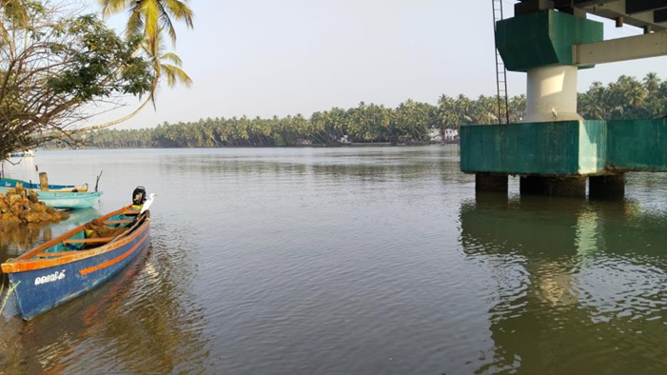 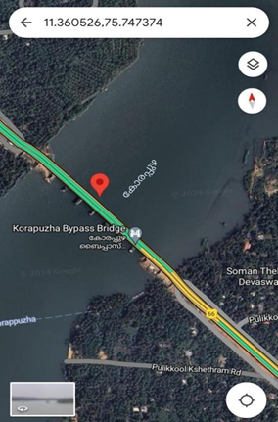

Picture 1 : **Location of Korapuzha River**

# **Site 2** - Kanayankode River

# The Kanayankode River (11°26'37.5"N 75°43'44.1"E) which is located in Kanayankode, Koyilandy.It is a small tributary of Korapuzha River.

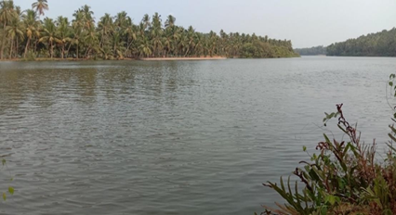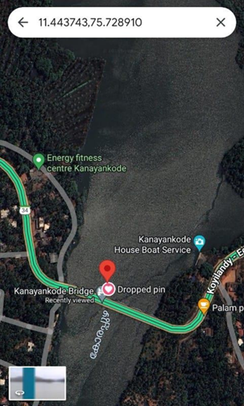

**Picture 2 : Location of Kanayankode River**

**Results and Discussion**

A total of 21 species from 8 orders and 18 families were documented in the Korappuzha and Kanayankode rivers over a six-month period from January 2024 to June 2024. The 9 orders recorded in the present study were Perciformes, Clupeiformes, Siluriformes, Cypriniformes, Pleuronectiformes, Mugiliformes, Beloniformes, and Scorpaeniformes. The order Perciformes exhibited the highest diversity, comprising 9 families: Leiognathidae, Gerreidae, Lutjanidae, Scatophagidae, Siganidae, Carangidae, Sillaginidae, Gobiidae and Cichlidae. Perciformes was the most dominant order, comprising 8 families and accounting for 52.38 % of the total fish species collected from Korapuzha. It was followed by Clupeiformes with 3 species (14.28%), and Siluriformes with 2 species (9.52%). The remaining five orders, with one species each, constituted 4.76% of the total fish species documented in the Korappuzha River.

In the Kanayankode River, Perciformes was the most dominant order, comprising 7 families and accounting for 55.55% of the total fish species collected. It was followed by Siluriformes with 2 species (11.11%), and the remaining 6 orders, each represented by one species (5.55%).

Of the 21 species (Plate-1 to 3) collected from the Korappuzha River, the most abundant species was Gerres filamentosus, followed by Leiognathus equula and Etroplus suratensis. In the Kanayankode River, a total of 18 species were collected, with Etroplus suratensis being the most dominant, followed by Mugil cephalus and Gerres filamentosus. Notably, Horabagrus brachysoma , Hyporhamphus xanthopterus and *Oreochromis mossambicus* listed as vulnerable by the IUCN (2024) were also recorded in both rivers.

A study by Vijayakumar and Fabiola (2021) recorded 18 species of fishes from 8 orders in the Korappuzha River, including *Horabagrus brachysoma* and *Hyporhamphus xanthopterus*. In contrast, the present study identified 21 species across 9 orders, with 21 species recorded from the Korappuzha River and 18 species from the Kanayankode River, with Perciformes as the dominant group. These findings suggest increased biodiversity and potential shifts resulting from ecological changes or improved sampling methods.

The comparison of the Shannon-Weiner diversity index between the Korappuzha River (2.86) and the Kanayankode River (2.66), as well as the Simpson index (0.936 vs. 0.921), showed no significant difference between the two rivers. The Shannon-Weiner diversity index values of 2.6 and 2.8 in the two rivers indicate a relatively high level of diversity within their fish communities. But species contributions to diversity vary, with *Gerres filamentosus*, *Leiognathus equula*, and *Mugil cephalus* contributing significantly in Korappuzha river, and *Etroplus suratensis*, *Mugil cephalus,* and *Leiognathus equula* in Kanayankode river. The greater diversity in the Korappuzha River may be attributed to its close proximity to the estuary. Overall, both rivers support a diverse and well-balanced fish population, indicating a healthier aquatic ecosystem. As the present study, conducted over a short period, documented 21 species, a detailed investigation, including an analysis of physico-chemical parameters, is needed to fully document and conserve the entire fish population.

**TABLE 1**

**LIST OF COLLECTED FISH SPECIES WITH THEIR IUCN STATUS ,COMMON NAME AND LOCAL NAME**



LC – Least concern VU – Vulnerable

**TABLE - 2**

**CHECKLIST OF FISH SPECIES COLLECTED FROM TWO RIVERS**

|  |  |  |  |
| --- | --- | --- | --- |
| **SI No.** | **Scientific name** | **Korappuzha River** | **Kanayankode River** |
| 1 | *Etroplus suratensis* | + | + |
| 2 | *Pseudetroplus maculatus* | + | + |
| 3 | *Cociella punctata* | + | + |
| 4 | *Brachirus orientalis* | + | + |
| 5 | *Lutjanus argentimaculatus* | + | + |
| 6 | *Caranx sexfasciatus* | + | + |
| 7 | *Thryssa dussumieri* | + | + |
| 8 | *Hyporhamphus xanthopterus* | + | + |
| 9 | *Sillago sihama* | + | + |
| 10 | *Scatophagus argus* | + | + |
| 11 | *Siganus vermiculatus* | + | - |
| 12 | *Oreochromis mossambicus* | + | + |
| 13 | *Stolephorus commersonii* | + | - |
| 14 | *Horabagrus brachysoma* | + | + |
| 15 | *Systomus sarana* | + | + |
| 16 | *Gerres filamentosus* | + | + |
| 17 | *Arius subrostratus* | + | + |
| 18 | *Leiognathus equula* | + | + |
| 19 | *Mugil cephalus* | + | + |
| 20 | *Anodontostoma chacunda* | + | - |
| 21 | *Glossogobius giuris* | + | + |

**TABLE- 3**

**ABUNDANCE OF FISHES OF DIFFERENT ORDERS FROM KORAPPUZHA RIVER**

|  |  |  |
| --- | --- | --- |
| **SI No.** | **Order** | **Number of species** |
| 1 | Perciformes | 11 |
| 2 | Siluriformes | 2 |
| 3 | Cypriniformes | 1 |
| 4 | Clupeiformes | 3 |
| 5 | Pleuronectiformes | 1 |
| 6 | Mugiliformes | 1 |
| 7 | Scorpaeniformes | 1 |
| 8 | Beloniformes | 1 |

**FIGURE- 1**

**PIE DIAGRAM SHOWING THE NUMBER OF SPECIES IN DIFFERENT ORDERS OF FISHES FROM KORAPPUZHA RIVER**

**FIGURE- 2**

**BAR DIAGRAM SHOWING THE NUMBER OF SPECIES IN DIFFERENT ORDERS OF FISHES FROM KORAPPUZHA RIVER.**

**TABLE -4**

**ABUNDANCE OF FISHES OF DIFFERENT ORDERS OF FISHES FROM STUDY KANAYANKODE RIVER**

|  |  |  |
| --- | --- | --- |
| **SI No.** | **Order** | **Number of**  **species** |
| 1 | Perciformes | 10 |
| 2 | Siluriformes | 2 |
| 3 | Cypriniformes | 1 |
| 4 | Clupeiformes | 1 |
| 5 | Pleuronectiformes | 1 |
| 6 | Scorpaeniformes | 1 |
| 7 | Mugiliformes | 1 |
| 8 | Beloniformes | 1 |

**FIGURE -3**

**PIE DIAGRAM SHOWING THE NUMBER OF SPECIES IN DIFFERENT ORDERS OF FISHES FROM KANAYANKODE RIVER**

**FIGURE 4**

**BAR DIAGRAM SHOWING THE NUMBER OF SPECIES IN DIFFERENT ORDERS OF FISHES FROM KANAYANKODE RIVER.**

**Figure-5**

**BAR DIAGRAM SHOWING SHANNON-WIENER INDEX OF STUDY AREA- 1 AND STUDY AREA-2**

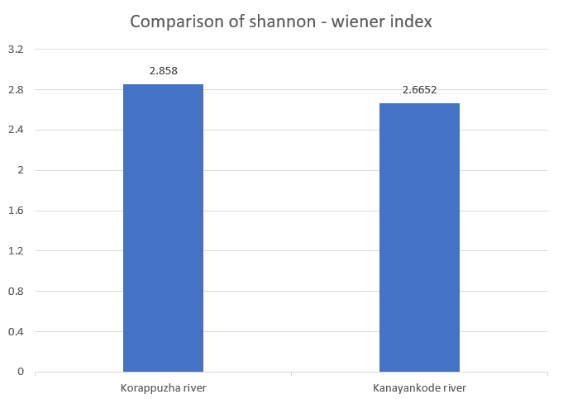

**Conclusion**

The present study carried out for a period of six months from January 2024 and June 2024 and collected 2,905 fishes from Korappuzha River and 1,750 from Kanayankode River. The greater number of fish in the Korappuzha River may be due to its close proximity to the estuary. Korappuzha River exhibited higher species richness with 21 species, compared to 18 species in Kanayankode River. Order Perciformes was the most diverse, represented by eight families: Leiognathidae, Gerreidae, Lutjanidae, Scatophagidae, Gobiidae, Sillaginidae, Carangidae, Cichlidae and Siganidae. Species-specific analysis revealed that *Gerres filamentosus* were more abundant in Korappuzha River, whereas *Etroplus suratensis* dominated in Kanayankode River. The higher abundance of *Gerres filamentosus* in Korappuzha and *Etroplus suratensis* in Kanayankode River indicates species-specific preferences and ecological niches within these rivers. The presence of vulnerable species under the IUCN category, such as Horabagrus brachysoma ,Hyporhamphus xanthopterus and *Oreochromis mossambicus* underscores the ecological significance of these rivers and highlights the need for targeted conservation efforts. This study provides valuable insights into the icthyodiversity of these river systems and highlights the importance of conservation strategies to protect and sustain their unique aquatic environments.

**Disclaimer (Artificial intelligence)**

Author(s) hereby declare that NO generative AI technologies such as Large Language Models (ChatGPT, COPILOT, etc) and text-to-image generators have been used during writing or editing of this manuscript.

**References**

Burton, P. J., Balisky, A. E., Coward, L. P., Cumming, S. G., & Kneeshaw, D. D. (1992). The value of managing for biodiversity. The Forestry Chronicle, 68(2), 225-237.

Day, F. (1878). The fishes of India: Being a natural history of the fishes known to inhabit the seas and freshwaters of India, including the Andaman and Nicobar Islands (Vol. 1). Superintendent of Government Printing.

Jhingran, V. G. (1991). Fish and fisheries of India. Hindustan Publishing Cooperation.

Ghosh, D. S. (2001). Fish diversity and associated aspects of selected sholas of Kerala. Shola forests of Kerala: Environment and biodiversity (pp. 353-363)

Gopi, K.C.(2000). Freshwater fishes of Kerala State. p. 56-76. In Ponniah, A.G. and A. Gopalakrishnan. (eds.). Endemic Fish Diversity of Western Ghats. NBFGR-NATP Publication. National Bureau of Fish Genetic Resources, Lucknow, U.P., India. 1, 347 p.

Hu, X., Wu, X., Zhou, Q., Niklas ,K., Jiang, L., Eisenhauer N., & et al., (2024). Warming causes contrasting spider behavioural responses by changing their prey size spectra. Nat. Clim. Change. 14, 190–197 (2024).

Jung, M., Rowhani, P., & Scharlemann, J.P.W.(2019). Impacts of past abrupt land change on local biodiversity globally. Nat. Commun. 10, 5474 .

Kurup, B. M., Manojkumar, T. G., & Radhakrishnan, K. V. (2006). Fish and fisheries of Periyar Lake, Kerala. Indian Journal of Fisheries, 53(2), 153-166

Manimekalan, A., & Arunachalam, M. (2002). Rediscovery of critically endangered air-breathing catfish Clarias dayi Hora (Pisces: Claridae) from Mudumalai Wildlife Sanctuary, Tamil Nadu. Journal of the Bombay Natural History Society, 99, 129- 131.

Mathew, S., Radhika, R., Rahim, S. A., Maria, E. N., & Raju, A. (2022). Ichthyofauna from freshwater of Kumarakom region of Vembanad Lake, Kottayam, Kerala, South India—with special reference to post-flood. Uttar Pradesh Journal of Zoology, 43(15), 51-57.

Ponniah, A. G., & Gopalakrishnan, A. (Eds.). (2000). Endemic fish diversity of Western Ghats. National Bureau of Fish Genetic Resources. Raghavan, R., Prasad, G., Ali, P. A., & Pereira, B. (2008). Fish fauna of Chalakudy River, part of Western Ghats biodiversity hotspot, Kerala, India: Patterns of distribution, threats, and conservation needs. Biodiversity and Conservation, 17, 3119-3131

Sreekantha, Chandran, M. S., Mesta, D. K., Rao, G. R., Gururaja, K. V., & Ramachandra, T. V. (2007). Fish diversity in relation to landscape and vegetation in Central Western Ghats, India. Current Science, 1592-1603.

Thuiller Wilfried ., Sandra Lavorel., Miguel B, Arau´ jo., Martin T. Sykes., & I, Colin Prentice.(2005). Climate change threats to plant diversity in Europe. Proceedings of the National Academy of Sciences of the United States of America.102 (23), 8245– 8250

Vijayakumar, A., & Fabiola, S. M. (2021). Ichthyofaunal diversity of Korapuzha River, Calicut, Kerala. Journal of Emerging Technologies and Innovative Research, 8(5), 476-483.

Vishnu, A. S., Lal, M., Tharian, J. C., Prabhakaran, M. P., & Ali, P. A. (2023). Diversity, distribution, and conservation status of fish species in Kallar Stream, Achankovil River, Western Ghats of Kerala, India. Journal of Threatened Taxa, 15(5), 23164-23189.

Zeena, K. V., & Jameela Beevi, K. S. (2011).Fish diversity in Ithipuzha and Murinjapuzha, Kerala, India. Journal of the Bombay Natural History Society, 108(2), 98.

**Website**

Froese, R., & D, Pauly. Editors. 2024. FishBase. World Wide Web electronic publication. www.fishbase.org, version (10/2024).

**Plate-1**

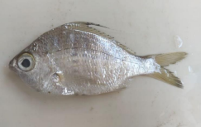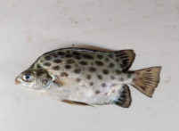

***Gerres filamentosus* (Cuvier, 1829) *Scatophagus argus* (Linnaeus, 1766)**

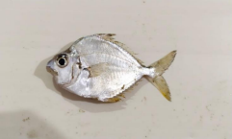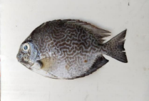

***Leiognathus equula* (Forsskål, 1775)  *Siganus vermiculatus* (Valenciennes, 1835)**

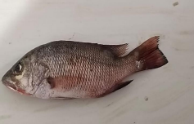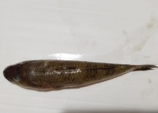

***Lutjanus argentimaculatus* (Forsskål, 1775) *Glossogobius giuris* (Hamilton, 1822)**

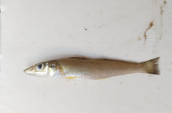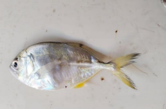

***Sillago sihama* (Forsskål, 1775) *Caranx sexfasciatus* (Quoy & Gaimard, 1825)**

**Plate-2**

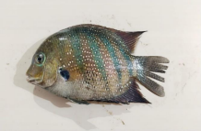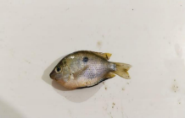

***Etroplus suratensis* (Bloch, 1790) *Pseudetroplus maculatus* (Bloch, 1795)**

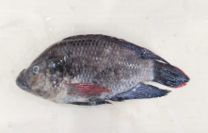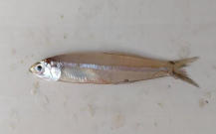

***Oreochromis mossambicus* (Peters, 1852) *Stolephorus commersonii* (Lacepède 1803)**

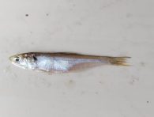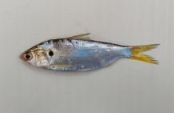

***Thryssa dussumieri* (Valenciennes, 1848) A*nodontostoma chacunda* (Hamilton, 1822)**

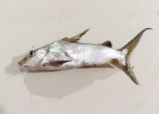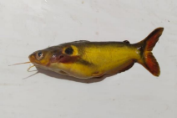

***Arius subrostratus* (Valenciennes, 1840) *Horabagrus brachysoma* (Günther, 1864)**

**Plate-3**

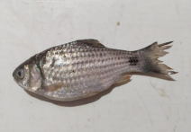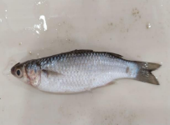

***Systomus sarana* (Hamilton, 1822) *Mugil cephalus* (Linnaeus, 1758)**

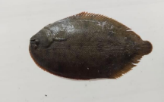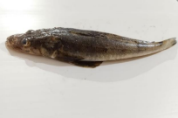

***Brachirus orientalis* (Bloch & Schneider, 1801) *Cociella punctata* (Cuvier, 1829)**

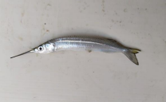

***Hyporhamphus xanthopterus* (Valenciennes, 1847)**