**Molecular Characterization and Phylogenetic Analysis of *Thrips tabaci* Lindeman. (Thysanoptera: Thripidae) Infesting Chrysanthemum Cultivation in Kashmir, India**

**Abstract**

Chrysanthemum (*Dendranthema grandiflora* L.), native to East Asia and cultivated for over 3,000 years, holds considerable economic significance, but is highly vulnerable to pests such as aphids, whiteflies, and thrips, resulting in substantial losses in both yield and quality. Accurate pest identification is crucial for developing effective management strategies. This study focuses on the molecular identification of thrips infesting this crop. Weekly field surveys were carried out from December 2022 to January 2025 in the polyhouse experimental fields of Sher-e-Kashmir University of Agricultural Sciences and Technology of Kashmir. Molecular analysis involved DNA extraction, phylogenetic tree construction, and protein modeling. The findings highlight the critical role of timely pest monitoring and integrated pest management (IPM) in minimizing pest-related damage.

**Keywords:** Onion thrips, molecular identification, chrysanthemum, phylogeny tree analysis, protein model

**1. Introduction:**

Chrysanthemum (*Dendranthema grandiflora* L.), a member of the Asteraceae (Compositae) family, is one of India's most significant flower crops and is commonly known as the "Autumn flower." It ranks second among the top ten cut flowers in the global flower trade, following the Rose (Brahma B, 2002). Recognized as one of the most important ornamental plants worldwide, chrysanthemum plays a vital role in the commercial flower markets of countries such as India, Colombia, and Brazil (Bhargavi et al., 2018; Dhiman et al., 2018; Zandonadi et al., 2018; Moreno et al., 2019). This plant is highly valued for its ease of maintenance, long-lasting blooms, and attractive inflorescences, making it a sought-after choice in the commercial flower industry (Heidemann et al., 2017). These desirable traits contribute to its widespread popularity as an ornamental plant, commonly used for indoor and outdoor decoration, floral exhibitions, and the creation of garlands and bouquets (Thakur et al., 2018).

Chrysanthemum crops are vulnerable to pests like thrips, aphids, caterpillars, mites, and flies, leading to significant economic losses (Saicharan et al., 2019). Thrips, belonging to the order Thysanoptera, are small insects that impact various agricultural and ornamental plants. Their effective control is challenging due to their intricate life cycle and rapid resistance development against chemical insecticides (Karuppaiah et al., 2018; Chen et al., 2020). Among the primary thrips species affecting chrysanthemums is *Frankliniella occidentalis* (Thysanoptera: Thripidae). The damage they cause includes direct harm to leaves, flowers, and fruits by piercing plant tissues and extracting cellular contents, as well as indirect harm through the transmission of plant viruses like tomato spotted wilt virus (TSWV). According to Singh et al. (2022), *Macrosiphoniella sanborni* (aphids), *Trialeurodes vaporariorum* (whiteflies), and *Thrips tabaci* (thrips) are the main sucking pests affecting Chrysanthemum in India, with infestation rates of 35.6%, 27.4%, and 21.1%, respectively. These pest infestations can severely impact crop yield and quality, resulting in up to a 30% reduction in plant height, a 40% decrease in flower yield, a 50% decline in flower quality, and a 75% rise in virus transmission.

These findings emphasize the urgent need for regular pest monitoring and the adoption of integrated pest management (IPM) strategies to mitigate the harmful impact of thrips on Chrysanthemum cultivation. Successful pest control demands a holistic approach that integrates cultural, biological, and chemical methods. Proper identification of thrips is crucial for formulating and implementing effective management techniques. This study specifically explores the molecular identification of thrips.

**2. Materials and methods:**

**2.1. Survey**

A systematic field survey was conducted at weekly intervals in the chrysanthemum polyhouse experimental field of the Division of Floriculture and Landscape Architecture, Faculty of Horticulture (FoH), Sher-e-Kashmir University of Agricultural Sciences & Technology-Kashmir, Shalimar, from December 2022 to January 2025. Observations were recorded from a representative sample of 10 plants, with three leaves collected from the apical, median, and basal portions of each plant. *Thrips* specimens were meticulously examined, collected, securely packed, and transported to the laboratory for further analysis.

**2.2. Molecular characterization of thrips**

Genomic DNA from thrips was extracted using the CTAB method. Samples were homogenized in CTAB buffer, transferred to microcentrifuge tubes, and incubated at 60°C for one hour. DNA was purified using phenol: chloroform: isoamyl alcohol, followed by centrifugation and precipitation with isopropanol and sodium acetate. The DNA pellet was washed with ethanol, air-dried, dissolved in TE buffer, and stored at -20°C. DNA quality was assessed via 0.8% agarose gel electrophoresis. The COI gene region was amplified using PCR with specific primers LCO1490 (5'-GGTCAACAAATCATAAAGATATTGG-3') and HCO2198 (5'-TAAACTTCAGGGTGACCAAAAAATCA-3'). PCR conditions included 35 cycles with an annealing temperature of 58°C. The PCR products were analyzed on 1% agarose gel and sequenced using the Sanger method at Eurofins Genomics India.

**2.2.1.** **Phylogeny tree analysis for thrips**

The mtCOI sequences of Thripswere annotated and manually curated using the DNA MAN program before submission to GenBank (Accession No. OR690649). Sequence similarity was assessed by comparing the obtained sequences with reference sequences available in GenBank, National Center for Biotechnology Information (NCBI), Bethesda, USA. Phylogenetic analysis was conducted using all available mtCOI sequences from GenBank, along with those generated in this study, incorporating appropriate out-group sequences. Final sequence refinement was performed using BioEdit Sequence Alignment Editor (Version 7.0.5.3), followed by multiple sequence alignment using Clustal W (Thompson et al., 1994) in MEGA-X software. A phylogenetic dendrogram was constructed using the Neighbor-Joining method with bootstrap support of 1000 replicates in MEGA-X.

**2.2.2.** **Protein Sequence Retrieval and Homology Modeling for *T. tabaci***

Protein sequences of cytochrome c oxidase subunit I (*COX-I*) from *Thrips tabaci* were retrieved from NCBI in FASTA format along with their respective accession numbers. Homology models were constructed using SWISS-MODEL, an automated platform for protein structure prediction based on sequence homology (Waterhouse et al., 2018). The structural accuracy of the predicted models was assessed using the SAVESv6.0 server (<https://saves.mbi.ucla.edu/>). Stereochemical quality evaluation was performed through Ramachandran plot analysis using PROCHECK, following the methodology of Laskowski et al. (1993). The validation confirmed the reliability of the predicted structural models for *T. tabaci*.

**3. Results**

**3.1. Molecular identification of *T. tabaci***

The nucleotide sequences (455 bp) obtained from Barcode Eurofins Genomics India, Pvt. Ltd., Bengaluru, Karnataka, India were analyzed for homology using the BLAST algorithm against the NCBI nucleotide database. The barcode sequences exhibited a 100% similarity with previously deposited *Thrips tabaci* *COI* gene sequences. The corresponding accession number is OR690649.

**3.1.1.** **Phylogeny tree analysis**

The phylogenetic tree in Figure 1 depicted the evolutionary relationships among various isolates of *Thrips tabaci*, commonly known as the onion thrips. It provided insights into genetic affiliations within the genera *Thrips* and *Frankliniella*, likely based on molecular markers such as the mitochondrial cytochrome oxidase I (COI) gene. Constructed using the maximum likelihood (ML) method, the tree included branch support as bootstrap values, with branch lengths representing genetic distances. The topology revealed three major clades: *Thrips tabaci* (pink), *Frankliniella occidentalis* (green), and *Frankliniella schultzei* (blue). *Thrips tabaci* exhibited significant internal divergence, as shown by long branches and multiple sub-clusters, whereas *Frankliniella occidentalis* and *Frankliniella schultzei* displayed lower genetic divergence.

Our sequence OR690649.1 was positioned within the magenta-colored clade, signifying its classification under the species *Thrips tabaci*. It was closely associated with *Thrips tabaci* isolate SKUAST-K, highlighting a strong genetic similarity and suggesting a recent common ancestry. OR690649.1 and *Thrips tabaci* isolate SKUAST-K shared a common ancestor, indicating that they stemmed from the same evolutionary lineage. This relationship suggested that the specimen was not highly divergent but rather a variant within the *Thrips tabaci* species. Their close clustering further supported a high degree of genetic similarity, implying that they belonged to the same or a closely related population. In addition to its close relationship with SKUAST-K, the specimen was embedded within a larger clade comprising multiple *Thrips tabaci* isolates and vouchers. Among the nearby sequences in this group were *Thrips tabaci* voucher KSA41, *Thrips tabaci* voucher JKTH1704, *Thrips tabaci* isolate IIHR-MH-T3-u4, and several other *Thrips tabaci* specimens. The strong clustering of these sequences indicated that they all shared a recent common ancestor, further solidifying their classification within the *Thrips tabaci* species.

Our specimen was genetically distinct from *Frankliniella* species, which were categorized separately into distinct clades *Frankliniella occidentalis* in the green clade and *Frankliniella schultzei* in the blue clade. This clear separation confirmed that the sequence belonged exclusively to *Thrips tabaci* and did not share an immediate common ancestor with any *Frankliniella* species. The evolutionary divergence between *Thrips tabaci* and *Frankliniella* established a well-defined species boundary, reinforcing their genetic and taxonomic distinction. OR690649.1 occupied a basal position within the *Thrips tabaci* cluster, which may have indicated several possibilities. It could have represented an ancestral variant of *Thrips tabaci*, reflecting an earlier evolutionary stage of the species. Alternatively, it may have belonged to a slightly divergent lineage that retained distinct genetic markers compared to other isolates. Another possibility was geographical variation, suggesting that this specimen evolved in a somewhat different environment from other *Thrips tabaci* populations.

Overall, the phylogenetic analysis suggested that *Thrips tabaci* represented a species complex with high genetic divergence, *Frankliniella occidentalis* exhibited genetic uniformity indicative of a recent expansion, and *Frankliniella schultzei* displayed moderate differentiation likely influenced by ecological factors. These findings held significant implications for evolutionary biology, taxonomy, and agricultural pest management.

**3.1.2.** **Structural Modeling and validation of target proteins in *T. tabaci***

The three-dimensional structures of target proteins from *T. tabaci* were generated using the SWISS-MODEL web server, as depicted in Fig. 2. To assess the accuracy and quality of the predicted models, Ramachandran plot analysis was performed, with results shown in Fig. 2. The analysis revealed that the majority of residues were located within permissible regions of the plot, as summarized in Table 1. This suggests that the modelled structures exhibit high geometric quality, ensuring reliable and precise structural predictions. These findings further confirm the integrity of the models, supporting their applicability in future research and analyses.

**4. Discussion**

In this study, molecular identification of *Thrips tabaci* was conducted using the mtCOI gene, resulting in a 455 bp sequence (Accession No. OR690649). Our findings closely align with those of Li et al. (2020), who examined the population genetic diversity of *T. tabaci* on *Allium* hosts in China using mitochondrial COI sequences. Their study identified three distinct clades: Clade T (tobacco-associated arrhenotokous), Clade L1 (leek-associated arrhenotokous), and Clade L2 (leek-associated thelytokous), revealing genetic diversity and potential cryptic speciation. Similarly, Farkas et al. (2019) developed a molecular identification method for the *T. tabaci* cryptic species complex, employing nuclear rDNA ITS regions to analyse genetic variation and phylogenetic relationships, providing insights into both interspecific and intraspecific diversity as well as evolutionary patterns. Soumiya et al. (2025) investigated the complete mitochondrial genomes of *T. tabaci* and *Thrips parvispinus*, emphasizing their phylogenetic significance. The advent of high-throughput sequencing technologies has greatly enhanced the genetic understanding of *T. tabaci*. Sequencing the complete mitochondrial genomes of *T. tabaci* and its closely related species has yielded valuable information for phylogenetic studies and the development of species-specific molecular markers. These genomic resources improve the accuracy of species identification and facilitate more effective pest management strategies. The mitochondrial genome of *T. tabaci* was sequenced to a total length of 15,277 bp. Pandi et al. (2024) conducted a comparative study examining the ultrastructural, morphological, and molecular characteristics of *T. tabaci* and *T. parvispinus* in onions. Molecular analysis identified a ~450 bp nucleotide fragment with over 98% similarity to NCBI reference sequences, confirming the presence of *T. tabaci*. The phylogenetic tree constructed in our study demonstrated substantial genetic diversity, with numerous novel gene sequences, suggesting the continuous evolution and diversification of Indian *T. tabaci* isolates. Extensive intraspecific genetic variations in the mtCOI gene of *T. tabaci* have been reported across economically important vegetable and crop hosts in multiple countries (Kadirvel et al., 2013; Li et al., 2020). Our study closely aligns with the findings of Khatun et al. (2024), who investigated the genetic diversity and DNA barcoding of thrips in Bangladesh, identifying 19 thrips species across various host plants. Among these, four primary vector species *Frankliniella intonsa, Thrips tabaci, Scirtothrips dorsalis,* and *Thrips palmi* were recorded, along with *Microcephalothrips abdominalis*, a notable pollinator species. *Thrips tabaci* was specifically identified on garlic plants, with accession numbers OR482098, KF840095, and JF839904. Rebijith et al. (2014) reported a barcode divergence of 12.3% in *T. palmi* and 13.8% in *T. tabaci* within Indian populations, while distance analysis showed a maximum divergence of 13% in *T. palmi* and 12% in *T. tabaci* from Pakistan. Furthermore, barcode gap analysis revealed significant intraspecific distances exceeding 2% in *Aelothrips intermedius, Haplothrips reuteri, T. palmi,* and *T. tabaci* (Iftikhar et al., 2016). Kadirvel et al. (2013) found that *Scirtothrips dorsalis* and *T. palmi* exhibited the highest levels of intraspecific genetic variation, followed by *T. tabaci* and *Frankliniella occidentalis*. These results highlight the mtCOI gene as a valuable molecular marker for differentiating thrips species and genera that coexist within specific crop environments.

In this study, phylogenetic tree analysis revealed that our sequence closely matches KSA8, JKTH170, and IIHR-MH-Tt3. Our findings are consistent with those of Li et al. (2020), as the phylogenetic tree constructed in our study demonstrated considerable genetic diversity, with a notable presence of novel gene sequences. This suggests the continuous evolution and diversification of Indian *Thrips tabaci* isolates. Additionally, extensive intraspecific genetic variations in the mtCOI gene of *T. tabaci* have been reported in economically important vegetable and crop hosts across multiple countries.

**5. Conclusion**

This study focuses on the molecular characterization of *T. tabaci* in chrysanthemum polyhouses at the Floriculture Division, FoH, SKUAST-Kashmir. *Thrips tabaci* is a major sap-sucking pest that significantly affects crop health by impairing plant growth, vigor, and flower yield, posing a serious threat to the floriculture industry. Effective management requires an integrated approach combining cultural, physical, biological, and chemical control methods. However, precise identification is essential for implementing appropriate management strategies. This research provides a detailed molecular identification of the pest, aiding in the development of targeted and effective pest control measures.

**DISCLAIMER (ARTIFICIAL INTELLIGENCE)**: Author(s) hereby declare that NO generative AI technologies such as Large Language Models (ChatGPT, COPILOT, etc) and text-to-image generators have been used during writing or editing of this manuscript.

**COMPETING INTERESTS:** Authors have declared that no competing interests exist.

**Reference**

Bhargavi SP, Hemla BN, Chandrashekar SY, Ganapathi M and Kantharaj Y. 2018. Efficacy of biostimulants on morphology, flowering and yield of chrysanthemum (Dendranthema grandiflora) cv, Kolar local under fan and pad greenhouse. International Journal of Chemical Studies 6 (5):1831-33.

Brahma B. Chrysanthemum when and how to grow? Floriculture Today, 2002: 30-32.

Chen G, Kim HK, Klinkhamer PG and Escobar-Bravo R. 2020. Site-dependent induction of jasmonic acid-associated chemical defenses against western flower thrips in Chrysanthemum. *Planta* 251 (1):1-14.

Dhiman SR, Gupta YC, Thakur P, Kashyap B, Sharma M and Sharma K. 2018. Effect of different black-out materials on off-season pot mum production of chrysanthemum (Dendranthema grandiflora). *Indian Journal of Agricultural Sciences* 88 (4):601-605.

Farkas P, György Z, Tóth A, Sojnóczki A and Fail J. 2020. A simple molecular identification method of the Thrips tabaci (Thysanoptera: Thripidae) cryptic species complex. *Bulletin of Entomological Research* 110 (3): 397-405.

Heidemann JC and Barbosa JG. 2017. Production and quality of three varieties of chrysanthemum grown in pots with different NPK rates. *Ornamental Horticulture* 23 (4):426-31. https://doi.org/10.14295/oh.v23i4.1020

Iftikhar R. Ashfaq M. Rasool A and Hebert PDN. 2016. DNA Barcode Analysis of Thrips (Thysanoptera) Diversity in Pakistan Reveals Cryptic Species Complexes. *PLoS ONE* 11: e0146014

Kadirvel P, Srinivasan R, Hsu YC, Su FC and De La Pena R. 2013. Application of cytochrome oxidase I sequences for phylogenetic analysis and identification of thrips species occurring on vegetable crops. *Journal of Economic Entomology* 106(1): 408-418.

Karuppaiah V, Soumia PS, Gawande SJ, Mahajan V and Singh M. 2018. Influence of dibbling time and weather factors on seasonal dynamics of thrips (Thrips tabaci Lindeman) on garlic in Maharashtra. *Journal of Agrometeorology* 20(4):311-14

Khatun MF, Hwang HS, Kang JH, Lee KY and Kil EJ. 2024. Genetic Diversity and DNA Barcoding of Thrips in Bangladesh. *Insects* 15(2): 107.

Li X, Zhang Z, Zhang J, Huang J, Wang L, Li Y and Lu Y. 2020. Population genetic diversity and structure of Thrips tabaci (Thysanoptera: Thripidae) on Allium hosts in China, inferred from mitochondrial COI gene sequences. *Journal of Economic Entomology* 113(3): 1426-1435.

Moreno CAP, Hernández RER, Arredondo HIV, Castro SHL, and Christian Hasenstab. 2019. An Environmental Evaluation of the Cut-Flower Supply Chain (Dendranthema grandiflora) Through a Life Cycle Assessment. *Revista EIA* 16(31):27-42. <https://doi.org/10.24050/reia.v16i31.747>

Pandi A, Malaichamy K, John Samuel K, Selvaraj D, Kasivelu G and Kolanthasamy E. 2024. Unveiling thrips morphology: A comparative analysis of microscopy‐based ultrastructural, morphological, and molecular characterization of Thrips tabaci and Thrips parvispinus in onion. *Microscopy Research and Technique* 87(12): 3003-3015.

Porta B, Vosman B, Visser RG, Galván GA and Scholten OE. 2023. Genetic diversity of thrips populations on Allium species around the world. *PLoS One* 18(8): e0289984.

Rebijith KB. Asokan R, Krishna Kumar NK. Krishna V. Chaitanya BN and RamamurthyVV. 2013. DNA barcoding and elucidation of cryptic aphid species (Hemiptera: Aphididae) in India. *Bull. Entomol. Res*. 103: 601–610

Saicharan M, Anitha V, Sridevi D and Kameshwari LA. 2019. Brief review on chrysanthemum aphid: Macrosiphoniella sanborni (Gillette) and its management. *International Journal of Current Microbiology and Applied Sciences*. 8(4):278-283.

Singh K, Kumar P. and Sharma, P. 2022. "Sucking pest complex on Chrysanthemum morifolium and their management in India". *Journal of Economic Entomology* 115(2): 533-542. doi: 10.1093/jee/toab202

Soumia PS, Dhananjay V. Shirsat, Vadivelu Karuppaiah, Pratap Divekar, and Vijay Mahajan. 2025. "Unravelling the complete mitochondrial genomes of Thrips tabaci Lindeman and Thrips parvispinus Karny (Thysanoptera: Thripidae) and their phylogenetic implications. *Frontiers in Insect Science* 5: 1536160.

Thakur N, Nair SA, Kumar R, Bharathi TU, Dhananjaya MV and Venugopalan R. 2018. Evaluation of chrysanthemum (Dendranthema grandiflora Tzvelev) for desirable horticultural traits. *International Journal of Current Microbiology and Applied Sciences* 7(8):565-574. <https://doi.org/10.20546/ijcmas.2018.708.062>

Zandonadi AS, Maia C, Barbosa JG, Finger FL and Grossi JAS. 2018. Influence of long days on the production of cut chrysanthemum cultivars. *Horticultura Brasileira* 36(1):33-39. [https://doi.org/10.1590/S0102 053620180106](https://doi.org/10.1590/S0102%20053620180106)

**Table 1. Ramachandran plot statistics of the *T. tabaci,* cytochrome c oxidase subunit I, partial protein target. \***

|  |  |  |  |  |
| --- | --- | --- | --- | --- |
| **Protein Target**  **(COI*, partial)** | **Ramachandran Plot Statistics** | | | |
| **Residues in most favored regions (%)** | **Residues in additional allowed regions (%)** | **Residues in generously allowed regions (%)** | **Residues in disallowed regions (%)** |
| OR690649 (*T. tabaci*) | 93.8 | 5.5 | 0.0 | 0.8 |

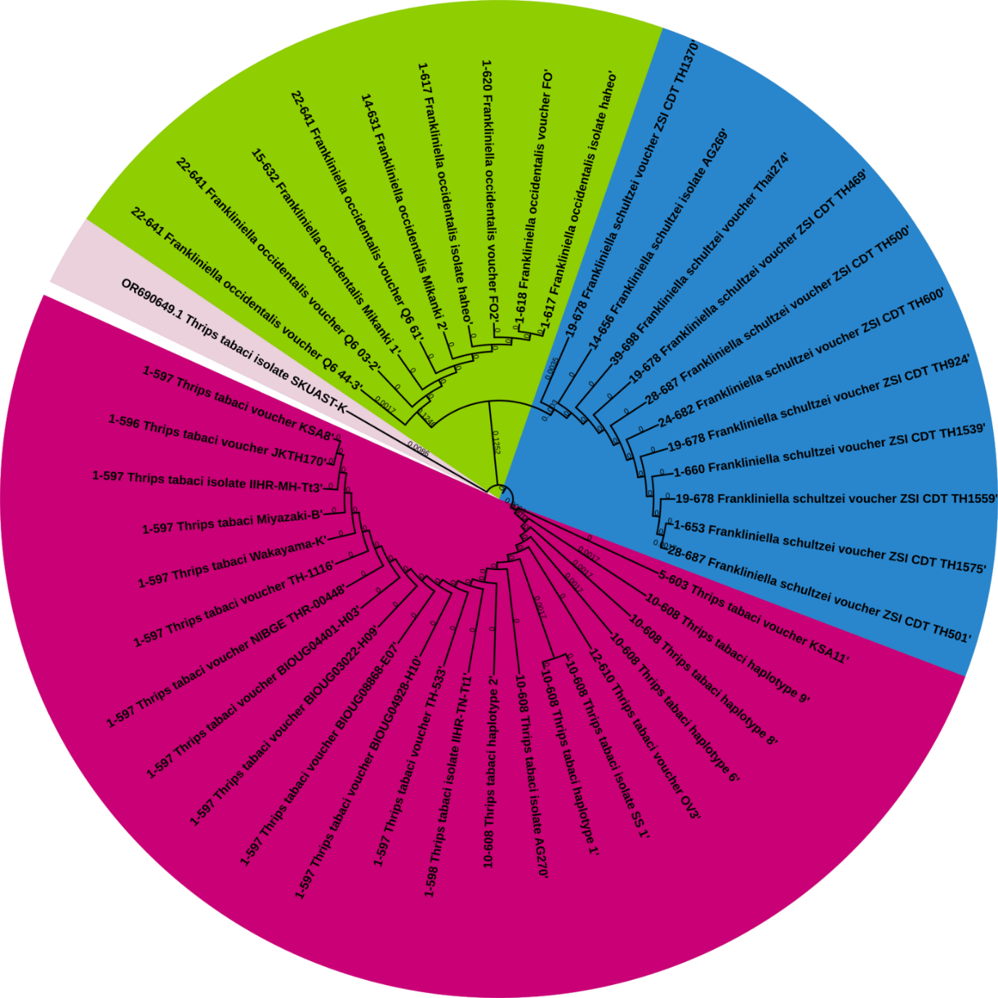

**Fig 1. Phylogeny tree of *Thrips tabaci***

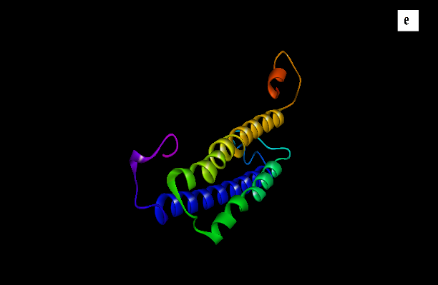

**Fig 2. Three-dimensional structure and Ramachandran plot analysis of the *T. tabaci*****cytochrome c oxidase subunit I, partial protein target**