TOXICITY OF MAGNESIUM SULPHATE IN NILE TILAPIA (*OREOCHROMIS NILOTICUS*)

**Abstract**

Magnesium sulphate commonly known as Epsom salt is used in aquaculture in order to intestinal problems related to digestion or parasites. In the present study an effort was made to understand the toxicity of magnesium sulphate in sub adults of *Oreochromis niloticus* (82± 4.5g). Acute toxicity test by bath treatment was done by exposing the fish to magnesium sulphate at concentrations of 0 gL-1, 10 gL-1 30 gL-1and 60 gL-1as per OECD 203 guidelines for 96 hours. Acute oral toxicity was done as per Limit test of OECD 425 guidelines. After the completion of experimental period, blood was collected and hematological parameters like total leucocytes, erythrocytes, thrombocytes, haemoglobin, haematocrit, mean corpuscular volume and mean corpuscular haemoglobin were estimated. Serum parameters like Aspartate transaminase (AST), Alanine transaminase (ALT), blood urea nitrogen (BUN), and creatinine (CRE) were determined. The antioxidant enzymes like superoxide dismutase, catalase and reduced glutathione in the gill and liver tissue were also estimated. Fish were euthanized and the histopathology of intestine, liver, muscle, gills and heart was done. The toxicity tests by oral and bath administration did not cause mortality in fish with the respective doses. In the bath treatment test, the serum parameters like AST, ALT, CRE and BUN showed significant difference at concentrations above 30gL-1. Histological observations also revealed pathologies in all the tissues at 30gL-1. In oral toxicity tests, there was no significant difference in any of the parameters tested between control and treatment groups. The results revealed that Epsom salt is non-toxic to *O. niloticus*, and can be used as a chemotherapeutant without any toxic effect when administered orally. For bath treatments, the fish can tolerate upto 10gL-1 without any toxic effect.

**Keywords**: Magnesium sulphate, Epsom salt, Nile tilapia, toxicity, therapeutant.

# Introduction

The use of magnesium sulphate as a chemotherapeutant in fish has been less recognized, even though US Food and Drug Administration (FDA) has included this compound among low regulatory priority aquaculture drugs for the treatment of crustacean parasites and external monogenic trematode infestations as bath treatments (FDA, 2001). Further, the use of Epsom salt has been reported for treating intestinal diplomonad parasites like *Hexamita* and *Spironucleus* in chinook salmon and rainbow trout (Yasutake *et al*., 1961; St-Hilaire *et al*., 2015), mainly because magnesium sulphate acts as a laxative in fish. It stimulates the mucosal enterocytes in the intestinal tract to release cholecystokinin, that can increase peristalsis and help in gastric evacuation, including associated parasites (Noga, 1996). But there are very few published reports of its toxicity in fish.

Tilapia, also labelled as aquatic chicken, has emerged to be one of the most productive and internationally traded fish foods in the world (Fitzsimmons and Watanabe, 2010). In India, the species is spread all across the continent due to its prolific breeding and adaptability to wide range of environmental condition. The farming of tilapias in India, especially of Nile tilapia *(Oreochromis niloticus)* fared well in 2020-21 with a 55.83% increase in quantity and a 38.07% gain in US profits compared to the previous year (MPEDA 2021).

One of the important disease that affect Tilapia in culture systems is the hole in the head disease caused by *Hexamita* *sp* , which is of great significance as it causes mass mortality (Morrison *et al*., 2007). Helminth infestation by *Clinostomum sp*., *Acanthocephala* sp. have also been reported in the species (El-Khayat *et al.,* 2024). Epsom salt is a cheap chemotherapeutant which can be used to treat these intestinal parasites. The aim of the present study is to investigate the toxicity of Epsom salt, in Nile tilapia, so as to advocate a dosage for the effective treatment of these intestinal parasites.

1. **Materials and methods**

The present study was conducted to delineate the acute toxicity of magnesium sulphate (MgSO4) in Nile tilapia *Oreochromis niloticus.* Two experiments were conducted to understand the toxicity by bath and oral administration. The 96-hour acute toxicity test by bath treatment was done as per test number 203 of OECD guidelines (OECD, 2019) and the acute oral toxicity test was done as per test number 425 of OECD guidelines (OECD, 2022).

**2.1. Experimental animals**

The experimental study was conducted in a total number of 60 apparently healthy disease-free fishes, (mean body weight 82± 4.5g) that were procured from Karthika fish farm, Cherthala, Kerala, India. The entire study was carried out under adequate management facility, operation, care and maintenance conditions as per the guidelines stipulated by CPCSEA (Committee for the Purpose of Control and Supervision of Experiments on Animals for Experimentation on Fishes, 2021). The experiment was conducted in the wet laboratory of Department of Aquatic Animal Health Management, Faculty of Fisheries Science, Kerala University of Fisheries and Ocean Studies (KUFOS), Panangad, Kochi, Kerala, India. The fish were quarantined for two weeks in 500 L FRP (fiberglass reinforced plastic) tanks with 20 fishes in each tank. During this period, the fish were fed two times daily with a drug-free commercial floating feed based on the biomass (3% of body weight), under static conditions. The daily ration was divided into two equal parts and fed in the morning and evening. Good quality potable water was used throughout the course of experiment and water quality parameters were checked and maintained optimum for the species. The tanks were cleaned and 50% water was exchanged daily.

For both the experiments, 30L glass aquarium tanks were used. The total volume of the water in tanks was maintained at 20L. Round-the-clock aeration was provided. The experimental tanks were cleaned manually and siphoning was done every day to remove the excess feed pellets and faecal matter. An equal volume of clean water replaced the siphoned water. Water quality parameters such as dissolved oxygen pH, alkalinity, hardness and ammonia were checked at the start of experiment and thereinafter every week.

**2.2. Experiment on 96 hr acute toxicity of MgSO4 by bath**

FDA has recommended a dose of 30000 ppm MgSO4 to control monogenic trematode and crustacean parasites in fish (Singh and Singh, 2018). Therefore, the concentrations selected for the acute toxicity test 203 of OECD using MgSO4 include 0 gL-1, 10 gL-1, 30 gL-1 and 60 gL-1. Water quality parameters were tested after the addition of respective doses of MgSO4 in the treatment tanks. The range of water quality parameters are presented in table 1

**Table 1.Water quality parameters in the acute toxicity test with MgSO4**

|  |  |  |  |  |
| --- | --- | --- | --- | --- |
| Water Quality Parameter | Treatment  0 gL-1 | Treatment  10gL-1 | Treatment  30gL-1 | Treatment  60gL-1 |
| pH | 7-7.5 | 7-7.5 | 7-7.5 | 6-6.5 |
| Alkalinity | 122-130 ppm of CaCO3 | 122 ppm of CaCO3 | 146 ppm of CaCO3 | 194 ppm of CaCO3 |
| Dissolved oxygen | 6-9 ppm | 6-9 ppm | 6-7ppm | 6-8ppm |
| Temperature | 25-29°c | 25-29°c | 25-29°c | 25-29°c |
| Ammonia | 0.01-0.05 | 0.01-0.05 | 0.01-0.05 | 0.01-0.05 |
| Salinity | 0ppt | 5ppt | 15ppt | 40ppt |

In the 96 hr acute toxicity study (test No. 203 OECD), seven animals were maintained at 0 gL-1 (control) and 10gL-1, 30gL-1, and 60gL-1 MgSO4 (anhydrous, technical grade SRL Chemicals, India), one animal in each tank of 30L capacity with 20L of water (OECD, 2019). The fish were monitored for abnormal behaviours or distress every four hours. No feeding was done. Water quality parameters were tested at the start of experiment. Blood and tissue samples were collected for haematological and histological studies and antioxidant enzyme analysis.

**2.3. Experiment on acute oral toxicity of MgSO4**

Experimental feed for acute oral toxicity test (test No. 425 OECD MgSO4) was prepared in the Fish Nutrition & Feed Technology Laboratory, KUFOS. Commercial feed was made into powder and the required quantity of MgSO4 (anhydrous, technical grade SRL Chemicals, India) (at the rate of 2000mg per kg body weight of the fish to be given at the rate of 3% of the body weight) dissolved in distilled water was added to it and was made into a dough consistency. Carboxyl Methyl Cellulose (CMC) (1%) was used as a binder. Further, the dough was pressed through a hand pelletizer and dried in room temperature for 36hr and crushed to get uniform-sized pellets. The pellets were stored in airtight plastic containers at room temperature for future use.

Acute oral toxicity of MgSO4 was tested as per test no. 425 of OECD guidelines (OECD, 2022). Ten fish weighing approximately 82 ± 4.5g were maintained as control and another ten as treatment in glass tanks of 30 L capacity at a stocking density of one animal in each tank in 20 L of water. The quarantined and acclimatized fish were starved for 24 hours before starting the experiment and the experimental feed was given for 10 fish (1.5% of body weight) in the treatment tanks on the first day of experiment in the morning and evening. The treatment groups were fed treatment diet for a single day and normal feed for next 13 days. The control fish received normal feed throughout the course of experiment of 14 days. The feed was given two times daily. The water quality parameters were maintained optimum by continuous aeration and 50% water was exchanged daily. After 14 days, blood and tissue samples were collected for haematological, serological and histological studies and antioxidant enzyme analysis. The results of the physiochemical characteristics of the rearing water from treatment tanks with different concentrations of MgSO4 are presented in table 2. All the values were within optimum range.

**Table 2. Water quality parameters in acute oral toxicity test with MgSO4**

|  |  |  |
| --- | --- | --- |
| Water Quality Parameter | 0 mg/kg | 2000 mg/kg |
| pH | 7-7.5 | 7-8 |
| Alkalinity | 122-134 ppm of CaCO3 | 134-115 ppm of CaCO3 |
| Hardness | 115-125 ppm of CaCO3 | 125-130gL-1 of CaCO3 |
| Dissolved oxygen | 6.3-7.2 ppm | 6.2 –6.6 ppm |
| Temperature | 25-29°c | 25-29°c |
| Ammonia | 0.01-0.05 | 0.01-0.05 |
| Salinity | 0ppt | 0ppt |

**2.4. Blood Sampling**

After 96 hours and 14 days of experiment, fishes that survived were anaesthetized by using clove oil (Eugenol) 0.5 mL/L. Blood samples were collected using sterile syringes (2.5 ml, 24 gauge) from caudal vein. The blood sample were collected with the addition of anticoagulant EDTA (Himedia) (1 g EDTA in 10 ml of distilled water, pH 8), in plastic K3 EDTA tubes (Microsidd, India) for haematological analysis and without anticoagulant in 1.5 ml Eppendorf tubes for serum analysis.

**2.4.1. Haematological Parameters**

The whole blood was analyzed for red blood cell count (RBC), white blood cell count (WBC), haemoglobin (HGB), haematocrit (HCT), mean corpuscular volume (MCV), mean corpuscular haemoglobin (MCH) and thrombocyte count (PLT) using Mindray Auto-Veterinary hematology analyzer (BC2800, China).

**2.4.2. Serum Analysis**

Serum was separated from blood by centrifuging at 3300 rpm for 15 min at 4 0C for serum analysis. It was stored at -20°C and used for further analysis. Serum parameters like alanine transaminase (ALT), aspartate transaminase (AST), creatinine (CRE) and, blood urea nitrogen (BUN) were measured using Serum Analyzer (Fuji, Japan) making use of the respective slides supplied for use in the equipment**.**

**2.5. Antioxidant Enzyme Assay**

Antioxidant enzyme activity such as superoxidase dismutase, SOD (Madesh and Balasubramanian, (1998), catalase CAT (Sinha, 1972), Reduced glutathione (GSH) (Sedlak and Lindsay, 1968) in liver and gills of Nile tilapia were analysed. The total protein in the tissue samples were determined by Biurette method. All the units were expressed in Units/mg protein.

**2.6. Histology**

The muscle, liver, gill, intestine and heart tissue of Nile tilapia exposed to different concentrations of magnesium sulphate (MgSO4) were aseptically and carefully removed and fixed in 10% Neutral Formalin Buffer (NBF). The tissues were processed, sections were made and haematoxylin - eosin staining was done (Roberts., 2012). The slides were observed under trinocular microscope (ZEISS, Carl Zeiss India) with camera attached (Leica, Germany) using 100X and 200X magnifications.

**2.7. Statistical Analysis**

All the data are expressed as mean ± standard deviation (Mean ± SD). The data were compared using a one-way analysis of variance (ANOVA). The significance level was set at P < 0.05. Statistical analysis was performed with the software package SPSS 26. Post hoc tests for comparison of means were also done using the same software.

1. **RESULTS**

**3.1. Determination of 96- hour acute toxicity by bath method**

**3.1.1. Cumulative mortality in Nile tilapia treated with MgSO4 by bath**

In the present experiment it was found that up to 60gL-1, the mortality was nil. The fishes seemed to be normal without showing any signs of stress. Since there is no requirement to add the compound more than this concentration in any culture system and the chemical seemed to be non-toxic for the fish, further tests to determine LD50 were not done.

**3.1.2. Haematological and serological analysis of Nile tilapia exposed to MgSO4 by bath**

The haematological and serum parameters of *O. niloticus* when expose different concentration of magnesium sulphate 0 gL-1, 10 gL-1 , 30 gL-1 , 60 gL-1 in the blood of fish from control and treatment groups are presented in table 3. The results obtained in the present study revealed that there is no significant difference (P > 0.05) in haematological parameters but serological parameters showed significant difference (P≤0.05) in haematological and serological parameters due to treatment with MgSO4.

The AST in the serum of Nile tilapia treated with different concentrations of MgSO4 are shown in table no 3. Among the treatments, the value obtained in 60g/L (181.66±5.13 U/l), and 30g/L (137.33±2.5b U/l) are significantly (P≤0.05) higher than that in 0g/L (95±4U/l) and 10g/L of MgSO4 (89±4U/l). The ALT in the serum of Nile tilapia treated with different concentrations of MgSO4 are expressed in table no 3. It can be seen that the values obtained at 10g/L (14±2 U/l) and control (13.66±1.52 U/l) showed no significant difference. But the values obtained at 30g/L (19.66±1.5 Ul) and 60g/L (30.33±1.52 U/l) were significantly higher (P≤0.05) compared to control and at 10g/L.

BUN in the serum of Nile tilapia treated with different concentrations of MgSO4 are depicted in table in 3.The values obtained for control (1.36±0.15 mg/dl), 10g/L (1.33±0.15 mg/dl) and 30g/L (1.35±0.1 mg/dl) were similar. But at 60g/L (1.63±0.15mg/dl) the value obtained was significantly higher. (P≤0.05). The values obtained for creatinine in the serum of Nile tilapia treated with different concentrations of MgSO4 are shown in table in no 3. It can be seen that the values obtained for all the treatment groups were almost similar but was significantly lower than the control (P≤0.05).

**Table 3. Hematological and serological parameters**

|  |  |  |  |  |  |  |
| --- | --- | --- | --- | --- | --- | --- |
| **Parameter** | Treatment  **0 gL-1** | Treatment  **10 gL-1** | Treatment  **30 gL-1** | Treatment  **60 gL-1** | **F value** | **Sig.**  **values** |
| **RBC×106/μl** | 1.67±0.31a | 1.42±0.07b | 1.45±0.07b | 1.53±0.07c | 0.899 | 0.516 |
| **WBC×10³/μl** | 116.35±0.07a | 115.9±0.6b | 114.7±2.1b | 115±1.5b | 1.277 | 0.396 |
| **HGB g/dl** | 8.6±0.42a | 8.35±0.21b | 8.45±0.21b | 8.75±0.07b | 0.891 | 0.519 |
| **PLT×103/μl** | 54.5±0.70a | 52.5±0.70b | 0.70±54.5c | 52.5±0.70b | 1.222 | 0.410 |
| **HCT%** | 18.4±1.34a | 18.4±0.63a | 18.8±0.56a | 19.15±0.07a | 2.000 | 0.256 |
| **MCV (fl)** | 126.15±5.7a | 123.7±0.70 b | 125.65±0.77a | 127.85±0.77a | 0.676 | 0.611 |
| **MCH (pg)** | 58.5±2.12a | 57.5±0.70a | 57±1.41a | 59.5±0.70b | 1.311 | 0.387 |
| **AST (U/l)** | 95±4a | 89±4a | 137.33±2.5b | 181.66±5.1c | 3.470 | <0.001 |
| **ALT (U/l)** | 13.66±1.52a | 14±2a | 19.66±1.5b | 30.33±1.52c | 16.220 | <0.001 |
| **BUN (mg/dl)** | 1.36±0.15a | 1.33±0.15a | 1.35±0.1a | 1.63±0.15b | 19.779 | <0.001 |
| **CRE (mg/dl)** | 0.73±0.04a | 0.27±0.03b | 0.27±0.02b | 0.27±0.01b | 48.531 | <0.001 |

**3.2. Acute oral toxicity of MgSO4 in Nile tilapia**

Acute oral toxicity test performed under the OECD guideline no 425 using normal feed and experimental feed incorporated with 2000mg/kg body weight.

# 3.2.1. Cumulative mortality in Nile tilapia exposed to acute oral toxicity test with MgSO4

In the present experiment it was found that when MgSO4 (2000 mg per kg body weight of fish), was administered through feed, the mortality was nil. So as per OECD guidelines, the compound is non-toxic to fish.

# 3.2.2. Haematological and serological parameters of Nile tilapia exposed to acute oral toxicity test with MgSO4

The haematological and serological parameters of *O. niloticus* when fed with 2000mg MgSO4 per kg body weight of fish are given in table 4. There was no significant difference between the t treatment and the control (P>0.05) in any of the haematological and serological parameters measured such as RBC, WBC, HGB, PLT, HCT, MCV, MCH and serological parameters ALT, AST, BUN, CRE.

# Table 4. Hematological parameters and serological parameters

|  |  |  |  |  |
| --- | --- | --- | --- | --- |
| **Parameters** | **0 mg/kg** | **2000 mg/kg** | **F value** | **Sig values** |
| **RBCx106/μl** | 1.46±0.10 | 1.41±0.10 | 0.149 | 0.709 |
| **WBCx103/μl** | 157.8±14.09a | 149.4±12.10b | 0.2.50 | 0.662 |
| **HGB g/dl** | 9.40±0.46 | 9.44±0.95a | 0.001 | 0.971 |
| **PLTx 103/µl** | 60.60±10.2 | 60.40±10.7 | 0.000 | 0.990 |
| **HCT%** | 19.60±1.69 | 18.80±4.33 | 0.148 | 0.710 |
| **MCV (fl)** | 135.6±10.81 | 132.9±11.76 | 0.147 | 0.711 |
| **MCH (pg)** | 64.62±4.34 | 67.14±6.02 | 0.577 | 0.469 |
| **AST(U/l)** | 130.7±28.9 | 86.00± 21.93 | 1.517 | 0.285 |
| **ALT(U/l)** | 736.66±75.18 | 807.3±98.31 | 0.326 | 0.599 |
| **CRE(mg/dl)** | 0.66±0.13 | 0.33±0.01 | 6.646 | 0.061 |
| **BUN (mg/dl)** | 1.83±0.13 | 1.70±0.12 | 0.571 | 0.492 |

# 3.3. Antioxidant enzyme assay of Nile tilapia treated orally with MgSO4

Activity of antioxidant enzymes such as superoxide dismutase (SOD), catalase (CAT) and reduced glutathione (GSH) in the liver of fish fed with normal diet (control) and feed incorporated with 2000 mg/kg body weight of MgSO4 are given in table 5.There was no significant difference between the treatment and the control (P>0.05)

# Table 5. Antioxidant enzyme activity in the liver of Nile tilapia treated orally with MgSO4

|  |  |  |  |  |
| --- | --- | --- | --- | --- |
| **Parameters** | **Control** | **2000 mg/kg body**  **weight MgSO4** | **F value** | **Sig.** |
| **Superoxide dismutase (U/mg**  **of protein )** | 13.27±2.73 | 22.30 ± 3.01 | 0.267 | 0.262 |
| **Catalase (U/mg of protein )** | 1.60± 0.06 | 1.62 ± 0. 06 | 0.127 | 0.073 |
| **Reduced Glutathione (U/mg of protein)** | 0.04 ± 0.02 | 0.04 ± 0.05 | 0.485 | 0.506 |

# 3.4. Histopathology of Nile tilapia exposed to different treatments with MgSO4

Histology of muscle, liver, heart, and gut of fish in the control and treatment group of acute oral toxicity test was done. In the 96 hr bath treatment, histology of muscle, liver, heart and gills of fish exposed to 0gL-1, 10gL-1, 30gL-1 and 60gL-1 were done. It was observed that in the muscle of fish exposed to 2000 mg/kg body weight MgSO4, there was heavy infiltration of blood cells in the spaces between muscle fiber bundles (Fig. 1B). In the case of fish exposed to bath treatment with 60gL-1 of MgSO4, the muscle bundles were found separated and blood cells were not seen (Fig. 1C). The histological section of liver tissue of the control fish and that treated with 2000 mg/kg body weight MgSO4 are given in fig. 2 A and 2B respectively. It can be observed that the fat globules are very less in the hepatocytes of treatment group. However, there was no sign of necrosis. But in the case of 96 hr bath treatment, there were necrotic areas in the liver and the nucleus was poorly stained at 30gL-1 (Fig. 2 C). At 10gL-1, there was no hepatic pathology (Fig. 2 D). Fig 3 A and 3 B shows the heart tissue of control and treatment groups in acute oral toxicity tests. There was no sign of pathology in the heart tissue. In the case of bath treatment also, at 10gL-1 there was no visible pathology (Fig. 3 C), but at 30gL-1, the tissue architecture was lost and severe necrosis was noted (Fig. 3 D). In the gut tissue sections (Fig. 4 A and B) also there were no pathology in the treated ones and the sections looked similar to that of control fish. The gill tissue of the fish exposed to 96 hr bath treatment at 10gL-1 showed no pathology (Fig. 5 A), but at 30gL-1, hyperplasia, lamellar fusion and loss of secondary lamellae were observed (Fig. 5 B). Thus, in the case of oral toxicity test, apart from some reversible changes in muscle and liver tissues, the dosage 2000 mg per kg body weight of fish was found to be non-toxic, where as in 96 hr bath treatment, a dose of 10gL-1 was found to be safe.

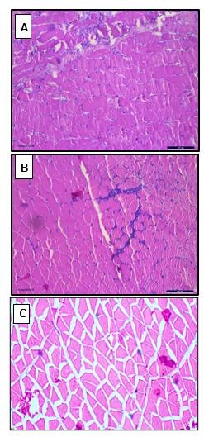

# Fig. 1. Histological section of muscles of Nile tilapia exposed to different treatments with MgSO4 (200x). A. Acute oral toxicity test for control B. Acute oral toxicity test at 2000 mg/kg showing infiltration of blood cells. C. Bath treatment at 30gL-1 separated muscle bundles and absence of blood cells

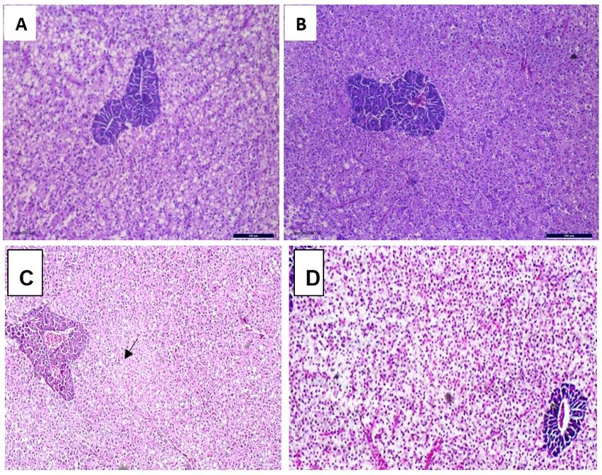

**Fig. 2. Histological section of liver of Nile tilapia exposed to different treatments with MgSO4 (200x). A. Acute oral toxicity test for control B. Acute oral toxicity test at 2000 mg/kg showing lack of fat globules. C. Bath treatment at 30gL-1 showing necrotic areas (arrow) D. Bath treatment at 10gL-1 showing normal structure**

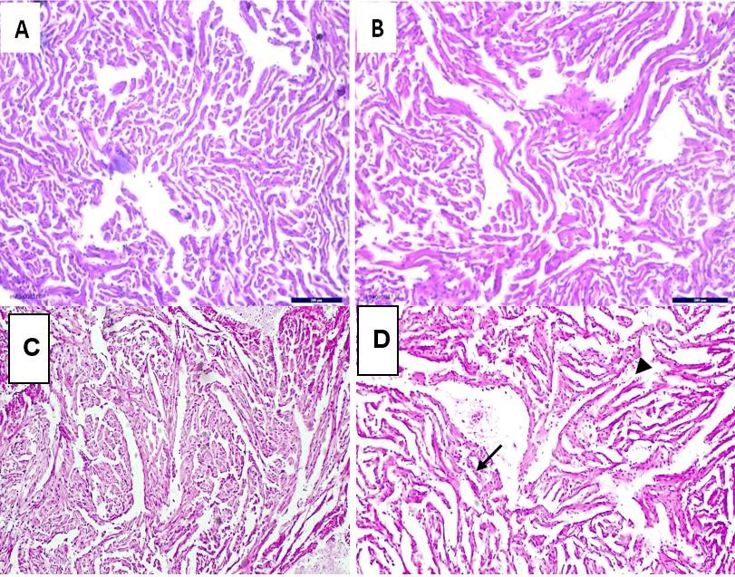

# Fig. 3. Histological section of heart of Nile tilapia exposed to different treatments with MgSO4 (200x). A. Acute oral toxicity test for control B. Acute oral toxicity test at 2000 mg/kg showing absence of pathology. C. Bath treatment at 10gL-1 showing absence of pathology. D. Bath treatment at 30gL-1 showing myocardial atypia (arrow) and necrotic areas (arrow head)

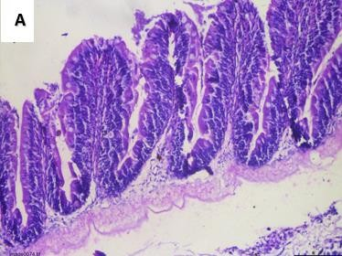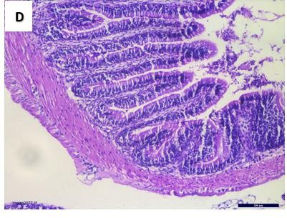

**B**

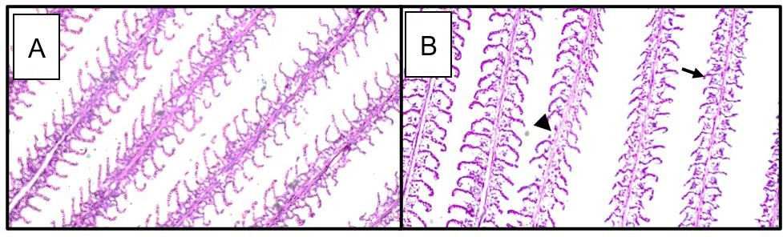**Fig. 4. Histological section of gut of Nile tilapia exposed to acute oral toxicity test with MgSO4 (200X). A. for control and B. At 2000 mg/kg showing no alterations in the tissue.**

# Fig. 5. Histological section of gills of Nile tilapia exposed to 96 hr bath treatment with MgSO4 (200X). A. At 10gL-1 ppm showing absence of pathology B. At 30gL-1 showing hyperplasia, lamellar fusion (arrow) and loss of secondary lamellae (arrow head).

# Discussion

The present study was conducted in order to find the toxicity of Epsom salt or magnesium sulphate in *O. niloticus*. USFDA has included the compound under low priority regulatory drugs to control crustacean parasite and trematode infestation at a concentration of 30gL-1 by bath treatment for 10 minutes. (Singh and Singh, 2018). St-Hilaire *et al*., (2015) reported that *Hexamita* infestation can be controlled by the inclusion of MgSO4 at the rate of 3% in the diet for 2 days. Studies on the toxicity of MgSO4 in fish is very limited. In the present study, two experiments were done. In the 96 hr toxicity tests performed as per OECD guidelines, it was observed that there was no mortality even at a concentration of 60gL-1. Even though salinity increased to 40 ppt and hardness to more than 2000 ppm, there was no signs of stress at a concentration of 60gL-1 for 96 hours. This may be because the species is euryhaline and easily tolerate salinity up to 25ppt (Watanabe *et al.,* 1985). Acute oral toxicity test done as per OECD guidelines also revealed that the compound is non-toxic when given as diet inclusion (2g/kg body weight fed at the rate of 3% of body weight for one day).

The haematological parameters studied including RBC, WBC, PLT, HGB, HCT, MCV and MCH did not show any significant difference between control and treatments in bath treatment test. Similar results were obtained by Siddiqui *et al.,* (2006) in *C. striata*. Serum parameters like AST and ALT showed significant increase at 30gL-1, but the values were similar to control at 10gL-1. Both these enzymes are present in the liver and plays an important role in synthesis and deamination of amino acids during stress imposed conditions for meeting the high energy demand of the organism (Van Waarde *et al.,* 1982). Its increase in the serum may be due to hepatic cells injury or increased synthesis of the enzymes by the liver (Yang and Chen, 2003). The present study indicates liver damage in fish at 30gL-1 MgSO4 when exposed for a period of 96 hrs. The blood urea nitrogen showed no significant difference at 30gL-1 MgSO4 in the 96hr bath treatment. Since gill is the primary organ responsible for the excretion of urea in fish, the results reveals that gill function is normal. At 60gL-1 also there not much difference in the values compared to control. The serum creatinine significantly reduced at high concentrations of MgSO4. The causes of a low serum creatinine concentration may be due to impaired muscle metabolism, liver disease or significant water intake (Udy *et al.,* 2016). The histological studies also revealed damage to liver and muscle at 30gL-1. The gills of fish exposed to this concentration showed mild hyperplasia and loss of secondary lamellae. A concentration of 10gL-1 is safe for fish for 96 hrs.

In the oral toxicity test, it was found that there were no significant difference in any of the parameters tested including histology. Augmentation of antioxidant status of sturgeon after oral treatment with 3% MgSO4 has been reported. (Zhang *et al.,* 2021). In the present study, the SOD and GSH increased as a result of oral treatment with MgSO4, but the difference was not significant. The results suggest that the compound is non- toxic to Nile tilapia and can be administered as a chemotherapeutant along with the diet to control intestinal parasites (St-Hilaire *et al*., 2015)

1. **REFERENCES**

El-Khayat, H. M., Sayed, S. S., Mohammed, W. A., & Sadek, A. S. M. (2024). Protozoan and helminths infestation of Nile tilapia *Oreochromis niloticus* and its correlation with certain water quality variables along river Nile in the area of Greater Cairo. Environmental Pollution, 345, 123459.

FDA. (2001). Aquaculture drugs. Ch. 11. In Fish and Fishery Products Hazards and Controls Guidance. 3rd ed., p. 127-144. Food and Drug Administration, Center for Food Safety and Applied Nutrition, Office of Seafood, Washington, DC.

Fitzsimmons, K. E. V. I. N., & Watanabe, W. O. (2010). Tilapia (family: *Cichlidae*). In Finfish aquaculture diversification (pp. 374-396). Wallingford UK: CABI

Madesh, M., & Balasubramanian, K. A. (1998). Microtiter plate assay for superoxide dismutase using MTT reduction by superoxide. Indian journal of biochemistry & biophysics, 35(3), 184-188.

Morrison, C. M., O'Neil, D., & Wright Jr, J. R. (2007). Histopathology of “hole-in-the-head” disease in the Nile Tilapia, *Oreochromis niloticus*. Aquaculture, 273(4), 427-433.

MPEDA.(2021). India’s Sea Food Export Trade: Issues and Concerns. CONTEMPORARY RESEARCH IN FINANCE, 64.

Noga, E. J. (1996). Fish diseases diagnosis and treatment. ISBN 1-55664-374-8.

OECD (2019), Test No. 203: Fish, Acute Toxicity Test, OECD Guidelines for the Testing of Chemicals, Section 2, OECD Publishing, Paris, https://doi.org/10.1787/9789264069961-en.

OECD (2022), Test No. 425: Acute Oral Toxicity: Up-and-Down Procedure, OECD Guidelines for the Testing of Chemicals, Section 4, OECD Publishing, Paris, https://doi.org/10.1787/9789264071049-en.

Roberts, R. J. (2012). Fish pathology. John Wiley & Sons.

Sedlak, J., & Lindsay, R. H. (1968). Estimation of total, protein-bound, and nonprotein sulfhydryl groups in tissue with Ellman's reagent. Analytical biochemistry, 25, 192-205.

Siddiqui, A., Prakash, M. M., & Patil, V. (2006). Study of effect of Malathion and Magnesium sulphate induced changes in Erythrocytes count of *Channa striatus*. Environment Conservation Journal, 7(3), 9-14.

Singh, M., & Singh, P.(2018). Drugs and chemicals applied in aquaculture industry: A review of commercial availability, recommended dosage and mode of application. J Entomol Zool Stud, 6(6), 903-7.

Sinha, A. K. (1972). Colorimetric assay of catalase. Analytical biochemistry, 47(2), 389-394.

St-Hilaire, S., Price, D., Taylor, S., & Groman, D. (2015). Treatment of diplomonad intestinal parasites with magnesium sulphate at a commercial rainbow trout (*Oncorhynchus mykiss*) facility. The Canadian Veterinary Journal, 56(8), 876.

Udy, A. A., Scheinkestel, C., Pilcher, D., & Bailey, M. (2016). The association between low admission peak plasma creatinine concentration and in-hospital mortality in patients admitted to intensive care in Australia and New Zealand. Critical care medicine, 44(1), 73-82.

Van Waarde, A., &amp; Henegouwen, M. D. W. V. B. (1982). Nitrogen metabolism in goldfish, *Carassius auratus* (L.): Pathway of aerobic and anaerobic glutamate oxidation in goldfish liver and muscle mitochondria. Comparative biochemistry and physiology b-Biochemistry &amp; molecular biology, 72(1), 133-136.

Watanabe, W. O., Kuo, C. M., & Huang, M. C. (1985). Salinity tolerance of Nile tilapia fry (*Oreochromis niloticus*), spawned and hatched at various salinities. Aquaculture, 48(2), 159-176.

Yang J, Chen H. (2003). Serum metabolic enzyme activities and hepatocyte ultra structure of common carp after gallium exposure. Zool stud.;42( 3):455–461.

Yasutake, W. T., Buhler, D. R., & Shanks, W. E. (1961). Chemotherapy of Hexamitiasis in Fish. The Journal of Parasitology, 47(1), 81–86.

Zhang, Y., Fan, Z., Wu, D. . (2021). Dietary magnesium requirement on dietary minerals and physiological function of juvenile hybrid sturgeon (Acipenser schrenckii♀ × Acipenser baerii♂). Aquacult Int 29, 1697–1709.