**Comparative Histological study of the kidney in the domestic dogs and cats**

**Abstract :**

The objective of the present study was to conduct a comparative histological of the renal anatomy in dogs and cats. A sample consisting of twenty healthy adult subjects (ten domestic cats and ten domestic dogs) was utilized for this investigation. The average weight of the local feline population was recorded at 2 ± 0.4 kg, whereas the local canine average weight was significantly higher at 20 ± 3 kg, with both species represented within the age range of one to three years. The histological attributes of the kidneys were examined post-slaughter. The structure of the nephron includes a renal corpuscle and various tubules-proximal straight and convoluted and distal straight and convoluted. Urine formation begins as fluid from the glomerular capsule enters the proximal tubule, which is lined by a simple cuboidal epithelium with a pronounced apical microvilli border. The thin tubule, a continuation of the proximal tubule, is encapsulated in simple squamous epithelium with spherical nuclei. Notably, the Bowman’s capsule serves as the convergence point for the glomeruli, comprising dense connective tissue. Comparative histological analysis identified that the urinary tubule linking to the glomerulus demonstrated greater clarity in feline tissues as opposed to canine tissues. Additionally, proximal tubule channels in cats appeared more dilated compared to those in dogs, and cats exhibited larger nuclei in both proximal and distal tubule cells. Periodic acid–Schiff staining revealed that feline renal tissues were more susceptible compared to their canine counterparts. Furthermore, cats displayed denser and more intensely red renal tissue and connective cells. Interestingly, islands of ascending branches of the loop of Henle were observed amid more densely arranged papillary ducts in feline kidneys, a structural feature that was notably absent in canines.

**Keyword:** kidney, domestic feline, domestic canine, histological structures, P.A.S. stain

**Introduction**

The urinary systems of dogs and cats consist of several key structures including the kidneys, bladder, ureters, and urethra. Positioned on either side of the body, the kidneys reside in the back region, nestled between the ribs and the pelvis. As blood is filtered through the kidneys, it generates a liquid waste product known as urine. The ureters function to transport this urine to the bladder, where it is temporarily stored before being expelled through the urethra, a tubular conduit leading to the outside of the body (Grossman and Sisson, 1975).

In the development stage, both the metanephric blastema and ureteric bud converge to create the nephron and collecting duct (CD), which ultimately develop into the mammalian kidney. Each nephron encompasses essential structures such as Bowman’s capsule, and both ascending and descending loops of Henle, along with proximal tubules (PTs) (Shunnosuke Kira, 2024).

The urinary system divides itself into two segments: the upper urinary tract, comprising the kidneys and ureters, and the lower urinary tract, which includes the bladder and urethra. Serving as a vital organ, the kidney performs multiple roles in filtering and removing waste from the body, producing urine through this filtration process. Beyond waste management, the urinary system also plays a crucial role in maintaining balance in blood pressure, calcium levels, pH, ions, and water in the body. Blood flows to the kidneys through the renal artery, with both organs situated within the abdominal cavity, typically receiving blood supply from paired renal arteries branching off from the abdominal aorta (Dyce et al., 2002).

The kidney operates with a sophisticated system of filtration units, meticulously regulating the amounts of salts, water, and other small compounds in the filtrate. Urine is stored in the bladder until the urinary nerve system signals its release through the urethra during the act of urination (Kira, Shunnosuke, et al.2024)

Each kidney comprises millions of nephrons, the diminutive functional units vital for urine generation and blood filtration. The nephron is composed of renal corpuscles, including the glomerulus and Bowman’s capsule, as well as renal tubules made up of the proximal convoluted tubule, the loop of Henle, and the distal convoluted tubule. The ureter acts as a transport tube, connecting each kidney to the bladder, effectively carrying urine from the kidneys to be stored in the bladder (Lu and Wang, 2014).

**Aim of study**

This study aims to provide a comprehensive comparative histological of the kidneys in domestic dogs and cats.

**Material & Methods**

**Experimental Animals**

Twenty apparently healthy adult animals (ten local cats and ten local dogs) were chosen for this study The mean weight of local cats is ( 2± 0.4 kg) In contrast, the average weight of the local canines is ( 20± 3 kg ) and they are between the ages of 1 and 3 years. Kidney samples were collected from twenty each from normal cats and dogs (males and females), obtained from Basra city. A physical checkup verified each dog's and cat's health. Ten samples of local dogs were taken for the purpose of anatomical study. 10 cats were caught using a special American-made Havahart 1045 trap designed to catch live animals without harming them. These animals were anesthetized with ketamine 10% and xylazine 2% by intramuscular injection. After that, the animals were sacrificed by bleeding in the carotid artery and emptying the blood.. The abdomens of all animals were opened. Than the viscera were removed carefully.

**Photograph(1): of a cat trap model Havahart1045**

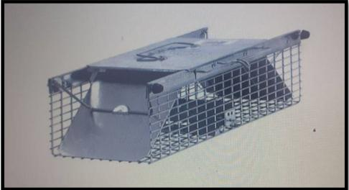

**Sampling Methods for Histological Study**

The kidneys that were taken were cut into slices that were about 5 mm (1 × 1 cm) thick. For The kidneys were preserved in 10% neutral UF formalin for 48 hours in two changes for histological analysis. Hematoxylin and eosin stain was applied to kidney paraffin slices that were 5-7 µm thick. A compound light microscope was used to examine the stained slices. The high-quality digital camera was used to take the microscopic pictures, which were then processed in sections ranging in thickness from 5 to 7 μm and embedded in paraffin. Hematoxylin-eosin (H&E) staining was applied to slices for general histological observations.

**Hematoxylin and Eosin stain (H&E)**

Following ten minutes of xylene removal of the paraffin wax, the section was hydrated for two to three minutes for each concentration of regressive ethyl alcohol (100%-90%-70%-50%), followed by a distal water wash, ten minutes of hematoxylin staining, another distal water wash, and five minutes of eosin staining. The section was then exposed to ethyl alcohol at progressively increasing concentrations (70, 90, and 100 percent) for five minutes at each concentration. It was then moved to xylene for five minutes at each concentration, mounted using Canada balsam, covered with a glass cover, placed on a hot plate, and examined under a light microscope.

**Periodic Acid-Schiff (PAS) stain**

To identify mucopolysaccharides that are acidic Before being immersed in the periodic acid solution for fifteen minutes and rinsed with tap water, the specimen was deparaffinized and washed with water. The specimen was then exposed to sulfite solution after being moved to Schiff reagent for 20 minutes. After two minutes of dehydration with 95–100% alcohol, the sections of two changes were cleaned with xylene. Before being cured in a hot plate, they were coated with glass and treaded with Canada balsam (Bancroft et al., 2013).

**Results**

**Histological study of kidneys in domestic Dog and cat:**

Histologically, The kidney is composed of up of two main sections: the inner section, which is formed up of renal tissue that contains nephrons, which are blood filtering units, and the outer section which has a three-layered, continuous tissue membrane covering it, known as the renal capsule. According to this study, the kidney capsule in dogs is thick Fig (1).

The kidney in dogs is covered in an outer capsule of adipose tissue and has a smooth surface with a single renal papilla. The renal cortex also has a coarsely granular texture and is reddish brown in color Fig (1,2)

There are medullary rays in the kidney's cortex. The distal and proximal convoluted tubules as well as the renal corpuscles are found in the cortex. The medullary rays are composed of straight tubules and the collecting duct. The outer medulla of the kidney contains collecting ducts, thin tubules in the inner strips, and straight tubules. Thin tubules and collecting channels are seen in the inner medulla Fig(1,2 ,5 ,6).

The kidney's structural and functional unit is called the nephron. Thin tubules, proximal straight and convoluted tubules, distal straight and convoluted tubules, and a renal corpuscle make up each nephron. The proximal tubule receives the urine space from the glomerular capsule. A basic cuboidal epithelium with a well-developed apical border of microvilli lines the proximal tubule. The thin tubule, which extends into the lumen and is encircled by simple squamous epithelium with spherical nuclei, is where the proximal tubule continues Fig(1,2 ,5.6).

After passing at the pole of the renal corpuscles The distal tubule emerges as a straight segment from the thin tubule and terminates as the convoluted segment and empties into the collecting duct. The simple cuboidal epithelium lines the distal tubule. The simple cuboidal epithelium covers the collecting duct Fig(1,2,6).

The proximal convoluted tubules have spherical nuclei, brush-bordered epithelium, and large lumens with cuboidal cells. The renal corpuscles are made up of two layers and a tuft of capillaries. Compared to the proximal convoluted tubule, which has apical spherical nuclei, the distal convoluted tubule's cuboidal epithelium, which lacks brush border cells, is smaller and lighter. Large lumens are found in simple columnar epithelial cells that line the collecting duct Fig(1,2,5,6,7).

The proximal and distal convoluted tubules in the kidneys of dogs were more sensitive to eosin staining than those of cats. It shows that the cytoplasm is basic in its ability to receive the acidic stain, eosin. In contrast, the cells in cat tissue responded less severely than those in dog tissue. Dogs' ascending and descending loop of Henle branches were found to include more receptive cells than cats' Fig(1,2 ,7,8 ,11 ,15 ,16).

The thick fibrous capsule (irregular dense connective tissue) that surrounds the kidneys provides protection. Otherwise, the connective tissue between the nephrons is extremely thin. A thick layer of collagen and elastic fiber surrounds the kidney's capsule, whereas loose connective tissue forms comprises the inner layer Fig(11,12,14 ,15).

The inner medulla displays a capsule and a medulla with medullary rays. Bowman's capsule, space, and glomeruli comprise the various renal corpuscles, which differ in size and shape. The Bowman's capsule is equipped with the glomeruli. Tissue that is densely connected forms comprises the capsules Fig(11,12,14,15,16).

The renal corpuscle has a large number of renal tubules. Columnar to low cuboidal cells line the ducts that make up the unique lower portion of A loose stroma of connective tissue separates these tubules. The proximal part of the renal tubules is lined by low columnar to cuboidal and infrequently squamous cells that are difficult to differentiate in the Bowman's gap. Cuboidal epithelium with brush boundaries (PCT) lines a number of tubules, whereas low cuboidal epithelial cells that stain profoundly with eosinophilia line the DCT Fig(11,12,13,14).

The Bowman's capsule is connected to the glomeruli. Dense connective tissue makes up the capsules. The urinary tubule that connects to the glomerulus was found to be clearer in cat tissue than in dog tissue. Furthermore, it was found that cat tissue had more dilated proximal tubule channels than dog tissue. Additionally, it has been found that cats have larger proximal and distal tubule cell nuclei than dogs Fig (1,2,3 ,11,12 ,14).

The kidneys of cats were more sensitive to P.A.S. staining than those of dogs. Compared to dogs, cats have denser and redder renal tissue cells and connective tissue. There are islands of ascending branches of the loop of Henle between the more densely dispersed papillary ducts in cats. The kidney of a dog does not have this structure Fig (5,6,13,14,15).

The glomeruli of cat kidney tissue were shown to be more responsive to the acidic dye P.A.S. dye than those in dog kidney tissue. We saw that cats' collecting ducts were more dilated than dogs' in histological sections Fig.(2,5,6,11,13,14).

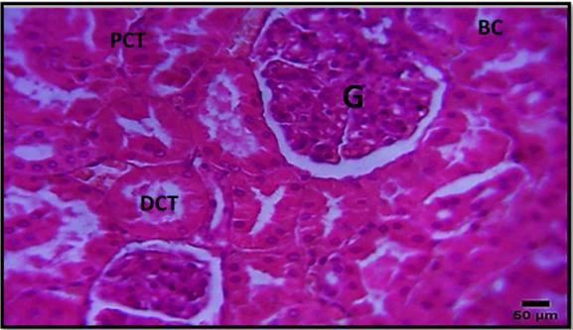

**Figure(1)** **Histological section of cortex shows proximal convoluted tubule (PCT) and glomerulus (G).Bowman's capsule epithelium (BC) and distal convoluted tubule (DCT).400x H&E Stain.**

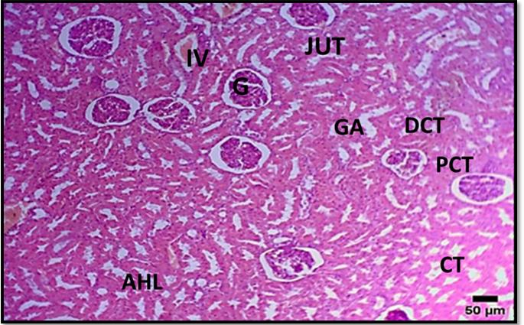

**Figure(2) The glomerulus (G) and proximal Convoluted Tubule (PT) are seen in the histological section of the cortex.collecting tubules (CT) and distal convoluted tubules (DT) GA, or glomerular arteriole vein interlobular (IV) A uriniferous tubule's junction with the Bowman capsule (JUT) Dogs have an ascending branch of the Henley loop (AHL). H&E Stain (100x)**

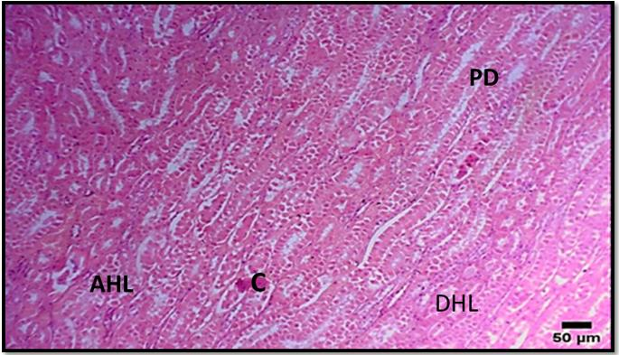

**Figure(3) Longitudinal portion of the kidney dog Show capillary(C) papillary duct (PD) Descending branch of Helens loop(DHL) Ascending branch of Helens loop(AHL) In dog H&E Stain(100x).**

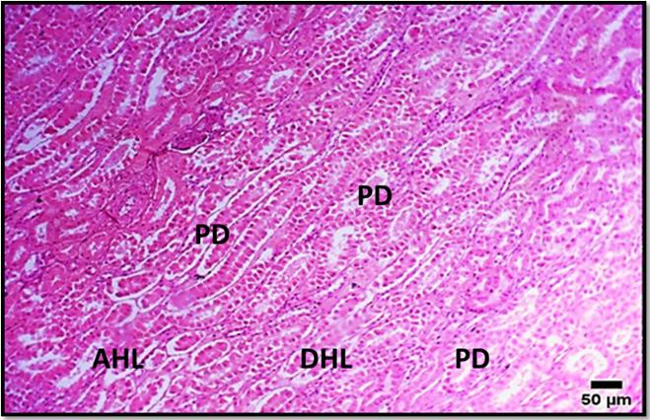

**Figure(4) The kidney's longitudinal segment dog show Ascending branch of Helens loop(AHL) Descending branch of Helens loop(DHL) Papillary duct(PD) In dog H&E Stain(400x).**

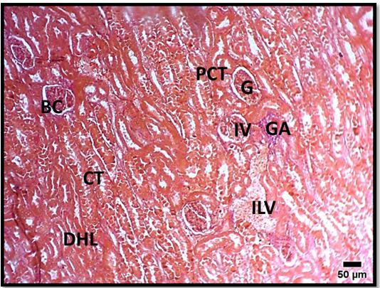

**Figure(5) Histological section of renal cortex shows: glomerulus (G) proximal convoluted tubules (PCT) Interlobular vein(IV) glomerular arteriole(GA) Collecting tubules(CT) Bowman's capsule epithelial lining(BC) Descending branch of Helens loop(DHL) In dog P.A.S Stain(100x)**

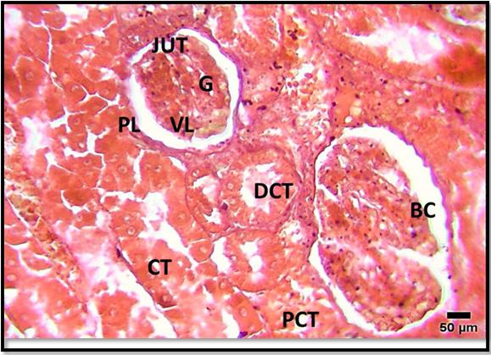

**Figure(6)** **The glomerulus (G), proximal convoluted tubules (PCT), distal convoluted tubules (DCT), and colleting tubules (CT) are visible in the histological section of the renal cortex.Visceral layers of bowman capsule (VL) Parietal layers of bowman capsule(PL) Bowman's capsule epithelia lining(BC) junction of aluminiferous tubule with bowman's capsule(JUT). PAS stain(400x).**

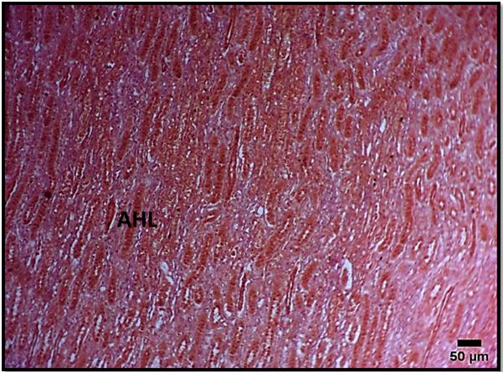

**Figure(7) Histological section of Kidney show Ascending branch of Helens loop Masson stain(100x).**

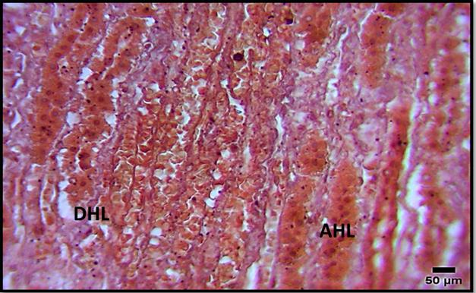

**Figure(8)Histological section of Kidney show Ascending branch of Helens loop (AHL) Descending branch of Helens loop(DHL).Masson stain(400x).**

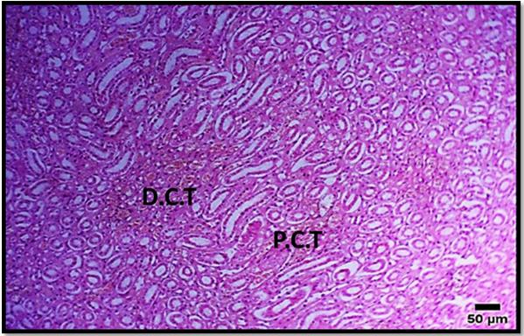

**Figure(9)** **Cat kidney tissue segment (cortex area) shows distal convoluted tables (D.C.T.) and proximal convoluted tubules (P.C.T.) stained with H&E (100x). in cats**

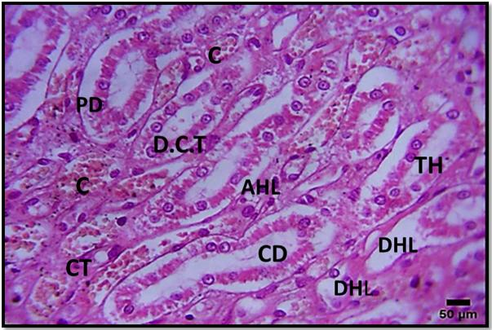

**Figure(10)longitudinal section kidney ducts of medullary region show Capillary(C) Papillary duct(PD) Descending branch of Henley loop(DHL) Ascending branch of Henley (AHL)Connective tissues(CT) In cat. Stain H&E (400X).**

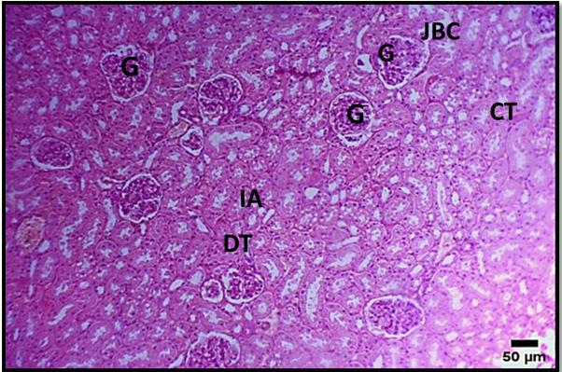

**Figure(11)Histological section of renal cortex shows Glomerulus(G) Junction of aluminiferous tubule with Bowman capsule(JBC) Collecting tubules(CT) Interlobular artery(IA) Distal convoluted tubules(DCT) In cat Stain(100x).**

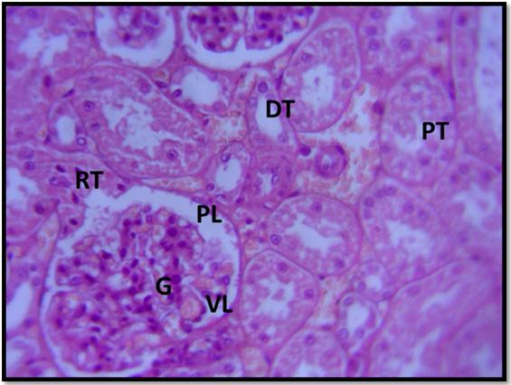

**Figure(12)Histological section of cortex shows glomerulus(G) proximal tubule(PT).distal tubule(DT)collected duct(CT). Renal tubule(RT). Paret layer (PL) ventral layer(VL) stain H&E(400x).**

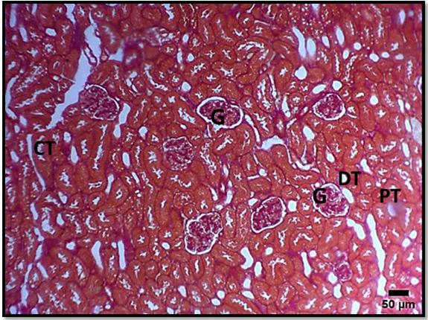

**Figure (13)Histological section of renal cortex shows glomerulus (G) proximal tubule Stain. (PT), distal tubule (DT) . collecting tubule(C T). Masson Stain (100x).**

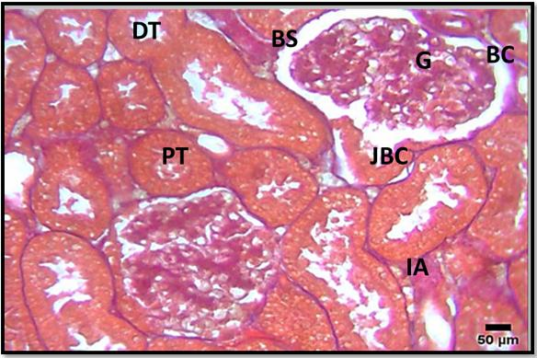

**Figure(14)** **The glomerulus (G) is visible in the renal cortex histological slice. Both the distal and proximal convoluted tubules (PT and DT) Bowman spaces (BS) Bowman capsule epithelium (BC) Uriniferous tubule-bowman capsule junction (JBC) (400x) Interlobular Artery (IA) in cat Masson stain.**

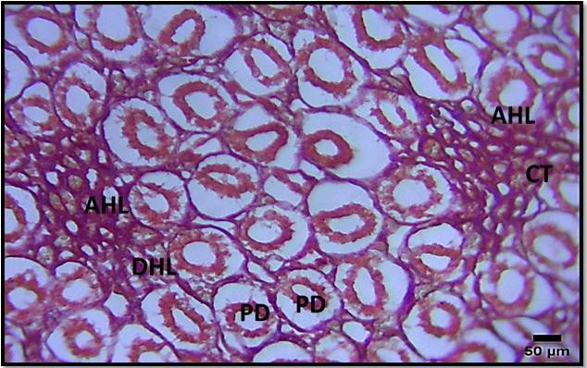

**Figure(15)Histological section Show papillary duct (PD) Descending branch of Henley loop(DHL) Ascending branch of Henley loop(AHL) Connective tissue(CT) In cat P.A.S stain(400x)**

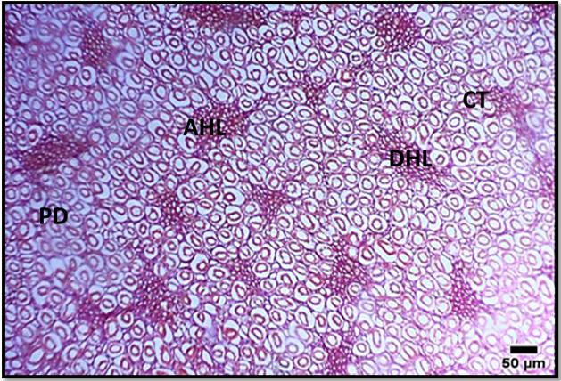

**Figure(16)Histological section Show papillary duct(PD)Descending branch of Henley loop(DHL) Ascending branch of Henley loop(AHL) Connective tissue(CT) P.A.S stain(100x).**

**Discussion**

1. **Histological study in dog.**

The kidneys of dogs are surrounded by a protective layer of fat tissue, creating an outer capsule, while their surfaces are notably smooth and feature a singular renal papilla. The renal cortex exhibits a distinctly coarse granular texture, displaying a reddish-brown hue. This observation aligns with the study conducted by Bundars K.D., McCarthy P.H., and Frike W.E. (2010), which indicated that a dog's kidney possesses a single renal papilla and adopts a bean-like shape with a similarly smooth external appearance.

The renal medulla is divided into two distinct areas: the inner zone, which appears lighter in color, and the outer zone, which is darker. In contrast, the renal cortex exhibits a reddish-brown coloration. This observation aligns with the research conducted by Bundars K.D., McCarthy P.H., and Frike W.E. (2010), who described the kidney of a dog as having a singular renal papilla and possessing a bean-like shape with a smooth exterior.

The cortex of the kidney is characterized by the presence of medullary rays. Within this region, one can observe the distal and proximal convoluted tubules alongside the renal corpuscles. These medullary rays consist of straight tubules and the collecting duct. Moving to the outer medulla, it contains an arrangement of collecting ducts, thin tubules situated in the inner strips, and additional straight tubules. In the inner medulla, one can find both thin tubules and collecting channels.

The kidney is structured into two primary regions: the outer region, enveloped by a robust three-layer membrane known as the renal capsule, and the inner region, which is formed from renal tissue containing the vital blood filtering units called nephrons. A research collaboration involving Ali Faidh Baragoth and others in 2014 revealed that the capsule surrounding the kidneys in dogs possesses considerable thickness. Furthermore, a study byKira, Shunnosuke, et al. in 2024 confirmed that the kidneys are made up of two key components: the cortex and the medulla. The cortex constitutes the larger portion of the kidney and is an intricate assembly of both large and small renal corpuscles. Encased within a substantial capsule, the kidney sheath is primarily composed of dense connective tissue. The renal corpuscles are specifically located in the sub-capsular, mid-cortical, and juxta-medullary zones.

The examination of the kidneys in the dogs studied revealed that these animals possessed a single renal artery. In contrast, the kidneys from other cases exhibited a more complex vascular arrangement, featuring two renal arteries—one positioned dorsally and the other ventrally. This finding stands in contrast to the observations made by Jain and colleagues in 1985, who identified that dogs typically have three renal arteries. Meanwhile, research conducted by Pereira-Sampaio and others in 2004 indicated that pigs are limited to a solitary renal artery. Consequently, it was noted that the kidney structure in dogs is characterized by a higher proportion of long-loop Henle nephrons while showing a diminished quantity of short-loop nephrons. This observation aligns with the assertions of Hall, J.F. in 1979, who suggested that the length of the loop of Henle could be somewhat associated with certain functional adaptations. The current study posits that the structural configuration of dogs’ kidneys, particularly the abundance of renal corpuscles located within the juxtamedullary and midcortical regions, which feature elongated loops of Henle, contributes significantly to these animals' capacity to excrete concentrated urine efficiently.

The nephron serves as the fundamental structural and functional unit of the kidney, comprising a series of delicate tubules: the proximal straight and convoluted tubules, the distal straight and convoluted tubules, along with a renal corpuscle. The proximal tubule is designed to receive urine from the glomerular capsule, where it becomes the starting point for the filtration process. This segment is lined with a simple cuboidal epithelium, characterized by a prominent apical surface adorned with microvilli, enhancing its absorptive capabilities. Following the proximal tubule, a thin tubule extends into the lumen, encased in simple squamous epithelium with rounded nuclei that gracefully complement its structure. The proximal convoluted tubules exhibit a broad lumen, populated with cuboidal cells that are brushed with a border of slender microvilli and feature spherical nuclei, creating a distinctive histological appearance. The renal corpuscles consist of two layers encompassing a tuft of capillaries, playing a critical role in filtration. This observed structure contradicts the findings of Al-Kinanny, A.F. (2006), who reported that the proximal convoluted tubules in buffalo exhibit smaller lumens. However, it aligns closely with the results from Hussin, A.M. (2003) and Al-Salami, N.M.A. (1992), which noted comparable structures in camels. This discrepancy may be attributed to the nature of the diluted urine produced by buffalo, influencing the morphology of their nephron.

Approaching the pole of the renal corpuscles, the distal tubule becomes apparent as it extends in a straight segment from the thin tubule. This segment then transitions into its convoluted portion before draining into the collecting duct. The lining of the distal tubule is comprised of simple cuboidal epithelium, which also envelops the collecting duct.

The distal convoluted tubule is characterized by its cuboidal nuclei and exhibits a smaller and lighter appearance in comparison to the proximal convoluted tubule, which features apical spherical nuclei. The epithelium of the distal tubule lacks the brush border cells that are typically present in other tubular structures. This observation aligns with findings from Eurell J. C. (2004) and Samuelson D. A. (2007), who reported that the collecting duct comprises simple columnar epithelial cells that are associated with a wide lumen.

1. **Histological study in cat.**

In comparison to the medulla's pale brown coloration, the renal cortex stood out with its distinct reddish-brown shade. This observation supported the findings of Bertram et al. (1999) in laboratory rats and Eze (2012) in Wistar rats. Furthermore, these results aligned with the research conducted by El-Salkh et al. (2008) on desert rodents, Al-Samawy (2012) on albino rats, and Diaz and Ojeda (1999) on spiny mice, all of whom remarked on the renal papilla's sharply pointed architecture, its considerable length, and its extension deep into the renal pelvis compared to the associated structures.

Every kidney is structured with three distinct layers: the cortex, which forms the outermost peripheral layer; the medulla, positioned internally; and the renal capsule, a tough fibrous outer covering. The medulla is organized into multiple pyramidal formations that, alongside the adjacent cortex, collectively create a renal lobe, as highlighted in red. In terms of its composition, the kidney consists of three main components: the renal pelvis located in the hilum area, an external cortex, and the centrally located medulla. The hilum is characterized by a concave section of the kidney's bean-like shape, serving as the entry and exit point for blood vessels and nerves, as well as the pathway for the ureters' drainage. Consistent with discoveries made by Nickel et al. (1981) and Aksoy et al. (2004) in Tuj sheep, this study illustrated that the renal arteries identified here arose from both sides of the abdominal aorta. In contrast, Ghoshal (1975) observed that these arteries emerged from the ventral aspect of the ruminant aorta.

The study under consideration indicates that the left renal artery exhibits a greater length than its right counterpart. In feline anatomy, there are two distinct right renal arteries—the right dorsal and right ventral renal arteries—originating from the ventral section of the abdominal aorta, as noted by Indykiewicz and Wiland (1999).

**Reference**

**Al-Samawy, E. R. M. (2012).** Morphological and Histological study of the kidneys on the Albino rats. Al-Anbar J. Vet. Sci., Vol.: 5 No. (1)pp:115-116.

**Al-kinanny, A.F. (2006)**. Anatomical, Histological and Radiological study of the kidney and the ureter of buffalo (*Bubalus bubalis*) in Iraq. M.Sc. thesis, Veterinary medicine, Baghdad University. Pp:54.

**Al-Salami,N.M.A.(1992).**Microscopic study of some parts of urinarysystem in one – humped dromedary camel specially the kidney ,M.Sc. Thesis. science college. Baghdad University .PP:19-30.

**Aslan, K., Kurtul, I., Nazli, M., & Ates, S. (2010).** Morphologic features of the interdigital sinus of the Tuj sheep. *Kafkas Üniversitesi Veteriner Fakültesi Dergisi*, *16*(4).‏

**Bundars K.D., Mcarthy P.H. and Frike W. E. (2010).**Anatomy of kidney:Anatomy of the dog. 6thed, schluterscheverlagese. Germany. pp:62.

**Bancroft, J.D. and Layton, C. (2013)** The Hematoxylin and Eosin. In: Suvarna, S.K., Layton, C. and Bancroft, J.D., Eds., Theory & Practice of Histological Techniques, 7th Edition, Churchill Livingstone of El Sevier, Philadelphia, Ch. 10 and 11, 172-214.

**Bertram, E. H., & Zhang, D. X. (1999).** Thalamic excitation of hippocampal CA1 neurons: a comparison with the effects of CA3 stimulation. *Neuroscience*, *92*(1), 15-26.‏

**Christensen, G.C. 1952.** Circulation of blood through the canine kidney. Am. J. Vet. Res. 13: 236-245.

**Dyce KM, WO Sack and CJG Wensing, 2002.** Textbook of Veterinary Anatomy. 3rd edition, Saunders, Philadelphia.

**Diaz, G. B., & Ojeda, R. A. (1999).** Kidney structure and allometry of Argentine desert rodents. *Journal of Arid Environments*, *41*(4), 453-461.‏

**El-salkh, B.A. ; Zaki ,Z.K ;Basuony , M.I. and Khidr,H.A. (2008):** Anatomical, Histological And Histochemical Studies On Some Organs Of True Desert Rodents In The Egyptian Habitats. Egyptian Journal of Hospital Medicine (2008) Vol., 33: 578– 306.

**Eurell, J.A.and Frappier, B.l. (2006):** Dellmanns Text book of veterinary histology Black well publishing sixth Edition,Ames,USA.pp:50-55.

**Eze, U. C., & Lee, C. H. (2012).** Consumers' attitude towards advertising. *International journal of business and management*, *7*(13), 94.‏

**faidh Baragoth, A., Ghazi, H. A. A. M., & AbdZaid, K. (2014).** Histological study to the nephrons of the kidney in Dogs (Canisfamiliaris) in midlle of Iraq. *Kufa Journal for Veterinary Medical Sciences*, *5*(1), 98-103.‏

**Hall ,J.F.(1979).**Animal anatomy and physiology .Reston publishing Company. Virginia. P:280.

**Hussin, A. M. (2003).** Seasonal Histological changes in kidney of one humped camel Camelus dromedarius in middle of Iraq.

**Jain, P. C. (1985).** The effect of voluntary sell‐off announcements on shareholder wealth. *The Journal of Finance*, *40*(1), 209-224.‏

**Jasim, S. A., Opulencia, M. J. C., Ramírez-Coronel, A. A., Abdelbasset, W. K., Abed, M. H., Markov, A., ... & Mirzaei, R. (2022).** The emerging role of microbiota-derived short-chain fatty acids in immunometabolism. *International Immunopharmacology*, *110*, 108983.‏

**Kira, Shunnosuke, et al.** "Species-specific histological characterizations of renal tubules and collecting ducts in the kidneys of cats and dogs." PloS one 19.7 (2024): e0306479.

**Pereira-Sampaio MA, Favorito LA, Sampaio FJ. 2004**. Pig kidney: anatomical relationships between the intrarenal arteries and the kidney collecting system. Applied study for urological research and surgical training. J Urol 172:2077–2081.

**Salih, A. N. (2024).** Histological and Histochemical Detection for the Gastric gland in Neonatal Wild Rabbit (Oryctolagus Cuniculus) in Iraq. *Wasit Journal for Pure sciences*, *3*(3), 165-171.‏

**Smith, B.J. 1999**. Canine Anatomy. Philadelphia: Lippincott Williams. 441-446.

**Samuelson D. A. (2007).**Textbook of Veterinary histology.1 sted. Saunders and Elsevier, Philadelphia. PP:371-374.

**Shunnosuke Kira,2024**;Species-specific histological characterizations of renal tubules and collecting ducts in the kidneys of cats and dogs. journal library medicine.

**Sisson and Grossman,1975;** Cat Anatomy and Physiology(The Anatomy of Domestic Animals, 5th Edition, Sisson and Grossman, WB Saunders Co., Philadelphia, 1975.).

**Yousif, R. R., & Rabee, F. O. (2019).** Anatomical and histological study of kidney, ureter and urinary bladder in male guinea pig (Cavia porcellus). *The Iraqi Journal of Veterinary Medicine*, *43*(1), 75-84.‏

**Wiland, C., & Indykiewicz, P. (1999).** Multiple renal arteries [aa. renales] in mink and dog. *Electronic Journal of Polish Agricultural Universities. Series Veterinary Medicine*, *2*(2).‏

**Zuasti A**, Jara JR, Ferrer C, Solano F.Pigment Cell Res. 1989 Mar-Apr;2(2):93-9. doi: 10.1111/j.1600-0749.1989.tb00168.x.PMID: 2497451