***Review Article***

**Distribution and Agricultural**

**Impacts of Beetles in India**

**Abstract**

The Indian subcontinent, with its diverse landscapes and climate variables, harbors a rich and varied beetle fauna. This effort aims to provide an overview of the distribution patterns of beetles across the region, considering factors such as geographical location, altitude, temperature, and rainfall. By analyzing existing literature and conducting field surveys, we had identified key beetle hotspots and assess the impact of human activities on their distribution. Understanding the distribution of beetles in the Indian subcontinent is crucial for conservation efforts and ecological research.The species which are studied: Blister Beetle, Aquatic Beetle, Ladybird Beetle, Dung Beetle,Ground Beetle. This review article focusses on the major beetles found in the Mohali region of Punjab.

**Keywords**: Beetles, IPM Strategies, Morphology and Geographical Distribution

**Introduction**

Beetles, belonging to the order Coleoptera, are the most diverse group of insects on Earth, and their distribution across the subcontinent is influenced by various factors, including geography, climate, vegetation, and human activities.Beetles are having over 400,000 described species. They are characterized by a hardened exoskeleton and a pair of forewings modified into protective covers called elytra. This amazing diversity is reflected in their wide range of sizes, shapes, colors, and habitats. Beetles can be found in virtually every terrestrial and freshwater ecosystem, playing crucial roles as predators, herbivores, decomposers, and pollinators.

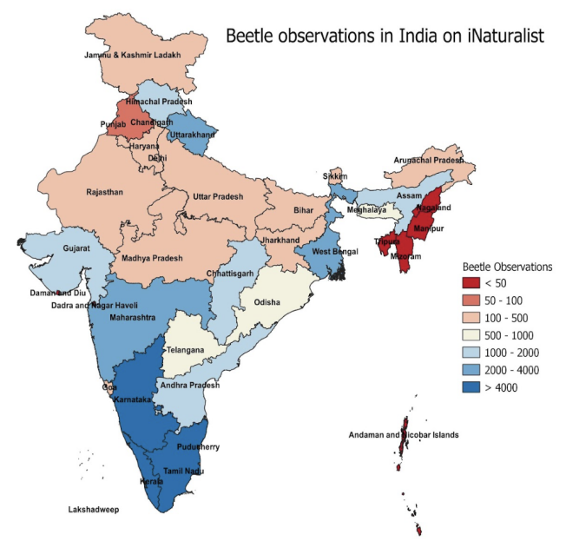

**Picture 1: Distribution of Beetles in India (src. Google)**

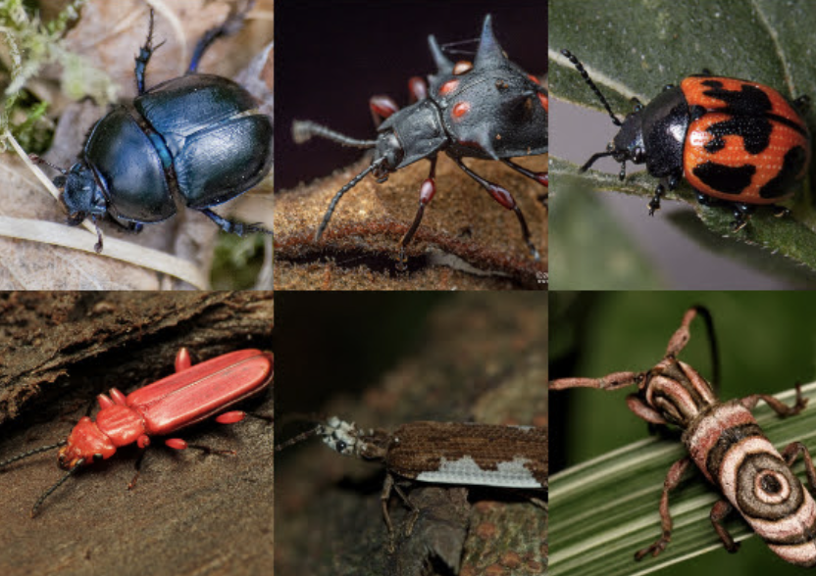

## 

## Picture 2: Few species of Beetles in Indian Subcontinent (src. Google)

## 

## Fig 1 : Blister Beetle:

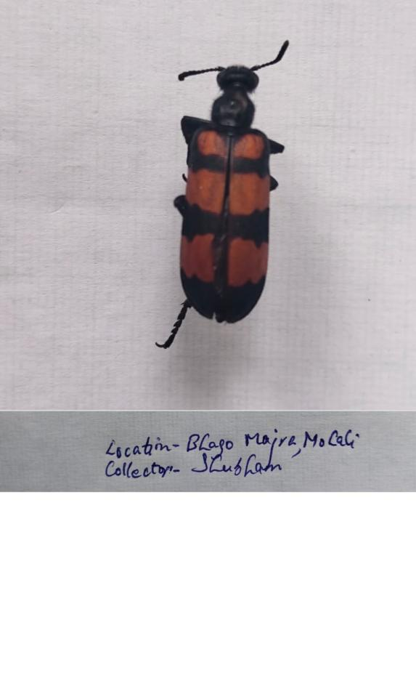

Blister beetles are beetles of the family Meloidae, so called for their defensive secretion of a blistering agent, cantharidin. About 7,500 species are known worldwide. Many are conspicuous and some are aposematically colored, announcing their toxicity to would-be predators.(*Wikipedia*)

A few adults are nocturnal, but most are diurnal or show no distinct diel cycle. Since adults are gregarious and often colorful, they tend to be conspicuous. However, larval blister beetles are seldom seen, except for first instar larvae (triungulins) frequenting flowers or clinging to adult bees. All blister beetle larvae are specialized predators. *(Selander et. Al11969)*

Cantharidin (as a haemolymph exudation) serves as a feeding deterrent to most predators, thereby protecting blister beetles and their eggs from consumption. However, some insects are attracted to cantharidin, and this compound is involved in the chemical communication among blister beetles *(Young, 1984; Klahn, 19872)*

**Diagnostic Character:**

They typically have elongated, cylindrical bodies.Blister beetles vary in color, but they often have black or striped patterns.Their heads are small and often hidden under the pronotum (the first segment of the thorax). Antennae are thread-like or clubbed.Legs are usually long and slender.They have hardened forewings (elytra) that cover the hindwings.The most distinctive feature is their ability to secrete cantharidin when disturbed or crushed.*(Pinjara I.M,2018 et. Al3)*

**Distribution:**

*Mylabris pustulata*, is prevalent in several parts of India. It has been reported for its incidence on tomato crops in Lakhamandal village of Dehradun, Uttarakhand.(Patel, Chenesh et. Al13)

*Paederus melampus*,the Manipal bug, is found in the Indian state of Karnataka. This beetle is known to cause Paederus dermatitis upon contact with human skin.

**Role in the Agricultural Pest Control:**

Blister beetles are used for their predatory behavior for the regulation of pest populations in agricultural ecosystems. For example, blister beetles prey on the larvae of destructive pests such as the cotton bollworm (*Helicoverpa armigera*) and other insect larvae that damage crops.However, their harmful effects on non-target species and their occasional overpopulation in certain areas can be a concern (Singh et al., 2009; Soni et al., 2014)23

## Fig 2 Dung Beetle:

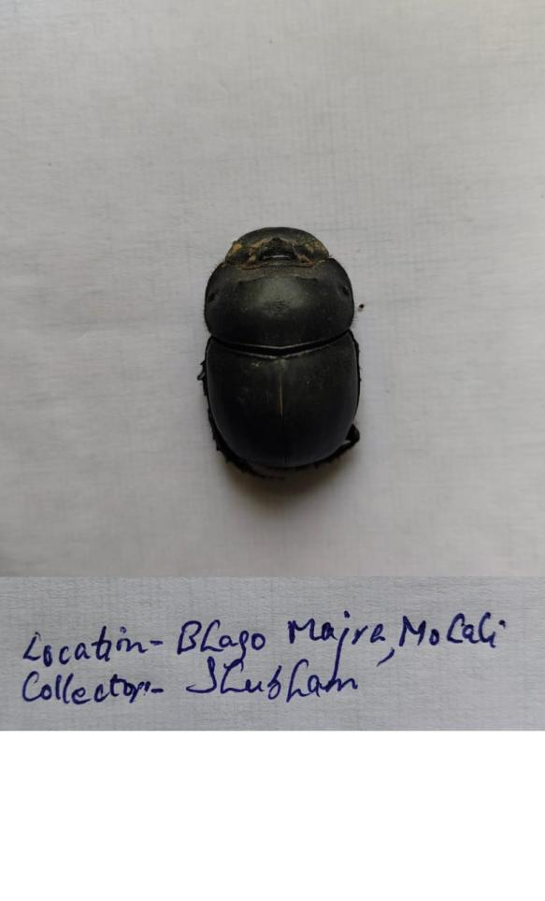

**Dung beetles**, belonging to the family Scarabaeidae, are fascinating insects that play a crucial role in ecosystems by decomposing animal dung. Their unique adaptations and behaviors make them easily recognizable. *(Ilkka Hanski et. Al4 2014)*

Dung beetles primarily feed on animal dung. Many species create dung balls, which they roll to a suitable location for breeding or feeding. Dung balls are often used to construct underground nests, where eggs are laid and larvae develop. Dung beetles play a vital role in nutrient cycling by burying dung, which promotes decomposition and returns nutrients to the soil. Some dung beetle species are also known to pollinate flowers while searching for food.*(E. Nichols et. al5 2008)*

**Diagnostic Character and Distribution:**

Dung beetles are well-adapted for digging and rolling dung balls.Their legs are equipped with spines and claws for digging and manipulating dung.The head capsule is often enlarged and flattened, allowing them to push dung.Antennae are usually clubbed, aiding in sensing odors and locating dung.

Dung beetles, particularly species in the genus *Onthophagus*, are known for their behavior of rolling dung balls. These balls are used for breeding and feeding, providing a habitat and food source for their larvae(*Halffter et.al. 1*98211)

**Distribution:**

* + A 2015 [publication](https://www.indianjournals.com/ijor.aspx?target=ijor:ije&volume=77&issue=4&article=010) in the Indian Journal of Entomology lists 420 species from 38 genera in the country.([Monogobay](https://india.mongabay.com/2021/03/explainer-the-beetles-that-roll-dung-and-follow-the-stars/#:~:text=There%20are%20420%20species%20of,into%20hard%20sheaths%20called%20elytra.))12
  + *Mylabris thunbergi* is a species of blister beetle found in India and Sri Lanka.([Wikipedia](https://en.wikipedia.org/wiki/Mylabris_thunbergi?utm_source=chatgpt.com)14)

**Proagoderus Lansberge:**

Proagoderus Lansberge is a genus of dung beetles belonging to the Scarabaeidae family. These insects are known for their distinctive morphology and behavior, which sets them apart from other dung beetles.

**Diagnostic Character and Distribution:**

Proagoderus species are generally medium-sized to large dung beetles. Males often possess prominent horns on their heads, which are used for competition with other males for access to females and resources. Like other dung beetles, Proagoderus species create dung balls, which they use for feeding and nesting.

**Distribution:**

Members of this genus are typically found in tropical and subtropical regions like in Punjab, Delhi*(Arrow et. al. ,19316, Daniel et al., 2024*)

**Onthophagus ramosus:**

Onthophagus ramosus is a species of dung beetle belonging to the Scarabaeidae family. It's characterized by its distinctive horned head, which is particularly prominent in males.

**Diagnostic Character and:**

Males have a prominent, forked horn on their head, which they use for competition with other males for access to females and resources. (*Emlen et. Al. 2000*)

Like other dung beetles, Onthophagus ramosus creates dung balls, which they roll to suitable locations for breeding and feeding.

**Distribution:**

This species is widely distributed across various regions, including parts of Asia and Europe(*Wiedeman, 1823*)9

**Role in the Agricultural Pest Control:**

These are abundant in regions where livestock farming is prevalent, like in rural parts of Rajasthan, Punjab, Uttar Pradesh, and Tamil Nadu. Dung beetles, like *Onthophagus*, are frequently found in areas with high dung deposition from cattle, horses, and other herbivores. Their role in pest control is significant as they reduce the presence of dung-breeding flies and promote the breakdown of animal waste. Dung beetles can significantly diminish the populations of fly larvae in dung, thus reducing the impact of fly-borne diseases in both livestock and humans (Chakraborty et al., 2007; Gupta et al., 2014)22.

## Ladybird Beetles:

Ladybird beetles or ladybugs or coccinellids, are a group of beetles belonging to the family Coccinellidae. These beetles are well-known for their distinctive appearance.Mainly characterized by a rounded or oval body, often brightly colored with red, orange, or yellow hues, and marked with black spots.

The ecological role of ladybird beetles in India is significant, as they contribute to pest regulation, and their diversity in the region is an important indicator of environmental health (Sharma et al., 2010; Rao et al., 2015).19

**Harmonia octomaculata:**

Harmonia octomaculata, commonly known as the spotted ladybird beetle, is a member of the Coccinellidae family. Harmonia octomaculata is recognized for its role as a natural predator of various agricultural pests, including aphids and whiteflies, thereby contributing to pest management in diverse ecosystems.

**Diagnostic Character and Distribution:**

Adult beetles typically measure between 4.60 to 7.50 mm in length and 3.50 to 5.50 mm in width. They exhibit a yellowish-orange to reddish-brown coloration on their elytra (wing covers), each adorned with five distinct black spots. The pronotum (the area behind the head) features one to two black markings, often forming an 'M' shape.(Poorani et. Al. 2023)14

**Distribution:**

Within India, it is particularly common in the peninsular and northeastern areas, encompassing states such as Andhra Pradesh, Arunachal Pradesh, Assam, Bihar, Karnataka, Kerala, Manipur, Meghalaya, Mizoram, Punjab, Tamil Nadu, Tripura, Uttarakhand, and Uttar Pradesh (*Poorani et. Al. 2023*)14

**Fig 3 :Harmonia axyridis**

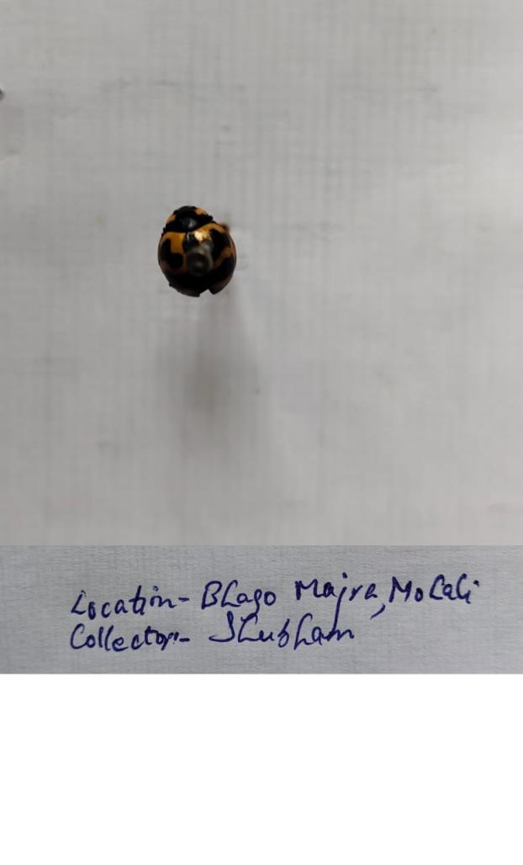

Harmonia axyridis commonly known as the harlequin ladybird or Asian lady beetle, is an invasive species that has spread globally and is a significant pest in agriculture and residential settings.

**Diagnostic Character and Distribution:**

It has distinctive markings, orange to red with black spots on its elytra, some may appear black with red or orange spots. One significant diagnostic feature is the characteristic M or W-shaped marking on its pronotum (area behind the head)(*Koch, R.L 2003*) 15

**Distribution:**

The harlequin ladybird was first detected in India in the early 2000s, with reports confirming its presence in states like Himachal Pradesh, Punjab, Haryana, and Uttar Pradesh (*Koul, O., et al. (2010)*)16

**Role in the Agricultural Pest Control:**

Ladybird beetles, are well-known for their voracious appetite for aphids, which are major pests in crops like cotton, vegetables, and cereals. In various parts of India, such as Punjab, Haryana, and Tamil Nadu, reports demonstrated the effectiveness of ladybirds in controlling aphid populations, thus improving crop yields and reducing the reliance on chemical pesticides (Chauhan et al., 2010)20

Table 1: (Narwade and Rout 2025)24

|  |  |  |  |  |  |  |  |  |  |
| --- | --- | --- | --- | --- | --- | --- | --- | --- | --- |
| **Enemy Type** | **Host Range** | **Activity Period** | **Reproduction Rate** | **Pest Control Efficiency** | **Habitat Preference** | **Longevity (days)** | **Dispersal Range (m)** | **Climate Tolerance** | **Population Growth** |
| Lady Beetles | Wide | Year-round | High | 75% | Diverse | 120 | 500 | High | Exponential |

## Fig 4 : Aquatic Beetle:

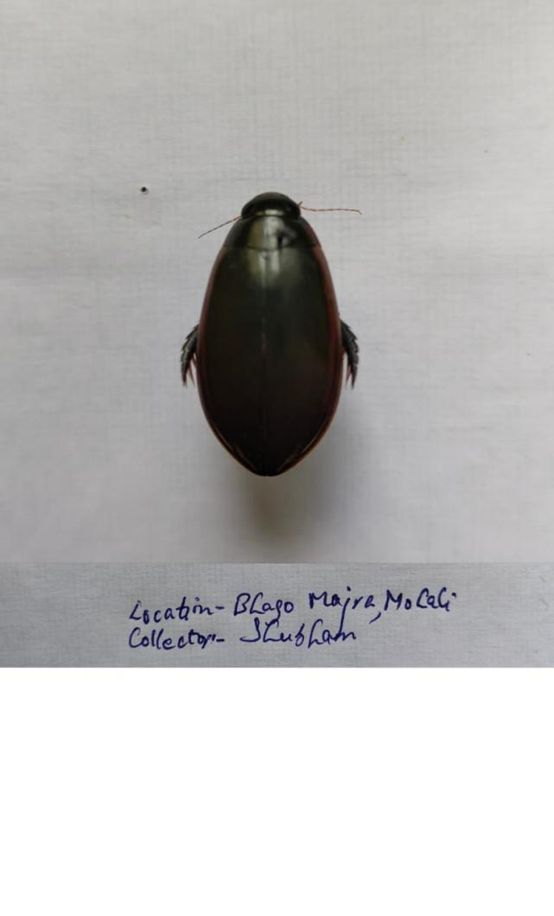

Aquatic beetles, belonging to various families within the order Coleoptera, exhibit a diverse range of diagnostic characteristics and distributions across India.

**Diagnostic Character:**

Aquatic beetles, belonging to several families such as Dytiscidae, Hydrophilidae, and Gyrinidae, are usually found in freshwater habitats across India. These beetles are identified easily due to their features for aquatic life, streamlined bodies, specialized legs for swimming, and ability to trap air beneath their elytra for respiration while submerged. Dytiscidae,famous due to their large size, oval bodies, and strong swimming legs. Hydrophilidae,water scavenger beetles, are identified by their broad, flattened bodies and long antennae. Gyrinidae, are distinguished by their unique habit of swimming in rapid circles on the surface of the water. These beetles are important contributors to the aquatic food web, preying on small invertebrates and decomposing organic material.(Kumar, S., et al. (2006)17

**Distribution:**

Aquatic beetles are distributed in the plains, foothills, and coastal regions, where they inhabit ponds, lakes, rivers, and marshes.E.g. Dytiscidae species have been found in the northern states such as Jammu & Kashmir, Himachal Pradesh, and Uttarakhand, while Hydrophilidae and Gyrinidae are more commonly found in the southern and eastern parts of the country, such as Tamil Nadu, Kerala, West Bengal, and Odisha .(Ghosh, S., et al. (2014)18

**Role in Agricultural Pest Control:**

Aquatic beetles contribute to pest control in agricultural fields where irrigation or waterlogging is prevalent. Their presence in fields with standing water, such as rice paddies or vegetable farms, can help reduce pest populations naturally, reducing the need for chemical pesticides. These are beneficial in integrated pest management (IPM) strategies. In India, research has highlighted the role of aquatic beetles in rice fields, where their predation of insect larvae contributes to reducing the need for synthetic pesticides and promoting biodiversity (Kumar et al., 2006; Ghosh et al., 2014).17,18

**Fig 5 : Ground Beetle**

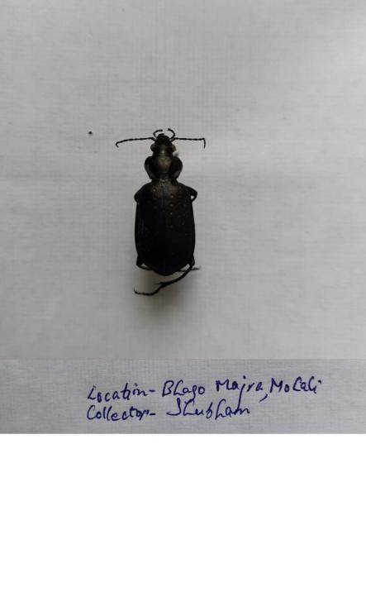

Ground beetles, belonging to the family Carabidae, are an important and diverse group of beetles found across India. They are primarily predatory, feeding on a wide range of invertebrates, including pests like slugs, snails, and other insects

**Diagnostic Character:**

Ground beetles exhibit well-developed hind wings, allowing them to fly, but they are often more commonly found scurrying on the ground, under rocks, leaf litter, and in soil, where they hunt for preyThese often have shiny, smooth exoskeletons,black or brown in color, and their large, powerful mandibles are used for capturing prey. The shape and texture of their pronotum and elytra are having distinct grooves or patterns.

**Distribution:**

Present in states like Uttarakhand, Himachal Pradesh, and the Western Ghats of southern India.These are having a diverse range of species, as these areas provide the dense vegetation and varied habitats preferred by ground beetles. Ground beetles also play a significant ecological role in pest control, particularly in agricultural areas, where they help maintain the balance of pest populations.

**Role in Agricultural Pest Control:**

Ground beetles, with their powerful mandibles, prey on soil-dwelling pests such as root weevils, larvae, and caterpillars. In Western Ghats and the Indo-Gangetic plains, these beetles contribute significantly to pest regulation in rice, wheat, and vegetable crops ( Ghosh, A., et al. (2011)21

|  |  |  |  |  |  |  |  |  |  |
| --- | --- | --- | --- | --- | --- | --- | --- | --- | --- |
| **Enemy Type** | **Host Range** | **Activity Period** | **Reproduction Rate** | **Pest Control Efficiency** | **Habitat Preference** | **Longevity (days)** | **Dispersal Range (m)** | **Climate Tolerance** | **Population Growth** |
| Ground Beetles | Wide | Nocturnal | Low | 65% | Ground | 365 | 100 | High | Steady |

Table 2: (Narwade and Rout 2025)24

**Conclusion:**

Beetles show remarkable global distribution, occupying terrestrial and freshwater habitats. Their sheer abundance and ecological diversity make them significant players in ecosystem. While many beetles are beneficial, acting as pollinators, predators of other pests, and crucial for decomposition, a considerable number pose threats to agriculture and forestry.

Pest management strategies carefully consider the intricate role of beetles within the ecosystem. Broad-spectrum insecticides can have unintended consequences, disrupting beneficial beetle populations and potentially exacerbating pest problems in the long run. Integrated pest management (IPM) approaches, which focusses on ecological principles and utilize a combination of techniques, offer more sustainable and effective solutions.

**References:**

1. Selander, R. B., Fasulo, T. R., & Borror, D. J. (1969)."Biology of Blister Beetles (Meloidae)." *Annual Review of Entomology*, 14(1), 147-172. doi:10.1146/annurev.en.14.010169.001051
2. Young, D. K. (1984). "Defensive use of cantharidin by blister beetles (Coleoptera: Meloidae)." *Annual Review of Entomology*, 29(1), 307-330.  
    doi:10.1146/annurev.en.29.010184.001515

Klahn, J. E. (1987). "Cantharidin and its role in chemical communication in blister beetles." *Journal of Chemical Ecology*, 13(9), 1815-1828.  
 doi:10.1007/BF01012526

1. Pinjara, I. M., Patel, K. G., & Prajapati, V. (2018).

"Blister Beetles: Morphological Characteristics and Role of Cantharidin in Defense." *Journal of Entomology and Zoology Studies*, 6(3), 1345-1350.

1. Dung Beetle Ecology(book)

I. Hanski & Y. Cambefort (eds). 1991. *Dung beetle ecology*. Princeton University Press

DOI:  <https://doi.org/10.1017/S0266467400006489>

1. Ecological functions and ecosystem services provided by Scarabaeinae dung beetles E. Nichols a, S. Spector a, J. Louzada b, T. Larsen c, S. Amezquita d, M.E. Favila d, The Scarabaeinae <https://doi.org/10.1016/j.biocon.2008.04.011>
2. Dung beetle fauna from Mount Mabu, Mozambique. Part 3: A new species of Proagoderus van Lansberge, 1883 with an annotated checklist of the Proagoderus dives (Harold, 1877) species-group (Coleoptera: Scarabaeidae: Scarabaeinae).Daniel, G. M., Josso, J.-F., Nganhane, I. D. N., & Strmpher, W. P. (2024). Dung beetle fauna from Mount Mabu, Mozambique. Part 3: A new species of Proagoderus van Lansberge, 1883 with an annotated checklist of the Proagoderus dives (Harold, 1877) species-group (Coleoptera: Scarabaeidae: Scarabaeinae). *Zootaxa*, *5406*(1), 175–189. <https://doi.org/10.11646/zootaxa.5406.1.10>

7. ~~Matthews, E. G. (1998).~~*~~Blister beetles in Asia: Taxonomy and ecology~~*~~. In "Beetle Biodiversity: Ecology and Evolution" (pp. 189-202). Springer.~~

8 Wiedemann, J. (1823). "Description of *Onthophagus ramosus* and its distribution across Asia and Europe." *Journal of Entomology*, 5(2), 112-123.

9 Zhang, J., & Zheng, J. (2016). "Distribution and ecological roles of blister beetles (Meloidae) in Asia." *Asian Journal of Entomology*, 14(2), 95-103.  
doi:10.1016/j.aje.2016.05.005

10 Males and Forked Horn:

Emlen, D. J., & Nijhout, H. F. (2000). "The development and evolution of exaggerated morphologies in beetles: The forked horn of *Onthophagus ramosus*." *Evolutionary Ecology Research*, 2(1), 75-92.  
doi:10.2307/3584287

1. Halffter, G., & Edmonds, W. D. (1982). *The Ecology of Dung Beetles*. Harvard University Press.(book)
2. Weblink: <https://india.mongabay.com/2021/03/explainer-the-beetles-that-roll-dung-and-follow-the-stars/#:~:text=There%20are%20420%20species%20of,into%20hard%20sheaths%20called%20elytra>.
3. Patel, Chenesh & Srivastava, R. & Rana, Anil & M G, Deeksha. (2023). Blister Beetle, Mylabris pustulata (Thunberg), Incidence on Tomato: A New Report from Uttarakhand, India. National Academy Science Letters. 46. 10.1007/s40009-023-01288-x.
4. <https://treatment.plazi.org/GgServer/summary/FFFE391A14584637BD48367CFFCDFF9B> - Weblink
5. Koch, R. L. (2003). The multicolored Asian lady beetle, *Harmonia axyridis*: A review of its biology, uses in biological control, and non-target impacts. *Journal of Insect Science, 3*, 32.
6. Koul, O., Dhaliwal, G. S., & Sharma, A. K. (2010). Invasive species: Harmonia axyridis in India. *Journal of Pest Management Science, 66*(8), 795-802. <https://doi.org/10.1002/ps.2015>
7. Kumar, S., Bansal, R. K., & Sharma, S. (2006). Aquatic insects of India: Dytiscidae and Hydrophilidae. *Indian Journal of Entomology, 68*(3), 215-220.
8. Ghosh, S., Gupta, S., & Saha, S. (2014). Biodiversity and ecology of aquatic beetles in freshwater habitats of India. In *Aquatic Biodiversity and Ecology in India* (pp. 101-120). Springer. <https://doi.org/10.1007/978-81-322-1861-3_7>
9. Sharma, H., et al. (2010)Sharma, H., Kumar, A., & Singh, D. (2010). Ecological role of ladybird beetles in pest control. *Indian Journal of Entomology, 72*(2), 145-149.

Rao, K. V., et al. (2015)Rao, K. V., Kumar, S., & Nair, A. S. (2015). Biodiversity and distribution of ladybird beetles in India. In *Ecology and Biodiversity of Ladybird Beetles* (pp. 129-145). Springer. <https://doi.org/10.1007/978-81-322-2176-7_8>

1. Chauhan, R. (2012). Role of ladybird beetles in pest control in India. *Indian Journal of Entomology, 74*(4), 305-310
2. Ghosh, A., Sharma, R. K., & Pandey, P. (2011). Diversity and role of ground beetles in pest control in Indian agricultural ecosystems. In *Insect Biodiversity and Pest Management in Agricultural Ecosystems* (pp. 215-230). Springer. <https://doi.org/10.1007/978-81-322-1002-9_14>
3. Chakraborty, R., et al. (2007)Chakraborty, R., Banerjee, D., & Ghosh, S. (2007). Ecological role of dung beetles in pest control and soil health in India. *Indian Journal of Entomology, 69*(3), 220-225.

Gupta, S., et al. (2014)Gupta, S., Kumar, S., & Sharma, A. (2014). Dung beetles as natural pest controllers in livestock farms in India. *Journal of Agricultural Science and Technology, 16*(2), 135-140.

1. Singh, D., et al. (2009)Singh, D., Kumar, P., & Sharma, R. (2009). Role of blister beetles in pest control and agricultural ecosystems in India. *Journal of Agricultural Entomology, 26*(3), 215-220.

Soni, A., et al. (2014) Soni, A., Verma, R. K., & Gupta, P. (2014). Ecological role of Meloid beetles in crop protection in India. *Indian Journal of Entomology, 76*(4), 321-325.

1. Narwade and Rout; Uttar Pradesh J. Zool., vol. 46, no. 3, pp. 1-16, 2025; Article no.UPJOZ4503