**Molecular detection of the seasonal bacterial diversity from a freshwater lake in West Bengal, INDIA**

**Abstract:**

Situated in the northeastern region of Kolkata, WB, Subhas Sarobar is a medium-sized artificial lake that is home to a variety of plants and animals, such as benthos, nekton, zooplankton, bacteria, and phytoplankton, all of which contribute to a balanced and interdependent ecosystem. The water's physic-chemical characteristics are impacted by seasonal variations in temperature, precipitation, and humidity, which could be a factor in the shift in the faunal population. Additionally, household effluents are used in this aquatic system. Thus, in addition to seasonal variations, household discharges, washing clothes and utensils, bathing, and disposing of plastic waste next to the lake water all affect the water's physico-chemical characteristics. The lake's water quality eventually deteriorates as a result of all these human activities. The lake system's low DO and high nutrient content create an ideal habitat for the growth of bacteria, including those that are infectious and could harm public health and other aquatic species. Containing harmful bacteria species in water is dangerous and can lead to a number of health problems, including diarrhea and gastroenteritis with fever, chills, nausea, hypertensive septic shock, secondary lesions, and infection. It may be possible to successfully stop the spread of disease if the traits and specifics of pathogenic bacteria are understood. Several enteropathogenic bacteria, including Shigella, Vibrio, Cholera, Salmonella, Enterobacter, and Yersinia, were identified, isolated, and purified in this study. In a model of live and heat-killed mice, the spread of bacterial zoonotic infections to other animals was found to cause major public health issues for those who are directly or indirectly using this water.

**Kew words:**

Biological tools & techniques, Water quality, Bacterial diversity, Enteropathogenic bacteria, Public Health, Subhas Sarobar, West Bengal.

**1. Introduction:**

The oxygen balance is maintained in lakes, making them the most productive and life-sustaining aquatic habitat. The water cycle and the ecosystem are typically regulated by lakes. In general, freshwater in urban areas has recreational and aesthetic value. Aquatic vegetation, mostly macrophytes from submerged, floating, and emergent categories, makes up the lake ecosystem (**Saha, 2000**). It offers an appropriate surface area for protection, oviposition sites, development, and nesting grounds for macroinvertebrates, Pisces, shellfish, and other aquatic aminals. As "microcosms," or tiny intra-universes, lake ecosystems respond to a wide range of variations in their floral and faunal compositions, which are highly dynamic (**Saha and Basak, 2024**). As a result, limnological methods for studying lakes aid in the evolution of ecosystem ecology as a habitat. Through macrophytic plants, the lake ecology plays a crucial part in naturally preserving the oxygen balance. In 1965, on the 69th anniversary of Netaji Subhas Chandra Bose's birth, Subhas Sarovar, the first artificial lake to be excavated as a recreational area during the 2nd Five Year Plan, was created for recreational purposes. It is located at latitude 220 34′ - 220 34′ 30′′ N and longitude 880 24′ - 880 24′ 30′′ E. Of the Subhas Sarobar's 39.6 hectares total area, about 6.04 ha are submerged in water (**Basak *et al.*, 2024**). Two islands, one small and the other huge, provide an excellent habitat for a wide range of organisms. The lake's mean length and width are 0.584 kilometers and 0.326 kilometers, respectively, while its maximum and mean depths are 10.36 meters and 9.6 meters. This lake, which is around 98 acres in total size (including the water bodies), was designed by the C.I.T. to provide infill material for the construction of this road network (**Khan and Sen, 2002**). About 40 acres of the 100 acres of land were excavated to make the lake. East Calcutta's lungs are Subhas Sarovar or Subhas Lake, whose ecosystem serves as a natural sink by drawing toxins out of the surrounding area. Thus, this lake is crucial to preserving the environment of the city. The two islands and the large body of water, along with the natural surroundings, enhance the biological diversity of the area (**Samal *et al.*, 2004**.). The emergence of the bacterial population and the physico-chemical characteristics of the lake's habitat is being impacted by everyday activities such as bathing, laundry, nutrient input, high plankton, etc. Many causes of water pollution, such as wastes and byproducts, cause natural ecosystems to become contaminated with bacteria and other pathogens, and human use of the water is also impacted. Human activities have been putting a lot of strain on the Subhas Sarobar recently. The facility is used by approximately 3,000 people every day for bathing and washing clothes and utensils (**Basak *et al.*, 2024**). Besides the lake, there is also a solid waste disposal facility that handles plastic. The conditions of the environment, particularly the lake water quality, have gotten worse as a result of all these human activities (**Saha *et al.*, 2001**). The sustainable development of the area's land and aquatic ecosystems is thus threatened by environmental degradation.

* 1. **Physical Status of Freshwater Lake:**

The Lake ecosystem possesses a diverse array of flora and fauna which make it a dynamic aquatic ecosystem (**Figure 1**). East Calcutta's lung, Subhas Sarobar, is a manmade lake managed by the Calcutta Improvement Trust and benefits greatly from the surrounding environment (**Figure 1**). Its latitude is between 220 34′ and 220 34′ 30′′ N and its longitude is between 880 24′ and 880 24′ 30′′. About 6.04 ha of the 39.6 ha total area of the Subhas Sarobar is covered by water. Two islands—one little and the other large—make up a fantastic home for a variety of living things. The total area is 39.6 ha including the lake and the surrounding vegetation of which 16.29 ha. of the area stands for the water body, according to CMC 1986. The total volume of the water body is an average of 634 m3 due to seasonal changes across the year and the mean depth is 4.8m (**Samal *et al.*, 2004**).

**1.2. Physicochemical status of Freshwater Lake:**

Temperature (Hanna, Romania), pH (Hanna, Romania), Dissolve oxygen (Lutron, Taiwan), Salinity (Erma, Japan), Ammonia (Himedia kit), nitrite (Himedia kit), nitrate (Himedia kit), hardness ((Himedia kit), *Vibrio* sp. (Himedia kit), were measured and record for determining the health condition of cultured pond water on the spot instantly and collection of water in bottle for determination of bacterial population and species. Throughout the study period, five sampling locations were designated for the monthly collection of water samples to determine the water quality. One-liter polythene cans were carefully waded into the water to get surface water samples. The analysis was completed through the standard methods (**APHA,1992**) (**Saha, 2000**) (**Table 1**).

**Table 1: Physicochemical Factors** (Adapted from **Khan and Sen, 2002**)

|  |  |
| --- | --- |
| **Physicochemical Factors** | |
| Water temperature(0C) | 30.20C |
| pH | 8.24 |
| Turbidity | 16.42 |
| Conductivity | 417.37 |
| Dissolved Oxygen (ppm) | 5.7 |
| Total alkalinity(mg/lit) | 216.47 |
| Chloride (mg/l) | 42.82 |
| Phosphate (mg/l) | 0.04 |
| Nitrite (mg/l) | 0.12 |
| Nitrate (mg/l) | 0.29 |
| Ammonium (mg/l) | 0.20 |

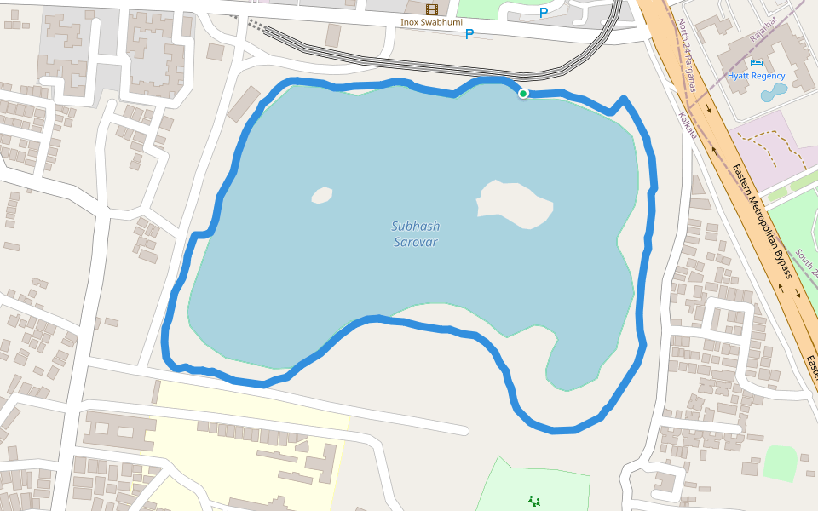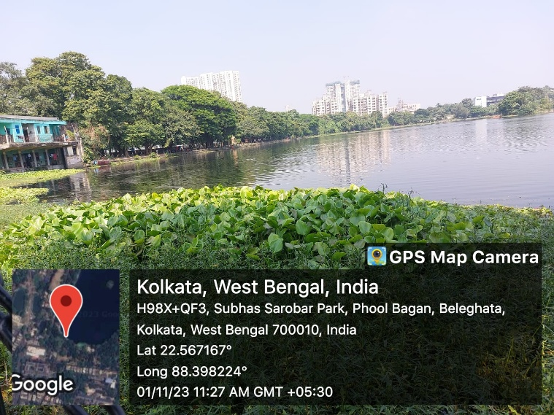

**Figure: 1. Areas of Subhas Sarobar Lake for collection of water samples (5 sites).**

* 1. **Zooplankton Status**: A wide range of zooplankton inhabited the water body among which the Cladocerans are the most dominant followed by rotifers and copepods. Some of the zooplanktons are listed below (**Saha *et al.*, 2001) (Table 1**).

**Table 2: List of few Zooplanktons** (Adapted from Khan *et al.*, 2002)

|  |  |
| --- | --- |
| **Group** | **Name of Zooplankton** |
| Copepoda | 1. *Cyclops* sp. 2. *Mesocyclops* sp. 3. *Heliodiaptomus* sp. |
| Rotifer | 1. *Brachionus* sp. 2. *Testudinella* sp. 3. *Lacane* sp. |
| Cladocera | 1. *Sida* sp. 2. *Moina* sp. 3. *Allona* sp. 4. *Pseudosida* sp. |

**1.4. Bacterial Diversity of The Lake**: The detrimental effects of human activities have increased dramatically in the last few years. The high concentration of nutrients that Subhas Sarabor receives from the surrounding environment as a result of human activity makes it a eutrophic lake. These nutrients contribute to the growth of the lake's phytoplankton and algae populations and decrease the amount of oxygen available for other aquatic organisms. This condition of the water body can give rise to several pathogenic bacteria that can cause serious waterborne diseases in humans (**Dutta *et al*., 2018; Saha *et al*., 2024**) (**Table 3**). Some common freshwater bacteria are Salmonella (Typhoid fever), Shigella (Diarrhoea), Vibrio (frequent diarrhea, and abrupt nausea and vomiting), Escherichia (urinary tract infection), Yersinia (gastrointestinal disorders from moderate diarrhea to inflammation of the mesenteric glands), Tetanus (food poisoning), Aeromonas (Gastroenteritis) (**Cabral, 2010**).

**Table 3: List of few pathogenic bacteria**

|  |  |
| --- | --- |
| **Diseases** | **Causative Bacteria** |
| Cholera | *Vibrio cholerae* |
| Gastroenteritis caused by vibrios | *Vibrio parahaemolyticus* |
| Typhoid fever and other serious salmonellosis | *Salmonella* sp. |
| Bacillary dysentery or shigellosis | *Shigella* sp. |
| Acute diarrheas and gastroenteritis | *Escherichia coli* |
| Gastroenteritis | *Aeromonas* sp. |

**1.5. Factors Responsible for The Lake Pollution**:

One of the biggest problems on the lake's grounds has been the unrestricted access to the lake and its natural resources by the nearby slum dwellers (**Khan and Sen, 2002**). The poor settlements' dependence on the lake's water and nearby resources for everyday necessities has grown as a result of the lack of infrastructure. This includes bathing, fishing in the lake, peeing around its edge, cleaning different cars with the water, dumping rubbish in this body of water, and regularly using the lake's meager water supply to wash clothes and cutlery. One of the primary contaminants of lake water is nonylphenol, which is found in detergents used to clean clothing and cutlery. The lake water is also being contaminated by other substances, such as microplastics and excrement (**Khan and Sen, 2002**). These pollutants pose major risks to human health because they bioaccumulate and get into the human food chain through fish. Phosphate salts, which are abundant in laundry detergents, can contaminate water. This phosphate salt makes the water body eutrophic by stopping organic materials from biodegrading. Eutrophication causes an algal bloom and raises the BOD level, which kills aquatic life. Since people use the lake water on a daily basis, all of these factors combined also encourage the growth of dangerous waterborne bacteria, which poses a major risk to human health (**Khan and Sen, 2002**).

**2. Material and Methods**:

**2.1. Site Selection –**

Water and tissue samples (blood) were collected from five different sites of Subhas Sarobar throughout the year (November 23 to October 2024). The schedule was prepared after collecting information from journals, and articles and after completing pilot field surveys in different sites of Subhas Sarobar Kolkata during pre-monsoon, monsoon, and post-monsoon physical analyses (**Figure 2**). Several aquatic animals (fish and shellfish) and water were collected during the survey for the detection of temperature, pH, dissolved oxygen, salinity, TDS, and nitrogen content (**Saha *et al.*, 2022**). Blood and other organs were examined in aquatic animals (fish and shellfish) to detect bacterial load, infection, and diversity.

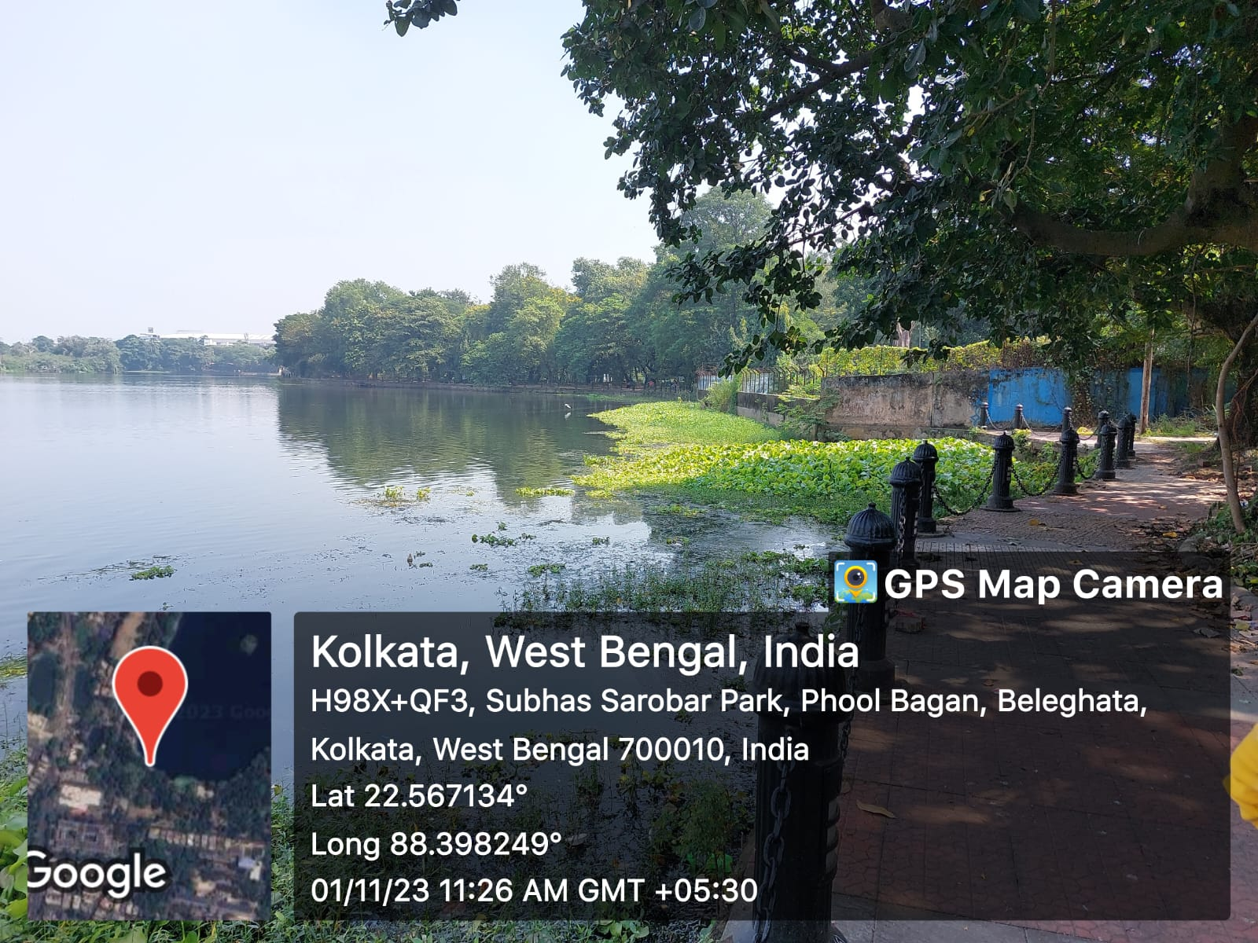

**Figure:2.** Water sample collection in Subhas Sarobar

**2.2. Determination of Water Quality –**

Temperature (Hanna, Romania), pH (Hanna, Romania), Dissolve oxygen (Lutron, Taiwan), Salinity (Erma, Japan), Ammonia (Himedia kit), nitrite (Himedia kit), nitrate (Himedia kit), hardness ((Himedia kit), *Vibrio* sp. (Himedia kit), were measured and record for determining the health condition of cultured pond water on the spot instantly and collection of water in bottle for determination of bacterial population and species. Throughout the study period, five sampling locations were designated for the monthly collection of water samples to determine the water quality. One-liter polythene cans were carefully waded into the water to get surface water samples. The analysis was completed through the standard methods (**APHA,1992**).

**2.3. Physical Detection of Bacteria (Kit Method):**

From the lake, collected water was put into a bacterial identification bottle kit (**Figure 3**). Incubate the bottle for 24 to 48 hr. in an incubator at 350C. The presence of the colour of bacterial colonies helps to recognize water from green to red, pink, blue, and black identity as different bacteria in lake water (**Figure 2**).

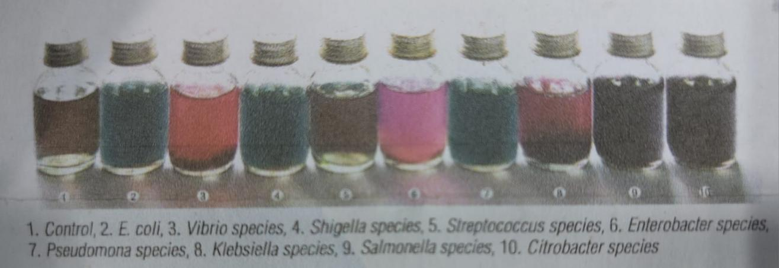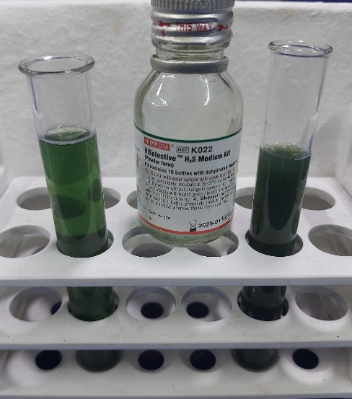

**Fig: 3. Detection of the bacterial population by colour using the kit (Himedia)**

Water samples were collected from the lake and at least 0.1 ml of water sample was taken on prepared microbiological culture media (species-specific) by spread plate method. Observe bacterial colonies after 24 hr. incubation at room temperature (350C) within a bacteriological incubator. The presence of colour or bacterial colonies (droplets) on plates indicates bacterial contamination of water with bacterial sp. The counts of colonies were considered per ml and were calculated by multiplying the average number of colonies per plate by the reciprocal of the dilution factor. The calculated results are expressed as colony-forming units (CFU) per ml of sample. Each colony, separated by colour and size, was counted separately as Colony Forming Unit per 100 µl of blood (CFU / 100µl) thrice and averaged. Then, discrete representatives of each colony type were randomly selected for purification and characterization (**Saha and Dash, 2021; Basak *et al.*, 2024**).

**2.4. Molecular Detection:**

**2.4.1. DNA extraction:**

From the media agar, selected colonies were transferred onto tryptone soy agar and finally purified into TSB after incubating at 350C for 24 hr. After final purification and growth in TSB cultured bacterial samples are to be centrifuged and transferred into a pellet in the bottom of a micro centrifuge tube. The pellet of bacteria was used for genomic DNA isolation by using a bacterial genomic DNA isolation kit according to the manufacturer's protocol. After 70% ethanol wash, followed by centrifugation, the DNA pellet was dissolved in TE buffer and subsequently sored at -200C for further use. The quality and quantity of isolated genomic DNA for each sample are to be evaluated by measuring and calculating the ratio of optical densities at 260 nm and 280 nm wavelengths respectively, using a NanoDropTM spectrophotometer. The aqueous phase contains purified DNA and is to be directly used for subsequent experiments (**Saha and Dash, 2021; Saha Basak, 2024**).

**2.4.2. PCR Amplification and Agarose gel electrophoresis and documentation:**

The PCR reaction is to be carried out by using 100ng of genomic DNA as a template. Each reaction mix contained Phusion reaction buffer with 1 X final concentration, 0.2 U of PhusionTM high fidelity DNA polymerase, 200 µM dNTPs, Forward primer and Reverse primer with a final concentration of 0.5 µM each, and template DNA. Primers are selected from available literature (Mookherjee *et al.*, 2015) (Table 5). The amplification was performed in a thermal cycler (Gene Amp 9700, ABI). After completion of PCR amplification steps, the amplified products are to be analyzed on 1%agarose gels containing 0.5 µg/ml ethidium bromide in 1X Tris-acetate- EDTA (TAE) buffer, and after electrophoresis, the gel is to be visualized and images are to be captured in gel documentation system **(Saha *et al*., 2023**).

**Table: 4. Primer selection of bacteria for freshwater bodies**

|  |  |  |  |  |
| --- | --- | --- | --- | --- |
| **Name of Primer** | **Sequence** | **Product**  **Length (bp)** | **Annealing**  **Temp.** | **Targets sp** |
| 8F  1492R | 5’-AGAGTTTGATCCTGGCTCAG-3'  5’-GGTTACCTTGTTACGACTT-3' | **1600** | 500C  1 min | Universal primer for bacteria |
| 27F  1492R | 5’- AGAGTTTGATCMTGGCTCAG-3’  5’- TACGGYTACCTTGTTACGACTT-3’ | **1500** | 500C  1 min |
| 700F  1325R | 5’-CGGTGAAATGCGTAGAGAT-3’  5’-TTACTAGCGATTCCGAGTTC-3’ | **663** | 570C  45 S | *Vibrio* genus  (16srRNA) |
| Vc-F  Vc-R | GTTCGCGCTGGTGAAGGTTCA TGGCATACCAGAGTCTTTCTGTG | **192** | 570C  1 min | ***Vibrio cholerae*** |
| 16S rDNA-F  16S rDNA-R | 5’-AGAGTTTGATCATGGCTTACGACTT-3’  5’-GGTTACCTTGTTACGACTT-3’ | **1542** | 550C  30 sec | ***Enterobacter* sp.** |
| uidA-F  uidA-R | 5’-AAAACGGCAAGAAAAAGCAG-3’  5’-ACGCGTGGTTAACAGTCTTGCG-3’ | **371** | 550C  30 sec | ***E.coli*** |
| Aero-F  Aero-R | 5’-TGTCGGSGATGACATGGAYGTG-3’ 5’-CCAGTTCCAGTCCCACCACTTCA-3’ | **720** | 550C  30 sec | ***Aeromonas hydrophila*** |
| IpaB-F  IpaB-R | 5′-GGACTTTTTAAAAGCGGC GG-3′  5′-GCCTCTCCCAGAGCCGTC TGG-3′ | **314** | 550C  30 sec | ***Salmonella*** ***enterica*** |
| IpaH-F  IpaH-R | 5’-TGGAAAAACTCAGTGCCTCT-3’ 5’-CCAGTCCGTAAATTCATTCT-3’ | **423** | 550C  30 sec | ***Shigella* sp.** |
| Ail-F  Ail-R | 5’-CTATTGGTTATGCGCAAAGC-3’ 5’-TGGAAGTGGGTTGAATTGC-3’ | **354** | 570C  30 sec | ***Yersinia enterocolitica*** |
| HP-F  HP-R | 5′-TCTGTCTGATTCGCTTTTCTG-3′  5′-AAGCTCGCTAAAAACGACC-3′ | **132** | 540C  5 Sec | ***Helicobacter pylori*** |

**3. Result:**

**3.1. Water Quality Parameter Statistics:**

Water quality parameters were recorded in the following tables to correlate the impact of different stressors leading to disease occurrences. The various water quality parameters like temperature, salinity, hydrogen ion concentration (pH), alkalinity, dissolved oxygen (DO), TDS, ammonia, nitrite, nitrate, etc. of the water determine the survival and multiplication of the bacterial population (Basak *et al.*, 2024). The main reasons for bacterial outbreaks are high organic loads, bad water conditions, and immunological suppression of hosts. Such water parameters influence the abundance of the bacterial population.

**Table: 5. Water parameters of Subhas Sarobar from January to December 2022 (Kolkata, WB)**

|  |  |  |  |  |  |
| --- | --- | --- | --- | --- | --- |
| **Water Parameters** |  | | | | |
| **Site 1** | **Site 2** | **Site 3** | **Site 4** | **Site 5** |
| **Temperature (0C)** | 34±4 | 34.5±4 | 34.2±5 | 32.5±5 | 32.2±5 |
| **pH** | 8.7±3 | 8.2±2 | 8.5±3 | 8.5±4 | 8.2±3 |
| **Salinity (ppt)** | 0.0106±0.21 | 0.0106±0.24 | 0.0105±0.20 | 0.0106±0.24 | 0.0105±0.21 |
| **Alkalinity (ppm)** | 125±25 | 139±30 | 147±26 | 135±27 | 141±29 |
| **DO2 (mg / L)** | 5.3±1.4 | 6.1±3 | 6.5±1.8 | 5.7±2.8 | 5.8±4 |
| **DCO2 (mg / L)** | 8±2 | 9±2.5 | 8±3 | 9±4.1 | 9±3.9 |
| **TDS (ppm)** | 160±30 | 148±26 | 150±28 | 155±18 | 160±28 |
| **Ammonia (mg / L)** | 0.5±0 | 0.5±0 | 0.5±0 | 0.5±0 | 0.5±0 |
| **Nitrite (mg/L)** | 0.5±0 | 0.5±0 | 0.5±0 | 0.5±0 | 0.5±0 |
| **Nitrate (mg / L)** | 0 | 0 | 0 | 0 | 0 |
| **Bacteria (+ / -) by kit** | +++ | +++ | +++ | +++ | +++ |

**Table:6. Water parameters of Subhas Sarobar on August & September, 23 (Kolkata, WB)**

|  |  |  |  |  |  |  |
| --- | --- | --- | --- | --- | --- | --- |
| **Water Parameters** | **Visit Subhas Sarobor**  **Date: August & September, 23** | | | | | |
| **Site 1** | **Site 2** | **Site 3** | **Site 4** | **Site 5** | **Average** |
| **Temperature (0C)** | 34 | 34.5 | 34.2 | 32.5 | 32.2 | **33.34** |
| **pH** | 8.7 | 8.2 | 8.5 | 8.5 | 8.2 | **8.42** |
| **Salinity (ppt)** | 0.0106 | 0.0106 | 0.0105 | 0.0106 | 0.0105 | **0.0105** |
| **Alkalinity (ppm)** | 125 | 139 | 147 | 135 | 141 | **137.4** |
| **DO2 (mg / L)** | 5.3 | 6.1 | 6.5 | 5.7 | 5.8 | **5.88** |
| **DCO2 (mg / L)** | 8 | 9 | 8 | 9 | 9 | **8.6** |
| **TDS (ppm)** | 160 | 148 | 150 | 155 | 160 | **154.6** |
| **Ammonia (mg / L)** | 0.5 | 0.5 | 0.5 | 0.5 | 0.5 | **0.5** |
| **Nitrite (mg/L)** | 0.5 | 0.5 | 0.5 | 0.5 | 0.5 | **0.5** |
| **Nitrate (mg / L)** | 0 | 0 | 0 | 0 | 0 | **00** |
| **Bacteria (+ / -) by kit** | + | + | + | + | + | + |

**Table: 7. Water parameters of Subhas Sarobar on October & November, 23 (Kolkata, WB)**

|  |  |  |  |  |  |  |
| --- | --- | --- | --- | --- | --- | --- |
| **Water Parameters** | **Visit Subhas Sarobor**  **Date: October & November, 23** | | | | | |
| **Site 1** | **Site 2** | **Site 3** | **Site 4** | **Site 5** | **Average** |
| **Temperature** | 29.6 | 31.6 | 30.5 | 32 | 30.2 | **30.78** |
| **pH** | 6.5 | 8.8 | 8.5 | 7.9 | 8.2 | **7.98** |
| **Salinity (ppt)** | 0.010 | 0.010 | 0.010 | 0.010 | 0.010 | **0.010** |
| **Alkalinity (ppm)** | 125 | 135 | 140 | 130 | 140 | **134** |
| **DO2 (mg / L)** | 5.8 | 4.6 | 6.8 | 5.7 | 6.2 | **5.82** |
| **DCO2 (mg / L)** | 9 | 9 | 8 | 9 | 8 | **8.6** |
| **TDS (ppm)** | 171 | 217 | 171 | 180 | 180 | **183.8** |
| **Ammonia (mg / L)** | 0.5 | 0.5 | 0.5 | 0.5 | 0.5 | **0.5** |
| **Nitrite (mg/L)** | 0.5 | 0.5 | 0.5 | 0.5 | 0.5 | **0.5** |
| **Nitrate (mg / L)** | 0 | 0 | 0 | 0 | 0 | **00** |
| **Bacteria (+ / -) by kit** | + | + | + | + | + | + |

**Table: 8. Water parameters of Subhas Sarobar on December & January, 23 (Kolkata, WB)**

|  |  |  |  |  |  |  |
| --- | --- | --- | --- | --- | --- | --- |
| **Water Parameters** | **Visit Subhas Sarobor**  **Date: December & January, 2023** | | | | | |
| **Site 1** | **Site 2** | **Site 3** | **Site 4** | **Site 5** | **Average** |
| **Temperature** | 25.8 | 24.8 | 24.3 | 25.1 | 24.8 | **24.96** |
| **pH** | 7.3 | 7.4 | 8.1 | 7.8 | 7.4 | **7.6** |
| **Salinity (ppt)** | 0.011 | 0.010 | 0.010 | 0.011 | 0.011 | **0.010** |
| **Alkalinity (ppm)** | 118 | 125 | 139 | 130 | 140 | **130.4** |
| **DO2 (mg / L)** | 5.8 | 5.7 | 6.2 | 5.8 | 5.7 | **5.84** |
| **DCO2 (mg / L)** | 8 | 9 | 9 | 9 | 9 | **8.8** |
| **TDS (ppm)** | 220 | 171 | 217 | 171 | 180 | **191.8** |
| **Ammonia (mg / L)** | 0.5 | 0.5 | 0.5 | 0.5 | 0.5 | **0.5** |
| **Nitrite (mg/L)** | 0.5 | 0.5 | 0.5 | 0.5 | 0.5 | **0.5** |
| **Nitrate (mg / L)** | 0 | 0 | 0 | 0 | 0 | **00** |
| **Bacteria (+ / -) by kit** | + | + | + | + | + | + |

**Table: 9. Water parameters of Subhas Sarobar on February & March, 24 (Kolkata, WB)**

|  |  |  |  |  |  |  |
| --- | --- | --- | --- | --- | --- | --- |
| **Water Parameters** | **Visit Subhas Sarobor**  **Date: February & March, 2024** | | | | | |
| **Site 1** | **Site 2** | **Site 3** | **Site 4** | **Site 5** | **Average** |
| **Temperature** | 20.2 | 21 | 20.9 | 21.9 | 21.8 | **21.2** |
| **pH** | 10.2 | 7.4 | 7.4 | 7.6 | 8 | **8.1** |
| **Salinity (ppt)** | 0.02 | 0.02 | 0.02 | 0.02 | 0.02 | **0.02** |
| **Alkalinity (ppm)** | 125 | 123 | 120 | 130 | 140 | **127.6** |
| **DO2 (mg / L)** | 3.8 | 3.7 | 10.5 | 8.5 | 9 | **7.1** |
| **DCO2 (mg / L)** | 09 | 09 | 08 | 09 | 08 | **8.6** |
| **TDS (ppm)** | 228 | 188 | 188 | 197 | 173 | **194.8** |
| **Ammonia (mg / L)** | 0.5 | 0.5 | 0.5 | 0.5 | 0.5 | **0.5** |
| **Nitrite (mg/L)** | 0.5 | 0.5 | 0.5 | 0.5 | 0.5 | **0.5** |
| **Nitrate (mg / L)** | 0 | 0 | 0 | 0 | 0 | **00** |
| **Bacteria (+ / -)** | + | + | + | + | + | **+** |

**Table: 10. Water parameters of Subhas Sarobar on April & May, 24 (Kolkata, WB)**

|  |  |  |  |  |  |  |
| --- | --- | --- | --- | --- | --- | --- |
| **Water Parameters** | **Visit Subhas Sarobor**  **Date: April & May, 2024** | | | | | |
| **Site 1** | **Site 2** | **Site 3** | **Site 4** | **Site 5** | **Average** |
| **Temperature** | 29.0 | 29.6 | 28.6 | 28.5 | 29.1 | **28.9** |
| **pH** | 7.5 | 8.4 | 7.5 | 8.4 | 7.5 | **7.81** |
| **Salinity (ppt)** | 0.0106 | 0.0106 | 0.0105 | 0.0106 | 0.0105 | **0.0105** |
| **Alkalinity (ppm)** | 118 | 117 | 118 | 115 | 117 | **117** |
| **DO2 (mg / L)** | 5.78 | 5.6 | 5.5 | 5.7 | 5.6 | **5.6** |
| **DCO2 (mg / L)** | 8 | 8.1 | 7.9 | 8 | 7.8 | **7.9** |
| **TDS (ppm)** | 287 | 285 | 286 | 287 | 286 | **286.2** |
| **Ammonia (mg / L)** | 0.5 | 0.5 | 0.5 | 0.5 | 0.5 | **0.5** |
| **Nitrite (mg/L)** | 0.5 | 0.5 | 0.5 | 0.5 | 0.5 | **0.5** |
| **Nitrate (mg / L)** | 0 | 0 | 0 | 0 | 0 | **00** |
| **Bacteria (+ / -)** | + | + | + | + | + | **+** |

**Table: 11. Water parameters of Subhas Sarobar on June & July, 24 (Kolkata, West Bengal)**

|  |  |  |  |  |  |  |
| --- | --- | --- | --- | --- | --- | --- |
| **Water Parameters** | **Visit Subhas Sarobor**  **Date: June & July, 2024** | | | | | |
| **Site 1** | **Site 2** | **Site 3** | **Site 4** | **Site 5** | **Average** |
| **Temperature** | 35.4 | 34 | 34.3 | 35.1 | 34.9 | **34.7** |
| **pH** | 7.62 | 6.9 | 7.88 | 8.1 | 7.88 | **7.7** |
| **Salinity (ppt)** | 0.0106 | 0.0106 | 0.0105 | 0.0106 | 0.0105 | **0.0105** |
| **Alkalinity (ppm)** | 119 | 120 | 118 | 120 | 119 | **119.2** |
| **DO2 (mg / L)** | 6.88 | 6.2 | 6.5 | 6.6 | 6.7 | **6.57** |
| **DCO2 (mg / L)** | 09 | 09 | 08 | 09 | 08 | **8.6** |
| **TDS (ppm)** | 334 | 330 | 332 | 334 | 335 | **333** |
| **Ammonia (mg / L)** | 0.5 | 0.5 | 0.5 | 0.5 | 0.5 | **0.5** |
| **Nitrite (mg/L)** | 0.5 | 0.5 | 0.5 | 0.5 | 0.5 | **0.5** |
| **Nitrate (mg / L)** | 0 | 0 | 0 | 0 | 0 | **00** |
| **Bacteria (+ / -)** | + | + | + | + | + | **+** |

Physico-chemical parameters of the lake water are shown in Table 5-11. From the table, it was observed that during the study period (9 months), all the physico-chemical parameters except Ammonia, Nitrite, and Nitrate show monthly variations. In the months of May- June temperature of the lake water was maximum (34.70C) and in the months of January- February it showed the minimum value (21.20C). pH value was highest in the month of October (8.42) and least in December (7.6). The value of TDS was max in May- June (333 ppm) and minimum in October (154 ppm). Total alkalinity showed the highest value in October (137 ppm) and least value in March- April (117 ppm). The highest D.O. value was shown in January-February (7.1 mg/L) and the least in November (5.82 mg/L). Dissolve CO2 value was highest in December (8.8 mg/L) and least in March- April (7.9 mg/L). The total hardness value almost remained the same throughout the year.

**Table: 12. Comparative study of water parameters of Subhas Sarobar among Pre-Monsson, Monsoon, and Post Monsoon)**

|  |  |  |  |
| --- | --- | --- | --- |
| **Water Parameters** | **Visit Subhas Sarobor (Pre-Monsson, Monsoon and Post Monsoon)** | | |
| **Pre-Monsson** | **Monsoon** | **Post Monsoon** |
| **Temperature** | 28.9 | 24.7 | **33.34** |
| **pH** | 7.8 | 7.7 | **8.42** |
| **Salinity (ppt)** | 0.0105 | 0.0105 | **0.0105** |
| **Alkalinity (ppm)** | 117 | 119.2 | **137.4** |
| **DO2 (mg / L)** | 5.6 | 6.57 | **5.88** |
| **DCO2 (mg / L)** | 7.9 | 8.6 | **8.6** |
| **TDS (ppm)** | 286.2 | 333 | **154.6** |
| **Ammonia (mg / L)** | 0.5 | 0.5 | **0.5** |
| **Nitrite (mg/L)** | 0.5 | 0.5 | **0.5** |
| **Nitrate (mg / L)** | 0 | 0 | **0** |
| **Bacteria (+ / -)** | +++ | +++++ | **+** |

Dissolved oxygen, TDS showed maximum values in monsoon season, whereas pH, alkalinity shows higher values in post monsoon. Ammonia, Nitrite and nitrate remain unchanged throughout the season.

**3.2. Bacterial Diversity in lake water:**

The present study primarily revealed that bacterial populations like *Aeromonas* sp., *E. coli*, *Shigella* sp., *Pseudomonas* sp., *Salmonella* sp., and *Vibrio* sp. are present in the lake water according to kit colour (green to pink to black) (Figure:4; Table:13). Foul water quality, high organic load, contaminated feed, and unhygienic conditions are some of the predisposing factors for an may cause an outbreak of diseases caused by *E. coli*, *Shigella* sp., *Pseudomonas* sp., *Salmonella* sp., *Citrobacter* sp. in local people.

**Table:13.** Colour detection kit for bacteria

|  |  |  |
| --- | --- | --- |
| **Sl. no.** | **Colour** | **Detection of bacteria** |
| 1. | Light green | Control |
| 2. | Deep green | *E. coli* |
| 3. | Blackish green | *Shigella* sp. |
| 4. | Pinkish red | *Vibrio* sp. |
| 5. | Light pink | *Enterobacter* sp. |
| 6. | Black | *Salmonella* sp. |

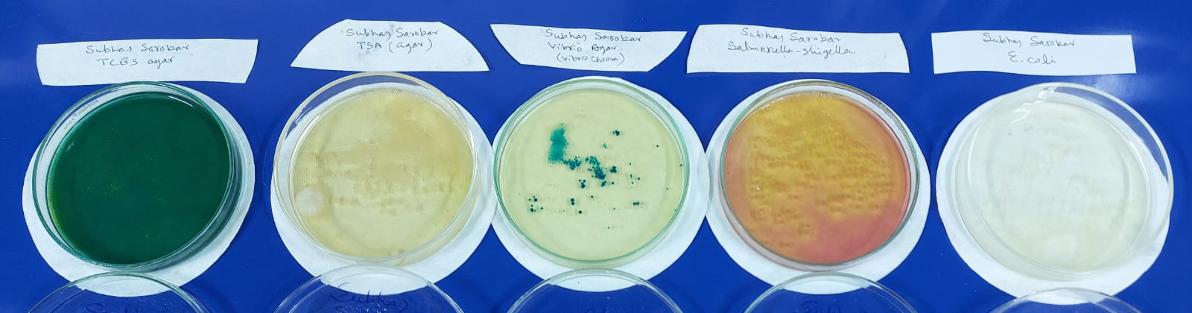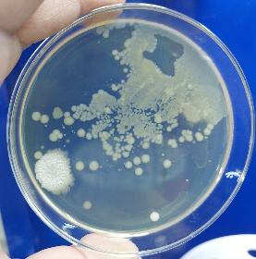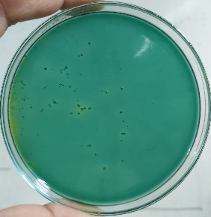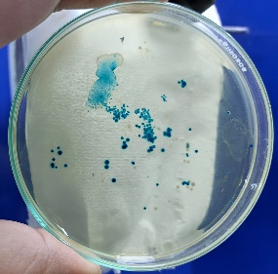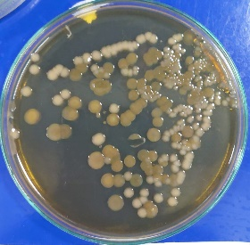

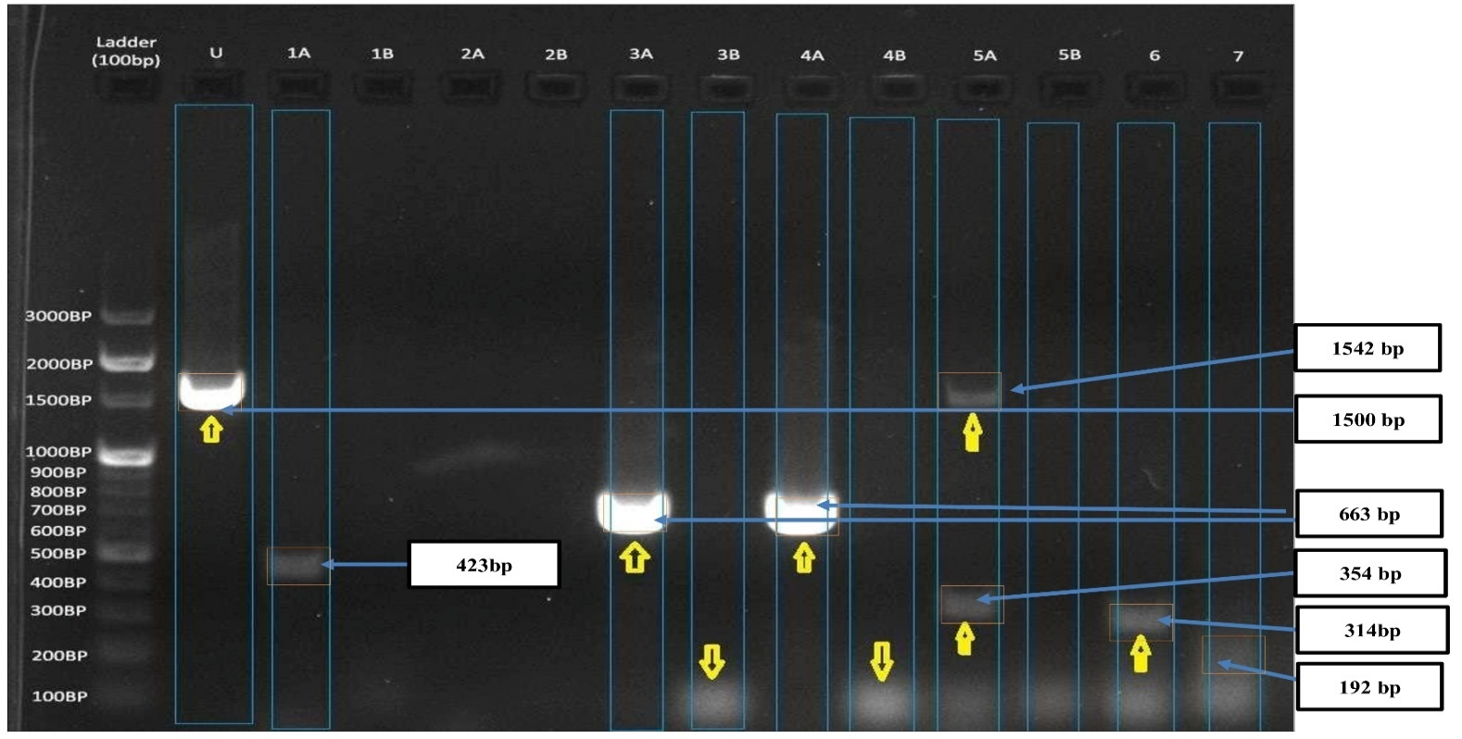**Fig: 4.** Water sample culture in different agar

**Figure 5.** Enteropathogenic bacteria [Universal Bacteria-1600, *Vibrio* sp. - 663 bp, *Enterobacter* sp.-1542 bp, *Salmonella* sp. – 314bp, *Shigella* sp. – 423bp, *Yersinia* sp. – 354bp)] were identified in freshwater Subhas Sarobar Lake in WB. The lane at the leftmost indicates the DNA ladder (100 bp).

PCR is a highly sensitive and powerful molecular technique frequently used for the detection of bacteria by targeting specific gene-specific primers. Through PCR assay-based identification, we completed a comprehensive investigation of previously identified bacteria-positive samples from Subhas Sarobar in Kolkata (Choudhury *et al.*, 2024; Figure 4).

When we screened these water samples against universal bacterial primers (27F and 1492R) targeting bacterial rDNA genes, from the results we observed the presence of bacteria primer-specific PCR amplified band corresponding U lane. which indicates the ubiquitous presence of bacterial populations in these regions (Figure 4). Further, we tried to investigate if the enteropathogenic bacterial-specific species causing the disease were present or not. Notably, in the lakes we detected all prominent PCR amplified bands corresponding to and indicating the presence of enteropathogenic bacteria (*Salmonella* sp. – 314 bp; *Yersinia* sp. – 354 bp; *Shigella* sp. – 423 bp; *Vibrio* sp. - 663 bp, *Aeromonas* sp. – 720 bp; *Enterobacter* sp.-1542 bp) (Figure: 5).

**4. Discussion:**

Since the locals utilize the lake for everyday tasks, Subash Sarovar, like most manmade lakes in the nation, is experiencing environmental deterioration as a result of growing bacterial populations, including Shigella sp., Pseudomonas sp., Salmonella sp., Citrobacter sp., and E. coli. Cleaning, swimming, and washing that contaminate and turn the lake's water alkaline. Because more people are living around the lake and visiting, there is also an increase in water pollution. Anthropogenic activities cause the body of water to become eutrophic, meaning it is rich in phosphate and nitrogen. As a result, populations of algae and phytoplankton are growing significantly. In addition, zooplankton and other aquatic life, such as fish and mollusks, are supported in this lake. There is a great deal of decomposition at the lake's bottom because this body of water is home to a vast variety of living things. Consequently, the oxygen needed for aquatic species to survive is reduced. An ideal environment for the growth of harmful bacteria is created by the water body's high BOD value. The health of the locals is at risk because they use this body of water frequently. Human gastrointestinal disorders can be caused by these harmful bacteria. It should be preserved by the government taking action. Additionally, a comprehensive tree planting effort has been initiated by the local government. Garbage dumping into the lake is the primary cause of Sarobar's degradation. Therefore, extensive research is required to identify all harmful microorganisms and regulate the lake water's pollution level. Differential culture of the pathogens and molecular identification of them are also necessary to comprehend the diversity of the bacterial population. Following an analysis of the findings, we are suggesting the following actions to restore the water quality of Subhas Sarobar Lake: refraining from bathing, cleaning clothing and utensils, and disposing of waste products in the water and the surrounding area. Stop fleeing from car washes as well.

**5. Conclusion:**

The molecular detection methods employed in this study revealed a significant shift in bacterial communities across different seasons, with a higher abundance of potentially pathogenic bacteria during the monsoon season. These findings have important implications for public health, as the lake water is used for various purposes. The presence of pathogenic bacteria, such as *Vibrio* sp., *Enterobacter* sp., *Salmonella* sp., *Shigella* sp., *Yersinia* sp. highlights the need for regular monitoring and management of the lake's water quality to prevent waterborne diseases. Furthermore, this study demonstrates the importance of molecular techniques in detecting and characterizing bacterial communities in freshwater ecosystems, providing valuable insights into the ecology and public health implications of these systems. Future studies should focus on exploring the functional roles of these bacterial communities and developing effective strategies for managing and conserving freshwater lakes in the region.

**7. Reference:**

APHA. 1995. Standard Methods for the Examination of Water and Wastewater. 19th Edition, American Public Health Association Inc., New York.

Basak, S., Choudhury, J., Mandal, P., Sarkar, K., Parveen, S. M., Bhagat, D., Saha, S. 2024. Studies on pathogenic bacterial diversity in Subhas Sarobar, Kolkata concerning public health. Ed. Ghosh, D. and Saha, S. Environment, Development and Sustainability. Bhumi Publisher, Mumbai, India. Pp. 95-106. ISBN: 978-93-95847-87-2).

Cabral, J.P.S. 2010. Water Microbiology. Bacterial Pathogens and Water. *Int. J. Environ. Res. Public Health*, *7*, 3657-3703; doi:10.3390/ijerph7103657

Dutta, S., Chakraborty, S. and Srivastava, R.C.2018. Environmental Impact Assessment & Incidence of Occurrence of Disease among the Public Health in East Kolkata Wetland Area. *International Journal of Bioinformatics and Biological Science*, Vol 6, 55-63.

Jones, K. E. Nikkita G. Patel, N. G., Levy, M. A., Storeygard, A., Balk, D. Gittleman, J. L. and Daszak, P. 2008. Global trends in emerging infectious diseases. *Nature,* **451:** 990 – 994.

Khan, R. A. and Sen, S. 2002. Studies on physicochemical and biological properties of two man-made lakes, Kolkata. *Rec. zool. Surv. India*: 100 (Part 3 - 4) : 1-19.

Percival, S. L., & Williams, D. W. 2014. Vibrio. *Microbiology of Waterborne Diseases (Second Edition)*, pp. 237-248.Elsevier.

Ryan, K.J. and Ray, C.G. 2004. Sherris Medical Microbiology: An introduction to infectious diseases. The McGraw-Hil Companies, Inc.

Saha, S. and Basak, S. 2024. Studies on Enteropathogenic Bacterial Diversity as the alarming indicator of freshwater lakes: Concerning public health in West Bengal. *Journal of XI’AN University of Architecture and Technology.* 16 (6): 38-57.

Saha, S.and Dash, G. 2021. Climatic Stress on Cultured *Scylla* sp.: Impact on Livelihood and Public Health in West Bengal. *International Journal of Researches in Biosciences, Agriculture & Technology,* **S17:** 331 – 344.

Saha, S. and Dash, G. 2021. Zoonotic Vibrio diversity and diseases in mudcrab fishery: impacts on public health in India. *Uttar Pradesh Journal of Zoology*, **42(19):** 48-58.

Saha, S., Pradhan, D. and Dash, G. 2023. Studies on diversity of bacterial diseases and occupational risks through mudcrab aquaculture in West Bengal. *Journal of Pure and Applied Microbiology*. **17(2):**722-731. doi: 10.22207/JPAM.17.2.23.

Saha, T., Manna, N. K., Majumder, S. S., Bhattacharya, I. N. 2001. Primary Productivity of the Subhas Sarobar Lake in East Calcutta in Relation to Some Selected Physico-Chemical Parameters.[Pollution Research](https://www.tib.eu/en/search?tx_tibsearch_search%5Baction%5D=search&tx_tibsearch_search%5Bcontroller%5D=Search&tx_tibsearch_search%5Bquery%5D=title%3A%22POLLUTION%20RESEARCH%22&cHash=9c2e5c6ee46956e561e0869f2ec1b81e) 20: 47-52.

Saha, S. and Basak, Srijoni. 2024. Studies on Enteropathogenic Bacterial Diversity as the alarming indicator of freshwater lakes: Concerning public health in West Bengal. Journal of XI’AN University of Architecture and Technology. 16 (6): 38-57. [https://doi.org/10.37896/JXAT16.6/34104](https://drive.google.com/file/d/18nC1Za5Vi2amxtUPxxG9NJ9ceuc9wJVe/view?usp=sharing).

Samal, N. R., Roy, D., Mazumdar, A. & Bose, B. 2004. Influence of thermal stratification on dissolved oxygen in Subhas Sarobar, Kolkata. Journal of Curriculum Sciences 7 (1), 259–266.

Saha, T. 2000. Monitoring of environmental studies of Subhas Sarobar, Calcutta and Preparation of management action.

Wang, R., Deng, Y., Deng, Q., Sun, D., Fang, Z., Sun, L., Wang, Y. and Gooneratne, R. 2020. Vibrio parahaemolyticus Infection in Mice Reduces Protective Gut Microbiota, Augmenting Disease Pathways. *Front. Microbiol.* **11:**73. doi: 10.3389/fmicb.2020.00073.