**THE NESTING SUCCESS OF THE INDIAN SHAG *PHALACROCORAX FUSCICOLLIS* (AVES:** **SULIFORMES: PHALACROCORACIDAE) IN THE KAMLANEHRU ZOOLOGICAL PARK, AHMEDABAD, INDIA**

**ABSTRACT**

The Indian shag Phalacrocorax fuscicollis is a freshwater species that has been nesting in the Kamlanehru Zoological Park (KZP), Ahmedabad since 2019. Here, the breeding of the Indian shag was studied during the period of 2021 to record the nesting success of species in KZP. The breeding activities of the Indian shag commenced in July and continued until November. It was noted that the birds built their nests on (Azadirachta indica, Ficus religiosa and Peltophorum pterocarpum) trees. As recorded both partners participated in nest building but male recorded while collecting most of materials. Incubation period was from 28-30 days and fledging period recorded upto 8 weeks. Though many studies were recorded of cormorants and breeding biology of little cormorants received major attention. Here, In particular, there no published information on the nesting success of Indian shag recorded. To support this information gap, this study was conducted to record the observations of successful nesting of Indian shag. Site observations and photographs of Indian shag nesting since 2019 were used to compile a record of successful breeding and compared with the present observations.

**Keywords:** Shag, successful breeding, nesting, conservation, Kamlanehru Zoological Park.

**INTRODUCTION**

*Phalacrocorax Fuscicollis* popularly known as Indian Cormorant or Indian Shag. It belongs to the order Suliformes and family Phalacrocoracidae, Ali (1996). Cormorants and Shags form the most diverse and adaptable family within the order.

Among the total number species of cormorants and shags of the world, only 4 species are occur in India (Anon 2003). Twenty- nine species are marine, four fresh- water and six both marine and freshwater (Nelson, J.B. (2005). As mentioned by Nelson, J.B. (2005), Indian shags are common and widespread in India, Pakistan, and Sri Lanka. Also widespread eastwards to southern Indo-china. Further, he also added the sighting details of some other authors, which is as mentioned here that, Del Hoyo et al. (1992) sighted 6000 in India, 1900 in Pakistan and 4000 in Sri Lanka but these figures sure to be approximate and seem too low to justify comment by Johnsgard 1993, that ‘one of commonest and most widely distributed cormorants of Indian sub- continent’. Here, Nelson, J.B. (2005) added for the movements of Indian Shag that mostly are resident. Local movements, extent unspecified, associated with creation and drying up of water bodies. As followed by the same that alone among pelecaniforms, they and the anhingids are adapted for underwater pursuit of prey by fast swimming. Although at home in a far greater range of habitats than any other seabird group, they are restricted to foraging comparatively near to the breeding colony and thus depend on predictable local food (Nelson, J.B. 2005). As mentioned by King, (1996) that cormorant spends some time in roosting and loafing and they use resting areas for preening and resting between feeding bouts.

In India sightings of Indian shag *Phalacrocorax Fuscicollis* recorded at many areas but none has been reported from Ahmedabad. Also, the nesting of Indian shag was not reported from the study area till now. However, Indian shags have been nesting year after year since 2019 in Kamlanehru zoological park (KZP). The establishment of the KZP, Kankaria in 1951, which is located in the urban centre of city with natural habitat allowed observations of nesting and other breeding behaviors of Indian Shag that used this park for nesting. Here, this paper focuses to report observations regarding the breeding ecology of Indian Shag in KZP for the continuous study of nesting success during study period of 2021.

**STUDY AREA AND METHODS**

The 117-ha kankaria zoo is located on the outer periphery of Kankaria Lake in the city of Ahmedabad. Kankaria lake itself having surface area of 31-ha and surrounded with different species of floras and faunas which creates a green habitat to attract many migratory birds for nesting, roosting and foraging. Lake also provides good opportunity for food to birds. As the area is suited for nesting, many migratory birds coming every year for nesting, which includes Spoonbill (*Platalea leucorodia*) , White Ibis (*Threskiornis melanocephalus*), Little Cormorant (*Microcarbo niger)*, Night Heron (*Nycticorax nycticorax*) and Cattle Egret (*Bubulcus ibis*).

Here, observations were noted from July to Nov 2021, during breeding season. Sightings were recorded twice a week during (July to Nov) and nest count was made at about (10:15-11:15 hr) and again between (16:30-17:30 hr). Overall observations and counting of nests with presence of Indian shags were carried out using binoculars from a safe distance of 10-15m. Here, the total count method, quoted by “Bibby et al. 2000”, was used to enumerate the bird numbers and nesting trees present at heronry site were enumerated (Patel & Thakker, 2021). Different breeding aspects as bird appearance, nesting behaviour, feeding and their all various activities were based on direct visual observations and by using binocular (10×50) as followed by (Joshi and Shrivastava 2012, Kaur and Sashi 2013) and photos were captured using camera. Study area records and photographs of Indian shag nesting since 2019 were used to compile a record of successful breeding and can be used to compare with the nesting success of Indian shags in present study. Other relevant observations were also made.

**RESULTS AND DISCUSSIONS**

The successful nesting of Indian shag has been recorded since 2019 on these trees located in the KZP and it also supports good vegetation along with many floral species (Patel R.S. *et al.* 2018), faunas surrounded within the area specially with the planktons (Verma P.U. *et al.* 2011) and fishes. It is the attraction point of many migratory birds during winter and also supports the breeding of rare species in KZP, like Python, crocodiles, bearcats and wild asses as mentioned by Patel, R.S. *et al.* (2018). Conservation of breeding population for resident species is common here.

Nests of Indian shag were seen on tree species like *Azadirachta indica, Ficus religiosa and Peltophorum pterocarpum* in 2021. As mentioned by Johnsgard, (1993) that Indian Shags are colonial and characteristically mobile with respect to the location of precise nest- site within the colony or sub- colony. Here, we noted the nests of Indian shag in a monospecific colony with no other colonial water-birds nesting in the neighborhood (Johnsgard (1993)).

As per the observation, total occupancy of nests period were recorded for 187 days with inclusion of nest building to total fledging. Generally, a representative shag breeding cycle occupies 19-20 weeks (Nelson, J.B., 2005). A total of forty eight nests were recorded with successful breeding status. As noted that nests were made up of dry twigs with unlined shape of sticks and nearby dry plant materials. Also, with the inclusion of Johnsgard (1993), he mentioned that Indian shags use only sticks and vegetation lined with grass or other suitable plant material. Here, we also observed that all nests of Indian shag were only built on tree species as *Azadirachta indica, Ficus religiosa and Peltophorum pterocarpum* and at the forking of branches or nearby to main trunk of mentioned tree species.

Nests were present on the trees present around the pond of marsh crocodile, so the nest height above the ground on trees was 20- 25ft. Also, noted the basal diameter of nests upto 25cm and was 8cm deep. Here, nests material was gathered by male shag as recorded.

During the period of visits, with the explanation of Johnsgard (1993), we also noted that both male and female Indian shags produce conspicuous plumes during breeding season. During Pre- breeding season, Indian shag are mainly black, with deep blue gloss, scapulars, wing coverts bronzy with darker edges to feathers giving scaly pattern. Eye green, orbital ring green or black, facial skin variously described as black, pale green or purple black, Bill blackish, gular skin purple black with yellow edge or yellow all over. Legs, feet black. Whereas, Post- breeding, Indian shag lacks white head plumes, chin whitish, often mottled, overall plumage browner. Facial skin yellowish or brown with yellow marks, gular skin yellow.

Here, after the completion of nest building, we noted that in day time the nesting area looks more active as the mating was began and Indian shag were recorded to perform highly ritualized behaviour to approaching each other. Here, our observation follows that the male attracts the female as male may ‘wing flick’, with or without ‘throwback’ or male may ‘throwback’ without the wing-flick, or do both with or without additional components, including vocalization- as defined by Siegel- Causey (1986a, 1986b, 1987, 1988). Incubation period was recorded of 28- 30 days. Total of 48 nests recorded; whereas mostly nests recorded with 2-3 chicks are sooty black and yellow edge gular skin. Fledging period was noted as 7.5- 8 weeks. Later, we observed that Indian shags were busy in parental care to their chicks. Both partners were participated while feeding and searching food from the kankaria lake and nearby areas. Fish species they used is Indian catfish, which locally known as mangur. Breeding records and photographs of Indian shag nesting in 2019 and 2020 noted around 52 nests, which is comparatively more than the 2021. During study period of 2021, we noted around total of 150 Indian shags were present in the breeding site. After November 27, we have not recorded shags in the nesting site.

***Plate (1,2,3,4,5,6)*** *- it shows chicks of Indian shag, nests, heronry of Indian shag, while roosting nearby lake area, parental care.*

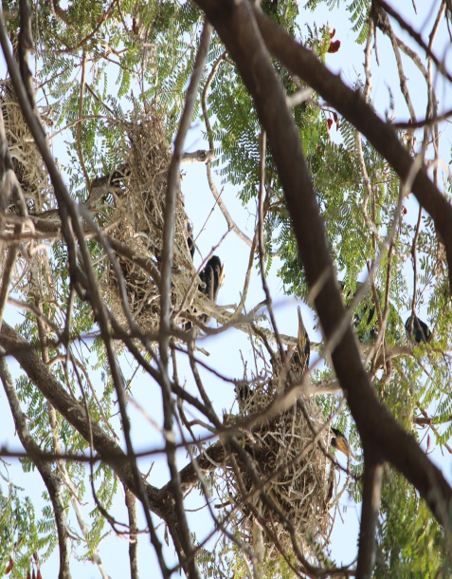 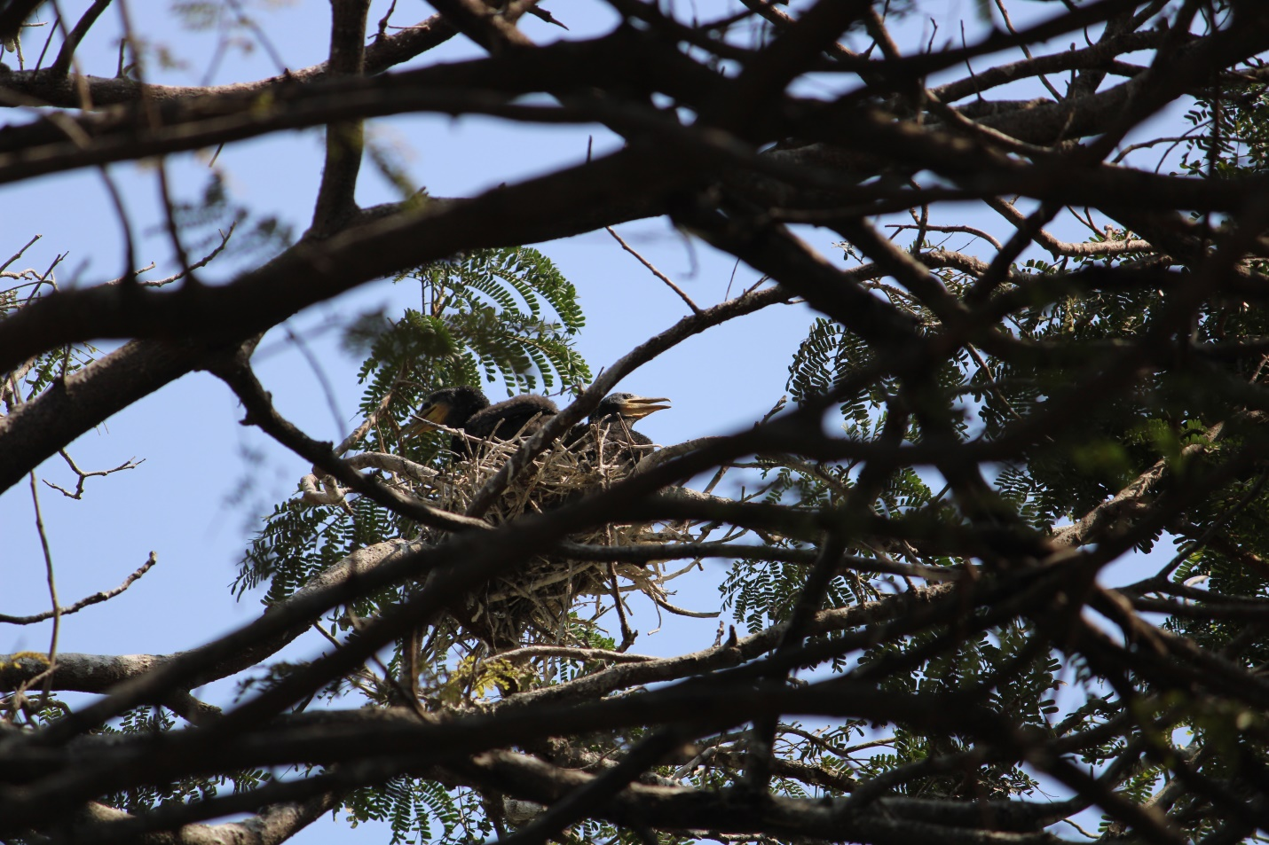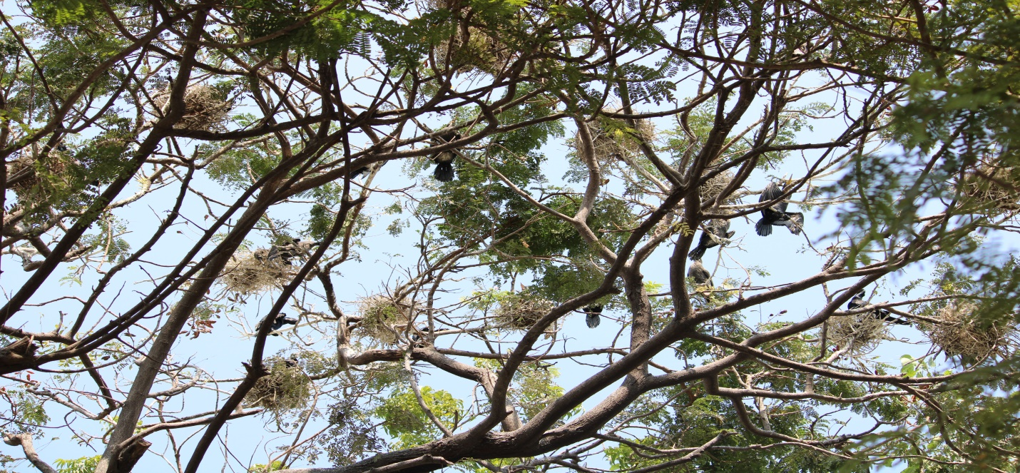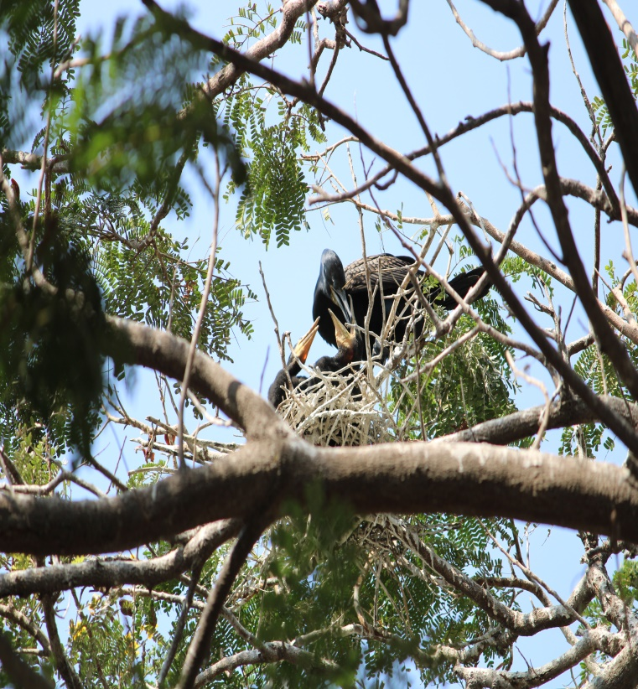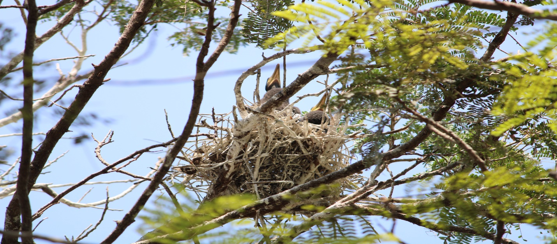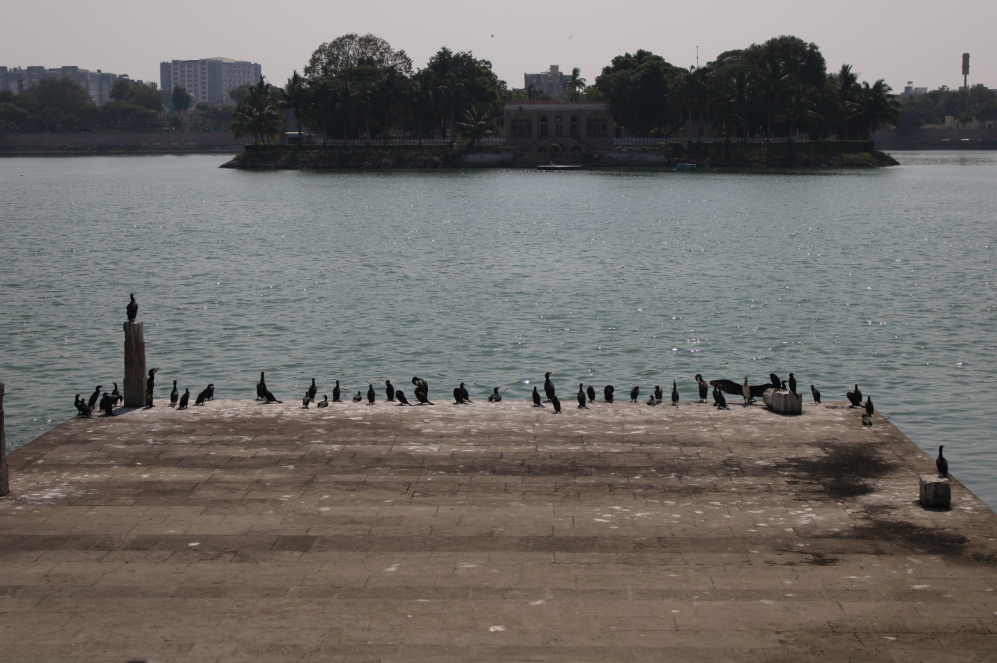

***Table-1*** Status of Indian Shag

|  |  |  |  |  |  |
| --- | --- | --- | --- | --- | --- |
| Scientific Name | Common Name | Order | Family | No. of Indian Shag | No. of Nests |
| Phalacrocorax fuscicollis | Indian Shag | Suliformes | Phalacrocoracidae | 150 | 48 |

**DISCUSSION**

However, Gujarat have importance for many migratory birds and even during non- breeding seasons, based on their counts, as quoted by Patel & Thakker, 2021. This study is based on our first observation of successful breeding of Indian shag in Kamlanehru zoological Park has added significant ecological value to the area. Here, we observed the nesting was done more successfully during period of 2021. As photographic records from 2019 to 2023 were compiled and have noted that in 2022 the number of nests is less as compared to 2021 but during 2023 total number of nest count is same as compared to 2021. Nesting survival during 2021 and noted preceding years shows that the Indian shag was breeding quite successfully in KZP. Also, the Kankaria Lake plays a very significant role to supports the successful breeding of Indian shags. As Indian shag breeds during monsoon and fishes also breed during monsoon so, there is abundant prey available for young birds from Sept- Jan (Kahl 1971, Desai *et al*. 1974). We noted during noon time they seen as roosting and loafing till hours before sunset and leave around sunrise. Also, they observed while maintaining body which involves bathing, splashing and beating the water with wings, rolling one side and head dipping.

This KZP close to the Kankaria Lake is safe for breeding population of many birds with inclusion of Indian shag now. Also, the area provides huge availability of food as catchable prey- base and green vegetation for nesting with very less anthropogenic disturbances.

**CONCLUSION**

As we noted the successful nesting of Indian shag in KZP as its aim is also conservation, research and educational trainings. Every year KZP records thousands of migratory birds with their heronry and Indian shag recorded for the first time here.

There is need to protect the breeding areas, especially when the existing wetlands and bird sanctuaries getting unsafe for nesting with involvement of public as picnic spots and KZP allowing more breeding birds in the urban setup. We believe that people should not be allowed near these trees during the breeding season. We also suggest that the Municipal Authorities should declare the roads adjoining to KZP as no honking zone or a silent zone.

Therefore, there is need to study the behaviour of waterbirds nesting in such urban settlements with their need for site- selection, food- source, and causes. This has huge implication on any conservation measures to be implemented and will help in policy making.

**References**

Ali, S., 1996. The book of Indian birds, 1st edition. Oxford University Press, New Delhi.

Anon. (2003). Wikipedia. Available at http://en.wikipedia.org/wiki/Cormorant# Species. Accesses date: 15-02-2003.

Bibby, C.J., N.D. Burgess, D.A. Hill & S.H. Mustoe (2000). Bird Census Techniques. Academic Press, London, 302pp.

Del Hoyo, J., Elliott, A. and Sargatal, J. (eds) (1992). Handbook of the Birds of the World, Vol. 1. ICBP, Lynx Edicions, Barcelona.

Desai, J. H., R. V. Shah, and G. K. Menon. 1974. Diet and food requirements of Painted Storks at the breeding colony in the Delhi Zoological Park. Pavo 12: 13-23.

Johnsgard, P.A. (1993). Cormorants, Darters and Pelicans of the World. Smithsonian Institution Press. Washington.

Joshi, P. and Shrivastava, V.K., 2012. Breeding biology and nest site selection of cattle egret (Bubulcus ibis) in Tawa Reservoir and surrounding area of Hoshangabad District (M.P). Asian J. exp. biol. Sci., 3: 525-530.

Kahl, M. P. 1971. The courtship of storks. Natural History 80: 36-4.

King, D.T. (1996). Movements of double-crested cormorants among winter roosts in the delta region of Mississippi. Journal of Field Ornithology, 67, 205–11.

Kour, D.N. and Sahi, D.N., 2013. Aspects of breeding biology of cattle egret, bubulcus ibis coromandus (boddaert) in Jammu, India. Int. J. environ. Sci., 3: 1547-1561.

Nelson, J.B. (2005). Pelicans, Cormorants and Their relatives: *The Pelecaniformes*, 17th vol. Oxford University Press, New York.

Niangthianhoi, S.L. & F.A. Khudsar (2015). The nesting success of the Oriental Darter Anhinga melanogaster (Aves: Suliformes: Anhingidae) in the Yamuna Biodiversity Park, New Delhi, India. Journal of Threatened Taxa 7(14): 8148–8153; <http://dx.doi.org/10.11609/jott.2430.7.14.8148-8153>.

Patel, N.A. Thakker, R.P (2021) Study on heronry of Painted Storks in and around of Sanathal Lake, Ahmedabad, Gujarat. International Journal of Zoology and Research, Vol.11, Issue 2, Dec 2021, 7-16.

Patel, R. S., Kadia, R., Bhatt, V. and Patel, V. (2018). Floristic Diversity of Family Malvaceae Found in Kankariya Zoo Campus, Ahmedabad, Gujarat, India. International Journal of Scientific Research in Science and Technology, Mar-Apr; 4(5): 603-609.

Siegel-Causey, D. (1986a). The courtship behaviour and mixed-species pairing of king and imperial blue eyed shags (Phalacrocorax albiventer and P. atriceps). Wilson Bulletin, 98, 571–80.

Siegel-Causey, D. (1986b). Behaviour and affinities of the Magellanic cormorant. Notornis, 33, 249–57.

Siegel-Causey, D. (1987). Behaviour of the red-footed cormorant (Phalacrocorax gaimardi). Notornis, 34, 1–9.

Siegel-Causey, D. (1988). Phylogeny of the Phalacrocoracidae. Condor, 90, 885–905.

Urfi, A. J. (1993). Breeding Patterns of Painted Storks (Mycteria leucocephala Pennant) at Delhi Zoo, India. Colonial Waterbirds, 16(1): 95-97.

Verma, P.U., Chandawat, D.K. and Solanki, H.A. (2011). Seasonal Variation in Physico-Chemical and Phytoplankton Analysis of Kankaria Lake. Life sciences Leaflets, 19, 842 –854.