**A PRELIMINARY LIST OF BUTTERFLIES (RHOPHALOCERA) FROM TALA, RAIGAD, MAHARASHTRA**

**Abstract*:***

The aim of this study was to evaluate butterfly diversity in the Tala region of Raigad district, Maharashtra. The study recorded 41 butterfly species from 29 genera across 5 families. The *Nymphalidae* family was the most abundant, with 14 genera and 21 species, followed by *Pieridae* with 7 genera and 9 species, *Satyridae* with 5 genera and 7 species, *Papilionidae* with 2 genera and 3 species, and *Hesperiidae* with 1 genus and 1 species. The results provide important information about the butterfly biodiversity in the area and serve as foundational data for future studies on butterfly populations.

**Keywords:** Diversity, Butterfly, Lepidoptera, Tala, *Nymphalidae*.

**Introduction:**

Tala is a small town 18.4388° N, 73.1261° E situated an elevation of 20 m above MSL in the Raigad district of Maharashtra’s Konkan region. The mean minimum temperature is 17.7°C and mean maximum temperature is 31.8°C. with significantly higher temperatures during the summer months and cooler temperatures during the monsoon season, experiencing a tropical climate with high humidity throughout the year. Biological diversity refers to the variety and variability of living organisms and their ecological interactions (Harper, 1995). Biodiversity forms the foundation of ecological integrity, supports sustainable development, ensures environmental stability, and provides economic and ecological security for future generations. India, the seventh-largest country globally, ranks among the twelve mega biodiversity nations and harbours approximately 80% of its insect species as endemics. The order Lepidoptera constitutes nearly 10% of the total known animal species, a figure comparable to the number of recognized flowering plant species (Srivastava, 2002).

The Western Ghats, designated as a global mega biodiversity hotspot, significantly contribute to India’s entomofaunal diversity, with approximately 800,000 insect species documented. The diversity and distribution of butterfly species are strongly influenced by the availability of host plants within their habitats (Kunte, 2000). Plant species provides essential food and egg-laying sites for butterflies, which in turn plays a crucial role in determining the diversity and abundance of butterfly species found in the area (Malek *et. al.,* 2024).

As the second-largest order within the class Insecta, Lepidoptera is of considerable ecological significance. Approximately 1,500 butterfly species have been identified from the Indian subcontinent, accounting for 8.33% of the 18,000 butterfly species documented worldwide (Hampson, 1891; Smetacek, 1992, 2002; Gay T, 2012). A substantial proportion of these species are concentrated within the Himalayan and Western Ghats regions (Larsen TB, 1987). Butterflies play critical roles in ecosystem functioning, serving as both pollinators and herbivores (Kunte, 2000; Tiple, 2006). They have co-evolved with angiosperms, relying on nectar as adults and host plant foliage during larval stages (Ehrlich, 1964). Furthermore, butterflies are widely recognized as bio-indicator species due to their sensitivity to habitat alterations, rapid response to environmental perturbations, specific vegetation associations, and ease of sampling (Erhardt A., 1985; Brown, 1991; Kremen, 1992; Thomas, 2005; Bonebrake, 2010; Gowda, 2011; Sethy, 2014). Migratory behaviour of butterflies associated with their genetic diversity (García‐Berro A et. al., 2023).

Anthropogenic disturbances such as habitat fragmentation, urbanization, and pollution have exacerbated environmental changes, leading to biodiversity decline. Habitat loss, primarily due to land-use transformation, directly impacts species survival and ecological balance (Choudhury, 2009; Saikia, 2010; Singh, 2011; Gogoi M.J., 2013; Joshi, 2014; Naro, 2014; Pollard, 1977). Insects contribute substantially to ecosystem processes within both aquatic and terrestrial habitats, providing essential services such as pollination, pest control, nutrient cycling, and overall ecosystem stability. Among insect taxa, butterflies are particularly significant due to their aesthetic appeal and their crucial function as pollinators (Tiple *et al.,* 2006).

In the Tala region, ongoing anthropogenic activities, including road construction towards Agardanda Port leads to substantial habitat degradation, potentially influencing butterfly populations. Despite the ecological importance of butterflies, no prior systematic studies have been conducted on their diversity within this region. Therefore, the present study was undertaken to document butterfly diversity in and around Tala, Raigad district, Maharashtra. The findings aim to establish a baseline inventory of butterfly species, evaluate the extent of human-induced habitat modifications, and contribute to future conservation initiatives in the region. This will provide a groundwork for future study.

**Material & Methods:**

1. **Study Area:**

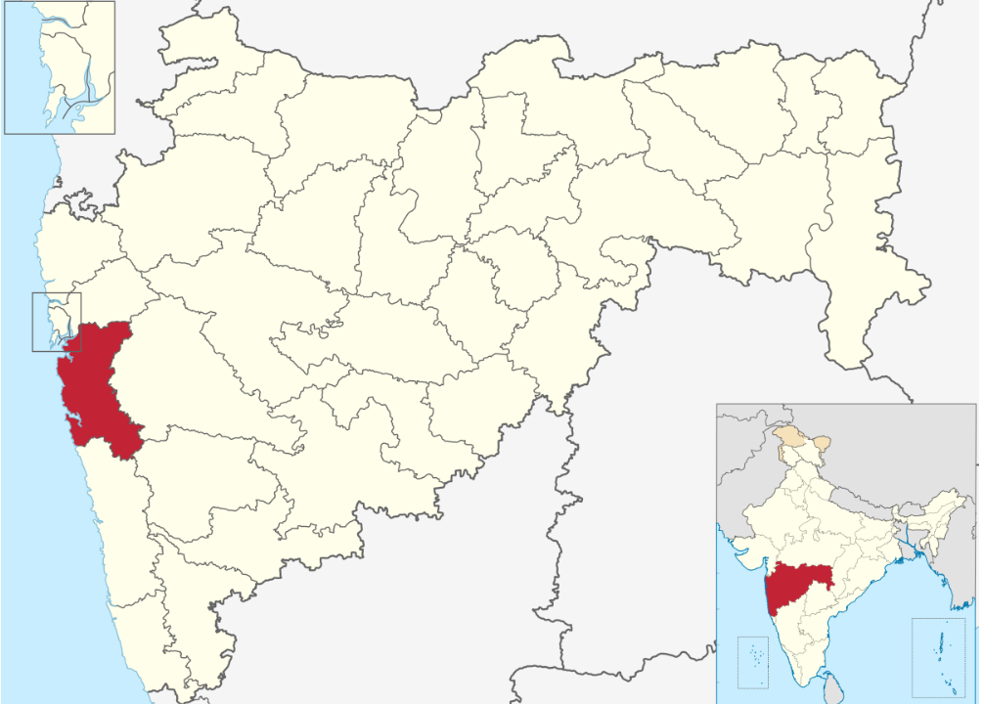

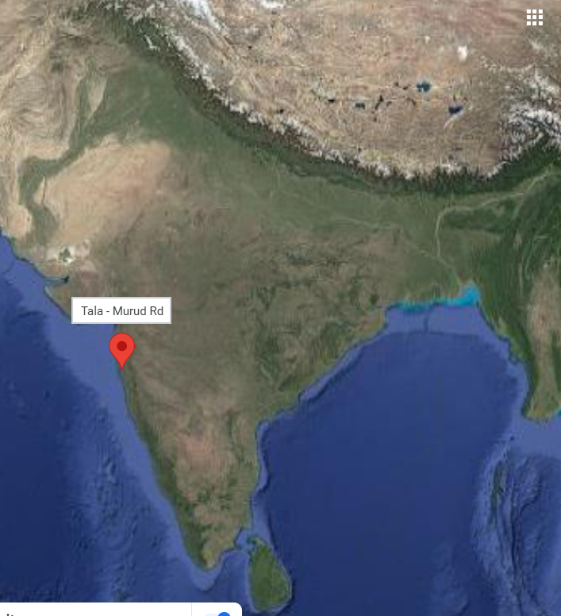

**Fig. 1. Map showing study area**

1. **Methodology:**

Butterflies were recorded along designated paths within the study area (Fig.1) and along water streams. The selected sites were surveyed over a one-year period from June 2022 to May 2023 to assess butterfly biodiversity. Field observations were conducted using the Pollard Walk Method (1977). Surveys were carried out weekly between 09:00 and 15:00 hours during sunny periods to document butterfly species through photography along transects. Lycaenid and hesperiidae butterflies were captured in nets when necessary, identified, and subsequently released. Photographs of butterflies were taken using a Canon 1300D camera. Species identification was conducted using the identification keys provided by Evans (1932), Kehimkar (2008), Kunte (2000), and Wynter-Blyth (1957), with classification following the system outlined by Kehimkar (2008).

**Table No. 01 List of families with number of genera & species of butterflies recorded in study area**

|  |  |  |  |  |
| --- | --- | --- | --- | --- |
| **Sr. No.** | **Family** | **Genera** | **Species** | **Species %** |
| 1 | Papilionidae | 02 | 03 | 7.1 |
| 2 | Hesperiidae | 01 | 01 | 2.38 |
| 3 | Pieridae | 07 | 09 | 21.42 |
| 4 | Nymphalidae | 14 | 21 | 50 |
| 5 | Satyridae | 05 | 07 | 19.04 |
|  | Total | 29 | 41 |  |

**Fig. 2 Occurrences of butterfly species under different families**

**Table No. 02 Checklist of Butterflies (Insecta: Lepidoptera) recorded in study area**

|  |  |  |  |  |
| --- | --- | --- | --- | --- |
| **Sr. No.** | **Family** | **Scientific Name** | **Common Name** | **IUCN Status** |
| I | Papilionidae | *Graphium doson* (C. & R. Felder, 1864) | Common Jay | NE |
| *Papilio demoleus* (Linnaeus, 1758) | Lime Butterfly | NE |
| *Papilio polytes* (Linnaeus, 1758) | Common Mormon | LC |
| II | Hesperiidae | *Aeromachus dubius* (Elwes& Edwards, 1897) | Dingy Scrub Hopper | NE |
| III | Pieridae | *Catopsilia pyranthe* (Linnaeus, 1758) | Mottled Emigrant | NE |
| *Colotis amata* (Cramer, 1775) | Small Salmon Arab | NE |
| *Delias eucharis* (Drury, 1773) | Common Jezebel | NT |
| *Eurema brigitta* (Stoll, 1780) | Small Grass Yellow | NE |
| *Eurema hecabe* (Linnaeus, 1758) | Common Grass Yellow | LC |
| *Eurema nilgiriensis* (Yata, 1990) | Nilgiri Grass Yellow | NE |
| *Leptosia nina* (Fabricius, 1793) | Psyche | NE |
| *Pareronia hippie* (Cramer, 1776) | Common Wanderer | NE |
| *Prioneris sita* (C. & R. Felder, 1865) | Painted Sawtooth | NE |
| IV | Nymphalidae | *Acraea violae* (Fabricius, 1793) | Tawny Coster | NE |
| *Ariadne ariadne* (Linnaeus, 1763) | Angled Castor | NE |
| *Cirrochroa thais* (Fabricius, 1787) | Tamil Yeoman | LC |
| Danaus chrysippus (Linnaeus, 1758) | Plain Tiger | LC |
| *Euploea core* (Cramer, 1780) | Common Crow | LC |
| *Euploea klugii* (Moore, 1858) | King Crow | NE |
| *Euploea sylvester* (Fabricius, 1793) | Double-branded Crow | NE |
| *Hypolimnas bolina* (Linnaeus, 1758) | Great Eggfly | NE |
| *Hypolimnas misippus* (Linnaeus, 1764) | Danaid Eggfly | LC |
| *Junonia almana* (Linnaeus, 1758) | Peacock Pansy | LC |
| *Junonia atlites* (Linnaeus, 1763) | Gray Pansy | NE |
| *Kallima horsfieldi* (Kollar, 1844) | Southern Blue Oakleaf | NE |
| *Melanitis leda* (Linnaeus, 1758) | Common Evening Brown | LC |
| *Mycalesis mineus* (Linnaeus, 1758) | Dark-brand Bushbrown | CR |
| *Mycalesis perseus* (Fabricius, 1775) | Common Bushbrown | NE |
| *Mycalesis visala* (Moore, 1858) | Long-brand Bushbrown | NE |
| *Neptis jumbah* (Moore, 1858) | Chestnut-streaked Sailer | NE |
| *Parantica aglea* (Stoll, 1782) | Glassy Tiger | NE |
| *Phalanta alcippe* (Stoll, 1782) | Small Leopard | NE |
| *Tirumala limniace* (Cramer, 1775) | Blue Tiger | NE |
| *Tirumala septentrionis* (Butler, 1874) | Dark Blue Tiger | NT |
| V | Satyridae | *Melanitis phedima* (Cramer, 1780) | dark evening brown | NE |
| *Elymnias hypermnestra undularis* (Linnaeus, 1763) | Common Palmfly | NE |
| *Lethe rohria* (Fabricius, 1787) | common treebrown | NE |
| *Lethe europa europa* (Fabricius, 1775) | bamboo treebrown | NE |
| *Ypthima huebneri* ( Kirby, 1871) | common four-ring | NE |
| *Ypthima baldus* (Fabricius, 1775) | common five-ring | NE |
| *Melanitis leda ismene* (Linnaeus, 1758) | rice butterfly | LC |

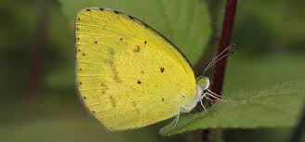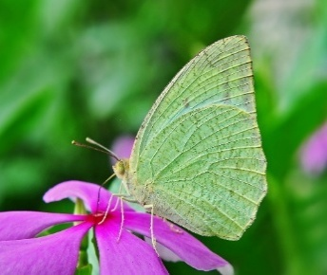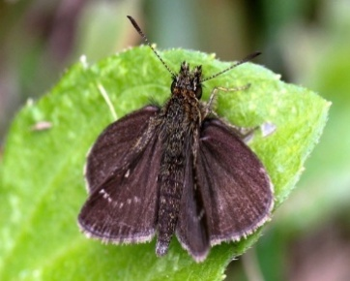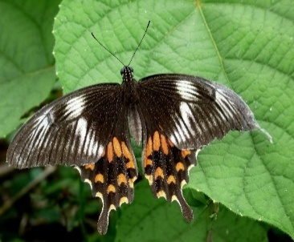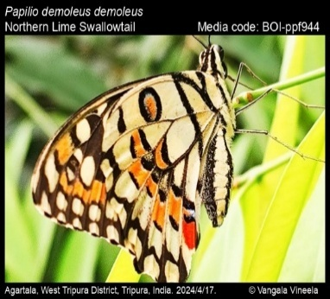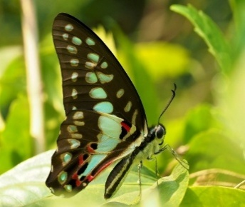*Graphium doson* *Papilio demoleus* *Papilio polytes Aeromachus dubius*

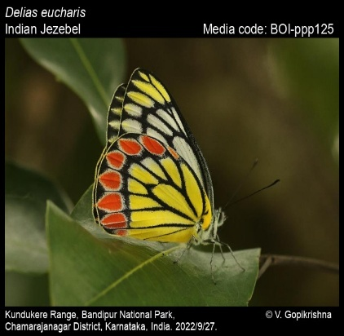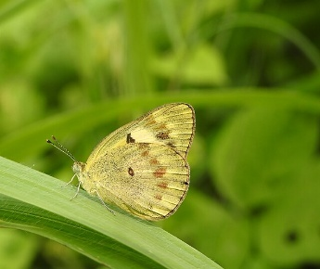

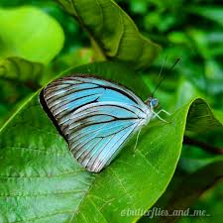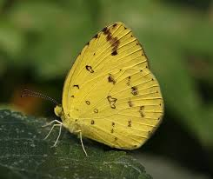*Catopsilia pyranthe Colotis amata Delias eucharis Eurema brigitta*

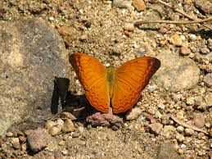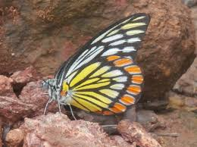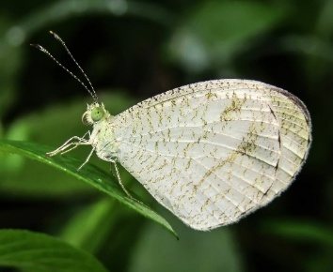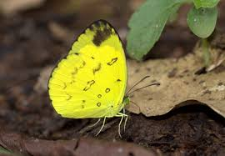*Eurema hecabe Eurema nilgiriensis* *Leptosia nina* *Pareronia hippie*

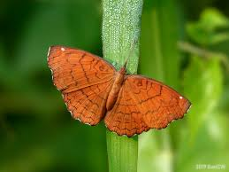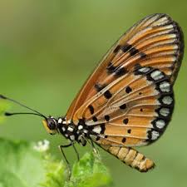

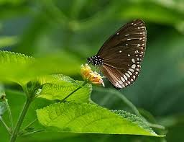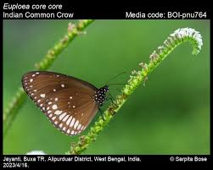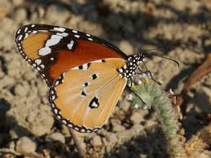*Prioneris sita Acraea violae Ariadne Ariadne Cirrochroa thais*

*Danaus chrysippus Euploea core Euploea klugii Euploea Sylvester*

**Fig. 3 Butterflies species recorded in study area**

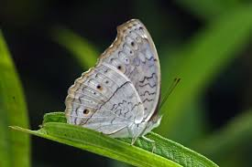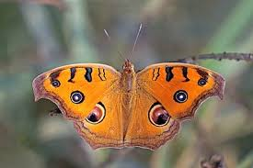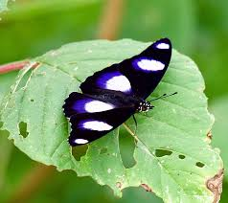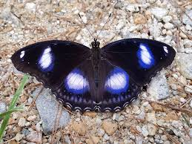

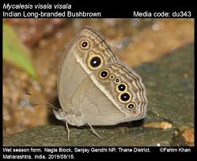*Hypolimnas bolina Hypolimnas misippus Junonia almanac Junonia atlites*

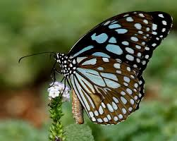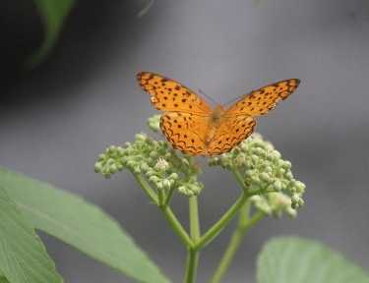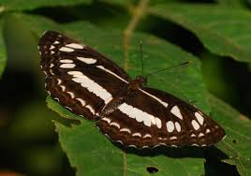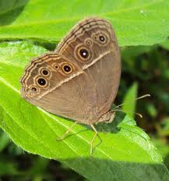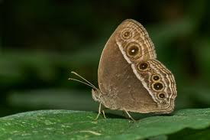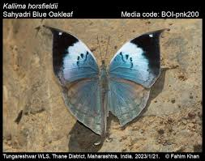*Kallima horsfieldi Mycalesis mineus Mycalesis perseus Mycalesis visala*

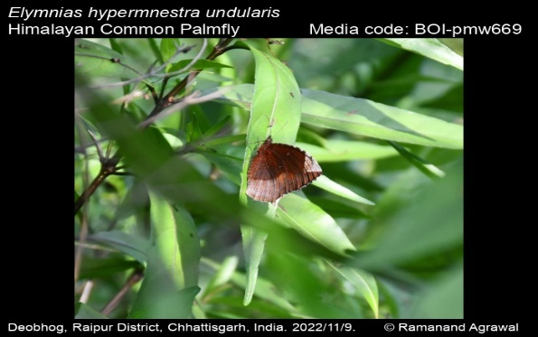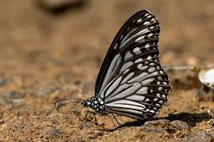*Neptis jumbah Parantica aglea Phalanta alcippe Tirumala limniace*

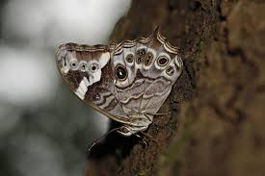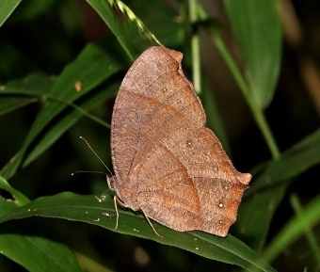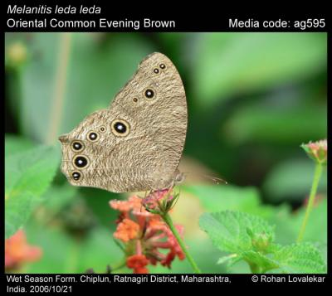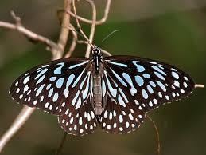*Tirumala septentrionis Melanitis leda Melanitis phedima Elymnias hypermnestra undularis*

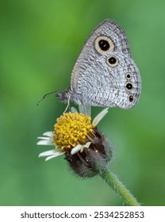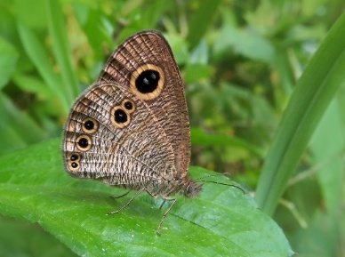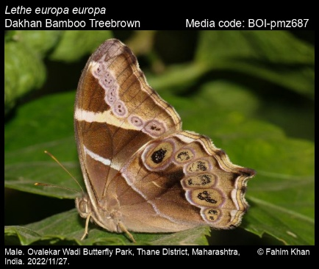*Lethe rohria Lethe europa europa Ypthima huebneri Ypthima baldus*

**Fig. 4 Butterflies species recorded in study area**

**Results & Discussion:**

In the current study, a total of 41 lepidopteran species from 29 genera and 5 families were recorded (Tables 1 & 2; Fig. 2). Among the 6 families, *Nymphalidae* was the most diverse, with 14 genera and 21 species, followed by *Pieridae* with 7 genera and 9 species, *Satyridae* with 5 genera and 7 species, *Papilionidae* with 2 genera and 3 species, and Hesperiidae with 1 genus and 1 species (Figures 3 & 4). The highest species diversity was observed in *Nymphalidae*, which accounted for 21 species (50%), followed by *Pieridae* with 9 species (21.42%), *Satyridae* with 7 species (19.04%), *Papilionidae* with 3 species (7.1%), and *Hesperiidae*, which had the fewest species, comprising just 2.38% of the total. Similar results were obtained by Tingare B. P. (2024) in Raigad district, recorded 73 species from 5 families & *Nymphalidae* was most diverse.

Butterflies (Lepidoptera: Rhophalocera) are valuable for their role in pollination, serve as ecological indicators, and are admired for their aesthetic appeal (Rosenberg, 1986; Johnson, 1995; Chakravarthy AK, 1997; McGeoch, 1998; Vu Van Lien, 2007). Factors such as the availability of food (host plants and nectar plants) and the microclimate significantly influence butterfly diversity ( Öckinger E, 2006, 2009; Mukherjee M, 2012; Mukherjee K, 2018).

The study area, rich in vegetation that provides food sources for butterflies, has led to the recording of a large number of species. The *Nymphalidae* family is the largest, accounting for nearly one-third of the world’s known butterflies. The high biodiversity of nymphalids and lycaenids in this study aligns with previous research on butterfly diversity (Dronamraju, 1960; Roy, 2010; Harsh S., 2014; Mukherjee, 2015). These families dominate due to the polyphagous nature of many species, their ecological adaptability (Jiggins CD, 1996), speciation, and high dispersal capabilities (Adler GH, 1996). Additionally, many species in these families are strong, active fliers, which helps them search for habitats and food over large areas (Eswaran R, 2005; Padhye AD, 2006; Krishnakumar N, 2008; Raut NB, 2010). Butterflies are effective indicators of anthropogenic disturbances and habitat quality (Kocher SD, 2000).

As this study serves as the first preliminary exploration of butterfly biodiversity in the area, conclusions regarding the loss of butterfly species cannot yet be drawn. The butterfly checklist created in this study will provide a foundation for future research. Further in-depth studies on butterfly diversity are necessary to expand the species list and assess the impact of anthropogenic changes on habitats in the Tala region.

**CONCLUSION:**

Butterflies (Lepidoptera: Rhophalocera) are valuable for their role in pollination, serve as ecological indicators, and are admired for their aesthetic beauty. Key factors influencing butterfly diversity include the availability of food, habitat, and microclimate. Human activities contribute to habitat destruction and the loss of food plants.

In this study, a total of 41 butterfly species from 29 genera and 5 families were recorded. As there are no previous records of butterfly species for this area, it is not possible to confirm any changes in butterfly diversity. This preliminary study is the groundwork for future research on the ecology, biology, and conservation of butterflies in the region. Further, more detailed studies are needed to enhance the butterfly species checklist and evaluate the impact of human-induced changes on butterfly diversity.

Disclaimer (Artificial intelligence)

Option 1:

Author(s) hereby declare that NO generative AI technologies such as Large Language Models (ChatGPT, COPILOT, etc.) and text-to-image generators have been used during the writing or editing of this manuscript.

Option 2:

Author(s) hereby declare that generative AI technologies such as Large Language Models, etc. have been used during the writing or editing of manuscripts. This explanation will include the name, version, model, and source of the generative AI technology and as well as all input prompts provided to the generative AI technology

Details of the AI usage are given below:

1.

2.

3.

**NO generative AI technology is used while writing manuscripts**

**REFERENCES**

1. Harper JL, Hawksworth DL (1995). Biodiversity measurement and estimation (ed. Hawksworth, D. L.). Royal Society, London.
2. Kunte K. (2000). Butterflies of peninsular India. Universities Press (Hyderabad) and Indian Academy of Sciences (Bangalore) ;147.
3. Malek S, Patel M, Desai B. (2024). Butterfly Diversity of Navsari Agricultural University (NAU), Navsari, Gujarat, India. J. Adv. Biol. Biotechnology ;27(9):44-53. <https://doi.org/10.9734/jabb/2024/v27i91272>.
4. Hampson GF (1891). The Lepidoptera Heterocera of the Nilgiri district. Typological specimen of Heterocera of British Museum ;8:1
5. Smetacek Peter (1992). Record of Plebejus eversmanni (Staudinger) (Lepidoptera: Lycaenidae) from India. Journal of the Bombay Natural History Society ;89:385 –386.
6. Smetacek, Peter (2002). Factors affecting distribution of Pontia daplidice in palaearetic region. JBNHS ;99(2):169-170
7. Srivastava A. (2002). Taxonomy of Moths in India. International Book Distributors. 9, Rajpur Road, Dehradun.
8. Gay T, Kehimkar I.D, Punetha JC (1992). Common butterflies of India. Oxford Uni. Press. Bombay ;67.
9. Larsen TB (1987). The butterflies of the Nilgiri Mountains of South India Lepidoptera Rhopalocera. J. Bombay Nat. hist. soc.;(84):26-43.
10. Tiple AD, Deshmukh VP, Dennis RLH (2006). Factors influencing nectar plant resource visits by butterflies on a university campus: implications for conservation; 28:213– 224.
11. Ehrlich PR, Raven PH (1964). Butterflies and plants: a study in coevolution. Evolution ;18(4):586–608.
12. Erhardt A. (1985). Diurnal lepidoptera. sensitive indicator of cultivated and abandoned grassland. Journal of Applied Ecology; 22:849-861.
13. Brown KS. (1991). The conservation of insects and their habitats. Conservation of neotropical environment: Insect as indicators: 15th Symposium of the Royal Entomological Society of London. Academic Press, London, England ;350-403.
14. Kremen C. (1992). Assessing the indicator properties of species assemblages for natural areas monitoring. Ecological Applications ;2(2):203-217
15. Thomas J.A.(2005). Monitoring change in the abundance and distribution of insects using butterflies and other indicator groups. Philosophical Transactions of the Royal Society B.;360(1454): 339–357.
16. Bonebrake TC, Ponisio LC, Boggs CL, Ehrlich PR (2010). More than just indicators: a review of tropical butterfly ecology and conservation. Biological conservation ;143(8):1831– 1841.
17. Gowda RHT, Kumar V, Pramod AF, Hosetti BB (2011). Butterfly diversity, seasonality and status in Lakkavalli range of Bhadra Wildlife Sanctuary, Karnataka. World Journal of Science and Technology ;1(11):67-72.
18. Sethy J, Behera S, Singh Chauhan (2014). Species diversity of Butterflies in South-Eastern part of Namdapha Tiger Reserve. Arunachal Pradesh. India Asian Journal of Conservation Biology ;3(1):75–82.
19. García‐Berro A, Talla V, Vila R, Wai HK, Shipilina D, Chan KG, Pierce NE, Backström N, Talavera G. (2023). Migratory behaviour is positively associated with genetic diversity in butterflies. Molecular Ecology;32(3):560-74.
20. Choudhury K, Ghosh S. (2009). Butterflies of chakrashila wildlife sanctuary. Assam. Indian Forester ;135(5):714-720.
21. Saikia MK, Kalita J, Saikia PK. (2010). Seasonality of Nymphalidae butterflies in Gani-Garbhanga Reserve Forest, Assam, India. NeBIO.;1(4):10-21.
22. Singh MI., Gupta A, Varatharajan R. (2011). Butterfly fauna of the Keibul Lamjao National Park, Manipur, North East India. Curr. Sci. ;101 (6):719-721.
23. Gogoi M.J. (2013). Notes on some skipper butterflies (Lepidoptera: Hesperiidae) from Panbari Forest and its adjoining areas, Kaziranga Karbi Anglong, upper Assam, India. Journal of Threatened Taxa ;5(13):4759– 4768.
24. Joshi RK, Dhyani S (2014). Butterflies, diversity, distribution and threats in Dibru-Saikhowa Biosphere Reserve Assam North-East India: A Review. World Journal of Zoology ;9(4):250-259.
25. Naro T, Sondhi S. (2014). Butterflies (Lepidoptera) of Chizami, Phek District, Nagaland, India. Journal of Threatened Taxa ;6(13):6593– 6634
26. Pollard E (1977). A method for assessing changes in the abundance of butterflies.

Biological Conservation ;12(2):115–134.

1. Evans WH (1932). Identifications of Indian Butterflies. Bombay Natural History Society, Bombay.
2. Kehimkar I (2008). The book of Indian Butterflies. Bombay Natural History Society and Oxford University Press ;497.
3. Wynter-Blyth MA (1957). Butterflies of the Indian Region. Bombay Natural History Society, Bombay; 523.
4. Tingare B. P. (2024). Assessment of Butterfly Diversity in Mahad Taluka, Western Ghats, Maharashtra, India. International Journal of Advanced Research in science, communication & Technology. 4 (3): 135-138.
5. Rosenberg DM, Danks HV, Lehmkuhl DM (1986). Importance of insects in environmental impacts assessment. Environmental Management ;(10):773-783.
6. Johnson, Steiner (1995). Long-proboscid fly pollination of two orchids in the Cape

Drakensberg Mountains South Africa. J. S. African Bot. Suppl;(195):169-175.

1. Chakravarthy AK, Rajagopal D, Jagannatha R. (1997). Insect as a bioindicator of conservation in tropics. Zoos print; 12:11-25.
2. McGeoch MA (1998). The selection testing and application of terrestrial insects as bioindicators. Biological Review ;(73):181-201.
3. Vu Van Lien (2007). Ecological indicator role of butterflies in Tam Dao National Park Vietnam. Russian Entomological J.;(16):473– 480.
4. Öckinger E, Eriksson AK, Smith HG (2006). Effects of grassland abandonment, restoration and management on butterflies and vascular plants. Biological Conservation ;133(3):291– 300.
5. Mukherjee M, Mukhopadhyay SK (2012). Butterfly diversity and abundance with reference to habitat heterogeneity in and around Neora Valley National Park, West Bengal, India ;10(1):53– 60.
6. Mukherjee K, Ghosh D (2018). Common banded peacock: record of new larval host plant of papiliocrino from Bankura, West Bengal ;33(12):11–14.
7. Dronamraju KR (1960). Selective visits of butterflies to flowers: a possible factor in sympatric speciation;186(4719):178.
8. Roy AB, Ghosh U, Kunte K. (2010). Sighting of Elymnias panther (Lepidoptera: Nymphalidae: Satyrinae) in West Bengal, eastern India. J.Threatened Taxa ;2(1):670-671.
9. Harsh S.(2014). Butterfly diversity of Indian institute of forest management, Bhopal, Madhya Pradesh, India ;1–4.
10. Mukherjee SS, Banerjee GK, Saha P. Basu, Aditya G. (2015). Butterfly diversity in Kolkata, India: An appraisal for conservation management. Journal of Asia-Pacific Biodiversity ;8(3):210–221.
11. Jiggins CD, McMillan WO, Neukirchen W, Mallet J. (1996). What can hybrid zones tell us about speciation? Biol. J. Linn. Society ;(59):221-242.
12. Adler GH, Dudley R. (1996). Biogeography of milkweed of Milk butterflies Nymphalidae Danainae and mimetic patterns on patterns on tropical pacific archipelagos. Biol. J. Linn.Society. ;(57):317-326.
13. Eswaran R, Pramod P. (2005). Structure of butterfly community of Anaikatty Hills, Western Ghats. Zoo’s Print J.;20(8):1939-1942.
14. Padhye AD, Dahanukar N, Paingankar M, Deshpande M, Deshpande D. (2006). Seasonality and landscape wise distribution of butterflies in Tamhini, Northern Western Ghats, India. Zoo’s Print J. ;21(3):2175- 2181.
15. Krishnakumar N, Kumaraguru A, Thiyagesan K, Asokan S. (2008). Diversity of Papilionid butterflies in the Indira Gandhi Wildlife Sanctuary, Western Ghats, Southern India. Tiger Paper; 35:1-8.
16. Raut NB, Pendharkar A. (2010). Butterfly (Rhopalocera) fauna of Maharashtra Nature
17. Park, Mumbai, Maharashtra, India. Zoo’s Print J.;6(1):22-25
18. Kocher SD, Williams EH. (2000). The diversity and abundance of North American butterflies vary with habitat disturbance and geography ;27(4):785–794.