**NEUROPHARMACOLOGICAL EVALUATION OF OCIMUM SANCTUM AND COLEUS AMBOINICUS IN EXPERIMENTAL MODEL OF DEPRESSION**

**Original Research Article**

# ABSTRACT

**Objective:** This study aimed to evaluate the antidepressant effects of a combination of *Ocimum sanctum* and *Coleus amboinicus* leaf extracts compared to amitriptyline using the tail suspension test (TST) and forced swim test (FST) in mice.

**Background:** Depression is a common mental health disorder marked by persistent sadness and loss of interest. While effective, current antidepressants like amitriptyline often cause side effects, leading to interest in natural alternatives. *Ocimum sanctum* and *Coleus amboinicus* have traditionally been used for their therapeutic, potentially antidepressant, properties.

**Methods:** The study involved male mice, divided into groups receiving either a combination of *Ocimum sanctum* and *Coleus amboinicus* extracts at varying doses, amitriptyline, or a control. Antidepressant activity was assessed using the TST and FST, with decreased immobility time indicating antidepressant effects.

**Results:** The combination of *Ocimum sanctum* and *Coleus amboinicus* extracts significantly reduced immobility in the TST and FST, showing a dose-dependent antidepressant effect. At higher doses, it was comparable to amitriptyline, suggesting the extracts act through monoaminergic systems in the brain.

**Conclusion:** The combination of *Ocimum sanctum* and *Coleus amboinicus* extracts showed significant antidepressant activity, comparable to amitriptyline, in preclinical models. These findings suggest potential for use as alternative or complementary therapies for depression, with further research needed to confirm efficacy and safety in humans.

**Keywords:** Antidepressant, *Coleus amboinicus,* Monoaminergic system, *Ocimum sanctum*

# INTRODUCTION:

Depression is a common mental illness that is characterized by symptoms like mood swings, hopelessness, diminished cognitive function, and decreased activity level. In severe situations, there may be sleep disturbances, appetite loss, reduced focus, and suicidal thoughts. According to a September 13, 2021, World Health Organization estimate, 280 million people worldwide or 3.8% of the population struggle with depression. The prevalence is 50% greater in adult females than in males. Approximately 15% of depressed people choose suicide each year, making depression a significant contributing factor to both ischemic heart disease and suicide rates. Depression ranks second globally. Depression thus has a major impact on the total burden of disease worldwide (Hong et al 2024). Up to two thirds of patients do not achieve remission even after an acceptable therapeutic trial, and up to 33% will not react even after several interventions (Matraszek-Gawron et al 2022). The pathophysiology of depression theories are primarily based on the following: (i) the monoaminergic hypothesis, which suggests that monoamine neurotransmitters are not active enough; (ii) abnormalities in the limbic cortical model and cortico-striatal model; (iii) dysfunction of the hypothalami-pituitary-adrenal axis; and (iv) over-activation of pro inflammatory cytokines (Leonard et al 2001). Depression involves neurotransmitter imbalances, HPA axis dysregulation, neuroinflammation, oxidative stress, and impaired neuroplasticity. Current antidepressants, mainly targeting serotonin and norepinephrine, show delayed onset and limited efficacy in many patients. Research highlights the role of BDNF deficiency, glutamate dysregulation, and chronic inflammation, leading to novel therapies like ketamine, neurosteroids, psychedelics, and anti-inflammatory agents (Bhattacharyya D et al 2008). Preclinical trials are essential to identify safer, more potent antidepressants, understand mechanisms, and optimize dosing before clinical use. With 30–40% of patients resistant to treatment, more effective and personalized therapies are urgently needed to improve outcomes and reduce the global burden of depression. Anti-depression studies in preclinical research are crucial for discovering new and innovative treatments, improving the safety and efficacy of therapeutic interventions, and deepening our understanding of the biological basis of depression (Bhattacharyya P et al 2013). By investigating the complex neurochemical, genetic, and environmental factors contributing to depression, preclinical research plays a foundational role in the development of novel antidepressant drugs, non-pharmacological therapies, and personalized treatment approaches (Chatterjee M et al 2010). Continued investment in preclinical research will not only accelerate the discovery of faster-acting and more effective treatments but also pave the way for targeted and precision-based mental health care, ultimately improving the quality of life for millions suffering from depression worldwide (Kalariya M et al 2010).

*Ocimum sanctum* (OS) Linn. (*Labiatae*), commonly referred to as Holy Basil in English and Tulsi in Hindi, is a native of India. The plant is grown and distributed all over India. It is a 30-to 60-cm-tall, erect, heavily branched, softly pubescent under shrub with sub-quadrangular branches that are either purple or scarlet. Simple, opposite, oblong leaves have thin, hairy petioles, minute gland spotted edges, and whole or dentate margins (Chatterjee et al 2011). About 71% of the volatile oil in OS leaves is eugenol, while 20% is methyl eugenol. Carvacrol, luteolin, caryophyllene, sesquiterpine hydrocarbon, ocimumosides A and B, orientin, olludistin, apigenin-7-O-glucuronide, ocimarin, and ursolic acid (Moinuddin et al 2011) are other components**.**

Previous research on *Ocimum sanctum* has shown anti-stress activity (Singh N et al 1991) and been shown to influence central monoamines such as dopamine, noradrenaline, and 5-hydroxytryptamine. Antidepressants are known to raise the levels of certain monoamines, and these neurotransmitters are known to have a significant part in the pathophysiology of depression (Chatterjee M et al 2012). Our investigation into antidepressant action was driven by the *Ocimum sanctum*'s antistress, anticataleptic, and monoamine modulation properties.

*Coleus amboinicus Loruri* is a medicinal plant that contains flavanoids (quercetin, agpigenin, luteolin, salvigenin, and genkwanin) and phytochemicals (carvacrol, a monoterpenoid, and caryophyllene, a bicyclic sesquiterpene). This plant's leaves have long been used to treat fever, renal and vesicle calculi, severe bronchitis, asthma, diarrhea, and epilepsy (Rajan Ravindran et al 2005). According to reports, it possesses antioxidant, chemo preventive, and antilithiatic qualities (Monica et al 2013). The aim of this study was to examine how oral administration of *ocimum sanctum* and *coleus amboinicus* enhances antidepressant effects in mice on depression-model animals.

*Ocimum sanctum* and *Coleus amboinicus* are medicinal plants known for their diverse pharmacological properties. *Ocimum sanctum* exhibits antioxidant, anti-inflammatory, adaptogenic, and neuroprotective effects, making it beneficial for stress, anxiety, and depression by enhancing serotonin levels (Yadav M et al 2017). *Coleus amboinicus* contains rosmarinic acid and flavonoids, which possess antidepressant, antimicrobial, and anti-inflammatory properties (Ali SS et al 2017). Both plants have shown potential in reducing immobility time in forced swim and tail suspension tests, indicating antidepressant activity (Lopresti AL et al 2022). Their bioactive compounds support mental well-being, immunity, and overall health, making them promising candidates for herbal-based antidepressanttherapies.

**MATERIALS AND METHODS**

## Plant material

Fresh leaves of *Ocimum sanctum* and *Coleus amboinicus* has been procured from the Chalapathi Institute of Pharmaceutical Sciences,Guntur. Plant-based matter was taxonomically identified and authenticated by Dr.P.Satyanarayana Raju Garu M.Sc.,M.Phil.,Ph.D from Department of Botany and Microbiology, Acharya Nagarjuna Nagar, AP on 21st November 2023.The leaves that had fully dried was ground into a coarse powder using a mechanical grinder. It was then evenly powdered and kept in an air tight container after passing through 40 mesh sieves.

## Preparation of the plant extract:

The fifty grams of botanical matter were extracted using the hot continuous Soxhlet extraction technique. The resulting substance was dried, concentrated, and filtered using a rotary evaporator. The extract was gathered, kept at a comfortable temperature in a container, and utilized in additional research projects.

## Selection of animals

We purchased 25–30 g of Swiss albino mice of both sexes from Mahaveer Enterprises, Hyderabad, an animal supplier recognized by the CPCSEA. Before the trial began, the animals were housed at 24+02°C and given 14 days to get acquainted to our animal facility. A standard pellet diet and unlimited access to clean drinking water were provided to the animals. In all of the experiment sets, 5 mice per group were utilized. After receiving approval from the Institutional Animal Ethics Committee (IAEC) of the Chalapathi Institute of Pharmaceutical Sciences, Guntur, all studies were carried out. The protocol of the experiment was approved by the Institutional animal ethics committee (03/IAEC/CLPT/2023-24). All animal experimental procedures were in compliance with the rules of the committee for the supervision and regulation of animal experiments (CCSEA), ministry of social justice and empowerment, Government of India.

**Drugs:** The drug used within this research is amitriptyline (Dr. Reddy’s Laboratories, Uttarakhand)

# Vehicle: Plant extract was suspended in distilled water and administered orally to mice. Amitriptyline was dissolved in normal saline and administered orally.

# Drug Treatment :

The mice in this investigation were divided into four groups in order to test their antidepressant activity. Every group has five animals in it. Group1 was given only saline treatments and served as the control group. Group 2 is given standard medication amitriptyline (10mg/kg) representing the standard. As test groups, groups 3 and 4 are given *Ocimum sanctum* and *Coleus amboinicus* in varying dosages (100 mg and 150 mg/kg) of the extract.

**EXPERIMENTAL METHODOLOGY**

## *Forced Swim Test/Despair Swim Test*

## The Forced Swim Test (FST) was conducted to evaluate the antidepressant-like effects of *Ocimum sanctum* and *Coleus amboinicus* extracts in comparison to a standard antidepressant. Swiss Albino were randomly divided into four groups (n=6 per group): Group 1 (Control) received only normal saline, Group 2 (Standard) was administered amitriptyline (10 mg/kg, p.o.), while Groups 3 and 4 (Test groups) received Ocimum sanctum and Coleus amboinicus extracts at 100 mg/kg and 150 mg/kg, respectively.

## For the experiment, a 1000 mL transparent glass measuring cylinder (height: 50 cm, diameter: 20 cm) filled with water (25 ± 1°C, 30 cm depth) was used. The animal was gently introduced into the cylinder, where it could not escape due to the smooth, high walls of the glass. Initially, the mouse exhibited struggling behavior in an attempt to escape, but over time, with continuous trials, it gradually lost hope and became immobile, a state considered as behavioral despair.

## The onset of immobility (time taken for the first episode of immobility) and the total immobility duration (time spent without escape-directed movements) were recorded during the 6-minute test session. The first 2 minutes were considered as an acclimatization phase, while immobility was recorded during the last 4 minutes. A decrease in immobility time and an increase in escape-directed mobility were indicative of antidepressant activity (Chatterjee M et al 2010). As expected, Group 2 (Amitriptyline-treated) mice exhibited significantly reduced immobility, demonstrating potent antidepressant effects. Similarly, Groups 3 and 4 (Herbal extract-treated) mice showed a notable reduction in immobility time, comparable to the standard group, suggesting that *Ocimum sanctum* and *Coleus amboinicus* extracts may possess antidepressant potential by enhancing survival-driven mobility and reducing behavioral despair.

## *Tail Suspension Test*

## The Tail Suspension Test (TST) was conducted to assess the antidepressant-like effects of Ocimum sanctum and Coleus amboinicus extracts by measuring behavioral despair in rodents. Swiss albino mice were randomly divided into four groups (n=6 per group): Group 1 (Control) received only normal saline, Group 2 (Standard) was administered amitriptyline (10 mg/kg, p.o.), while Groups 3 and 4 (Test groups) received Ocimum sanctum and Coleus amboinicus extracts at 100 mg/kg and 150 mg/kg, respectively.

## Each mouse was individually suspended by its tail using adhesive tape (1 cm from the tip), attached to a horizontal rod at a height of 50 cm above the ground (Prakash P et al 2005). The animal was positioned in such a way that it could not grasp nearby surfaces or objects, ensuring that escape-directed movements were purely voluntary. Initially, the mouse exhibited active struggling behaviors, attempting to escape. However, after persistent attempts, the animal eventually became immobile, indicating a state of behavioral despair similar to depressive symptoms.

## The onset of immobility (time taken for the first episode of immobility) and the total duration of immobility (defined as a lack of active movements except for minor postural adjustments) were recorded during the 6-minute test session. A decrease in immobility time suggested an increase in survival-driven efforts and motivation, which correlates with enhanced serotonin neurotransmission and antidepressant activity.

## As expected, Group 2 (Amitriptyline-treated) mice displayed significantly reduced immobility time, confirming its strong antidepressant effects. Similarly, Groups 3 and 4 (Herbal extract-treated) mice showed notable reductions in immobility duration, comparable to the standard drug group. This indicated that Ocimum sanctum and Coleus amboinicus extracts possess antidepressant potential, as their administration resulted in enhanced mobility and increased effort to escape, reflecting a reduction in behavioral despair.

## *Kdenlive Software*

## Kdenlive is a popular open-source video editing software that provides various video editing and post-production features. While Kdenlive primarily focuses on video editing and basic compositing, it may not have advanced motion tracking capabilities like some specialized software tools such as Adobe After Effects or Mocha. However, Kdenlive does have some basic motion tracking functionality for simple tracking tasks (Mendelovich Y. 2024).

## RESULTS

Data of Automated Motion tracking.

### Forced Swim Test (FST)

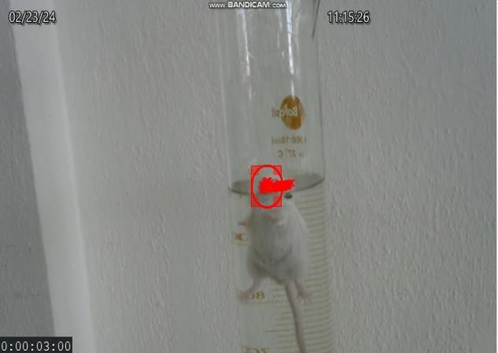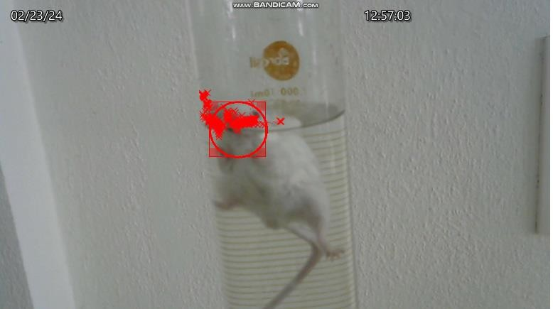

Figure 1 : Evaluation of **control group** using forced swim test

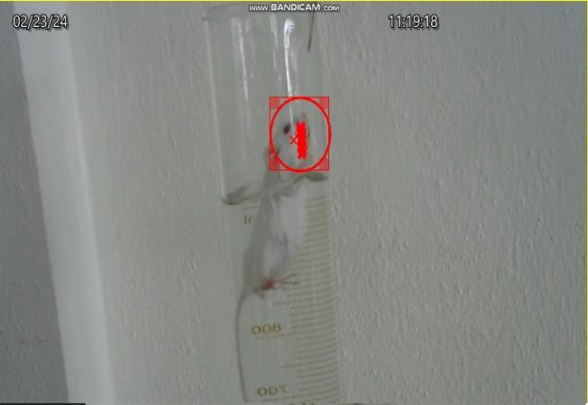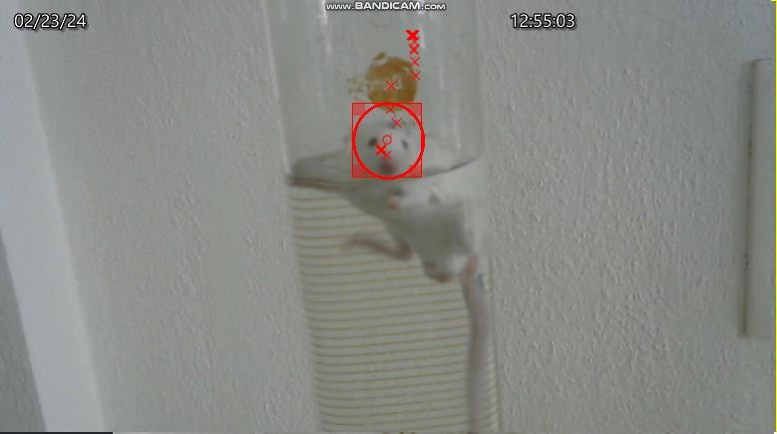

Figure 2 : Evaluation of **standard group** using forced swim test

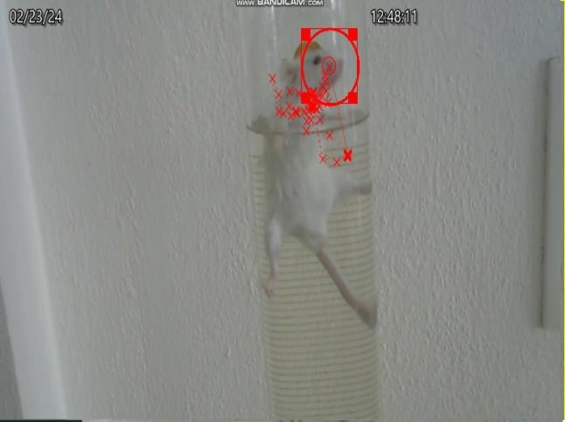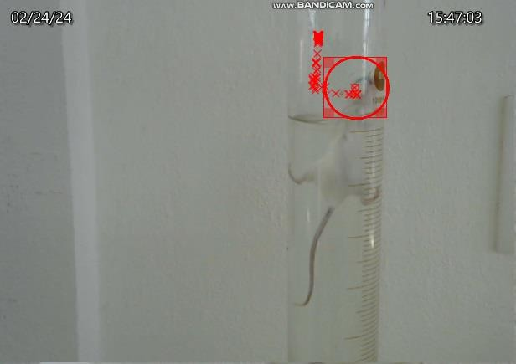

Figure 3 : Evaluation of ***Coleus Amboinicus*** Figure 4: Evaluation of ***Ocimum Sanctum***

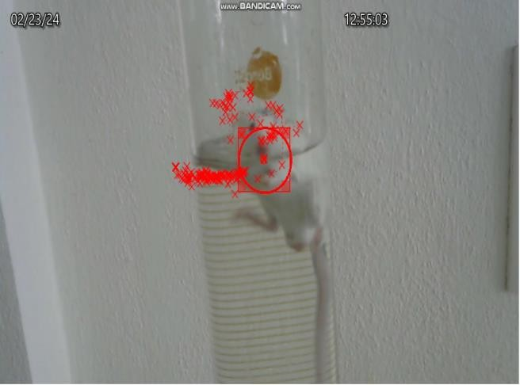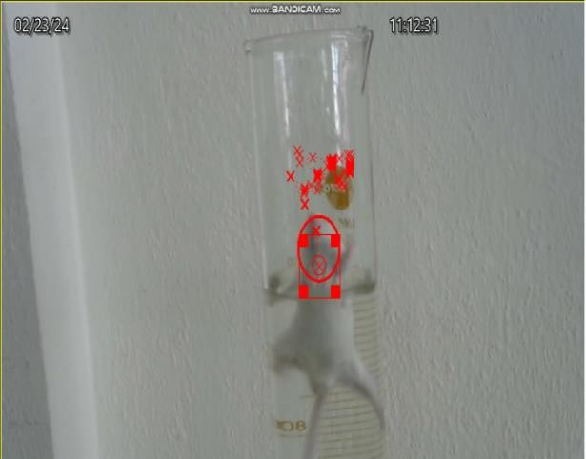Figure 5: Evaluation of **Test – I and II treatments group** using forced swim test Table 1: Evaluation data using Forced swim test

|  |  |  |  |  |
| --- | --- | --- | --- | --- |
| **S.No** | **Treatment Groups** | **Average Time of Immobility (Sec)** | **Number of Trials** | **Gap between the trials (Sec)** |
| 1 | Control | 34.00 ± 0.91 | 3.75 ± 0.25 | 8.75 ± 0.47 |
| 2 | Standard (Amitriptyline 10mg/kg I.P) | 13.25 ± 0.62 | 8.25 ± 0.47 | 4.50 ± 0.28 |
| 3 | Test – I (*Ocimum sanctum* with  *Coleus amboinicus*- Dose 1 100mg/Kg 50:50 Oral) | 15.00 ± 0.40 | 6.75 ± 0.25 | 5.50 ± 0.28 |
| 4 | Test – II (*Ocimum sanctum* with  *Coleus amboinicus* Dose 2 100mg/Kg 25:75 Oral) | 8.75 ± 0.47 | 6.75 ± 0.25 | 5.0 ± 0.40 |

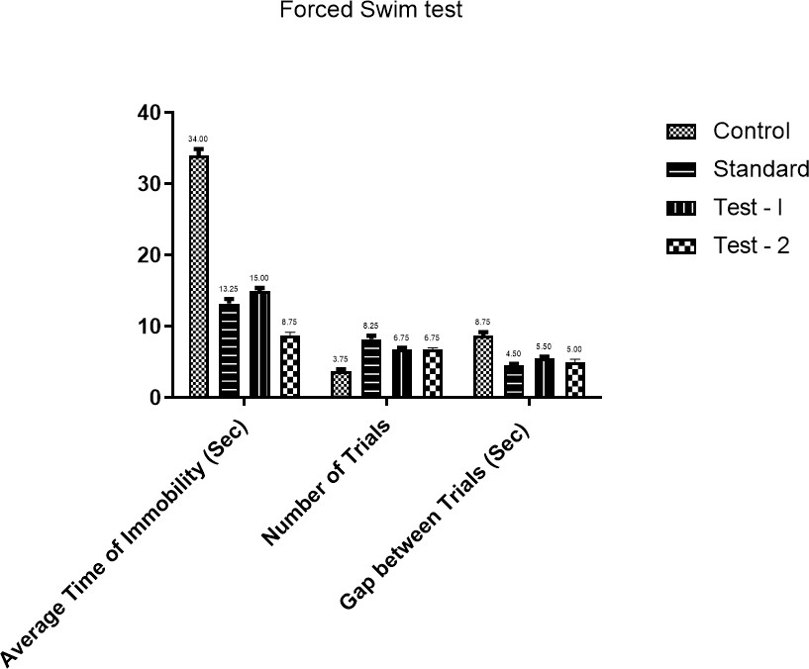

Graph 1: Evaluation of **all treatments group** using forced swim test

### Tail Suspension Test (TST)

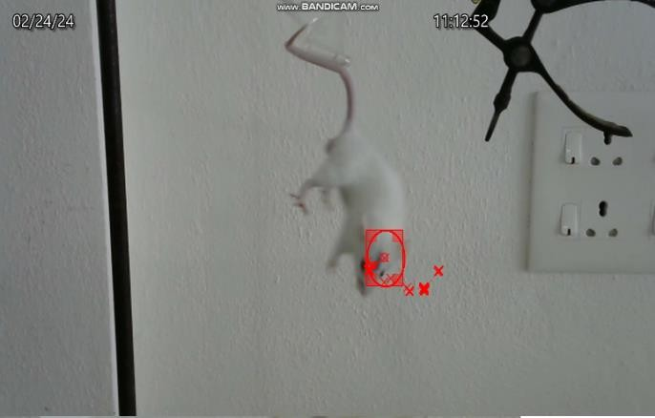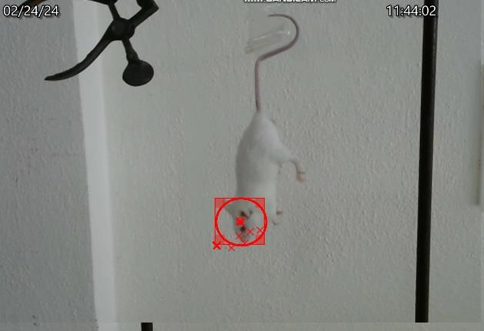

Figure 6: Evaluation of **control group** using Tail suspension Test

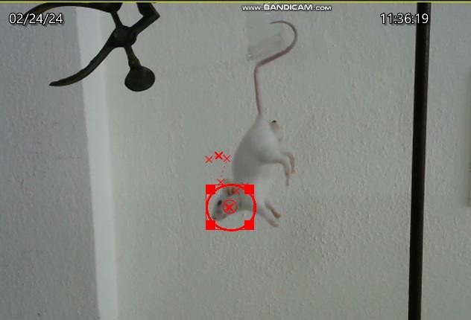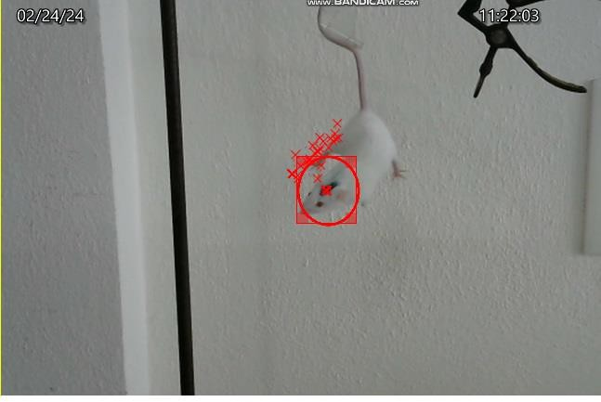

Figure 7: Evaluation of **Standard group** using Tail suspension Test

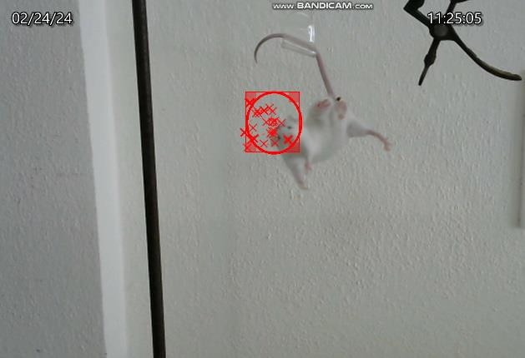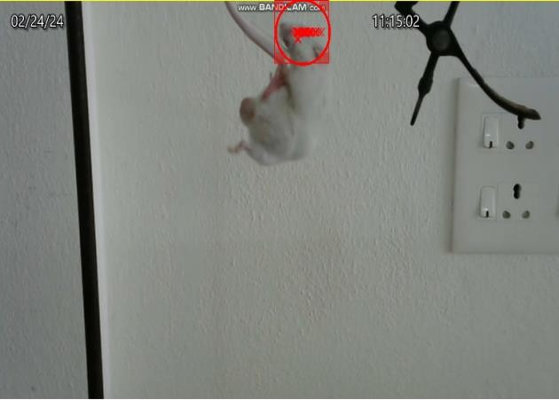

Figure 8: Evaluation of ***Coleus Amboinicus*** Figure 9 : Evaluation of ***Ocimum Sanctum***

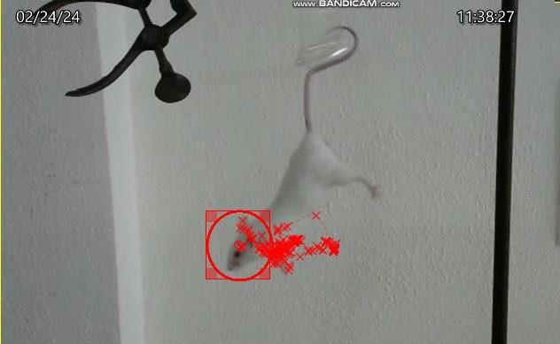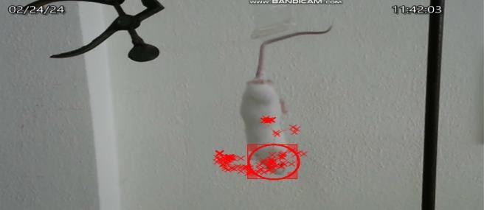

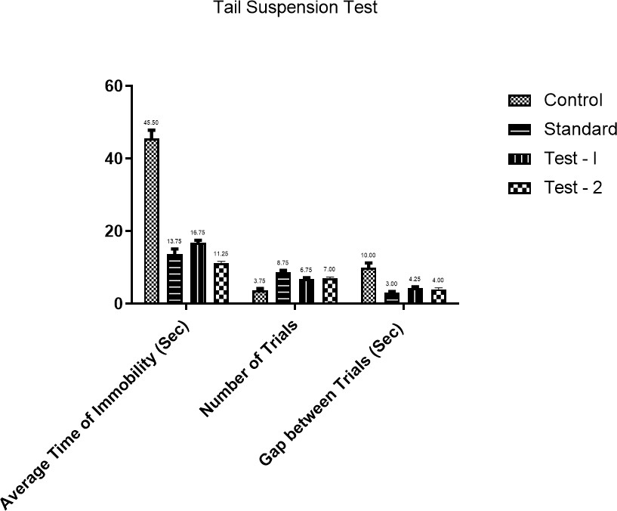Figure 10 : Evaluation of **Test – I and II treatments group** using Tail suspension test Table 2 Evaluation data using Tail suspension test

|  |  |  |  |  |
| --- | --- | --- | --- | --- |
| **S.No** | **Treatment Groups** | **Average Time of Immobility (Sec)** | **Number of Trials** | **Gap between the trials (Sec)** |
| 1 | Control | 45.50 ± 2.39 | 3.75 ± 0.47 | 10.00 ± 1.29 |
| 2 | Standard (Amitriptyline 10mg/kg I.P) | 13.75 ± 1.37 | 8.75 ± 0.47 | 3.00 ± 0.40 |
| 3 | Test – I (*Ocimum sanctum* with  *Coleus amboinicus*- Dose 1 100mg/Kg 50:50 Oral) | 16.75 ± 0.75 | 6.75 ± 0.47 | 4.25 ± 0.47 |
| 4 | Test – II (*Ocimum sanctum* with  *Coleus amboinicus* Dose 2 100mg/Kg 25:75 Oral) | 11.25 ± 0.47 | 7.00 ± 0.40 | 4.0 ± 0.40 |

Graph 2: Evaluation of **all treatments group** using Tail suspension Test

***Analysis – Forced Swim Test***

The study results indicate that the test groups treated with *Ocimum sanctum* and *Coleus amboinicus* exhibited significant antidepressant activity comparable to the standard drug Amitriptyline (10 mg/kg). The control group showed the highest immobility time (34.00 sec), reflecting behavioral despair, whereas the standard group had a significantly reduced immobility time (13.25 sec) with an increased number of trials. The test groups (Dose 1 & Dose 2) also showed a marked reduction in immobility time (15.00 sec and 8.75 sec, respectively), with Dose 2 closely resembling the standard drug's effect, confirming the antidepressant potential of these herbal extracts.

***Analysis – Tail Suspension Test***

The results demonstrate the antidepressant potential of *Ocimum sanctum* and *Coleus amboinicus*, as both test groups significantly reduced immobility time compared to the control group. The control group exhibited the highest immobility time (45.50 sec), with fewer trials (3.75), and the longest gap between trials (10.00 sec), indicating behavioral despair. The standard group (Amitriptyline, 10 mg/kg) showed a substantial reduction in immobility time (13.75 sec) and increased trials (8.75). Similarly, Test-I (Dose 1) and Test-II (Dose 2) demonstrated dose-dependent efficacy, with Dose 2 (11.25 sec) closely resembling the standard drug's effect, confirming their antidepressant activity.

## DISCUSSION

The forced swim test (FST) is a widely used behavioral assay for assessing depressive-like states and the efficacy of antidepressant treatments in animal models. In this test, animals are placed in an inescapable container filled with water, and their behavior is observed, particularly the time spent immobile, which is considered indicative of behavioral despair.

In the current study, the FST results revealed notable differences between the test groups and the control group. The control group, which did not receive any treatment, exhibited a typical level of immobility, as expected in this model. In contrast, the test groups, which were subjected to a specific intervention or treatment, demonstrated significantly reduced immobility time. This suggests that the animals in these groups were more active and exhibited less depressive-like behavior, indicating that the treatment had a positive effect on their behavior under stress.

The similarity in activity levels between the test groups and the control group suggests that the treatment was effective in reducing behavioral despair, bringing the activity of the treated animals closer to normal levels. This outcome implies that the treatment may have potential antidepressant properties, as it successfully mitigated the symptoms of immobility typically observed in the FST. The observed improvements in the test groups highlight the potential for further investigation into the mechanisms underlying these effects and their applicability in therapeutic contexts.

The tail suspension test (TST) is another commonly used behavioral assay to assess depressive-like behavior and the efficacy of antidepressant treatments in animal models, particularly mice. In this test, animals are suspended by their tails, and their movements are monitored, with immobility time being the primary measure of despair- like behavior.

In this study, the TST results revealed important distinctions between the test groups and the control group. The control group, which did not receive any experimental treatment, exhibited a standard duration of immobility, consistent with expected outcomes in this type of assay. The test groups, however, showed a marked reduction in immobility time compared to the control group. This reduction suggests that the animals in the test groups were less prone to behavioral despair, indicating an increased level of motivation or decreased depressive-like symptoms.

The reduced immobility observed in the test groups, similar to the control group's active behavior, suggests that the intervention or treatment applied to these groups had a significant antidepressant-like effect. The results support the hypothesis that the treatment is effective in improving the animals' coping behavior under stress, as evidenced by their enhanced struggle to escape, which is reflected in the decreased immobility time. These findings align with the idea that the treatment used in the test groups may have therapeutic potential for alleviating depressive symptoms. The consistency of the activity levels between the test and control groups further underscores the treatment's efficacy, warranting additional research to explore the underlying mechanisms and potential clinical applications of these findings.

***Relation of Immobility with Depression***

Studies have demonstrated that the chemical constituents of *Ocimum sanctum* and *Coleus amboinicus* exhibit significant antidepressant effects by enhancing serotonin levels in the brain, thereby reducing immobility time in behavioral despair models like the Forced Swim Test (FST) and Tail Suspension Test (TST). The primary compounds responsible for this activity include eugenol, rosmarinic acid, luteolin, and ursolic acid in *Ocimum sanctum*, along with thymol and carvacrol in *Coleus amboinicus*. These bioactive molecules modulate serotonergic neurotransmission, leading to increased motivation and a reduced state of learned helplessness in rodents. More immobility in these tests is indicative of behavioral despair and a lack of effort for survival, whereas reduced immobility (increased mobility) suggests an enhanced drive to survive and a restoration of hope, which correlates with increased serotonin activity in the brain. By decreasing oxidative stress, regulating the hypothalamic-pituitary-adrenal (HPA) axis, and promoting neuroplasticity, these phytochemicals contribute to their antidepressant-like effects, making these herbal plants promising candidates for natural depression therapy.

# STATISTICAL ANALYSIS

The mean standard error (SEM) accustomed to represent all of the above results. Two-way ANOVA was used to analyse the data, and Tukey's multiple comparison test was then performed. A P value of less than 0.0001 was deemed statistically significant.

# CONCLUSION

The combination of *Ocimum sanctum and Coleus amboinicus* extracts demonstrates effective antidepressant activity, as indicated by the results from the Forced Swim Test and Tail Suspension Test in mice. The combination treatment group showed significant reductions in immobility time compared to the control group, suggesting enhanced antidepressant effects. Furthermore, the efficacy of the combined extracts was comparable to that of the standard treatment groups, indicating their potential as a natural and synergistic alternative for managing depressive disorders. These findings warrant further exploration in clinical settings to confirm the antidepressant benefits and safety profile of this herbal combination.

# REFERENCES

1. Ali SS, Abd El Wahab MG, Ayuob NN, Suliaman M. The antidepressant-like effect of Ocimum basilicum in an animal model of depression. Biotech Histochem. 2017 Aug;92(6):390-401.
2. Bhattacharyya D, Sur TK, Jana U, Debnath PK. Controlled programmed trial of Ocimum sanctum leaf on generalized anxiety disorders. Nepal Med Coll J. 2008 Sep;10(3):176-9.
3. Bhattacharyya P, Bishayee A. Ocimum sanctum Linn. (Tulsi): an ethnomedicinal plant for the prevention and treatment of cancer. Anticancer Drugs. 2013 Aug;24(7):659-66.
4. Chatterjee M, Singh S, Kumari R, Verma AK, Palit G. Evaluation of the antipsychotic potential of Panax quinquefolium in ketamine induced experimental psychosis model in mice. Neurochem Res. 2012 Apr;37(4):759-70.
5. Chatterjee M, Verma P, Palit G. Comparative evaluation of Bacopa monniera and Panax quniquefolium in experimental anxiety and depressive models in mice. Indian J Exp Biol. 2010 Mar;48(3):306-13.
6. Chatterjee, Manavi, et al. "Evaluation of ethanol leaf extract of Ocimum sanctum in experimental models of anxiety and depression." *Pharmaceutical biology* 49.5 (2011): 477-483.
7. Hong, Huixia, et al. "Ethyl acetate extract of Nymphaea candida Presl: A potential anti-depressant and neuroprotective treatment strategy." *Biomedicine & Pharmacotherapy* 179 (2024): 117304.
8. Kalariya M, Parmar S, Sheth N. Neuropharmacological activity of hydroalcoholic extract of leaves of Colocasia esculenta. Pharm Biol. 2010 Nov;48(11):1207-12.
9. Leonard, B. E. Stress, norepinephrine and depression. *J Psychiatry Neurosci.* 2001, *26*, S11
10. Lopresti AL, Smith SJ, Metse AP, Drummond PD. A randomized, double-blind, placebo-controlled trial investigating the effects of an Ocimum tenuiflorum (Holy Basil) extract (Holixer™) on stress, mood, and sleep in adults experiencing stress. Front Nutr. 2022 Sep 2;9:965130.
11. Matraszek-Gawron, Renata, et al. "Current Knowledge of the Antidepressant Activity of Chemical Compounds from Crocus sativus L." *Pharmaceuticals* 16.1 (2022): 58.
12. Mendelovich Y. Meet Kdenlive: Free Open Source NLE That Aims for Professionals. Y.M.Cinema Magazine. Published November 14, 2024. Available from: https://www.ymcinema.com.
13. Moinuddin, Ghulam, et al. "Comparative pharmacological evaluation of Ocimum sanctum and imipramine for antidepressant activity." *Lat Am J Pharm* 30 (2011): 435-9Smail Amtaghri, Mourad Akdad, Miloudia Slaoui, Mohamed Eddouks.
14. Monica, Sharma, Khemani Naresh, and Singh Janardhan. "Effect of Parnayavani (Coleus Amboinicus Lour.) On Mes Induced Epilepsy in Rats." *Global Journal of Research on Medicinal Plants & Indigenous Medicine* 2.6 (2013): 435.
15. Prakash P, Gupta N. Therapeutic uses of Ocimum sanctum Linn (Tulsi) with a note on eugenol and its pharmacological actions: a short review. Indian J Physiol Pharmacol. 2005 Apr;49(2):125-31.
16. Rajan Ravindran, Rathinasamy Sheela Devi, James Sams and Manohar Senthilvelan.Noise stress induced brian neurotransmitter changes and the effect of Ocimum sanctum ( Linn) treatment in albino rats. J Pharmcol Sci 98,2005,354-360.
17. Singh N, Misra N, srivastava AK, Dixit KS and Gupta GP. Effect of antistress plants on biochemical changes during stress reaction. Ind Jpharmacol. 23; 1991,137-142.
18. Yadav M, Parle M, Sharma N, Dhingra S, Raina N, Jindal DK. Brain targeted oral delivery of doxycycline hydrochloride encapsulated Tween 80 coated chitosan nanoparticles against ketamine induced psychosis: behavioral, biochemical, neurochemical and histological alterations in mice. Drug Deliv. 2017 Nov;24(1):1429-1440.