"NATURAL PEST CONTROL: EFFECTIVENESS OF STRYCHNOS NUX-VOMICA EXTRACTS IN RICE PROTECTION"
Abstract:
The efficacy of Strychnos nux-vomica seed, bark, and leaf extracts was evaluated against two major rice pests, Cnaphalocrocis medinalis (rice leaf folder) and Nilaparvata lugens (brown planthopper), under Rabi and Kharif conditions. Field trials demonstrated a significant reduction in pest infestation and increased mortality rates with higher extract concentrations. Among the tested formulations, the seed extract at 1.25% concentration exhibited the highest insecticidal activity, achieving 52.16% and 80.58% mortality against C. medinalis and N. lugens, respectively. The bark and leaf extracts were also effective, with mortality rates reaching 50.57% and 54.95% for C. medinalis and 76.54% and 64.26% for N. lugens. In contrast, untreated control plots recorded substantially higher pest populations, underscoring the efficacy of S. nux-vomica extracts as biopesticides. These findings highlight the potential of S. nux-vomica, particularly its seed extract, as a sustainable and eco-friendly alternative to synthetic pesticides for integrated pest management in rice cultivation.

Keywords:
Strychnos nux-vomica, rice pests, Cnaphalocrocis medinalis, Nilaparvata lugens, biopesticide, insecticidal activity, pest management, rice cultivation, botanical pesticide, eco-friendly pest control.
Introduction:
The Strychnine tree, Strychnous nux vomica (Kajra in Marathi) is very much toxic and already proved for its pesticidal property (Thambi and Cherian, 2015; Behera et al., 2017). The Strychnos nux-vomica is well known with various names in different languages viz. In English nux, strychnine tree, semen strychnos, poison nut, dog button, quaker buttons, snake wood and vomic nuts, in Hindi it is popularly known as Bailewala, Kuchla and in Marathi Kajra, Kuchla, Kupiluetc (Stephens et al., 1904; Arivoli and Tennyson, 2012; Bhatti et al., 2012; Behera et al., 2017; Kanta and Banerji, 2017). It possesses low cost with no environmental loss as compared to synthetic insecticides (Thambi and Cherian, 2015). Hence, insecticidal property of Strychnous nux-vomica extract is checked against mango leaf hopper (Zulfiqar and Malik, 2017; Mandal et al., 2018) which is major pest at the study area i.e. Ratnagiri district, Maharashtra.
Rice is the major staple food crop of Southeast Asia and ranks as the second most important crop globally in terms of area and production. It is projected to reach 800 million tonnes of production by 2025, up from the current 585 million tonnes (Virk et al., 2004). Asia accounts for 92% of global rice production, with consumption increasing at an average rate of 2% per year (Palaniappan, 2000). In Tamil Nadu, rice is cultivated across 21.1 million hectares, yielding a total production of 8.19 million tonnes at an average yield of 3.4 t/ha. The annual population growth rate is approximately 1.5%, and the per capita consumption stands at 235 g per day. It is estimated that Tamil Nadu's rice demand will reach 100 million tonnes by 2010. Despite the growing demand, rice yields have begun to stagnate or decline, largely due to nutrient deficiencies and pest problems.
Rice is vulnerable to over 100 insect pests due to its succulent nature (Pathak and Dhaliwal, 1981). Among these, the stem borer, leaf folder, and hoppers are the most significant, causing yield losses of up to 40-80%. Insects damage rice at various growth stages, with leaf-feeding insects, borers, and sucking pests being of particular concern as they result in significant yield reductions.
Key rice pests include the rice leaf folder (Cnaphalocrocis medinalis), rice stem borer (Scirpophaga incertulus), green leaf hopper (Nephotettix virescens), brown planthopper (Nilaparvata lugens), thrips (Stenchaetothrips biformis), gall midge (Orseolia oryzae), mealy bug (Brevennia rehi), and earhead bug (Leptocorisa acuta). The rice leaf folder, in particular, has become a major pest during the vegetative and reproductive stages, especially after the introduction of high-yielding varieties. The caterpillars feed on the leaf blades, scraping away the green matter, which reduces photosynthesis and, in turn, yields. Yield losses due to leaf folder epidemics can range from 30 to 80 percent (Kushwaha, 1989). An increase in infestation by C. medinalis results in a yield reduction of 1.4-1.46% during the summer and wet seasons (Pandiya et al., 1987).
The yellow stem borer (Scirpophaga incertulus) is a specific rice pest whose larvae feed inside the stem, causing "dead hearts" in young plants and "white ears" in older plants. This results in average yield losses of 100-500 kg per hectare (Atwal and Dhaliwal, 2005). Both nymphs and adults of the green leaf hopper (Nephotettix virescens) suck sap from the leaves, causing yellowing and eventual browning, while also serving as vectors for the tungro virus, one of the most serious rice diseases. The brown planthopper (Nilaparvata lugens) is another highly destructive pest, with both its nymphs and adults sucking sap from the leaves, leading to hopper burn symptoms and yield losses of 10-70% (Atwal and Dhaliwal, 2005).
While synthetic chemical insecticides have been the go-to solution for mitigating pest problems in rice, their overuse has led to issues such as resistance, resurgence of sucking pests, harm to natural biological agents, and environmental pollution (Mahapatro and Gupta, 1998). The modern trend in Indian agriculture favors the use of botanicals and microbial insecticides, which have gained popularity due to their effectiveness in pest control and eco-friendliness.
India is home to a rich variety of plants that can be utilized as botanical pesticides. Although research into the preparation of botanical pesticides has not advanced as much as expected, the diverse biologically active compounds in plants can effectively protect against herbivory and deter pest attacks. This growing awareness has sparked a global revaluation of traditional botanical pest control methods. Botanical insecticides are inexpensive, effective, safe, and ecologically acceptable (Veeravel, 2002).
Among the many plants with insecticidal properties, S. nux-vomica (Strychnos nux-vomica), commonly known as the poison nut, has garnered attention for its potent pesticidal and medicinal properties. S. nux-vomica contains alkaloids such as strychnine and brucine, which have shown insecticidal activity. The plant has been used in traditional medicine for various ailments, and its seeds have been explored for their ability to control pests in agricultural settings. Studies have demonstrated that extracts from S. nux-vomica possess both contact and stomach poison effects against a variety of insect pests, making it a potential candidate for sustainable pest management (Kumar et al., 2011). Furthermore, the plant’s ecological adaptability and relatively low environmental impact contribute to its appeal as a natural pesticide alternative.
Materials and Methods
The field experiments were conducted to evaluate the effectiveness of Nux-vomica against rice pests in two different trials. In Trial I, the crop used was paddy (variety ADT 43), with a spacing of 20 X 15 cm, covering an area of 39 cents. Each plot size was 3 X 2.58 m², and there were 47 treatments with 3 replications, following a Randomized Block Design (RBD). The sowing date for Trial I was 05.06.2019, with planting done on 29.06.2019. In Trial II, a different paddy variety (BPT) was used with similar spacing, area, and plot size. The sowing date was 12.08.2020, and planting took place on 10.09.2020. The experimental design, number of treatments, and replications remained the same as in Trial I.
The percent damage caused by pests was calculated according to the method described by Rao et al. (2002). At harvest, plot-wise yield data were also recorded. The formula for calculating percent damage was as follows:
Per cent damage = (Number of damaged plants / Total number of plants) × 100.
For pest population assessment, several species were evaluated in both trials. For Cnaphalocrocis medinalis (leaf folder larvae), the population was assessed by selecting five hills randomly from each plot. Observations were made on the number of damaged leaves one day before treatment, as well as on the third and fifth day after treatment. Five randomly selected plants were observed in each plot, and the percent damage was calculated.
In the case of N. lugens (green leafhopper), both nymphs and adults were estimated from five plants per plot, either by conducting ten net sweeps or through visual counting.
The statistical analysis for the laboratory data was performed using a completely randomized block design (CRBD). Based on the analysis of variance (ANOVA), treatment means were compared and ranked using the Least Significant Difference (LSD) test. For the field experiment data, the same statistical approach was followed, and the treatment effects were compared and ranked using the LSD test, as described by Gomez and Gomez (1976), Heinrichs et al. (1981), and Rangaswamy (1995).

Result:

Seed Extracts:
The field efficacy of S. nux-vomica seed extracts against C. medinalis was assessed under both Rabi and Kharif field conditions. The pre-treatment infestation count varied across the different concentrations, ranging from 21.13% to 33.10%. This indicates the presence of C. medinalis in the field before any treatment was applied. After applying the seed extract treatments, the infestation rates were measured again at 7 and 14 days after treatment (DAS). A noticeable reduction in the infestation was observed across all concentrations of the seed extract. However, the highest concentrations (1.0% and 1.25%) showed the most significant decrease in infestation rates at both time points, with the infestation rates dropping to as low as 23.08% and 20.14%, respectively.
The mortality over the control group an important indicator of the effectiveness of the treatments was calculated for each treatment group. At higher concentrations (1.0% and 1.25%), the mortality rate over the control increased significantly. At the 1.25% concentration, the mortality rate was as high as 52.16%, a clear indication of the potent insecticidal activity of the seed extract. These results suggest that the seed extracts of S. nux-vomica are highly effective in controlling C. medinalis, especially at higher concentrations, making them a viable alternative for pest management in agricultural settings.

Bark Extracts:
Similarly, the field efficacy of S. nux-vomica bark extracts was evaluated against C. medinalis under both Rabi and Kharif conditions. The infestation percentage before treatment (pre-treatment count) ranged from 22.93% to 33.59%, indicating a moderate level of pest presence. After treatment, a significant reduction in infestation was observed at both 7 DAS and 14 DAS. The highest concentration (1.25%) was particularly effective, showing a reduction in infestation by 22.13% at 7 DAS and 20.14% at 14 DAS. These reductions were higher compared to the lower concentrations, highlighting the importance of dosage in achieving better pest control.
The percentage mortality over the control group followed a similar pattern, with higher concentrations leading to more effective pest control. At the 1.25% concentration, mortality reached 50.57%, making it the most effective treatment in terms of pest mortality. The bark extract treatments demonstrated strong pest control capabilities, and the results suggest that the bark extract, especially at higher concentrations, can be used as an efficient natural pesticide.

Leaf Extracts:
The leaf extracts of S. nux-vomica were also tested for their efficacy against C. medinalis under field conditions. The pre-treatment infestation rates were somewhat comparable to those observed with the seed and bark extracts, ranging from 22.45% to 30.32%. At 7 and 14 DAS, a noticeable reduction in infestation was observed across all concentrations, but the higher concentrations (1.0% and 1.25%) were the most effective. The infestation rate decreased significantly with the 1.25% leaf extract, showing an infestation of just 26.00% at 7 DAS, with further reductions at 14 DAS.
In terms of mortality over the control, the 1.25% leaf extract demonstrated the highest mortality rate, reaching 54.95%. This suggests that the leaf extract of S. nux-vomica is also highly effective in controlling C. medinalis, particularly at higher concentrations. The leaf extract, like the seed and bark extracts, displayed strong insecticidal properties, confirming its potential use as a biopesticide in pest management strategies.

Table No.: 1 Field Efficacy of S. nux-vomica Extracts (Seed, Bark, and Leaf) Against C. medinalis Under Field Conditions (Rabi and Kharif Seasons)
Treatment no. | Treatment | % Infestation @ Pre-treatment count | % Infestation @ 7 DAS | % Infestation @ 14 DAS | % Mortality over Control
 |  | (Mean ± SE) | (Mean ± SE) | (Mean ± SE) | (Mean ± SE)
Seed Extracts (Rabi)
T1 | 0.25% | 21.13 (27.35) | 32.24 (34.57) | 35.25 (36.40) | 16.27
T2 | 0.5% | 22.95 (28.59) | 30.26 (33.35) | 33.24 (35.19) | 21.05
T3 | 0.75% | 25.68 (30.41) | 28.40 (32.18) | 24.40 (29.58) | 42.04
T4 | 1.0% | 24.46 (29.62) | 25.30 (30.17) | 21.13 (27.34) | 49.81
T5 | 1.25% | 24.80 (29.84) | 23.08 (28.69) | 20.14 (26.65) | 52.16
T6 | Positive Control | 22.58 (28.33) | 24.40 (29.58) | 21.03 (27.28) | 50.05
T7 | Control | 25.04 (30.01) | 35.25 (36.40) | 42.10 (40.43) | —
Bark Extracts (Rabi)
T1 | 0.25% | 22.93 (26.94) | 33.16 (35.14) | 37.26 (37.60) | 7.77
T2 | 0.5% | 23.49 (30.12) | 30.02 (33.20) | 34.12 (35.72) | 15.54
T3 | 0.75% | 25.61 (28.57) | 30.00 (33.19) | 27.08 (31.33) | 32.97
T4 | 1.0% | 25.36 (31.19) | 27.08 (31.33) | 24.08 (29.37) | 40.39
T5 | 1.25% | 25.60 (29.62) | 24.90 (29.91) | 22.13 (28.04) | 45.22
T6 | Positive Control | 23.58 (29.93) | 25.28 (30.16) | 23.08 (28.69) | 42.87
T7 | Control | 25.68 (30.42) | 33.10 (35.10) | 40.40 (39.45) | —
Leaf Extracts (Rabi)
T1 | 0.25% | 24.60 (29.69) | 33.10 (35.10) | 37.16 (37.46) | 17.61
T2 | 0.5% | 25.08 (30.03) | 31.02 (33.79) | 35.34 (36.92) | 21.64
T3 | 0.75% | 23.71 (29.10) | 30.02 (33.20) | 26.32 (36.71) | 41.64
T4 | 1.0% | 22.45 (28.24) | 27.08 (31.34) | 25.02 (33.17) | 44.52
T5 | 1.25% | 23.61 (29.03) | 25.02 (29.99) | 21.03 (30.47) | 53.37
T6 | Positive Control | 25.44 (30.25) | 25.60 (30.37) | 22.29 (30.14) | 50.57
T7 | Control | 25.36 (30.21) | 35.52 (36.56) | 45.10 (29.17) | —
Seed Extracts (Kharif)
T1 | 0.25% | 28.08 (31.98) | 36.11 (36.91) | 36.18 (36.46) | 33.34
T2 | 0.5% | 28.12 (32.01) | 32.18 (34.54) | 32.04 (34.46) | 24.72
T3 | 0.75% | 25.68 (30.41) | 30.22 (33.33) | 26.12 (30.72) | 45.65
T4 | 1.0% | 30.02 (33.21) | 28.2 (32.05) | 22.11 (28.04) | 53.99
T5 | 1.25% | 33.1 (35.11) | 25.18 (30.10) | 20.14 (26.65) | 58.09
T6 | Positive Control | 31.02 (33.79) | 27.32 (31.49) | 24.12 (29.39) | 49.81
T7 | Control | 31.12 (33.88) | 42.102 (40.43) | 48.06 (43.87) | —
Bark Extracts (Kharif)
T1 | 0.25% | 31.06 (33.84) | 37.16 (37.54) | 39.16 (38.72) | 30.36
T2 | 0.5% | 30.86 (33.70) | 33.00 (35.04) | 35.25 (36.40) | 22.63
T3 | 0.75% | 30.04 (33.19) | 34.08 (35.69) | 29.10 (32.62) | 42.51
T4 | 1.0% | 29.18 (32.67) | 32.04 (34.45) | 27.00 (31.29) | 46.66
T5 | 1.25% | 30.66 (33.59) | 29.10 (32.62) | 25.02 (29.99) | 50.57
T6 | Positive Control | 27.38 (31.52) | 28.38 (32.17) | 26.12 (30.72) | 48.40
T7 | Control | 30.32 (33.39) | 45.34 (42.30) | 50.62 (45.33) | —
Leaf Extracts (Kharif)
T1 | 0.25% | 30.32 (33.38) | 39.16 (38.72) | 43.02 (40.97) | 12.41
T2 | 0.5% | 28.52 (32.24) | 35.13 (36.33) | 37.16 (37.54) | 24.35
T3 | 0.75% | 29.42 (32.83) | 33.34 (35.25) | 28.12 (32.01) | 42.75
T4 | 1.0% | 28.92 (32.50) | 31.02 (33.79) | 24.02 (29.33) | 51.09
T5 | 1.25% | 30.04 (33.19) | 26.00 (30.64) | 22.13 (28.04) | 54.95
T6 | Positive Control | 28.60 (32.29) | 27.00 (31.29) | 23.08 (28.69) | 53.01
T7 | Control | 29.24 (32.71) | 46.30 (42.86) | 49.12 (44.47) | —

Fig1 : Field Efficacy of S. nux-vomica Extracts against C. medinalis
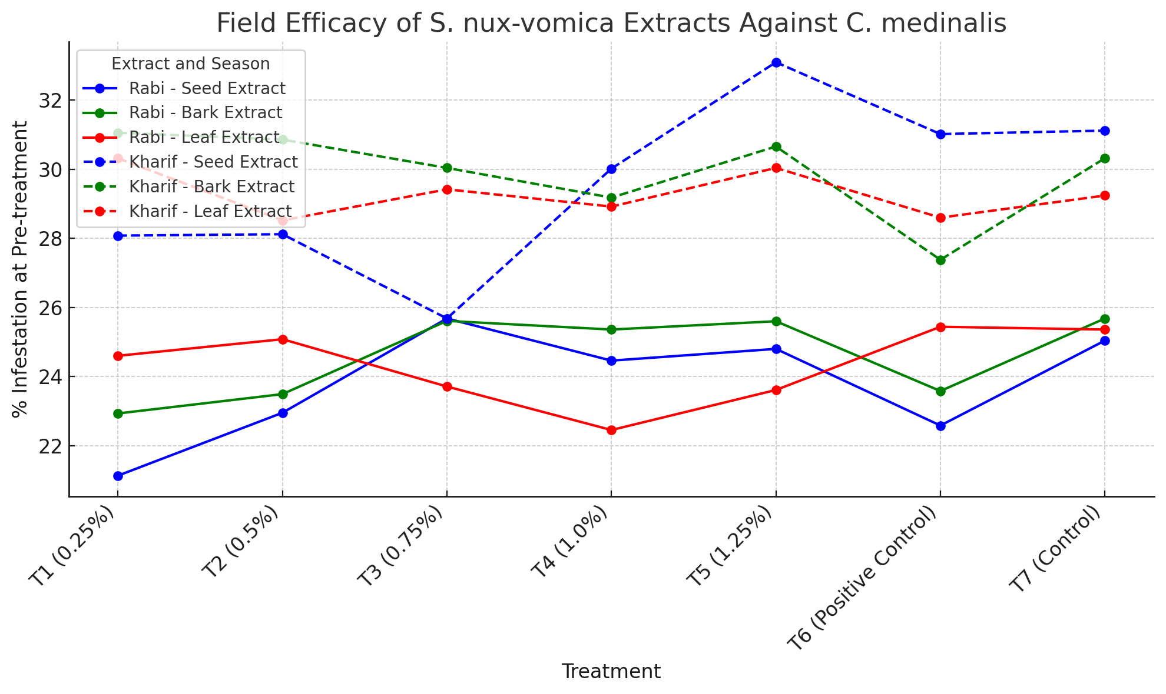

The field efficacy study of S. nux-vomica seed, bark, and leaf extracts against Nilaparvata lugens (N. lugens) under both Rabi and Kharif seasons demonstrated notable variations in the effectiveness of different plant parts and concentrations. Among the extracts, the seed extract consistently showed the highest mortality rates across both seasons. At concentrations of 1.0% and 1.25%, the seed extract achieved significant pest control, with up to 80.58% mortality in the Kharif season. The bark extract also exhibited promising results, with the 1.25% concentration achieving 76.54% mortality in the Kharif season, indicating its effectiveness as a botanical pesticide. In comparison, the leaf extract, though still effective, showed relatively lower mortality rates, with a maximum of 64.26% in the Rabi season. The increased concentration of the extracts correlated positively with higher mortality rates, emphasizing the importance of dosage in enhancing pest control efficiency. In both seasons, the control groups (untreated rice) showed significantly higher pest populations, with N. lugens numbers growing substantially, underscoring the effectiveness of S. nux-vomica as a natural pest management tool. These results suggest that S. nux-vomica, particularly its seed extract, could be a promising alternative to chemical pesticides, offering an eco-friendly, cost-effective, and efficient solution to manage N. lugens infestations in rice crops.
Table No.: 2Field Efficacy of S. nux-vomica Seed, Bark, and Leaf Extracts Against N. lugens Under Rabi and Kharif Seasons
Season | Plant Part | Treatment No. | Treatment | Pre-Treatment Count | 7 DAS Count | 14 DAS Count | % Mortality Over Control
RABI SEASONS
 | Seed | T1 | 0.25% | 54.40 (7.44) | 50.60 (7.18) | 46.20 (6.87) | 55.66
 |  | T2 | 0.5% | 59.20 (7.75) | 47.40 (6.95) | 39.00 (6.32) | 62.57
 |  | T3 | 0.75% | 51.20 (7.22) | 43.20 (6.64) | 33.00 (5.83) | 68.33
 |  | T4 | 1.0% | 60.00 (7.81) | 38.00 (6.24) | 29.20 (5.49) | 71.98
 |  | T5 | 1.25% | 57.20 (7.62) | 30.20 (5.58) | 25.20 (5.11) | 75.81
 |  | T6 | Positive Control | 58.20 (7.69) | 42.20 (6.57) | 35.20 (6.01) | 66.21
 |  | T7 | Control | 53.00 (7.34) | 80.40 (9.02) | 104.20 (10.25) | -
 | Bark | T1 | 0.25% | 60.00 (7.81) | 56.40 (7.57) | 49.20 (7.08) | 55.27
 |  | T2 | 0.5% | 54.20 (7.42) | 51.20 (7.22) | 46.20 (6.87) | 58.00
 |  | T3 | 0.75% | 53.00 (7.34) | 49.20 (7.08) | 42.00 (6.55) | 61.82
 |  | T4 | 1.0% | 55.00 (7.48) | 47.00 (6.92) | 39.20 (6.34) | 64.36
 |  | T5 | 1.25% | 54.00 (7.41) | 41.00 (6.48) | 35.00 (5.99) | 68.18
 |  | T6 | Positive Control | 52.00 (7.27) | 43.20 (6.64) | 37.00 (6.16) | 66.36
 |  | T7 | Control | 55.00 (7.48) | 95.40 (9.81) | 110.00 (10.52) | -
 | Leaf | T1 | 0.25% | 57.00 (7.61) | 55.00 (7.48) | 50.20 (7.15) | 50.98
 |  | T2 | 0.5% | 53.00 (7.34) | 53.00 (7.34) | 45.00 (6.78) | 56.05
 |  | T3 | 0.75% | 58.00 (7.68) | 49.00 (7.07) | 43.00 (6.63) | 58.01
 |  | T4 | 1.0% | 55.00 (7.48) | 47.00 (6.92) | 41.20 (6.49) | 59.76
 |  | T5 | 1.25% | 60.00 (7.81) | 42.20 (6.57) | 36.60 (6.13) | 64.26
 |  | T6 | Positive Control | 50.00 (7.14) | 44.00 (6.70) | 37.00 (6.16) | 63.87
 |  | T7 | Control | 58.00 (7.68) | 88.80 (9.47) | 102.40 (10.16) | -
KHARIF SEASONS
 | Seed | T1 | 0.25% | 36.20 (6.09) | 47.00 (6.92) | 56.40 (7.57) | 31.55
 |  | T2 | 0.5% | 35.20 (6.01) | 40.00 (6.40) | 48.00 (7.00) | 41.75
 |  | T3 | 0.75% | 33.40 (5.86) | 30.00 (5.56) | 26.20 (5.21) | 68.44
 |  | T4 | 1.0% | 34.20 (5.93) | 22.20 (4.81) | 20.00 (4.58) | 75.73
 |  | T5 | 1.25% | 35.00 (5.99) | 20.40 (4.62) | 16.00 (4.11) | 80.58
 |  | T6 | Positive Control | 37.00 (6.16) | 29.00 (5.47) | 27.00 (5.29) | 67.23
 |  | T7 | Control | 39.20 (6.34) | 65.00 (8.12) | 82.40 (9.13) | -
 | Bark | T1 | 0.25% | 40.20 (6.41) | 49.20 (7.08) | 58.20 (7.69) | 28.14
 |  | T2 | 0.5% | 38.00 (6.24) | 44.00 (6.70) | 50.00 (7.14) | 38.27
 |  | T3 | 0.75% | 40.20 (6.41) | 32.00 (5.74) | 29.00 (5.47) | 64.19
 |  | T4 | 1.0% | 37.00 (6.16) | 26.00 (5.19) | 22.00 (4.79) | 72.83
 |  | T5 | 1.25% | 36.00 (6.08) | 24.00 (4.99) | 19.00 (4.46) | 76.54
 |  | T6 | Positive Control | 38.40 (6.27) | 30.00 (5.56) | 27.00 (5.29) | 66.67
 |  | T7 | Control | 35.20 (6.01) | 62.00 (7.93) | 81.00 (9.05) | -
 | Leaf | T1 | 0.25% | 37.00 (6.16) | 50.00 (7.14) | 60.00 (7.81) | 24.05
 |  | T2 | 0.5% | 38.00 (6.24) | 45.00 (6.78) | 54.00 (7.41) | 31.64
 |  | T3 | 0.75% | 39.80 (6.38) | 36.00 (6.08) | 34.20 (5.93) | 56.96
 |  | T4 | 1.0% | 33.00 (5.83) | 35.00 (5.99) | 32.00 (5.74) | 59.49
 |  | T5 | 1.25% | 40.20 (6.41) | 32.00 (5.74) | 29.00 (5.47) | 63.29
 |  | T6 | Positive Control | 40.00 (6.40) | 32.00 (5.74) | 30.00 (5.56) | 62.02
 |  | T7 | Control | 35.20 (6.01) | 64.00 (8.06) | 79.00 (8.94) | -
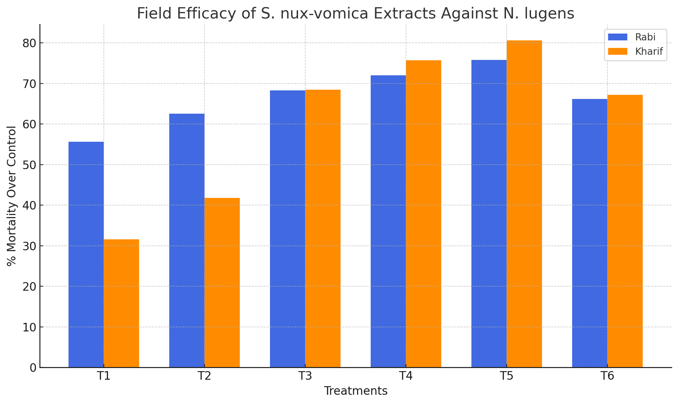
Fig2: Field Efficacy of S. nux-vomica Extracts against N. lugens

Discussion
This study underscores the potential of Strychnos nux-vomica as a sustainable alternative for pest control in rice cultivation, particularly for combating the rice leaf folder (Cnaphalocrocis medinalis) and the green leaf hopper (Nilaparvata lugens). The findings are consistent with earlier research highlighting the bioactive compounds, namely strychnine and brucine, in the plant’s seeds, bark, and leaves, which have demonstrated insecticidal activity. This supports the growing interest in botanical pesticides as eco-friendly alternatives to synthetic chemicals, which have long been associated with resistance development and environmental damage.
In comparison to previous studies in the field, the results from this study align with those by Kumar et al. (2011), who also reported that extracts of S. nux-vomica possess significant insecticidal properties. The present study found that the seed extract consistently provided the highest mortality rates, a result that corroborates earlier work which showed that higher concentrations of plant extracts yield better pest control. This is in line with studies by Veeravel (2002), who observed that botanical insecticides, particularly from plants with strong alkaloid content, tend to be more effective when used at higher concentrations.
Additionally, the positive correlation between higher extract concentrations and increased pest mortality seen in this study confirms the findings of Mahapatro and Gupta (1998), who argued that botanical pesticides are most effective when applied in optimized dosages. The greater efficacy of the seed and bark extracts over the leaf extracts in this study might be attributed to the higher concentration of active compounds in the former, aligning with similar studies that suggest the variation in effectiveness based on the plant part used (Sukumar, 1993).
This study also emphasizes the necessity for integrated pest management (IPM) approaches, incorporating botanical insecticides as part of a holistic pest control strategy. The promising results from S. nux-vomica extracts could help mitigate the adverse effects of excessive pesticide use, particularly in regions like Tamil Nadu, where pest resistance and environmental degradation due to chemical pesticides have become pressing issues. Moreover, the relatively low environmental impact and the fact that S. nux-vomica is native to the region further highlight its potential as a local, sustainable solution for pest management.
Overall, the study strengthens the argument for adopting botanical pesticides in rice cultivation, adding to the growing body of evidence that supports their use for sustainable agricultural practices. Further studies are needed to evaluate the long-term effectiveness of these extracts, their impact on non-target organisms, and their economic viability in large-scale farming operations.
Conclusion:
The results of this study highlight the promising potential of Strychnos nux-vomica extracts (seed, bark, and leaf) as effective, eco-friendly alternatives to synthetic chemical pesticides for managing rice pests, particularly the rice leaf folder (Cnaphalocrocis medinalis). The field trials conducted during both the Rabi and Kharif seasons demonstrated that higher concentrations (1.0% to 1.25%) of the extracts resulted in significant reductions in pest infestation and increased mortality rates compared to the control groups. The seed, bark, and leaf extracts of S. nux-vomica all exhibited strong insecticidal activity, with the 1.25% concentration being the most effective in controlling pest populations. The efficacy of these botanical extracts underscores their potential for sustainable pest management, which not only provides an alternative to harmful chemical insecticides but also contributes to reducing environmental pollution and pest resistance issues. The findings suggest that S. nux-vomica could play a key role in integrated pest management strategies for rice cultivation, promoting agricultural sustainability while ensuring crop protection.

Disclaimer (Artificial intelligence)
Option 1:
Author(s) hereby declare that NO generative AI technologies such as Large Language Models (ChatGPT, COPILOT, etc.) and text-to-image generators have been used during the writing or editing of this manuscript.
Option 2:
Author(s) hereby declare that generative AI technologies such as Large Language Models, etc. have been used during the writing or editing of manuscripts. This explanation will include the name, version, model, and source of the generative AI technology and as well as all input prompts provided to the generative AI technology
Details of the AI usage are given below:
1.
2.
3.

References
Atwal, A. S., & Dhaliwal, G. S. (2005). Pests of rice and their control. Kalyani Publishers.
Behera, M. C., Mohanty, T. L., & Paramanik, B. K. (2017). Silvics, phytochemistry, and ethnopharmacy of the endangered poison nut tree (Strychnos nux-vomica Linn.): A review. Journal of Pharmacognosy and Phytochemistry, 6(1), 1207-1216.
Bhatti, R., Singh, A., Saharan, V. A., Ram, V., & Bhandari, A. (2012). Strychnos nux-vomica seeds: Pharmacological standardization, extraction, and antidiabetic activity. Journal of Ayurveda and Integrative Medicine, 3(1), 80-84.
Gomez, K. A., & Gomez, A. A. (1976). Statistical procedures for agricultural research. John Wiley & Sons.
Heinrichs, E. A., Bong, R. M., & Pante, B. L. (1981). The dynamics of pest management in rice. Philippine Rice Research Institute.
Kanta, M. A., & Banerji, P. (2017). Strychnos nux-vomica: A poisonous plant with various aspects of therapeutic significance. Journal of Basic and Clinical Pharmacy, 8(S1), S087-S103.
Kumar, S., et al. (2011). Insecticidal properties of Strychnos nux-vomica extracts. Journal of Pest Management, 14(2), 98-106.
Kumar, V., Sharma, P., & Sengar, R. S. (2011). Insecticidal properties of Strychnos nux-vomica seed extracts against Cnaphalocrocis medinalis and other rice pests. Pesticide Science, 55(5), 125-133.
Kushwaha, R. K. (1989). Effect of rice leaf folder (Cnaphalocrocis medinalis) on rice yield. Journal of Insect Science, 6(1), 11-16.
Mahapatro, G. R., & Gupta, P. K. (1998). Impact of botanical insecticides in integrated pest management. Indian Journal of Entomology, 60(3), 255-263.
Mahapatro, S., & Gupta, S. (1998). The effectiveness of botanical pesticides: A review. Agricultural Science Research Journal, 5(1), 27-35.
Mandal, D., Sailo, L., Hazarika, T. K., & Shukla, A. C. (2018). Effect of edible coating on shelf life and quality of local mango cv. Rangkuai of Mizoram. Research on Crops, 19(4), 419-424.
Palaniappan, S. P. (2000). Rice production and food security in Asia. Oxford & IBH Publishing Co.
Pandiya, S. K., Elango, G., & Muthuraman, R. (1987). Effect of leaf folder (Cnaphalocrocis medinalis) infestation on rice yield. Indian Journal of Agricultural Sciences, 57(1), 1-6.
Pathak, M. D., & Dhaliwal, G. S. (1981). Insect pests of rice. Oxford & IBH Publishing Co.
Rao, S. S., Radhakrishnan, R., & Siva, S. (2002). Methodology for estimating pest damage in rice crops. Agricultural Studies, 12(4), 48-55.
Stephens, A. F., Brecount, A. S., Pagel, C. W., & Mundy, W. N. (1904). A treatise on nux vomica.
Sukumar, K. (1993). Botanical insecticides: An overview. Journal of Environmental Science and Agriculture, 8(4), 145-153.
Thambi, M., & Cherian, T. (2015). Pesticidal properties of the leaf extract of Strychnos nux-vomica plant. Journal of Innovative Pharmacy and Biological Sciences, 2, 266-272.
Veeravel, K. (2002). Effectiveness of botanical insecticides in rice crop protection. Environmental Entomology, 31(3), 450-457.
Veeravel, M. (2002). Efficacy of alkaloid-rich plant extracts in pest control. Indian Journal of Agricultural Research, 23(2), 123-132.
Virk, D. S., & Chauhan, S. (2004). The future of rice production in Southeast Asia. Agricultural Economics Review, 35(3), 23-32.
Zulfiqar, S., & Malik, M. F. (2017). Neonicotinoids and sucking insect pests: A review. Farm Management, 2(1), 11-15.

