**Diversity of Faunal Species Observed in the Campus of the University of Rajasthan, India**

# Abstract

This study presents a comprehensive assessment of the faunal diversity found on the campus of the University of Rajasthan. Through observational surveys and taxonomic identification, a total of 3 phyla, 5 classes, 74 families, 29 orders, and 109 species from various phyla were identified. This research highlights the ecological significance of campus biodiversity and provides a baseline for future conservation efforts. Arthropoda (73.5%), Chordata, comprising 24.8% of the entries, includes a mix of reptiles, birds, and mammals and Annelida (1.8%) found in campus of University of Rajasthan. Continued monitoring and conservation efforts will be essential to preserve this diversity, ensuring that the ecosystem remains resilient and capable of supporting both wildlife and human needs.

Keywords: Abundance, Diversity, Fauna, Rajasthan University

# Introduction

No scientifically supported barriers exist to preserving biodiversity in all of its diversity and beauty (Thonicke et al., 2024). Biodiversity, defined as the variety of life on Earth, is crucial for maintaining ecosystem health and stability. It plays a pivotal role in ecological functions, including nutrient cycling, pollination, and habitat provision, which collectively support human well-being. In the context of urbanization, the preservation of biodiversity becomes increasingly challenging as natural habitats are fragmented or lost. Urban and semi-urban environments, such as university campuses, represent unique landscapes where biodiversity can be both threatened and preserved. The University of Rajasthan campus in Jaipur serves as a critical green space amidst the rapidly urbanizing landscape of the city. This campus not only provides a habitat for a diverse array of flora and fauna but also acts as a living laboratory for ecological study and environmental education. Understanding the faunal diversity within such urban ecosystems is essential for assessing their ecological health and resilience against urban pressures. Previous studies have highlighted the significance of maintaining green spaces in urban areas, as they support various species and contribute to ecosystem services. This research paper aims to compile and analyze existing literature on faunal diversity in urban environments, with a specific focus on the University of Rajasthan campus. By documenting the species present and exploring the ecological implications of biodiversity in these settings, this paper seeks to provide insights into effective conservation strategies and the role of educational institutions in fostering environmental awareness. Through a comprehensive examination of available data and methodologies, we aim to contribute to the understanding of urban biodiversity and its importance for ecological balance in increasingly developed landscapes(Nautiyal et al., 2015).

# Materials and Methods

# The study was conducted within the confines of the University of Rajasthan campus in Jaipur. Data collection involved field surveys carried out throughout the year 2024, during which specimens were either observed in their natural habitat (in situ) or collected for subsequent laboratory identification.

Taxonomic classification of the species was performed, adhering to a hierarchical system that includes the following categories: Phylum (e.g., Chordata, Arthropoda, Annelida), Class (e.g., Oligochaeta, Mammalia, Aves, Reptilia, Insecta), Order, Family, and Species (scientific name). This systematic approach facilitated the accurate identification and categorization of the biodiversity present within the campus ecosystem, enabling a comprehensive understanding of species distribution and ecological dynamics(Charan et al., 2020). The study employed a systematic approach to capture, spread, and identify specimens within the University of Rajasthan campus. Field Surveys Conducted at various times throughout the year, these surveys involved direct observation and collection of specimens. Methods varied based on taxa, including: Netting, Trapping, Hand collection, Sediment sampling. Sampling Techniques Different techniques were used depending on the habitat and the target organisms.(Lewthwaite et al., 2024) For example -Sweep nets were used in grassy areas for insect collection and Quadrat sampling helped assess plant diversity and associated fauna(Nautiyal et al., 2015). Collected specimens were immediately preserved using appropriate methods: Ethanol, Formaldehyde or buffered solutions. Labeling and Documentation of each specimen was labeled with relevant information, including date, location, habitat type, and collector details, ensuring accurate data recording for further analysis. Morphological Analysis of Specimens were identified based on distinct morphological traits using taxonomic keys and reference guides. Important features included: - Body structure and coloration, Specific anatomical structures (e.g., wing venation in insects, skeletal features in vertebrates). Laboratory techniques for more precise identification, specimens were examined under microscopes. Taxonomic classification of Identified specimens was categorized according to established taxonomic hierarchies, including Phylum, Class, Order, Family, and species name. This classification was validated against current taxonomic databases and literature. Expert consultation in cases of uncertainty, specialists in various taxonomic groups were consulted to confirm identifications, ensuring accuracy and reliability in the study's findings. This comprehensive approach to capturing, preserving, and identifying specimens facilitated a thorough understanding of the biodiversity present on the University of Rajasthan campus, contributing to ecological research and conservation efforts. (Lewthwaite et al., 2024)

# Results

The study identified a total of 109 species belonging to 29 orders and 3 phyla. The majority of species belonged to the phylum Arthropoda, which accounted for 73.5% of the total species observed.

To perform calculations related to this data, we can consider various analyses, such as:

**1. Total Count of Organisms by Phylum -** Counted how many organisms belong to each phylum.

**2. Proportional Representation -** Calculated the percentage representation of each phylum based on the total number of entries.

**3. Distribution Across Classes -** Counted how many entries are present in each class and provide proportions.

**List 1 : Total Count of Organisms by Phylum**

|  |  |
| --- | --- |
| **Phylum** | **Count** |
| Arthropoda | 80 (based on the insects and arachnids listed) |
| Chordata | 27 (including reptiles, birds, and mammals) |
| Annelida | 2 (earthworms) |
| Total |  |

**List 2 : Percentage Representation**

|  |  |
| --- | --- |
| **Phylum** | **Percentage** |
| Arthropoda | 73.5% |
| Chordata | 24.8% |
| Annelida | 1.8% |

**List 3 : Distribution Across Classes**

|  |  |
| --- | --- |
| **Class** | **Distribution** |
| Insecta | 66 |
| Reptilia | 7 |
| Aves | 33 |
| Mammalia | 10 |
| Oligochaeta | 2 |
| Total | 109 |

**List 4 :Phylum Distribution**

|  |  |
| --- | --- |
| **Phylum** | **Percentage** |
| Arthropoda | 73.5% |
| Chordata | 24.8% |
| Annelida | 1.8% |

**List 5 : Class Distribution**

|  |  |
| --- | --- |
| **Class** | **Percentage** |
| Insecta | 60.6% (66/109) |
| Aves | 30.3% (33/109) |
| Mammalia | 9.2% (10/109) |
| Reptilia | 6.4% (7/109) |
| Oligochaeta | 1.8% (2/109) |

These calculations provide insights into the biodiversity represented in your data, showing the dominance of certain groups like insects and the overall diversity in the region(Avolio et al., 2019). The distribution of species per order is shown in the bar chart (Figure 2), while the species distribution by phyla is represented in the pie chart (Figure 1).

**Fig. 1. Species distribution by phyla**

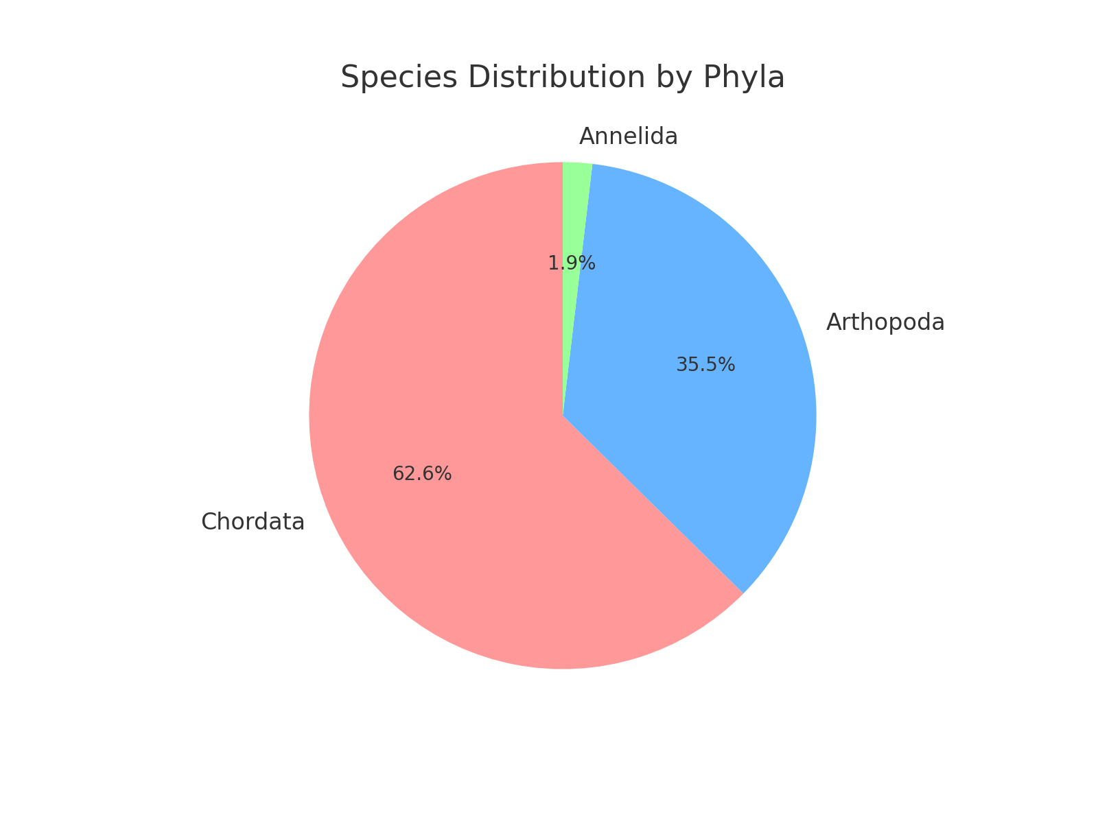

**Fig. 2. Number of species per order**

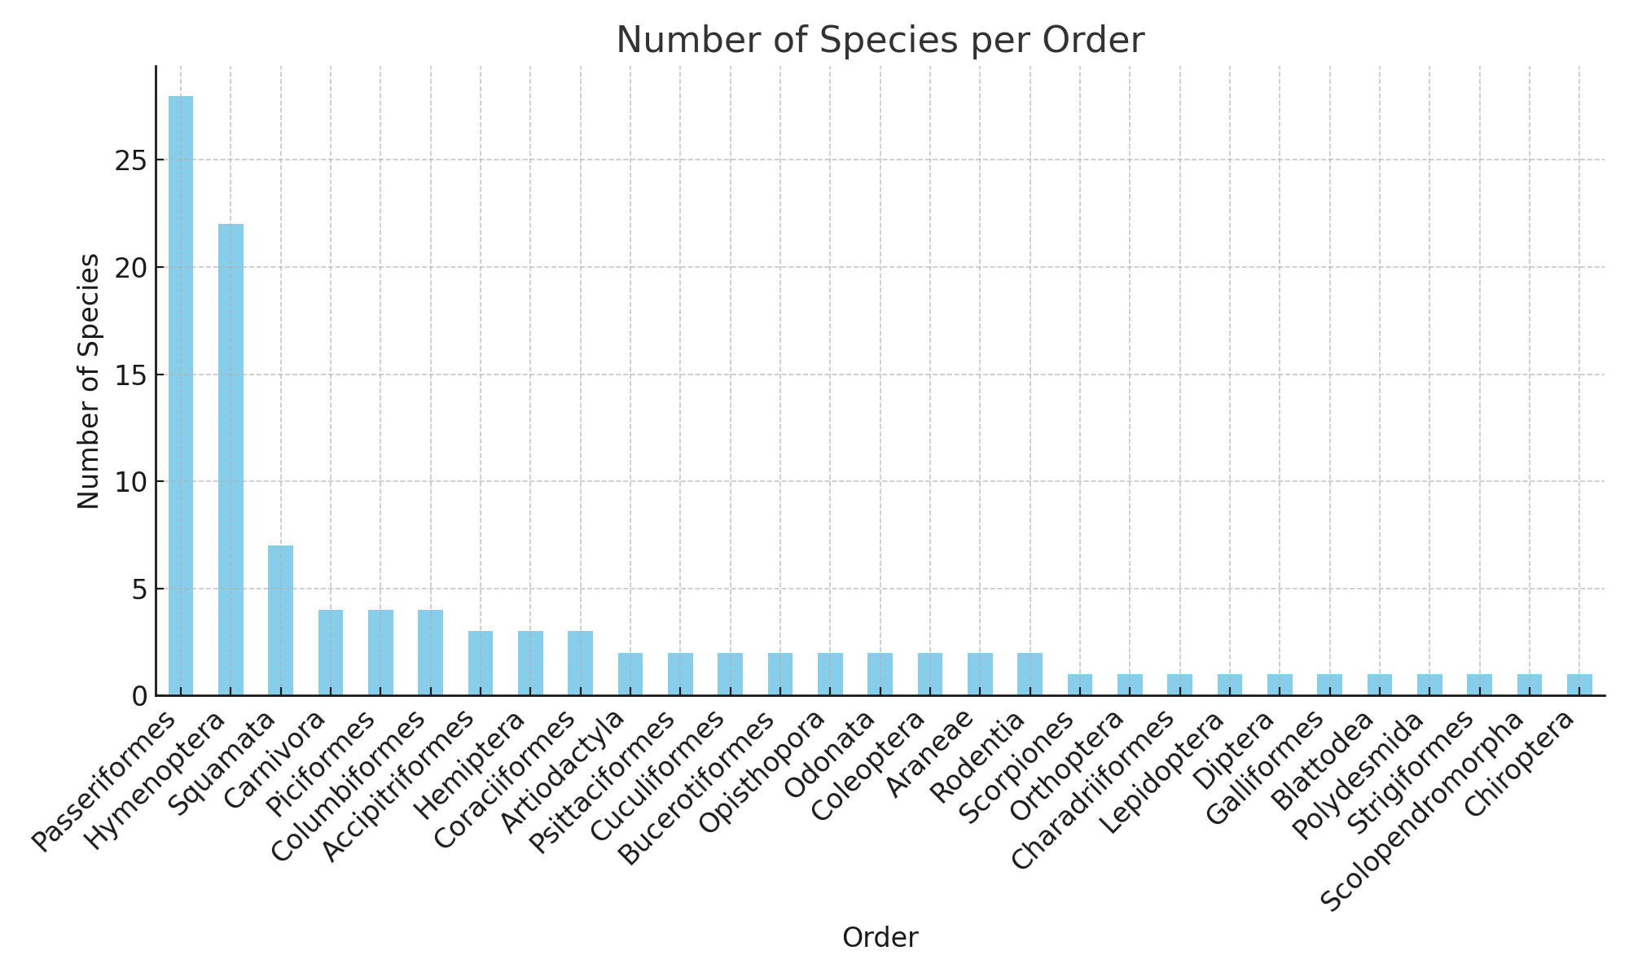

## Discussion

The analysis of the provided biodiversity data reveals significant insights into the ecological composition of the studied region, highlighting the dominance of certain groups and the overall balance of different life forms. The overwhelming representation of Arthropoda (73.5%) in the dataset underscores the ecological significance of this phylum, particularly insects. Insects play crucial roles in various ecological processes, such as pollination, decomposition, and serving as food sources for other organisms. Their abundance suggests a rich diversity of habitats that support numerous species, likely reflecting a healthy ecosystem.

In contrast, Chordata, comprising 24.8% of the entries, includes a mix of reptiles, birds, and mammals. This suggests a balanced ecosystem where both invertebrates and vertebrates coexist. The presence of diverse bird(Crespo et al., 2018) species indicates that the area may serve as a critical habitat for avian life, which can contribute to seed dispersal and pest control. The minimal representation of Annelida (1.8%), specifically earthworms, while lower, still signifies their essential role in soil health and nutrient cycling. Their presence indicates good soil conditions, which are vital for plant growth and, by extension, the broader ecosystem. When examining the distribution across classes, Insecta emerges as the most prevalent group, accounting for 60.6% of the total entries(Prajapat & Meena, 2021). This high diversity within insects could be indicative of various ecological niches being filled, from pollinators like bees to predators such as spiders and beetles. The significant representation of various bee species (e.g. *Apis* and *Megachile*) highlights the importance of pollination in the local ecosystem, which is critical for maintaining plant diversity and agricultural productivity.

Aves, representing 30.3%, also play essential roles in the ecosystem, from pollination to pest control and seed dispersal. The variety of birds, including raptors and songbirds, suggests a complex food web and a functioning ecosystem where different species interact and depend on one another. The representation of Mammalia (9.2%) (Kalkman et al., 2008) and Reptilia (6.4%) (Lalremsanga et al., 2018) points to the presence of both terrestrial mammals and reptiles, indicating a rich terrestrial biodiversity. Species like the Indian Fox and various birds of prey are critical for controlling populations of smaller animals, thereby maintaining ecological balance. The data collectively suggest that the region supports a rich and diverse ecosystem, characterized by a variety of trophic levels and interactions. The predominance of insects, particularly pollinators, indicates that maintaining this biodiversity is crucial for ecosystem services that benefit both wildlife and human populations, such as food production and ecological resilience. Furthermore, the relatively low presence of certain groups, such as annelids (Kumar & Tripathi, 2021), while not alarming, serves as a reminder of the need to monitor soil health and conditions, as these organisms are vital for maintaining soil quality and ecosystem function.

## Conclusion –

The biodiversity data provides a dynamic and interdependent ecosystem, where arthropods, particularly insects, play a crucial role in maintaining ecological integrity. Continued monitoring and conservation efforts will be essential to preserve this diversity, ensuring that the ecosystem remains resilient and capable of supporting both wildlife and human needs.

Table 1 : Faunal Diversity of the Campus

|  |  |  |  |  |  |
| --- | --- | --- | --- | --- | --- |
| **S. No.** | **Scientific Name** | **Family** | **Order** | **Class** | **Phylum** |
| 1 | *Pheretima posthuma* (Indian Earthworm) | Megascolecidae | Opisthopora | Oligochaeta | Annelida |
| 2 | *Pheretima elongata* (Elongated Earthworm) | Megascolecidae | Opisthopora | Oligochaeta | Annelida |
| 3 | *Hottentotta tamulus* (Indian Red Scorpion) | Buthidae | Scorpiones | Arachnida | Arthopoda |
| 4 | *Plexippus paykulli* (Pantropical Jumper Spider) | Salticidae | Araneae | Arachnida | Arthopoda |
| 5 | *Neoscona theisi* (Garden Spider) | Araneidae | Araneae | Arachnida | Arthopoda |
| 6 | *Scolopendra morsitans* (Common Centipede) | Scolopendridae | Scolopendromorpha | Chilopoda | Arthopoda |
| 7 | *Oxidus gracilis* (Greenhouse Millipede) | Paradoxosomatidae | Polydesmida | Diplopoda | Arthopoda |
| 8 | *Supe lla longipalpa* (Brown-Banded Cockroach) | Ectobiidae | Blattodea | Insecta | Arthopoda |
| 9 | *Coccinella septempunctata* (Seven-Spotted Ladybird) | Coccinellidae | Coleoptera | Insecta | Arthopoda |
| 10 | *Anthia sexguttata* (Six-Spotted Ground Beetle) | Carabidae | Coleoptera | Insecta | Arthopoda |
| 11 | *Musca domestica* (Housefly) | Muscidae | Diptera | Insecta | Arthopoda |
| 12 | *Bagrada hilaris* (Bagrada Bug) | Pentatomidae | Hemiptera | Insecta | Arthopoda |
| 13 | *Oxycarenus hyalinipennis* (Cotton Seed Bug) | Lygaridae | Hemiptera | Insecta | Arthopoda |
| 14 | *Dysdercus cingulatus* (Red Cotton Bug) | Phyrrhocoridae | Hemiptera | Insecta | Arthopoda |
| 15 | *Apis dorsata* (Giant Honeybee) | Apidae | Hymenoptera | Insecta | Arthopoda |
| 16 | *Apis cerana* (Asian Honeybee) | Apidae | Hymenoptera | Insecta | Arthopoda |
| 17 | *Apis florea* (Dwarf Honeybee*)* | Apidae | Hymenoptera | Insecta | Arthopoda |
| 18 | *Trigona irridipenis* (Stingless Bee) | Apidae | Hymenoptera | Insecta | Arthopoda |
| 19 | *Megachile hera* (Leafcutter Bee [Hera]) | Megachilidae | Hymenoptera | Insecta | Arthopoda |
| 20 | *Megachile lanata* (Wool-Carder Bee) | Megachilidae | Hymenoptera | Insecta | Arthopoda |
| 21 | *Megachile coelioxyoides* (Leafcutter Bee [Coelioxyoides]) | Megachilidae | Hymenoptera | Insecta | Arthopoda |
| 22 | *Megachile femorata* (Leafcutter Bee [Femorata]) | Megachilidae | Hymenoptera | Insecta | Arthopoda |
| 23 | *Megachile gathela* (Leafcutter Bee [Gathela]) | Megachilidae | Hymenoptera | Insecta | Arthopoda |
| 24 | *Megachile ruficauda* (Leafcutter Bee [Ruficauda]) | Megachilidae | Hymenoptera | Insecta | Arthopoda |
| 25 | *Megachile studiosa* (Leafcutter Bee [Studiosa]) | Megachilidae | Hymenoptera | Insecta | Arthopoda |
| 26 | *Megachile suavida* (Leafcutter Bee [Suavida]) | Megachilidae | Hymenoptera | Insecta | Arthopoda |
| 27 | *Megachile vera* (Leafcutter Bee [Vera]) | Megachilidae | Hymenoptera | Insecta | Arthopoda |
| 28 | *Ceratina binghami* (Small Carpenter Bee [Binghami]) | Apidae | Hymenoptera | Insecta | Arthopoda |
| 29 | *Ceratina hieroglyphica* (Small Carpenter Bee [Hieroglyphica]) | Apidae | Hymenoptera | Insecta | Arthopoda |
| 30 | *Ceratina sexmaculata* (Six-Spotted Small Carpenter Bee) | Apidae | Hymenoptera | Insecta | Arthopoda |
| 31 | *Amegilla fallax* (Blue-Banded Bee) | Apidae | Hymenoptera | Insecta | Arthopoda |
| 32 | *Nomia curvipes* (Green-Sweat Bee) | Halictidae | Hymenoptera | Insecta | Arthopoda |
| 33 | *Nomia elliotii* (Elliott's Sweat Bee) | Halictidae | Hymenoptera | Insecta | Arthopoda |
| 34 | *Nomia oxybeloides* (Sweat Bee [Oxybeloides]) | Halictidae | Hymenoptera | Insecta | Arthopoda |
| 35 | *Hylaeus mixta (Yellow-Faced Bee)* | Colletidae | Hymenoptera | Insecta | Arthopoda |
| 36 | *Ammophila sabulosa (Sand Wasp)* | Sphecidae | Hymenoptera | Insecta | Arthopoda |
| 37 | *Danaus chrysippus (Plain Tiger Butterfly)* | Nymphalidae | Lepidoptera | Insecta | Arthopoda |
| 38 | *Anax immaculifrons (Blue Emperor Dragonfly)* | Aeshnidae | Odonata | Insecta | Arthopoda |
| 39 | *Orthetrum sabina (Slender Skimmer Dragonfly)* | Libellulidae | Odonata | Insecta | Arthopoda |
| 40 | *Poekilocerus pictus (Painted Grasshopper)* | Pyrogomorphidae | Orthoptera | Insecta | Arthopoda |
| 41 | *Hemidactylus frenatus (Common House Gecko)* | Gekkonidae | Squamata | Reptilia | Chordata |
| 42 | *Bungarus caeruleus (Common Krait)* | Elapidae | Squamata | Reptilia | Chordata |
| 43 | *Calotes versicolor (Indian Garden Lizard)* | Agamidae | Squamata | Reptilia | Chordata |
| 44 | *Chamaeleo zeylanicus (Indian Chameleon)* | Chamaeleonidae | Squamata | Reptilia | Chordata |
| 45 | *Eutropis carinata (Keeled Indian Mabuya)* | Scincidae | Squamata | Reptilia | Chordata |
| 46 | *Naja naja (Indian Cobra)* | Elapidae | Squamata | Reptilia | Chordata |
| 47 | *Varanus bengalensis (Bengal Monitor)* | Varanidae | Squamata | Reptilia | Chordata |
| 48 | *Accipiter badius (Shikra)* | Accipitridae | Accipitriformes | Aves | Chordata |
| 49 | *Aquila fasciata (Bonelli's Eagle)* | Accipitridae | Accipitriformes | Aves | Chordata |
| 50 | *Milvus migrans (Black Kite)* | Accipitridae | Accipitriformes | Aves | Chordata |
| 51 | *Ocyceros birostris (Indian Grey Hornbill)* | Bucerotidae | Bucerotiformes | Aves | Chordata |
| 52 | *Upupa epops (Eurasian Hoopoe)* | Upupidae | Bucerotiformes | Aves | Chordata |
| 53 | *Vanellus indicus (Red-Wattled Lapwing)* | Charadriidae | Charadriiformes | Aves | Chordata |
| 54 | *Treron phoenicopterus (Yellow-Footed Green Pigeon)* | Columbidae | Columbiformes | Aves | Chordata |
| 55 | *Spilopelia senegalensis (Laughing Dove)* | Columbidae | Columbiformes | Aves | Chordata |
| 56 | *Columba livia (Rock Pigeon)* | Columbidae | Columbiformes | Aves | Chordata |
| 57 | *Streptopelia decaocto (Eurasian Collared Dove)* | Columbidae | Columbiformes | Aves | Chordata |
| 58 | *Coracias benghalensis (Indian Roller)* | Coraciidae | Coraciiformes | Aves | Chordata |
| 59 | *Halcyon smyrnensis (White-Throated Kingfisher)* | Alcedinidae | Coraciiformes | Aves | Chordata |
| 60 | *Merops orientalis (Green Bee-Eater)* | Meropidae | Coraciiformes | Aves | Chordata |
| 61 | *Eudynamys scolopaceus (Asian Koel)* | Cuculidae | Cuculiformes | Aves | Chordata |
| 62 | *Centropus sinensis (Greater Coucal)* | Cuculidae | Cuculiformes | Aves | Chordata |
| 63 | *Ortygornis pondicerianus (Grey Francolin)* | Phasianidae | Galliformes | Aves | Chordata |
| 64 | *Copsychus saularis (Oriental Magpie-Robin)* | Muscicapidae | Passeriformes | Aves | Chordata |
| 65 | *Argya striata (Jungle Babbler)* | Leiothrichidae | Passeriformes | Aves | Chordata |
| 66 | *Parus cinereus (Cinereous Tit)* | Paridae | Passeriformes | Aves | Chordata |
| 67 | *Pycnonotus cafer (Red-Vented Bulbul)* | Pycnonotidae | Passeriformes | Aves | Chordata |
| 68 | *Passer domesticus (House Sparrow)* | Passeridae | Passeriformes | Aves | Chordata |
| 69 | *Acridotheres tristis (Common Myna)* | Sturnidae | Passeriformes | Aves | Chordata |
| 70 | *Acridotheres ginginianus (Bank Myna)* | Sturnidae | Passeriformes | Aves | Chordata |
| 71 | *Argya malcolmi (Large Grey Babbler)* | Leiothrichidae | Passeriformes | Aves | Chordata |
| 72 | *Cinnyris asiaticus (Purple Sunbird)* | Nectarinidae | Passeriformes | Aves | Chordata |
| 73 | *Corvus splendens (House Crow)* | Corvidae | Passeriformes | Aves | Chordata |
| 74 | *Dendrocitta vagabunda (Rufous Treepie)* | Corvidae | Passeriformes | Aves | Chordata |
| 75 | *Dicrurus caerulescens (White-Bellied Drongo)* | Dicruridae | Passeriformes | Aves | Chordata |
| 76 | *Dicrurus macrocercus (Black Drongo)* | Dicruridae | Passeriformes | Aves | Chordata |
| 77 | *Euodice malabarica (Indian Silverbill)* | Estrildidae | Passeriformes | Aves | Chordata |
| 78 | *Gracupica contra (Pied Myna)* | Sturnidae | Passeriformes | Aves | Chordata |
| 79 | *Gymnoris xanthocollis (Yellow-Throated Sparrow)* | Passeridae | Passeriformes | Aves | Chordata |
| 80 | *Hirundo rustica (Barn Swallow)* | Hirundinidae | Passeriformes | Aves | Chordata |
| 81 | *Lanius schach (Long-Tailed Shrike)* | Laniidae | Passeriformes | Aves | Chordata |
| 82 | *Oenanthe fusca (Brown Rock Chat)* | Muscicapidae | Passeriformes | Aves | Chordata |
| 83 | *Oriolus kundoo (Indian Golden Oriole)* | Oriolidae | Passeriformes | Aves | Chordata |
| 84 | *Orthotomus sutoris (Common Tailorbird)* | Cisticolidae | Passeriformes | Aves | Chordata |
| 85 | *Parus major (Great Tit)* | Paridae | Passeriformes | Aves | Chordata |
| 86 | *Pastor roseus (Rosy Starling)* | Sturnidae | Passeriformes | Aves | Chordata |
| 87 | *Petrochelidon fluvicola (Streak-Throated Swallow)* | Hirundinidae | Passeriformes | Aves | Chordata |
| 88 | *Prinia socialis (Ashy Prinia)* | Cisticolidae | Passeriformes | Aves | Chordata |
| 89 | *Copsychus fulicatus (Indian Robin)* | Muscicapidae | Passeriformes | Aves | Chordata |
| 90 | *Sturnia pagodarum (Brahminy Starling)* | Sturnidae | Passeriformes | Aves | Chordata |
| 91 | *Zosterops palpebrosus (Oriental White-Eye)* | Zosteropidae | Passeriformes | Aves | Chordata |
| 92 | *Chrysocolaptes festivus (White-Naped Woodpecker)* | Picidae | Piciformes | Aves | Chordata |
| 93 | *Dendrocopos mahrattenis (Yellow-Crowned Woodpecker)* | Picidae | Piciformes | Aves | Chordata |
| 94 | *Dinopium benghalense (Black-Rumped Flameback)* | Picidae | Piciformes | Aves | Chordata |
| 95 | *Megalaima haemacephala (Coppersmith Barbet)* | Megalaimidae | Piciformes | Aves | Chordata |
| 96 | *Psittacula krameri (Rose-Ringed Parakeet)* | Psittaculidae | Psittaciformes | Aves | Chordata |
| 97 | *Psittacula cyanocephala (Plum-Headed Parakeet)* | Psittaculidae | Psittaciformes | Aves | Chordata |
| 98 | *Athene brama (Spotted Owlet)* | Strigidae | Strigiformes | Aves | Chordata |
| 99 | *Bos indicus (Zebu)* | Bovidae | Artiodactyla | Mammalia | Chordata |
| 100 | *Boselaphus tragocamelus (Nilgai)* | Bovidae | Artiodactyla | Mammalia | Chordata |
| 101 | *Canis lupus familiaris (Domestic Dog)* | Canidae | Carnivora | Mammalia | Chordata |
| 102 | *Felis domestica (Domestic Cat)* | Felidae | Carnivora | Mammalia | Chordata |
| 103 | *Urva edwardsii (Indian Grey Mongoose)* | Herpestidae | Carnivora | Mammalia | Chordata |
| 104 | *Vulpes vulpes pusilla (Indian Fox)* | Canidae | Carnivora | Mammalia | Chordata |
| 105 | *Pteropus medius (Indian Flying Fox)* | Pteropodidae | Chiroptera | Mammalia | Chordata |
| 106 | *Mus musculus (House Mouse)* | Muridae | Rodentia | Mammalia | Chordata |
| 107 | *Funambulus palmarum (Indian Palm Squirrel)* | Sciuridae | Rodentia | Mammalia | Chordata |

# (Bitterman, 1988)

Disclaimer (Artificial intelligence)

Option 1:

Author(s) hereby declare that NO generative AI technologies such as Large Language Models (ChatGPT, COPILOT, etc.) and text-to-image generators have been used during the writing or editing of this manuscript.

Option 2:

Author(s) hereby declare that generative AI technologies such as Large Language Models, etc. have been used during the writing or editing of manuscripts. This explanation will include the name, version, model, and source of the generative AI technology and as well as all input prompts provided to the generative AI technology

Details of the AI usage are given below:

1.

2.

3.

# References

Avolio, M. L., Forrestel, E. J., Chang, C. C., La Pierre, K. J., Burghardt, K. T., & Smith, M. D. (2019). Demystifying dominant species. *New Phytologist*, *223*(3), 1106–1126. https://doi.org/10.1111/nph.15789

Bitterman, M. E. (1988). Vertebrate-Invertebrate Comparisons. *Intelligence and Evolutionary Biology*, 251–276. https://doi.org/10.1007/978-3-642-70877-0_14

Charan, S. K., Kachhawa, G., & Naval, S. K. (2020). Record of insect pollinators , their diversity , richness and abundance on Calotropis procera ( AIT .) R . Br ., in the desert of Thar in Rajasthan , India Record of insect pollinators , their diversity , richness and abundance on Calotropis procera ( AIT. *International Journal of Entomology Research*, *5*(6), 183–188.

Crespo, R., França, M. S., Fenton, H., & Shivaprasad, H. L. (2018). Galliformes and columbiformes. In *Pathology of Wildlife and Zoo Animals*. Elsevier Inc. https://doi.org/10.1016/B978-0-12-805306-5.00031-6

Kalkman, V. J., Clausnitzer, V., Dijkstra, K. B., Orr, A. G., & Tol, J. van. (2008). Freshwater Animal Diversity Assessment. *Freshwater Animal Diversity Assessment*, *January*. https://doi.org/10.1007/978-1-4020-8259-7

Kumar, S., & Tripathi, G. (2021). Earthworm Species Diversity In Rajasthan-A Review. *Uttar Pradesh Journal of Zoology*, *42*(16), 64–75.

Lalremsanga, H. T., Sailo, S., & Chinliansiama. (2018). Diversity of Snakes ( Reptilia : Squamata ) and Role of Environmental Factors in Their Distribution in Mizoram , Northeast India. *Advances in Environmental Chemistry*, *September*, 265–268.

Lewthwaite, J. M. M., Baiotto, T. M., Brown, B. V., Cheung, Y. Y., Baker, A. J., Lehnen, C., McGlynn, T. P., Shirey, V., Gonzalez, L., Hartop, E., Kerr, P. H., Wood, E., & Guzman, L. M. (2024). Drivers of arthropod biodiversity in an urban ecosystem. *Scientific Reports*, *14*(1), 1–14. https://doi.org/10.1038/s41598-023-50675-3

Nautiyal, S., K. Bhaskar, & YD Imran Khan. (2015). Biodiversity of Semiarid Landscape. In *Environmental Science*. https://doi.org/10.1007/978-3-319-15464-0

Prajapat, R., & Meena, S. (2021). Diversity of insect fauna in Rajasthan, India: A Review. *Flora and Fauna*, *27*(2), 321–329. https://doi.org/10.33451/florafauna.v27i2pp321-329

Thonicke, K., Bonn, A., Borchard, N., & Chaudhary, A. (2024). *10 MustKnows from biodiversity science 2024* (Issue March). https://doi.org/10.5281/zenodo.10837769