**Ichthyofaunal Diversity and their Conservation Status in River Kuwano, Flowing through District Balrampur, Uttar Pradesh India**

“Please try to include water quality parameters of the particular sampling sites season wise”

**Abstract:**

The present study was carried out to know the Ichthyofaunal diversity and their conservation status in the river Kuwano, flowing through Balrampur district of Uttar Pradesh. The systematic survey of five sampling sites of the river was conducted once in a month for a period of one year from February 2024 to January 2025. The result of this study revealed the occurrence of 58 species belonging to 36 genera, 20 families and 8 orders. The order Cypriniformes was found as dominated order with 24 species (41.38%) followed by Siluriformes 16 species (27.59%), Perciformes 7 species (12.07%), Ophiocephaliformes 4 species (6.90%), Mastacembeliformes 3 species (5.17%), Osteoglossiformes 2 species (3.45%), Clupeiformes 1 species (1.72%) and Beloniformes with 1 species (1.72%). According to IUCN red list most of the species (51) are under least concern (LC), while 5 species including *Hypophthalmichthys molitrix*, *Notopterus chitala*, *Ompak bimaculatus*, *Ompak pabda* and *Ailia coila* are in near threatened (NT) category and the remaining 2 species *Wallago attu* and *Bagarius bagarius* are reported as vulnerable (VU) category. The river Kuwano and its fauna are under severe ecological degradation due to anthropogenic activities, overfishing, illegal fishing approaches, aquatic pollution, siltation, introduction of exotic species of fishes and alien plant species. Thus, there is an urgent need to taking up steps to maintain this valuable river and to conserve the aquatic fauna and flora. The present study will provide base line data and may contribute as skeletal information for future studies of this river ecosystem. Author strongly recommends practical conservation action plan to prevent the Ichthyofauna from extinction.

**Keywords:** Ichthyofauna, Biodiversity, Kuwano River, Conservation status

**Introduction:**

Fish provides a protein-rich diet and are also a source of income in developing countries. Fishes were used even in prehistoric ages and supposed to be beneficial to long life and intelligence. Fish is one of the most important component of the human diet, because the flesh of fish contain protein, lipid, essential amino acids, fatty acids, especially omega 3 polyunsaturated fatty acids, vitamins and minerals for the growth and development of the body as well as maintenance of health by preventing several nutritional deficiency ailments (Prakash, 2020a; Ali, 2024). Biodiversity is the variability of life forms on earth. It is one of the key components of our basic life support system. Vast fishery resources with enormous diversity of species distribution offer peerless scope for genetic and evolutionary studies (Bano & Serajuddin, 2016). Altogether 36,272 fish species have been reported from the world (Fricke et al., 2022), out of these 3,496 fish species are reported in different aquatic habitat of India bowing to 9.6% of the total fish diversity (Banerjee et al., 2022). Uttar Pradesh has enormous potential of aquatic resources these natural aquatic resources exist in the form of 28,500 km rivers & canals, 1.33 lakh ha of lakes, 1.38 lakh ha of reservoirs and 1.61 lakh ha of ponds & tanks that harboring a variety of fishes and contributes about 14.68% of Indian fish diversity (Lakra, 2010). However, due to increasing anthropogenic activities, these aquatic water bodies declining rapidly (Kanoujiya et. al., 2023).

Fish distribution and abundance in the different freshwater bodies of Uttar Pradesh have been evaluated by different authors (Prakash, 2021; Prakash, 2020a & 2020b; Sanjay and Prakash, 2020;Sarkar *et al*., 2010; Mishra *et al*., 2011; Serajuddin*et al*., 2004; Sarkar *et al*., 2008). The exclusive literature survey indicates that there is inadequate information is available on the pattern of fish diversity in the Kuwano river. However, some authors take initiative to explore the biodiversity and fish diversity of Kuwano river (Kanoujiya et. al., 2023; Hasan and Tewari, 2023; Kushwaha et al., 2021). There is a considerable knowledge gap on the fish diversity patterns in many riverine ecosystems of India, including in the case of smaller riverine systems and river Kuwano also.

Keeping in mind, the present study was carried out to focus on the diversity, abundance, distribution, and richness of fish fauna and also suggest proper management strategies for the conservation of Ichthyofauna of the river Kuwano.

**Materials and Methods:**

**Study area:** River Kuwano is a small tributary of the river Ghaghra (Saryu), which originates as a spring near Basaupur village in Bahraich district, Uttar Pradesh. The river flows through Bahraich, Gonda, Balrampur, Siddharth Nagar and Basti districts, join in the river Rapti at Sant Kabir nagar and finally joins in the river Ghaghara at Gorakhpur district. There is a long chain of bushes on both sides of the river which is also rare. Due to the slow flow of water, many floating weeds are also found in this river.

**Collection of samples:** Fish samples were collected from river Kuwano during February, 2024 to January, 2025. Five different ghats of district Balrampur, Uttar Pradesh India selected as sampling sites for collection of fishes *viz*. picture -1 (Bhainsahwa Ghat), picture -2 (Gomadi Ghat), picture -3 (Sundar Ghat), picture -4 (Kushmaura Ghat) and picture -5 (Chorghata Ghat). Fish samples were collected on a monthly basis by local fisherman using hand-nets, gill nets, cast nets, drag nets, scoop net including hooks and lines mainly during the time of fishing. The collected small sized fishes were directly placed in a wide mouth jar having 10% formalin solution. But larger specimens were preserved with incision on belly in the plastic containers. Fresh or preserved samples were identified up to species level. Identification of fish specimens was done by examining its shape, colour, scales, fins, fin formula, shape of mouth and other morphological characters with the help of standard taxonomic keys for fishes (Datta Munshi and Srivastava, 1988; Day, 1989; Talwar and Jhingran 1991; Menon, 1992; Srivastava, 2002; Jayaram, 2011). The conservation status of the fish species is based on IUCN (2024).

“Please try to include water quality parameters of the particular sampling sites season wise”

Map 1

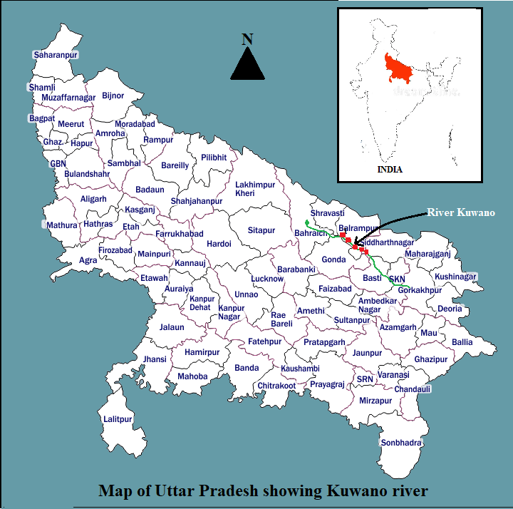

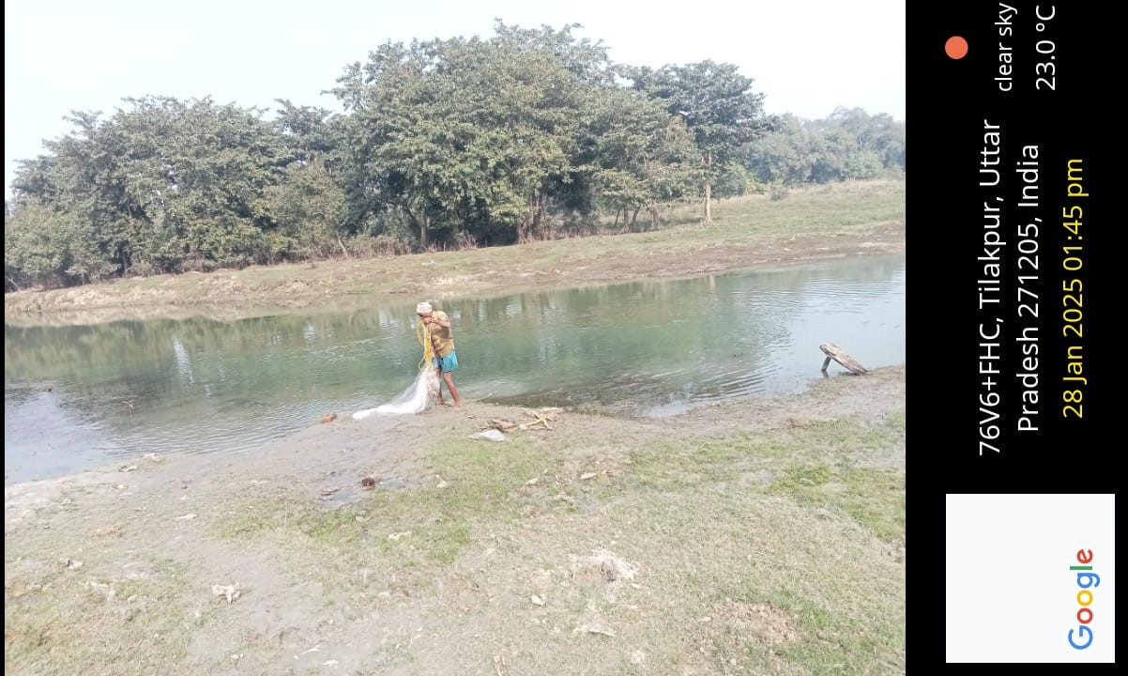

**Picture - 1 Bhainsahwa Ghat, Tilakpur, Balrampur**

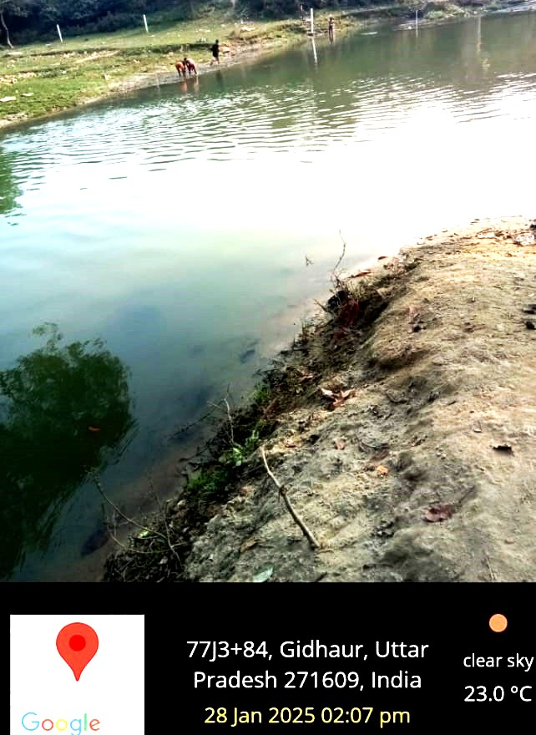

**Picture - 2 Gomadi Ghat, Gidhaur, Balrampur**

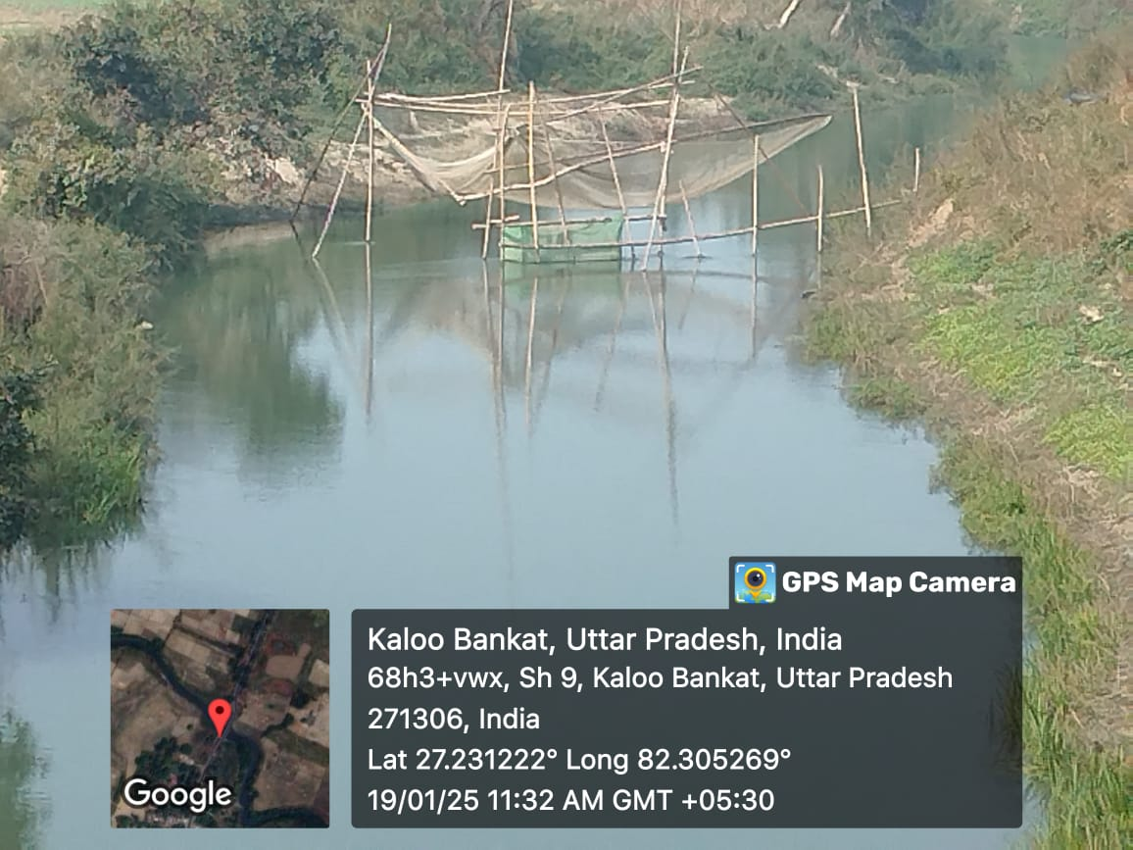

**Picture - 3 Sundar Ghat, Kaloo Bankat, Balrampur**

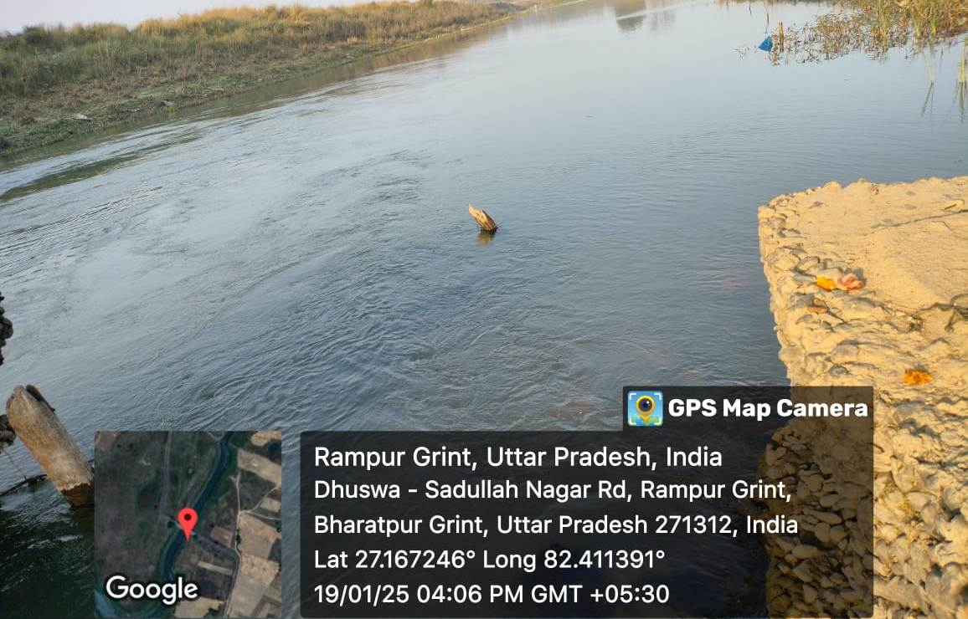

**Picture - 4 Kushmaura Ghat, Bharatpur Grint, Balrampur**

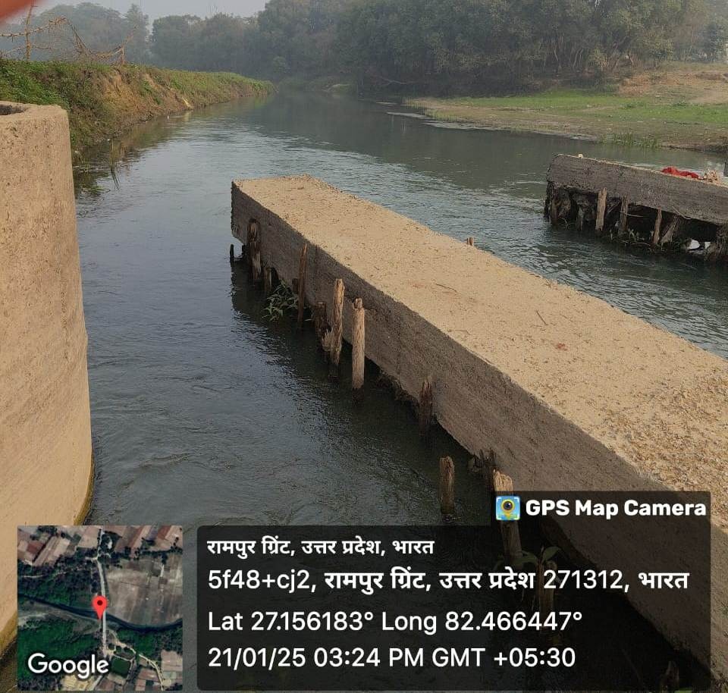

**Picture - 5 Chorghata Ghat, Rampur Grint, Balrampur**

**Results and Discussion:**

In the present study, a total 58 fish species were collected from five sampling sites of river Kuwano belonging to 36 genera, 20 families and 8 orders. All the identified fish species their economic importance and IUCN conservation status are given in the Table1. Out of them the maximum 24 species were found to belong the order Cypriniformes (41.39%) followed by Siluriformes with 16 Species (27.58%), Perciformes with 7 species (12.06%), Ophiocephaliformes with 4 species (6.89%), Mastacembaliformes with 3 species (5.17%), Osteoglossiformes with 2 species (3.45%), Clupeiformes with 1 species (1.72%) and Belonifoemes with 1 species (1.72%) Table 2, Fig1. Fish species composition when grouped into families reveal that Cyprinidae constituting major share with 21 species (36.20%) followed by family Bagridae with 6 species (10.34%); Ophiocephalidae with 4 species (6.90%); Cobitidae, Siluridae and Mastacembelidae with 3 species each (5.17% share each); Notopteridae, Claridae, Schilbeidae and Ambassidae with 2 species each (3.45% share each) and remaining 10 families with 1 species comprises 1.72% each (Fig. 2).

The number of fish species (58) were recorded in the present study is almost similar as that reported by Kanoujiya et.al. (2023) in same river, they were reported 56 fish species belonging to 7 orders, 22 families and 40 genera. Many researchers reported a strong dominance of fish fauna in different rivers, notable among them are Jaya et. al. (2024) who reported 60 fish species in Gosthani estuaries, Bheemunipatnam, belonging 54 genera, 38 families and 20 orders; Saha et. al. (2024) reported of 29 fish species in Mora Dhanshri river Assam, belonging to 12 families and 05 orders; Mishra et. al. (2021) reported 69 fish species, in different water bodies of eastern Uttar Pradesh, belonging to 39 genera, 20 families and 07 orders; Masih and Prakash (2020) reported 46 fish species in the river Rapti, belonging to 30 genera, 19 families and 9 orders; Prakash (2021) reported 58 fish species in different water bodies of Devipatan division, belonging to 36 genera, 21 families and 9 orders; Bano and Serajuddin (2016) reported 56 species in different sites of river Gomti at Lucknow, belonging to 41 genera, 21 families and 9 orders; Mishra et. al. (2011) reported 62 fish species at Ganga basin, belonging to   48 genera and 24 families.

A total 58 fish species reported in present study. Out these, 30 species are commonly found and reported in almost all 5 sampling sites, whereas 5 species are moderate, 19 species are rare and 4 species are very rare in the river Kuwano. Kanoujiya et. al. (2023) also reported 56 finfish species in the river Kuwano, out of which 48 were common and found abundantly, 4 were moderate and 4 were rarely found in the river. In the present investigation a total 5 exotic fish species *viz, Clarias gariepinus*, *Ctenopharyngodon idella*, *Hypopthalmichthys molitrix*, *Cyprinus carpio* and *Gudusia chapra* were reported in the river Kuwano. The migratory fishes *viz, Bagarius bagarius*, *Ompak pabda* and *Wallago attu* also reported in the river. The invasion of these exotic fishes in the river creates competition for food and habitat with native carps and indigenous fishes. The increasing appearance of exotic species in the river is alarming situation and major causes of erosion or devastation of the native fish biodiversity in freshwater ecosystem (De Silva et. al., 2009; Singh and Lakra, 2011; Sarkar *et.al,* 2015; Kanoujiya et. al., 2023).

According to IUCN Red List (2024), most of the recorded fish species (87.93%) are under the Least Concern (LC) status, 5 species (8.62%) at near threatened (NT) and 2 species (3.45 %) are in vulnerable (VU) status, Fig 3. *Hypophthalmichthys molitrix*, *Notopterus chitala*, *Ompak bimaculatus*, *Ompak pabda* and *Ailia coila* are near threatened (NT) fish species and W*allago attu* and *Bagarias bagarias* are listed as vulnerable (VU) in IUCN Red List, 2024. Recently 56 fish species were reported in the same river at Gonda and Basti districts, representing 7 orders, 22 families and 40 genera. Out of 56 species, 48 species belong to the least concern (LC), 2 species near threatened (NT), 2 species vulnerable (VU), 1 species endangered (EN) and 2 species were reported as not evaluated categories of the IUCN Red List (Kanoujiya et. al., 2023). Jaya et. al. (2024) were collected 60 species from Gosthani estuary, out of which 39 species were at least concern (LC), 14 species not evaluated (NE), 3 species with data deficient (DD), 2 species near threatened (NT) and 2 species were reported as vulnerable (VU). Prakash, (2021) was reported 58 fish species in different freshwater bodies of Devipatan division. Out of 58 identified species, 3 species were under endangered (EN), 1 species under vulnerable (UV), 5 under near threatened (NT), 44 under least concern (LC) and 3 species were not evaluated (NE).

During the survey and collection of information by the local fishermen, it was observed that many species of fish, which were abundant in past years, showed a decline in recent catches from river Kuwano. The environmental stress, loss of habitats, aquatic pollution, use of pesticides, poor vegetation cover in the river banks, siltation, water obstruction, low water velocity, unsustainable fishing practices, unauthorized collection of fishes, invasion of exotic fish species are the main factors for depletion of these fish resources from their natural habitats (Kanoujiya et. al., 2023; Sarkar et. al., 2015; Kurup et. al, 2004). Although much published literature is not available on the threat status of fish species of freshwater bodies of U.P., yet it is fact that population of some species is constantly decreasing and there is an urgent need to protect the same before vanishing from the area. Thus, for the conservation of natural aquatic resources, there is need to reduce the anthropogenic activities that affect the fishes and aquatic habitats.

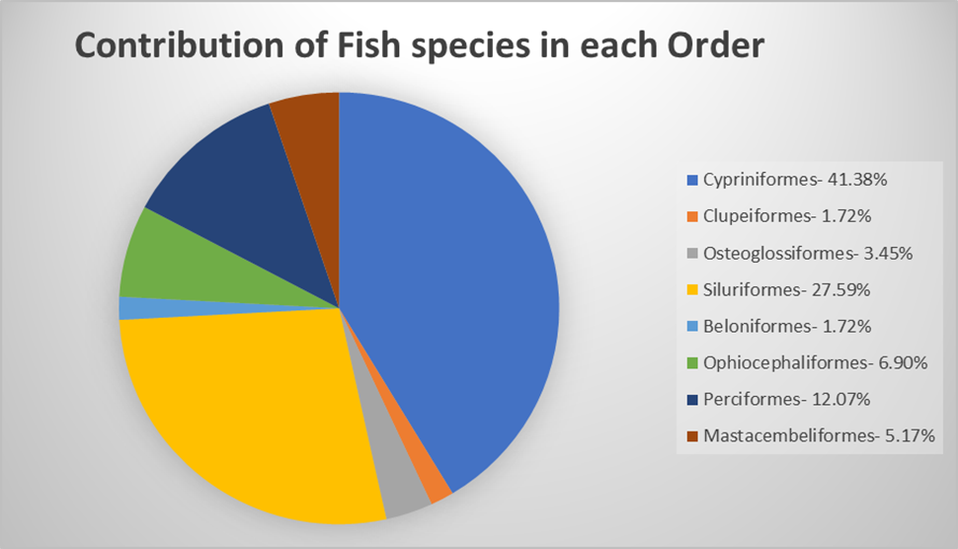

**Fig. 1: Diagrammatic representation of percent** **contribution of fish species in each order**

**Fig. 2: Diagrammatic representation of percent contribution of fish species in each family**

**Fig. 3: IUCN conservation status of fish species recorded from river Kuwano**

|  |  |  |  |  |  |  |  |  |  |  |  |
| --- | --- | --- | --- | --- | --- | --- | --- | --- | --- | --- | --- |
| **Table1:** Occurrence, economic importance and conservation status of Ichthyofauna of river Kuwano, Balrampur (U.P.) India | | | | | | | | | | | |
| **S. No.** | **Order/ Family** | **Scientific Name** | **Common/ Local Name** | **Economic Importance** | **IUCN Status** | **Occurrence of Fish Species in Sampling Sites** | | | | | **Availability in the river** |
| **S-1** | **S-2** | **S-3** | **S-4** | **S-5** |
| 1 | Cypriniformes/Cyprinidae | *Catla catla*  (Hamilton, 1822) | Bhakur | FF | LC | + | + | + | + | + | Common |
| 2 | Cypriniformes/Cyprinidae | *Labeo rohita*  (Hamilton, 1822) | Rohu | FF | LC | + | + | + | + | + | Common |
| 3 | Cypriniformes/Cyprinidae | *Labeo calbasu*  (Hamilton, 1822) | Karaunchhar | FF | LC | + | + | - | - | + | Moderate |
| 4 | Cypriniformes/Cyprinidae | *Labeo bata*  (Hamilton, 1822) | Bata | FF | LC | + | + | + | + | + | Common |
| 5 | Cypriniformes/Cyprinidae | *Labeo gonius*  (Hamilton, 1822) | Kursi/Bata | FF | LC | - | + | - | + | - | Rare |
| 6 | Cypriniformes/Cyprinidae | *Labeo dero*  (Hamilton, 1822) | Kalabans | FF | LC | + | - | - | - | + | Rare |
| 7 | Cypriniformes/Cyprinidae | *Cirrhinus mrigala*  (Hamilton, 1822) | Naini | FF | LC | + | + | + | + | + | Common |
| 8 | Cypriniformes/Cyprinidae | *Cirrhinus reba*  (Hamilton, 1822) | Raia | FF | LC | + | + | - | + | + | Common |
| 9 | Cypriniformes/Cyprinidae | *Cyprinus carpio*  (Linnaeus, 1758) | Common carp/China carp | FF | LC | - | + | - | + | + | Common |
| 10 | Cypriniformes/Cyprinidae | *Ctenopheryngodon idella* (Valenciennes, 1884) | Grass carp | FF | LC | + | + | + | - | + | Common |
| 11 | Cypriniformes/Cyprinidae | *Hypophthalmichthys molitrix* (Valenciennes, 1884) | Silver carp | FF | NT | - | + | + | - | + | Common |
| 12 | Cypriniformes/Cyprinidae | *Puntius sophore*  (Hamilton, 1822) | Sidhari | FF, OF | LC | + | + | + | + | + | Common |
| 13 | Cypriniformes/Cyprinidae | *Puntius ticto*  (Hamilton, 1822) | Sidhari | FF, OF | LC | + | - | - | + | + | Rare |
| 14 | Cypriniformes/Cyprinidae | *Puntius sarana*  (Hamilton, 1822) | Sidhari | FF, OF | LC | + | + | - | + | + | Common |
| 15 | Cypriniformes/Cyprinidae | *Puntius chola*  (Hamilton, 1822) | Sidhari | FF, OF | LC | - | - | + | + | - | Rare |
| 16 | Cypriniformes/Cyprinidae | *Rasbora daniconius*  (Hamilton, 1822) | Dendua | FF, OF | LC | + | - | - | + | - | Very Rare |
| 17 | Cypriniformes/Cyprinidae | *Oxygaster bacaila*  (Hamilton, 1822) | Chalhawa | FF, OF | LC | + | - | - | + | + | Rare |
| 18 | Cypriniformes/Cyprinidae | *Amblypharyngodon mola* (Hamilton, 1822) | Mola Carplet | FF, OF | LC | - | + | - | + | - | Rare |
| 19 | Cypriniformes/Cyprinidae | *Barilius bola* (Hamilton, 1822) | Bola | FF | LC | + | - | - | - | - | Very Rare |
| 20 | Cypriniformes/Cyprinidae | *Osteobrama cotio*  (Hamilton, 1822) | Gurda | FF | LC | - | + | - | + | - | Rare |
| 21 | Cypriniformes/Cyprinidae | *Esomus danricus*  (Hamilton, 1822) | Dendu | FF, OF | LC | + | - | + | - | - | Rare |
| 22 | Cypriniformes/ Cobitidae | *Botia dario*  (Hamilton, 1822) | Baggha | FF, OF | LC | - | + | - | + | - | Very Rare |
| 23 | Cypriniformes/ Cobitidae | *Botia lohachata* (Chaudhury, 1922) | Bagha | FF, OF | LC | + | - | + | - | + | Rare |
| 24 | Cypriniformes/ Cobitidae | *Lepidocephalichtys guntea* (Hamilton, 1822) | Nakti/ Naun | FF, OF | LC | + | - | + | - | + | Rare |
| 25 | Clupeiformes/Clupeidae | *Gudusia chapra*  (Hamilton, 1822) | Suhia | FF | LC | - | + | - | + | - | Rare |
| 26 | Osteoglossiformes/Notopteridae | *Notopterus chitala*  (Hamilton, 1822) | Moya | FF, OF | NT | + | + | - | + | + | Moderate |
| 27 | Osteoglossiformes/Notopteridae | *Notopterus notopterus*  (Hamilton, 1822) | Patra | FF | LC | + | + | + | + | + | Common |
| 28 | Siluriformes/Siluridae | W*allago attu*  (Bloch & Schneider, 1801) | Padhani | FF | VU | + | + | + | + | + | Common |
| 29 | Siluriformes/Siluridae | *Ompak bimaculatus*  (Bloch, 1794) | Jalkapoor | FF, OF | NT | - | + | + | - | + | Rare |
| 30 | Siluriformes/Siluridae | *Ompak pabda*  (Hamilton, 1822) | Pabda | FF, OF | NT | + | - | - | + | - | Rare |
| 31 | Siluriformes/Bagridae | *Mystus tengra*  (Hamilton, 1822) | Tengana | FF | LC | + | + | + | + | + | Common |
| 32 | Siluriformes/Bagridae | *Mystus seenghala*  (Sykes, 1839) | Dariai Tengara | FF | LC | + | + | - | + | + | Common |
| 33 | Siluriformes/Bagridae | *Mystus cavasius*  (Hamilton, 1822) | Tengara | FF, OF | LC | + | + | + | + | + | Common |
| 34 | Siluriformes/Bagridae | *Mystus vittatus*  (Bloch, 1794) | Tengara | FF, OF | LC | + | + | + | + | + | Common |
| 35 | Siluriformes/Bagridae | *Mystus oar*  (Hamilton, 1822) | Tengara | FF | LC | - | + | + | - | + | Moderate |
| 36 | Siluriformes/Bagridae | *Rita rita*  (Hamilton, 1822) | Hunna/ Rita | FF | LC | - | - | + | + | - | Rare |
| 37 | Siluriformes/Sisoridae | *Bagarius bagarius*  (Hamilton, 1822) | Ghhonch | FF | VU | + | + | + | + | - | Common |
| 38 | Siluriformes/Schilbeidae | *Pangasius pangasius* (Hamilton, 1822) | Payas | FF | LC | + | + | - | + | + | Common |
| 39 | Siluriformes/Schilbeidae | *Ailia coila*(Hamilton, 1822) | Minti/Patasi | FF, OF | NT | - | + | - | + | - | Rare |
| 40 | Siluriformes/Claridae | *Clarias batrachus* (Linnaeus, 1758) | Mangur | FF, LF | LC | + | + | + | + | + | Common |
| 41 | Siluriformes/Claridae | *Clarias gariepinus*  (Burchell, 1822) | African Catfish | FF | LC | + | + | + | + | + | Common |
| 42 | Siluriformes/Heteropneustidae | *Heteropneustes fossilis* (Bloch, 1794) | Singhi | FF, LF | LC | + | + | + | + | + | Common |
| 43 | Siluriformes/Chacidae | *Chaca chaca*(Hamilton, 1822) | Chakawa | FF | LC | + | - | - | + | - | Very Rare |
| 44 | Beloniformes/Belonidae | *Xenentodon cancila*  (Hamilton, 1822) | Kawwa fish | FF, OF | LC | + | + | + | + | + | Moderate |
| 45 | Ophiocephaliformes/ Ophiocephalidae | *Channa punctatus*  (Bloch, 1793) | Girai | FF, LF | LC | + | + | + | + | + | Common |
| 46 | Ophiocephaliformes/ Ophiocephalidae | *Channa striatus*  (Bloch, 1793) | Saur | FF | LC | + | + | + | + | + | Common |
| 47 | Ophiocephaliformes/ Ophiocephalidae | *Channa marulius*  (Hamilton, 1822) | Saur | FF | LC | + | + | + | + | + | Common |
| 48 | Ophiocephaliformes/ Ophiocephalidae | *Channa gachua*  (Hamilton, 1822) | Chargan | FF, LF | LC | + | + | - | + | - | Moderate |
| 49 | Perciformes/Ambassidae | *Chanda nama*  (Hamilton, 1822) | Chanda | OF | LC | - | - | + | + | - | Rare |
| 50 | Perciformes/Ambassidae | *Chanda ranga*  (Hamilton, 1822) | Chanari | OF | LC | + | - | + | - | + | Rare |
| 51 | Perciformes/Gobiidae | *Glossogobius giuris*  (Hamilton, 1822) | Bulla | FF, OF | LC | + | - | - | + | - | Rare |
| 52 | Perciformes/Nandidae | *Nandus nandus*  (Hamilton, 1822) | Dhebari | FF | LC | + | - | + | - | + | Rare |
| 53 | Perciformes/Badidae | *Badis badis*  (Hamilton, 1822) | Sumha | FF, LF | LC | + | + | + | + | + | Common |
| 54 | Perciformes/Anabantidae | *Anabas testudineus*  (Bloch, 1792) | Kawai | FF, LF | LC | + | + | + | + | + | Common |
| 55 | Perciformes/Osphronemidae | *Colisa fasciatus* (Bloch & Schneider,1801) | Khosti/ Khasuwa | OF, LF | LC | + | + | + | + | + | Common |
| 56 | Mastacembeliformes/ Mastacembelidae | *Mastacembelus armetus*  (Lacepede, 1800) | Baam/ Bamla | FF | LC | - | + | + | + | + | Common |
| 57 | Mastacembeliformes/ Mastacembelidae | *Mastacembelus pancalus* (Hamilton, 1822) | Baam | FF | LC | + | + | + | + | - | Common |
| 58 | Mastacembeliformes/ Mastacembelidae | *Mastacembelus aculeatus* (Bloch, 1786) | Baam/ Bamla | FF | LC | - | + | + | + | + | Common |

FF= Food Fish, OF= Ornamental Fish, LF= Larvicidal Fish, LC= Least Concern, NT= Near Threatened, VU= Vulnerable

|  |  |  |  |  |  |  |  |
| --- | --- | --- | --- | --- | --- | --- | --- |
| **Table-2:** Number and percentage composition of family, genus and species of each order of Ichthyofauna of river Kuwano flowing through Balrampur (U.P.), India. | | | | | | | |
| **S.No.** | **Order** | **Family** | **Genus** | **Species** | **Percentage of Families in Order** | **Percentage of Genus in Order** | **Percentage of Species in Order** |
| 1 | Cypriniformes | 2 | 15 | 24 | 10 | 41.66 | 41.38 |
| 2 | Clupeiformes | 1 | 1 | 1 | 5 | 2.78 | 1.72 |
| 3 | Osteoglossiformes | 1 | 1 | 2 | 5 | 2.78 | 3.45 |
| 4 | Siluriformes | 7 | 10 | 16 | 35 | 27.78 | 27.59 |
| 5 | Beloniformes | 1 | 1 | 1 | 5 | 2.78 | 1.72 |
| 6 | Ophiocephaliformes | 1 | 1 | 4 | 5 | 2.78 | 6.90 |
| 7 | Perciformes | 6 | 6 | 7 | 30 | 16.66 | 12.07 |
| 8 | Mastacembeliformes | 1 | 1 | 3 | 5 | 2.78 | 5.17 |
| **Total** | | **20** | **36** | **58** | **100** | **100** | **100** |

**Conclusion:**

River Kuwano is a small tributary of the river Ghaghra. The richness of fish diversity in the river is considered to be satisfactory at present. The river and its fauna are under threat due to several anthropogenic activities such as illegal and overfishing, fishing of small sized fishes, commercial exploitation, indiscriminate use of fertilizers and pesticides, habitat alteration and introduction of exotic species. It is suggested that the fishery authorities should investigate the fishing practices properly and to manage the fishery resources according to ecological principles. Fishing of small fishes during breeding season is a serious concern and it should be banned. There are no more documentary records are available about the Ichthyofaunal diversity of the river Kuwano, so the present study will provide the baseline data on fish fauna of the river that would be beneficial for ichthyologists, fish culturist and researchers of fishery sector.

**References:**

1. Ali, H. (2024). Fish parasites and their impact on human health. Environment and Society 2023. pp 25-40.
2. Banerjee, D.C., Raghunathan, A.N., Rizvi and Das, D. (2022) Animal discoveries 2021: New Species and New Records, Director, Zool. Surv. India, Kolkata, 232pp.
3. Bano F., Serajuddin M. (2016). Biodiversity, Threat Status and Conservation Priority of Icthyo-fauna of River Gomti at Lucknow Region, India. *Biodiversity Journal*, 7(4):913-922.
4. Datta Munshi, J. and Srivastava, S. (1988). Natural history of fishes and systematic of freshwater fishes of India. Narendra Publishing House New Delhi.
5. Day, F. (1989). The fauna of British India including Ceylon and Burma, vol. 2, Taylor and Francis, London.
6. De Silva, S.S., Nguyen Thuy T.T., Turchini G.M., Amarasinghe U.S. & Abery N.W., (2009). Alien species in aquaculture and biodiversity: a paradox in food production. *Ambio*, 38: 24–28.
7. Fricke, R., Eschmeyer, W.N. and Laan, R. V. (2022). Eschmeyer’s catalog of fishes: genera, species, The New Finfish Genetic Resource Discoveries from Indian Waters 297. *Indian J. Plant Genet. Resour*. 35(3): 293–297.
8. Kushwaha, G.J., Pandey, S. M. and Kumar, P. (2021). Seasonal variation in water quality:A study with reference to River Kuwano, Basti (U.P.), India. *Applied Ecology and Environmental Sciences,* 9(11): 976-982*.*
9. Hasan, Z. and Tewari, D.D. (2023). Microbiological status of Kuwana river at Balrampur.*Int. J. Res. Ed.Sci. Methods.*11 (6):731-734.
10. IUCN (2024). The IUCN Red List of Threatened Species, 2024. Available: http://www.iucnredlist.org.
11. Jaya, P., Rao, K. R., Surya, N., Rao, M. B., Balaji, M., & Ramakrishna, M. (2024). Annotated Check List of Ichthyofaunal Diversity in the Freshwater Tidal Stretch Along the Gosthani Estuary, Bheemunipatnam, East Coast of India*. UTTAR PRADESH JOURNAL OF ZOOLOGY,* 45(12):89–101. https://doi.org/10.56557/upjoz/2024/v45i124108.
12. Jayaram, K.C. (2011). The Freshwater Fishes of Indian Region Narendra Publication House, New Delhi, 2nd Edition.
13. Kanoujiya, S., Sahu, A., Gautam, R. K. and Gorakh S. S. (2023). An assessment of fish diversity of Kuwano river (A tributary of river Ghaghra), emerging threats and conservation perspectives. *The Pharma Innovation Journal* 12(11): 275-285.
14. Kurup, B.M., Radhakrishnan, K.V. & Manojkumar T.G., (2004). Biodiversity status of fishes inhabiting rivers of Kerala (S. India) with special reference to endemism, threats and conservation measures. In: Welcome R.L. & Petr T. (Eds.), Proceeding of LARS2. 2nd large rivers symposium. Mekong River Commission and Food and Agricultural Organization, 162–163.
15. Lakra, WS. (2010). Fish biodiversity of Uttar Pradesh: Issues of livelihood security, threats and conservation, In: National Conference on Biodiversity, Development and Poverty Alleviation (May 22, 2010). Uttar Pradesh State Biodiversity Board, Lucknow: 40-45.
16. Masih, C.S., Prakash, S. (2020). Ichthyofaunal diversity of Rapti river flowing through Shravasti and Balrampur districts of Uttar Pradesh (India). *Bulletin of Pure and Applied Sciences*, 39 (2): 272-280.
17. Menon, A.G.K. (1992). The fauna of India and adjacent countries. Pisces 4 (Part-I). Homalopteridae, Zoological Survey of India, Calcutta.
18. Mishra, S.K., Sarkar, U.K., Gupta, B.K., Trivedi, S.P., Dubey, V.K. and Pal, A., (2011). Pattern of freshwater fish diversity, threats and issues of fisheries management in an unexplored tributary of the Ganges basin, Northern India. *Journal of Ecophysiology and Occupational Health*, 11(3/4), pp.149.
19. Mishra, S.P., Mishra, D.V. and Mishra, A. K. (2021). Diversity of Fresh Water Fishes and their Conservation Status in Eastern Uttar Pradesh, India. *International Journal for Modern Trends in Science and Technology*, 7:69-77. https://doi.org/10.46501/IJMTST0708014
20. Prakash, S. (2020a). Fish diversity of Semara Taal, a wetland of district Siddharthnagar (U.P.), India. *International Journal of Fisheries and Aquatic Research*. 5(2):07-09.
21. Prakash, S. (2020b). Conservation status of fishes reported from Semara Taal of District Siddharthnagar (U.P.). India. *International Journal of Fauna and Biological Studies*. 7(3): 21-24.
22. Prakash, S. (2021). Present status of fish diversity of Davipatan Division of Uttar Pradesh, India. *Intern. J. Zool. Invest*. 7(2): 629-636. <https://doi.org/10.33745/ijzi.2021.v07i02.047>
23. Saha, A., Ahmed , S., Das , R., Bhattacharjee , S., Kashyap , S. C., Bhattacharjee , C., & Sur, S. (2024). A Study on the Fresh Water Fish Diversity of Mora Dhansiri River, Assam, India. *UTTAR PRADESH JOURNAL OF ZOOLOGY*, *45*(6):164–171. <https://doi.org/10.56557/upjoz/2024/v45i63963>
24. Sanjay, M.C. and Prakash, S. (2020) Ichthyofaunal diversity of Rapti River flowing through Shravasti and Balrampur districts of Uttar Pradesh (India). *Bull Pure Appl Sci Zool.* 39A(2): 272-280
25. Sarkar, U.K., Pathak, A.K. and Lakra, W.S. ( 2008) Conservation of freshwater fish resources of India: new approaches, assessment and challenges. *Biodiversity Conservation*.17:2495-2511.
26. Sarkar, U.K., Gupta, B.K., Lakra, W.S. (2010) Biodiversity, ecohydrology, threat status and conservation priority of the freshwater fishes of river Gomti, a tributary of river Ganga (India). *Environmentalist.* 30 (1):3-17.
27. Sarkar, U.K., Dubey, V.K., Pathak, A.K. and Mahapatra, B.K. (2015). Biodiversity of freshwater fishes in Uttar Pradesh: Regenerating status and reinforcing conservation efforts for sustainable management In: International Day for Biological Diversity Biodiversity for Sustainable development (May 22,2015). Uttar Pradesh State Biodiversity Board, Lucknow. 88-91.
28. Serajuddin, M., Ali, R and Faridi, A.A.( 2004). Freshwater fish diversity of Sant Ravidas Nagar, Bhadohi District of eastern Uttar Pradesh*. India. J. Natural Conserv*.16:413-422.
29. Singh, A. K. & Lakra, W. S., (2011). Risk and benefit assessment of alien fish species of the aquaculture and aquarium trade into India. *Reviews in Aquaculture*,3: 3–18.
30. Srivastava, G.J. (2002) Fishes of U.P. and Bihar, 9th edn., Vishwavidalaya Prakashan, Varanasi, India.
31. Talwar, P.K., Jhingran, A.G. (1991). Inland fishes of India and adjacent countries Oxford and IBH Publishing Co. Pvt. Ltd., New Delhi, Bombay and Calcutta. 1 (2): 1158.