**Phylogenetic Analysis of Spider Specimens Collected from the Tropical Butterfly Conservatory, Tiruchirappalli, South India**

**Abstract:**

This study investigates the phylogenetic relationships among five spider species using a combination of molecular techniques. This study effectively identified species by analyzing the COI gene, a common genetic marker. DNA was extracted and amplified using specific primers, and the resulting sequences showed a high degree of similarity (98-99%) to known species, validating the method's reliability. Phylogenetic analysis, conducted using the Neighbour-Joining method with bootstrap support, produced a clear phylogenetic tree. Notably, the resulting Dendogram, constructed using UPGMA in NTSYS spc2.2 software, revealed distinct clades among the spider species.Our findings demonstrate a discrepancy between the phylogenetic relationships inferred from molecular data and those based on morphological characteristics. This discrepancy underscores the critical role of molecular tools in accurate taxonomic classification and a deeper understanding of spider evolutionary history.

**Keywords:***Spider Phylogeny, Mitochondrial COI, Molecular Phylogenetics, Taxonomic Classification, Evolutionary Relationships*

1. **Introduction:**

Taxonomy, while slowly evolving, is beginning to embrace modern techniques. Although traditional methods persist, new tools are emerging. A key advancement is the use of molecular data, particularly DNA, for species identification, definition, and diagnosis (Hebert et al., 2003; Macias-Hernandez et al., 2010; Hamilton et al., 2011; Hedin & Carlson, 2011; Satler et al., 2011; Keith & Hedin, 2012; Richardson & Gunter, 2012). Other improvements include better imaging techniques (Ramirez et al., 2007), computerized specimen databases, cyber-informatics (Miller et al., 2009, 2012a; Penev et al., 2009, 2010), and digitized collections linked to global databases like GBIF. DNA taxonomy is now being integrated with traditional morphology to delineate species (Tautz et al., 2002). Despite its potential, DNA taxonomy isn't yet widely adopted, with current research focusing on phylogeny and phylogeography using DNA. While morphology remains important, DNA's role is expected to grow, and international DNA barcoding standards are proposed to facilitate this.

DNA barcoding, pioneered by Paul Hebert, uses short DNA sequences, similar to product barcodes, for species identification (Savolainen et al., 2005). While limited to four nucleotide bases, the sheer volume of DNA allows for a vast number of unique sequences (Hebert et al., 2003). Mitochondrial DNA, particularly the COI gene, is a common target. This gene, part of the mitochondrial respiratory chain, exhibits low intraspecific but high interspecific variation, making it suitable for species identification. A roughly 600 base pair fragment of the COI gene is typically used (Hebert et al., 2003), though obtaining the full sequence (around 650 base pairs) can sometimes be difficult (Hajibabaei et al., 2007). The mitochondrial genome itself contains various components, including ribosomal and transfer RNA genes, protein-coding genes, and control regions (with fish having two) (Lee et al., 2001; Muller, 2006).

This study demonstrates that RAPD-PCR is a valuable tool for rapidly identifying genetic polymorphisms in spiders due to its consistent results across different species. The mitochondrial genome remains an important area of study in both phylogenetic and phylogeographic research, and advances in sequencing technologies are making it easier to sequence and analyze this genome from a wide range of organisms.

1. **Materials and Methods** 
   1. **Collection of Spider species**

This study examined five spider species, each from a distinct family, collected at the Tropical Butterfly Conservatory in Trichy, India as shown in table 1. Species identification initially relied on field guides and consultations with a field biologist. Subsequently, the classification was further refined through expert guidance from scientists and by referring to relevant scientific literature.

**Table 1. List of spider specimens collected from TBC, Tiruchirappalli**

| **Sl.No.** | **Species** | **Spider Species Image** |
| --- | --- | --- |
| 1 | Family:*Salticidae* |  |
| Myrmarachnespissa |
| 2 | Family:*Dictynidae* |  |
| Dictynidae sp. |
| 3 | Family:*Oxyopidae* |  |
| Peucetiaviridana |
| 4 | Family:*Lycosidae* |  |
| Hippasapisaurina |
| 5 | Family:*Hersilidae* |  |
| Hersilia savignyi |

**2 Molecular Methods**

**2.1 DNA isolation and sequencing**

This study utilized DNA extracted from five spider species. The CTAB-NaCl method was employed for DNA extraction, followed by agarose gel electrophoresis to assess DNA quality and quantity as shown fig 1. The gel image (Figure 1) confirmed the high quality of the extracted DNA, suitable for further molecular analyses. The DNA concentration was estimated to be approximately 100 ng/µl.Subsequently, all five DNA samples were carefully stored and transported to the Trichy Research Institute of Biotechnology Pvt. Ltd. in South India for molecular analysis. The cytochrome c oxidase subunit I (COI) gene, a crucial marker for species identification, was amplified using specifically designed primers. This resulted in DNA fragments (amplicons) of approximately 650 base pairs in length.Following amplification, the PCR products were purified to remove any unwanted contaminants. Lastly, to ascertain the precise nucleotide sequence of the COI gene for every spider species, DNA sequencing was performed utilizing an automated sequencer and the dye-termination technique.



**Fig 1. Agarose gel (0.8 %) with genomic DNAs isolated from spiders**

**2.2.2 DNA sequence analysis**

Data from DNA sequencing was used in this investigation. The CAP3 software was used to put the raw sequencing data together. CAP3 creates contigs, which are longer, continuous sequences, by combining overlapping fragments (reads). The BLAST tool was then used to compare these contigs to a sizable library of genomic sequences at the National Centre for Biotechnology Information (NCBI). Low-quality areas at the contigs' ends were found and eliminated with the use of this comparison. The high-quality contigs that were produced were then ready for more thorough examinations, such identifying genes, figuring out evolutionary links, or comprehending how genes work.

**2.2.3 BLAST analysis**

Figure 2 illustrates how this study identified the gathered species by comparing their DNA sequences to a sizable database of known sequences using BLAST (Basic Local Alignment Search Tool), a crucial bioinformatics tool. By identifying similarities, BLAST's sequence alignment method provides information on functional and evolutionary links. The program effectively locates these comparable areas using algorithms, and the closest matches are identified by analyzing the findings according to criteria including sequence identity, query coverage, and E-value. Specifically, the investigation centered on the COI gene—the COI gene is highly conserved and is relied on for DNA barcoding due to its consistency with respect to species. The BLAST analysis confirmed the reliability of the COI gene as species identifier since all examined sequences showed high sequence identity (98–99%). A thorough record of species identifications is provided by Table 2, which also includes the BLAST results, database matches, and their highest identity scores.

**Submission of DNA sequences in GenBank**

All five of our DNA sequences were posted to the public GenBank database to guarantee that our genetic data will be accessible. For this submission, we choose to make it immediately available to the public via the BankIt service. Table 3 of the findings section provides a handy summary of the distinct accession numbers that GenBank has allocated to each sequence.

**2.2.5. Phylogenetic analysis**

DNA sequence information from the COI gene of five spider species was used in this investigation. Evolutionary relationships determination relies on Neighbour-Joining which produced the phylogenetic tree. The tree branches received statistical confirmation through bootstrap evaluation.

1. **Results and Discussion**

The tables 3 and 4 present a detailed description of spider specimens together with their accession numbers which were collected from Tropical Butterfly Conservatory in Tiruchirappalli.

**Table 3. NCBI accession number for collected spider specimen from TBC, Tiruchirappalli**

| **Sl.No.** | **Species** | **Accession Number** |
| --- | --- | --- |
| 1 | Family:Salticidae | ON326563 |
| Myrmarachnespissa |
| 2 | Family:Dictynidae | OP028108 |
| Dictynidae sp. |
| 3 | Family:Oxyopidae | OP020884 |
| Peucetiaviridana |
| 4 | Family:Lycosidae | OP020895 |
| Hippasapisaurina |
| 5 | Family:Hersilidae | OP020917 |
| Hersilia savignyi |

**Table 4. Selected spider specimen and their detailed description**

| **Sample** | **Description** | **Species**  **Name** | **MaxScore** | **TotalScore** | **Query Cover** | **Evalue** | **Per.Ident** | **Accession** |
| --- | --- | --- | --- | --- | --- | --- | --- | --- |
|  |
| **A** | Myrmarachnespissa voucher PUZ-IMP-1073 cytochrome c oxidase subunit 1(COI) gene, partial cds; mitochondrial | Myrmarachnespissa | 704 | 704 | 100% | 0 | 100.00% | **KY587560.1** |  |
| **B** | Dictynidae sp. BU HRSP3 voucherBU:HRSP3 cytochrome c oxidase subunitI (COX1) gene, partial cds;mitochondrial | Dictynidae sp. | 675 | 675 | 68% | 0 | 93.79% | **OL623736.1** |  |
| **C** | Peucetiaviridana voucher RK7COIcytochrome oxidase subunit I (COI)gene, partial cds; mitochondrial | Peucetiaviridana | 1201 | 0.96 | 0% | 0.9985 | 71600.00% | **KX587525.1** |  |
| **D** | Hippasapisaurina voucherBU:01HCOR cytochrome c oxidasesubunit I (COX1) gene, partial cds;mitochondrial | Hippasapisaurina | 933 | 0.95 | 0% | 0.9238 | 67400.00% | **OL546839.1** |  |
| **E** | Hersilia savignyi voucher AA_346cytochrome c oxidase subunit I gene,partialcds; mitochondrial | Hersilia savignyi | 1059 | 0.87 | 0% | 0.9832 | 59700.00% | **MK393092.1** |  |

|  |
| --- |
| **Sample A** |
|  |
| **Sample B** |
|  |
| **Sample C** |
|  |
| **Sample D** |
|  |
| **Sample E** |
|  |

**Fig 2. Blast Analysis for the collected spider specimen from TBC, Tiruchirappalli**

Phylogenetics serves as the scientific field dedicated to studying species evolutionary history along with their connections. Its primary mission involves reconstructing the evolutionary tree that demonstrates different species' ancestral relationships. The phylogenetic tree functions as a branching schematic which demonstrates relationships between species across diverse levels of complexity. An evolutionary tree contains separate branches for every split point in the evolutionary timeline corresponding to the separation instances of lineages from common ancestors. The duration since the separation event gets indicated through the branches' extended lengths. Each evolutionary narrative benefits from bootstrap values as numeric indications that attach to branch points. The confidence levels appearing between 0 and 100 determine the strength of observed correlations in the data.

A higher overall confidence in the observed evolutionary pattern becomes evident when the specific branching pattern holds high bootstrap values that point to greater accuracy of observed patterns in reflecting original evolutionary history. An illustration can be drawn from the butterfly species pair Euremahecabe and Euremablanda that represent the genus Eurema. The phylogenetic study should show these two species as direct descendants from the same ancestral node and could possibly receive a bootstrap value of 100. Due to their evolutionary connection these species must share an ancestor from a short period ago. Acraea sp. together with Junonialemonias occupy separate branches in the tree despite being members of the Nymphalidae family. This placement suggests that the species would bear more genetic and phenotypic differences since they shared a remote common ancestor during evolutionary time. The results from phylogenetic analysis sometimes reveal unexpected genetic matches. An evolutionary link exists between Acraea sp. from the Nymphalidae family and Borbocinnara from the Hesperiidae family instead of other Nymphalidae species. The unexpected discovery shows that evolutionary history remains complicated because it constantly evolves.

**3.1 Molecular Phylogenetic Analysis of Spiders**

The research analyzed evolutionary relationships through molecular phylogenetic analysis between five diverse spider species split across separate families. The evolutionary history of these spiders was analyzed through DNA isolation and examination procedures.

**3.2 DNA Isolation and Quality Assessment**

We refined the CTAB-NaCl extraction method to obtain DNA from thorax and legs tissue of all spider specimens. CTAB serves as the cell membrane break-down agent for DNA extraction because it functions as a detergent alongside bromide to release DNA. Agarose gel electrophoresis enabled precise analysis of both extracted DNA quantity and quality after DNA extraction took place. DNA fragments of different sizes move according to size through a gel matrix when an electric current is applied. We could evaluate DNA integrity and quantity by checking bands of DNA under UV light to ensure it would work for follow-up molecular investigations.

**3.3 Amplification and Sequencing of the COI Gene**

The main research area in this investigation focused on the mitochondrial Cytochrome Oxidase subunit I (COI) gene. The COI gene serves as a popular DNA identifier for investigating related species because it evolves swiftly which makes it appropriate for molecular systematics studies. The regular COI gene amplification primers used for different species failed to work when we applied them to our spider samples. The challenge required us to use degenerate primers containing mixed nucleotide bases at specific positions to generate target sequences effectively. The degenerate design of these primers made the amplification process successful by covering possible sequence variations found in the spider DNA. The custom-designed primer set allowed us to obtain a ~650 base pair fragment of the COI gene from all spiders in our samples. The amplified DNA fragments went through purification and then went to automated DNA sequencing to obtain exact information about DNA sequence order.

**3.4** **Sequence Analysis and Data Submission**

The initial data output from sequencers often contains both inaccuracies and ambiguous values. Population of overlapping sequence readings occurred through the CAP3 software to generate a single continuous sequence. The DNA sequence precision and dependability improve through the Contig assembly process which involves analyzing COI sequences against a vast National Center for Biotechnology Information (NCBI) database collection. To perform this analysis the Basic Local Alignment Search Tool (BLAST) searched for similarity areas between the query sequence and database sequences. Our research group used BLAST search results to determine genetic match names through analysis of sequence identity and E-value together with query coverage. The examined organisms establish clearer evolutionary connections because of this information. All five COI sequences underwent GenBank database submission for public accessibility. Chinese scientists can access our data through GenBank because we added the sequences to this database which provides research opportunities for scientific analysis.

**3.5 FASTA Sequence**

FASTA Sequence for various samples presented above are as follows

**SAMPLE A**

TTGGAGTTTGATCCGCTATAGTTGGGACTTCTATAAGTGTTTTGATTCGCACTGAATTGGGGCAGCCTGGGAGAT

TTTTAGGAGATGACCATTTATATAATGTTATTGTTACTGCTCATGCTTTTGTTATAATTTTTTTTATAGTTATAC

CTATTTTGATTGGGGGGTTTGGAAATTGGTTAGTTCCTTTAATGTTAGGGGCTCCTGATATAGCTTTTCCTCGGA

TAAATAATTTGAGATTTTGGTTGTTGCCTCCTTCTTTATTTTTATTGTTTATTTCGTCTATAGTTGAAGTTGGGG

TAGGTGCAGGATGAACAGTGTATCCTCCTTTAGCGAGTACTTTGGGACATGCCGGTAGTTCTATGGATTTTGCTA

TTTTTTCTCTTCATTTAGCAGGGGCTTCTTCTATTATAGGGGCGATTAATTTTATTTCTACTATTATTAATATAC

GGTCTAGAGGGATAGGGATAGAGAAGGTCCCTTTATTTGTGTGGTCTGTGTTGATTACTGCTGTATTATTATTAT

TATCTCTTCCTGTTTTAGCGGGTGCTATTACAATATTGTTGACTGATCGTAATTTTAATACTTCTTTTTTTGATC

CTGCGGGAGGGGGGGATCCTGTGCTTTTCCAGCATTTATTTTTTGGAGTTTGATCCGCTATAGTTGGGACTTCTA

TAAGTGTTTTGATTCGCACTGAATTGGGGCAGCCTGGGAGATTTTTAGGAGATGACCATTTATATAATGTTATTG

TTACTGCTCATGCTTTTGTTATAATTTTTTTTATAGTTATACCTATTTTGATTGGGGGGTTTGGAAATTGGTTAG

TTCCTTTAATGTTAGGGGCTCCTGATATAGCTTTTCCTCGGATAAATAATTTGAGATTTTGGTTGTTGCCTCCTT

CTTTATTTTTATTGTTTATTTCGTCTATAGTTGAAGTTGGGGTAGGTGCAGGATGAACAGTGTATCCTCCTTTAG

CGAGTACTTTGGGACATGCCGGTAGTTCTATGGATTTTGCTATTTTTTCTCTTCATTTAGCAGGGGCTTCTTCTA

TTATAGGGGCGATTAATTTTATTTCTACTATTATTAATATACGGTCTAGAGGGATAGGGATAGAGAAGGTCCCTT

TATTTGTGTGGTCTGTGTTGATTACTGCTGTATTATTATTATTATCTCTTCCTGTTTTAGCGGGTGCTATTACAA

TATTGTTGACTGATCGTAATTTTAATACTTCTTTTTTTGATCCTGCGGGAGGGGGGGATCCTGTGCTTTTCCAGC

ATTTATTTT

**SAMPLE B:**

CATGCTTTTGTAATAATTTTTTTTATAGTAATACCTATTTTAATTGGTGGATTTGGAAATTGGTTGGTTCCTTTA

ATATTAGGGGCACCTGATATAGCTTTTCCTCGTATAAATAATTTAAGATTTTGATTATTACCTCCTTCTTTAATG

TTATTATTTATTTCTTCTATAGTTGAAATAGGTGTTGGAGCTGGATGAACTGTTTATCCACCTTTAGCGTCTGTT

GTTGGTCATGGTGGAAGATCAGTTGATTTTGCTATTTTTTCTTTACATTTGGCTGGTGCTTCTTCTATTATAGGG

GCTATTAATTTTATTTCTACTATTATTAATATACGATCGGTAGGTATTTCTATAGATAAAATTTCTTTATTTGTT

TGATCT

**SAMPLE C:**

TTTTTGGTGTTTGGTCAGCTATAGTTGGAACAGCTATAAGTGTTTTAATTCGGATAGAATTAGGTCGTCC

TGGTAGATTTTTAGGTGATGATCATTTATATAATGTAATAGTAACTGCTCATGCTTTTGTAATGATTTTT

TTTATAGTTATACCTATTTTGATTGGAGGATTTGGAAATTGACTAGTTCCTTTAATATTAGGTGCGCCAG

ATATATCATTTCCTCGAATAAATAATTTATCTTTTTGATTGTTACCTCCTTCTTTGTTTTTATTATTTAT

TTCTTCAATAGTTGAAGTAGGAGTAGGAGCTGGTTGGACAGTATATCCACCATTAGCTTCGACTGTAGGA

CATATAGGAAGATCTATAGATTTTGCTATTTTTTCTTTACATTTAGCTGGAGCTTCTTCTATTATAGGAG

CTATTAATTTTATTTCTACTATTATTAATATACGATCTGTTGGAATAACAATAGAAAAAGTTCCTTTATT

TGTTTGATCAGTATTTATTACTGCTATTTTGTTATTATTATCTTTACCTGTTTTAGCAGGTGCTATTACT

ATATTATTAACTGATCGAAATTTTAATACTTCTTTTTTTGATCCTGCAGGAGG

**SAMPLE D:**

TTGATCACGTCAACAATATTTTAATGGGCACCCGCTAAAACAGGAAGAGATAACAATAATAATACAGCAGTAATCAATAC

AGACCATACAAATAAAGGAACTTTCTCTATCCCTATCCCTCTAGACCGTATATTAATAATAGTAGAAATAAAATTAATCG

CCCCTATAATAGAGGAAGCCCCTGCTAAATGAAGAGAAAAAATAGCAAAATCCATAGAACTACCAGCATGCCCCAAAGTA

CTCGCTAAAGGAGGATACACTGTCCATCCTGCACCTACCCCAACTTCAACTATAGACGAAATAAACAATAAAAACAAAGA

AGGAGGCAATAATCAAAATCTCAAATTATTCATCCGAGGAAAAGCTATTTCAGGAGCCCCCAACATTAAGGGGACTAACA

ATTTCCAAACCCTCCCATCAAAATAGGGCTAACTTTTAAAAAAATTTTTCCAAAGGCTGGGCAGAAACAAAAAAATTTTT

TTAAATGGTTCTTTCCCCAAAAATTCCCC

**SAMPLE E:**

GCTTGATCGGCTATAGTGGGGACTGCAATAAGAGTATTGATTCGGGGTGAATTAGGGCAGGCTGGAAGAT

TGCTAGGGGATGATCATATATATAATGTGATTGTAACTGCTCATGCTTTTGTTATGATTTTTTTTATAGT

TATACCAATTTTAATTGGGGGGTTTGGGAACTGGCTGGTTCCTTTAATGTTAGGGGCCCCCGATATAGCT

TTTCCTCGTATAAATAATTTAAGTTTTTGGTTGCTCCCCCCATCTTTATTTTTACTTTTTATTTCTTCTT

TGGCTGAGGTTGGTGTTGGGGCCGGGTGGACTGTGTACCCCCCTCTTGCTAGTACTGTAGGCCATGCTGG

TAGATCAATAGATTTTGCTATTTTTTCTTTACATTTAGCTGGGGCATCCTCTATCATAGGGGCTATTAAT

TTCATTTCTACTATTATTAATATACGCTCTAAAGGAATGACAATGGAAAAAGTTCCGTTATTTGTGTGAT

CTGTTTTGATTACTGCTGTATTATTACTATTGTCTCTTCCTGTATTGGCTGGGGCTATCACTATACTTTT

AACTGATCGAAATTTTAATA

* 1. **Phylogenetic Tree Construction**

As illustrated in figures 3–7, we used the MEGA6 software program to create a phylogenetictree in order to reconstruct the evolutionary relationships among our spider species. The Neighbour-Joining (NJ) method is a statistical approach used in this software that organizes sequences according to how similar they are overall.

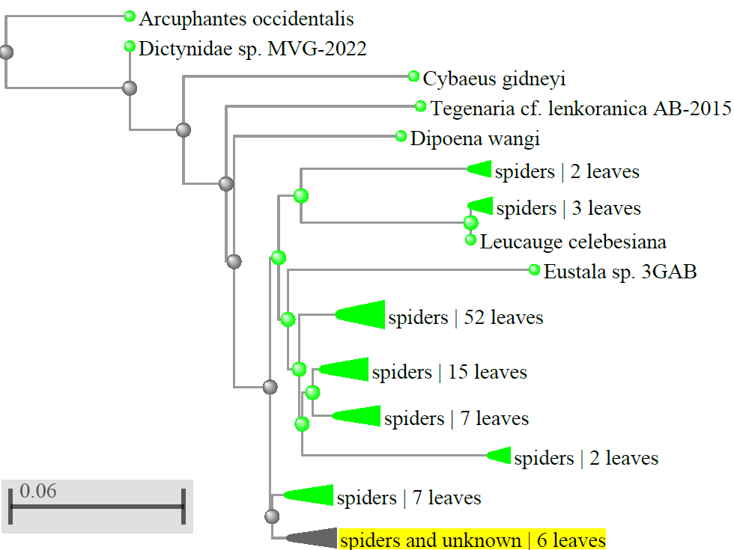

**Fig. 3. Phylogenic tree of sample A**

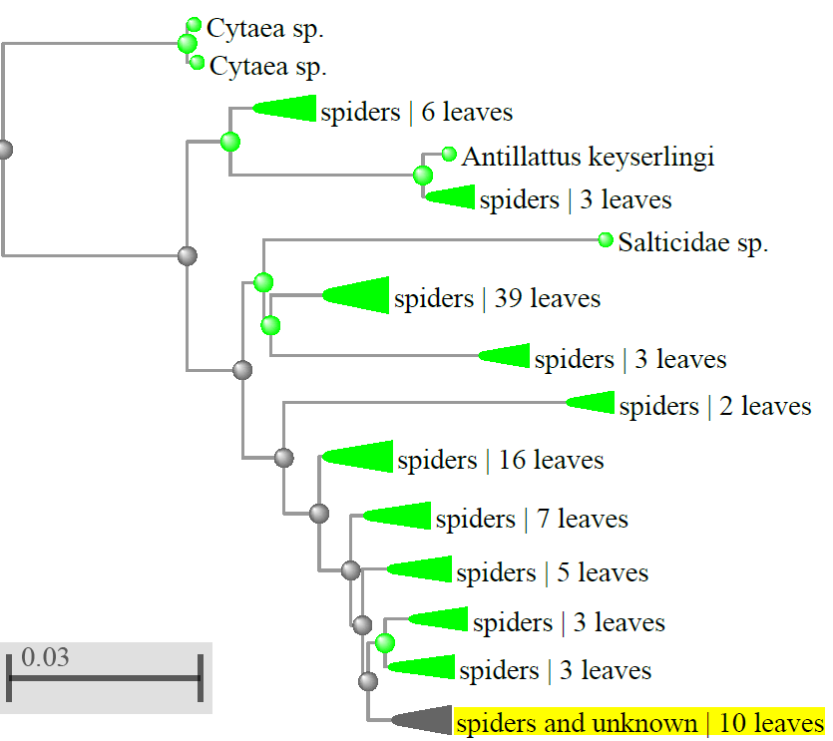

**Fig. 4. Phylogenic tree of sample B**

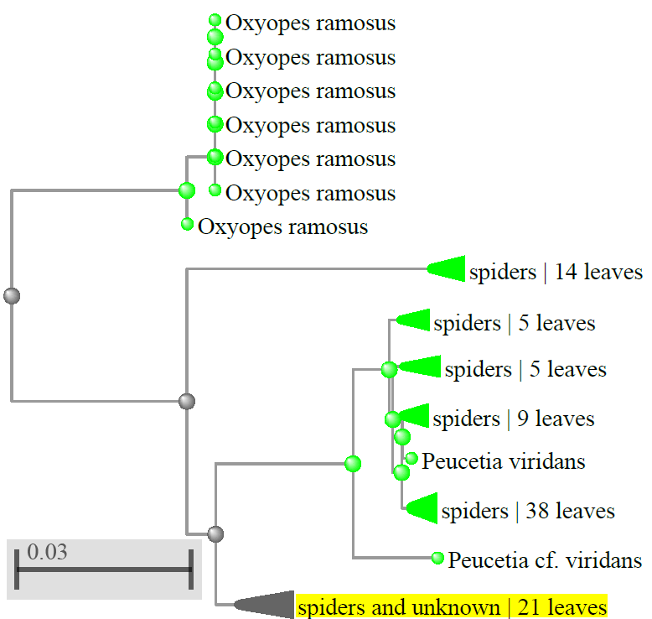

**Fig. 5. Phylogenic tree of sample C**

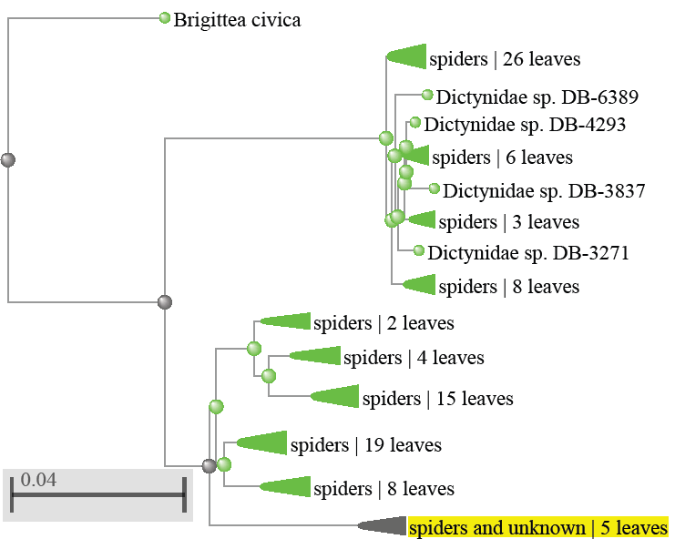

**Fig. 6. Phylogenic tree of sample D**

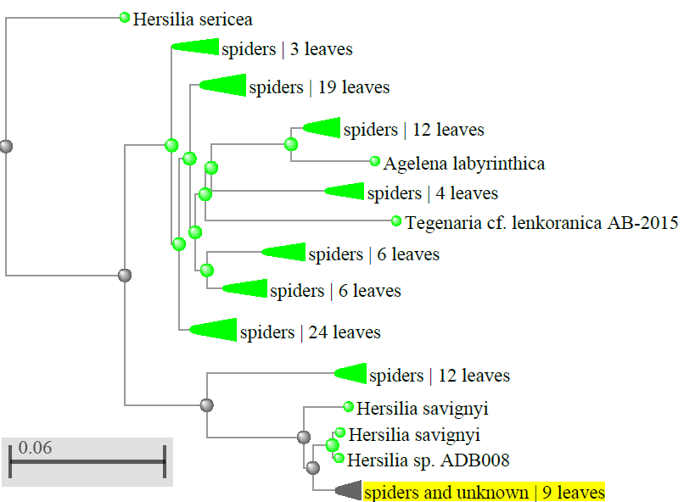

**Fig. 7. Phylogenic tree of sample E**

We used bootstrap analysis to evaluate the phylogenetic tree's robustness. In this process, the original dataset is repeatedly resampled with replacement, and the NJ method is applied to each resampled dataset. This generates multiple phylogenetic trees, and the frequency with which a particular branching pattern appears across these trees provides a measure of its statistical support. We set the number of bootstrap replications to 500, meaning that the NJ method was repeated 500 times on different resampled datasets. The degree of confidence in the observed associations is shown by the bootstrap values that are subsequently assigned to each branch point on the tree. Stronger support for the specific branching pattern is indicated by higher bootstrap scores. Building the phylogenetic tree involved using Maximum Composite Likelihood as our substitute model by default. Through this model scientists achieve more accurate distance measurements between sequences because the model analyzes individual nucleotide (A, T, C, and G) transformation rates over time.

* 1. **Sequence Alignment**

Building a phylogenetic tree requires correct sequence alignment as its foundation. Sequence alignment positions nucleotides according to homologous site locations whereby descendant nucleotides from a common ancestral nucleotide appear in corresponding sequence locations. We used MEGA6 ClustalW to create several sequence alignments through its method of first aligning pairs of sequences followed by the addition of additional sequences. The method ensures that evolutionary relationships appear properly throughout the final alignment. The evolutionary connections between spider species become more understandable through the information revealed in this research. Molecular phylogenetic approaches allowed researchers to collect more information about the evolutionary path of these remarkable animals. The research findings developed from this study offer benefits to future work on spider studies while enhancing our comprehension of spider diversity across evolutionary time scales.

1. **Conclusion**

Results in this work show that Random Amplified Polymorphic DNA (RAPD-PCR) proves effective in fast detection of genetic variations in spiders from the order Araneae. The important aspect of using RAPD-PCR as a technique is its capability for cross-species replication. RAPD-PCR offers universal application for distinguishing species that share tight genetic relationships since it needs no prior DNA sequence information. Multiple random primers should likely be used when conducting this process. News has emerged about evolutionary-conserved Cytochrome Oxidase genes through phylogenetic analyses which together show how selected spider species connect yet differ from one another. The results of these molecular methods surpass traditional approaches in delivery of exact information about evolutionary ties. Traditional approaches exclusively rely on observable characteristics that include morphology and body patterns as well as pigmentation. Most biological information from external influences affects these traits which may fail to preserve complete species evolutionary records. By analyzing genetic composition through molecular techniques scientists obtain an objective verification of evolutionary relationships between different organisms. Scientists detect tiny genetic variations that traditional morphological methods cannot see through DNA sequence comparisons between various species. Scientists can utilize this method to restore evolutionary branches in improved detail which reveals crucial information about biological history.

**References**

1. Tautz D, Arctander P, Minelli A, Thomas RH, Vogler AP. DNA points the way ahead in taxonomy. Nature. 418(6897): 479, 2002.
2. Savolainen V, Cowan R, Vogler A, Roderick G, Lane R. Towards writing the encyclopaedia of life: an introduction to DNA barcoding. Philosophical Transactions of the Royal Society B 360:, 2005, 1805-1811.
3. Hebert PDN, Cywinska A, Ball SL, de Waard JR. Biological identifications through DNA barcodes. Proceedings of the Royal Society of London. Series B, 2003a:270:313-321.
4. Hebert PDN, Ratnasingham S, Waard JR. Barcoding animal life: cytochrome c oxidase subunit 1 divergences among closely related species. Proceedings of the Royal Society B: Biological Sciences,2003b:270:96-99.
5. Muller RL. Evolutionary Rates, Divergence Dates, and the Performance of Mitochondrial Genes in Bayesian Phylogenetic Analysis. Systematic Biology,2006:55(2):289- 300.
6. Lee J, Miya M, Lee Y, Kim C, Park E, Aoki Y *et al*. The complete DNA sequence of the mitochondrial genome of the self-fertilizing fish Rivulusmarmoratus (Cyprinodontiformes, Rivulidae) and the first description of duplication of a control region in fish. Gene,2001:280:1-
7. Ward RD, Hanner R, Hebert PDN. The campaign to DNA barcode all fishes, FISH-BOL. Journal of Fish Biologym,2009:74:329-356.
8. Hajibabaei M, Singer GAC, Hebert PDN, Hickey DA. DNA barcoding: how it complements taxonomy, molecular phylogenetics and population genetics. Trends In Genetics, 2007:23(4):167-172.
9. Subhashini RM, Antoney PU. The spider diversity in an open forest in bangalore-urban. Int. J. Zool. Stud. 2020;5(3):11-6.
10. Penney D. Spider research in the 21st century trends & perspectives, The University of Manchester, UK, 2013: ISBN 978-0-9574530-1-2
11. Macias-Hernandez, N., Oromi, P. & Arnedo, M.A. 2010. Integrative taxonomy uncovers hidden species diversity in woodlouse hunter spiders (Araneae, Dysderidae) endemic to the Macaronesian archipelagos. Syst. Biodivers., 8: 531–553.
12. Hamilton, C.A., Formanowicz, D.R. & Bond, J.E. 2011. Species delimitation and phylogeogra- phy of *Aphonopelmahentzi*(Araneae, Mygalomorphae, Theraphosidae): Cryptic di- versity in North American tarantulas. PLoS ONE, 6(10): e26207. doi:10.1371/journal. pone.0026207.
13. Hedin, M. & Carlson, D. 2011. A new trapdoor spider species from the southern Coast Ranges
14. of California (Mygalomorphae, Antrodiaetidae, *Aliatypuscoylei*, sp. nov,), includingconsideration of mitochondrial phylogeographic structuring. Zootaxa, 2963: 55–68.
15. Satler, J.D., Starrett, J., Hayashi, C.Y. & Hedin, M. 2011. Inferring species trees from gene trees in a radiation of California trapdoor spiders (Araneae, Antrodiaetidae, *Aliatypus*). PLoS ONE, 6(9): e25355. doi:10.1371/journal.pone.0025355.Keith, R. & Hedin, M. 2012. Extreme mitochondrial population subdivision in southern Appala- chian paleoendemic spiders (Araneae: Hypochilidae: *Hypochilus*), with implications for species delimitation. J. Arachnol., 40: 167–181.
16. Richardson, B.J. & Gunter, N.L. 2012. Revision of Australian jumping spider genus *Servaea*Simon 1887 (Aranaea: Salticidae) including use of DNA sequence data and predicted distributions. Zootaxa, 3350: 1–33.
17. Ramírez, M.J. *et al*. 2007. Linking of digital images to phylogenetic data matrices using a
18. morphological ontology. Syst. Biol., 56: 283–294.
19. Miller, J.A., Griswold, C.E. & Yin, C.M. 2009. The symphytognathoid spiders of the Gaoli- gongshan, Yunnan, China (Araneae, Araneoidea): Systematics and diversity of micro- orbweavers. ZooKeys, 11: 9–195.