**First sighting record of Eared Grebe/Black-necked grebe *Podiceps nigricollis* from Chhattisgarh, India.**

**Abstract**

On 14th December 2024, a Black-necked Grebe (*Podiceps nigricollis*) was observed at Kopra Dam, Bilaspur district, Chhattisgarh, marking the first recorded occurrence of this species in the region. The bird, identified based on its distinct morphological features, was photographed and compared with standard literature for confirmation. This sighting expands the known wintering range of the species in India and highlights the importance of Kopra Dam as a potential habitat for rare migratory birds.

Keywords:

**Introduction**

**Black-Necked Grebe**

The Black-necked Grebe *Podiceps nigricollis* has a steep forehead, red eyes, and a black crown extending below the eye, with dusky grey ear coverts. In non-breeding plumage, its white throat curves up behind the ear coverts Grimmette et al. (2018). It inhabits freshwater marshes and lakes with shallow water and dispersed vegetation O’Donnell et al. (1997). In Asia, the Black-necked Grebe winters primarily in the western Gangetic Plains, Gujarat, and western India, including Maharashtra, Rajasthan, and Pakistan, with scattered records from the lower Himalaya ranges, northeastern India, eastern Assam Valley, Bangladesh, coastal Odisha, and Pune, Maharashtra Rasmussen & Anderton (2012); Kazmierczak (2000), across Nepal with most count from Koshi Tappu wildlife reserve, Jagadishpur, Khaptad National Park, Annapurna Conservation Area, Chitwan National Park Inskipp et al. 2016 and Rara lake Inskipp et al. (2016); Shrestha et al. (2022). The Black-necked Grebe has no previous record from Chhattisgarh, making this sighting significant.

**Study site**

Kopra Reservoir, located at 22°4’2.6616"N, 82°2’34.026"E, is situated 13 km east of Bilaspur city. Built by the Government of Chhattisgarh as part of an irrigation initiative, the reservoir also serves as the main drinking water supply for Kopra village. The surrounding area sustains a rich food chain, including nectar-producing and seed-bearing plants, fruits, insects, beetles, grubs, mollusks, shrimp, crustaceans, tadpoles, fish, amphibians, and reptiles. These favorable environmental conditions make it an ideal habitat that attracts both resident and migratory bird species for feeding and nesting. In a recent study Vishwakarma et al. (2021) recorded 133 avian species from 18 orders and 47 families in a study conducted over three winter seasons. Of these, 80 were resident and 53 migratory species.

**Methodology**

During a routine birdwatching survey on 14th December 2024, at Kopra Dam (22.064818, 82.050461), the first author observed an unusual grebe around 1:30 PM. The bird was photographed using a Canon EOS 90D with a Sigma 150-600mm lens. Identification was conducted through a comparison with field guides and ornithological literature Grimmett et al. (2018); Rasmussen & Anderton (2012). A literature review, including searches on Google Scholar and ResearchGate, was performed to determine prior records of the species in Chhattisgarh.

**Results and Discussion**

The Black-necked Grebe was identified based on its greyish overall appearance, blackish cap, red eyes, and distinct body shape. It differs from the smaller Little Grebe *(Tachybaptus ruficollis),* which has a rounder forehead, and the larger Great Crested Grebe (*Podiceps cristatus*), which has a sloping forehead and a head crest. The Black-necked Grebe is a rare winter visitor to western Maharashtra Prasad (2004) and an uncommon winter visitor to Gujarat, primarily in Charakala, with scattered records from Saurashtra, Kachchh Ganpule (2016), Bharuch district in South Gujarat Patel (2018), Nasik in Maharashtra Raha et al. (2005), and Hokersar wetland in Jammu and Kashmir Sofi et al. (2023). The absence of prior records in Chhattisgarh suggests this could be a vagrant occurrence or an indication of an underexplored migratory pathway. The Black-necked Grebe is vulnerable due to its dependence on stable saline lakes for feeding O’Donnell et al. (1997), with notable concentrations reported at Fateh Sagar Lake- 1000 individuals, Rajasthan Perennou et al. (1994);O’Donnel et al. (1997) and Charakala, Gujarat- 1405 individuals Jadhav et al. (2003). Previous bird studies by Naidu et al. (2021) Arjun et al. (2023) and Vishwakarma et al. (2021) at Kopra dam, the literature review revealed no recorded occurrence of this species in Chhattisgarh.This sighting emphasizes the importance of Kopra Dam as a potential stopover site for migratory waterbirds.

**Conclusion**

The documentation of the Black-necked Grebe at Kopra Dam represents the first confirmed record of this species in Chhattisgarh. This sighting contributes to the understanding of its wintering distribution in India and underscores the need for further avian studies in the region. Kopra Dam may serve as an important habitat for migratory waterbirds, warranting continued monitoring and conservation efforts.

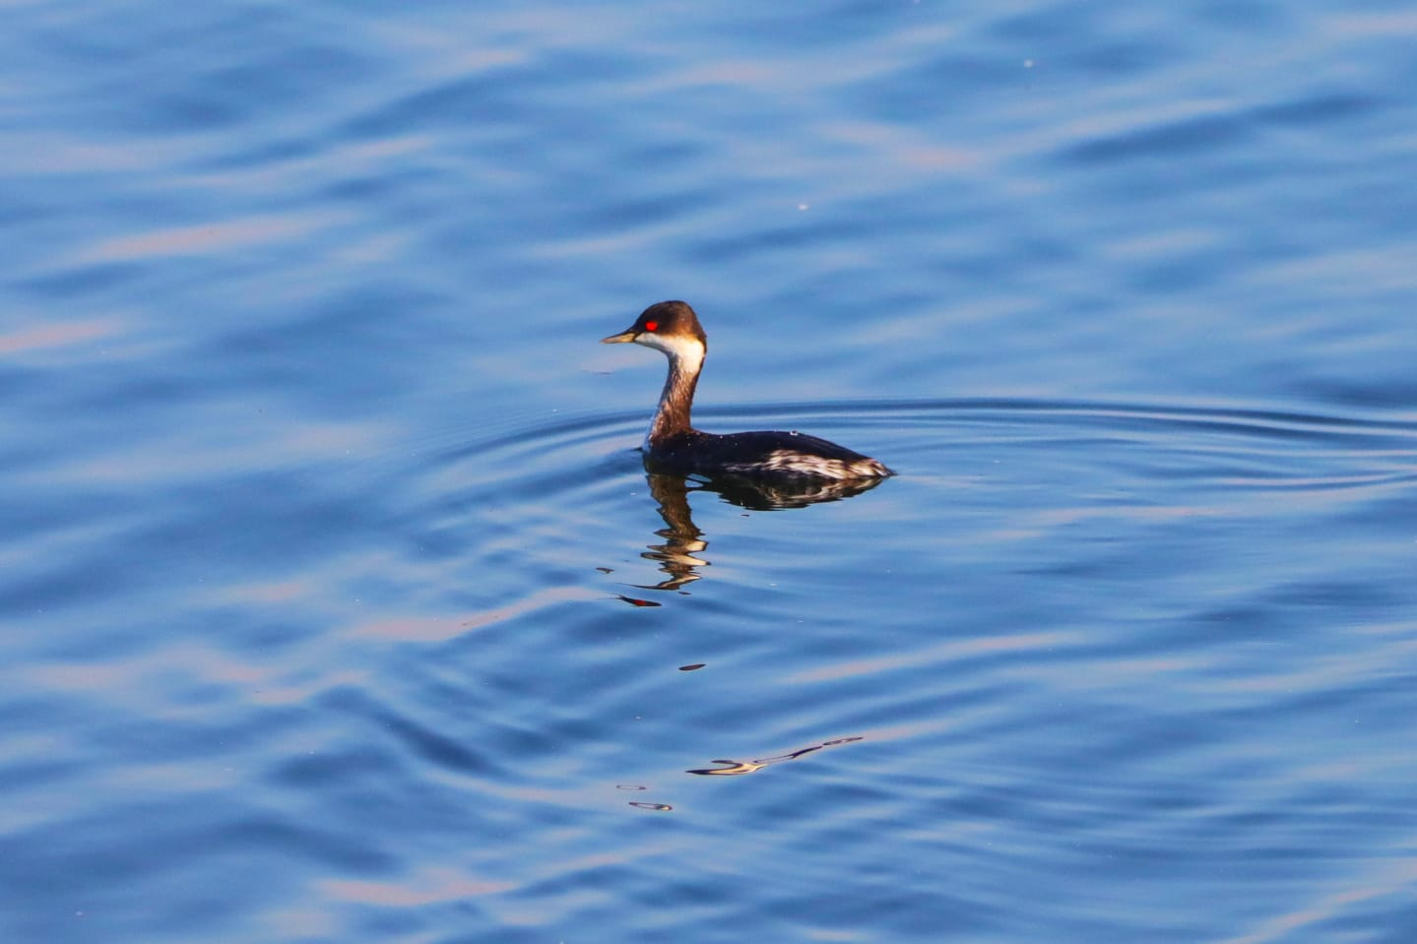

Figure 1 Photograph taken on 14th Dec by Lokesh Sharan

**COMPETING INTERESTS DISCLAIMER:**

Authors have declared that they have no known competing financial interests OR non-financial interests OR personal relationships that could have appeared to influence the work reported in this paper.

**Reference:-**

1. **Arjun, M.S., Panda, B. P., Arun, P. R. &Bharos, A.M.K. (2023)**. *Status of Ornithological work from the state of Chhattisgarh, India, and conservation implecations: A review.* Journal for nature conservation , (75)126471.
2. **Ganpule, P., (2016.** *The Birds of Gujarat: Status and Distribution*. Flamingo 8 (3) – 12 (4): 2-40
3. **Grimmett, R., Inskip, C., &amp; Inskipp, T. (2018).***Birds of the Indian subcontinent. 2 nd ed.* London: Oxford University Press &Christopher Helm, Pp. 528.
4. **Jadhav, A., Parasharya, B. M. &Rughani, B. (2006)*.****Charakla saltpans: a haven for Black-necked Grebe (Podicepsnigricollis) Brehm*. J Bombay Nat Hist Soc. 102: (2) 228–229
5. **Inskipp C., Baral H. S., Phuyal S., Bhatt T. R., Khatiwada M., Inskipp, T, Khatiwada A., Gurung S., Singh P. B., Murray L., Poudyal L. and Amin R. (2016)** The status of Nepal's Birds: The national red list series, Vol 1: Pp 248-251. Zoological Society of London, UK.
6. **Naidu, R., Bharos, A. M. K., &amp; Quader, S. (2021).***Birds of Chhattisgarh. Report by Bird Count India 2017–2018.* Chhattisgarh State Biodiversity Board,Pp 146
7. **O’Donnel, C. &Fjeldsa, J. (compilers)(1997)*.*** *Grebes - Status Survey and Conservation Action Plan*. IUCN/SSC Grebe Specialist Group. IUCN, Gland, Switzerland and Cambridge, UK, vii + 59 pp.
8. **Patel, J.H. (2018).***Black-necked Grebe’ in Bharuch district, south Gujarat.* Flamingo Newsletter for BCSG, 16 (1).
9. **KAZMIERCZAK, Krys. (2000).***A field guide to the birds of India, Sri Lanka, Pakistan, Nepal, Bhutan, Bangladesh and the Maldives.* 1st ed. New Delhi: Om Book Service. Hbk. [14.7 x 20.9cm (illus., covers by; John Cox)], pp. 1-352, pll. 1- 96 (col. by; Ber van Perlo), pll. 1-96 (300+ maps), 3 pll. line drawings, 1 map (line drawing), endpapers (illus.). (ISBN 81- 87107-04-9.)
10. **Perennou, C., Mundkur, T., Scott, D. A., Follestad, A. & Kvenild, L. (1994)**. *The Asian Waterfowl Census 1987-91: Distribution and Status of Asian Waterfowl.* Kuala Lumpur; Slimbridge, UK: Asian Wetland Bureau; The International Waterfowl and Wetlands Research Bureau.
11. **PRASAD, A. (2004)**. *Annotated checklist of the birds of Western Maharashtra.* Buceros, 8 (2&3): i-ii, 1-174
12. **Raha, B., Bhure, R. & Bob, I. (2005).***Sighting of Black-necked Grebe Podicepsnigricollis at Gangapur Dam, Nashik District, Maharashtra, India.* Indian birds, 1:(1)
13. **Shrestha, M.B., Nepal, K., GhartiMagar, T.B. & Rijal, D. (2022).** Ornithological survey and habitat quality in Rara Lake, Nepal. Journal of Environment Science, Vol VIII (2022): Pp. 15-44. DOI: [10.3126/jes.v8i1.53650](http://dx.doi.org/10.3126/jes.v8i1.53650" \t "_blank)
14. **Sofi. H. & Ahmad A. (2023).***Black-necked Grebe Podicepsnigricollis in Jammu and Kashmir.* Indian birds Vol. 9 (4)**11. Rasmussen, P. C., &Anderton, J. C. (2012).***Birds of South Asia: the Ripley guide.* 2nd ed. Washington, D. C., and Barcelona: Smithsonian Institution and Lynx Edicions, (2) Pp. 378; 683.**12.**
15. **Vishwakarma, A., Anthony, F.M., Tiwari, S. &Choubey, S. (2021).** Avifaunal Diversity of Winter Season in Kopra Reservoir of Bilaspur, Chhattisgarh, India. *Proceedings of the Zoological Society (pp. 1-9). Springer India*.<http://doi.org/10.1007/s12595-020-00349-z>