Review Article
Biodiversity and Animal Genetic Resources in the North-Eastern State of Assam: AnOverview

Abstract
Assam is a rich repository of diverse livestock and poultry genetic resources, which form a vital component of global biodiversity. The region's indigenous livestock and poultry breeds are highly valued for their milk, meat, eggs, and adaptability. The unique genes and adaptive traits of these breeds hold immense potential for enhancing agricultural resilience, productivity, and sustainability in the face of future challenges. However, many native breeds are experiencing rapid genetic decline and dilution due to intensive production systems and the unregulated introduction of exotic germplasm.The conservation of animal biodiversity has become increasingly crucial in recent years as the rate of species extinction continues to accelerate.Numerous organizations have been instrumental in promoting development and conservation initiatives to protect livestock biodiversity. Assam is renowned for its rich diversity of indigenous livestock breeds. Among cattle, the region is home to the Lakhimi breed, while the unique Luit and Manah buffaloes add to its distinctiveness. In smaller hoofed animals, the Assam Hill goat is a notable native breed. The state also takes pride in its indigenous pig breeds, such as the Doom pig. Furthermore, Assam boasts hardy native poultry breeds like the Daothigir and Miri chickens, as well as the Pati duck, all well-adapted to local conditions. Additionally, the Manipuri horse, known for its cultural and historical significance, highlights the rich genetic diversity of Northeast, India. These valuable genetic resources highlight Assam’s significant role in conserving biodiversity and promoting sustainable livestock farming.
Key Words: Assam,Conservation,Genetic resources, Livestock, Poultry
Introduction
Assam, a biodiversity-rich state in northeastern India, boasts a wide range of genetic resources, including indigenous livestock and poultry breeds. This rich genetic diversity has evolved over centuries through natural selection, traditional breeding practices, and adaptation to local environments. These genetic assets are vital for sustaining rural livelihoods, ensuring food security, and maintaining ecological balance. Efficient preservation and utilization of these resources are essential for promoting agricultural sustainability, mitigating the impacts of climate change, and driving economic growth in the region.
Biodiversity is vital for the sustainable existence of life on Earth, and livestock genetic diversity is a key component of it, often evaluated through the genetic makeup of breeds and indigenous animals. Indigenous livestock contribute significantly to global biodiversity, as they possess unique genes and gene combinations with immense potential for future agricultural advancements. These native breeds, adapted to diverse habitats and shaped by selective breeding practices, are increasingly at risk due to uncontrolled crossbreeding with exotic stocks and indiscriminate mixing of indigenous populations. Adaptation has played a critical role in the evolution of their unique traits, enabling them to thrive in harsh climatic conditions and exhibit strong disease resistance. However, these well-adapted domestic animals are gradually being replaced by crossbreeds, whose productivity has shown a declining trend [1].

According to the 20th Livestock Census conducted in Assam in 2019, the state had a total livestock population of 180.92 lakh. Cattle were the most predominant species, numbering 109.09 lakh and constituting 60% of the total livestock. Goats formed the second-largest group with a population of 43.15 lakh (24%), followed by pigs at 20.99 lakh (12%). Buffalo and sheep had smaller populations, with 4.22 lakh (2%) and 3.32 lakh (2%), respectively. Additionally, Assam had a significant poultry population of 467.12 lakh [2].
India is home to a vast diversity of domestic animal genetic resources, with 53 recognized breeds of cattle and 21 breeds of buffalo. Among smaller hoofed animals, the country has identified 46 sheep breeds and 41 goat breeds. India is also known for nine distinct camel breeds and eight indigenous horse breeds. Additionally, the nation boasts 20 chicken breeds, four duck breeds, and one geese breed. Furthermore, 15 native pig breeds have been recognized to date. Notably, the Bureau has registered Frieswal cattle as the first synthetic breed developed in the country [3].
Of the 230 recognized breeds in India, Assam is home to one breed each of cattle, goat, swine, and horse, along with two breeds each of chicken and buffalo, and one breed of duck. This review highlights the genetic resources of Assam, emphasizing their significance, conservation status, and potential applications in modern agricultural and livestock improvement programs.
- Genetic Resource of Cattle:The indigenous cattle breed of Assam, such as Lakhimi, is known for adaptability, disease resistance and ability to thrive on low-input systems. This breed plays a crucial role in the rural economy by providing milk, draught power and manure for agriculture. Conservation and genetic improvement of these native breeds are essential to maintaining biodiversity, enhancing productivity, and ensuring sustainable livestock farming in the region.
- Lakhimi:Lakhimi cattle is an indigenous breed from Assam, officially recognized as a breed by ICAR-NBAGR, Karnal in 2017. These cattle are small but hardy, well-adapted to hot and humid conditions. Lakhimi is a dual-purpose (milk and draught) breed, valued for both milk and draft purposes. They are small-sized, horned animals with relatively short legs. The horn is straight and the size is 17 cm. Their coat colour varies, predominantly seen in shades of brown and grey. They have a medium-sized hump and a slightly curved backline. The udder is small and bowl-shaped. The bullocks are known for their exceptional draft capabilities, particularly suited for carting and ploughing, making them highly efficient for working in muddy fields during paddy cultivation [4]. The males and females exhibit distinct physical characteristics. On average, males have a height of 101.63 cm, while females stand at 91.48 cm. The average body length is 92.32 cm in males and 83.1 cm in females. The heart girth measures approximately 131.34 cm in males and 112.38 cm in females. The average body weight is 240 kg for males and 185 kg for females. At birth, male calves weigh around 15.46 kg, whereas female calves have an average birth weight of 14.67 kg. Lakhimi cattle are traditionally reared under a low or zero-input system, primarily following an extensive management approach. They are typically released in the morning to graze in nearby areas. Milking is carried out only once a day, usually in the morning [5].The average age at sexual maturity in Lakhimi cattle is 32.98 ± 0.59 months, while the average age at first calving is 46.07 ± 0.61 months. The breed has an average dry period of 223.13 ± 3.51 days and a service period of 264.43 ± 2.51 days under traditional rearing systems. The inter-calving period averages 539.63 ± 3.83 days. Regarding milk production, the average daily milk yield of Lakhimi cattle under traditional management is 1.36 ± 0.04 liters, with an average peak yield of 1.53 ± 0.05 liters. The lactation length averages 241.59 ± 4.64 days, and the total lactation milk yield is approximately 327.76 ± 5.97 liters. The average milk fat is 5.3% [6].

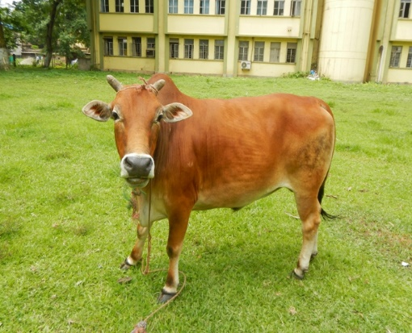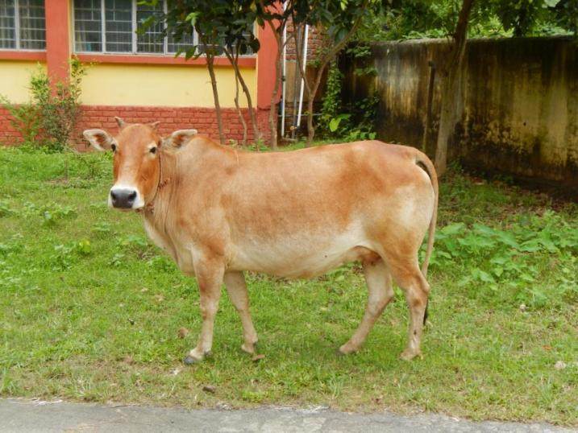
Fig 1 Lakhimi (Male)fig 2Lakhimi (Female)
Source: NBAGR, Karnal

- Genetic Resources of Buffalo:Assam is home to valuable genetic resources in buffalo, primarily represented by the Swamp buffalo, which plays a significant role in the region’s rural livelihood. These buffaloes are well adapted to the agro-climatic conditions of Assam and are primarily used for draught power in paddy fields, milk production and meat. They possess unique traits such as high disease resistance, efficient feed utilization and the ability to thrive in wetland ecosystems. Conservation and genetic improvement of Assam’s buffalo population are crucial for enhancing productivity while preserving their indigenous traits and biodiversity.
- Luit:The Luit buffalo, also known as the Assamese Swamp buffalo, is a locally adapted breed traditionally reared by the people of Assam. They are predominantly distributed in the upper Brahmaputra Valley, covering nine districts of upper Assam including Biswanath, Majuli, Golaghat, Dhemaji, Tinisukia, Dibrugarh, Lakhimpur, Sibsagar and Jorhat. These swamp buffaloes are named after the mighty Brahmaputra River (locally called "Luit") as they are commonly found in embankments and small islands along its course. Primarily utilized for both milk production and draught work, Luit buffalo bullocks are excellent draft animals, particularly suited for carting and ploughing in muddy fields, making them ideal for paddy cultivation. Additionally, they are found in certain areas of Manipur, Mizoram, and Nagaland, especially in regions bordering Assam. Luit buffaloes thrive in extensive management systems with a nomadic lifestyle. They are typically reared in large groups, locally referred to as "khuti," on river islands, riverbanks, and forest lands. Their diet primarily consists of grazing, supplemented with fodder and concentrate feed.The Luit buffalo is predominantly black in colour, with distinct physical characteristics. Its horns are curved laterally backward and then upward, forming a semi-circle, with an average length of 60.13 cm in males and 57.13 cm in females. These medium-sized, strongly built animals have a prominent wither, a short tail, a broad and concave forehead, prominent eyes and a wide muzzle. Both males and females possess distinct semi-circular horns and exhibit light white stocking up to the knee on both fore and hind legs.In terms of body measurements, males have an average height of 135.33 cm, while females stand at 130.28 cm. The average body length is 128.0 cm in males and 126.24 cm in females. Heart girth measurements average 211.14 cm in males and 193.25 cm in females. The average body weight is approximately 470 kg for males and 416 kg for females. At birth, male calves weigh around 29.31 kg, while female calves have an average birth weight of 28.47 kg.A unique peculiarity of the Luit buffalo is its diploid chromosome number (2N), which is 48. This includes 23 pairs of autosomes and one pair of sex chromosomes. Notably, the 4th pair of metacentric chromosomes in swamp buffaloes results from the tandem fusion of chromosomes 4 and 9 of the riverine buffalo [7].The average body measurements for adult Luit buffaloes showed that males had a body length of 135.78 ± 0.64 cm, a height at withers of 142.32 ± 0.81 cm, and a heart girth of 195.56 ± 1.22 cm. In females, these values were slightly lower, with an average body length of 133.44 ± 0.81 cm, a height at withers of 140.74 ± 0.76 cm, and a heart girth of 189.34 ± 1.06 cm. Regarding body weight, male buffaloes had an average birth weight of 27.12 ± 2.50 kg, reaching 307.78 ± 8.80 kg at 2–3 years and 430.56 ± 7.25 kg at 4 years and above. Female buffaloes had an average birth weight of 25.78 ± 3.14 kg, weighing 280.90 ± 2.16 kg at 2–3 years and 398.12 ± 9.54 kg at 4 years and above. The reproductive and production performance of Luit buffaloes indicated an average age at first calving of 54.62 ± 4.10 months. The average lactation milk yield was 458.73 ± 8.98 kg, with a lactation length of 245.84 ± 7.92 days. The service period averaged 177.34 ± 9.26 days, while the calving interval was recorded at 482.53 ± 8.82 days. The milk composition included an average fat percentage of 8.45% and a solids-not-fat (SNF) content of 9.30%. The breed is known for its high milk fat content, averaging 8.68%, with recorded values ranging between 7.8% and 10.9%[8].

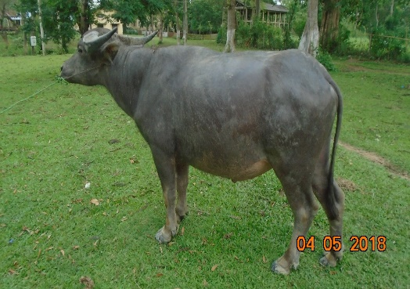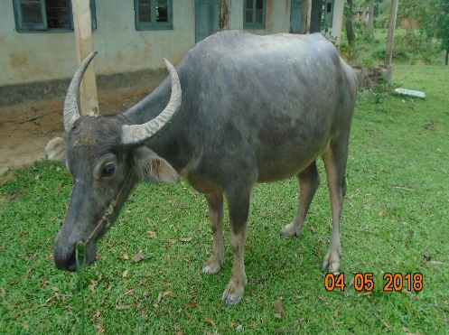
Fig 3 Luit (Male) fig 4 Luit (Female)
Source: NBAGR, Karnal
- Manah:The Manah buffalo is a dual-purpose breed reared for both milk production and draught work. It is primarily found in the Nalbari, Kamrup rural, Barpeta and Goalpara districts of Assam. This buffalo breed is medium in size and well-suited for both milk yield and draught purpose. The average daily milk production is approximately 1.75 kg [9].

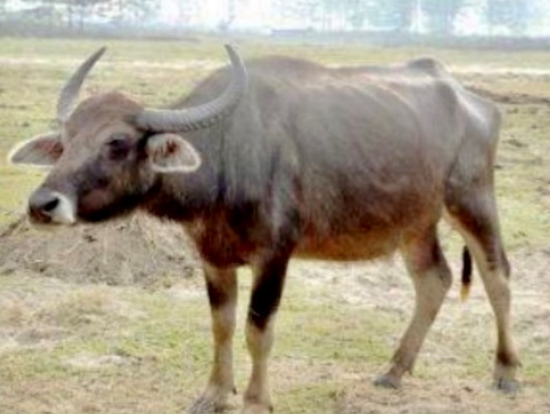
Fig 5 Manah
Source: NBAGR, Karnal
Genetic Resource of Goat:Assam possesses rich genetic resources in goats, with the Assam Hill Goat being a prominent indigenous breed. This goat is well adapted to the hilly terrain, humid climate and is primarily reared for meat production and contribute significantly to the livelihood of small and marginal farmers. Known for their resilience, high fertility and efficient feed conversion, they play a vital role in the region’s livestock economy. Conservation and genetic improvement of Assam’s goat breed is essential for enhancing productivity, ensuring food security and maintaining the biodiversity of small ruminants in the state.
- Assam Hill Goat:Assam Hill goat is commonly known as “Asomi”. The Asomi goat is predominantly found in the hilly regions of North Cachar and KarbiAnglong districts in Assam, as well as in the neighboring hilly areas of Meghalaya [10]. This breed is an indigenous breed primarily valued for its meat utility. It demonstrates remarkable adaptability to the traditional open grazing and zero-input management system, thriving across diverse topographic and climatic conditions of Assam. This breed is well-suited to the region's unique environmental challenges, showcasing its resilience and compatibility with local pastoral practices. The Asomi breed is primarily managed under an extensive system of husbandry, characterized by stationary mobility and grazing as the primary feeding method for adults. Goat husbandry in rural areas relies heavily on backyard farming. Morphologically, Asomi goats are typically white, occasionally exhibiting black patches on the backline and legs. They possess cylindrical, tapering horns that are usually straight, though some may have a slight backward curve; these horns are small, corrugated, and pointed at the tip. The goats are short-legged with small body sizes, and both bucks and does are bearded. Their ears are medium-sized, horizontally placed, and have pointed tips, while their tails are short and hairy. On average, males and females have a height of 48.06 cm and 47.21 cm, body length of 57.63 cm and 54.98 cm, heart girth of 52.79 cm and 51.02 cm, body weight of 19.81 kg and 18.61 kg, and birth weights of 1.26 kg and 1.13 kg, respectively. The age at first parturition averages 13.34 months, with a range of 11 to 15 months, while the parturition interval is approximately 7.63 months, varying between 6 and 10 months. The milk yield per lactation averages 10.19 kg, with a fat percentage of 7.64%, and ranges between 7 to 22 kg of milk per lactation. The breed exhibits a dressing percentage of 46%, underscoring its suitability for meat production. In terms of performance, the breed demonstrates prolific reproductive traits, with an average litter size of 1.56 ranging from single births to quadruplets. The incidence rates of singletons, twins, triplets, and quadruplets are 51.17%, 41.92%, 6.69%, and 0.22%, respectively [7].Twinning is a common occurrence in Assam Hill goats [11]. The average age at first heat in Asomi goat is 266 days [10].

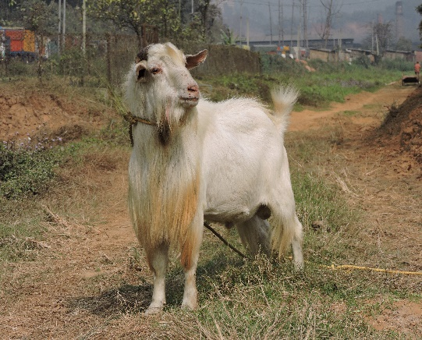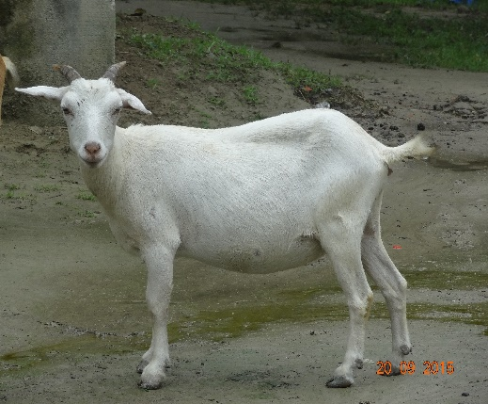
Fig 6 Assam Hill Goat (Male) fig 7 Assam Hill Goat (Female)
Source: NBAGR, Karnal
Genetic resource of Swine:The Doom pig is an important indigenous genetic resource of Assam, known for its adaptability, disease resistance and efficient feed conversion. This native breed is primarily reared by rural and tribal communities for meat production, contributing significantly to their livelihoods. Doom pigs are well-suited for smallholder farming. Conservation and genetic improvement efforts are essential to enhance their productivity while preserving their unique traits, ensuring sustainable pig farming in the region.
- Doom:The breeding tract of Doom pig is Bongaigaon, Dhubri and Kokrajhar districts of Assam. This is a medium-sized pig with a black coat, noticeably larger than other local pig breeds in the region [10]. The major utility of this breed is for pork consumption since the meat of the Doom breed is lean. They typically migrate in groups under a scavenging system, with flock sizes ranging from 90 to 150 [12]. The pigs are primarily managed in a backyard system and are characterized by their black coloration. Morphologically, they have a short, concave snout, a large and flat belly and short, erect ears. On average, males and females exhibit a height of 63.1 cm and 68.2 cm, a body length of 79.2 cm and 84.3 cm, and a heart girth of 83.6 cm and 86.7 cm, respectively. Their average body weight is 41.65 kg for males and 45.3 kg for females, with an average birth weight of 0.72 kg and 0.73 kg, respectively. In terms of performance, the average litter size is 6.29, ranging from 5 to 8 piglets. The average age at first parturition is 11.1 months, with a range of 10.7 to 11.3 months, and the parturition interval averages 7.1 months, ranging between 6.6 and 7.5 months. The breed has a dressing percentage of 62%, making it a valuable resource for meat production [7]. In the backyard production system, the average age at first heat and first conception were 223.11 ± 2.51 days and 245.95 ± 2.38 days, respectively. The mean carcass characteristics of Doom pigs under this system included a carcass weight of 29.48 ± 1.04 kg, carcass length of 47.27 ± 0.63 cm, back fat thickness of 28.50 ± 0.29 mm, lean meat content of 47.74 ± 1.48%, and loin eye area of 15.44 ± 1.61 cm² [13].

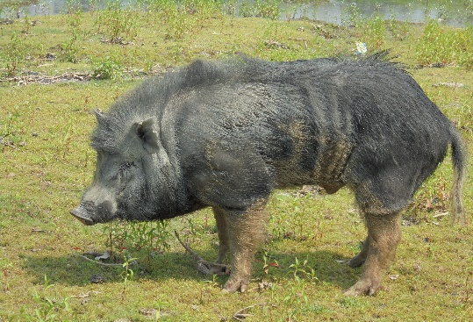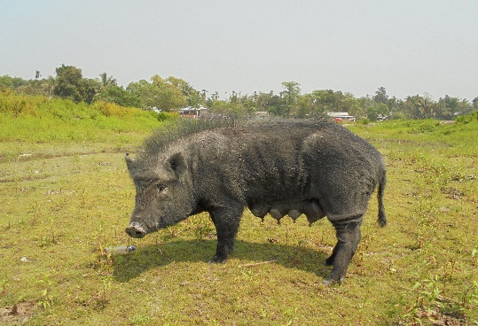
Fig 8 Doom (Male) fig 9 Doom (Female)
Source: NBAGR, Karnal
Genetic Resource of Horse:The Manipuri horse, a unique equine genetic resource found in Assam and the northeastern region, is renowned for its agility, endurance and adaptability to the hilly terrain. Traditionally used in polo and warfare, this indigenous breed holds significant cultural and historical importance. Characterized by its compact build, resilience and high stamina, the Manipuri horse thrives in diverse environmental conditions with minimal management. Conservation and genetic improvement efforts are essential to safeguard this heritage breed, ensuring its continued role in traditional sports, rural livelihoods, and biodiversity preservation.
- Manipuri:This breed is found in different parts of Assam and Manipur. The Manipuri pony is widely recognized for its extensive use in polo games worldwide. In addition to polo, these ponies are also utilized for transportation, hunting, and racing, showcasing their versatility and importance in various activities [10]. The Manipuri pony is managed under a semi-intensive system, with adult ponies being fed a combination of grazing, fodder and concentrates. In the Manipuri breed, coat colors such as bay, chestnut, brown, grey, and cream were commonly observed, while black and roan were exceptionally rare. Additionally, other colours, locally known as palomino, cream, dun, and pinto, were also present [14]. These ponies have almond-shaped, alert ears, a light and well-proportioned head with a straight profile and a slightly wider muzzle with a convex nose. Their neck is well-formed with a full mane, while their sturdy legs and tough hooves make them resilient. On average, males and females have a height of 129.1 cm and 129.0 cm, a body length of 129.2 cm and 129.9 cm, a heart girth of 143.7 cm and 143.4 cm, and an average body weight of 300 kg for both sexes. At birth, the average weight is 28.5 kg for males and 26.5 kg for females. In terms of performance, the average age at first parturition is 48 months, with a parturition interval averaging 12.7 months. These traits underscore the breed's suitability for a range of purposes, including polo, transportation, hunting, and racing [15]. Moreover, Manipuri ponies are possessing small, compact body with a fairly long face. The legs are well-proportioned to the body, with strong knees and hocks. The pasterns have a gradual, balanced slope. The hooves are round and appropriately sized, avoiding a boxy appearance, while the tail is set high [14].

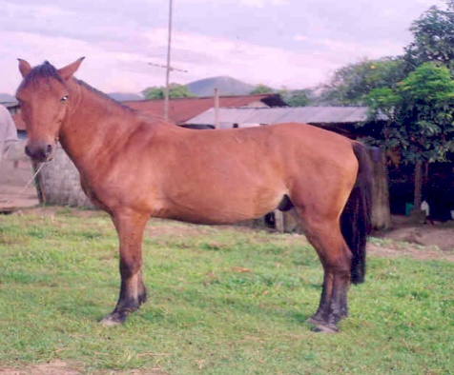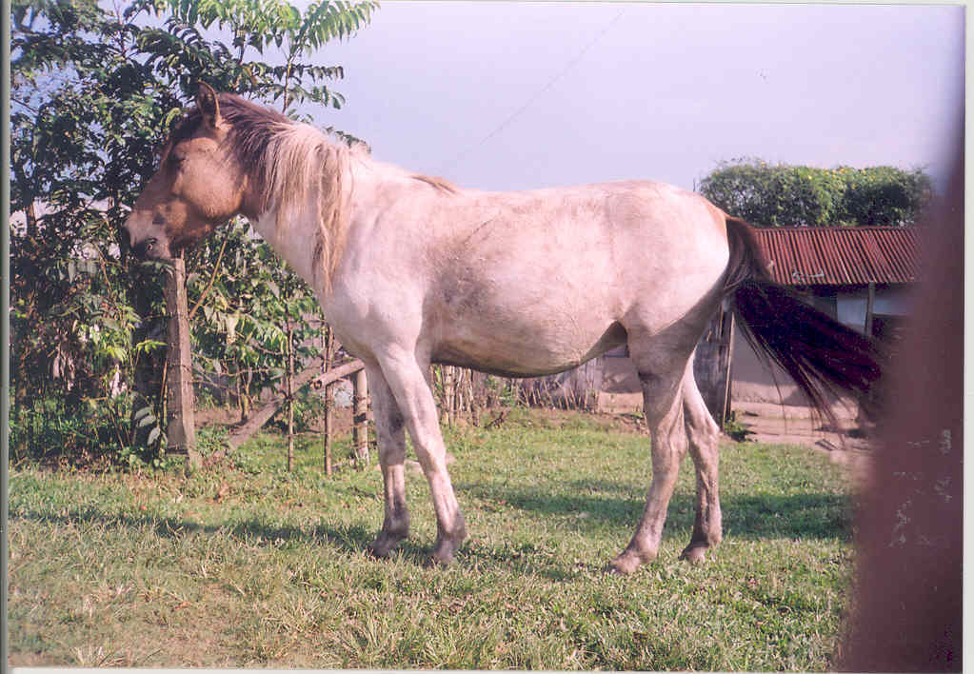
Fig 10 Manipuri (Male) fig 11 : Manipuri (Female)
Source: NBAGR, Karnal
Genetic Resources of Poultry:Assam is home to rich poultry genetic resources, with indigenous breeds like Miri and Daothigir, along with the duck breed Pati, playing a vital role in rural livelihoods. These native poultry breeds are well adapted to the local agro-climatic conditions, exhibiting high disease resistance, efficient scavenging ability and good adaptability to low-input systems. They are primarily reared for both meat and egg production, contributing to household nutrition and income generation. Conservation and genetic improvement of these indigenous poultry resources are crucial for enhancing productivity while preserving their unique traits and biodiversity.
- Chicken:
Miri:These chicken breeds are primarily found in the Dhemaji, North Lakhimpur, Sibsagar, Dibrugarh, and Majuli districts of Assam. The name of the bird is derived from the Miri or Missing tribe, as these birds are traditionally reared by them [10]. This breed is commonly known as Porog which is mainly reared for meat and egg purpose. The management system for these chickens is predominantly backyard-based, with stationary mobility. Adult birds primarily rely on scavenging for their feed, though they are provided with supplemental feeding. The birds are housed in cane and bamboo cages at night, which are kept inside the owners' dwellings. Morphologically, the plumage of this breed is predominantly black and brown, with the most common pattern being solid; however, a few individuals exhibit spotted or striped patterns. The skin colour ranges from white to yellow, and the shank is either white or yellow. The ear lobes are typically red, while the comb is single and also red. Brown eyes are the most commonly observed in this breed. The average weight at 6 months was recorded as 1.06 ± 0.049 kg, while at 12 months, it was 1.525 ± 0.048 kg. The age at first egg was observed to be 212 days. Clutch size ranged from 4 to 5 days, and the average annual egg production was 62 eggs. Hatchability, based on the total egg basis, was found to be 79%, while the mortality rates up to one month ranged between 10% and 15%. The dressing percentage varies between 65% and 74%[16].
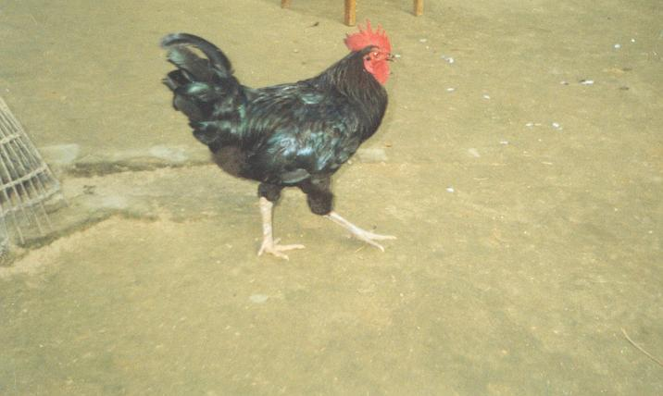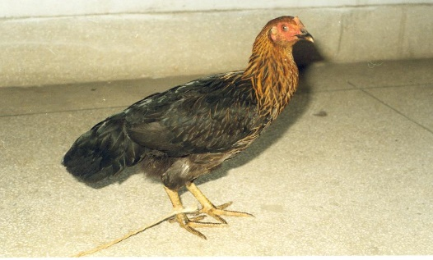
Fig 12 :Miri (Male) fig 13:Miri (Female)
Source: NBAGR, Karnal
Daothigir:This breed is exclusively found in the districts of Kokrajhar, Chirang, Udalguri, and Baska in Assam, where it is primarily reared by the local Bodo tribes using a backyard or free-range system [17]. The Daothigir breed, derives its name from the plant Thigir (Dilleniaindica), which is native to the region. This plant bears flowers in various colors, resembling the diverse plumage of these birds. Additionally, the shape of the flowers resembles the comb of the Daothigir chickens. In the Bodo language, Dao means bird, and thus, these birds are called Daothigir. The primary utility of this breed lies in providing food in the form of meat and eggs. They are mainly reared to meet the domestic needs of the farmers, serving as a vital source of sustenance. Moreover, these birds also act as a cash reserve, contributing to the farmers' financial stability [18].The Daothigir birds are small-sized, compact, yet heavy, with long legs. Their plumage is predominantly black interspersed with white feathers, although variations such as white with black or brown with white are also common. The patterns can be either striped or spotted. The wings and tail exhibit black or brown feathers, while the neck and back display golden yellow or brown feathers in certain birds. The skin is cream-colored, often showing a slight pinkish hue. The eye ring is red, and the ear lobe is typically red but may sometimes be white or a mix of white and red. The wattles are medium to large in size and red in color. The comb is red, single, erect, and large. The beak and shank are yellow, and the tail is short, aligning almost at the level of the back. The average body weight in cock and hen is 1.79±0.13 kg and 1.63±0.13 kg [27].The average age at first egg and egg weight is 6 months and 44 g, respectively [18]. The annual egg production in Daothigir breed is approximately, 60-70 [19]. The fertility rate, hatchability on total egg set, and hatchability on fertile egg set were observed to be 80.30 ± 3.50, 66.84 ± 4.90, and 83.90 ± 5.60, respectively. The average dressing percentage in both male and female is 73.88±2.68 and 72.22±3.51, respectively [17].
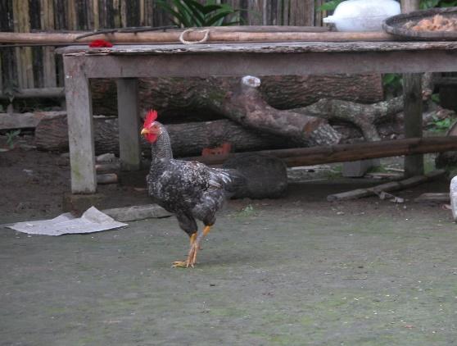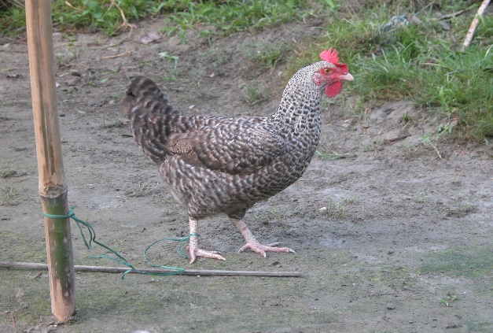
Fig 14 :Daothigir (Male) fig 15 : Daothigir (Female)
Source: NBAGR, Karnal
- Duck:
Pati:Pati ducks are well-suited for the backyard production system. Their shelters are constructed using locally available materials, such as bamboo and wood, and are typically placed near or within the farmer's residence. The most common feeding method involves scavenging, supplemented with additional feed.This breed is mainly utilized for egg, meat and ritual sacrifices. The Pati ducks exhibit distinct morphological characteristics, with males averaging a birth weight of 35.48 grams and females 33.32 grams. In terms of adult weight, males reach an average of 1.67 kg, while females weigh 1.48 kg. They possess normal plumage type with a selective pattern and brown colour. The comb type is selective, and the skin and shank colours are both yellow. The egg shell colour is white, and the ducks display a squat posture. Male ducks, or drakes, have dark brown plumage with a greyish-black head and black-and-white tail feathers, while females are solid brown. A white ring may or may not be present at the neck in both sexes. The bill, shank, and feet are predominantly yellow.
In terms of performance, the average fertility rate for the breed is 83.74%, with a minimum of 70.0% and a maximum of 90.0%. The hatching rate averages 59.68%, ranging from 51.0% to 67.0%, while the dressing percentage is 59.3%, with a minimum of 55.0% and a maximum of 63.0%. A notable peculiarity of the breed is that about 60% of the birds exhibit broodiness, particularly between 40 to 48 weeks of age [20]. Pati ducks exhibit higher resistance to diseases and are better adapted to the local environmental conditions [21]. The Pati duck reaches sexual maturity between 220 and 235 days of age, with the average age at first egg laying being around 240 days. They produce eggs weighing approximately 60.5 grams, with an annual egg production ranging from 75 to 90 eggs [22].
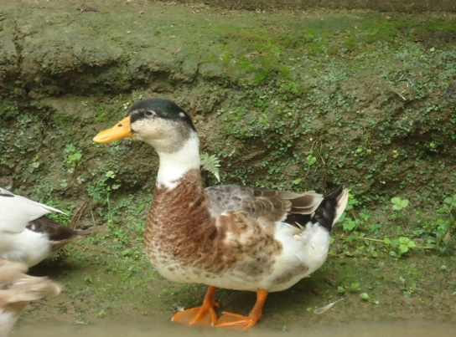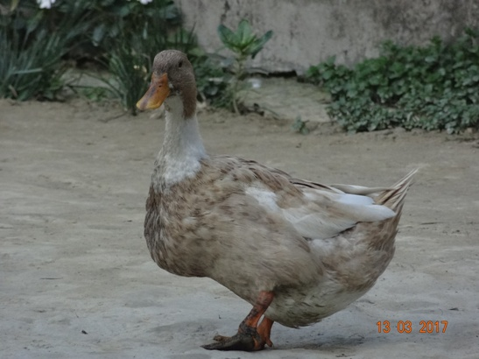
Fig 16 :Pati (Male) fig 17 : Pati (Female)
Source: NBAGR, Karnal
Conservation of indigenous animals in the North-Eastern State of Assam
Conservation of indigenous breeds is critical for maintaining genetic diversity, which serves as a reservoir for traits such as disease resistance, adaptability and nutritional quality. These breeds also hold cultural and traditional value for local communities, serving as a vital source of livelihood and playing a role in rituals and customs.The state has implemented several initiatives aimed at conserving and developing these native breeds. Therefore, it emphasizes the need for a concerted effort from policymakers, researchers, and local communities to ensure the sustainable use and preservation of these genetic resources for future generations.
Programmes like National programme for bovine breeding (NPBB) focuses on the genetic improvement of bovine populations with an emphasis on indigenous breeds. Its objectives include providing quality artificial insemination services, bringing all breedable females under organized breeding, conserving and developing selected indigenous breeds of high socio-economic importance and supplying quality breeding inputs to prevent breed deterioration and extinction (Animal Husbandry and Veterinary, Government of Assam).
The Assam Livestock Development Agency (ALDA) serves as the state implementing agency for the National Project for Bovine Breeding (NPBB). As part of its initiatives, ALDA has launched a program aimed at the improvement and conservation of the indigenous Swamp buffalo population, supported by the establishment of a nucleus farm at Barhampur in Assam[10].
All India Coordinated Research Project (AICRP) on Poultry Breeding was implemented by Assam Agricultural University, this project aims to improve rural poultry production through the conservation and development of indigenous poultry breeds. It focuses on enhancing the productivity of native chicken varieties while maintaining their genetic diversity[23].
Research has been conducted to document and understand the traditional free-range indigenous chicken farming systems in Assam. Such studies provide valuable insights into existing practices and help formulate strategies for the conservation and improvement of native poultry breeds [24].
Recognizing the importance of conserving the Doom pig, the All India Coordinated Research Project on Pig initiated a conservation unit at Krishi Vigyan Kendra in Goalpara, under the ICAR-National Research Centre on Pig. This unit maintains a herd of 30 sows dedicated to the conservation and selective breeding of the Doom pig [25].
Further emphasizing the state's commitment, the Assam Pig Breeding Policy of 2019 outlines strategies for the conservation and genetic improvement of indigenous pig breeds. The policy advocates for the establishment of breeding units for pure indigenous registered breeds at multiplier farms. These units aim to provide cross-bred or pure indigenous pigs to farmers, entrepreneurs, self-help groups, cooperative societies, and farmers' producer organizations. Additionally, the policy proposes setting up a nucleus farm for the Doom pig breed as part of its conservation efforts [26].

Conclusion
The North-Eastern state of Assam boasts a rich and diverse repository of animal genetic resources, shaped by its unique agro-climatic conditions and traditional practices. These resources not only sustain the livelihoods of local communities but also hold significant potential for sustainable agricultural and livestock development. However, in recent years, many native breeds have faced rapid genetic decline and dilution due to the unplanned introduction of exotic germplasm. If this trend continues, it could result in the loss of valuable native genetic material known for its superior draught power, disease resistance, and heat tolerance.While alterations to native germplasm for production and reproduction purposes may be necessary, they must remain within scientifically defined limits. The inclusion of exotic genetics should be restricted to optimal levels, such as 52–62.5% for semi-intensive systems and 62–75% for intensive production systems. By integrating traditional knowledge with modern breeding technologies and fostering community participation, Assam's rich genetic heritage can be preserved for future generations, ensuring resilience and productivity in the livestock sector.
References
- Singh KV. Biodiversity and Conservation Status of Indigenous Livestock of India. InBiodiversity 2022 Dec 30 (pp. 143-155). CRC Press.
- Assam Animal Husbandry and Veterinary Department. 20th Livestock Census Report, Assam. 2019.
- ICAR-NBAGR. Annual Report. Indian Council of Agricultural Research - National Bureau of Animal Genetic Resources, Karnal, India. 2023. https://nbagr.icar.gov.in
- Savalia KB, Ahlawat AR, Gamit VV, Parikh SS, Verma AD. Recently recognized indigenous cattle breeds of India: A review. International Journal of Current Microbiology and Applied Sciences. 2019;8(12):161-8.
- ICAR-NBAGR. Lakhimi cattle. National Bureau of Animal Genetic Resources, Karnal (Haryana). 2017. http://www.nbagr.res.in/ lakhimi.html
- Deka D, Phookan A, Bhattacharyya SK, Baruah R, Chutia R, Neog M, Saud RK, Sarma UJ. PERFORMANCE EVALUATION OF LAKHIMI CATTLE UNDER TRADITIONAL REARING SYSTEM OF ASSAM. 2024 Jan 1;21(2):16.
- ICAR-NBAGR. New Breed Registered. ICAR-National Bureau of Animal Genetic Resources (NBAGR), Karnal. 2018. http:// www.nbagr.res.in/registeredbreed.html
- Das GC, Zaman G, Bhattacharyya BN. Studies on some morphometric and performance traits of Assamese buffaloes. North-East Veterinarian. 2020 Apr 1;20(1).
- ICAR-NBAGR. New Breed Registered. ICAR-National Bureau of Animal Genetic Resources (NBAGR), Karnal. 2025. http:// www.nbagr.res.in/registeredbreed.html
- Kadirvel G, Singh LA, Rahman M, Singh NM. Farm animal genetic resources in agro ecosystem of north east India. The Indian Journal of Animal Sciences. 2019 Nov 1;89(11):1175-83.
- Zeshmarani S, Dhara KC, Samanta AK, Samanta R, Majumder SC. Reproductive performance of goats in Eastern and North-eastern India. Livestock Research for Rural Development. 2007;19(8):114.
- Banik S, Naskar S, Zaman G, Sarma DK, Tamuly MK, Gandhi RS. Doom pig, an indigenous pig germplasm of Assam. ICAR-National Research Centre on Pig, Rani, Guwahati. 2016;781131.
- Rahman M, Phookan A, Zaman GU, Ahmed MS, Deori S, Hoque E. Performance of Doom pigs under different production systems in subtropical ecosystem of north east India. The Indian Journal of Animal Sciences. 2020 Feb 1;90(2):292-5.
- Gupta AK, Tandon SN, Pal Y, Bhardwaj A, Chauhan M. Phenotypic characterization of Indian equine breeds: a comparative study. Animal Genetic Resources/Resources génétiquesanimales/Recursosgenéticosanimales. 2012 Jun;50:49-58.
- ICAR-NBAGR. Manipuri pony. National Bureau of Animal Genetic Resources, Karnal (Haryana). 2011.
- Vijh RK, Vij PK, Tantia MS, Ahlawat SP. Chicken Breeds of India-Kalasthi. Leaflet-21, ICAR-National Bureau of Animal Genetic Resources, Karnal. 2005.
- Kalita N, Talukdar A, Borah MK. A study on the performance of the Daothigir breed of chicken under intensive system of management in Assam. Journal of Entomology and Zoological Studies. 2021;9:1753-5.
- ICAR-NBAGR. Daothigir Fowl. New Breed Registered. ICAR-National Bureau of Animal Genetic Resources (NBAGR), Karnal. 2005.
- SAPPLPP. “Daothigir,” South Asia Pro-Poor LivestockPolicy Programme. 2013. http://www. sapplpp.org/interactive-maps/indigenous-poultry-breeds-of india/daothigir. Htm
- ICAR-NBAGR. Pati duck. National Bureau of Animal Genetic Resources, Karnal (Haryana). 2017.
- Islam R, Mahanta JD, Barua N, Zaman G. Duck farming in north-eastern India (Assam). World's Poultry Science Journal. 2002 Dec;58(4):567-72.
- Kaushik P, Saikia J, Kalita K, Deka R. Morphology and morphometry characteristics of Pati duck. International Journal of Chemical Studies. 2021;9(1):351-4.
- Assam Agricultural University. Department of Animal Biotechnology. 2025 Jan. https://www.aau.ac.in/department/department_details/279
- Islam R, Kalita N, Sapcota D, Sheikh IU, Mahanta JD, Sarma M. Characterization of free-range indigenous chicken production system in North-East India (Assam). Journal of Animal Research. 2021;11(1):59-70.
- Banik S, Barman K, Choudhary H, Das PJ, Thomas R, Kumar S, Rajkhowa S. Performance appraisal and conservation need of Doom pig of Assam. The Indian Journal of Animal Sciences. 2022 Jan 1;92(1):132-5.
- Animal Husbandry and Veterinary, Government of Assam. https://animalhusbandry.assam.gov.in/projects/national-project-on-bovine-breeding-npbb
- Vij PK, Tantia MS, Vijh RK, Nahardeka N, Ahlawat SP. Chicken Breeds of India. Danki. Leaflet. 2005;23.
Table 1. Registration number of livestock and poultry breeds of Assam
Sr. No. | Breed | Home Tract | Accession Number
1 | Lakhimi | Assam | INDIA_CATTLE_0200_LAKHIMI_03041
2 | Assam Hill Goat | Assam and Meghalaya | INDIA_GOAT_0213_ ASSAMHILL _06031
3 | Luit | Upper Assam | INDIA_BUFFALO_0212_LUIT_01014
4 | Manah | Lower Assam | INDIA_BUFFALO_0200_MANAH_01021
5 | Doom | Lower Assam | INDIA_PIG_0200_DOOM_09006
6 | Manipuri | Assam and Manipuri | INDIA_HORSE_1200_MANIPURI_07003
7 | Miri | Upper Assam | INDIA_CHICKEN_0200_MIRI_12012
8 | Daothigir | Lower Assam | INDIA_CHICKEN_0200_DAOTHIGIR_12006
9 | Pati | Assam | INDIA_DUCK_0200_PATI_11001
The above breeds of livestock and poultry have been registered by National Bureau of Animal Genetics and Breeding (NBAGR), Karnal, India.
Table 2. Population status (Lacs) of indigenous breeds in Assam as per 20th Livestock Census
Category | 2019 | Share (%)
Cattle | 109.09 | 60
Buffalo | 4.22 | 2
Sheep | 3.32 | 2
Goat | 43.15 | 24
Pig | 20.99 | 12
Others | 0.15 | 0.08

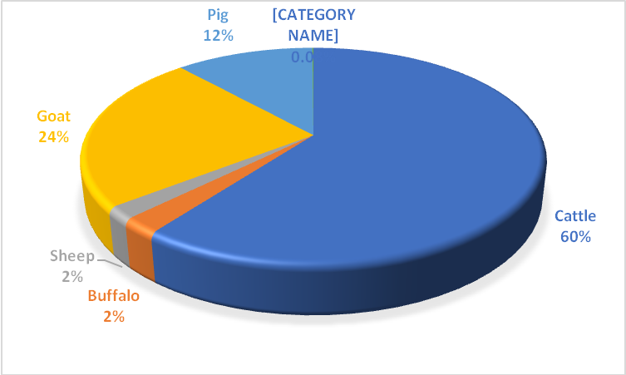
(Source: 20th Livestock Census of Assam)
Graph 1 :. Population status of indigenous breeds in Assam

