**EFFICACY OF BIORATIONALS FOR THE MANAGEMENT OF INVASIVE THRIPS, Thrips parvispinus (KARNY) UNDER SEMI FIELD CONDITIONS**

**Abstract**

The present study was conducted during Rabi, 2023, in the pot culture yard of the Department of Entomology, Annamalai University, Chidambaram, to evaluate the bio-efficacy of five different biorationals against the invasive thrips, *Thrips parvispinus* (Karny). The experiment employed a Completely Randomized Design (CRD) with seven treatments, including an untreated control and an absolute control, replicated five times. The efficacy of biorationals was assessed at 1, 3, 5, 7, and 14 days after application. All treatments significantly outperformed the control. Among the tested biorationals, five-leaf extracts (5%) and a combination of ginger, garlic, and green chili extracts (3%) demonstrated the highest efficacy, with the maximum thrips mortality percentage (61.21  
% and 60.97%, respectively). These were followed by herbal insect repellent (3%) and azadirachtin (1500 ppm). The least effective treatment was turmeric powder + lime extract (5%), which recorded a minimum mortality rate of 44.29%. The findings suggest that these eco-friendly biorationals could be potential alternatives to synthetic insecticides for managing *T. parvispinus*, emphasizing their role in sustainable pest management practices.

**Keywords: Management, botanicals, mortality, invasive thrips, No-choice assay**

**1. Introduction**

India's most important, widely cultivated, and economically significant spice crop is the chilli (*Capsicum annuum* L.) belongs to Solanaceae family [1]. Chillies are essential for enhancing the flavour, colour, and pungency of food [2]. The origin of chilli is believed to be in Mexico, with a secondary origin in Guatemala [3]. The cultivation of chilli was first brought to India by the Portuguese in the middle of the 17th century, and since then, it has expanded quickly throughout the India [4, 5]. India is the world's leading producer of chillies, followed by China and Pakistan. The main chilli-growing states in India are Andhra Pradesh, Maharashtra, Karnataka, Orissa, Tamil Nadu, Bihar, Uttar Pradesh, and Rajasthan [6]. With an annual yield of 4363 thousand metric tonnes, chilli is grown on an area of 417.82 thousand hectares in India (Reference needed where source is mentioned). In terms of producing chillies, Madhya Pradesh stands first, followed by Karnataka and Andhra Pradesh (Reference needed).

Tamil Nadu ranks fifth in the world chilli production with 13.81 thousand hectares under cultivation and 382.93 thousand metric tonnes (Reference needed). The cultivation of chilli is predominantly concentrated in the southern states, namely Andhra Pradesh, Karnataka, Maharashtra, and Tamil Nadu, which account for 75 percent of the total chilli cultivation area in India [7]. The chilli crop faces significant yield loss ranging from 50 to 90 per cent due to insect pests [8]. Around 293 insects and mite species, are directly causing damage in the field as well as during storage in chilli [9]. The major pests affecting chilli include thrips (*Scirtothrips dorsalis* Hood), yellow mites (*Polyphagotarsonemus latus* (Banks)), aphids (*Aphis gossypii* Glover), tobacco caterpillar (*Spodoptera litura* F.), and pod borer (*Helicoverpa armigera* Hubner) [10]. In India, the recent invasion of *Thrips parvispinus* (Karny) in chilli cultivation has forced farmers to abandon the crop. *T. parvispinus* (Karny) is a cosmopolitan species of quarantine importance and has been reported from Thailand to Australia [11]. The last two decades witnessed a drastic extension in the geographic distribution of   
*T. parvispinus* and besides India, it is now known to occur in France, Greece, Hawaii, Mauritius, Reunion, Spain, Tanzania, and Netherlands [12, 13]. In India, *T. parvispinus* was first reported on *Carica papaya* L. (Caricaceae) in Bengaluru [12] and later *Brugmansia* sp. (Solanaceae) and *Dahlia rosea* Cav. (Asteraceae) [14, 15]. It is also a polyphagous pest, infesting beans, eggplant, papaya, pepper, potato, shallot, and strawberry [13]. The adult thrips has been observed to gather in significant numbers on flowers, leading to extensive flower drop and causing substantial loss. A study in Indonesia found that *T. parvispinus* infestations reduced chilli yields by up to 23 per cent [16]. In India, *T. parvispinus* has caused widespread damage to chilli crops in recent years, with loss of up to 95 per cent with an average count of 18.20 thrips per flower [17]. Keeping this in view the present investigation was carried out to evaluate the different biorationals against chilli flower thrips *T. parvispinus* under semi field condition.

**2. Materials and methods**

The experiment was conducted under semi field (pot) conditions at Annamalai University, Cuddalore district, Chidambaram, Tamil Nadu to evaluate the efficiency of different biorationals against chilli flower thrips. For this experiment, Seedlings of chilli (variety CO1, 30 days old), were planted in HDPE grow bags (9’’ x 12’’). Three seedlings per bag were planted and thinned after establishment and one plant per bag was retained. No-choice assay was followed to evaluate the efficacy of five selected botanicals such as Five leaf extract (5%) (Details of this ‘five leaf extract’ needs to be mentioned hrer), Ginger, garlic & green chilli extracts (3%), Herbal insect repellent (3%) (Details of this herbal repellent needs to be mentioned here), Turmeric powder & Lime extract (5%), and Notchi, neem & green chilli extracts (5%), which were found effective against various sucking pests in earlier study [18]. At the age of 45, when the flowers initiated, the plants were covered with cylindrical mylar film cages (Fig. 1.) and infested with adults obtained from culture, using an aspirator at a rate of 50 per plant. The flowers of the chilli plants were periodically monitored for the presence of thrips. When it reached an average of 10 adults per flower, the plants were sprayed with the respective concentration of each botanical separately using an atomizer. The spray volume was 5 ml per plant. The experiments were conducted in the pot culture yard. Each treatment was replicated five times with two sprays and the experiment was conducted in *Rabi*, 2023. In all the bioassays, positive (1500 ppm azadirachtin) and absolute controls (No spray and water spray) were maintained. The post treatment observations on the mean number of thrips per plant on 1, 3, 5, 7 and 14 days after treatment (DAT) and pre count of the pest population before initiating the spray was also done. Population reduction over control was the response measured from the assays. Then the cumulative population reduction over absolute control was calculated. The efficacy of the biorationals were graded as per the scale mentioned below.

List 1 : Efficacy grading of the biorationals as per the scale

|  |  |
| --- | --- |
| **Per cent population reduction** | **Efficacy Grading** |
| 10 -20 | No Efficacy |
| 21-30 | Very Less Efficacy |
| 31-40 | Less Efficacy |
| 41-50 | Moderate Efficacy |
| 51-60 | Good Efficacy |
| 61-70 | High Efficacy |
| >71 | Very High Efficacy |

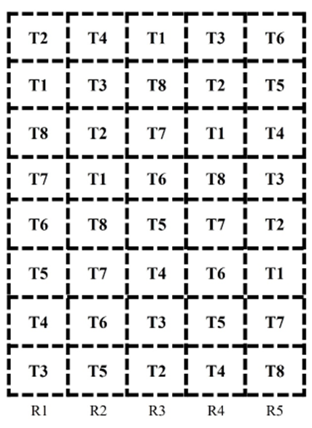 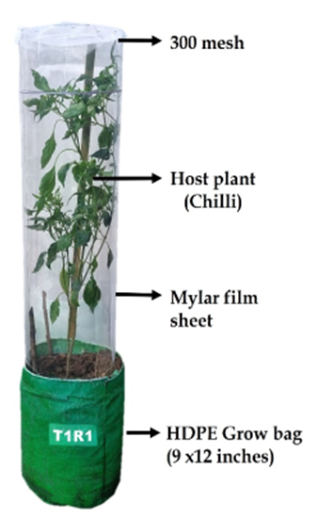

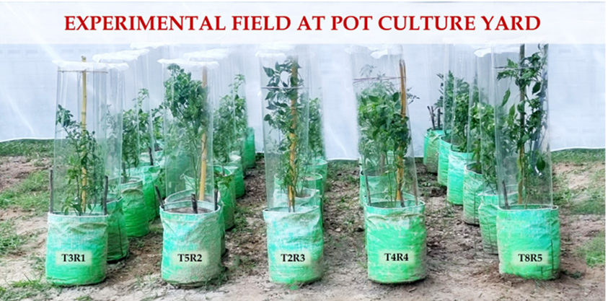

**Fig. 1. Layout and a view of efficacy studies against *T. parvispinus* on chilli**

In addition to the bio-efficacy, symptoms for phytotoxicity (leaf tip injury, wilting, vein clearing, necrosis, epinasty and hyponasty), were also recorded and rated as per the scale given below

List 2 : Symptoms for phytotoxicity rated as per the scale

|  |  |
| --- | --- |
| **Rating** | **Phytotoxicity (%)** |
| 0 | 0 (No phytotoxicity) |
| 1 | 1-10 |
| 2 | 11-20 |
| 3 | 21-30 |
| 4 | 31-40 |
| 5 | 41-50 |
| 6 | 51-60 |
| 7 | 61-70 |
| 8 | 71-80 |
| 9 | 81-90 |
| 10 | 91-100 |

**Statistical analysis**

In management studies, treatments were replicated five times and Completely Randomized Design (CRD) was performed to test for significant differences among treatments. The means of treatments were compared using the Least Significant Difference (LSD) at a probability level of 0.05 and by Duncan’s multiple range test (DMRT).

**3. Results and discussion**

**3.1 Effects of certain biorationals against *T. parvispinus* during *Rabi*, 2023**

The results on the effect of plant extracts against the invasive thrips   
(*T. parvispinus*) on Chilli (Co.1) are given in the Table 1. Before the first spray, the incidence of thrips ranged from 11.92 to 12.24 adults per flower, and statistically no significant difference among the treatments before initiation of the treatment.

**First Spray**

At 1 day after treatment (DAT), the five-leaf extract @ 5% and Ginger + garlic + green chilli extracts @ 3% recorded the lowest thrips incidence of 5.56 and 5.60 adult thrips/flower, respectively which was followed by Notchi + neem + green chilli extracts @ 5% (6.32), herbal insect repellent @ 3% (7.04), Azadirachtin @ 1500ppm (7.08), Turmeric powder + lime extract @ 5% (8.52) and untreated control (12.72). At 3 DAT, the same trend was observed and the thrips population ranged from 4.60 to 6.68 adult thrips/flower when compared to the untreated control (13.32). Similar to that of 1 DAT, the treatments with five leaf extract @ 5% and Ginger + garlic + green chilli extracts @ 3% recorded the lowest thrips incidence of 4.60 and 4.64 thrips/flower respectively, followed by Notchi + neem + green chilli extracts @ 5% (5.08). The similar effect was observed in the 5 DAT (Table 1).

At 7 DAT, thrips population gradually raised in all the treatments (Table 1). Thrips population ranged from 4.96 to 7.36 thrips/flower and when compared to the untreated control (14.12). Among the treatments lower thrips population was found in the Ginger + garlic + green chilli extracts @ 3% and five leaf extract @ 5% with the average of 4.96 and 5.00 thrips/flower, respectively. However, the highest thrips population was noticed in the Turmeric powder + lime extract @ 5% (7.36 thrips/flower) next to the untreated control (14.12). An increase in the thrips population was noticed from 7 DAT and continued up to 14 DAT. When compared to all the treatments, the overall mean population of thrips was lower in five leaf extract @ 5% (5.30 thrips/flower) and Ginger + garlic + green chilli extracts @ 3% (5.34) followed by Notchi + neem + green chilli extracts @ 5% (6.01), Azadirachtin @ 1500ppm (6.58), Turmeric powder + lime extract @ 5% (7.62) and Untreated control (13.67). It was found that all the treatments were superior to the untreated control. The efficacy grading of the first spray, the five leaf extracts @ 5% and Ginger + garlic + green chilli extracts @ 3% scored the high efficacy with the 61.21 and 60.97% percent reduction over control. Notchi + neem + green chilli extracts @ 5%, Azadirachtin @ 1500ppm and Herbal insect repellent @ 3% expressed the good efficacy. Turmeric powder + lime extract @ 5% exhibited the moderate efficacy with 44.29% percent reduction over control.

**Second spray**

Before the second spray of botanicals, the thrips incidence ranged from 7.68 to 14.48 thrips/flower (Table 2). At 1 DAT, the thrips infestation was found to be in the range of 5.52 to 14.72 thrips/flower. Among all the treatments, thrips population was lower in the Ginger + garlic + green chilli extracts @ 3% and five leaf extract @ 5% treated plants with the average of 5.52 and 5.56 thrips/flower respectively. Thrips population was found to be high in the absolute control with the average of 14.72 thrips/flower. A similar trend was observed in 3, 5 and 7 DAT.

At 14 DAT, less thrips population was observed in five leaf extract @ 5% (1.00 thrips/flower) and Ginger + garlic + green chilli extracts @ 3% (1.04) followed by Notchi + neem + green chilli extracts @ 5% (2.32), herbal insect repellent @ 3% (2.72) and Azadirachtin @ 1500 ppm (2.64). It was found that five leaf extract@ 5% and Ginger + garlic + green chilli extracts @ 3% was superior to the other treatments with the percent reduction of 78.18 and 78.13%, respectively when compared with the absolute control. The efficacy grading of the second spray, the five leaf extracts @ 5% and Ginger + garlic + green chilli extracts @ 3% scored the very high efficacy with 78.18 and 78.13% percent reduction over control. Notchi + neem + green chilli extracts @ 5%, Herbal insect repellent @ 3% and Azadirachtin @ 1500ppm scored the high efficacy with the 70.85, 67.27 and 67.61% percent reduction over control. Turmeric powder + lime extract @ 5% exhibited the good efficacy with 59.26% percent reduction over control (Table 2). The order of efficacy was Five leaf extracts @ 5% and Ginger + garlic + green chilli extracts @ 3% >Notchi + neem + green chilli extracts @ 5% > Herbal insect repellent @ 3% and Azadirachtin @1500 ppm > Turmeric powder + lime extract @ 5%.

**Phytotoxicity effect on the plants**

In addition to the efficacy, symptoms for phytotoxicity on the treated plants were observed and the data presented in Table 3. The observations indicated that Five leaf extracts @ 5%, Ginger + garlic + green chilli extracts @ 3%, Herbal insect repellent @ 3%, Turmeric powder + lime extract @ 5%, Notchi + neem + green chilli extracts @ 5%, Azadirachtin @ 1500ppm had not caused any phytotoxic symptoms like leaf tip injury, wilting, vein clearing, necrosis, epinasty and hyponasty on the chilli.

**4. Discussion**

The incidence of thrips was observed from 46 days after transplanting, when the flowering begins. Before the first biorational application, thrips incidence ranged from 11.92 to 12.24 adult thrips per flower, and there was no significant difference among the treatments. The results from Yulianti [19] stated that the *T. parvispinus* were found to predominantly infest chilli plantations in the surrounding West Java region, with an average population of 8.18–19.22 thrips/plant. The above study is in consonance with the present findings. At 1 DAT, the Five leaf extract @ 5% and Ginger + garlic + green chilli extracts @ 3% recorded the lowest thrips incidence of 5.56 and 5.60 thrips/flower, respectively which is followed by other treatments. At 3 and 5 DAT, the same trend was observed as the 1 DAT. An increase in the thrips population was noticed from 7 DAT and continued up to 14 DAT. After the first spray, the five leaf extracts @ 5% and Ginger + garlic + green chilli extracts @ 3% scored the high efficacy with the 61.21 and 60.97% percent reduction over control (Fig. 2). At 1 DAT of second spray, the thrips infestation was found to be in the range of 5.52 to 14.72 thrips/flower. Among all the treatments, thrips population was lower in the Ginger + garlic + green chilli extracts @ 3% and five leaf extract @ 5% treated plants (Fig. 2). Similar trend was observed in 3, 5, 7 and 14 DAT. After the second application, it was found that Five leaf extract @ 5% and Ginger + garlic + green chilli extracts @ 3% was scored very high efficacy and superior to the other treatments with the percent reduction of 78.18 and 78.13%, respectively (Fig. 2).

Nareshchandra [20] found that botanical extracts are highly efficient to manage the Onion thrips, *T. tabaci* in an environment friendly way without the usage of harmful pesticides. Rani and Sivaraman [21] reported that Five leaf extracts (5%) and Ginger + garlic + green chilli extracts @ 5% were effective against rice stem borer, *Scirpophaga incertulas* (Walker) with the 66.66 and 100 percent larval mortality, respectively. Praveenkumar and Kandibane [22] found that Five leaf extracts (10%) and Garlic + chilli extract extracts (5%) were effective against spotted pod borer, *M. vitrata* in blackgram. The above studies are in consonance with the present findings. Nishanthini and Kandibane [23] observed the similar effect of the Five leaf extracts (10%) and Garlic + chilli extract extracts (5%) against rice stem borer, *S. incertulas*. Padaliya *et al.* [24] and Prema *et al.* [25] evaluated the different botanical extracts, and reported a good efficacy against *Scirtothrips dorsalis* and *T. palmi* in cotton. These reports are found to support with the present findings.

**Table 1. Effects of certain botanicals against *T. parvispinus* on chilli after first spray during *Rabi*, 2023**

|  |  |  |  |  |  |  |  |  |  |
| --- | --- | --- | --- | --- | --- | --- | --- | --- | --- |
| **Sl. No.** | **Treatment** | **Number of adult thrips/flowers/plant** | | | | | | **Mean** | **Percent reduction over control** |
| **PTC** | **1 DAT** | **3 DAT** | **5 DAT** | **7 DAT** | **14 DAT** |
| T1 | Five leaf extracts @ 5% | 11.92 (3.45) | 5.56 (2.36)a | 4.60 (2.14)a | 3.60 (1.90)a | 5.00 (2.24)a | 7.76 (2.79)a | 5.30 | 61.21 |
| T2 | Ginger + garlic + green chilli extracts @ 3% | 12.04 (3.47) | 5.60 (2.37)a | 4.64 (2.15)a | 3.80 (1.95)a | 4.96 (2.23)a | 7.68 (2.77)a | 5.34 | 60.97 |
| T3 | Herbal insect repellent @ 3% | 12.20 (3.49) | 7.04 (2.65)c | 5.56 (2.36)c | 5.04 (2.24)c | 6.08 (2.47)c | 9.32 (3.05)c | 6.61 | 51.67 |
| T4 | Turmeric powder + lime extract @ 5% | 12.04 (3.47) | 8.52 (2.92)d | 6.68 (2.58)d | 5.64 (2.37)d | 7.36 (2.71)d | 9.88 (3.14)d | 7.62 | 44.29 |
| T5 | Notchi + neem + green chilli extracts @ 5% | 11.96 (3.46) | 6.32 (2.51)b | 5.08 (2.25)b | 4.44 (2.11)b | 5.48 (2.34)b | 8.72  (2.95)b | 6.01 | 56.06 |
| T6 | Azadirachtin @ 1500ppm | 12.12 (3.48) | 7.08 (2.66)c | 5.64 (2.37)c | 5.00 (2.24)c | 5.96 (2.44)c | 9.20 (3.03)c | 6.58 | 51.90 |
| T7 | Untreated control  (water spray) | 12.20 (3.49) | 12.64 (3.56)e | 13.28 (3.64)e | 13.68 (3.70)e | 14.04 (3.75)e | 14.40 (3.79)e | 13.61 | 0.47 |
| T8 | Absolute control | 12.24 (3.50) | 12.72 (3.57)e | 13.32 (3.65)e | 13.72 (3.70)e | 14.12 (3.76)e | 14.48 (3.81)e | 13.67 | - |
| SE.d | | NS | 0.03 | 0.04 | 0.04 | 0.03 | 0.03 |  | |
| CD (P=0.05) | | NS | 0.05 | 0.09 | 0.07 | 0.06 | 0.06 |
| CV | | NS | 1.39 | 2.48 | 2.22 | 1.66 | 1.43 |

* DAT – Days after Treatment; PTC – Pre-treatment count

Values in parentheses are square root transformed values.

Values with different alphabets differ significantly

**Table 2. Effects of certain botanicals against *T. parvispinus* on chilli after second spray during *Rabi*, 2023**

|  |  |  |  |  |  |  |  |  |  |
| --- | --- | --- | --- | --- | --- | --- | --- | --- | --- |
| **Sl. No.** | **Treatment** | **Number of adult thrips/flowers/plant** | | | | | | **Mean** | **Percent reduction over control** |
| **PTC** | **1 DAT** | **3 DAT** | **5 DAT** | **7 DAT** | **14 DAT** |
| T1 | Five leaf extracts @ 5% | 7.76 (2.79) | 5.56 (2.36)a | 4.08 (2.02)a | 2.88 (1.70)a | 1.84 (1.36)a | 1.00 (1.00)a | 3.07 | 78.18 |
| T2 | Ginger + garlic + green chilli extracts @ 3% | 7.68 (2.77) | 5.52 (2.35)a | 3.96 (1.99)a | 2.92 (1.71)a | 1.96 (1.40)a | 1.04 (1.02)a | 3.08 | 78.13 |
| T3 | Herbal insect repellent@ 3% | 9.32 (3.05) | 7.24  (2.69)c | 5.48 (2.34)c | 4.08 (2.02)c | 3.52 (1.88)c | 2.72 (1.65)c | 4.61 | 67.27 |
| T4 | Turmeric powder + lime extract @ 5% | 9.88 (3.14) | 8.52 (2.92)d | 7.64 (2.76)d | 5.64 (2.37)d | 3.80 (1.95)d | 3.08 (1.75)d | 5.74 | 59.26 |
| T5 | Notchi + neem + green chilli extracts @ 5% | 8.72 (2.95) | 6.76 (2.60)b | 4.92 (2.22)b | 3.76 (1.94)b | 2.76 (1.66)b | 2.32 (1.52)b | 4.10 | 70.85 |
| T6 | Azadirachtin @ 1500ppm | 9.20 (3.03) | 7.20  (2.68)c | 5.44 (2.33)c | 4.00 (2.00)c | 3.52 (1.88)c | 2.64 (1.62)c | 4.56 | 67.61 |
| T7 | Untreated control  (water spray) | 14.40 (3.79) | 14.68 (3.83)e | 13.28 (3.64)e | 13.64 (3.69)e | 14.08 (3.75)e | 14.40 (3.79)e | 14.02 | 0.45 |
| T8 | Absolute control | 14.48 (3.81) | 14.72 (3.84)e | 13.36 (3.66)e | 13.72 (3.70)e | 14.12 (3.76)e | 14.48 (3.81)e | 14.08 | - |
| SE.d | | 0.03 | 0.04 | 0.04 | 0.03 | 0.03 | 0.04 |  | |
| CD (P=0.05) | | 0.06 | 0.08 | 0.09 | 0.06 | 0.06 | 0.08 |
| CV | | 1.43 | 2.00 | 1.92 | 2.06 | 2.26 | 3.32 |

* DAT – Days after Treatment; PTC – Pre-treatment count

Values in parentheses are square root transformed values.

Values with different alphabets differ significantly

**Table 3. Phytotoxicity studies on the botanical extracts on chilli during *Rabi*, 2023**

|  |  |  |  |  |  |  |  |
| --- | --- | --- | --- | --- | --- | --- | --- |
| **SI.**  **No.** | **Treatments** | **Phytotoxicity rating \***  **(*Rabi,* 2023)** | | | | | |
| **LTI** | **W** | **VC** | **N** | **E** | **H** |
| 1. | Five leaf extracts @ 5% | 0 | 0 | 0 | 0 | 0 | 0 |
| 2. | Ginger + garlic + green chilli extracts @ 3% | 0 | 0 | 0 | 0 | 0 | 0 |
| 3. | Herbal insect repellant @ 3% | 0 | 0 | 0 | 0 | 0 | 0 |
| 4. | Turmeric powder + lime extract @ 5% | 0 | 0 | 0 | 0 | 0 | 0 |
| 5. | Notchi + neem + green chilli extracts @ 5% | 0 | 0 | 0 | 0 | 0 | 0 |
| 6. | Azadirachtin @ 1500ppm | 0 | 0 | 0 | 0 | 0 | 0 |
| 7. | Untreated control  (water spray) | 0 | 0 | 0 | 0 | 0 | 0 |
| 8. | Absolute control | 0 | 0 | 0 | 0 | 0 | 0 |

* LTI- Leaf tip injury, W- Wilting, VC- Vein clearing, N- Necrosis,   
E- Epinasty, H- Hyponasty

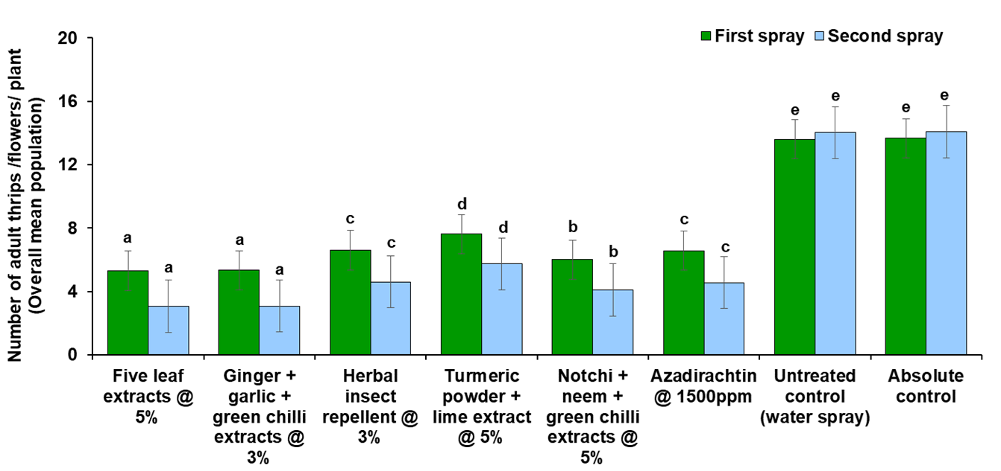

**Fig 2. Effect of botanicals against *T. parvispinus* on chilli during *Rabi,* 2023**

**5. Conclusion**

The present study demonstrates the efficacy of various biorational treatments in managing *T. parvispinus* on chilli (CO 1) under pot culture conditions. Among the tested treatments, five leaf extract @ 5% and Ginger + garlic + green chilli extracts @ 3% consistently exhibited superior thrips suppression, achieving the highest percent reduction over the untreated control in both sprays. Notchi + neem + green chilli extracts @ 5%, Azadirachtin @ 1500 ppm, and Herbal insect repellent @ 3% also showed significant efficacy, while Turmeric powder + lime extract @ 5% provided moderate control. Importantly, none of the treatments caused phytotoxic effects, indicating their safety for plant health. The findings highlight the potential of these plant-based formulations as effective, eco-friendly alternatives to chemical insecticides for the sustainable management of *T. parvispinus*. Further field validation is recommended to confirm their efficacy under different agro-climatic conditions and optimize application strategies for integrated pest management (IPM) programs.

**DISCLAIMER (ARTIFICIAL INTELLIGENCE)**

Author(s) hereby declare that NO generative AI technologies such as Large Language Models (ChatGPT, COPILOT, etc) and text-to-image generators have been used during writing or editing of manuscripts.

**References**

1. Kumar, S. and Rai, M. (2005). Chilli in India. Chilli and Pepper Institute Newsletter (XXII), pp. 1-3.

2. Dagnoko, S., Yaro-Diarisso, N., Sanogo, P. N., Adetula, O., Dolo-Nantoumé, A., Gamby-Touré, K., ... and Diallo-Ba, D. (2013). Overview of pepper (*Capsicum* spp.) breeding in West Africa. *African Journal of Agricultural Research*, **8***(13)*: 1108-1114.

3. Hancock, J. F. (2022). Dispersal of New World Crops into the Old World. In *World Agriculture Before and After 1492: Legacy of the Columbian Exchange* (pp. 111-133). Cham: Springer International Publishing.

4. Smith, S. H. (2015). In the shadow of a pepper-centric historiography: Understanding the global diffusion of capsicums in the sixteenth and seventeenth centuries. *Journal of Ethnopharmacology*, **167**: 64-77.

5. Mukharji, P. B. (2020). Historicizing “Indian Systems of Knowledge” Ayurveda, Exotic Foods, and Contemporary Antihistorical Holisms. *Osiris*, **35***(1)*: 228-248.

6. Srinivasarao, C. H., Rao, K. V., Gopinath, K. A., Prasad, Y. G., Arunachalam, A., Ramana, D. B. V., ... and Mohapatra, T. (2020). Agriculture contingency plans for managing weather aberrations and extreme climatic events: Development, implementation and impacts in India. *Advances in Agronomy*, **159**: 35-91.

7. MoA and FW. (2022). Area and Production of Horticulture crops for 2020-21 (3rd Advance Estimates).

8. Kumar, N. K. (1995). Yield loss in chilli and sweet pepper due to *Scirtothrips dorsalis* Hood (Thysanoptera: Thripidae). *Pest Management in Horticultural Ecosystems*, **1***(2)*: 61-69.

9. Butani, D. K. (1976). Pest and diseases of Chillies and their control. *Pesticides*, **10**: 38-41.

10. Kumar, K. P., Reddy, D. J. and Narendranath, V. V. (2001). Bio-efficacy of selected insecticides against pest complex in chilli (*Capsicum annuum* L.). *Pesticide Research Journal*, **13***(1)*: 36-41.

11. Mound, L. A. and Collins, D. W. (2000). A South East Asian pest species newly recorded from Europe: *Thrips parvispinus* (Thysanoptera: Thripidae), its confused identity and potential quarantine significance. *European Journal of Entomology*. **97***(2)*: 197–200.

12. Tyagi, K., Kumar, V., Singha, D. and Chakraborty, R. (2015). Morphological and DNA barcoding evidence for invasive pest thrips, *Thrips parvispinus* (Thripidae: Thysanoptera), newly recorded from India. *Journal of Insect Science*, **15***(1)*: 105.

13. The Netherlands Plant Protection Organization (NPPO). (2019). *Thrips parvispinus*, Quick scan, QS.Ent., 001.

14. Rachana, R. R., Roselin, P. and Varadharajan, R. (2018). Report of Invasive thrips species *Thrips parvispinus* (Karny) (Thripidae: Thysanoptera) on *Dahlia rosea* (Asteraceae) in Karnataka. *Pest Management in Horticultural Ecosystems*, **24***(2)*: 175-176.

15. Roselin, P., Sharma, K. and Rachana, R. R. (2021). Diversity of floral thrips from Western Ghats of Karnataka. *Indian Journal of Entomology,* **83***(3)*: 407–410.

16. Johari, A., Herlinda, S., Pujiastuti, Y., Irsan, C. and Sartiami, D. (2014). Morphological and genetic variation of *Thrips parvispinus* (Thysanoptera: Thripidae) in chilli plantation (*Caspicum annuum* L.) in the lowland and highland of Jambi Province, Indonesia. *American Journal of BioScience*, **2**: 17–21.

17. Rachana, R. R., and Shylesha A. N. (2022). Pest Alert: Invasive thrips, *Thrips parvispinus* (Karny) threatening chilli cultivation in India.

18. Ranjith, R. (2021). *Revitalization of indigenous Insecticidal formulations*. Doctoral Thesis, Annamalai University, Annamalainagar, Chidambaram, India. pp. 139.

19. Yulianti, P. (2008). Species Thrips (Ordo: Thysanoptera) pada Tanaman Cabai dan Tanaman Sekitarnya di Jawa Barat.

20. Nareshchandra, S. J. (2016). *Evaluation of botanical extracts against thrips (Thrips tabaci lindeman) infesting garlic* (Doctoral dissertation, M. Sc. Thesis, Hort. Entom., Navsari Agric. Univ., Navsari, Gujarat).

21. Rani, T. and Sivaraman, A. (2019). Studies on the insecticidal efficacy of certain botanicals against rice stem borer *Scirpophaga incertulas* (Walker). *Journal of Pharmacognosy and Phytochemistry*, **8***(2S)*: 557-559.

22. Praveenkumar, C. and Kandibane, M. (2022). Bioefficacy of Botanical extracts against Blackgram Borer Pests and Safety to their Natural Enemies. *Biological Forum – An International Journal*, **14***(4a)*.

23. Nishanthini, K. and Kandibane, M. (2022). Efficacy of Botanical Extracts Against Rice Stem Borer, *Scirpophaga incertulas* (Walker). *Indian Journal of Entomology* **84***(2)*: 363-367.

24. Padaliya, S. R., Thumar, R. K., Pipaliya, G. K. and Bhagora, J. K. (2018). Bio-efficacy of different botanicals against Thrips, *Scirtothrips dorsalis* Hood infesting Bt cotton. *International Journal of Current Microbiology and Applied Sciences*, **7***(7)*: 2893-2903.

25. Prema, M. S., Ganapathy, N., Renukadevi, P., Mohankumar, S. and Kennedy, J. S. (2018). Efficacy of different botanical extracts on *Thrips palmi* in cotton. *Journal of Pharmacognosy and Phytochemistry*, **7***(2)*: 2824-2829.