**Histopathological investigation on *Puntius sophore* affected by Epizootic Ulcerative Syndrome**

**Abstract**

Histopathological investigation of *Puntius sophore* (commonly known as the pool barb) affected by Epizootic Ulcerative Syndrome (EUS) would typically reveal a range of pathological changes in the tissues, particularly in the skin, muscle, and internal organs. EUS is a disease caused by the oomycete *Aphanomyces invadans*, which leads to severe ulcerative lesions in fish. The histological analysis of the afflicted *Puntius sophore* was the main aim of this investigation. During the one-year study period, the putative fungus was detected from 228 EUS-infected fish samples using established techniques for isolation, culture, and identification. The EUS outbreak was visible in the muscle, liver, and kidney sections of infected fish samples. Granulomatous and inflammatory tissues replaced underlying muscles whereas the epidermis is completely lost.

1. **INTRODUCTION**

Epizootic ulcerative syndrome (EUS), which involves certain bacteria and fungi in its later phases and likely some viruses as well, is the most deadly of the complicated diseases that affect fish (Chinabut, 1995). This disease was first noticed in 1972 in Australia (Chattopadhyay et al., 1990) and Southeast-Asia (Rodgers and Burke, 1981). EUS is believed to have entered India in 1988 and since then has been causing large-scale mortalities in both freshwater and brackish water fish (Das and Das, 1993). It was believed that a different environmental factors and diverse group of organisms were responsible for these diseases since the symptoms differed with each outbreak. The *Aphanomyces* infection that grows fast caused necrotising ulcerations and granulomatosis was identified as the seasonal epizootic disease for freshwater and estuaries warm water fish with a variety of viral aetiologies (DFID, 1994). The causative agents, also known as *A. invadans* or *A. piscida*, were once again discovered during the Fifth Colloquium on Diseases in Asian Aquaculture in Australia. Furthermore, lesions induced by EUS are usually associated with gram-negative bacteria, whereas severe outbreaks are also associated with parasites and *Rhabdo* viruses. (OIE, 2013; FAO, 2009). According to Miyazaki and Plumb (1985), the illness can impact the afflicted fish's kidney, liver, spleen, and brain. EUS currently affects 130 fish species across 26 countries (Pradhan et al. 2018).

As a component of our cultural legacy, the fishing and aquaculture industries are crucial to India's socioeconomic development. Many rural fish farmers in India have turned to fish farming as a secondary source of income in order to meet the country's per capita protein needs. The majority of people engage in fish farming as a way to enhance their socioeconomic status through pond farming. Large-scale fish production has increased as a result of intensive fish rearing, utilising elevated densities of stockings, fertiliser and feed substitutes, and chemotherapeutic agent treatment. Additionally, it led to physiological stress and a higher chance of an outbreak of illness (Pillay 1996; McLean 1996). In addition, people are less likely to undertake aquaculture because of the elevated chance of infections, particularly EUS outbreaks, and their ignorance on fish illnesses (Callinan et al. 1999).

The infection typically began as numerous inflamed red patches on the body, resulting in localised haemorrhage, during the disease's first stage. A dark melanistic rim resulted from the ulcers being deep, hemorrhagic, and necrotic in the later stage. These were discovered in all areas of the fish's body in the latter stages, primarily in the head, abdomen, and peduncle. During the first outbreak of EUS, Pal and Pradhan (1990) noticed a red patch on the scaleless fish's skin, and later on, ulcers severely formed on the underlying muscle layer. More research is needed to fully understand the role of the different environmental risk factors that cause EUS, as outbreaks of the disease occur cyclically when temperatures drop, particularly after autumn, minimal alkalinity, and pH variations in Asia Pacific regions (Roberts et al. 1986; Pradhan et al. 2014). Thus, using histological findings of the muscles, livers, and kidneys of fish samples gathered from Darbhanga rural areas, the study seeks to report EUS.

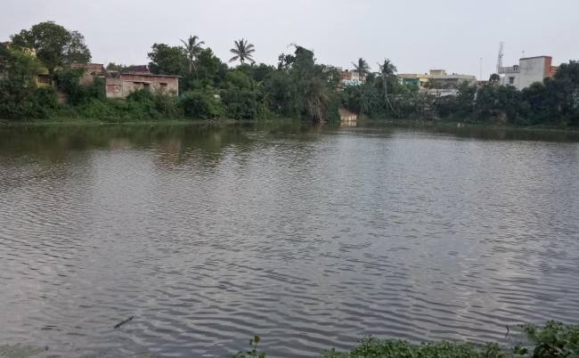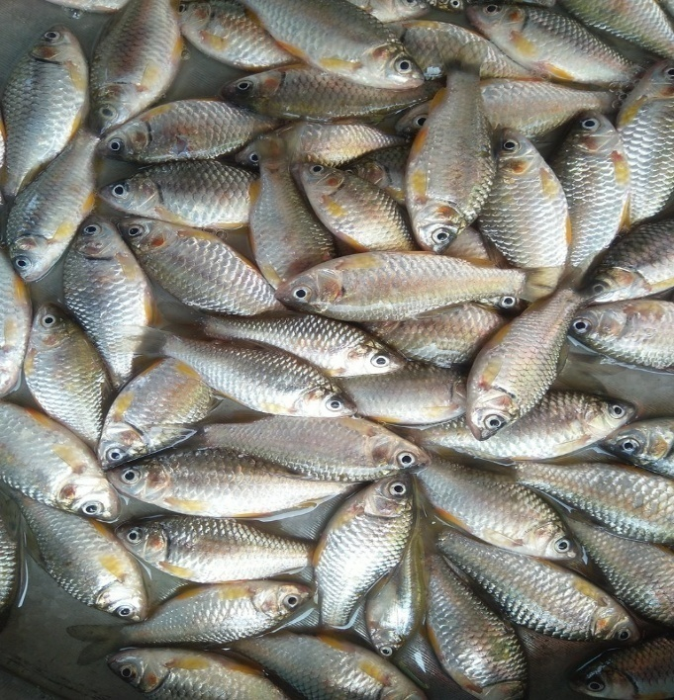

**Figure 1: Showing Dihlahi pond, Darbhanga**

1. **MATERIALS AND METHODS**
   1. **Study area**

In the Mithilanchal region, Dihlahi pond, Darbhangawas selected and collected *Puntius sophore* fish from this site for study (Figure 1).

* 1. **Collection of fish**

For this investigation, the fish *Puntius sophore* (commonly known as pothia) was selected. *Puntius sophore* is commonly found in ditches, marshes, paddy fields, and waterlogged areas. Fish species, both healthy and sick, were collected with the help of fishermen and kept in various aquariums with pond water. The fish impacted by the EUS were kept in the lab for 26 hours to allow them to acclimatize to the conditions. After that, these fish were used in studies. The fish that were found to be impacted by the EUS were carefully placed under investigation before they perished because they could not survive after ninety-six hours.

* 1. **Fungal isolation**

Fungal isolation was done using the techniques outlined by Chinabut and Roberts (1999). In fish, the scales surrounding the edges of the somewhat ulcerated lesions were removed and using a red-hot spatula, the underlying skin of sick fish was seared to sterilise the surface. Once the superficial tissues were cut, the underlying muscles of the lesion were visible. The tissue were excised into 4 mm pieces and placed on Petri dishes with glucose peptone (GP) treated media. Until the cultures were clear of bacterial contamination, the developing hyphal tips were regularly moved to new GP plates that contained antibiotics. For sporulation of fungus, an agar plug was used containing growing mycelium in a Petri dish. This petri dish (Containing GPY broth) was incubated at 200C for four days. After that, the mat was sequentially transferred through five Petri dishes filled with autoclaved pond water and kept at 20ºC for whole night. Under a microscope, motile secondary zoospores were seen after 12 hours. On a sterile glass slide, a sample of ulcerated tissue was taken and spread. Lactophenol cotton blue was used to stain the smear, which was then examined under a microscope. Following cotton blue staining, the sporangium and fungal hyphae from the isolated cultures maintained in GPYA were examined under a microscope (OIE 2013). After microscopic observation, the affected parts of the tissue were cut into smaller pieces (one cubic centimeter) and preserved in aqueous Bouin's fluid fixative. The fixed normal and infected tissues were further processed using standard histological techniques. The paraffin sections were cut at 5-7 microns and stained with haematoxylin-Eosin(H-E) stain, GMS And PAS stain.

* 1. **Pathogenicity test**

Newly developed hyphae were seen using a microscope after 6 hours of incubation at 22–27°C. The development of the hyphal tips was regularly observed, and after a day, they were transferred. Following several transfers, the pure culture was acquired and subsequently moved to GPA and GPYA for regular upkeep.

The presence of branched, aseptate fungal mycelium was visible under a microscope in all samples of cotton blue-stained ulcer tissue. The fungal mycelium isolate that developed on GPA and GPYA had a smaller, branching, aseptate that resembled those found in ulcer tissue. The presence of terminal zoosporangia, which have a single row of zoospores, was also shown.

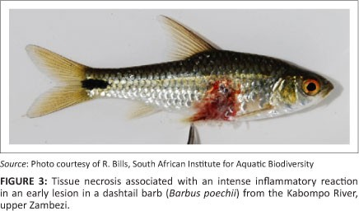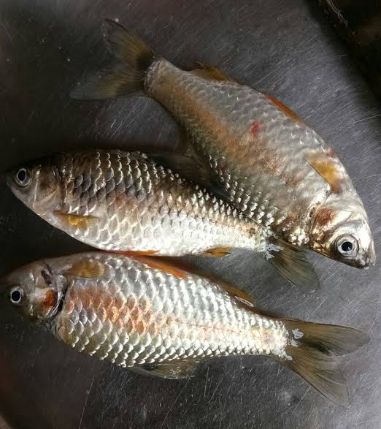

**Figure 2: Showing necrosis associated with a EUS affected fish *Puntius sophore*.**

1. **RESULT**
   1. **Histopathological observations of diseased fish**

In histopathological examinations, the fish samples infected with *Aphanomyces* sp. had EUS in their muscles, livers, and kidneys (Fig 2 and 3). Fungal hyphae shown in figure 4 and myonecrosis indicated the presence of *Aphanomyces* sp. Additionally evident shows the complete loss of the epidermis and the underlying muscle, which had been replaced by inflammatory and granulomatous tissues. In *Puntius sophore* granulomatous and inflammatory tissues replaced the epidermis and muscle in a portion of advanced lesions’ histology. Fungal hyphae that are darkly tinted with GMS and necrosis are commonly seen in a variety of locations. The presence of fungus is also visible in the H-E stained section. Degenerative alterations and blood capillary infiltration are visible in the liver region. While no fungi were found, several regions showed necrotic alterations, a chord-like configuration with expanded sinusoids, and extensively vacuolated liver cells. There are several areas of necrotic alterations and haemorrhages in the kidney portion. Although tubular degeneration and tubular cell vacuolation are visible, there is no indication that fungi are present.

***Puntius sp***. The epidermal layer was completely absent from the ulcerated area, and the usual structure of the dermal layer was replaced by granulomas. In the dermis, many non-septate fungal hyphae are visible (Fig. 3A). Vacuolation was seen in the hepatocytes in the liver section of the infested *Puntius* sp. Certain areas also exhibit blood capillary infiltration (Fig. 3B). It is possible to see haemorrhages in some kidney parts. There were no hyphae of the fungus found. Moreover, tubular rupture, tubular necrosis, and tubular cell vacuolation are visible (Fig. 3C).

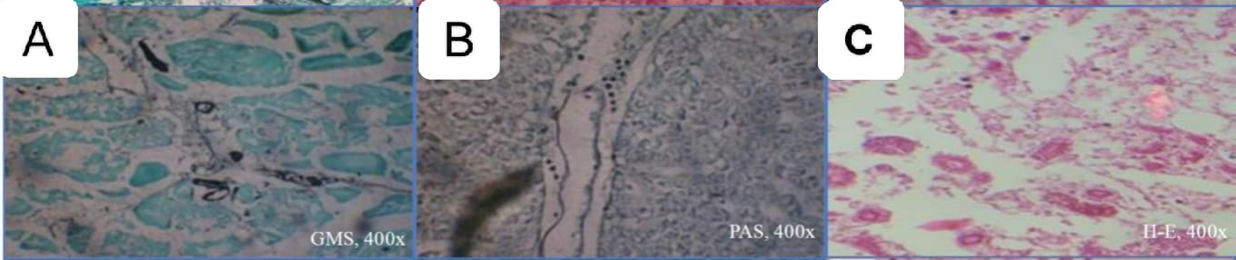

**Figure 3: Showing Histological observations of (A) ulcer, (B) liver and (C) kidneys of diseased *Puntius sp.***

Figure 4 Displays the primary zoospores that were discovered within the zoosporangia. The fungal isolates did not grow at 37°C, although they did grow slowly in culture conditions between 25 and 30°C. *Aphanomyces* sp. was recovered from the ulcerous areas of *Puntius* sp. and was exclusively found in muscle samples.

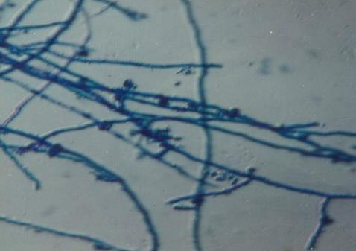

Figure 4: Showing zoosporangia of *Aphanomyces invandans sp.* from naturally infected *Puntius sp*.

**Table No 1:** **Effect of EUS infection on erythrocyte and leucocytes numbers and haemoglobin concentration of *Puntius sp*. in winter season to onset of monsoon.**

|  |  |  |
| --- | --- | --- |
| **Parameters** | **Normal fish** | **EUS Infected Fish** |
| Weight of animal (gm) | 60±10.5 | 70±5.7 |
| Erythrocyte No (106/mm³) | 2.28±0.88 | 1.481±0.89 |
| Leucocytes No. (104/mm³) | 6.78±0.4 | 8.3±0.7 |
| Plasma haemoglobin (mg/100 ml ) | 21.53±0.58 | 218.51±58.7 |

**(±= Standard error n=4 animals in each group)**

**3.2 Hematological observations of diseased fish**

Studies were conducted to document the impact of EUS infection on the hematological characteristics of carp, *Punctius* species. Both the total leucocyte count and plasma hemoglobin levels showed a marked increase (Table 1).The percentage of neutrophils and eosinophils also showed an upward trend. However, in the fish impacted by EUS, the concentration of blood hemoglobin, erythrocyte counts, packed cell volume, haemotocrit percentage, and total non-globulocyte dramatically decreased. Lower hemoglobin levels, extra and intravascular red blood cell destruction, an increase in immature erythrocytes, irregular and centrally located nuclei, nuclear and cytoplasmic vacuoles, and polychromatic mature erythrocytes were among the pathological features seen in the erythrocytes of an infected fish. There was no discernible pattern among basophiles. In comparison to normal fish, EUS-affected fish were shown to have higher MCV values and higher MCH and MCHC values. According to experimental research, fish became anemic in January (peak winter) and their erythrocyte counts showed declining patterns. In January, the hemoglobin levels also trended downward; however, a slow but noticeable increase in value was observed thereafter. The PCV value was seen to drop until January, when the minimal value was reached. The hematological tests conducted for this study made it abundantly evident that these tests would be useful for diagnosing EUS-infected fish.

1. **DISCUSSION**

Histopathology is a crucial diagnostic technique for illnesses. A microbial agent must first penetrate the host in order to proliferate and infiltrate the host's essential organs. Granuloma, myonecrosis, and epidermal loss were found in the ulcerated muscles of EUS infected *Puntius sp*. along with a number of non-septate hyphae. (Fig 3 A). However, no fungal hyphae were found in the liver and kidney sections. Sections of *Puntius* liver displayed degenerative alterations and necrotic changes, as well as enlarged sinusoids and vacuolated hepatic cells. These changes were more or less identical to one another (Fig. 3 B). Similar pathological alterations, such as tubular rupture and necrosis, tubular cell vacuolation, and haemorrhages, were also seen in kidney sections (Fig. 3 C). A histological study by Vishwanath et al. (1998) found that the fungus invades and grows in tissues away from the dermal ulcer regions, and even penetrates the spinal septum, indicating that fungal invasion and associated diseases are not restricted to the regions where cutaneous ulcers originate. All visceral organs develop mycotic granulomas when fungus invades the body cavity. Chinabut et al. (1995) noted that mycotic epithelioid granulomas developed as a result of infections of the muscular tissues. However, in the European catfish experiment, these granulomas are not necessarily linked to the infection (Oidtmann et al. 2008). A morphologically distinctive fungus was found inside the lesion of fish with EUS in numerous Southern Asian nations, according to a survey conducted by Roberts et al. (1993). When mycelium from pathogenic samples of *Aphanomyces* sp. was inoculated below the dermis of healthy fish, it caused an inflammatory response that spread into the tissues, resulting in brutal myonecrosis with a profound epithelial impact.

When Roberts et al. (1989) examined the early lesions of EUS outbreaks in Indian major carp cultures, they discovered acute myopathy that was more severe than what is typically observed in wild fish and that spread over a large area beneath the active skin lesion. The epidermis at the ulcer's margin was thickened and degenerate, and the epithelioid capsule contained a very small number of fungal hyphae. The dermal blood arteries were extremely hyperemic, and some of them had collar of myeloid or lymphoid cells, which could be linked to a virus infection even if no viral inclusion bodies were found. In 1998, Lilley et al. reported the advanced lesions of fish infected with EUS and noted severe necrotising granulated mycosis of the underlying muscle cells, involving the distinctive growing aseptate, invasive fungal mycelium.

There is a wealth of research on the effects of bacterial, fungal, parasitic and viral infections on fish haematological parameters. Many researchers found that there is a decrease in erythrocyte count of infected fish and the presence of immature and abnormal erythrocytes caused by EUS. According to reports by Das et al., (1993), Pathiratne et al., (1999), and Qureshi et al., (2001), fish with mild or advanced lesions had considerably higher leukocyte counts than in healthy fish (Table 1).

1. **CONCLUSIONS**

The histopathological findings in *Puntius sophore* affected by EUS are characterized by severe ulcerative lesions, necrosis, granulomatous inflammation, and the presence of fungal-like hyphae. These changes are indicative of a severe inflammatory response to the infection by *Aphanomyces invadans*. The haematological studies found that there is a decrease in erythrocyte count, and increase in leukocyte and Plasma haemoglobin in EUS infected fish. The disease can lead to significant morbidity and mortality in affected fish populations of Dihlahi Pond.

**REFERENCES**

ADB/NACA. 1991. Fish Health Management in Asia- Pacific [Report]. Series No.1 ADB Agriculture Department Network of Aquaculture Centers in Asia- Pacific, Bangkok., Thailand.

ADB/NACA. 1995. Shrimp and carp sustainability. Regional study and workshop on aquaculture sustainability and the environment. Regional shrimp and carp summary data, P 491.

Afzali, S. F., Hassan, M. D., Abdul-Rahim, A. M., Sharifpour, I. and Sabri, J. 2013. Isolation and identification of Aphanomyces species from natural water bodies and fish farms in Selangor, Malaysia. Malaysian Applied Biology 42:21–31.

Bhowmick, U., Pandit, P. K. and Chatterjee, J. G. 1991. Impact of epizootic ulcerative syndrome on the fish yield, consumption and trade in West Bengal. Journal of Inland Fishery Society India 23:45–51.

Blazer,V. S., Vogelbein, W. K., Densmore, C. L., May, E. B., Lilley, H. J. and Zwerner, D. E. 1999. Aphanomyces as a cause of ulcerative skin lesions of Menhaden from Chesapeake Bay Tributaries. Journal of Aquatic Animal Health 11:340–349.

Callinan, R. B., Chinabut, S., Mohan, C. V. and Lilley, J. H. 1999. Report of EUS Extension Visits to Nepal, India and Sri Lanka, 7-20 June 1999. Australian Centre for International Agricultural Research and Department for International Development, p 32.

Callinan, R.B., Pacilibare, J.O.,Bondad-reantaso, M.G. and Gogolewski, R.P. 1995a. Aphanomyces species associated with epizootic ulcerative syndrome (EUS) in the Philippines and red spot disease (RSD) in Australia: preliminary comparative studies. Disease of Aquatic Organisms 21:233–238.

Callinan, R. B., Paclibare, J. O., Reantaso, M. B., LumanlanMayo, S. C., Fraser, G. C. and Sammut, J. 1995b. EUS outbreaks in estuarine fish in Australia and the Phillipines: associations with acid sulphate soils, rainfall and Aphanomyces. In Shariff, M. Arthur, J.R. and R.P. Subashinghe (Eds.) Diseases of Asian Aquaculture II (Manila. Fish Health Section, Asian Fisheries Society, pp 291–298.

Chattopadhyay, D. Pal, M.S. Das, S. Das and R.N. Pal, 1990. The National Workshop on Ulcerative Disease Syndrome in Fish. Technical papers Ministry of Agriculture, Govt. of India.

Chinabut, S. and Roberts, R. J. 1999. Pathology and histopathology of epizootic ulcerative syndrome (EUS). Aquatic Animal Health Research Institute, Department of Fisheries, Bangkok, p 33.

Chinabut, S., Roberts, R. J., Willoughby, G. R. and Pearson, M. D. 1995. Histopathology of snakehead, Channa striatus (Bloch), experimentally infected with the specific Aphanomyces fungus associated with epizootic ulcerative syndrome (EUS) at different temperatures. Journal of Fish Diseases 18:41–47.

Chinabut, S. 1995. Epizootic ulcerative syndrome: the current state of knowledge. In: Shariff, M. Arthur, J.R. and R.P. Subashinghe (Eds.) Diseases in Asian Aquaculture Vol. II. (Manila, Philippines. Fish Health Section, Asian Fisheries Society, pp 285–290.

Das, M. K. and R. K. Das, 1993. A review of the fish disease epizootic ulcerative syndrome in India. Environment and Ecology, 11: 134-145.

David, J. C. and Kirk, P. M. 1997. Index of Fungi. 6:706.

DFID. 1994. Proceedings of the regional seminar on epizootic ulcerative syndrome.25-27 Jan, 1994. The Aquatic Animal Health Research Institute, Bangkok.

Egusa, S. and Masuda, N. 1971. A new fungal disease of Plecoglossusaltivelis. Fish Pathology 6:41–46.

FAO. 2009. Report of the International Emergency Disease Investigation Task Force on a Serious Finfish Disease in Southern Africa, 8–26 May 2007. Food and Agriculture Organization of the United Nations, Rome.

Jhingran, A. G. and Das, M. K. 1990. Epizootic ulcerative syndrome in fishes. [Newsletter] Bull. No. 65. Central Inland Capture Fisheries Research Institute, Barrackpore, India. Journal of Fish Diseases 20:135–144.

Lilley, J. H., Thompson, K. D. and Adams, A. 1997b. Characterization of Aphanomyces invadans by electrophoretic and Western blot analysis. Disease of Aquatic Organisms 30:187–197.

Lilley, J. H., Hart, D., Richards, R. H., Roberts, R. J.,Cerenius, L. and Söderhäll, K. 1997a. Pan-Asian spread of single fungal clone results in large scale fish –kills. Veterinary Record 140:653–654.

Lilley, J. H., Callinan, R. B. and Khan, M. H. 2002. Social, economic and biodiversity impacts of epizootic ulcerative syndrome (EUS). In: Arthur, J. R., Phillips, M. J., Subasinghe, R. P., Reantaso, M. B. and Rae, H. M. (Eds.) Primary Aquatic Animal Health Care in Rural, Smallscale, Aquaculture Development (Vol. Tech. Pap. No.406). pp 127-139.

Lilley, J. H., Callinan, R. B., Chinabut, S., Kanchanakhan, S., Macrae, I. H. and Phillips, M. J. 1998. Epizootic Ulcerative Syndrome (EUS) Technical Hand book. The Aquatic Animal Health Research Institute (AAHRI) Bangkok, P 88.

Lilley, J. H., Hart. D., Panyawachira,V., Kanchanakhan, S Chinabut, S., Soderhall, K. and Cerenius, L. 2003. Molecular characterization of fish pathogenic fungus Aphanomyces invadans. Journal of Fish Diseases 26:263– 275.

Lumanlan-Mayo, S. C., Callinan, R. B., Paclibare, J. O., Catap, E. S. and Fraser, G. C. 1997. Epizootic ulcerative syndrome (EUS) in rice-fish culture systems: an overview of field experiments 1993-1995. In: Flegel, T.W. and MacRae, I.H. (Eds.) Disease in Asian aquaculture III. Fish Health Section, Asian Fisheries Society, Manila, pp 129–138.

Mclean, E. 1996. Growth accelerating biotechnologies for aquaculture: present status, future trends. [Abstract]. World Aquaculture Society, 29 January- 2 February 1996, Bangkok, Thailand, pp 251–252.

Miyazaki, T. and Plumb, J. A. 1985. Histopathology of Edwardsiellaictaluri in channel catfish, Ictalurus punctatus (Rafinesque). Journal of Fish Diseases 8:389–392. Mudenda, H. B. 2012. Epizootic ulcerative syndrome (EUS) in Africa – Current state. University of Zambia, School of Veterinary Medicine Lusaka, Zambia. Retrieved from www.rrafrica.oie.int/docspdf/en/2012/AAH/14- EUSAfrica -Mudenda.pdf

Oidtmann, B., Steinbauer, P., Geiger, S. and Hoffmann, R. W. 2008. Experimental infection and detection of Aphanomyces invadans in European catfish, rainbow trout and European eel. Disease of Aquatic Organisms 82:195– 207.

OIE. 2013. Epizootic ulcerative syndrome. In: Manual of DiagnosticTests for Aquatic Animals, Office International des Epizooties, pp 1–13.

Pal, J. and Pradhan, K.1990. Bacterial involvement in ulcerative condition of air breathing fish from India.Journal of Fish Diseases 36:833–839.

Paclibare, J. O., Catap, E.S. and Callinan, R. B. 1994. Fungal isolation from EUS affected fish in the Philippines. Proceedings ODA Reg. Sem. on Epizootic Ulcerative Syndrome, Aquatic Animal Health Research, 25-27 January 1994. AAHRI, Bangkok, pp 238–243.

Phillips, M. J. 1989. A report on the NACA workshop on the regional research programme on ulcerative syndrome in fish and the environment. 20-24 March 1989. Network of Aquaculture Centers in Asia-Pacific, Bangkok.

Pillay, T. V. R. 1996. Challenges facing aquaculture development. In: World Aquaculture. Jan 29 - Feb 2. 1996 abstracts. World Aquaculture Society, Bangkok, Thailand. p 312.

Pradhan, P. K., Sooda, N., Yadav, M. K., Aryaa, P., Chaudhary, D. K., Kumar, U., Kumar, C. B., Swaminathan, T. R. and Rathore, G. 2018. Effect of immunization of rohu, Labeorohita with inactivated germinated zoospores in providing protection against Aphanomyces invadans. Fish and Shellfish Immunity 78:195–201.

Rahman, T., Choudhury, B. and Barman, N. 1988. Role of UDS affected fish in the health of ducks in Assam: an experimental study. Proceedings of the Symposium on Recent Outbreak of Fish Disease in North Eastern India. 30 December 1998, Gauhati, Assam, India.

Roberts, R. J., Macintosh, D. J., Tonguthai, K., Boonyaratpalin, N., Tayaputch, N., Phillips M. J. and Millar, S. D.1986. Field and laboratory investigations into ulcerative fish diseases in the Asia Pacific region. Technical Report of FAO Project TCP/RAS/4508, Bangkok, Thailand, p 214.

Roberts, R. J., Willoughby, L. G. and Chinabut, S.1993. Mycotic aspects of epizootic ulcerative syndrome (EUS) of Asian fishes. Journal of Fish Diseases 16:169–183.

Rodgers, L.J. and J.B. Burke, 1981. Seasonal variation in the prevalence of "red spot" disease in estuarine fish with particular reference to the sea mullet, Mugil cephalus. L. J. Fish Dis., 4: 297-307.

Schäperclaus, W., Kulow, H. and Schreckenbach, K. (Eds.) 1986. Fish Diseases. Fifth edition, Oxonian Press Pvt. Ltd. New Delhi.

Thapa, G. B. and Pal, J. 2022. Histopathology of the fish infected with the epizootic ulcerative syndrome in Eastern Nepal. Nepalese Journal of Zoology 6(1):20–29.

Vishwanath, T. S., Mohan, C. V. and Shankar, K. M. 1997. Clinical and histopathological characterization of different types of lesions associated with epizootic ulcerative syndrome (EUS). Journal of Aquatic and Tropics 12:35–42.

Vishwanath, T. S., Mohan, C. V. and Shankar, K. M. 1998. Epizootic ulcerative syndrome (EUS), associated with a fungal pathogen, in Indian fishes: histopathology- ‘a cause for invasiveness’. Aquaculture 165:1–9.

Vogelbein, W. K., Shields, J. D., Has, L. W., Reece, K. S. and Zwerner, D. E. 2001. Skin ulcers in estuarine fishes. A comparative pathological evaluation of wild and laboratory exposed fish. Environmental Health Perspectives 109:687–693.

Willoughby, L. G. and Roberts, R. J. 1994. Improved methodology for isolation of the Aphanomyces fungal pathogen of epizootic ulcerative syndrome (EUS) in Asian fish. Journal of Fish Diseases 17:541–543.