**Predicting Insect Pest Outbreaks Using Climate Models and Remote Sensing**

**Abstract**

Insect pest outbreaks threaten agricultural productivity and global food security. Predicting their outbreaks is crucial for implementing effective pest management strategies. Traditional pest control measures often rely on reactive interventions, leading to significant economic losses. However, climate models and remote sensing technologies have emerged as powerful tools for predicting pest outbreaks before they occur. Climate models analyze atmospheric conditions to forecast pest behaviour, while remote sensing provides real-time data on environmental factors influencing pest populations. This paper discusses the integration of these technologies, highlighting key methodologies, case studies, challenges, and future directions in pest outbreak prediction. The findings underscore the importance of interdisciplinary approaches in developing early warning systems and sustainable pest management strategies.

**Keywords:** Insect pests, climate models, remote sensing, pest outbreak prediction, agricultural sustainability, early warning systems

1. **Introduction**

Insect pest outbreaks pose significant threats to global agriculture, forestry, and biodiversity, leading to substantial economic losses and food insecurity. Agricultural productivity is increasingly threatened by insect pest outbreaks, which are influenced by climatic factors such as temperature, humidity, and precipitation (Parmesan and Yohe, 2003; Lesk et al., 2016; Nitta et al., 2024). Climate change and environmental variability play crucial roles in influencing insect population dynamics, making the prediction of pest outbreaks an essential aspect of integrated pest management (IPM) (Rani et al., 2018; Abd El-Ghany et al., 2020; Kovalev et al., 2024). Traditional pest monitoring relies on field surveys and historical records, which often fail to provide timely and accurate predictions.

Recent advancements in climate modelling and remote sensing technologies have revolutionized pest forecasting by enabling the analysis of environmental factors such as temperature, humidity, vegetation indices, and precipitation patterns (Parmesan and Yohe, 2003; Logan et al., 2003). Climate models help in understanding the long-term impact of global warming on pest populations, while remote sensing provides real-time monitoring of pest habitats and host vegetation. The integration of these technologies allows for the development of predictive models that can anticipate pest outbreaks with greater precision, aiding in early warning systems and targeted pest control strategies (Lesk et al., 2016).

This study explores the role of climate models and remote sensing in predicting insect pest outbreaks, highlighting recent advancements, case studies, and the challenges associated with their implementation. By leveraging these tools, researchers and policymakers can develop proactive strategies to mitigate the risks posed by insect pests and ensure sustainable agricultural and ecological management.

1. **Climate Models in Pest Prediction**

Climate models simulate atmospheric and environmental conditions over time, providing valuable insights into factors that influence insect population dynamics (Lesk et al., 2016). Key climatic variables affecting insect pests include:

* **Temperature**: Influences insect metabolism, reproduction, and migration patterns.
* **Precipitation**: Affects the availability of host plants and breeding conditions.
* **Humidity**: Plays a crucial role in insect survival and egg-laying behaviors.
* **Wind patterns**: Determine the dispersal of airborne pests such as locusts.

By integrating historical climate data with predictive models, scientists can estimate future pest population trends. Machine learning and statistical models, such as species distribution models (SDMs) and process-based ecological models, enhance the predictive power of climate models by incorporating biological responses of insect pests to environmental changes (Parmesan and Yohe, 2003; Lesk et al., 2016). These models help anticipate pest proliferation and guide timely interventions, reducing the risk of widespread infestations (Rani et al., 2018; Soukhovolsky et al., 2023). Commonly used climate models for pest prediction include (fig. 1):

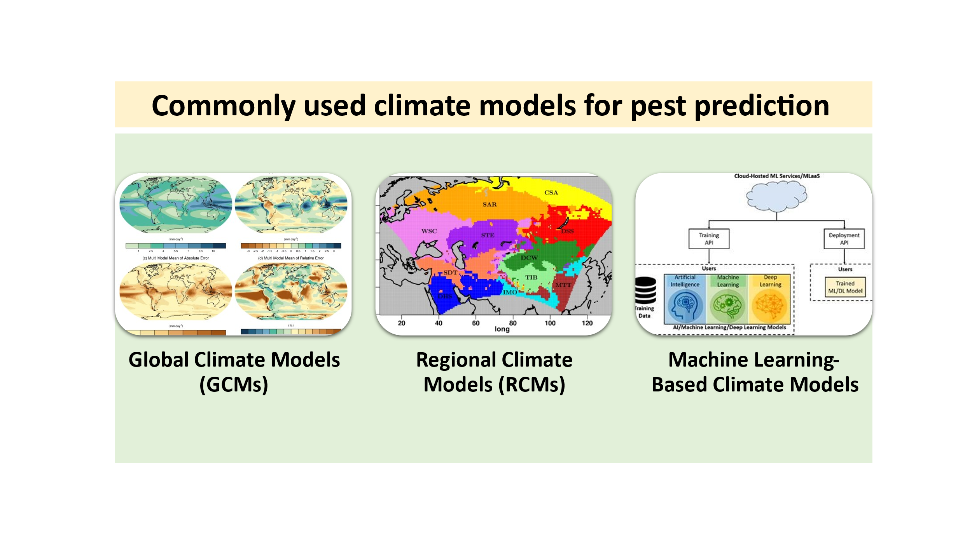

**Fig. 1: Commonly used climate models for pest prediction**

* **Global Climate Models (GCMs)**: Provide large-scale climate projections.
* **Regional Climate Models (RCMs)**: Offer higher resolution climate data for localized pest forecasting.
* **Machine Learning-Based Climate Models**: Utilize historical pest data and climate variables to improve prediction accuracy.

1. **Remote Sensing for Pest Monitoring**

Remote sensing technologies, including satellite imagery and drone-based surveillance, provide real-time data on vegetation health, land surface temperature, and moisture levels, all of which are key indicators of potential pest outbreaks (Rani et al., 2018; Soukhovolsky et al., 2023; Kovalev et al., 2024; Gajbhiye et al., 2023). Techniques include (fig. 2):

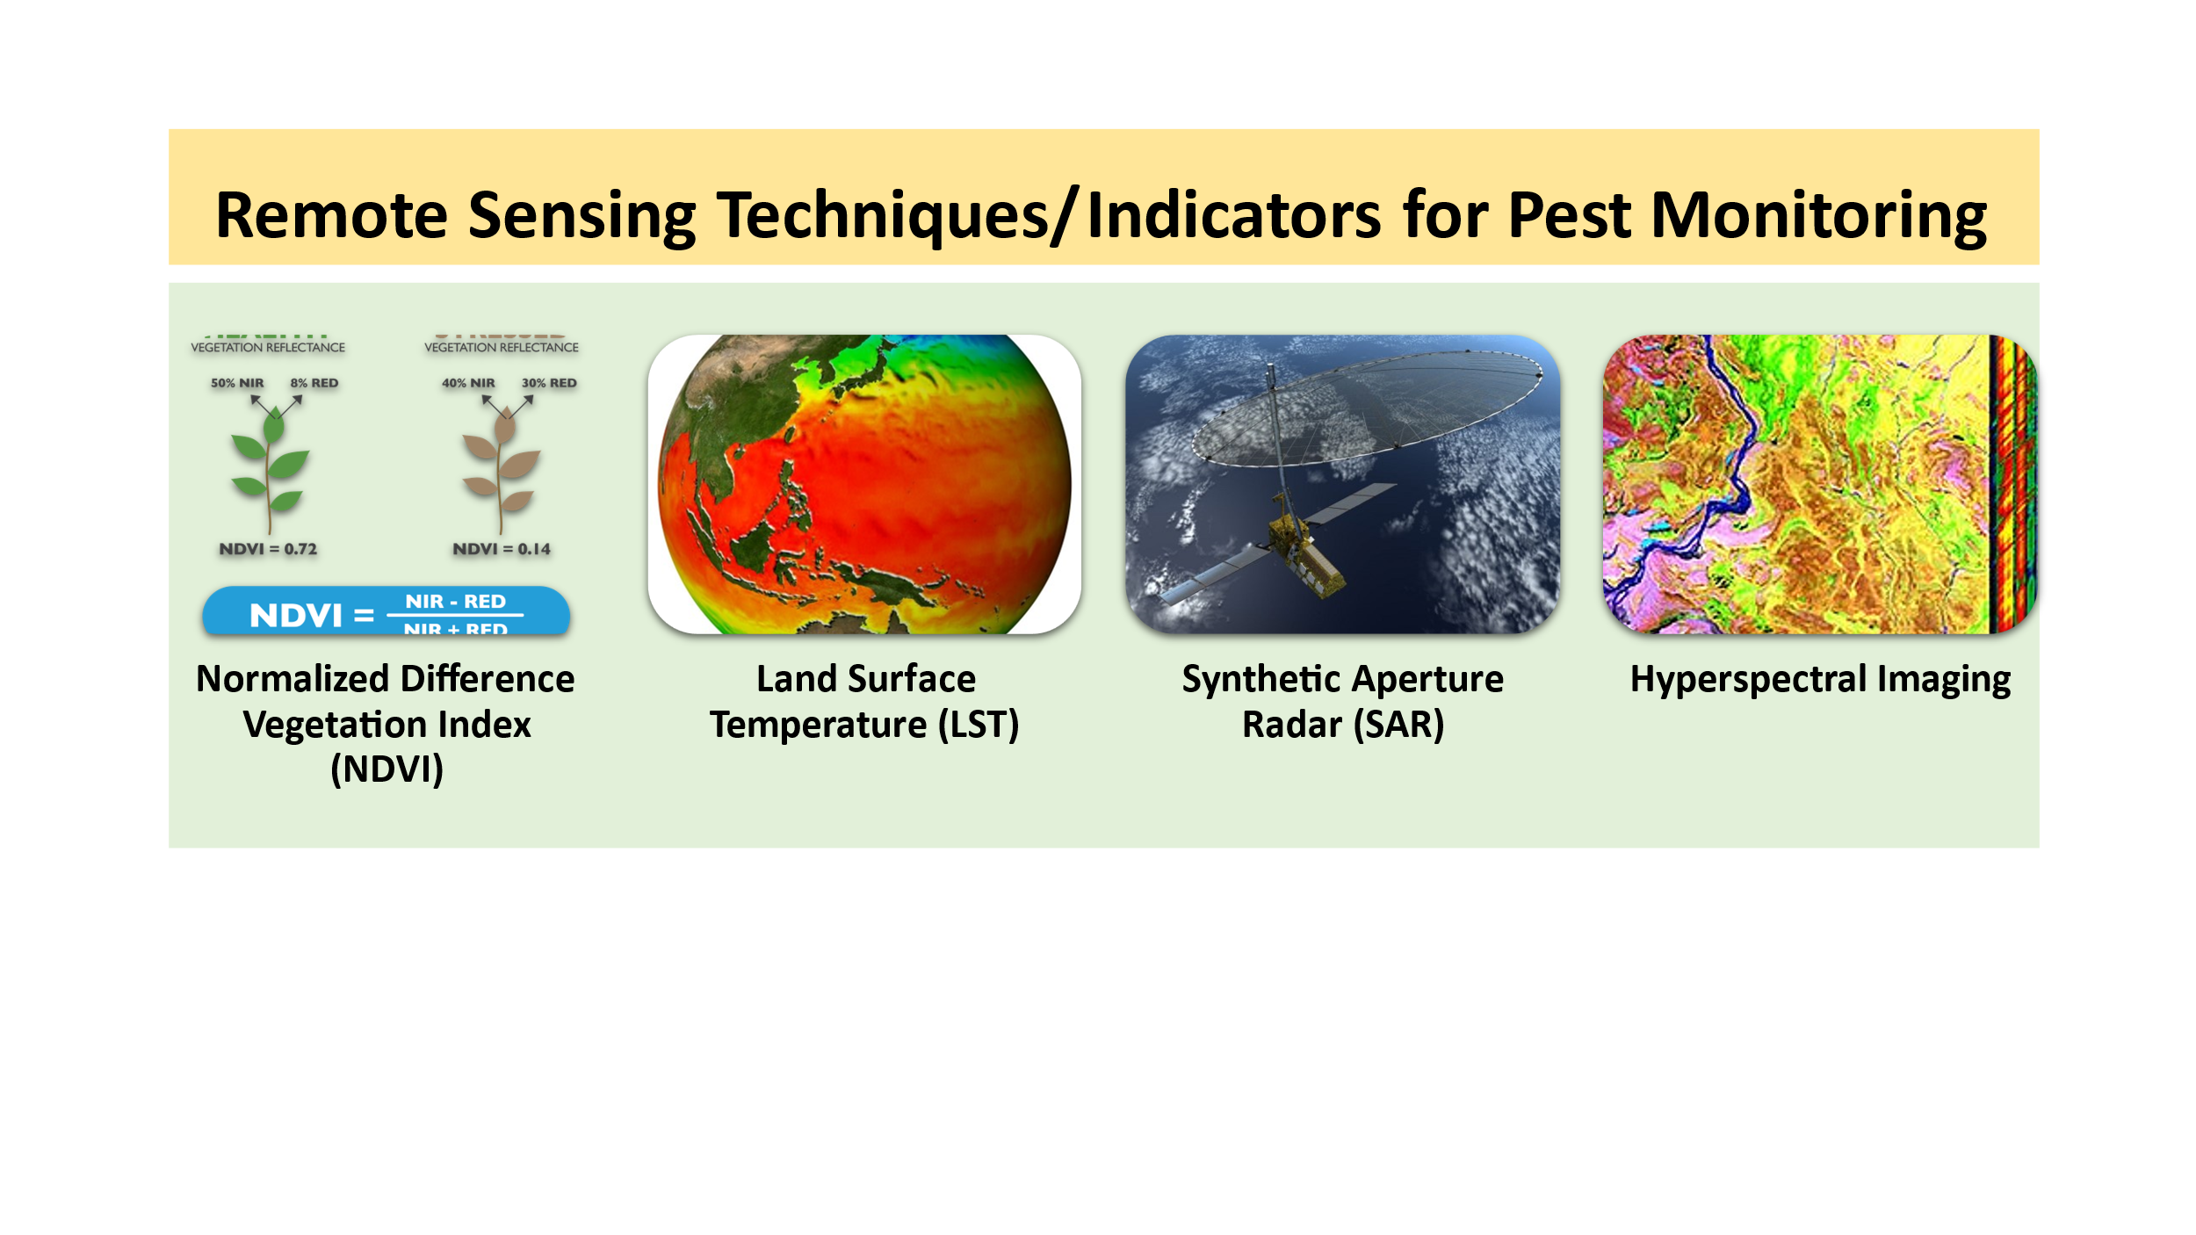

**Fig. 2: Remote Sensing Techniques/Indicators for Pest Monitoring**

* **Normalized Difference Vegetation Index (NDVI)**: Assesses plant stress levels, which may indicate pest activity.
* **Land Surface Temperature (LST)**: Helps track temperature variations influencing insect activity.
* **Synthetic Aperture Radar (SAR)**: Monitors soil moisture, crucial for certain pest species like locusts.
* **Hyperspectral Imaging**: Detects subtle changes in plant reflectance associated with pest infestations.

The integration of these remote sensing tools with Geographic Information Systems (GIS) allows for spatial analysis of pest hotspots, enabling targeted intervention strategies (Cock et al., 2016; Hall et al., 2016). These technologies facilitate rapid detection of pest-infested areas, optimizing pesticide application and minimizing ecological impacts.

1. **Integration of Climate Models and Remote Sensing for Pest Prediction**

Combining climate models with remote sensing enhances prediction accuracy by linking environmental variables with real-time pest distribution data (Cock et al., 2016; Soukhovolsky et al., 2023). Methods of integration include:

* **Data Assimilation Techniques**: Merging climate projections with satellite observations to refine predictions.
* **Geographic Information Systems (GIS)**: Mapping pest outbreak risks using spatial analysis.
* **Predictive Modeling Approaches**:
  + **Ecological Niche Models**: Estimate potential pest habitats based on climate variables.
  + **Machine Learning Algorithms**: Train predictive models using historical outbreak data.
  + **Process-Based Models**: Simulate pest life cycles under changing climatic conditions.

1. **Case Studies and Applications**

Several studies have demonstrated the effectiveness of climate models and remote sensing in pest outbreak prediction:

* **Desert Locust Monitoring in Africa and Asia**: The FAO's early warning system integrates climate models and satellite data to predict locust swarms and guide control measures. By utilizing meteorological data and remote sensing imagery, authorities can track locust movements and deploy targeted mitigation strategies.
* **Fall Armyworm Surveillance in South America**: Remote sensing combined with climate projections has helped predict outbreaks and mitigate crop damage. Machine learning techniques process climate data to forecast the migration patterns of armyworms, enabling farmers to take preventive actions.
* **Rice Brown Planthopper in Southeast Asia**: NDVI-based monitoring has been instrumental in identifying areas prone to pest infestations, allowing for timely pesticide application. Coupling satellite observations with climate trends enhances the accuracy of outbreak predictions and resource allocation.
* **Cotton Bollworm (Helicoverpa armigera)**: Researchers have applied interpretable machine learning models using earth observation vegetation indices, numerical weather predictions, and insect trap data to predict the presence of cotton bollworm in Greece. This approach aids in timely interventions by identifying key drivers of pest abundance.
* **Sunn Pest (*Eurygaster integriceps*)**: A forecasting and warning system has been developed to predict the ecological life cycle of the Sunn Pest by correlating climate data with its life stages. Machine learning models determine optimal pesticide application times, improving pest management in affected regions.
* **Forest Insect Disturbances**: Remote sensing has been effectively utilized to map and understand insect outbreak dynamics in forests. Studies have focused on various insect types, including bark beetles and defoliators, to assess their spatial and temporal distribution and impacts on forest ecosystems.

These examples underscore the practical benefits of these technologies in mitigating pest-related agricultural losses. Here are some recent case studies on predicting insect pest outbreaks using climate models and remote sensing:

* **A Geospatial Approach to Predicting Desert Locust Breeding Grounds in Africa** (Yusuf et al., 2024): This study develops an operational model for predicting desert locust breeding areas by analyzing spatio-temporal features through deep learning techniques, utilizing remotely sensed environmental and climate data.
* **Pest Presence Prediction Using Interpretable Machine Learning** (Nanushi et al., 2022): Researchers applied interpretable machine learning models using earth observation vegetation indices, numerical weather predictions, and insect trap data to predict the presence of cotton bollworm (*Helicoverpa armigera*) in Greece, aiding in timely interventions.
* **Development of a Forecasting and Warning System on the Ecological Life-Cycle of Sunn Pest** (Balaban et al., 2019): This study provides a machine learning solution that replaces traditional methods for deciding the pesticide application time of Sunn Pest by correlating climate data with phases of its life-cycle.
* **Remote Sensing of Forest Insect Disturbances: Current State and Future Directions** (Senf et al., 2017): This review discusses the use of remote sensing in mapping and understanding insect outbreak dynamics in forests, focusing on various insect types, including bark beetles and defoliators.
* **Forecasting Insect Abundance Using Time Series Embedding and Machine Learning** (Palma et al., 2023): This research proposes a novel approach combining statistics, machine learning, and time series embedding to forecast insect abundance, using datasets containing time series of aphids and climate data collected weekly in Southern Brazil.

These studies highlight the integration of climate data, remote sensing, and machine learning techniques in predicting insect pest outbreaks, contributing to more effective pest management strategies.

1. **Challenges and Future Directions**

Despite their potential, climate models and remote sensing face several challenges (fig. 3):

* **Data resolution and accuracy**: High-resolution, real-time data is essential for precise predictions, but satellite imagery may have limitations in detecting small-scale infestations.
* **Integration of multiple data sources**: Combining climate data, remote sensing, and field surveys remains complex and requires advanced computational models.
* **Climate change uncertainties**: Unpredictable climate variations can impact model reliability, necessitating continuous model adjustments and validation.
* **Cost and accessibility**: Advanced remote sensing technologies may be expensive for small-scale farmers, highlighting the need for cost-effective and scalable solutions.

Future research should focus on enhancing model accuracy through artificial intelligence, improving data-sharing platforms, and developing cost-effective monitoring solutions for broader accessibility. Additionally, interdisciplinary collaborations between meteorologists, entomologists, and data scientists will be crucial in refining predictive models and implementing effective pest management strategies.

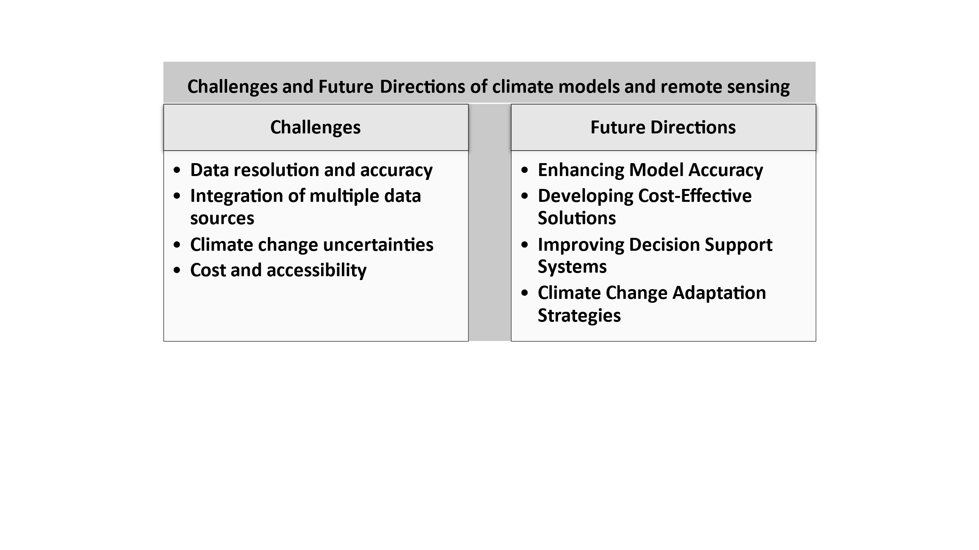

**Fig. 3: Challenges and Future Directions of climate models and remote sensing**

Future research should focus on (fig. 3):

* **Enhancing Model Accuracy**: Incorporating real-time field data and machine learning advancements.
* **Developing Cost-Effective Solutions**: Expanding access to affordable satellite data and UAV technology.
* **Improving Decision Support Systems**: Creating user-friendly platforms for farmers and policymakers.
* **Climate Change Adaptation Strategies**: Addressing long-term pest dynamics under changing climatic conditions.

1. **Conclusion**

The integration of climate models and remote sensing technologies represents a transformative approach to predicting insect pest outbreaks. By leveraging these tools, agricultural stakeholders can transition from reactive to proactive pest management, reducing crop losses and promoting sustainable agricultural practices. Continued advancements in technology, data integration, and model refinement will be crucial in realizing the full potential of these predictive systems. Policymakers and researchers must collaborate to ensure the widespread adoption of these technologies, paving the way for resilient agricultural systems in the face of climate change.

**References**

1. Abd El-Ghany, N. M., Abd El-Aziz, S. E., & Marei, S. S. (2020). A review: application of remote sensing as a promising strategy for insect pests and diseases management. Environmental Science and Pollution Research, 27(27), 33503-33515.
2. Balaban, İ., Acun, F., Arpalı, O. Y., Murat, F., Babaroğlu, N. E., Akci, E., ... & Temizer, S. (2019). Development of a forecasting and warning system on the ecological life-cycle of sunn pest. *arXiv preprint arXiv:1905.01640*.
3. Cock, M. J. W., Tang Rui, T. R., Liu Zhi, L. Z., Wan HuanHuan, W. H., McGillivray, L. A., Thomas, S. E., ... & Zhang Feng, Z. F. (2016). The main agricultural insect and disease pests of China and implications for the use of remote sensing for their management. CABI Reviews, (2016), 1-23.
4. Hall, R. J., Castilla, G., White, J. C., Cooke, B. J., & Skakun, R. S. (2016). Remote sensing of forest pest damage: A review and lessons learned from a Canadian perspective. The Canadian Entomologist, 148(S1), S296-S356.
5. Kovalev, A., Tarasova, O., Soukhovolsky, V., & Ivanova, Y. (2024). Is It Possible to Predict a Forest Insect Outbreak? Backtesting Using Remote Sensing Data. Forests, 15(8), 1458.
6. Lesk, C., Rowhani, P., & Ramankutty, N. (2016). Influence of extreme weather disasters on global crop production. *Nature*, *529*(7584), 84-87.
7. Logan, J. A., Régnière, J., & Powell, J. A. (2003). Assessing the impacts of global warming on forest pest dynamics. *Frontiers in Ecology and the Environment*, *1*(3), 130-137.
8. Nanushi, O., Sitokonstantinou, V., Tsoumas, I., & Kontoes, C. (2022, June). Pest presence prediction using interpretable machine learning. In *2022 IEEE 14th Image, Video, and Multidimensional Signal Processing Workshop (IVMSP)* (pp. 1-5). IEEE.
9. Palma, G. R., Mello, R. F., Godoy, W. A., Engel, E., Lau, D., Markham, C., & Moral, R. A. (2025). Forecasting insect abundance using time series embedding and machine learning. *Ecological Informatics*, *85*, 102934.
10. Parmesan, C., & Yohe, G. (2003). A globally coherent fingerprint of climate change impacts across natural systems. *nature*, *421*(6918), 37-42.
11. Rani, D. S., Venkatesh, M. N., Sri, C. N. S., & Kumar, K. A. (2018). Remote sensing as pest forecasting model in agriculture. Int J Curr Microbiol Appl Sci, 7(3), 2680-2689.
12. Senf, C., Seidl, R., & Hostert, P. (2017). Remote sensing of forest insect disturbances: Current state and future directions. *International journal of applied earth observation and geoinformation*, *60*, 49-60.
13. Soukhovolsky, V., Kovalev, A., Goroshko, A. A., Ivanova, Y., & Tarasova, O. (2023). Monitoring and Prediction of Siberian Silk Moth Dendrolimus sibiricus Tschetv.(Lepidoptera: Lasiocampidae) Outbreaks Using Remote Sensing Techniques. Insects, 14(12), 955.
14. Yusuf, I. S., Yusuf, M. O., Panford-Quainoo, K., & Pretorius, A. (2024). A Geospatial Approach to Predicting Desert Locust Breeding Grounds in Africa. *arXiv preprint arXiv:2403.06860*.
15. Nitta, A., Natarajan , V., Reddy , A. J., & Rakesh , T. (2024). Impact of Climate Change on Pest Biology, Behaviour and Their Distributions. *International Journal of Environment and Climate Change*, *14*(4), 46–56.
16. Gajbhiye , M., Agrawal , K. K., Jha , A. K., Kumar , N., & Raghuwanshi , M. (2023). Crop Health Monitoring through Remote Sensing: A Review. *International Journal of Environment and Climate Change*, *13*(10), 2581–2589.